

CONTRACT FOR THE CONSTRUCTION OF MALEMBO RURAL GROWTH CENTRE

BETWEEN
THE MINISTRY OF LOCAL GOVERNMENT, UNITY AND CULTURE THROUGHTRANSFORMING AGRICULTURE THROUGH DIVERSIFICATION AND ENTREPRENEURSHIP (TRADE) PROGRAMME

AND

SICO CIVILS LIMITED

TRADE/LL/MMKT/2024/01

15th November 2024

- Contract Agreement

THIS AGREEMENT made the day of 20_____ between The Ministry of Local Government, Unity and Culture through Transforming Agriculture Through Diversification and Entrepreneurship (TRADE) Programme of P.O. Box 2135, Lilongwe (hereinafter called “the employer”) of the one part and SICO CIVILS Limited, P. O. Box 3206, Lilongwe, Malawi (hereinafter called “the Contractor) of the other part:
Whereas the employer desires that the works known as Construction of Malembo Rural Growth Market Centre in Lilongwe District should be executed by the contractor, and has accepted a bid by the contractor in the sum of in the sum of 3,657,384,112.84 (Three billion six hundred fifty-seven million three hundred eighty-four thousand one hundred twelve point eight four Kwacha Only) (hereinafter called “the contract price”). for the execution and completion of these works and the remedying of any defects therein.

The employer and the contractor agree as follows:

1. In this agreement words and expressions shall have the same meanings as are respectively assigned to them in the contract documents referred to.
2. The following documents shall be deemed to form and be read and construed as part of this agreement. This agreement shall prevail over all other contract documents.
(a) the Letter of Acceptance
(b) the Letter of Bid
(c) the Addenda nos ________(if any)
(d) the Particular Conditions
(e) the General Conditions of Contract, including appendices;
(f) the Specifications
(g) the Drawings
(h) Bill of Quantities; and
(i) any other document listed in the PCC as forming part of the contract, including;
i. the ES Management Strategies and Implementation Plans; and
ii. Code of Conduct for Contractor’s Personnel (ES).
3. In consideration of the payments to be made by the employer to the contractor as specified in this agreement, the contractor hereby covenants with the employer to execute the works and to remedy defects therein in conformity in all respects with the provisions of the contract.
4. The employer hereby covenants to pay the contractor in consideration of the execution and completion of the works and the remedying of defects therein, the contract price or such other sum as may become payable under the provisions of the contract at the times and in the manner prescribed by the contract.

IN WITNESS whereof the parties hereto have caused this agreement to be executed in accordance with their respective laws the day and year first above written

Signed by: Signature: …………………….………………………………
Name: Mrs. Chrissy Chiumia
Position: Principal Secretary Rural Development -Ministry of Local Government, Unity and Culture
(for the Employer)

Witnessed by: Signature: ……………………...………………………………
Name: Mr. Francis Sakala
Position: National Programme Coordinator, TRADE
(for the Employer)

Signed by: Signature: ………………….………..………………………….
Name: .........................................................................................................
Position: ......................................................................................................
(for the Contractor)

Witnessed by: Signature: ………………………………………………….........
Name: ………………………………………………………………………………………
Position: …………………………………………………………………………………….
(for the Contractor)

2.0. General Conditions of Contract

Table of clauses

1. Definition 6
2. Interpretation 9
3. Language and law 10
4. Project manager’s decision 10
5. Delegation 10
6. Communications 10
7. Subcontracting 10
8. Other contractors 10
9. Personnel and equipment 11
10. Employer’s and contractor’s risks 18
11. Employer’s risks 18
12. Contractor’s risks 19
13. Insurance 19
14. Site data 19
15. Contractor to construct the works 19
16. The works to be completed by the intended completion date 20
17. Approval by the project manager 20
18. Health, safety and protection of the environment 21
19. Archaeological and geological findings 24
20. Possession of the site 24
21. Access to the site 24
22. Instructions, inspections and audits 25
23. Appointment of the adjudicator 25
24. Procedure for disputes 26
25. Fraud and corruption (prohibited practices) 26
26. Stakeholder engagement 26
27. Suppliers (other than subcontractor) 27
28. Code of conduct 28
29. Security of the site 28
30. Program and progress report 29
31. Extension of the intended completion date 30
32. Acceleration 31
33. Delays ordered by the project manager 31
34. Management meetings 31
35. Early warning 31
36. Identify defects 32
37. Tests 32
38. Correction of defects 32
39. Uncorrected defects 32
40. Contract price 32
41. Changes in the contract price 33
42. Variations 33
43. Cash flow forecast 35
44. Payment certificates 35
45. Payments 36
46. Compensation events 37
47. Tax 38
48. Currencies 38
49. Price adjustment 38
50. Retention 39
51. Liquid damages 39
52. Bonus 40
53. Advance payment 40
54. Securities 40
55. Dayworks 40
56. Cost of repairs 41
57. Completion 41
58. Taking over 41
59. Final account 41
60. Operating and maintenance manuals 41
61. Termination 42
62. Payment upon termination 43
63. Property 43
64. Release from performance 43
65. Suspension of IFAD loan or credit 43
66. SECAP Performance standards 44

- Definition | Boldface type is used to identify defined terms.  The accepted contract amount means the amount accepted in the letter of acceptance for the execution and completion of the works and the remedying of any defects.  The activity schedule is a schedule of the activities comprising the construction, installation, testing, and commissioning of the works in a lump-sum contract. It includes a lump-sum price for each activity, which is used for valuations and for assessing the effects of variations and compensation events.  The adjudicator is the person appointed jointly by the employer and the contractor to resolve disputes in the first instance, as provided for in GCC 23.  IFAD or FUND means the financing institution named in the PCC.  Bill of quantities means the priced and completed bill of quantities forming part of the bid.  Compensation events are those defined in GCC clause 42 hereunder.  The completion date is the date of completion of the works as certified by the project manager, in accordance with GCC sub-clause 57.1.  The contract is the contract between the employer and the contractor to execute, complete, and maintain the works. It consists of the documents listed in GCC sub-clause 2.3 below.  The contractor is the party whose bid to carry out the works has been accepted by the employer.  The contractor’s bid is the completed bidding document submitted by the contractor to the employer.  The contract price is the accepted contract amount stated in the letter of acceptance and thereafter as adjusted in accordance with the contract.  Days are calendar days; months are calendar months.  Dayworks are varied work inputs subject to payment on a time basis for the contractor’s employees and equipment, in addition to payments for associated materials and plant.  A defect is any part of the works not completed in accordance with the contract.  The defects liability certificate is the certificate issued by project manager upon correction of defects by the contractor.  The defects liability period is the period named in the PCC pursuant to GCC sub-clause 38.1 and calculated from the completion date.  Drawings means the drawings of the works, as included in the contract, and any additional and modified drawings issued by (or on behalf of) the employer in accordance with the contract, include calculations and other information provided or approved by the project manager for the execution of the contract.  The employer is the party who employs the contractor to carry out the works, as specified in the PCC.  Equipment is the contractor’s machinery and vehicles brought temporarily to the site to construct the works.  “In writing” or “written” means hand-written, type-written, printed or electronically made, and resulting in a permanent record;  The initial contract price is the contract price listed in the employer’s letter of acceptance.  The intended completion date is the date on which it is intended that the contractor shall complete the works. The intended completion date is specified in the PCC. The intended completion date may be revised only by the project manager by issuing an extension of time or an acceleration order.  Materials are all supplies, including consumables, used by the contractor for incorporation in the works.  Plant is any integral part of the works that shall have a mechanical, electrical, chemical, or biological function.  The project manager is the person named in the PCC (or any other competent person appointed by the employer and notified to the contractor, to act in replacement of the project manager) who is responsible for supervising the execution of the works and administering the contract.  PCC means particular conditions of contract.  The site is the area defined as such in the PCC.  Site investigation reports are those that were included in the bidding document and are factual and interpretative reports about the surface and subsurface conditions at the site.  Specifications means the specifications of the works included in the contract and any modification or addition made or approved by the project manager.  The start date is given in the PCC. It is the latest date when the contractor shall commence execution of the works. It does not necessarily coincide with any of the site possession dates.  A subcontractor is a person or corporate body who has a contract with the contractor to carry out a part of the work in the contract, which includes work on the site.  Temporary works are works designed, constructed, installed, and removed by the contractor that are needed for construction or installation of the works.  A variation is an instruction given by the project manager which varies the works.  The works are what the contract requires the contractor to construct, install, and turn over to the employer, as defined in the PCC.  “Contractor’s personnel” refers to all personnel whom the contractor utilizes on the site or other places where the works are carried out, including the staff, labor and other employees of each subcontractor.  “Key personnel” means the positions (if any) of the contractor’s personnel that are stated in the specifications.  “ES” means environmental and social (including sexual exploitation and abuse (SEA), and sexual harassment (SH));  “Sexual exploitation and abuse” “(SEA)” means “any actual or attempted abuse of a position of vulnerability, differential power, or trust, for sexual purposes, including, but not limited to, profiting monetarily, socially or politically from the sexual exploitation of others (sexual exploitation); the actual or threatened physical intrusion of a sexual nature, whether by force or under unequal or coercive conditions (sexual abuse)”.  “Sexual harassment” “(SH)” is defined as “unwelcome sexual advances, requests for sexual favors, and other verbal or physical conduct of a sexual nature that unreasonably interferes with work, alters or is made a condition of employment, or creates an intimidating, hostile or offensive work environment.  “Employer’s personnel” refers to the project manager and all other staff, labor and other employees (if any) of the project manager and of the employer engaged in fulfilling the employer’s obligations under the contract; and any other personnel identified as employer’s personnel, by a notice from the employer or the project manager to the contractor.
- Interpretation | In interpreting these GCC, words indicating one gender include all genders. words indicating the singular also include the plural and words indicating the plural also include the singular. Headings have no significance. Words have their normal meaning under the language of the contract unless specifically defined. The project manager shall provide instructions clarifying queries about these GCC.  If sectional completion is specified in the PCC, references in the GCC to the works, the completion date, and the intended completion date apply to any section of the works (other than references to the completion date and intended completion date for the whole of the works).  The documents forming the contract shall be interpreted in the following order of priority:  (a) Agreement,  (b) Letter of acceptance,  (c) Contractor’s bid,  (d) Particular conditions of contract,  (e) General conditions of contract, including appendices,  (f) Specifications,  (g) Drawings,  (h) Bill of quantities, and  (i) any other document listed in the PCC as forming part of the contract.
- Language and law | The language of the contract and the law governing the contract are stated in the PCC.  Throughout the execution of the contract, the contractor shall comply with the import of goods and services prohibitions in the employer’s country when  - as a matter of law or official regulations, the borrower’s country prohibits commercial relations with that country; or  - by an act of compliance with a decision of the United Nations Security Council taken under chapter VII of the Charter of the United Nations, the borrower’s country prohibits any import of goods from that country or any payments to any country, person, or entity in that country.
- Project manager’s decision | Except where otherwise specifically stated, the project manager shall decide contractual matters between the employer and the contractor in the role representing the employer.
- Delegation | Unless otherwise specified in the PCC, the project manager may delegate any of his duties and responsibilities to other people, except to the adjudicator, after notifying the contractor, and may revoke any delegation after notifying the contractor.
- Communications | Communications between parties that are referred to in the conditions shall be effective only when in writing. A notice shall be effective only when it is delivered.
- Subcontracting | The contractor may subcontract with the approval of the project manager but may not assign the contract without the approval of the employer in writing. Subcontracting shall not alter the contractor’s obligations. The contractor shall require that its subcontractors execute the works in accordance with the contract, including complying with the relevant ES requirements and the obligations set out in sub-clause 28.1.
- Other contractors | The contractor shall cooperate and share the site with other contractors, public authorities, utilities, and the employer between the dates given in the schedule of other contractors, as referred to in the PCC. The contractor shall also provide facilities and services for them as described in the schedule. The employer may modify the schedule of other contractors, and shall notify the contractor of any such modification.  The contractor shall also, as stated in the specifications or as instructed by the project manager, cooperate with and allow appropriate opportunities for the employer’s or any other personnel, notified to the contractor by the employer or project manager, to conduct any environmental and social assessment.
- Personnel and equipment | The contractor shall employ the key personnel and use the equipment identified in its bid, to carry out the works or other personnel and equipment approved by the project manager. The project manager shall approve any proposed replacement of key personnel and equipment only if their relevant qualifications or characteristics are substantially equal to or better than those proposed in the bid.  The project manager may require the contractor to remove (or cause to be removed) any person employed on the site or works, including the key personnel (if any), who:  - persists in any misconduct or lack of care;  - carries out duties incompetently or negligently;  - fails to comply with any provision of the contract;  - persists in any conduct which is prejudicial to safety, health, or the protection of the environment;  - based on reasonable evidence, is determined to have engaged in fraud and corruption during the execution of the works;  - has been recruited from the employer’s personnel;  - undertakes behavior which breaches the code of conduct for contractor’s personnel (ES).  If appropriate, the contractor shall then promptly appoint (or cause to be appointed) a suitable replacement with equivalent skills and experience.  Notwithstanding any requirement from the project manager to remove or cause to remove any person, the contractor shall take immediate action as appropriate in response to any violation of (a) through (g) above. Such immediate action shall include removing (or causing to be removed) from the site or other places where the works are being carried out, any contractor’s personnel who engages in (a), (b), (c), (d), (e) or (g) above or has been recruited as stated in (f) above.”  The Contractor shall take all necessary safety measures to avoid the occurrence of incidents and injuries to any third party, associated with the use of, if any, equipment on public roads or other public infrastructure. The contractor shall monitor road safety incidents and accidents to identify negative safety issues, and establish and implement necessary measures to resolve them.  Labor  - Engagement of staff and labor. The contractor shall provide and employ on the site for the execution of the works such skilled, semi-skilled and unskilled labor as is necessary for the proper and timely execution of the contract. The contractor is encouraged, to the extent practicable and reasonable, to employ staff and labor with appropriate qualifications and experience from sources within the country.  Unless otherwise provided in the contract, the contractor shall be responsible for the recruitment, transportation, accommodation and welfare facilities in accordance with GCC sub-clause 9.4.6, of the contractor’s personnel, and for all payments in connection therewith.  The contractor shall provide the contractor’s personnel information and documentation that are clear and understandable regarding their terms and conditions of employment. The information and documentation shall set out their rights under relevant labor laws applicable to the contractor’s personnel (which will include any applicable collective agreements), including their rights related to hours of work, wages, overtime, compensation and benefits, as well as those arising from any requirements in the specifications. The contractor’s personnel shall be informed when any material changes to their terms or conditions of employment occur.  - Conditions of labor. The contractor shall inform the contractor’s personnel about:  (a) any deduction to their payment and the conditions of such deductions in accordance with the applicable laws or as stated in the specifications; and  (b) their liability to pay personal income taxes in the country in respect of such of their salaries, wages, allowances and any benefits as are subject to tax under the laws of the country for the time being in force.  The contractor shall perform such duties in regard to such deductions thereof as may be imposed on him by such laws. Where required by applicable laws or as stated in the specifications, the contractor shall provide the contractor’s personnel written notice of termination of employment and details of severance payments in a timely manner. The contractor shall have paid the contractor’s personnel (either directly or where appropriate for their benefit) all due wages and entitlements including, as applicable, social security benefits and pension contributions, on or before the end of their engagement/ employment.  - The contractor may bring in to the country any foreign personnel who are necessary for the execution of the works to the extent allowed by the applicable laws. The contractor shall ensure that these personnel are provided with the required residence visas and work permits. The employer will, if requested by the contractor, use its best endeavors in a timely and expeditious manner to assist the contractor in obtaining any local, state, national, or government permission required for bringing in the contractor’s personnel.  - The contractor shall at its own expense provide the means of repatriation to and the contractor’s personnel employed on the contract at the Site to their various home countries. It shall also provide suitable temporary maintenance of all such persons from the cessation of their employment on the contract to the date programmed for their departure. In the event that the contractor defaults in providing such means of transportation and temporary maintenance, the employer may provide the same to such personnel and recover the cost of doing so from the contractor.  - Disorderly conduct. The contractor shall at all times during the progress of the contract use its best endeavors to prevent any unlawful, riotous or disorderly conduct or behavior by or amongst the contractor’s personnel.  - Facilities for staff and labor. Except as otherwise stated in the specifications, the contractor shall provide and maintain all necessary accommodation and welfare facilities for the contractor’s personnel. If stated in the specifications, the contractor shall give access to or provide services that accommodate the physical, social and cultural needs of the contractor’s personnel. The contractor shall also provide similar facilities for the employer’s personnel if stated in the specifications.  - The contractor shall, in all dealings with the contractor’s personnel, pay due regard to all recognized festivals, official holidays, religious or other customs and all local laws and regulations pertaining to the employment of labor. The contractor shall provide the contractor’s personnel annual holiday and sick, maternity and family leave, as required by applicable laws or as stated in the specifications.  - Supply of foodstuffs. The contractor shall arrange for the provision of a sufficient supply of suitable food as may be stated in the specifications at reasonable prices for the contractor’s personnel for the purposes of or in connection with the contract.  - Supply of water. The contractor shall, having regard to local conditions, provide on the site an adequate supply of drinking and other water for the use of the contractor’s personnel.  - Measures against Insect and pest nuisance. The contractor shall at all times take the necessary precautions to protect the contractor’s personnel employed on the site from insect and pest nuisance, and to reduce the danger to their health. The contractor shall comply with all the regulations of the local health authorities, including use of appropriate insecticide.  - Alcoholic liquor or drugs. The contractor shall not, otherwise than in accordance with the laws of the country, import, sell, give, barter or otherwise dispose of any alcoholic liquor or drugs, or permit or allow importation, sale, gift, barter or disposal thereto by contractor’s personnel.  - Arms and ammunition. The contractor shall not give, barter, or otherwise dispose of, to any person, any arms or ammunition of any kind, or allow contractor’s personnel to do so.  - Funeral arrangements. The contractor shall be responsible, to the extent required by local regulations, for making any funeral arrangements for any of its local employees who may die while engaged upon the works.  - Forced labor. The contractor, including its subcontractors, shall not employ or engage forced labor. Forced labor consists of any work or service, not voluntarily performed, that is exacted from an individual under threat of force or penalty, and includes any kind of involuntary or compulsory labor, such as indentured labor, bonded labor or similar labor-contracting arrangements.  No persons shall be employed or engaged who have been subject to trafficking. Trafficking in persons is defined as the recruitment, transportation, transfer, harboring or receipt of persons by means of the threat or use of force or other forms of coercion, abduction, fraud, deception, abuse of power, or of a position of vulnerability, or of the giving or receiving of payments or benefits to achieve the consent of a person having control over another person, for the purposes of exploitation.  Child Labor. The contractor, including its subcontractors, shall not employ or engage a child under the age of 14 unless the national law specifies a higher age (the minimum age).  The contractor, including its subcontractors, shall not employ or engage a child between the minimum age and the age of 18 in a manner that is likely to be hazardous, or to interfere with, the child’s education, or to be harmful to the child’s health or physical, mental, spiritual, moral, or social development.  The contractor including its subcontractors, shall only employ or engage children between the minimum age and the age of 18 after an appropriate risk assessment has been conducted by the contractor with the project manager’s approval. The contractor shall be subject to regular monitoring by the project manager that includes monitoring of health, working conditions and hours of work.  Work considered hazardous for children is work that, by its nature or the circumstances in which it is carried out, is likely to jeopardize the health, safety, or morals of children. Such work activities prohibited for children include work:  (a) with exposure to physical, psychological or sexual abuse;  (b) underground, underwater, working at heights or in confined spaces;  (c) with dangerous machinery, equipment or tools, or involving handling or  (d) transport of heavy loads;  (e) in unhealthy environments exposing children to hazardous substances, agents, or processes, or to temperatures, noise or vibration damaging to health; or(f) under difficult conditions such as work for long hours, during the night or in confinement on the premises of the employer Employment records of workers. The contractor shall keep complete and accurate records of the employment of labor at the site. The records shall include the names, ages, genders, hours worked, and wages paid to all workers. These records shall be summarized on a monthly basis and submitted to the project manager.  - Workers’ organizations. In countries where the relevant labor laws recognize workers’ rights to form and to join workers’ organizations of their choosing and to bargain collectively without interference, the contractor shall comply with such laws. In such circumstances, the role of legally established workers’ organizations and legitimate workers’ representatives will be respected, and they will be provided with information needed for meaningful negotiation in a timely manner. Where the relevant labor laws substantially restrict workers’ organizations, the contractor shall enable alternative means for the contractor’s personnel to express their grievances and protect their rights regarding working conditions and terms of employment. The contractor shall not seek to influence or control these alternative means. The contractor shall not discriminate or retaliate against the contractor’s personnel who participate, or seek to participate, in such organizations and collective bargaining or alternative mechanisms. Workers’ organizations are expected to fairly represent the workers in the workforce.  - Non-discrimination and equal opportunity. The contractor shall not make decisions relating to the employment or treatment of contractor’s personnel on the basis of personal characteristics unrelated to inherent job requirements. The contractor shall base the employment of contractor’s personnel on the principle of equal opportunity and fair treatment, and shall not discriminate with respect to any aspects of the employment relationship, including recruitment and hiring, compensation (including wages and benefits), working conditions and terms of employment, access to training, job assignment, promotion, termination of employment or retirement, and disciplinary practices.  Special measures of protection or assistance to remedy past discrimination or selection for a particular job based on the inherent requirements of the job shall not be deemed discrimination. The Contractor shall provide protection and assistance as necessary to ensure non-discrimination and equal opportunity, including for specific groups such as women, people with disabilities, migrant workers and children (of working age in accordance with GCC Sub-Clause 9.4.15).  Contractor’s personnel grievance mechanism. The contractor shall have a grievance mechanism for contractor’s personnel, and where relevant the workers’ organizations stated in GCC sub-clause 9.4.16, to raise workplace concerns. The grievance mechanism shall be proportionate to the nature, scale, risks and impacts of the contract. The mechanism shall address concerns promptly, using an understandable and transparent process that provides timely feedback to those concerned in a language they understand, without any retribution, and shall operate in an independent and objective manner.  The contractor’s personnel shall be informed of the grievance mechanism at the time of engagement for the contract, and the measures put in place to protect them against any reprisal for its use. Measures will be put in place to make the grievance mechanism easily accessible to all contractor’s personnel. The grievance mechanism shall not impede access to other judicial or administrative remedies that might be available, or substitute for grievance mechanisms provided through collective agreements.  The grievance mechanism may utilize existing grievance mechanisms, providing that they are properly designed and implemented, address concerns promptly, and are readily accessible to contractor’s personnel. Existing grievance mechanisms may be supplemented as needed with contract-specific arrangements.9.4.20 Training of contractor’s personnel. The contractor shall provide appropriate training to relevant contractor’s personnel on ES aspects of the contract, including appropriate sensitization on prohibition of SEA and SH, and health and safety training referred to in GCC sub-clause 18.2.  As stated in the specifications or as instructed by the project manager, the contractor shall also allow appropriate opportunities for the relevant contractor’s personnel to be trained on ES aspects of the contract by the employer’s personnel.  The contractor shall provide training on SEA and SH, including its prevention, to any of its personnel who has a role to supervise other contractor’s personnel.
10. Employer’s and contractor’s risks | The employer carries the risks which this contract states are employer’s risks, and the contractor carries the risks which this contract states are contractor’s risks.
11. Employer’s risks | From the start date until the defects liability certificate has been issued, the following are employer’s risks:  - The risk of personal injury, death, or loss of or damage to property (excluding the works, plant, materials, and equipment), which are due to  - use or occupation of the site by the works or for the purpose of the works, which is the unavoidable result of the works or  - negligence, breach of statutory duty, or interference with any legal right by the employer or by any person employed by or contracted to him except the contractor.  - The risk of damage to the works, plant, materials, and equipment to the extent that it is due to a fault of the employer or in the employer’s design, or due to war or radioactive contamination directly affecting the country where the works are to be executed.  From the completion date until the defects liability certificate has been issued, the risk of loss of or damage to the works, plant, and materials is an employer’s risk except loss or damage due to  a defect which existed on the completion date,  an event occurring before the completion date, which was not itself an employer’s risk, or  the activities of the contractor on the site after the completion date.
12. Contractor’s risks | From the starting date until the defects liability certificate has been issued, the risks of personal injury, death, and loss of or damage to property (including, without limitation, the works, plant, materials, and equipment) which are not employer’s risks are contractor’s risks.
13. Insurance | The contractor shall provide, in the joint names of the employer and the contractor, insurance cover from the start date to the end of the defects liability period, in the amounts and deductibles stated in the PCC for the following events which are due to the contractor’s risks:  - loss of or damage to the works, plant, and materials;  - loss of or damage to equipment;  - loss of or damage to property (except the works, plant, Materials, and equipment) in connection with the contract; and  - personal injury or death.  Policies and certificates for insurance shall be delivered by the contractor to the project manager for the project manager’s approval before the start date. All such insurance shall provide for compensation to be payable in the types and proportions of currencies required to rectify the loss or damage incurred.  If the contractor does not provide any of the policies and certificates required, the employer may effect the insurance which the contractor should have provided and recover the premiums the employer has paid from payments otherwise due to the contractor or, if no payment is due, the payment of the premiums shall be a debt due.  Alterations to the terms of an insurance shall not be made without the approval of the project manager.  Both parties shall comply with any conditions of the insurance policies.
14. Site data | The contractor shall be deemed to have examined any site data referred to in the PCC, supplemented by any information available to the contractor.
15. Contractor to construct the works | The contractor shall construct and install the works in accordance with the specifications and drawings.  If the contract specifies that the contractor shall design any part of the permanent works, the contractor shall take into the employer’s requirements which may include, if stated in the specifications:  - designing structural elements of the works taking into account climate change considerations;  - applying the concept of universal access (the concept of universal access means unimpeded access for people of all ages and abilities in different situations and under various circumstances; and  - considering the incremental risks of the public’s potential exposure to operational accidents or natural hazards, including extreme weather events.
16. The works to be completed by the intended completion date | The contractor may commence execution of the works on the start date and shall carry out the works in accordance with the program submitted by the contractor, as updated with the approval of the project manager, and complete them by the intended completion date.  The contractor shall not carry out mobilization to the site unless the project manager gives approval, an approval that shall not be unreasonably delayed, to the measures the contractor proposes to address environmental and social risks and impacts, which at a minimum shall include applying the management strategies and Implementation plans (MSIPs) and code of conduct for contractor’s personnel submitted as part of the bid and agreed as part of the contract.  The contractor shall submit, to the project manager for its approval any additional MSIPs as are necessary to manage the ES risks and impacts of ongoing works. These MSIPs collectively comprise the contractor’s environmental and social management plan (C-ESMP). The contractor shall review the C-ESMP, periodically (but not less than every six (6) months), and update it as required to ensure that it contains measures appropriate to the works. The updated C-ESMP shall be submitted to the project manager for its approval.
17. Approval by the project manager | The contractor shall submit specifications and drawings showing the proposed temporary works to the project manager, for his approval.  The contractor shall be responsible for design of temporary works.  The project manager’s approval shall not alter the contractor’s responsibility for design of the temporary works.  The contractor shall obtain approval of third parties to the design of the temporary works, where required.  All drawings prepared by the contractor for the execution of the temporary or permanent works, are subject to prior approval by the project manager before this use.
18. Health, safety and protection of the environment | The contractor shall be responsible for the safety of all activities on the site.  The contractor shall:  - comply with all applicable health and safety regulations and laws;  - comply with all applicable health and safety obligations specified in the contract;  - take care for the health and safety of all persons entitled to be on the site and other places, if any, where the works are being executed;  - keep the site and works clear of unnecessary obstruction so as to avoid danger to these persons;  - provide fencing, lighting, safe access, guarding and watching of the works until the issue of the contract certificate of completion;  - provide any temporary works (including roadways, footways, guards and fences) which may be necessary, because of the execution of the works, for the use and protection of the public and of owners and occupiers of adjacent land;  - provide health and safety training of contractor’s personnel as appropriate and maintain training records;  - actively engage the contractor’s personnel in promoting understanding, and methods for, implementation of health and safety requirements, as well as in providing information to contractor’s personnel, training on occupational safety and health, and provision of personal protective equipment without expense to the contractor’s personnel;  - put in place workplace processes for contractor’s personnel to report work situations that they believe are not safe or healthy, and to remove themselves from a work situation which they have reasonable justification to believe presents an imminent and serious danger to their life or health;  - Contractor’s personnel who remove themselves from such work situations shall not be required to return to work until necessary remedial action to correct the situation has been taken. Contractor’s personnel shall not be retaliated against or otherwise subject to reprisal or negative action for such reporting or removal;  - where the employer’s personnel, any other contractors employed by the employer, and/or personnel of any legally constituted public authorities and private utility companies are employed in carrying out, on or near the site, of any work not included in the contract, collaborate in applying the health and safety requirements, without prejudice to the responsibility of the relevant entities for the health and safety of their own personnel; and  - establish and implement a system for regular (not less than six-monthly) review of health and safety performance and the working environment.  Subject to GCC sub-clause 16.2, the contractor shall submit to the project manager for its approval a health and safety manual which has been specifically prepared for the works, the site and other places (if any) where the contractor intends to execute the works.  The health and safety manual shall be in addition to any other similar document required under applicable health and safety regulations and laws.  The health and safety manual shall set out all the health and safety requirements under the contract,  - which shall include at a minimum:  - the procedures to establish and maintain a safe working environment without risk to health at all workplaces, machinery, equipment and processes under the control of the contractor, including control measures for chemical, physical and biological substances and agents;  - details of the training to be provided, records to be kept;  - the procedures for prevention, preparedness and response activities to be implemented in the case of an emergency event (i.e. an unanticipated incident, arising from both natural and man-made hazards, typically in the form of fire, explosions, leaks or spills, which may occur for a variety of different reasons including failure to implement operating procedures that are designed to prevent their occurrence, extreme weather or lack of early warning);  - remedies for adverse impacts such as occupational injuries, deaths, disability and disease;  - the measures to be taken to avoid or minimize the potential for community exposure to water-borne, water-based, water-related, and vector-borne diseases,  - the measures to be implemented to avoid or minimize the spread of communicable diseases (including transfer of sexually transmitted diseases or infections (STDs), such as HIV virus) and non-communicable diseases associated with the execution of the works, taking into consideration differentiated exposure to and higher sensitivity of vulnerable groups. This includes taking measures to avoid or minimize the transmission of communicable diseases that may be associated with the influx of temporary or permanent contract-related labor;  - the policies and procedures on the management and quality of accommodation and welfare facilities if such accommodation and welfare facilities are provided by the contractor in accordance with GCC sub-clause 9.4.6; and  - any other requirements stated in the specifications.  Protection of the environment  - The contractor shall take all necessary measures to: protect the environment (both on and off the Site); and  - limit damage and nuisance to people and property resulting from pollution, noise and other results of the Contractor’s operations and/ or activities.  - The contractor shall ensure that emissions, surface discharges, effluent and any other pollutants from the contractor’s activities shall exceed neither the values indicated in the Specifications, nor those prescribed by applicable laws.  - In the event of damage to the environment, property and/or nuisance to people, on or off site as a result of the contractor’s operations, the contractor shall agree with the project manager the appropriate actions and time scale to remedy, as practicable, the damaged environment to its former condition. The contractor shall implement such remedies at its cost to the satisfaction of the project manager.
19. Archaeological and geological findings | All fossils, coins, articles of value or antiquity, structures, groups of structures, and other remains or items of geological, archaeological, paleontological, historical, architectural or religious interest found on the site shall be placed under the care and custody of the employer. The contractor shall:  - take all reasonable precautions, including fencing-off the area or site of the finding, to avoid further disturbance and prevent contractor’s personnel or other persons from removing or damaging any of these findings;  - train relevant contractor’s personnel on appropriate actions to be taken in the event of such findings; and  - implement any other action consistent with the requirements of the specifications and relevant laws.  The contractor shall, as soon as practicable after discovery of any such finding, notify the project manager of such discoveries and carry out the project manager’s instructions for dealing with them
20. Possession of the site | The employer shall give possession of all parts of the site to the contractor. If possession of a part is not given by the date stated in the PCC, the employer shall be deemed to have delayed the start of the relevant activities, and this shall be a compensation event.
21. Access to the site | The contractor shall allow the project manager and any person authorized by the project manager (including the IFAD staff or consultants acting on the IFAD’s behalf, stakeholders and third parties, such as independent experts, local communities, or non-governmental organizations), including to carry out environmental and social audit, as appropriate, access to the site and to any place where work in connection with the contract is being carried out or is intended to be carried out.
22. Instructions, inspections and audits | The contractor shall carry out all instructions of the project manager which comply with the applicable laws where the Site is located.  The contractor shall keep, and shall make all reasonable efforts to cause its subcontractors and subconsultants to keep, accurate and systematic accounts and records in respect of the works in such form and details as will clearly identify relevant time changes and costs.  Inspections & Audit by the IFAD  Pursuant to paragraph 2.2 e. of Appendix A to the GCC- fraud and corruption, the contractor shall permit and shall cause its agents (where declared or not), subcontractors, subconsultants, service providers, suppliers, and personnel, to permit, the IFAD and/or persons appointed by the IFAD to inspect the site and/or the accounts, records and other documents relating to the procurement process, selection and/or contract execution, and to have such accounts, records and other documents audited by auditors appointed by the IFAD. The contractor’s and its subcontractors’ and subconsultants’ attention is drawn to GCC sub-clause 25.1 (fraud and corruption) which provides, inter alia, that acts intended to materially impede the exercise of the IFAD’s inspection and audit rights constitute a prohibited practice subject to contract termination (as well as to a determination of ineligibility pursuant to the IFAD’s prevailing sanctions procedures).
23. Appointment of the adjudicator | The adjudicator shall be appointed jointly by the employer and the contractor, at the time of the employer’s issuance of the letter of acceptance. If, in the letter of acceptance, the employer does not agree on the appointment of the adjudicator, the employer will request the appointing authority designated in the PCC, to appoint the adjudicator within 14 days of receipt of such request.  Should the adjudicator resign or die, or should the employer and the contractor agree that the adjudicator is not functioning in accordance with the provisions of the contract, a new adjudicator shall be jointly appointed by the employer and the contractor. In case of disagreement between the employer and the contractor, within 30 days, the adjudicator shall be designated by the appointing authority designated in the PCC at the request of either party, within 14 days of receipt of such request.
24. Procedure for disputes | If the contractor believes that a decision taken by the project manager was either outside the authority given to the project manager by the contract or that the decision was wrongly taken, the decision shall be referred to the Adjudicator within 14 days of the notification of the project manager’s decision.  The adjudicator shall give a decision in writing within 28 days of receipt of a notification of a dispute.  The adjudicator shall be paid by the hour at the rate specified in the PCC, together with reimbursable expenses of the types specified in the PCC, and the cost shall be divided equally between the employer and the contractor, whatever decision is reached by the adjudicator. Either party may refer a decision of the adjudicator to an arbitrator within 28 days of the adjudicator’s written decision. If neither party refers the dispute to arbitration within the above 28 days, the adjudicator’s decision shall be final and binding.  The arbitration shall be conducted in accordance with the arbitration procedures published by the institution named and, in the place, specified in the PCC.
25. Fraud and corruption (prohibited practices) | The IFAD requires compliance with the IFAD’s Anti-Corruption Guidelines and its prevailing sanctions policies and procedures as set forth in Appendix A to the GCC.  The employer requires the contractor to disclose any commissions or fees that may have been paid or are to be paid to agents or any other party with respect to the bidding process or execution of the contract. The information disclosed must include at least the name and address of the agent or other party, the amount and currency, and the purpose of the commission, gratuity or fee.
26. Stakeholder engagement | The contractor shall provide relevant contract-related information, as the employer and/or project manager may reasonably request to conduct stakeholder engagements. “stakeholder” refers to individuals or groups who:  - are affected or likely to be affected by the contract; and  - may have an interest in the contract.  The contractor may also directly participate in stakeholder engagements, as the employer and/or project manager may reasonably request.
27. Suppliers (other than subcontractor) | Forced labor: The contractor shall take measures to require its suppliers (other than subcontractors) not to employ or engage forced labor including trafficked persons as described in GCC sub-clause 9.4.14. If forced labor/trafficking cases are identified, the contractor shall take measures to require the suppliers to take appropriate steps to remedy them. Where the supplier does not remedy the situation, the contractor shall within a reasonable period substitute the supplier with a supplier that is able to manage such risks.  Child labor: The contractor shall take measures to require its suppliers (other than Subcontractors) not to employ or engage child labor as described in GCC sub-clause 9.4.15. If child labor cases are identified, the contractor shall take measures to require the suppliers to take appropriate steps to remedy them. Where the supplier does not remedy the situation, the contractor shall within a reasonable period substitute the supplier with a supplier that is able to manage such risks.  Serious safety issues: The contractor, including its subcontractors, shall comply with all applicable safety obligations, including as stated in GCC sub-clause 18.2. The contractor shall also take measures to require its suppliers (other than subcontractors) to adopt procedures and mitigation measures adequate to address safety issues related to their personnel. If serious safety issues are identified, the contractor shall take measures to require the suppliers to take appropriate steps to remedy them. Where the supplier does not remedy the situation, the contractor shall within a reasonable period substitute the supplier with a supplier that is able to manage such risks.  Obtaining natural resource materials in relation to supplier: The contractor shall obtain natural resource materials from suppliers that can demonstrate, through compliance with the applicable verification and/ or certification requirements, that obtaining such materials is not contributing to the risk of significant conversion or significant degradation of natural or critical habitats such as unsustainably harvested wood products, gravel or sand extraction from river beds or beaches.  If a supplier cannot continue to demonstrate that obtaining such materials is not contributing to the risk of significant conversion or significant degradation of natural or critical habitats, the contractor shall within a reasonable period substitute the supplier with a supplier that is able to demonstrate that they are not significantly adversely impacting the habitats.
28. Code of conduct | The contractor shall have a code of conduct for the contractor’s personnel.  The contractor shall take all necessary measures to ensure that each contractor’s personnel is made aware of the code of conduct including specific behaviors that are prohibited, and understands the consequences of engaging in such prohibited behaviors.  These measures include providing instructions and documentation that can be understood by the contractor’s personnel and seeking to obtain that person’s signature acknowledging receipt of such instructions and/or documentation, as appropriate.  The contractor shall also ensure that the code of conduct is visibly displayed in multiple locations on the site and any other place where the works will be carried out, as well as in areas outside the site accessible to the local community and project affected people. The posted code of conduct shall be provided in languages comprehensible to contractor’s personnel, employer’s personnel and the local community.  The contractor’s management strategy and implementation plans shall include appropriate processes for the contractor to verify compliance with these obligations.
29. Security of the site | The contractor shall be responsible for the security of the site, and:  - or keeping unauthorized persons off the site;  - authorized persons shall be limited to the contractor’s personnel, the employer’s personnel, and to any other personnel identified as authorized personnel (including the employer’s other contractors on the Site), by a notice from the employer or the project manager to the contractor.  Subject to GCC sub-clause 16.2, the contractor shall submit for the project manager’s No-objection a security management plan that sets out the security arrangements for the site.  The contractor shall (i) conduct appropriate background checks on any personnel retained to provide security; (ii) train the security personnel adequately (or determine that they are properly trained) in the use of force (and where applicable, firearms), and appropriate conduct towards contractor’s personnel, employer’s personnel and affected communities; and (iii) require the security personnel to act within the applicable laws and any requirements set out in the specifications.  The contractor shall not permit any use of force by security personnel in providing security except when used for preventive and defensive purposes in proportion to the nature and extent of the threat.  In making security arrangements, the contractor shall also comply with any additional requirements stated in the specifications.”
B.Time Control
30. Program and progress report | Within the time stated in the PCC, after the date of the Letter of acceptance, the contractor shall submit to the project manager for approval a program showing the general methods, arrangements, order, and timing for all the activities in the works. In the case of a lump-sum contract, the activities in the program shall be consistent with those in the activity schedule. The project manager’s approval of the program shall not alter the contractor’s obligations. The contractor may revise the program and submit it to the project manager again at any time. A revised program shall show the effect of variations and compensation events.  An update of the program shall be a program showing the actual progress achieved on each activity and the effect of the progress achieved on the timing of the remaining work, including any changes to the sequence of the activities.  The contractor shall monitor progress of the works and submit to the project manager progress report and any updated program showing the actual progress achieved and the effect of the progress achieved on the timing of the remaining works, including any changes to the sequence of the activities, at intervals no longer than the periods stated in the PCC. If the contractor does not submit an updated program within this period, the project manager may withhold the amount stated in the PCC from the next payment certificate and continue to withhold this amount until the next payment after the date on which the overdue program has been submitted. In the case of lump-sum contract, the contractor shall provide an updated activity schedule within 14 days of being instructed to by the project manager.  Unless otherwise stated in the specifications, each progress report shall include the environmental and social (ES) metrics set out in Appendix B.  In addition to the progress reports, the contractor shall inform the project manager immediately of any allegation, incident or accident in the site, which has or is likely to have a significant adverse effect on the environment, the affected communities, the public, employer’s personnel or contractor’s personnel. This includes, but is not limited to, any incident or accident-causing fatality or serious injury; significant adverse effects or damage to private property; or any allegation of SEA and/or SH. In case of SEA and/or SH, while maintaining confidentiality as appropriate, the type of allegation (sexual exploitation, sexual abuse or sexual harassment), gender and age of the person who experienced the alleged incident should be included in the information.  The contractor, upon becoming aware of the allegation, incident or accident, shall also immediately inform the project manager of any such incident or accident on the subcontractors’ or suppliers’ premises relating to the works which has or is likely to have a significant adverse effect on the environment, the affected communities, the public, employer’s personnel, or contractor’s, its subcontractors’ and suppliers’ personnel. The notification shall provide sufficient detail regarding such incidents or accidents. The contractor shall provide full details of such incidents or accidents to the project manager within the timeframe agreed with the project manager.  The contractor shall require its subcontractors and suppliers (other than Subcontractors) to immediately notify the contractor of any incidents or accidents referred to in this subclause.
31. Extension of the intended completion date | The project manager shall extend the intended completion date if a compensation event occurs or a variation is issued which makes it impossible for completion to be achieved by the intended completion date without the contractor taking steps to accelerate the remaining work, which would cause the contractor to incur additional cost.  The project manager shall decide whether and by how much to extend the intended completion date within 21 days of the contractor asking the project manager for a decision upon the effect of a compensation event or variation and submitting full supporting information. If the contractor has failed to give early warning of a delay or has failed to cooperate in dealing with a delay, the delay by this failure shall not be considered in assessing the new intended completion Date.
32. Acceleration | When the employer wants the contractor to finish before the intended completion date, the project manager shall obtain priced proposals for achieving the necessary acceleration from the contractor. If the employer accepts these proposals, the intended completion date shall be adjusted accordingly and confirmed by both the employer and the contractor.  If the contractor’s priced proposals for an acceleration are accepted by the employer, they are incorporated in the contract price and treated as a variation.
33. Delays ordered by the project manager | The project manager may instruct the contractor to delay the start or progress of any activity within the works.
34. Management meetings | Either the project manager or the contractor may require the other to attend a management meeting. The business of a management meeting shall be to review the plans for remaining work and to deal with matters raised in accordance with the early warning procedure.  The project manager shall record the business of management meetings and provide copies of the record to those attending the meeting and to the employer. The responsibility of the parties for actions to be taken shall be decided by the project manager either at the management meeting or after the management meeting and stated in writing to all who attended the meeting
35. Early warning | The contractor shall warn the project manager at the earliest opportunity of specific likely future events or circumstances that may adversely affect the quality of the work, increase the contract price, or delay the execution of the works. The project manager may require the contractor to provide an estimate of the expected effect of the future event or circumstance on the contract price and completion Date. The estimate shall be provided by the contractor as soon as reasonably possible.  The contractor shall cooperate with the project manager in making and considering proposals for how the effect of such an event or circumstance can be avoided or reduced by anyone involved in the work and in carrying out any resulting instruction of the project manager.
C. Quality Control
36. Identify defects | The project manager shall check the contractor’s work and notify the contractor of any defects that are found. Such checking shall not affect the contractor’s responsibilities. The project manager may instruct the contractor to search for a defect and to uncover and test any work that the project manager considers may have a defect
37. Tests | If the project manager instructs the contractor to carry out a test not specified in the specifications to check whether any work has a defect and the test shows that it does, the contractor shall pay for the test and any samples. If there is no defect, the test shall be a compensation event.
38. Correction of defects | The project manager shall give notice to the contractor of any defects before the end of the defect’s liability period, which begins at completion, and is defined in the PCC. The defects liability period shall be extended for as long as defects remain to be corrected.  Every time notice of a defect is given, the contractor shall correct the notified defect within the length of time specified by the project manager’s notice.
39. Uncorrected defects | If the contractor has not corrected a defect within the time specified in the project manager’s notice, the project manager shall assess the cost of having the defect corrected, and the contractor shall pay this amount.
D. Cost control
40. Contract price | The bill of quantities shall contain priced items for the works to be performed by the contractor. The bill of quantities is used to calculate the contract price. The contractor will be paid for the quantity of the work accomplished at the rate in the bill of quantities for each item.
41. Changes in the contract price | If the final quantity of the work done differs from the quantity in the bill of quantities for the particular item by more than 25 percent, provided the change exceeds 1 percent of the initial contract price, the project manager shall adjust the rate to allow for the change. The project manager shall not adjust rates from changes in quantities if thereby the initial contract price is exceeded by more than 15 percent, except with the prior approval of the employer.  If requested by the project manager, the contractor shall provide the project manager with a detailed cost breakdown of any rate in the bill of quantities.
42. Variations | All variations shall be included in updated programs produced by the contractor.  The contractor shall provide the project manager with a quotation for carrying out the variation when requested to do so by the project manager. The contractor shall also provide information of any ES risks and impacts of the variation. The project manager shall assess the quotation, which shall be given within seven (7) days of the request or within any longer period stated by the project manager and before the variation is ordered.  If the contractor’s quotation is unreasonable, the project manager may order the variation and make a change to the contract price, which shall be based on the project manager’s own forecast of the effects of the variation on the contractor’s costs.  If the project manager decides that the urgency of varying the work would prevent a quotation being given and considered without delaying the work, no quotation shall be given and the Variation shall be treated as a compensation event.  The contractor shall not be entitled to additional payment for costs that could have been avoided by giving early warning.  If the work in the variation corresponds to an item description in the bill of quantities and if, in the opinion of the project manager, the quantity of work above the limit stated in GCC sub-clause 41.1 or the timing of its execution do not cause the cost per unit of quantity to change, the rate in the bill of quantities shall be used to calculate the value of the variation. If the cost per unit of quantity changes, or if the nature or timing of the work in the variation does not correspond with items in the bill of quantities, the quotation by the contractor shall be in the form of new rates for the relevant items of work.  Value engineering: The contractor may prepare, at its own cost, a value engineering proposal at any time during the performance of the contract. The value engineering proposal shall, at a minimum, include the following;  - the proposed change(s), and a description of the difference to the existing contract requirements;  - a full cost/benefit analysis of the proposed change(s) including a description and estimate of costs (including life cycle cost) the employer may incur in implementing the value engineering proposal;  - a description of any effect(s) of the change on performance/functionality; and  - a description of the proposed work to be performed, a program for its execution and sufficient ES information to enable an evaluation of ES risks and impacts.  The employer may accept the value engineering proposal if the proposal demonstrates benefits that:  - accelerates the contract completion period; or  - reduces the contract price or the life cycle costs to the employer; or  - improves the quality, efficiency, safety or sustainability of the facilities; or  - yields any other benefits to the employer,  without compromising the functionality of the works.  If the value engineering proposal is approved by the employer and results in:  - a reduction of the contract price; the amount to be paid to the contractor shall be the percentage specified in the PCC of the reduction in the contract price; or  - an increase in the contract price; but results in a reduction in life cycle costs due to any benefit described in (a) to (d) above, the amount to be paid to the contractor shall be the full increase in the contract price
43. Cash flow forecast | When the program, is updated, the contractor shall provide the project manager with an updated cash flow forecast. The cash flow forecast shall include different currencies, as defined in the contract, converted as necessary using the contract exchange rates.
44. Payment certificates | The contractor shall submit to the project manager monthly statements of the estimated value of the work executed less the cumulative amount certified previously.  The project manager shall check the contractor’s monthly statement and certify the amount to be paid to the contractor.  The value of work executed shall be determined by the project manager.  The value of work executed shall comprise the value of the quantities of work in the bill of quantities that have been completed.  The value of work executed shall include the valuation of variations and compensation events.  The project manager may exclude any item certified in a previous certificate or reduce the proportion of any item previously certified in any certificate in the light of later information.  If the contractor was, or is, failing to perform any ES obligations or work under the contract, the value of this work or obligation, as determined by the project manager, may be withheld until the work or obligation has been performed, and/or the cost of rectification or replacement, as determined by the project manager, may be withheld until rectification or replacement has been completed. Failure to perform includes, but is not limited to the following:  - failure to comply with any ES obligations or work described in the Works’ Requirements which may include: working outside site boundaries, excessive dust, failure to keep public roads in a safe usable condition, damage to offsite vegetation, pollution of water courses from oils or sedimentation, contamination of land e.g. from oils, human waste, damage to archeology or cultural heritage features, air pollution as a result of unauthorized and/or inefficient combustion;  - failure to regularly review C-ESMP and/or update it in a timely manner to address emerging ES issues, or anticipated risks or impacts;  - failure to implement the C-ESMP e.g. failure to provide required training or sensitization;  - failing to have appropriate consents/permits prior to undertaking Works or related activities;  - failure to submit ES report/s (as described in Appendix B), or failure to submit such reports in a timely manner;  - failure to implement remediation as instructed by the project manager within the specified timeframe (e.g. remediation addressing non-compliance/s).
45. Payments | Payments shall be adjusted for deductions for advance payments and retention. The employer shall pay the contractor the amounts certified by the project manager within 28 days of the date of each certificate. If the employer makes a late payment, the contractor shall not be paid interest on the late payment in the next payment.  If an amount certified is increased in a later certificate or as a result of an award by the adjudicator or an arbitrator, the contractor shall be paid interest upon the delayed payment as set out in this clause. Interest shall be calculated from the date upon which the increased amount would have been certified in the absence of dispute.  Unless otherwise stated, all payments and deductions shall be paid or charged in the proportions of currencies comprising the contract price.  Items of the works for which no rate or price has been entered in shall not be paid for by the employer and shall be deemed covered by other rates and prices in the contract.
46. Compensation events | The following shall be compensation events:  - The employer does not give access to a part of the site by the site possession date pursuant to GCC sub-clause 20.1.  - The employer modifies the schedule of other contractors in a way that affects the work of the contractor under the contract.  - The project manager orders a delay or does not issue drawings, specifications, or instructions required for execution of the works on time.  - The project manager instructs the contractor to uncover or to carry out additional tests upon work, which is then found to have no defects.  - The project manager unreasonably does not approve a subcontract to be let.  - Ground conditions are substantially more adverse than could reasonably have been assumed before issuance of the letter of acceptance from the information issued to bidders (including the site investigation reports), from information available publicly and from a visual inspection of the site.  - The project manager gives an instruction for dealing with an unforeseen condition, caused by the employer, or additional work required for safety or other reasons.  - Other contractors, public authorities, utilities, or the employer does not work within the dates and other constraints stated in the contract, and they cause delay or extra cost to the contractor.  - The advance payment is delayed.  - The effects on the contractor of any of the employer’s risks.  - The project manager unreasonably delays issuing a certificate of completion.  If a compensation event would cause additional cost or would prevent the work being completed before the intended completion date, the contract price shall be increased and/or the intended completion date shall be extended. The project manager shall decide whether and by how much the contract price shall be increased and whether and by how much the intended completion date shall be extended.  As soon as information demonstrating the effect of each compensation event upon the contractor’s forecast cost has been provided by the contractor, it shall be assessed by the project manager, and the contract price shall be adjusted accordingly. If the contractor’s price based on the project manager’s own forecast. The project manager shall assume that the contractor shall react competently and promptly to the event.  The contractor shall not be entitled to compensation to the extent that the employer’s interests are adversely affected by the contractor’s not having given early warning or not having cooperated with the project manager
47. Tax | The project manager shall adjust the contract price if taxes, duties, and other levies are changed between the date 28 days before the submission of bids for the contract and the date of the last completion certificate. The adjustment shall be the change in the amount of tax payable by the contractor, provided such changes are not already reflected in the contract price or are a result of GCC clause 49.
48. Currencies | Where payments are made in currencies other than the currency of the employer’s country specified in the PCC, the exchange rates used for calculating the amounts to be paid shall be the exchange rates stated in the contractor’s bid.
49. Price adjustment | Prices shall be adjusted for fluctuations in the cost of inputs only if provided for in the PCC. If so provided, the amounts certified in each payment certificate, before deducting for advance payment, shall be adjusted by applying the respective price adjustment factor to the payment amounts due in each currency. A separate formula of the type specified below applies to each contract currency:  Pc = Ac + Bc Imc/Ioc  where:  Pc is the adjustment factor for the portion of the contract Price payable in a specific currency “c.”  Ac and Bc are coefficients specified in the PCC, representing the nonadjustable and adjustable portions, respectively, of the contract price payable in that specific currency “c;” and  Imc is the index prevailing at the end of the month being invoiced and Ioc is the index prevailing 28 days before bid opening for inputs payable; both in the specific currency “c.”  49.2 If the value of the index is changed after it has been used in a calculation, the calculation shall be corrected and an adjustment made in the next payment certificate. The index value shall be deemed to take account of all changes in cost due to fluctuations in costs.
50. Retention | The employer shall retain from each payment due to the Contractor the proportion stated in the PCC until completion of the whole of the works.  Upon the issue of a certificate of completion of the works by the project manager, in accordance with GCC sub-clause 57.1, half the total amount retained shall be repaid to the contractor and half when the defects liability period has passed and the project manager has certified that all defects notified by the project manager to the contractor before the end of this period have been corrected. The contractor may substitute retention money with an “on demand” bank guarantee.
51. Liquid damages | The contractor shall pay liquidated damages to the employer at the rate per day stated in the PCC for each day that the completion date is later than the intended completion date. The total amount of liquidated damages shall not exceed the amount defined in the PCC. The employer may deduct liquidated damages from payments due to the contractor. Payment of liquidated damages shall not affect the contractor’s liabilities.  If the intended completion date is extended after liquidated damages have been paid, the project manager shall correct any overpayment of liquidated damages by the contractor by adjusting the next payment certificate. The contractor shall be paid interest on the overpayment, calculated from the date of payment to the date of repayment, at the rates specified in GCC sub-clause 45.1.
52. Bonus | The contractor shall be paid a bonus calculated at the rate per calendar day stated in the PCC for each day (less any days for which the contractor is paid for acceleration) that the completion is earlier than the intended completion date. The project manager shall certify that the Works are complete, although they may not be due to be complete
53. Advance payment | The employer shall make advance payment to the contractor of the amounts stated in the PCC by the date stated in the PCC, against provision by the contractor of an unconditional bank guarantee in a form and by a bank acceptable to the employer in amounts and currencies equal to the advance payment. The guarantee shall remain effective until the advance payment has been repaid, but the amount of the Guarantee shall be progressively reduced by the amounts repaid by the Contractor. Interest shall not be charged on the advance payment.  The contractor is to use the advance payment only to pay for equipment, plant, materials, and mobilization expenses required specifically for execution of the contract. The contractor shall demonstrate that advance payment has been used in this way by supplying copies of invoices or other documents to the project manager.  The advance payment shall be repaid by deducting proportionate amounts from payments otherwise due to the contractor, following the schedule of completed percentages of the works on a payment basis. No account shall be taken of the advance payment or its repayment in assessing valuations of work done, Variations, price adjustments, compensation events, bonuses, or liquidated damages.
54. Securities | The performance security shall be provided to the employer no later than the date specified in the letter of acceptance and shall be issued in an amount specified in the PCC, by a bank or surety acceptable to the employer, and denominated in the types and proportions of the currencies in which the contract price is payable. The performance security shall be valid until a date 28 days from the date of issue of the certificate of completion in the case of a bank guarantee, and until one year from the date of issue of the certificate of completion in the case of a performance bond.
55. Dayworks | If applicable, the dayworks rates in the contractor’s bid shall be used only when the project manager has given written instructions in advance for additional work to be paid for in that way.  All work to be paid for as dayworks shall be recorded by the contractor on forms approved by the project manager. Each completed form shall be verified and signed by the project manager within two days of the work being done.  The contractor shall be paid for dayworks subject to obtaining signed dayworks forms.
56. Cost of repairs | Loss or damage to the works or materials to be incorporated in the works between the start date and the end of the defects correction periods shall be remedied by the contractor at the contractor’s cost if the loss or damage arises from the contractor’s acts or omissions.
E. Finishing the Contract
57. Completion | The contractor shall request the project manager to issue a certificate of completion of the works, and the project manager shall do so upon deciding that the whole of the works is completed.
58. Taking over | The employer shall take over the site and the works within seven days of the project manager’s issuing a certificate of completion.
59. Final account | The contractor shall supply the project manager with a detailed account of the total amount that the contractor considers payable under the contract before the end of the defects liability period. The project manager shall issue a defects liability certificate and certify any final payment that is due to the contractor within 56 days of receiving the contractor’s account if it is correct and complete. If it is not, the project manager shall issue within 56 days a schedule that states the scope of the corrections or additions that are necessary. If the final account is still unsatisfactory after it has been resubmitted, the project manager shall decide on the amount payable to the contractor and issue a payment certificate.
60. Operating and maintenance manuals | If “as built” drawings and/or operating and maintenance manuals are required, the contractor shall supply them by the dates stated in the PCC.  If the contractor does not supply the drawings and/or manuals by the dates stated in the PCC pursuant to GCC sub-clause 60.1, or they do not receive the project manager’s approval, the project manager shall withhold the amount stated in the PCC from payments due to the contractor.
61. Termination | The employer or the contractor may terminate the contract if the other party causes a fundamental breach of the contract.  Fundamental breaches of contract shall include, but shall not be limited to, the following:  (a) the contractor stops work for 28 days when no stoppage of work is shown on the current program and the stoppage has not been authorized by the project manager;  (b) the project manager instructs the contractor to delay the progress of the works, and the instruction is not withdrawn within 28 days;  (c) the employer or the contractor is made bankrupt or goes into liquidation other than for a reconstruction or amalgamation;  (d) a payment certified by the project manager is not paid by the employer to the contractor within 84 days of the date of the project manager’s certificate;  (e) the project manager gives notice that failure to correct a particular defect is a fundamental breach of contract and the contractor fails to correct it within a reasonable period of time determined by the project manager;  (f) the contractor does not maintain a security, which is required;  (g) the contractor has delayed the completion of the works by the number of days for which the maximum amount of liquidated damages can be paid, as defined in the PCC; or  (h) if the contractor, in the judgment of the employer has engaged in fraud and corruption, as defined in paragraph 2.2 a of the Appendix A to the GCC, in competing for or in executing the contract, then the employer may, after giving fourteen (14) days written notice to the contractor, terminate the contract and expel him from the site.  61.3 Notwithstanding the above, the employer may terminate the contract for convenience.  61.4 If the contract is terminated, the contractor shall stop work immediately, make the site safe and secure, and leave the site as soon as reasonably possible  61.5 When either party to the contract gives notice of a breach of contract to the project manager for a cause other than those listed under GCC sub-clause 61.2 above, the project manager shall decide whether the breach is fundamental or not.
62. Payment upon termination | If the contract is terminated because of a fundamental breach of contract by the contractor, the project manager shall issue a certificate for the value of the work done and materials ordered less advance payments received up to the date of the issue of the certificate and less the percentage to apply to the value of the work not completed, as specified in the PCC. Additional liquidated damages shall not apply. If the total amount due to the employer exceeds any payment due to the contractor, the difference shall be a debt payable to the employer.  If the contract is terminated for the employer’s convenience or because of a fundamental breach of contract by the employer, the project manager shall issue a certificate for the value of the work done, materials ordered, the reasonable cost of removal of equipment, repatriation of the contractor’s personnel employed solely on the works, and the contractor’s costs of protecting and securing the works, and less advance payments received up to the date of the certificate.
63. Property | All materials on the site, plant, equipment, temporary works, and works shall be deemed to be the property of the employer if the contract is terminated because of the contractor’s default.
64. Release from performance | If the contract is frustrated by the outbreak of war or by any other event entirely outside the control of either the employer or the contractor, the project manager shall certify that the contract has been frustrated. The contractor shall make the site safe and stop work as quickly as possible after receiving this certificate and shall be paid for all work carried out before receiving it and for any work carried out afterwards to which a commitment was made.
65. Suspension of IFAD loan or credit | In the event that IFAD suspends the loan or credit to the employer, from which part of the payments to the contractor are being made:  - The employer is obligated to notify the contractor of such suspension within 7 days of having received the IFAD’s suspension notice.  - If the contractor has not received sums due to it within the 28 days for payment provided for in GCC sub-clause 45.1, the contractor may immediately issue a 14-day termination notice.
66. SECAP Performance standards | This contract shall be implemented in a manner consistent with IFAD’s Social, Environmental and Climate Assessment Procedures (SECAP), available on https://www.ifad.org/en/secap

Appendix A

Revised IFAD Policy on Preventing Fraud and Corruption in its Activities and Operations
(revised on 12 December 2018 (EB 2018/125/R.6)
I. Introduction
- The Fund recognizes that the prevention and mitigation of fraud and corruption in its activities and operations are core components of its development mandate and fiduciary duties. The Fund does not tolerate the diversion or waste of its resources through the practices defined in paragraph 6 below.
- The objective of this policy is to establish the general principles, responsibilities and procedures to be applied by the Fund in preventing and addressing prohibited practices in its activities and operations.
- This policy takes effect on the date of its issuance. It supersedes and replaces the IFAD Policy on Preventing Fraud and Corruption in its Activities and Operations (EB 2005/85/R.5/Rev.1) dated 24 November 2005.
II. Policy
A. General principles
- The Fund has no tolerance towards prohibited practices in its activities and operations. All individuals and entities listed in paragraph 7 below must take appropriate action to prevent, mitigate and combat prohibited practices when participating in an IFAD-financed and/or IFAD-managed operation or activity.
- The Fund endeavours to ensure that individuals and entities that help to prevent or report, in good faith, allegations of prohibited practices are protected against retaliation and to protect individuals and entities that are the subject of unfair or malicious allegations.
B. Prohibited practices
- The following practices are considered to be prohibited practices when engaged in connection with an IFAD-financed and/or IFAD-managed operation or activity:
- A “corrupt practice” is the offering, giving, receiving or soliciting, directly or indirectly, of anything of value in order to improperly influence the actions of another party;
- A “fraudulent practice” is any act or omission, including a misrepresentation, that knowingly or recklessly misleads, or attempts to mislead, a party in order to obtain a financial or other benefit or to avoid an obligation;
- A “collusive practice” is an arrangement between two or more parties designed to achieve an improper purpose, including improperly influencing the actions of another party;
- A “coercive practice” is impairing or harming, or threatening to impair or harm, directly or indirectly, any party or the property of the party in order to improperly influence the actions of that or another party;
- An “obstructive practice” is: (i) deliberately destroying, falsifying, altering or concealing evidence that may be material to an investigation by the Fund or making false statements to investigators in order to materially impede an investigation by the Fund; (ii) threatening, harassing or intimidating any party in order to prevent that party from disclosing its knowledge of matters relevant to an investigation by the Fund or from pursuing such an investigation; and/or (iii) the commission of any act intended to materially impede the exercise of the Fund’s contractual rights of audit, inspection and access to information.
C. Scope
- This policy applies to all IFAD-financed and/or IFAD-managed operations and activities and to the following individuals and entities:
- IFAD staff and other persons working for IFAD as non-staff personnel (“IFAD
- staff and non-staff personnel”);
- Individuals and entities holding a commercial contract with the Fund and any of their agents or personnel (“vendors”);
- Public entities receiving IFAD financing or financing managed by the Fund and any of their agents or personnel (“government recipients”) and private entities receiving IFAD financing or financing managed by the Fund and any of their agents or personnel (“non-government recipients”) (all collectively referred to as “recipients”); and
- Individuals and entities, other than those referred to above, that receive, apply to receive, are responsible for the deposit or transfer of, or take or influence decisions regarding the use of proceeds from IFAD financing or financing managed by the Fund, including, but not limited to, implementing partners, service providers, contractors, suppliers, subcontractors, sub- suppliers, bidders, consultants and any of their agents or personnel. (All such individuals and entities are collectively referred to as “third parties”.)
D. Responsibilities
(i) Responsibilities of the Fund
- The Fund endeavours to prevent, mitigate and combat prohibited practices in its operations and activities. This may include adopting and maintaining:
- Communication channels and a legal framework designed to ensure that this policy is communicated to IFAD staff and non-staff personnel, vendors, recipients and third parties and that it is reflected in procurement documents and contracts relating to IFAD-financed and/or IFAD-managed activities and operations;
- Fiduciary controls and supervisory processes designed to support adherence to this policy by IFAD staff and non-staff personnel, vendors, recipients and third parties;
- Measures relating to the receipt of confidential complaints, whistle-blower protection, investigations, sanctions and disciplinary measures which are designed to ensure that prohibited practices can be properly reported and addressed; and
- Measures designed to ensure that the Fund can report individuals and entities that have been found to have engaged in prohibited practices to other multilateral organizations which may be exposed to similar actions by the same individuals and entities and to local authorities in cases where local laws may have been violated.
(ii) Responsibilities of IFAD staff and non-staff personnel, vendors and third parties
- When participating in an IFAD-financed and/or IFAD-managed operation or activity, IFAD staff and non-staff personnel, vendors and third parties will:
- Refrain from engaging in prohibited practices;
- Participate in due diligence checks and disclose, as required, information relating to themselves or any of their key personnel concerning relevant criminal convictions, administrative sanctions and/or temporary suspensions; information concerning agents engaged in connection with a procurement process or contract, including the commissions or fees paid or to be paid; and information concerning any actual or potential conflicts of interest in connection with a procurement process or the execution of a contract;
- Promptly report to the Fund any allegations or other indications of prohibited practices that come to their attention by virtue of their involvement in an IFAD-financed and/or IFAD-managed operation or activity;
- Fully cooperate with any investigation conducted by the Fund, including by making personnel available for interviews and providing full access to any and all accounts, premises, documents and records (including electronic records) relating to the relevant IFAD-financed and/or IFAD-managed operation or activity, and by having such accounts, premises, documents and records audited and/or inspected by auditors and/or investigators appointed by the Fund; and
- Maintain strict confidentiality regarding any and all information received as a consequence of their participation in an IFAD investigation or sanctioning process.
- When participating in an IFAD-financed and/or IFAD-managed operation or activity, vendors and third parties will maintain all accounts, documents and records relating to that operation or activity for an adequate period of time, as specified in the relevant procurement documents or contract.
(iii) Responsibilities of recipients
- When participating in an IFAD-financed and/or IFAD-managed operation or activity, recipients will take appropriate action to prevent, mitigate and combat prohibited practices. In particular, they will:
- Adopt appropriate fiduciary and administrative practices and institutional arrangements in order to ensure that the proceeds of any IFAD financing or financing managed by the Fund are used only for the purposes for which they were provided;
- During selection processes and/or prior to entering into a contractual relationship with a third party, conduct appropriate due diligence checks of the selected bidder or potential contractor, including by verifying whether the selected bidder or potential contractor is publicly debarred by any of the IFIs that are signatories to the Agreement for Mutual Enforcement of Debarment Decisions and, if so, whether the debarment meets the requirements for mutual recognition under the Agreement for Mutual Enforcement of Debarment Decisions;
- Take appropriate action to inform third parties and beneficiaries (defined as “persons whom the Fund intends to serve through its grants and loans”) of the present policy as well as the Fund’s confidential and secure e-mail address for the receipt of complaints concerning prohibited practices;
- Include provisions in procurement documents and contracts with third parties which:
- Require third parties to disclose, in the course of a procurement process and any time thereafter, information relating to themselves or any of their key personnel concerning relevant criminal convictions, administrative sanctions and/or temporary suspensions; information concerning agents engaged in connection with a procurement process or the execution of a contract, including the commissions or fees paid or to be paid; and information concerning any actual or potential conflicts of interest in connection with a procurement process or the execution of a contract;
- Require third parties to promptly report to the Fund any allegations or other indications of prohibited practices that come to their attention by virtue of their involvement in an IFAD-financed and/or IFAD-managed operation or activity;
- Inform third parties of the Fund’s jurisdiction to investigate allegations and other indications of prohibited practices and to impose sanctions on third parties for such practices in connection with an IFAD-financed and/or IFAD-managed operation or activity;
- Require third parties to fully cooperate with any investigation conducted by the Fund, including by making personnel available for interviews and by providing full access to any and all accounts, premises, documents and records (including electronic records) relating to the relevant IFAD- financed and/or IFAD-managed operation or activity and to have such accounts, premises, records and documents audited and/or inspected
- by auditors and/or investigators appointed by the Fund;
- Require third parties to maintain all accounts, documents and records relating to an IFAD-financed and/or IFAD-managed operation or activity for an adequate period of time as agreed with the Fund;
- Inform third parties of the Fund’s policy of unilaterally recognizing debarments imposed by other IFIs if such debarments meet the requirements for mutual recognition under the Agreement for Mutual Enforcement of Debarment Decisions; and
- Provide for early contract termination or suspension by the recipient if such termination or suspension is required as a consequence of a temporary suspension or sanction imposed or recognized by the Fund;
- Promptly inform the Fund of any allegations or other indications of Prohibited Practices that come to their attention;
- Fully cooperate with any investigation conducted by the Fund, including by making personnel available for interviews and by providing full access to any and all accounts, premises, documents and records (including electronic records) relating to the relevant IFAD-financed and/or IFAD-managed operation or activity and to have such accounts, premises, documents and records audited and/or inspected by auditors and/or investigators appointed by the Fund;
- Maintain all accounts, documents and records relating to an IFAD-financed and/or IFAD-managed operation or activity for an adequate period of time, as specified in the relevant financing agreement; and
- Maintain strict confidentiality regarding any and all information received as a consequence of their participation in an IFAD investigation or sanctioning process.
- Where the Fund finds that prohibited practices have occurred, recipients will: (a) Take appropriate corrective measures in coordination with the Fund; and (b) Give full effect to any temporary suspension or sanction imposed or recognized by the Fund, including by not selecting a bidder, not entering into a contract or suspending or terminating a contractual relationship.
- Prior to the implementation of an IFAD-financed and/or IFAD-managed operation or activity, government recipients will inform the Fund of the arrangements that they have made for receiving and taking action in response to allegations of fraud and corruption relating to the IFAD-financed and/or IFAD-managed operation or activity, including by designating an independent and competent local authority to be responsible for receiving, reviewing and investigating such allegations.
- When participating in an IFAD-financed and/or IFAD-managed operation or activity, government recipients will, in consultation with the Fund, take timely and appropriate action to launch a local investigation into allegations and/or other indications of fraud and corruption relating to the IFAD-financed and/or IFAD- managed operation or activity; inform the Fund of the actions taken in any such investigation at such intervals as may be agreed upon by the recipient and the Fund on a case-by-case basis; and, upon the completion of such investigation, promptly share the findings and results thereof, including the supporting evidence, with the Fund. Government recipients will work with the Fund to coordinate any actions other than investigations that they may wish to undertake in response to an alleged or otherwise indicated prohibited practice.
- Government recipients are encouraged to have in place, in accordance with their laws and regulations, effective whistle-blower protection measures and confidential reporting channels in order to appropriately receive and address allegations of fraud and corruption relating to IFAD-financed and/or IFAD-managed operations and activities.
E. Process
(i) Reporting
- A designated confidential and secure e-mail address for the receipt of allegations of prohibited practices is available on the Fund’s website.
- In the event of uncertainty as to whether or not an act or omission constitutes a prohibited practice, the designated confidential and secure e-mail address may be used to seek guidance.
- The Fund treats all reported allegations with strict confidentiality. This means that the Fund does not normally reveal the identity of a reporting party to anybody outside of the investigative, sanctioning or disciplinary process without the consent of the reporting party.
- The Fund endeavours to provide protection from retaliation to any individuals or entities that have helped prevent or have reported to the Fund, in good faith, allegations or other indications of prohibited practices. IFAD staff and non-staff personnel are protected from retaliation under the Fund’s Whistle-blower Protection Procedures.
(ii) Investigations
- Where the Fund has reason to believe that prohibited practices may have occurred, the Fund may decide to review and investigate the matter, irrespective of any investigative actions launched or planned by the recipient.
- The purpose of an investigation conducted by the Fund is to determine whether an individual or entity has engaged in one or more prohibited practices in connection with an IFAD-financed and/or IFAD-managed operation or activity.
- Reviews and investigations conducted by the Fund are, inter alia:
- Strictly confidential, meaning that the Fund does not disclose to anyone outside of the investigative, sanctioning or disciplinary process any evidence or information relating to the review or investigation, including the outcome of a review or investigation, unless such disclosure is allowed under the Fund’s legal framework;
- Independent, meaning that no authority is allowed to interfere with an ongoing review or investigation or to otherwise intervene in, influence or stop such a review or investigation; and
- Administrative, as opposed to criminal, in nature, meaning that reviews and investigations conducted by the Fund are governed by the Fund’s rules and procedures, not by local laws.
- The office within the Fund that is mandated to conduct reviews and investigations into alleged or otherwise indicated prohibited practices is the Office of Audit and Oversight (AUO). Without prejudice to paragraphs 9(d) and 11(f), AUO may agree not to disclose to anybody outside of AUO any evidence or information that it has obtained on the condition that such evidence or information may be used solely for the purpose of generating new evidence or information, unless the provider of the evidence or information consents.
F. Sanctions and related measures
(i) Temporary suspensions
- During the course of an IFAD review or investigation, or pending the conclusion of a sanctioning process, the Fund may decide, at any time, to temporarily suspend payments to IFAD non-staff personnel, non-government recipients, vendors or third parties or to temporarily suspend their eligibility to participate in IFAD- financed and/or IFAD-managed operations and activities for an initial period of six (6) months, subject to a possible extension of that suspension for an additional six (6) months.
- IFAD staff may be temporarily suspended from their duties in accordance with the applicable human resources framework.
(ii) Sanctions
- If the Fund determines that IFAD non-staff personnel, non-government recipients, vendors or third parties have engaged in prohibited practices, the Fund may impose administrative sanctions on such individuals or entities.
- Sanctions are imposed on the basis of: (i) the findings and evidence presented by AUO, including mitigating and exculpatory evidence; and (ii) any evidence or arguments submitted by the subject of the investigation in response to the findings presented by AUO.
- The Fund may apply any of the following sanctions or a combination thereof:
- Debarment, which is defined as declaring an individual or entity ineligible, either indefinitely or for a stated period of time, to: (i) be awarded any IFAD- financed contract; (ii) benefit, financially or otherwise, from any IFAD- financed contract, including by being engaged as a subcontractor; and (iii) otherwise participate in the preparation or implementation of any IFAD- financed and/or IFAD-managed operation or activity;
- Debarment with conditional release, which is defined as a debarment that is terminated upon compliance with conditions set forth in the sanction decision;
- Conditional non-debarment, which is defined as requiring an individual or entity to comply with certain remedial, preventive or other measures as a condition for non-debarment on the understanding that a failure to comply with such measures within a prescribed period of time will result in an automatic debarment under the terms provided for in the sanction decision;
- Restitution, which is defined as a payment to another party or the Fund (with respect to the Fund’s resources) of an amount equivalent to the amount of the diverted funds or the economic benefit obtained as a result of having engaged in a prohibited practice; and
- Letter of reprimand, which is defined as a formal letter of censure for the actions of an individual or entity which informs that individual or entity that any future violation will lead to more severe sanctions.
- The Fund may extend the application of a sanction to any affiliate of a sanctioned party even if the affiliate has not been directly involved in the prohibited practice. An affiliate is defined as any individual or entity that is: (i) directly or indirectly controlled by the sanctioned party; (ii) under common ownership or control with the sanctioned party; or (iii) acting as an officer, employee or agent of the sanctioned party, including owners of the sanctioned party and/or those who exercise control over the sanctioned party.
- For the purposes of IFAD-financed and/or IFAD-managed operations and activities, the Fund may consider as debarred individuals and entities that have been debarred by another IFI where: (i) that IFI is a signatory to the Agreement for Mutual Enforcement of Debarment Decisions; and (ii) such debarment meets the requirements for mutual recognition under the Agreement for Mutual Enforcement of Debarment Decisions.
(iii) Disciplinary measures
- If the Fund finds that IFAD staff have engaged in prohibited practices, the Fund may apply disciplinary measures and may require restitution or other compensation in accordance with the applicable human resources framework.
G. Referrals and information-sharing
- The Fund may, at any time, refer information or evidence relating to an ongoing or completed investigative, sanctioning or disciplinary process to the local authorities of a Member State. In determining whether such a referral is appropriate, the Fund takes into consideration the interests of the Fund, the affected Member States, the individuals or entities under investigation and any other persons, such as witnesses, who are involved in the case.
- If the Fund obtains information or evidence indicating potential wrongdoing in connection with the operations and/or activities of another multilateral organization, the Fund may make such information or evidence available to the other organization for the purposes of its own investigative, sanctioning or disciplinary processes.
- In order to facilitate and regulate the confidential exchange of information and evidence with local authorities and multilateral organizations, the Fund seeks to conclude agreements which establish the rules for such an exchange.
H. Operational responses to Prohibited Practices
(i) Rejection of an award of contract
- The Fund may refuse to give its no-objection to the award of a contract to a third party if it determines that the third party, or any of its personnel, agents, subconsultants, subcontractors, service providers, suppliers and/or their employees, engaged in a prohibited practice while competing for the contract in question.
(ii) Declaration of misprocurement and/or ineligibility of expenditures
- The Fund may, at any time, declare a misprocurement and/or the ineligibility of any expenditures associated with a procurement process or contract if it determines that a third party or a representative of the recipient has engaged in a prohibited practice in connection with the procurement process or contract at issue and that the recipient has not taken timely and appropriate action, satisfactory to the Fund, to address such practices when they occur.
(iii) Suspension or cancellation of loan or grant
- If the Fund determines that a recipient has not taken timely and appropriate action, satisfactory to the Fund, to address prohibited practices when they occur, the Fund may suspend or cancel, in whole or in part, the loan or grant affected by such practices.

Appendix B

Environmental and Social (ES)
Metrics for Progress Reports

Metrics for regular reporting:
a. environmental incidents or non-compliances with contract requirements, including contamination, pollution or damage to ground or water supplies;

b. health and safety incidents, accidents, injuries that require treatment and all fatalities;

c. interactions with regulators: identify agency, dates, subjects, outcomes (report the negative if none);

d. status of all permits and agreements:
i. work permits: number required, number received, actions taken for those not received;
ii. status of permits and consents:
- list areas/facilities with permits required (quarries, asphalt & batch plants), dates of application, dates issued (actions to follow up if not issued), dates submitted to resident engineer (or equivalent), status of area (waiting for permits, working, abandoned without reclamation, decommissioning plan being implemented, etc.);
- list areas with landowner agreements required (borrow and spoil areas, camp sites), dates of agreements, dates submitted to resident engineer (or equivalent);
- identify major activities undertaken in each area in the reporting period and highlights of environmental and social protection (land clearing, boundary marking, topsoil salvage, traffic management, decommissioning planning, decommissioning implementation);
- for quarries: status of relocation and compensation (completed, or details of activities and current status in the reporting period).
e. health and safety supervision:
i. safety officer: number days worked, number of full inspections & partial inspections, reports to construction/project management;
ii. number of workers, work hours, metric of PPE use (percentage of workers with full personal protection equipment (PPE), partial, etc.), worker violations observed (by type of violation, PPE or otherwise), warnings given, repeat warnings given, follow-up actions taken (if any);

f. worker accommodations:
i. number of expats housed in accommodations, number of locals;
ii. date of last inspection, and highlights of inspection including status of accommodations’ compliance with national and local law and good practice, including sanitation, space, etc.;
iii. actions taken to recommend/require improved conditions, or to improve conditions.
g. Health services: provider of health services, information and/or training, location of clinic, number of non-safety disease or illness treatments and diagnoses (no names to be provided);
h. gender (for expats and locals separately): number of female workers, percentage of workforce, gender issues raised and dealt with (cross-reference grievances or other sections as needed);
i. training:
i. number of new workers, number receiving induction training, dates of induction training;
ii. number and dates of toolbox talks, number of workers receiving occupational health and safety (OHS), environmental and social training;
iii. number and dates of communicable diseases (including STDs) sensitization and/or training, no. workers receiving training (in the reporting period and in the past); same questions for gender sensitization, flag person training.
iv. number and date of SEA and SH prevention sensitization and/or training events, including number of workers receiving training on code of conduct for contractor’s personnel (in the reporting period and in the past), etc.
j. environmental and social supervision:
i. environmentalist: days worked, areas inspected and numbers of inspections of each (road section, work camp, accommodations, quarries, borrow areas, spoil areas, swamps, forest crossings, etc.), highlights of activities/findings (including violations of environmental and/or social best practices, actions taken), reports to environmental and/or social specialist/construction/site management;
ii. sociologist: days worked, number of partial and full site inspections (by area: road section, work camp, accommodations, quarries, borrow areas, spoil areas, clinic, HIV/AIDS center, community centers, etc.), highlights of activities (including violations of environmental and/or social requirements observed, actions taken), reports to environmental and/or social specialist/construction/site management; and
iii. community liaison person(s): days worked (hours community center open), number of people met, highlights of activities (issues raised, etc.), reports to environmental and/or social specialist /construction/site management.
k. Grievances: list new grievances (e.g. number of allegations of SEA and SH) received in the reporting period and number of unresolved past grievances by date received, complainant’s age and sex, how received, to whom referred to for action, resolution and date (if completed), data resolution reported to complainant, any required follow-up (Cross-reference other sections as needed):
i. Worker grievances;
ii. Community grievances
l. Traffic, road safety and vehicles/equipment:
i. traffic and road safety incidents and accidents involving project vehicles & equipment: provide date, location, damage, cause, follow-up;
ii. traffic and road safety incidents and accidents involving non-project vehicles or property (also reported under immediate metrics): provide date, location, damage, cause, follow-up;
iii. overall condition of vehicles/equipment (subjective judgment by environmentalist); non-routine repairs and maintenance needed to improve safety and/or environmental performance (to control smoke, etc.).
m. Environmental mitigations and issues (what has been done):
i. dust: number of working bowsers, number of waterings/day, number of complaints, warnings given by environmentalist, actions taken to resolve; highlights of quarry dust control (covers, sprays, operational status); % of rock/ spoil lorries with covers, actions taken for uncovered vehicles;
ii. erosion control: controls implemented by location, status of water crossings, environmentalist inspections and results, actions taken to resolve issues, emergency repairs needed to control erosion/sedimentation;
iii. quarries, borrow areas, spoil areas, asphalt plants, batch plants: identify major activities undertaken in the reporting period at each, and highlights of environmental and social protection: land clearing, boundary marking, topsoil salvage, traffic management, decommissioning planning, decommissioning implementation;
iv. blasting: number of blasts (and locations), status of implementation of blasting plan (including notices, evacuations, etc.), incidents of off-site damage or complaints (cross-reference other sections as needed);
v. spill clean-ups, if any: material spilled, location, amount, actions taken, material disposal (report all spills that result in water or soil contamination;
vi. waste management: types and quantities generated and managed, including amount taken offsite (and by whom) or reused/recycled/disposed on-site;
vii. details of tree plantings and other mitigations required undertaken in the reporting period;
viii. details of water and swamp protection mitigations required undertaken in the reporting period.
n. compliance:
i. compliance status for conditions of all relevant consents/permits, for the Work, including quarries, etc.): statement of compliance or listing of issues and actions taken (or to be taken) to reach compliance;
ii. compliance status of CESMP/ESIP requirements: statement of compliance or listing of issues and actions taken (or to be taken) to reach compliance
iii. compliance status of SEA and SH prevention and response action plan: statement of compliance or listing of issues and actions taken (or to be taken) to reach compliance
iv. compliance status of health and safety management plan re: statement of compliance or listing of issues and actions taken (or to be taken) to reach compliance
v. other unresolved issues from previous reporting periods related to environmental and social: continued violations, continued failure of equipment, continued lack of vehicle covers, spills not dealt with, continued compensation or blasting issues, etc. Cross-reference other sections as needed.

3.0. Particular Conditions of Contract

Except where otherwise specified, all particular conditions of contract should be filled in by the employer prior to issuance of the bidding document. Schedules and reports to be provided by the employer should be annexed.

- General
GCC 1.4 | The financing institution is:  OPEC Fund for International Development (OFID) and International Fund for Agricultural Development (IFAD)
GCC 1.18 | The employer is:  Ministry of Local Government, Unity & Culture  TRADE Programme  P.O Box 2135,  Lilongwe  Malawi
GCC 1.22 | The intended completion date for the whole of the works shall be:  310 days from the start date
GCC 1.25 | The project manager is:  Infrastructure Specialist or Designated Expert(Consultant)  National Programme Coordinator  TRADE Programme  P.O Box 2135,  Lilongwe
GCC 1.27 | The site is located at Malembo Village in Lilongwe District and is defined in drawings No. MAL-LM-01
GCC 1.30 | The start date shall be within 14 days from the site possession date
GCC 1.34 | The works consist of Construction of Malembo Rural Growth Market Centre Facilities
GCC 2.2 | Sectional completions are:  1. Kiosks/shops buildings  2. Market Stalls/Market Sheds and Warehouse/Hall  3. Carpark
GCC 2.3(i) | The following documents also form part of the contract: No Additional Documents
GCC 3.1 | The language of the contract is English  The law that applies to the contract is the Laws of the Republic of Malawi.
GCC 5.1 | The project manager may delegate any of his duties and responsibilities.
GCC 8.1 | Schedule of other contractors: N/A
GCC 13.1 | The minimum insurance amounts and deductibles shall be:  (a) For loss or damage to the works, plant and materials:10% of contract price  (b) For loss or damage to equipment:5% of contract price  (c) For loss or damage to property (except the works, plant, materials, and equipment) in connection with contract 5% of contract price  (d) For personal injury or death:  (i) of the contractor’s employees: MK15,000,000  (ii) of other people: MK15,000,000
GCC 14.1 | Site data are:  Major Structure Coordinates  Market facilities 544,850mE; 8,494,880mS
GCC 20.1 | The site possession date(s) shall be:  14 days after signing the contract
GCC 23.1  GCC 23.2 | Appointing authority for the adjudicator:  National Construction Industry Council of Malawi
GCC 24.3 | Hourly rate to be paid to the adjudicator: USD50
GCC 24.4 | Institution whose arbitration procedures shall be used:  “United Nations Commission on International Trade Law (UNCITRAL) arbitration rules:  Any dispute, controversy, or claim arising out of or relating to this contract, or breach, termination, or invalidity thereof, shall be settled by arbitration in accordance with the UNCITRAL arbitration rules as at present in force.”
- Time Control
GCC 30.1 | The contractor shall submit for approval a program for the works within 14 days from the date of the letter of acceptance.
GCC 30.3 | The period between program updates is 30 days.  The amount to be withheld for late submission of an updated program is MK500,000.  The period for submission of progress reports is 30 days.
- Quality Control
GCC 38.1 | The defects liability period is: 365 days.
- Cost Control
GCC 42.7 | If the value engineering proposal is approved by the employer the amount to be paid to the contractor shall be 50% of the reduction in the contract price.
GCC 48.1 | The currency of the employer’s country is: Malawi Kwacha (MK)
GCC 49.1 | The contract shall be subjected to price adjustment in case of devaluation or inflation or unforeseen circumstances. In such circumstances, the contractor shall write the employer requesting for an adjustment with all documentary evidence provided. the employer shall apply GCC clause 41 and 49 to effect the price adjustment.
GCC 50.1 | The proportion of payments retained is: 10%
GCC 51.1 | The liquidated damages for the both sectional completion and the whole of the works are 0.10% of the final contract price per day. The maximum amount of liquidated damages for the whole of the works is 10% of the final contract price.
GCC 52.2 | The bonus for the whole of the works is N/A per day. The maximum amount of bonus for the whole of the works is N/A of the final contract price.
GCC 53.1 | The advance payments shall be: 20% of the contract price less contingency and taxes and shall be paid to the contractor against irrevocable Bank Guaratee of the same amount no later than 28 days after signing the contract and submission of performance security by the contractor
GCC 54.1 | An environmental and social (ES) performance security shall be provided to the employer.  “GCC sub-clause 54.1 is replaced with the following  The performance security and an environmental and social (ES) performance security shall be provided to the employer no later than the date specified in the letter of acceptance and shall be issued in an amount specified in the PCC (for GCC sub-clause 54.1).  The performance security shall be issued by a bank acceptable to the employer, and denominated in the types and proportions of the currencies in which the contract price is payable. The ES performance security shall be issued by a bank acceptable to the employer and denominated in the types and proportions of the currencies in which the contract price is payable. The performance security and, if applicable, the ES performance security, shall be valid until a date 28 days from the date of issue of the certificate of completion in the case of a bank guarantee, and until one year from the date of issue of the certificate of completion in the case of a performance bond.”
GCC 54.1 | The performance security amount is 10% of the contract price:  (a) Performance security – bank guarantee: in the amount(s) of 7% of the accepted contract price and in the same currency(ies) of the accepted contract price.  (b) Environmental and social (ES) performance security - bank guarantee: in the amount(s) of 3% of the accepted contract price and in the same currency(ies) of the accepted contract price.
- Finishing the Contract
GCC 60.1 | The date by which operating and maintenance manuals are required is: within 90 days after execution of the works.  The date by which “as built” drawings are required is: within 90 days after execution of the works.
GCC 60.2 | The amount to be withheld for failing to produce “as built” drawings and/or operating and maintenance manuals by the date required in GCC sub-clause 60.1 is: 1.5% of the Contract price
GCC 61.2(g) | The maximum number of days is: 100 days
GCC 62.1 | The percentage to apply to the value of the work not completed, representing the employer’s additional cost for completing the works, is: 20% of the Contract price

4.0. Works Requirements

4.1. Scope of Works 63
4.2. Technical Specification 65
4.3. Environmental and Social (ES) Requirements 120
4.4. Contractor’s Representative and Key Personnel 167
4.5. Drawings 168

This section contains the scope of works, technical specifications, environmental and social requirements, the drawings, and supplementary information that describe the works to be procured and includes the following sub-sections:

Scope of Works, Technical Specifications, ES requirements

This sub-section describes the scope of the works and presents a clear statement of the required standards for materials, plant, supplies, and workmanship to be provided. The technical specifications also reference applicable standards and codes, key personnel requirements, and the ES requirements include the environmental, social, health, safety, and gender standards to be satisfied by the contractor in executing the works.

Please note that the winning contractor shall be required to prepare a site-specific “contractor’s environmental & social management plan” (“CESMP”) and a site-specific “health and safety management plan” (“HSMP”) based on the relevant environmental, social, health and safety specifications found in the technical specifications, the bill of quantities, drawings, and applicable country laws and regulations. Additional environmental, social, health and safety analyses and documents may be provided as reference to help bidders understand what will be required to implement the environmental and social mitigation measures associated with the project.

4.1. Scope of Works
Malembo Rural Growth Agricultural Commodity Market is situated in Lilongwe District. The proposed area is located in Malembo Village in Sub-Traditional Authority Chiwaula. The area is served by the Kasiya – Santhe tarmac road at an approximate distance of 68km from Lilongwe City. The central area of the facility is located at UTM coordinate 544,850mE and 8,494,880mS.
The detailed designs for Malembo Market facility is based on the purposed functions derived from characteristics of various agricultural commodities promoted by TRADE Programme in the area and the district as a whole. The layout of the facility has been planned based on the gross area of 1.74ha under development.

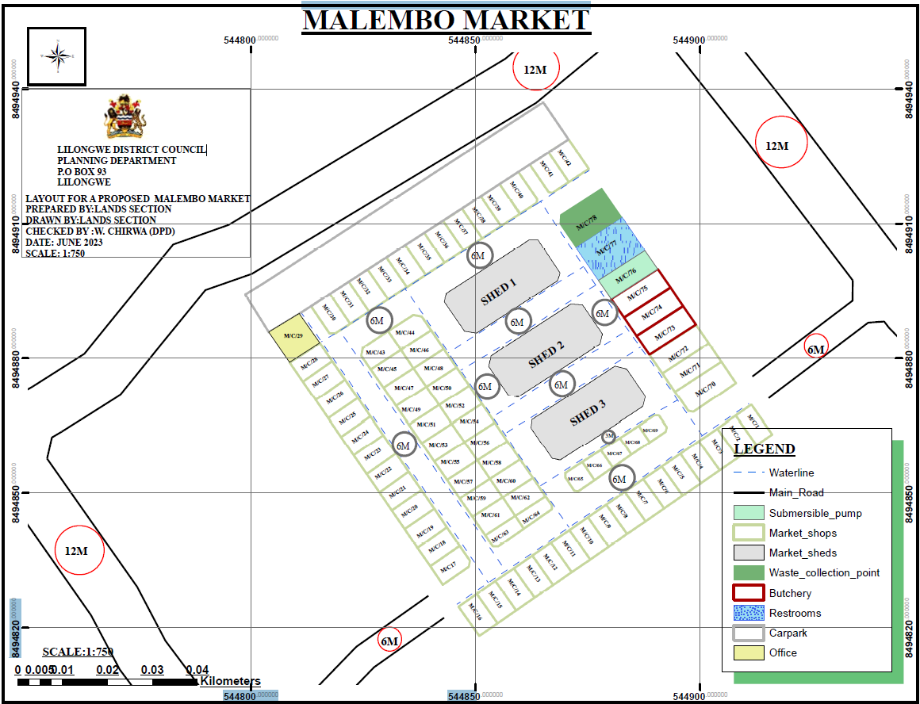

4.2. Technical Specification

PART A: SCHEDULE OF REQUIREMENTS

Item DEFINITIONS

The following are the definitions of terms used in the contract documents:

A The term ‘Project Manager” shall mean The Infrastructure Specialist or a Designated Person/Consultant, TRADE Programme, P.O. Box 2135, Lilongwe, Malawi.

B “Contractor” shall mean the person or persons appointed to execute the Works.

C “Nominated Sub-Contractor” shall mean the person or firm nominated or selected by the Architect/Supervising Officer in accordance with the Conditions of Contract to execute a portion of the Works for which a P.C. or Provisional Sum, as hereinafter defined, is included in the Bills of Quantities.

D “Approved” or “Directed” shall mean respectively approved or directed in writing by the Architect / Supervising Officer.

E “Or other equal and approved” or similar phrase shall mean an alternative of equal quality and price, which has been approved in writing by the Architect / Supervising Officer as being a satisfactory substitute for the item described.

F “Making good” shall mean reinstatement to the complete satisfaction of the Architect / Supervising Officer.

G “Take delivery and fix only” or similar phrase shall mean off loading at the nearest railway station or merchant’s store or taking delivery of imported items from the customs and excise department, transporting to site, unloading, unpacking, and checking on arrival, immediately reporting any damage or deficiencies to the Architect / Supervising Officer and storing and protecting on site until required, taking from store, distributing and assembling as necessary and hoisting and fixing complete and, if required by the supplier, for returning crates and packing cases in good condition, carriage paid, and for making good any theft, loss or damage to the goods whilst on the site, in storage, whilst fixing and when in position. The Contractor shall carefully check the quantity, quality and condition of all items before taking delivery as any goods subsequently found to be missing or damaged shall be replaced at his own expense. It shall be the responsibility of the Contractor to make and pursue any claim against the Railways, Insures or other parties in event of any loss or damage.

H “Attendance” shall mean assisting and collaborating with any sub-contractors and specialists and their tradesmen in every respect including obtaining particulars of their requirements concerning work to be executed for them by the Contractor, supplying them with and taking responsibility for accurate dimensions, details and particulars relating to their work, providing full facilities to enable their employees to execute their work, providing full use, free of charge, of storage and working space, lock up accommodation, standing scaffolding, ladders and other plant, maintaining, altering, shifting and removing same as required, unloading and hoisting their plant and materials or assisting to do so and providing them free of charge, with water, watching, artificial lighting and electric power, covering up and protecting their goods and materials and their work and making good any loss or damage and supplying all unskilled labour in respect of the foregoing.

Item DEFINITIONS (cont’d)

A “Attendance” shall mean assisting and collaborating the any sub-contractors and specialists and their tradesmen in every respect including obtaining particulars of their requirement concerning work to be executed for them but the Contractor, supplying them with and taking responsibility for accurate dimensions, details and particulars relating to their work, providing full facilities to enable their employees to execute their work, providing full use, free of charge, of storage and working space, lock up accommodation, standing scaffolding, ladders and other plant, maintaining, altering, shifting and removing same as required, unloading and hoisting their plant and materials or assisting to do so and providing them free of charge, with water, watching, artificial.

B Lighting and electric power, covering up and protecting their goods and materials and their work and making good any loss or damage and supplying all unskilled labour in respect of the foregoing.

C “Extra over” shall mean that a portion of the cost of the item following this term is included elsewhere in another item and only the extra cost of additional labour and / or materials is required to be priced with the item so described.

D “Measured separately” shall mean that the work to which the term refers is included elsewhere in the bills of Quantities for pricing and does not require pricing in which it so described.

E “Small pipe” shall mean a pipe having an internal diameter of 55 mm or under, “large pipe” shall mean a pipe having an internal diameter exceeding 55 mm and not exceeding 110 mm and “extra large” pipe shall mean a pipe having an internal diameter exceeding 110 mm.
F “M.B.S.” shall mean the latest edition or amended edition of the relevant Malawi bureau of Standards Specification Published by the Malawi Bureau of Standards, Moir Road, P.O. Box 946, Blantyre.

DESCRIPTION (cont’d)

A “S.A.B.S.” shall mean the latest edition or amended edition of the relevant South Africa Bureau of Standards Specification published by the South Africa Bureau of Standards, Private Bag X 191, Pretoria, South Africa.

B “B.S.” shall mean the latest edition or amended edition of the relevant British Standard Specification published by the British Standard Institute, British Standards House, 2 park Street, London, W1A 2 BS, England.

C “C.P.” shall mean the latest edition or amended edition of the relevant British Standard Code of Practice or other approved Standard Code of practice.

D “Provisional Sum” shall mean a sum provided for work or for cost which cannot be entirely foreseen, defined or detailed at the time tender documents are issued.

E “Prime Cost Sum” or the abbreviation “P.C. Sum” shall mean a sum provided for work or services to be executed by a nominated sub-contractor or statutory authority or public undertaking or statuary authority or public undertaking or for materials or goods to be obtained from a nominated supplier. Such sums shall be deemed to be exclusive of any profit required by the Contractor and provisional should be made for the addition thereof. P.C. Sum in respect of nominated suppliers shall mean the net amount to be paid.

F To a supplier or merchant after deducting any trade or other discount, except the discount for cash defined hereinafter, and shall include the cost of packing and of carriage and delivery.

ALTERNATIVE MATERIALS COMPONENTS AND GOODS SPECIFIED

G Wherever materials, components and goods, whether basic or proprietary, are specified the Contractor may, subject to approval in writing, used materials, components and goods from an alternative source providing the quality, properties design are similar.

Item DESCRIPTION (cont’d)

A All materials, components and goods shall be used and fixed in an approved manner and, where applicable, in accordance with the manufacturer’s instructions.

ALTERNATIVE STANDARDS

B wherever reference is made in the Contract Documents to Malawi Bureau of Standard or British Standards and Codes of Practice or South Africa Bureau of Standards the latest or amended edition shall apply. Alternatively, the latest editions of the standards the latest or amended edition shall apply. Alternatively, the latest editions of the standard issued by other authoritative bodies shall apply, providing that the Contractor satisfied the Architect / Supervising Officer that the standards are equal or of better standard than the above standards.

EXCAVATION

GENERAL

A It shall be deemed that the Contractor has visited the site to make himself thoroughly acquainted with the nature of the materials to be excavated and has consulted all available information concerning the nature of this material before submitting his tender as no extra cost will be allowed by reason of his failure to do so.

CLEAR SITE

B Clear site shall mean the clearing away of all rubbish, grass, shrubs, bushes, trees not exceeding 600 mm girth, measured 1000 mm above ground level, and tree stumps not exceeding 600 mm girth, measured as ground level, and the grubbing up of roots. Root holes shall be cleaned out filed with earth and well rammed and consolidated. All unusable materials resulting from clearing the site shall be burned on an approved part of the site.

C All timber from site shall remain the property of the Employer. The Contractor shall allow for cutting to portable lengths and stacking in an approved position on the site.

EXCAVATION

D The term “excavation” shall mean excavating in all types of ground met with other than hard stones or rock of such size or position that it can, in the opinion of the Architect / Supervising Office only be removed by barring, wedging, drilling, splitting of blasting and shall include excavating in made up ground, soft rock, gravels, shale, clay, etc. and shall also include for grubbing up and removing any minor obstructions, including boulders not exceeding 0.14 cubic metres in volume, drains, clinker and gravel paths, tree roots, etc and for filling in voids with approved materials from the excavations.

E The term shall also include for removing the excavated materials from the trench and depositing in temporary spoil heaps in readiness for backfilling or removal from site.

Item GENERAL (cont’d)

A Should excavations be made below or beyond the dimensions and levels shown or required to obtain a solid bottom, and in the case of tree stumps being removed, the Contractor must fill up the excavation to the correct level with weak concrete Grade 10/40.

B No concrete foundations shall be poured until the Architect / Supervising Officer and Local Authority have approved the excavations.

EXCAVATION

C Notwithstanding any authorization, approval or direction given by the Architect / Supervising Officer with regard to excavation or any matter or things connected therewith, the Contractor shall be responsible for taking necessary precautions against any damage from the operations.

MEASUREMENT

D The measurement of all excavations and subsequent disposal are those before excavation or after compacting in the case planking and strutting shall be allowed for by the Contractor in his rates.

E Excavation and disposal items have been measured in accordance with the Standard Method of Measurement of Building Works in Malawi and the Contractor is to allow in his rates for additional excavations, filling and ramming and any formwork which he may consider necessary to carry out the Works.

F All excavations shall be deemed to commence from ground level or reduced level except where otherwise expressly stated and the Contractor is to include in his rates for any additional handling which he may incur.

G Rates for excavations shall include leveling or grading, watering and consolidation to form a solid bottom and for trimming sides and for forming any necessary steps in foundations as directed.

H The Contractor is to include in his items of excavation and disposal for any additional handling he may incur due to the manner or order in which he carries out the work.

Item MEASUREMENT (cont’d)

ROCK

A Should any rock be encountered, the Contractor shall notify the Quantity Surveyor/Supervising Officer immediately before excavating same in order that the quantity thereof may be assessed.

B The Contractor is to include in his rates for excavating in rock and for removing any additional materials arising from over break or over blast and for the additional filling occasioned thereby. The Contractor must provide for any method of removal which may be adopted as there is no guarantee given or implied that blasting will be permitted.

BACKFILLING

C Filling in of excavated materials is measured after consolidated. All refilling of excavated material next to foundations, etc. is to be carried out, unless otherwise described, in layers not exceeding 150 mm thick with the best, clean, dry, excavated materials free from rubbish or refuse and is to be approved by the Architect / Supervising Officer for this purpose. If excavated materials is not suitable, imported laterite is to be used to the approval of the Architect / Supervising Officer. Every later is to be well watered and rammed before another layer is deposited.

HARDCORE

D Hardcore is to consist of hard stones, coarse gravels, sound slag, hard broken bricks or other inert materials to pass a 100 mm diameter ring and is to be blinded with fine chippings, ash or sand ready to received concrete slab.

E The hardcore slabs and filling to make up levels shall be laid to the minimum finished thickness and compacted until a mechanical interlock is obtained and to a standard consistent with the use of a 2.5/3 tonne roller. The surface of the hardcore is then to be checked to ensure that a true level has been obtained over the whole area.

F The rates for hardcore filling are to include for all necessary temporary boards.

G The ant repellent is to be aldrin, dieldrin, shell rite, chlordane or heptachlor diluted with water and applied by or watering can strictly in accordance with the manufacturer’s instructions.

H The Contractor is to ensure that the surface to be sprayed is cleaned of all foreign matter before and after application. Great care is to be taken to prevent disturbance of the treated surface and the Contractor is to include in his rates for providing raised barrow runs or other means to prevent disturbance of the treated surface.

I The Contractor shall furnish to the Architect / Supervising Officer a guarantee covering the content and quality of the work for a period of one year. Within this guarantee covering the content and quality of the work for a period of one year, the Contractor must undertake to retreat, without further charge, any area showing re-infestation.

WATER IN EXCAVATIONS

A Excavations shall be kept free from water at all times. The responsibility for removing water shall rest with the Contractor and no claim for expenses incurred will be entertained. Where pumping is necessary the materials in and around the excavations shall not be disturbed by pumping all pumps shall be formed clear of excavations for permanent work. The Contractor shall divert as all ditches and other waterways wherever encountered during the progress of the Works.

PLANKING AND STRUTTING

B Plank and strut the sides of all excavations as necessary to ensure the safety of the workmen and to prevent any movement, all to the satisfaction of the Architect / Supervising Officer. All responsibility for the foregoing shall rest entirely with the Contractor and should any of the excavations, other than that required to be excavated, collapse due to the omission or the insufficiency of the planking and strutting, it will be paid for as excavations and must be dug out and deposited on the site, backfilled or carted away and the depression filled in as directed by the Architect / Supervising Officer the contractor’s expense.

Should the Architect / Supervising Officer reasonably consider that adequate safety is not provided he may instruct the Contractor accordingly and extra planking and strutting shall be provided at the contractor’s own expense.

CONCRETE WORK

GENERAL

A Materials and workmanship shall comply with B S 8110 Part 1 1985 “Structural Use of Concrete” except as varied by this specification.

CEMENT

B Cement shall comply with M B S 0066 and shall be delivered to the site in sealed and branched bags properly protected from the weather during transport. Admixtures shall be used only if instructed or approved.

C The cement shall be store in a waterproof shed on a dry floor raised above the ground and stacked in such a manner that individual consignments are used in the Works in the order in which they are received. Any cement found to be damp, contaminated to have deteriorated will be condemned by the Architect / Supervising Officer.

AGGREGATES

D Fine and coarse aggregates shall comply with B.S. 882 Coarse aggregate shall satisfy the grading limits defined for 20 mm aggregate graded down to 5 mm.

E Aggregated shall be stored on concrete or other hard standing with dividing aggregate walls between each type of aggregate.

GENERAL (cont’d)

WATER

F Water shall be clean, fresh from an approved source and shall be free chemical or organic impurities or other deleterious matter.

Item CONCRETE PROPORTIONS

A The proportions for concrete shall be as follows :-

NOMINAL  MIX  (GRADE) | PROPORTIONS OF MIX BY VOLUME Cement Fine Agg. Coarse Agg. | MINIMUM CRUSHING TRENGTH (CUBE STRENGTH) IN N/mm  7 days 28 days
1:1.5:3  1:2:4  1:3:6  (15/40)  1:4:8  (10/40) | 1 Cu. ft: 1.5 Cu. ft: Cu. ft  50 Kg bags: 0.05 m2: 0.1 m2  (up to 20 mm)  1 Cu. ft:2 Cu. ft :4 Cu. ft  50 Kg bag : 0.07 m2: 0.14 m2  (up to 20 mm)  1 Cu.ft: Cu ft:6 Cu. ft  50 Kg bag : 0.1 M2: 0.2 m2  (up to 40 mm)  1 Cu. ft: 4 Cu. Ft : 8 Cu. ft  50 Kg bag: 0.14 m2 : 0.28 m2  (up to 40 mm) | 16.5  13.5  10 | 25  20  15

B The proportions given for the concrete mixes are by volume. The quantities in each batch shall be so calculated as to use one or more whole bags of cement in each batch. One pocket (bag) of cement is equivalent to one cubic foot. The use of cement from split bags will not be permitted.

C The coarse and fine aggregate shall be measured in approved gauge boxes.

CONCRETE PROPORTIONS (cont’d)

A The quantity of water used shall be minimum to produce a dense concrete of adequate workability for its purpose. The workability shall be strictly maintained by carefully control of water added.

MIXING

B The cement and aggregate shall be mixed dry in an approved revolving drum mixer for two minutes and then for a continuous period of at least two minutes after the water has been added until the whole mass is of uniform colour and consistency. The whole batch shall be discharged from the mixer before a fresh batch is added.

C Hand mixing may be permitted in special circumstances. When permission has been granted for hand mixing, the Contractor shall use 10 per cent additional cement his own expense and produce concrete not inferior in strength to machine-mixer concrete. Mixing shall be carried out on a clean, close-joined timber or metal mixing platform.

D Immediately on cessation of work the drum mixer and / or mixing platform shall be cleaned.

TRANSPORTING AND PLACING

E Concrete shall be transported from the mixer to its position in the structure as quickly as possible and in such a manner as to avoid any risk of segregation, consolidation or drying out and shall be compacted into poison before it has taken initial set.

F Unless otherwise authorized by the Architect / Supervising Officer compacting shall be accomplished with the use of immersion vibrators together, if necessary, with rods, shovels and the like.

G If the Contractor wished to use an alternative means of compacting for any portion of the Works, he shall submit his proposals and shall receive the Architect / Supervising Officer’s approval before commencing this portion of the Works.

H Vibrators shall be of a suitable type and used in sufficient number to suit the nature of the work and quantities of concrete placed.

TRANSPORTING AND PLACING (cont’d)

A Only men experience in the use of vibrators shall be employed on this type of work. Particular care shall be taken to fill all voids and to work the concrete against rock and existing concrete surfaces round the reinforcement and embedded fixtures and into corners of formwork.

B Vibration shall be continued at each point until the concrete to contract and a thin layer of mortar has appeared on the surface and air bubbles have ceased to appear. Vibrators shall be inserted vertically to penetrate into the layer underneath at regular spacing which shall not exceed the distance over which vibration is visibly effective nor more than 750 mm. Vibrators shall not be used to move concrete laterally and shall be withdrawn slowly to prevent the formation of voids.

C In reinforced concrete, great care shall be taken to prevent any displacement or damage to the reinforcement during compaction.

PROTECTION AND CURING

D Immediately after compaction, the concrete shall be protected from cold, heat, drying winds, rapid evaporation of water and from running water. The concrete shall be kept constantly damp for the first 7 days of its hardening by means of spraying, damp sand, waterproof paper, polythene or other approved materials.

E Works shall not be permitted on slabs for 7 days or until the cube strength is 1 N/sq.mm or twice the stress to which it will then be subjected, whichever is the greater period.

CONSTRUCTION JOINS

F The Contractor shall, well before concreting, submit to the Architect / Supervising Officer details proposals for methods of forming and location of construction joints.

G Construction joints shall be as few as possible.

H Construction joints shall be made at right angle to the main reinforcement and shall be formed square against firm stopping-off boards, slotted if necessary to allow continuity of reinforcement. The stopping-off boards shall be removed as soon as possible after placing the concrete without risk of movement to the concrete.

PLACING OF NEW CONCRETE AGAINST OLD

A In re-staring work which has been stopped, the surface of the existing concrete shall be hacked, roughened, and thoroughly cleaned and hosed down with water to remove all loose particles. Before concreting is recommenced, the hacked and roughened surface shall be wetted covered with a thin layer of freshly mixed mortar, composed of cement and find aggregate in the same proportion as the concrete mix.

TESTING

B As and when requested by the Architect / Supervising Officer, the Contractor shall, at his own expense, provide sets of four standard 150 mm test cubes, and carry out a slump test when each sample is made for making test cubes.

SAMPLING

C Each cube shall be made from a single sample taken from a randomly selected batch of concrete, where practicable, taken at the point of discharge from the mixer.

D A batch of concrete is the quantity of concrete mixed in one cycle of operation of a mixer, the quantity carried by ready-mix vehicle, or the quantity discharge in one minute from a continuous mixer.

E Concrete shall be sampled using a standard scoop (holding approximately 5 kg mass of concrete), referred to as a coop below. In sampling to make test cubes, one test cube shall be from a sample consisting of two scoops taken from one batch nominally divided into a number of equal parts equal to the number of scoops required, a scoop being taken from each part but disregarding the very first part and last part of the discharge.

F The number of scoops required will be :-

One 150 cube - 2
Slump test - 4

A A sample shall be taken from one batch selected randomly from the following quantities of concrete :-

Sampling
Rate 1 | Rate 2 | Rate 3
10 cu m or  10 batches | 20 cu m of  20 batches | 50 cu m or  50 batches

B At the commencement of the Works, the sampling rate shall be Rate 1. if concrete is satisfactory, Rate 2 may be applied. If subsequent failure to meet requirements occurs, Rate 1 shall be reapplied until results are satisfactory.

C Fresh concrete samples shall at all stages be protected against or losing water an excessive temperatures.

D Sample shall be taken by a person charged with responsibility for taking samples who shall provide certificates giving the following information :-

Date and time of sampling
Location in the works of the concrete the sample represents
Location of sample (e.g. mixer discharge or from heap)
Sample identification mark
Ambient temperature and weather
Identification marks of cubes made from sample
Slump test result
Name of sampler
Name of person responsible

SLUMP TEST REQUIREMENTS

E The slump shall not exceed 50 mm for mass concrete, 40 mm for vibrated concrete and 75 mm for hand compacted concrete.

STRENGTH REQUIREMENTS

F Compliance with the specified characteristic strength shall be assumed if :-

A The average strength determined from any ground of four consecutive test cubes and the lowest strength of an individual cube shall exceed the value shown below :-

Characteristic Strength N/mm | Average cube strength N/mm | Min. individual cube strength N/mm
10  15  20  25 | 13.33  20.00  27.50  32.50 | 80.50  12.75  17.00  21.50

B One cube fails to meet the requirements for an individual cube the result shall be considered to represent only the batch of concrete from which that cube was taken provided the result for the average strength is satisfied.

C More than one cube result fails to meet the requirement for individual cubes or if the average cube result fails to meet the requirement for average strength then all the batched represented by all cubes shall be deemed not to comply with strength requirements.

D In the event of test cubes failing to meet the above requirements the Contractor shall be directed to take to take such remedial action as the Architect / Supervising Officer may consider necessary. This action may include the cutting out of the concrete or the taking of cores for further testing at the Contract’s expense.

STRENGTH REQUIREMENTS

F From time to time, the Architect / Supervising Officer may direct that additional cubes be made to check the attained strength levels of parts of the structure or for other particular purposes. These cubes shall be taken, stored and tested in a manner suitable for their purpose as directed by the Architect / Supervising Officer. No extra payment will be made for such special cubes.

REINFORCEMENT (cont’d)

A Type F2: This type is for surfaces exposed to view where good appearance and alignment are important. Formed or closely jointed wrot timber, plywood or steel forms arranged in an approved uniform pattern. Whenever possible, joint shall be arranged to coincide with architectural features or changes in direction of the surface joints shall be vertical and horizontal unless otherwise directed. Slight grain and joint marks and small blemishes cause by entrapped air or water are permissible.

FORMWORK

B Type S; Formed as F1 then scrabbled to leave a keyed surface for subsequent rendering or as construction joint preparation.

C Type SP: This type is for exceptional or special appearance. The surface shall be superior to F2, profiled or profiled with further surface treatment, as specified.

D Uniformed surface shall be as follows :-

E Type U1: The concrete shall be uniformly levelled and screeded to produce a plain, textured or ridged surface, prior to receiving an applied finish or where a superior finish is not required.

F Type U2: after forming a surface finish Type U1 and after the moisture film has disappeared and the concrete has hardened sufficiently to prevent laitance from being worked to the surface, the surface shall be steel trowel-led under firm pressure to produce a dense, smooth uniform surface free from trowel marks.

REMOVAL OF FORMWORK AND SUPPORTS

G Formwork and supports shall be carefully removed without shock loading or disturbance to the concrete. No formwork shall be removed until the concrete has gained sufficient strength to withstand without damage the stresses to which it may be subjected.

H If the Contractor wishes to strip soffit formwork, to beams or slabs before the due period for the supports, the formwork shall be suitable for removal without disturbing the supports.

REINFORCEMENT (cont’d)

A The Contractor shall be responsible for the removal of formwork without damage to the concrete. The minimum period given below between completion of placing concrete and removal of forms is given as guidance. If the period is determined by strength the attained strength must be determined by making test cubes and curing them under the same conditions as the concrete to which they refer.

REMOVAL OF FORMWORK AND SUPPORTS

Position of
form
Vertical or near vertical  faces of mass concrete,  columns, walls and beams  Soffit (formwork only) to  Beams  Supports to beams | 9 hrs 12 hrs  8 days 14 days  15 days 21 days | 0.3 fcu  )10N/sq mm or twice the  )stress to which the  )Concrete will be  )Subjected – whichever  is the greater

B The aforementioned periods of time apply for ordinary Portland cement only. The periods of the time shall be increased for lower temperatures.

DIMENSIONAL TOLERANCES

C Construction shall be sufficiently accurate so as not to significantly impair appearance or performance of the building. In additions, he following tolerances shall apply :-

D Thickness of walls and slabs, width and depth of beams and columns + 10 per cent or + 20 mm whichever is the lesser. Verticality of centerline of columns and walls, + 20 mm in one storey and + 40 mm in two or more storeys.

SUNDRY LABOURS

A Perform all sundry labours necessary for the full and proper execution of the work.

PROTECTION

B Include for the proper protection of all concrete work throughout the section.

PRECAST CONCRETE

C The specification for in-situ concrete will apply except as varied in this section.

D Precast units shall have proper lifting attachments suitably located to minimize stresses during handling. The strength of the concrete shall be sufficient to withstand handling and placing stresses.

E Units shall be placed in a manner that minimizes shock loadings to the units and structure. Units shall be stored in a manner which shall not cause distortion or damage of the units. When stacked, units shall be separated by packing to prevent transmission of bending loads to lower units. Packing shall not discolour or otherwise permanently damage the units.

F All units shall be of uniform appearance, of the same texture and colour, and where an approved sample has been used, they shall match the approved sample.

G The Contractor shall be used temporary supports required to resist all construction loads, including wind, likely to be encountered.

H Unless shown otherwise on the drawings units shall be bedded and jointed in (1:3) cement and sand mortar thoroughly compacted, pointed and finished as necessary to match surrounding work and carefully cleaned down on completion.

I The Contractor is to include for all necessary moulds, formwork, templates, handling and lifting attachments, bolt fixings, temporary supports and the like associated with the construction of the units.

PRECAST CONCRETE (cont’d)

A Any precast work damaged will be cut out and replaced, at the Contractor’s expense. No patching will be allowed.

RATES TO INCLUDE

Testing of Materials

B The costs of all preliminary and works tests required by the Architect / Supervising Officer to be carried out on cement, water, aggregates, steel or any other materials for any reason shall be deemed to be included by the Contractor in his rates.

RATES TO INCLUDE

Formwork

C Rates for centering and formwork are to include for all straight cutting and waster, notchings, allowance for overlaps and passings at angles, horsing up, bolting, wedging, easing, striking and removing and, in the case of formwork described as wrot, shall in addition include for finishing the concrete perfectly smooth and true, slopping surface imperfections with cement and sand (1:1) and removing board marks and feathers.

Preparation of Surfaces

(a) Earth and Rock

D The preparation of all earth or rock foundation surfaces upon or against which concrete is to be cast is to be to the satisfaction of the Architect / Supervising Officer and the coats thereof shall be deemed to be included by the Contractor in his rates.

Existing Concrete

E Any bonding of new concrete to existing shall be carried out as directed by the Architect / Supervising Officer and the cost thereof shall be deemed to be included by the Contractor in his rates.

Precast Concrete

A Rates for precise concrete are to include for all necessary formwork and mould, including wrot or lined formwork to exposed faces, stopping surface imperfections in cement and sand (1:1), rubbing off board marks and for all necessary light wire reinforcement to prevent damage or breakage in handling, casting in the requisite lengths, hoisting, bedding and building in composition or cement mortar and covering up protecting exposed surface and cleaning down at completion and making good.

Reinforcement

B Reinforcement steel is measured in Bills of Quantities according to the calculated weight as scheduled and the rates shall include for all cutting, bending, cranking, hooking at ends, hoisting, assembling, placing, fixing and maintaining in the correct position, for wastage and rolling margin and for all wire and other fixing devices employ.

C Rates for fabric reinforcement shall include for all banding, typing wire, distance blocks and 300 mm side and end laps.

Testing of Concrete

D Any works cubes, or cores cut from the Works, which fail to meet the strength or other requirements described herein shall be paid for by the Contractor.

BRICKWORK/BLOCKWORK

CEMENT

A Cement shall be as specified in “Concrete Work”.

SAND FOR MORTAR

B Sand shall be lean, sharp, uncoated grains of natural occurring pit or fresh water sand, free from injurious amounts of dust, lumps, soft or flaking particles, shale, alkali, organic matter, loam or other deleterious substances, washed if necessary and shall pass a 5000 um (5 mm) B.S. sieve and not more than 15 per cent by weight pass a 1500 um (0.150 mm) B.S. sieve.

LIME

C Lime shall be non-hydraulic or semi-hydraulic well burnt quick lime from an approved source or hydrated lime to comply with B.S. 890.

D Quicklime shall be thoroughly slaked, but not to saturation, for a period of from two to five days for lump lime and from one to three days for ground lime before mixing into wet mortar. Hydrated lime can be mixed into wet mortar without slaking.

WATER

E Water shall be as specified in “Concrete Work”.

NON-LOAD BEARING COMMON BRICKS

F Brick shall be standard format complying with the Malawi Bureau of Standard MBS 006-1979 for ground B bricks. Generally, the strength of common bricks, when tested wet, shall not be less than 5.2 meganewtons per square metre and water absorption shall not be more than 15 per cent after 24 hours immersion.

G Bricks shall be hard, sound, square and clean, well and evenly burnt, of even and uniform size and shape with sharp and straight arises and free from stones, lumps, especially of lime, cracks and all other defects.

SELECTED NON-LOAD BEARING COMMON BRICKS

A The selected bricks shall comply with the requirements above for “Non-Load Bearing Common Bricks” and shall be handpicked and selected for trueness of arises and evenness of texture and surface finish.

B They shall be free from all defects, cracks, spalls and the like and shall be approved by the Architect / Supervising prior to laying.

C Selected brickwork shall be built fair face and shall have joints raked out 6 mm deep after the general brickwork has been completed and be pointed with neat horizontal joint and flush perpends.

D Fair faced brickwork shall be kept perfectly clean and rubbing down will not be allowed.

SAMPLES OF NON-LOAD BEARING BRICKS

E The Contractor is to include for submitting samples of non-load bearing bricks to be used in the Works to the Architect / Supervising Officer for approval before the bricks are delivered to the site, and all subsequent deliveries must conform to the approved samples.

MORTAR

F The nominal mix proportions are given below. Proportions shall be adjusted as necessary to meet strength requirements.

G Mortar for brickwork below ground floor level, manholes, etc. and for external pointing shall be composed of one part cement, and four parts sand by volume.

H Mortar brickwork above ground floor level shall be composed of one part cement, one part lime and six parts sand by volume.

I Composition mortar is to be mixed at least seven days before being required and kept damp with wet sacking. Immediately before use the cement is to be added with sufficient water to provide a proper consistency and any such mortar which has been mixed for more than one hour shall not be used on the Works.

MORTAR (cont’d)

A The proportions shall be measured in approved gauge boxes. The mortar shall be mixer or by hand on a clean, close-jointed timber or metal mixing platform.

B If the mortar is mixed by hand, the materials shall be turned three times dry or until the mixture is of an even colour throughout and turned three times wet. All mortar shall be prepared in sufficient quantity for immediate use only. No mortar shall be re-tempered for re-use after it has taken initial set.

PLASTICIZERS

C Plasticizers shall only be used following written permission from the Architect / Supervising Officer. Plasticizers shall comply with B.S. 4887 and be used strictly in accordance with the manufacturer’s instructions.

TILES

D Ties shall comply with B.S. 1243, walls in two skins have ties embedded in mortar at the time the course is laid, to a minimum depth of 50 mm, and placed staggered and evenly distributed. Tie spacing shall be 450 mm vertically and horizontally wherever possible but may be varied where necessary provided ties are placed at the rate of five per square metre. At the sides openings additional ties shall be used to provide ties at 300 mm spacing vertically.

E Ties shall be galvanized mild steel and may be of the butterfly, double-triangle or vertically-twist strip type.

DAMP-PROOF COURSES

F The damp-proof courses are to be formed o one layer of three ply bituminous felt sheeting complying with B.S. 743 laid on a level bed of mortar where under walls. The sheeting is to be slightly wider than the walls in which they are laid and laps at ends, etc. are to be not less than 150 mm or the thickness of the wall on the case of angles and intersections and thoroughly bedded in mastic.

G Rolls of damp-proof course shall be stored on a level surface way from heat, in such a manner as to prevent damage by squashing and generally in accordance with the manufacturer’s instructions.

BRICKWORK/BLOCKWORK

A All bricks are to be laid in accordance with the British Standard Code of Practice C.P. 121 part 1.

B All bricks must be properly stacked on the site and are to be carefully handled. Dumping or tipping of bricks will not be allowed.

C All brickwork is to be accurately set out horizontally and all vertically planes, quoins, jambs and reveals kept perfectly plumb. Course heights are to be agreed with the Architect / Supervising Officer prior to commencing construction but four courses of brickwork shall not rise more than 40 mm higher than four courses of bricks laid dry and proper gauge rods shall be used.

BRICKWORK

D All bricks are to be well wetted before being laid and any brickwork not so wetted must be pulled down and re-built in a proper manner. Tops of all walls and rackings are to be covered over and protected when work is stopped for the day and are to be well wetted before work is recommenced.

E All brickwork is to be solidly and evenly built with all joints well flushed up with mortar as the work proceeds and well grouted at every course solid throughout the width of the wall with proper perpends kept.

F The bond is to be English bond throughout unless otherwise directed except for half-brick walls which are to be in stretcher bond.

G All the walls are to be built up in uniform stages and no part is to be carried up more than one metre above any other part at time.

H No false headers or half bats are to be used except where legitimately required for bonding.

J The joints of all walls to be plastered, rendered or screeded, etc. are to be well raked out as the work proceeds to provide a key.

BRICK WORK (cont’d)

A The prices for brick work shall include for all plumbing of angle.

BUILDING IN PRESSED METAL WINDOWS AND FRAMES

B Rates for building in pressed metal windows and door frames shall include for assembling all parts and fixing in accordance with the manufacturer’s instructions including setting perfectly plumb and free from the slightest distortion and for cutting, pinning or building in lugs to brickwork or plugging and screwing to concrete, bedding and filling frames sold in cement mortar (1:4) and pointing in mastic, easing and adjusting windows, oiling hinges and fastenings and leaving in perfect working order of completion.

BUILDING IN TIMBER WINDOWS, DOOR FRAMES AND ENTRANCE SCREENS

C Rates for building in timber windows, door frames and entrance screens are to include for setting and maintaining frames and screens perfectly plumb and free from the slightest distortion cutting and pinning cramps to brickwork, setting and fixing dowels in mortises and for protecting from and for protecting from damage and all substances likely to cause stains.

ROOFING

“DERBIGUM SP” WATER PROOFING SYSTEM

Preparation of surface

D The whole surface shall be first thoroughly cleaned of dust, loose particles, etc. by wire brushing followed by either compressed air joining or thorough washing with water and then prime the dried surface with bitumen primer.

Application

E The “Derbigum SP” water proofing system is to be laid on the primed surface strictly in accordance with the manufacturer’s instructions and finished with either an aluminium or colour finish or with a 50 mm thick layer of 25 mm crushed stone as directed.

ROOF TILING

A The roof tilling shall be refinished concrete tiles as manufactured by Concrete Tile Industries Limited or other equal and approved manufactured strictly in accordance with MBS 161:1968 and fixed strictly in accordance with the manufacturer’s instructions.

B The tiles shall be 333 x 420 mm and each tile shall be fixed to 38 x 50 mm softwood battens with 2.5 mm diameter galvanized.

C Clout nails with 75 mm headlamp. The eaves course and the verges shall be wired or clipped as recommended by the manufacturer.

Ridge and Hip Capping

D The ridge and hip capping shall be the standard angle pattern concrete capping recommended be the manufacturers and shall be bedded and pointed in cement and sand mortar (1:3)

Valley Gutters

E The valley gutters shall be constructed from 0.60 mm thick (24 gauge) galvanized sheet steel bent to profile with 150 mm laps and fixed to softwood.

Rates

F Rates are to include for laps, dressings, bends, welds, welts and turning and wedging into grooves all in accordance with the manufacturer’s instructions.

CARPENTRY, JOINERY AND IRON MONGER

TIMBER

Generally

A All timber shall be sound, thoroughly seasoned, free from sap, shakes, loose or dead knots, wane edges, insect attack, warps or twists or other defects within the limits contained in the relevant British Standard as hereafter specified.

Softwood

B The softwood for structural carpentry work shall be equal to B.S. 4978 Grade SS.

C The softwood for non-structural carpentry work shall be equal to B.S. 4978 Grade SS.

D The timber may be :-

Imported best quality kiln seasoned softwood.
Local softwood of cypress, pine or cedar, properly air or kiln seasoned and free from warp, twist or rot. Softwood with the following defects will be acceptable provided the defects do not extend beyond the limits specified :-

Splints and cracks shall not be extended for more than one third of the width or thickness, or for more than one length of the length of the timber.

Wane shall not extend for more than one fifth of the length or timber and be one edge only.

The diameter of knot shall not exceed one third of the width of the face of the timber on which it occurs.

E The moisture content at time of fixing shall be not more than 20 per cent or less than 15 per cent of the dry weight.

Soft wood (cont’d)

A The softwood for joinery work shall be kiln dried and specially selected for clearness and uniformity of grain and colour and shall be to B.S. 1186 part 1 Class 2 in respect of joinery work finished with paint or other opaque finish and Class 1 S in respect of joinery work selected for clear finish.

Hardwood

B The hardwood timbers are to be B.S. 1186 Part 1 Class 1 S and shall be selected Mlombwa or other equal and approved, selected, straight, close grained hardwood equal to sample to be approved.

LAMINATED SOFTWOOD

C The laminated softwood shall be obtained from International Timber Ltd (formerly called Imperial Timber Ltd), P.O. Box 5050, Limber or other equal and approved.

D The rarabers shall be to S.A.B.S. 876 and 1089 and adhesives are to be phenol resorcinol to B.S. 1204, Type WBP and S.A.B.S. 1349, exposure Class 1.

E The members are to be supplied sanded, with an application of water repellent and are to be free from warps and twists, cracks, waned edges, insect attached and all other defects.

SOFTBOARD

F Softboard shall be “Celotex” or other equal and approved to B.S. 1142 Part 3.

G Ceiling boards shall have splayed edges all round and shall be fixed to brandering with close butted joints. Boards shall be close nails with galvanized clout nails and shall be set out with equal margins on opposite sides of rooms and symmetrical and regular joints.

H Cracked or broken boards, those showing evidence of insect attack or any other defect shall not be used in the Works.

PLYWOOD

A Plywood shall be to B.S. 1455 Grade 1 veneer for polishing or Grade 2 veneer for painting, manufactured from kiln dried Tola or other equal and approved and covered on both sides with hardwood veneer as specified. Both faces are to have a fine sanded finish and shall be free from knots, splits, dots, glue stains, filling or inlay of any kind, lifting at edge, blistering, surface cracks inset attach and all other defects. No patches or plugs will be permitted.

PLYWOOD

B Bonding between veneers shall be type WBP or Type INT for exterior or interior use respectively as specified.

BLOCKBOARD

C All block board shall be to B.S. 3444 Grade 1 veneer for polishing or Grade 2 veneer for painting and shall be obtained from an approved manufacturer.

D Kiln dried Tola or other timber of equal and approved quality shall be used for the construction of block except where described as being veneered with hardwood which shall be as previously described.

E Bonding between veneers and the core shall be Type BR or Type INT for exterior use respectively as specified.

F Both faces of all block board shall have a fine sanded finish and shall be free from knots, splits, dote, glue stains. Lifting at edges, blistering, insect attach, sinking or raising of the surface due to faults in the base material and all other defects. No patches or plugs will be permitted.

FLUSH DOORS

G All flush doors are to be B.S. 459 Part 2 of the finished thickness stated, of the best quality obtained from an approved source, of an approved semi-solid core construction with egg orate filling, covered on both sides with 4 mm plywood as described suitable for painting and with hardwood lip pings tongued and grooved to both stiles. All timber is to be kiln dried and all glued together under pressure with an approved synthetic resin, water insoluble, cold setting adhesive.

ITEM DEFINITION

PLASTIC VENEER

A The plastic veneer shall be 1.5 mm “Formica” or other equal and approved cigarette proof single-surface decorative laminated plastic with sanded back and shall be fixed with approved contact adhesive suitable to the backing used strictly in accordance with the manufacturer’s instructions.

B The colours and patterns of the veneers are to be in accordance with samples to be submitted to and approved by, the Architect / Supervising Officer.

SIZE OF TIMBER

C All timbers are to be sawn die square and are to hold up full specified sizes when sawn.

D An allowance from the sizes stated not exceeding 3 mm will be permitted for each wrot face, except to timber not exceeding 1250 square millimeters cross-sectional area which must hold up to the full size specified.

RATES TO INCLUDE

E Rates for structural timbers described as “sawn” shall include for all workmanship and labour in preparing and connecting together by lapping, notching, splay or birds mouth cutting, halving and for all nails and spikes. Rates for non-structural timbers described as “sawn” shall in additional include for dovetailed and scarfed joints and for wrot faces to exposed ends.

F Rates for work described as “framed” shall include for workmanship and labour in connecting by mortice and tenon and dovetailing, housing, tonguing and grooving and the like and for all nails.

G Rates “wrot” woodwork shall include for the foregoing, arise rounded corners to salient angles and in addition include for short lengths, mitres and returned, scribed, housed and fitting ends.

RATES TO INCLUDE (cont’d)

A Rates for doors shall include for hanging on butts, trimming and easing over floor finish, priming and undercoating the top and bottom edges prior to fixing and filling, stopping and rubbing down the surface of plywood to a perfectly smooth finish to receive decoration.

B When timber members are described as being screwed and pelleted, the contractor is to include in his rates for letting in heads of screws and pelleting with matching timber glued and correctly grained.

WORKMANSHIP

C All joiner’s shall be in accordance with B.S. 1186 Part 2 and shall be worked exactly to detailed drawings and prepared and loosely framed together as soon as possible after commencement of the Contract and taken apart and stacked until required for fixing. All joints to external work shall be glued, all joints and wedges to external work shall be thoroughly painted with priming paint or water insoluble glue, all mortise and tenoned joints shall be wedged and dowelled, all joints shall be tight fitting, all surface to be painted shall be finished with a fine glass papered surface free from machine or tool marks and all nails and springs shall be punched and filled before work is painted. All surface to be polished shall be finished with a smoothing plane, all arises shall be slightly rounded and any work in which the joints shall have opened or other defects shall be occurred during the Defects liability Period shall be reinstated and all work disturbed made good at

WORKMANSHIP

the Contractor’s expense to the satisfaction of the Architect / Supervising Officer. Clearance to doors when hung shall be 3 mm at top and sides and 6 mm at bottom.

D Where timber members are specified as being plugged, the contractor is to form neat mortises of the required depth and plug with “raw plugs” or other approved filling in accordance with best practice.

IRONMONGERY

E Ironmongery not specified hereafter by reference to manufacturer’s catalogue shall be in accordance with B.S. 455, 1331 and 1494 as applicable.

IRONMONGERY (cont’d)

A All locks are to be supplied with two keys stamped with numbers corresponding with the number stamped on the fore end of the lock and handed to the Architect / Supervising Officer with identification labels attached.

B Rates are to include for submitting a sample of all ironmongery to the Architect / Supervising Office for approval before ordering, for carefully wrapping and protecting until completion and replacing any damaged or defaced items with new or repairing and reacquiring at the Contractor’s expense as instructed by the Architect / Supervising Officer for fixing with and including suitable screws to match the metal and for oiling and leaving in perfect working order at completion.

C Louver clips where specified shall be level operated, of natural finish aluminium set perfect alignment and fixed to timber frames with matching screws.

D Where ironmongery is described as fixed to metal the contractor is to include in his rates for drilling and fixing with matching self-tapping screws.

METALWORK

WILD STEEL

A All steel and steelwork is to be of approved manufactured and shall comply in all respects with B.S. 4, 449, 1775, 2994, 4360 and 4848 as applicable.

B Bolts and the use thereof shall comply in all respects with B.S. 325, 916, 1083, 1494, 1768, 1769, 2708, 3139, 3294, 3692, 4186, 4190, 4395, 4604 and 4933 as applicable.

WELDING

C All welding is to comply with the relevant British Standard where applicable and electrodes to B.S. 639 and 4215. Welding is to be carried out by skilled operators in accordance with the principles set out in the British Standard Code of Practice CP 3012.

D All welding is to be left in its original state and neatly finished off and polished after examination by the Architect / Supervising Officer. All connections are to be capable of transferring a load of ten per cent more than the members connected.

E All members are to be in one length and butt welding will only be allowed with the Architect / Supervising Officer’s approval.

GENERALLY

F The details of construction may be decided by the Contractor to suit his methods of manufacture subject to the Architect / Supervising Officer’s approval.

G All steelwork is to be erected in its correct position, accurately leveled, lined and plumb.

PRESSED METAL WINDOWS

A The pressed metal windows are to be cottage section to B.S. 990 with an approved rust proof finish obtained from B. and C. Metal Products Ltd., P.O. Box 52, Blantyre, or other equal and approved manufacturer and complete with all necessary fixing lugs. Opening lights to metal windows are to be provided with friction stays or roto operators, matching ironmongery, hinges and fasteners of a type to be approved by the Architect / Supervising Officer.

PRESSED METAL DOOR FRAMES

B The pressed metal door frames are to be obtained from B. & C. metal Products Ltd., P.O. Box 52, Blantyre or other equal and approved manufacturer. Frames are to have an approved rust proof finish. Frames are to be provided with lock striking plates, rubbers, loose hinges and pins, stay bars to feet and fixing lugs.

PLUMBING

GALVANIZED SHEET STEEL

A All sheet is to be galvanized of an approved brand and of the gauge specified.

B Rates are to include for clips, welted edges, wedging and fixing.

U.P.V.C. GUTTERS, RAINWATER PIPES, FITTING AND FIXING

C The U.P.V.C. gutters, pipes and fittings are to be to B.S. 4514 and shall be obtained from a manufacturer approved by the Architect / Supervising Officer.

D The pipes and fittings shall be jointed in accordance with the manufacturer’s instructions.

E Rates for eaves gutters shall include for fixing on purpose made bolted brackets to falls.

U.P.V.C. SOIL, WASTE AND VENTILATING PIPES, FITTINGS AND FIXING

F Rates for rainwater pipes are to include for temporary supporting the pipes in position while the mortar packing is placed around and for all loose pipe sockets, double sockets, straight couplings, union couplings, expansion couplings, short lengths and for forming all joints and cutting and waste and all necessary jointing materials. All other fittings are measured and rates shall include for extra joints.

G The U.P.V.C. pipes and fittings are to be to B.S. 4514 and shall be obtained from a manufacturer approved by the Architect / Supervising Officer.

H The pipes and fittings shall be jointed and fixed in accordance with the manufacturer’s instructions. Vertical and horizontal pipe runs shall be supported and fixed with clips drilled, plugged and screwed to walls and soffits and where necessary suitable hangers shall be provided.

I All branch connections to main soil, waste and ventilating pipes shall be swept in the direction of flow, and pitches tees only shall be used.

U.P.V.C. SOIL, WASTE AND VENTILATING PIPES, FITTINGS AND FIXING (cont’d)

A Generally, soil pipes where “horizontal” shall fall at 2.50 % towards the main vertical pipes, “horizontal” waste pipes shall fail at 1.50 % towards the main vertical pipes and “horizontal” ventilating pipes shall rise at 1.50 % away from the traps they serve.

B Expansion joint couplings shall be fixed in pipe runs at intervals in accordance with the manufacturer’s instructions.

C Rates for pipes are to include for fixing with all necessary clips, holder bats and hangers and drilling, plugging and screwing or cutting and pinning to walls and soffits and for making good the finishings to surfaces to which the pipes are fixed and for all loose pipe sockets, double sockets, straight couplings, union couplings, expansion couplings, short lengths and for forming all joints and cutting and waste and all necessary jointing materials. Allotter fittings are measured and rates shall include for extra joints.

MEDIUM DUTY GALVANIZED STEEL TUBING, FITTINGS AND FIXING

D The galvanized steel tubing is to be medium weight in accordance with B.S. 1387 and joints are to be screwed with red lead and hemp.

E Fittings are to be galvanized wrought steel to B.S. 1740. All bends in any pipe run.

F Long and short nipples shall be used as required, running nipples will not be permitted. Unions shall be used at the final connection to all fittings, after all valves and on vertical pipe runs in ducts at each floor level. They shall be of the types having galvanized malleable cast iron bodies with ground spherical or taper gunmetal seating faces.

MEDIUM DUTY GALVANIZED STEEL TUBING, FITTINGS AND FIXING (cont’d)

A All screwed tubing and fittings shall be connected by means of joints having taper or taper threads complying with B.S. 21. Prior to making and joint the male end of the connection shall be coated with “Boss White” as manufacturer by Crane Ltd. Or other equal and approved compound.

B Welding of galvanized tubing will not be permitted. No joints shall be made within an unobstructed distance of 600 mm of any electrical cable, conduit or component, nor shall any joints be formed with the thickness of any wall, slab, etc.

C Rates are to include for fixing pipes with approved pipe clips or galvanized holder bats including cutting and pining and making good the finishing’s to the surfaces to which the pipes are fixed.

D Rates for tubing of 20 mm diameter and less are to include for all labour to bend pipes and fittings such as bends, elbows, tees, crosses, connectors, nipples, sockets, unions, reducing sockets, brackets, backnuts, plugs and the like and for all short lengths and cutting and waste.

E Rates for tubing exceeding 20 mm diameter shall include for all paralled sockets, nipples, unions and for all short running lengths and cutting and waste. All other fittings and labours are measured and the rats for fittings shall include for extra red lead joints.

PIPE WORK GENERALLY

F All internal pipe work shall be executive in collaboration with the work of any specialist employed for electrical work, etc. So that all trade provide a neat and workmanlike finish.

G Cutting of holes, chases, etc, through reinforced concrete shall be carried out only with the writing authority of the written of the Architect / Supervising Officer and all holes, chases, etc. shall be properly made good on completion.

PIPEWORK GENERALLY (cont’d)

A Plumbing work shall be carried out strictly in accordance with the plumbing and drainage plans and details and written authority shall be obtained from the Architect / Supervising Officer before any change or variation from the plan is made.

B Pipes shall be arranged and fixed in a neat workmanlike manner, straight, parallel in line and with the fittings set true and plumb.

C Exposed pipe shall be so fixed that there will be not less than 25 mm clear space everywhere between the pipes or pipe fittings and the finished wall, ceiling or beam face. Where such a clearance does not appear to be practicable or workmanlike, the Architect / Supervising Officer shall be consulted before fixing the piping and his written approval obtained. Access plates and fittings shall be used only where shown on the drawings.

D All service and distribution pipe runs shall be set out and fixed to avoid traps and air locks, and branches taken from vertical pipes shall have a constant slight rise or fall as the case may require for the release of air and the enable the free end of all overflow pipes.

E Pipe-work of unlike materials shall be joint an approval manner in accordance with the best standard practice.

BRASS WORK AND SUNDRIES

F All taps, valves, traps, etc. shall comply with the type and B.S. specified and to any requirements of the Local authority. Samples of taps, valves etc. are to be submitted to the Architect / Supervising Officer before fixing.

G Taps shall be marked with an approved colour or letter identification. Cold water taps shall in every case be fixed at the right hand side of sanitary fitments.

BRASS WORK AND SUNDRIES (cont’d)

A All ball valves shall comply with B.S. 1212 and shall be of the sized and for the pressure indicated or directed. The loose orifice seats shall be of nylon for sizes 13 mm and 19 mm and bronze for sizes 25 mm, 38 mm and 51 mm. Ball valves shall be supplied and fixed complete with copper floats to B.S. 1968 or with plastic floats not less robust and having lifting effort not less than a B.S. 1968 copper float for the same duty.

B Rates for taps, valves, traps, etc. are to include for jointing to pipes including making joints and any necessary connectors to suit the particular type of pipe to which they are fitted and for supplying samples and for providing and handling to the Architect / Supervising Officer here valve keys for each type and size of gate valve installed in the Works.

SANITARY FITTINGS

C Sanitary fittings not specified reference to manufacturer’s catalogues shall be in accordance with B.S. 1125, 1188, 1189, 1206, 1213, 1244, 1254, 3380 (Part 1) and 3402 as applicable.

FIRE FIGHTING EQUIPMENT

D The fire-fighting equipment shall be of the type specified and shall be guaranteed by the manufacturer.

E Rates shall include for fixing complete including drilling, plugging and screwing or bolting brackets to walls.

PIPE SLEEVES

A All pipes shall be sleeved where passing through concrete roofs, suspended floors and where directed through walls. Sleeves shall be of galvanized mild steel tubes and such bore as to provide an annular space not less than 3 mm wide at any point. They shall project 40 mm above roof level but in all other cases shall finish flush with finished surfaces. The annular space shall be caulked with lead wool and approved wall plates shall be fixed where directed.

MARKING OF PIPES AND VALVES

B The Contractor is to include in his rates for providing aluminium identification labels wired on to all valves and for making and labeling all exposed pipes to indicate the paid identification colour in accordance with B.S. 1710 and at completion of the Works, for providing the Architect / Supervising Officer with a valve chart and “as fixed” drawings indicating the valve number, position and purpose of each respective valve.

MARKING OF PIPES AND VALVES

C The Contractor is to include on his rates for painting identification colour bands 300 mm wide on all concealed pipe work in accordance with B.S. 1710 at access points.

MARKING OF PIPES AND VALVES

D The Contractor is to include in his rates for painting pipe work for painting all brackets, pipe clips, holder bats, hangers, etc. and for painting in all various identification colours in accordance with B.S. 1710.

TESTING OF PIPES

A All pipelines shall be hydraulically tested after laying to pressure equal to the maximum working pressure plus at least 50 per cent in accordance with Clause 602 of C.P. 310 (1962). The test pressure shall be maintained for a period of thirty minutes without measurable loss. Pipelines shall be tested in sections by closing off at stop valves or by inserting temporary stop ends. Each class of pipe shall be tested separately. The pipelines shall be tested in lengths as approved by the Architect / Supervising Officer.

B As soon as a length of pipeline of the same class of pipe not exceeding 1000 metres or the distance between successive valves on each class of pipeline, whichever is the lesser, is laid and jointed, the pipeline shall be tested before further pipe laying and joint proceeds unless otherwise approved by the Architect / Supervising Officer. The Contractor shall supply, fix, strut and secure all temporary stop ends for testing purpose and the costs there of shall be deemed to be included in the costs for testing. In the event of a fault or suspected fault occurring subsequent to testing a pipeline, the Architect / Supervising Officer may require at further test and this shall be carried out the Contractor without extra payment. The cost of testing shall be included in the various rates for laying pipes. Immediately a section has been passed by the Architect / Supervising Officer is shall be backfilled to avoid subsequent damage.

C The position of the pressure gauge for recording the test pressure shall be at a point in the section being tested where the working pressure is greatest.

FLOOR, WALL AND CEILING FINISHING

IN-SITU FINISHINGS

CEMENT, LIME, WATER, ETC

A The cement, lime, water etc. are to be as previously described in “Concrete Work” or “Brickwork” sections.

B The method of mixing of materials for screeds and grounds, pavings, plastering and undercoats are to be as previously described for mortar in “Brickwork”.

SAND

C The sand shall be approved, clean, naturally occurring sand, crushed stone or crushed gravel sand. The sand for screeds and grounds, cement and sand pavings, internal and external plastering shall comply with B.S. 1199 and is to be graded in accordance with table 1 or table 2 as applicable.

INTERNAL OR EXTERNAL PLASTERING

D The internal or external plastering is to be executed in accordance with C.P. 221 shall be composed of one part of cement to four parts of sand or one part of cement to one part of hydrated lime to six parts of sand by volume as hereinafter specified applied in one coat not more than 20 mm and not less than 13 mm thick unless otherwise described and finished with a steel or wood float as specified to a perfectly smooth and even surface.

TYROLEAN FINISH

E where the plastering is specified as having tyrolean finish the Contractor is to include for a thin spatter dash composed of one part of cement to two parts of coarse sand being vigorously thrown on.

WATERPROOFING

F Where plastering is described as being waterproof the Contractor is to include in his rates for incorporating “Drikon”, “Pudlo” or other equal and approved waterproofing compound mixed strictly in accordance with the manufacturer’s instructions.

POLISHED TERRAZZO FINISHINGS

A All terrazzo finishings are to be laid by terrazzo specialists to be approved by the Architect / Supervising Officer.

B The materials, mix and method of preparing and laying the terrazzo shall be in complete accordance the C.P. 204.

C The thickness of finishing stated if the finished thickness including grounds and screeds and the Contractor shall allow for the additional thickness necessary for polishing and grinding.

D Cement used in the manufacture of terrazzo shall be white cement tinted, if required, with a colouring pigment to the approval of the Architect / Supervising Officer.

E Aggregate shall consist of crushed marble of approved colour, hardness and grading. The aggregate shall be angular and free form elongated or flaky pieces, dust, fines or other impurities. Aggregate of less than 3 mm shall not be used.

F Screeds are to be laid by the terrazzo specialist and shall consist of one part of cement of three parts of coarse screened sand. The terrazzo finishing are to be laid whilst the screed is still green.

G The aggregate is to be crushed and graded before delivered to the site. The pigment to be used shall be mixed mechanically with the cement in order to obtain uniformity of colour. The mix for all in-situ finishings is to consist of one part of cement to two and a half of aggregate by weight. The materials are t be thoroughly mixed in the dry state and water shall be added by means of a fine spray while the materials are being worked until the proper consistency is obtained. The mix shall be plastic but not fluid.

H The terrazzo finish shall be thorough compacted by tamping and only sufficiently trowelled immediately after laying to give a true surface. When all water is extracted by further compacting, the surface is to be trowelled to a smooth and even surface with approximately 85 per cent of the marble aggregate showing.

POLISHED TERRAZZO FINISHINGS (cont’d)

A As soon as possible after laying, finishings are to be covered with damp hessian or clean, wet sand and kept wet for four days, after which the terrazzo surface is to be ground with a coarse abrasive stone using an ample supply of water until the surface is completely smooth and the aggregate properly exposed.

POLISHED TERRAZZO FINISHING

B The surface shall then be washed clean, all voids cleaned out and the entire surface covered with neat grout, tinted as required, to fill all voids and kept damp for further period of not less than three days. The final polishing shall be carried out with a fine abrasive stone to give a fine grit finish.

C The Contractor is to include in his rates for making sample panels so that the appearance in-situ can be judged and a selection made.

D One completion of the building and before handing over, the finishings shall be washed with hot water and a mild household cleaning powder free from alkali. All terrazzo finishings shall be left perfect at completion.

FINISHINGS

EXPANDED METAL LATHING

E Expanded metal lathing shall be 1.6 mm thick with a 31 x 13 mm mesh size and thoroughly coated with asphaltum paint.

F Expanded metal lathing shall be tightly stretched and secured with galvanized wire staples, sufficiently, to prevent any sagging either under its own weight or under the weight of the applied finish.

TILE FINISHINGS

VINLY ASBESTOS FLOOR TILING

A The floor tiles shall be “Marleyflex” P.V.C. vinly asbestos floor tiles or other equal and approved in accordance with B.S. 3260, of the patterns and colours specified laid square pattern. Tiles are to be laid in strict accordance with the C.P. 203 and are to be fixed with an adhesive recommended by the manufacturer.

GLAZED WALL TILING

B The wall tile shall comply with B.S. 1281.

C Wall tiling shall be fixed in strict accordance with the principles set out in C.P. 212 Part 1.

CARPET TILES

D The carpet tiles are to be “Heuga” or other equal and approved rubber backed felt tiles of patterns of colours specified laid loose to a square pattern.

GLAZED WALL TILING

E The cement and sand ground shall be plumb and even to within 3 mm in any distance of 3 metres and shall be scored to afford a key for the bedding materials. All tiles shall be soaked for a minimum period of half an hour and fixed immediately after the surface water has drainage off. Before tiling commences, the ground shall be wetted just sufficiently to prevent absorption from the bedding materials. Uniform joints of not less than 2 mm shall be provided by spacer pegs and all tiling shall be laid with flat surfaces which shall not vary by more than 2 mm from the general plane any distance of 3 metres. All joints shall be wetted and filled with white cement grout worked into the joints and finished with pencil rounded recessed joints, all surplus grout is to be removed from the tiles and the tiling is to be given a final polish with a dry cloth.

WORKMANSHIP

F All finishings are to be carried out by experience operatives under efficient supervision.

WORKMANSHIP (cont’d)

A All surfaces upon which screeds, pavings, etc. are to be laid shall be thoroughly cleaned, hacked and coated with neat cement slurry immediately prior to laying the finish. All concrete wall or ceiling surfaces are to be well hacked or coated with spatter dash consisting of one part of cement to three parts of sand and all joints of brickwork are to be raked out to form a key before applying the grounds, and other in-situ finishings. All backing surface shall be moistened as necessary before receiving the finish.

B Mixing of materials shall be carried out in mechanical mixers and mixing shall continue until the materials are uniformly mixed.

C Each coat shall be allowed to dry out for as long as possible before any subsequent coat of finish is applied.

D Plaster under coats shall be brushed down to remove dust and loost particles and, if of a porous nature and very dry, they are to be slightly wetted.

E Screeds and pavings are to be covered up and kept moist until they have attained sufficient strength to resist stresses dur to shrinkage.

F All finishings are to be clean and free from cement and plaster droppings and all materials likely to cause stains. Floor finishing subjects to staining are to be covered up and protected until completion of the Works.

G All finishings are to be cleaned down and handed over in a perfect condition. Any defective work shall be removed and reinstated at the Contractor’s expense.

RATES

A The Contractor is to include in his rate for all of the foregoing and in the case of all in-situ finishings, except where otherwise described, for all joints and fair joints to abutments and boundaries, internal angles, fair edges, rounded edges, chamfered edges, arises, chamfered external angles not exceeding 15 mm wide, rounded external angles not exceeding 15 mm radius, cover internal angles not exceeding 15 mm radius, v-grooves, throatings, making good to roof sheeting, intersections to groins and the like, making good around steel joists, channels, angles, tees, pipes, tubes, bars cabbles, conduits, ducting, trucking, brackets, timbers, newels, W.C. pedestals, floor springs, ventilators, soot doors and the like, making good to skirting, door and window frames, etc. and for all temporary screeds and rules.

B Rates for skirting, finishes to risers, kerbs and the like are to be included for all short lengths, fair ends, stopped ends, etc.

GRAZING

GLASS

A All grass is to be of the best quality complying with B.S. 952 and free from flaws, specks, scratches and other defects. All grass shall be stored to prevent the accumulation of moisture between sheets.

PUTTY

B The putty for glazing to wood frames is to be best quality linseed oil putty complying with B.S. 544. The putty for glazing to metal frames shall be an approved specially manufactured compound for glazing to metal.

GRAZING

C All glazing is to be in accordance with the recommendations and standard of workmanship contained in C.P. 152. All well rebates are to be clean and dry and painted before glazing. All glass is to be well bedded, back puttied and sprigged to wood or secured with approved pegs or spring clips for glazing to metal. All glass is to rest on properly placed locating blocks with a minimum clearance of 2 mm between the face of the glass and the rebate. All edges of glass shall be cut clean and a clearance of edge of 2 mm shall be provided for glass glazed to wood and 3 mm for glass glazed to metal. In the case of solar control glasses, opaque glass with painted surfaces, ordinary glass exposed to sunshine or when used with a dark background, glazing clearance at edges shall be a minimum of 3 mm all round where the longer dimension of less than 750 mm and not less than 5 mm all round where the longer dimension exceeds 750 mm. All glazing to metal sashes or surrounds shall be in accordance with the metal window manufacturer’s instructions and all putty shall be stripped at an angle to prevent accumulation of water.

PAINTS, ETC.

D All paints, knotting, etc. are to comply with the relevant British Standard where applicable. Colours are to be in accordance with B.S. 3810 or 4800 where applicable and the identification of pipelines is to be in accordance with B.S. 1710.

PAINT, ETC cont’d)

A All paints are to be the best of their respective types. Paints described as hard gloss are to be those named as synthetic enamel, hard gloss enamels or super gloss enamels. Paints described as P.V.A. emulsion are to be those named as “acrylic P.V.A. or Acrylic emulsion”.

B All paints, etc, are to be delivered to the site in sealed containers and must be used strictly in accordance with the instructions of the manufacturer and without adulteration or dilution. Where recommended by the treated with one coat of sealed, primer or petrifying liquid suitably bodies for opacity.

C All containers are to be properly labeled stating the name of the manufacturer, brand, type, colour and quality, interior or exterior, of the contents.

D Any paint which is defective or unsatisfactory shall immediately be returned t the manufacturer.

E Undercoats and priming coats are to be types recommended by the manufacturer for use on the particular material or surface and suitable for the subsequent coats specified. Undercoats are to be of similar but distinctive tints to the finishings coats.

F Finishings coats are to be of colours selected and approved in accordance with the painting schedule prepare by the Architect / Supervising Officer and the Contractor is to include in his rates for painting in varying colours as directed by the Officer and the Contractor.

WORKMANSHIP GENERAL AND PREPARATORY WORK

G All workmanship is to be in accordance with C.P. 231.

H Clear away all dirt, rubbish and superfluous materials as it accumulates and keep the work swept clean and the floors washed over while painting operations are in progress, and take all necessary precautions to keep down dust.

PAINT, ETC (cont’d)

A All paints are to be the best of the respective types. Paints described as hard gloss are to be those named as synthetic enamel, hard gloss enamels or super gloss enamels. Paints described as P.V.A. emulsion are to be those named as “acrylic P.V.A. or Acrylic emulsion”.

B All paints, etc. are to be delivered to the site in sealed containers and must be used strictly in accordance with the instructions of the manufacturer and without adulteration or dilution. Where recommended by the manufacturer, all surfaces are to be treated with one coat of sealed, primer or petrifying liquid suitably bodied for opacity.

C All containers are to be properly labeled stating the name of the manufacturer, brand, type, colour and quality, interior or exterior, of the contents.

D Any paint which is defective or unsatisfactory shall immediately be returned to the manufacturer.

E Undercoats and priming coats are to be types recommended by the manufacturer for use on the particular materials or surface and suitable for the subsequent coats specified. Undercoats are to be of similar but distinctive tints to the finishings coats.

F Finishings coats are to be of colours selected and approved in accordance with the painting schedule prepared by the Architect / Supervising Officer and the Contractor is to include in his rates for painting in varying colours as directed by the Officer and the Contractor.

WORKMANSHIP GENERAL AND PREPARATORY WORK

G All workmanship is to be in accordance with C.P. 231.

H Clear away all dirt, rubbish and superfluous materials as it accumulates and keep the work swept clean and the floors washed over while painting operations are in progress, and take all necessary precautions to keep down dust.

WORKMANSHIP GENERAL AND PREPARATORY WORK

A All surfaces to be painted shall be clean, free from dust, dry and sound, not friable or unduly absorbent and shall have reached a stable condition prior to painting. Painting shall not be carried out in unfavourable weather or unsuitable conditions.

B All paint shall be applied uniformly in thickness appropriate to the particular type of paint used.

C All paint containers shall be emptied and cleaned with a suitable solvent each day after use. All brushes, knives, etc. shall be cleaned after use.

D Adequate time shall be allowed to elapse between the application of successive coats of paint. Generally, each coat of paint shall be lightly rubbed down with fine glass paper and dusted before applying the next coat.

E All metal fittings and fastenings and fly screens are to be removed preparatory processes are commenced, cleaned and prefixed in positions on completion.

PAINTING ON PLASTERWORK, BRICKWORK AND CONCRETE WORK

F Should the surface to be painted or the quality of the paint to be used in such that it will not provide an acceptable finish within the number of coats specified then the Contractor is to include in his rates for painting a “mist” coat, priming coat, sealing coat or coat of petrifying liquid to the approval of the Architect / Supervising Officer in addition to the number of coats specified.

G All plasterwork is to be thoroughly dry and mature before painting is commenced. Under no circumstances will plasterwork showing efflorescence or blowing or pitting due to unslaked lime be decorated.

H All defective plasterwork, both internally and externally, is to be cut out and made good before decoration.

J Small cracks are to be made good with Alabastine filler and large cracks are to be cut out with edges undercut, given one coat of oil paint filled flush with “Gipsy” or other approved stopping plaster.

PAINTING ON METAL WORK

A The metalwork is to be clean and dry and is to be free from rust and scale with steel wire brushes or other means and all oil, wax and grease is to be removed before the initial priming coat is applied.

PAINTING ON METAL WORK

B Special attention shall be given to the painting of edges, re-entrants, protuberances such as bolt heads, rivets, etc.

C On metalwork described as galvanized, the initial priming coat is to be of the self-etching type.

PAINTING ON WOODWORK

D All woodwork is to be carefully prepared, cleaned and dry and glass-papered and dusted. Large or loose knots are to be cut out and filled with sound wood or hard stopping. Small knots are to be treated with two coats of approved knotting free from resin and consisting of a solution of shellac in mentholated spirit. All nail holes are to be filled with an approval hard stopping.

E Woodwork that is to be painted shall be properly seasoned to a moisture content appropriate to its use in the building. In no case shall be moisture content at the time of painting exceeds 18 per cent.

F External woodwork or woodwork in damp situations internally shall be painted with strongly adhesent, water restant, flexible and otherwise suited paint for the particular conditions of exposure.

G All machined and finished surfaces of joinery whether to be visible or cancelled shall receive one coat of appropriate primer end grain surfaces are to receive a second coat after the first has dried. All surfaces of paints to be jointed but not glued shall also receive one coat of priming paint and wherever practicable, shall be brought together while the paint is wet.

H In addition to the foregoing, the Contractor is to include in his rates for painting in narrow widths and to bands which have been included in general wall surfaces.

PAINTING ON WOODWORK (cont’d)

A The Contractor is to include in his rates for painter’s time and the necessary materials for executing sample panels of paint in different colours so that the appearance on site may be judged and a selection made.

EXTERNAL WORKS

STONE PITCHING

B The stone pitching shall be constructed with an approved local stone not more than 25 per cent of which shall pass a 150 mm ring but not a 60 mm ring and not less than 75 per cent of which shall not pass a 150 ring. The stone pitching shall be placed and compacted to a finished thickness of not less than 100 mm and is to be grouted up in cement mortar (1:3) and finished with neat flush joints.

PREPARATION OF ROAD FORMATION

C Where the sub-grade is below existing ground level, the Contractor shall excavate to sub-grade level. Where the sub-grade is above existing ground level, the Contractor shall fill to sub-grade level with approved materials. The sub-grade shall be compacted to a CBR of not less than 5 per cent.

D The final surface of the sub-grade shall not vary more than 25 mm from the true elevation.

COMPACTION OF SUB-GRADE

E The area to be compacted shall be scarified and watered evenly, mixed in for the full depth to be compacted until a uniform mixture is obtained with a moisture content within the range of 1 per cent of the optimum.

F During the full compaction process, the materials shall be kept at the optimum moisture content, the surface if necessary being occasionally lightly watered to counteract the effects of evaporation.

COMPACTION OF SUB-GRADE (cont’d)

A compaction shall be carried out by means of an 8/10 tonne smooth wheeled roller or a combination of such a roller and approved pneumatic roller. Roller shall continue until 93 per cent of the modified A.A.S.H.T.O. density has been obtained over the full are compacted.

B The surface of each compacted layer which is to be followed by an overlying layer of less than 100 mm compacted depth, shall be lightly scarified before the succeeding layer is placed on it. Notwithstanding the provision of any other clause of this Specification, each compacted layer shall be to the satisfaction of the Architect / Supervision Officer in all respects and no material shall be placed on a compacted layer until the approval of the Architect / Supervision Officer has been obtained.

SUB-BASE COURSE

C The sub-base course is to consist of approved late rite, free from all vegetable matter, earth, rubbish or other deleterious materials and uniformity graded in accordance with the following requirements :-

(i) Plasticity index not greater than 12.

(ii) Percentage passing a B.S. 200 sieve not greater than 30.

D The late rite is to be spread and leveled, mixed evenly with water to within 1 per cent of the optimum moisture content and compacted in layers not exceeding 150 mm consolidated thickness until 95 per cent of the modified A.A.S.H.T.O. density is obtained. The sub-base course is to be graded to cambers, falls and cross-falls as necessary.

BASE COURSE

E The base course is to consist of approved late rite, free from all vegetable matter, earth, rubbish or other deleterious materials and uniformly graded in accordance with the following requirements :-

(i) Plasticity index not greater than 12.

(ii) Percentage passing a B.S. 200 sieve not greater than 30.

BASE COURSE (cont’d)

A The late rite is to be spread and levelled mixed evenly with water to within 1 per cent of the optimum moisture content and compacted in layers not exceeding 150 mm consolidated thickness until 98 per cent of the modified A.A.S.H.T.O. density is obtained. The sub-base course is to be graded to cambers, falls and cross-falls as necessary.

PREPARATION OF BASE AND PRIME COAT

B Immediately prior to applying the prime coat, the Contractor shall well brush the road surface with soft brooms to remove all loose materials and expose the aggregate and finally lightly water.

C The prime coat shall consist of prime tar and shall be evenly applied at the rate of 1.1 litres per square meter and at a temperature of 40 – 50 degrees celcius. The prime coat shall be left for a sufficient period to obtain adequate penetration and shall be inspected and passed by the Architect / Supervising Officer before the bituminous surface is laid.

PREPARATION OF BASE AND PRIME COAT

D Extreme care must be exercised to avoid damage to the prime coat prior to or during the laying of the surfacing and any such damage caused shall be made good by the Contractor as his own expense.

SURFACING

E Wearing course shall be dense Bitumen Macadam to B.S. 2040 and shall have the following composition:-

Aggregate Size |  | Total % Passing
1.40  75 | 20 mm  13 mm  6  15 – 35  2 – 5 | 100  50 – 100  30 - 60

F The coarse aggregate shall be crushed stone or gravel, clean, hard and cubical in shape. The binder shall be light to heavy cut-back or soft straight bitumen.

G The fine aggregate shall be angular, sharp stone.

SURFACING (cont’d)

A Initial rolling for both layers shall be carries out with a 2 to 2.5 tonne roller and final rolling with a 6 to 8 tonne roller done only when the surface is sufficiently hard to resist excessive movement. The second layer shall then be applied and again roller as above.

B A final rolling with a 2 to 2.5 tonne roller is required after blinding with approved crushes dust applied at the rate of 400 square metres per cubic metre.

FOUNDATIONS TO KERBS AND CHANNELS

C foundations to kerbs and channels shall be mass concrete laid to the dimensions on the drawings and compacted to a dense finish.

KERBS AND CHANNELS

D Kerbs and channels shall be hydraulically pressed and shall comply with B.S. 340 and be lola on layer of mortar not less than 134 thick. For a radius of 10000 mm or less, kerbs of appropriate radius shall be used. Any unit of kerb or channel deviating more than 3 mm from line and level at either end shall be made good by lifting and relaying.

PROTECTION AND MAINTENANCE

E The Contractor shall protect the completed bituminous surfacing from all damage until the work is finally accepted by the Architect / Supervising Officer and he shall maintain the surface work until the issue of the maintenance certificate. Any damage occurring to the surface or any defects which may develop due to faulty workmanship shall be made good by the Contractor at his own expense and to the satisfaction of the Architect / Supervising Officer.

F The Contractor is to include for ensuring that all kerbs, manholes, bring or concrete surrounds and the walls of the buildings adjacent to the roadwork are protected and kept clean and free from tar and bitumen stains, etc. by protecting the surfaces which might be contaminated with building paper or such other materials as is approved by the Architect / Supervising Officer.

DRAINAGE

EXCAVATION OF TRENCHES AND BACKFILLING

A excavation of drains shall be commenced at the outfall end of each drain. Trenches shall be accurately cut t the correct depths and gradients required, for pies and shall be of sufficient width to afford room for the proper laying. In the event of any excavations being made below the required level, they shall filled up with concrete at the Contractor’s expense. No trench shall be filled in until the drain therein has been tested and approved. Earth filling to a height of 230 mm above the top of pipes shall be selected fine materials free from stones, well watered and lightly rammed and consolidated around the pipe without causing any damage thereto. The remainder of the trench shall be filled with each filling in 150 mm layers, each layer well watered and consolidated and the ground level made good to the satisfaction of the Architect / Supervising Officer.

U.P.V.C. DRAIN PIPES AND FITTINGS, LAYING AND JOINTING PIPES AND FITTINGS

B The U.P.V.C. drain pipes and fittings are to be B. 4660 and obtained from a manufacturer to be approved by the Architect / Supervising Officer.

JOINTING OF PIPES AND FITTINGS

C The pipes are to be jointed with ring seals used strictly in accordance with the manufacturer’s instructions.

LAYING

D Pipes shall be laid to straight lines, to even gradients, to the levels indicated and strictly in accordance with the manufacturer’s instructions. Pipes shall be laid in such a manner that the pipe shall have a firm bearing for the entire length. Socket pockets shall be kept free from mud, sit, debris or other obstruction during the laying thereof and until completion.

RATE TO INCLUDE

A Rates for pipes are to include for all necessary cutting wastes, short running lengths and for all instruments, boning rods, sight rails, etc. required for the proper execution of the Works. Rates for fittings are to include for cutting and waste on pipes and extra joints.

4.3. PARTICULAR SPECIFICATIONS FOR ENVIRONMENTAL MANAGEMENT PLAN

1.0 ENVIRONMENTAL MANAGEMENT TEAM (EMT)

TRADE will be represented on site by a Resident Engineer (RE) and his inspection team will include an Environmental Control Officer (ECO) who shall determine members of the site supervision team as the Environmental Management Team (EMT) that will report on the activities to the Contracting Entity through the RE.

The EMT will be responsible for monitoring the performance of the Contractor during the construction phase with regard to Environmental issues and to assess the effectiveness of the impact mitigation measures in protecting the environment on behalf of TRADE and the local communities. The role of the EMT will be “pro-active” with regard to impacts seeking to predict and prevent negative impact and pollution.

The Contractor will provide one full time Contractor’s Environmental, Occupational Health and Safety Expert (EOHSE) to be responsible for the implementation of all environmental mitigation measures. The EOHSE will also undertake liaison with local community leaders and ensure that the Contractor’s compliance with the requirements of the Malawi Environmental Affairs Department, the District Valuer’s Office, and other relevant authorities in connection with environmental and social considerations.

The Contractor shall prepare a Project Environmental Management Plan (PEMP) based on the headings, risks and responsibilities given in the EMP Table.

This Plan shall be particular to the works required under this Contract. The draft PEMP will be discussed, reviewed, where necessary amended and finally agreed in the EMT. The PEMP will form the principal document upon which all Environmental Monitoring will be based throughout the project.

IMPACT MITIGATION MEASURES

Landscape Preservation

General

The Contractor shall exercise care to conserve the natural landscape and shall conduct his construction operations so as to prevent any unnecessary destruction, scarring, or defacing of the natural surroundings in the vicinity of the works. Except where clearing is required for permanent works, diversions or excavation operations, all trees, native shrubbery and vegetation shall be preserved and shall be protected from damage by the contractor’s construction operation and equipment. The edges of clearing and cuts through trees, shrubbery, and vegetation shall be irregularly shaped to soften the undesirable visual impact of straight lines. Movement of labour and equipment within the right-of-way and over routes provided for access to the work shall be performed in a manner to prevent damage to grazing land, crops or property.

Except as otherwise provided special reseeding or replanting will not be required under these specifications; however, on completion of the work all work areas not seeded shall be scarified and left in a condition which will facilitate natural re-vegetation provided for proper drainage and prevent erosion. All unnecessary destruction, scarring, damage or defacing reseeded or the landscape resulting from the Contractor’s operations shall be repaired, replanted reseeded or otherwise corrected as directed by the Resident Engineer and at the Contractor’s expense.

Construction Roads

The location, alignment, and grade of construction roads shall be subject to approval of the Resident Engineer. When no longer required by the Contractor, construction roads shall, if required by the Resident Engineer, be restored to the original contour and made impassable to vehicular traffic. The surfaces of such diversions shall be scarified as needed to provide a condition that will facilitate natural re-vegetation provided for proper drainage and prevent erosion.

Construction Facilities

The Contractor’s workshops office and yard area shall be located and arranged in a manner to preserve trees and vegetation to the maximum practicable extent. On completion of the project all temporary buildings including concrete footings and slabs, and all construction materials and debris shall be removed from the site. The area shall be regarded, as required, so that all surfaces drain naturally, blend with natural terrain, and are left in a condition that will facilitate natural re-vegetation, provide for proper drainage and prevent erosion.

Blasting Precautions

In addition to any requirements of local regulations, the contractor shall adopt precautions when using explosives that will prevent scattering rocks, stumps, or other debris outside the work area, and prevent damage to surrounding trees, shrubbery and vegetation.

Preservation of Trees and Shrubbery

Preservation

All trees and shrubbery which are not specifically required to be cleared or removed for construction purposes shall be protected from any damage that may be caused by the construction operations and equipment. Special care shall be exercised where trees or shrubs are exposed to injuries by construction equipment, blasting excavating, dumping, chemical damage or other operations; and the Contractor shall adequately protect such trees by use of protective barriers or other methods approved by the Resident Engineer. The removal of trees or shrubs will only be permitted after prior approval by the Resident Engineer.

The layout of the Contractor’s construction facilities such as workshops, warehouse storage areas and parking areas; location of access and haul routes; and operation in borrow and spoil areas shall be planned and conducted in such a manner that all trees and shrubbery not approved for removal by the Resident Engineer shall be preserved and adequately protected from either direct or indirect damage by the Contractor’s operations.

Except in emergency cases or when otherwise approved by Resident Engineer, trees shall not be used as anchorages. Where such use is approved, the trunk shall be wrapped in with a sufficient thickness of approved protective material before any rope, cable, or wire is placed.

Repair or Treatment of Damage

The Contractor shall be responsible for injuries to trees and shrubs caused by his operations. The term “injury” shall include without limitation, bruising, scarring, tearing and breaking of roots, trunk or branches. All injured trees and shrubs shall be repaired or treated without delay, at the Contractor’s expense. If damage occurs, the Resident Engineer will determine method of repair or treatment to be used for injured trees and shrubs as recommended by an experienced horticulturist or a licensed tree surgeon provided by and at the expense of the Contractor.

Replacement

Trees or Shrubs that in the opinion of the Resident Engineer are beyond savings shall be removed and replaced early in the next planning season. The replacement shall be the same species or other approved species and of the maximum size that is practicable to plant and sustain growth in the particular environment. Replacement trees and shrubs shall be stayed, watered and maintained for a period of 1 year from the date of replacement.

Prevention of Water Pollution

General

The Contractor’s construction activities shall be performed by methods that will prevent entrance or accidental spillage, of solid matter, contaminants, debris, and other pollutants and wastes into streams, flowing or dry watercourses, lakes, and underground water sources, concrete, sanitary waste, industrial waste, radioactive substances, oil and other petroleum products, aggregate processing tailings, mineral salts and thermal pollution.

Dewatering work for structure foundations or earthworks operations adjacent to or encroaching on streams or watercourses shall be conducted in a manner to prevent muddy water and eroded materials from entering the streams or watercourses by construction of intercepting ditches, bypass channels, barriers, settling ponds or by other approved means. Excavated materials or other construction materials shall not be stockpiled or deposited near or on-stream banks, lake shorelines or other watercourse perimeters where they can be washed away by high water or storm runoff or can in any way encroach upon watercourse itself.

Turbidity increases in a stream or other bodies of after that are caused by construction activities shall be strictly controlled. When necessary to perform required construction work in a stream channel, the turbidity may be increased, as approved by the Resident Engineer, for the shortest practicable period required to complete such work. This required construction work may include such work as diversion of a stream, construction or removal of cofferdams, specified earthworks in or adjacent to a stream channel, pile driving, and construction of turbidity control structures. Mechanised equipment shall not be operating in flowing water except as necessary to construct crossing or to perform the required construction.

Wastewater from aggregate processing, concrete batching, or other construction operations shall not enter streams, watercourses, or other surface waters without the use of such turbidity control methods as settling ponds, gravel-filter entrapment dikes, approved flocculating processes that are not harmful to fish, re-circulation systems for washing of aggregates or other approved methods. Any such wastewaters, discharged into surface of these specifications, settle-able material is defined as that material possible. For the purpose of these specifications settle-able material is defined as material which will settle from the water by gravity during a 1- hour quiescent detention period.

Compliance with law and regulations

The Contractor shall comply with applicable laws and regulations and water quality standards concerning the control and abatement of water pollution.

Abatement of Air Pollution

The Contractor shall comply with applicable laws and regulations concerning the prevention and control of air pollution. Notwithstanding the above in conduct of construction activities and operation of equipment, the Contractor shall utilize such practicable methods and devices as are reasonably available to control prevent and otherwise minimize atmospheric emissions or discharges of air contaminants.

The emission of dust into the atmosphere shall be strictly controlled during the manufacture, handling and storage of concrete and road aggregates, and the Contractor shall use such methods and equipment as are necessary for the collection and disposal or prevention of dust during these operations. The Contractor’s methods of storing and handling cement and lime shall also include means of eliminating atmospheric discharges of dust. Equipment and vehicles that show excessive emissions of exhaust gases due to poor engine adjustments or other inefficient operating conditions. Shall not be operated until corrective repairs or adjustments are made.

Burning of materials resulting from clearing of trees and bush, combustible construction materials, and rubbish will be permitted only when atmospheric conditions for burning are considered favourable and when authorized by the Resident Engineer. In lieu of burning, such combustible materials may be disposed of by other methods as provided in Clause 2.10 hereof. Where open burning is permitted, the burn piles shall be properly constructed to minimize smoke, and in no case shall unapproved materials such as tires, plastic rubber products, asphalt products, or other materials, that create heavy black smoke or nuisance odours, be burned.

Dust Abatement

During the performance of the work required by this specifications or any other appurtenant thereto, whether on right-of-way provided by the Employer or elsewhere, the Contractor shall furnish all the labour, equipment, materials, and means required, and shall carry out proper and efficient measures wherever and as often as necessary to reduce the dust nuisance and to prevent dust which has originated from his operations from damaging crops, orchards, cultivated fields and dwellings or causing nuisance to obtain adequate control.

Noise Abatement

The Contractor shall comply with applicable National laws, orders and regulations concerning the prevention, control and abatement of excessive noise.

Blasting, the use of jackhammers, pile driving, rock crushing or other operations producing high-intensity impact noise may be not be performed during the night.

Light Abatement

The Contractor shall exercise special care to direct all stationary flood-light to shine downwards at an angle less than horizontal. These floodlights shall also be shielded so as not to be a nuisance to surrounding areas. No lighting shall include a residence in its direct beam.

The Contractor shall be responsible for correcting light problems when they occur as directed by the Resident Engineer.

Preservation of Historical & Archaeological Data

Should the Contractor or any of his employees in the performance of his contract discover evidence of possible scientific, prehistoric, or archaeological data he will notify the Resident Engineer immediately, giving the location and nature of the findings. Written confirmation shall be forwarded within 2 days. The Contractor shall exercise care so as not to damage artefacts or fossils uncovered during excavation operation and shall provide such co-operation and assistance as may be necessary to preserve the findings for removal or other disposition by the employer. The Contractor will also report his findings for the Ministry of Forestry, Fisheries and Environmental Affairs and the authority responsible for antiquities.

Where appropriate by reasons of a discovery the Resident Engineer may order delays in the time of performance, or changes in the work, or both. If such delays, or changes or both are ordered, the time of performance and contract price shall be adjusted in accordance with the applicable clause in the conditions of contract.

The Contractor shall insert this Clause in all subcontracts that involve the performance of work on the project site.

Pesticides

Pesticides include herbicides, insecticides, fungicides rodenticides, and pesticides, surface disinfectants animal repellent and insect repellent. Should the Contractor find it necessary to use pesticides in work areas of this contract, he shall submit his plan for such use to the Resident Engineer for written approval.

The Contractor shall read and comply with all labelling requirements when using pesticides.

Clean-Up and Disposal of Waste Materials

Clean – Up

The Contractor shall, at all times keep the construction area, including storage areas used free from accumulation of waste material or rubbish.

All waste water and sewerage from office, residential and mobile camps shall be piped to soak pits or other disposal areas constructed in accordance with local government regulations, and where and when regulations require it the Contractor shall obtain a permit or other appropriate documentation approving the disposal methods used.

All used fuels, oils, other plant or vehicle fluids, and old tyres and tubes shall be collected to a central disposal area on a daily basis and disposed of in a manner approved by the Resident Engineer.

Servicing of plant equipment and vehicles shall whenever possible be carried out at a workshop area. This workshop area shall be equipped with secure storage areas for fuels oils and other fluids and constructed in such a way as to contain any spillage, which may occur, and similar storage where fluids can be stored securely prior to their disposal.

When servicing of plant, equipment and vehicles is carried out away from the workshop area it shall be done at locations and in such a manner as to avoid spillage and contamination of streams and other drainage courses. Any spillage shall be cleaned up by either burning in place or collecting the contaminated soils and burning them at the central disposal area, all to the satisfaction of the Resident Engineer.

Prior to the completion of the work, the Contractor shall remove from the vicinity of the work all facilities, buildings, rubbish, unused materials, concrete forms and other like material, belonging to him or used under his directions during construction.

All work areas shall be graded and left in a neat manner conforming to the natural appearance of the landscape as provided in these specifications.

Any residue deposited on the ground from washing out truck mixers, agitating trucks or any other similar concrete operations shall be buried or cleaned up in a manner acceptable to the Resident Engineer.

In the event of the Contractor’s failure to perform the above work, the work may be performed by the Employer at the expense of the Contractor, and his surety or sureties shall be liable therefore.

Disposal of Waste Material

General

Waste materials including, but not restricted to refuse, garbage, sanitary wastes industrial wastes and oil and other petroleum products, shall be disposed of by the Contractor. Disposal of combustible materials shall be by burying, where burial of such materials is approved by the Resident Engineer by burning, where burning of approved materials is permitted; or by removal from the construction area. Disposal of non-combustible materials shall be by burying where burial of such materials is approved by the Resident Engineer or by removal from the construction area. Waste materials removed from the construction area shall be dumped at an approved dump

Disposal of Material by Burying

Only materials approved by the Resident Engineer may be buried. Burial shall be in pits and the location, size and depth of which shall be approved by the Resident Engineer. The pits shall be covered by at least 0.6 metre of earth material prior to abandonment.

Disposal of Material by Burning

All materials to be burned shall be piled in designated burning areas in such a manner as will cause the least fire hazards. Burning shall be through and complete and all charred pieces remaining after burning, except for scattered small pieces, shall be removed from the construction area and disposed of as otherwise provided in this Clause.

The Contractor shall at all times, take special precautions to prevent fire from spreading beyond the piles being burned and shall be liable for any damage caused by this burning operation. The Contractor shall have available, at all times, suitable equipment and supplies for use in preventing and suppressing fires and shall be subject to all laws and regulations locally applicable for pre-suppression, suppression and prevention of fires.

Disposal of Material by Removal

Material to be disposed of by removal from the construction area shall be removed from the area prior to the completion of the work under these specifications. All materials removed shall become the property of the Contractor.

Materials to be disposed of by dumping shall be hauled to an approved dump. It shall be the responsibility of the Contractor to make any arrangements of such dumping. Any fees for charges required to be paid for dumping of materials shall be paid by the Contractor and shall be included in the prices tendered in the Bill of Quantities for other work.

PROJECT ENVIRONMENTAL MANAGEMENT PLAN (PEMP)

The Contractor will be deemed to have prepared his tender upon sound environmental practice and the guidelines contained in this section together with the entire contents of the Guidelines to Environmental Impact Assessment issued by the Ministry of Forestry, Fisheries and Environmental Affairs in December 1997 and the heading applicable to this contract in the Environmental Management Plan that follows this Section; as well as Environmental and Social Management Guidelines in the Road Sector issued by the Malawi Roads Authority in March, 2008.

The PEMP will be read in conjunction with and shall be deemed to include all descriptions of environmental protection and mitigation described elsewhere in the Specification, Design Standards and Conditions of Contract. The PEMP will supplement but not supersede normal Regulatory Controls from Health and Safety Inspectorates and shall be made available to all parties.

The following is a summary of the guidelines to be incorporated into the PEMP:

Specific proposals

Drainage

Drainage and Proper installation of drainage structures

Soil erosion

Controlling and management of excavation activities
Installation of erosion control measures such as check dams, scour checks and impact dissipaters
Landscaping and re-vegetating road embankment and gravel sites

Pollution (air, noise, water)

Supervision of construction traffic, including control of speed
Sensitisation of workforce
Maintenance of plant and equipment
Proper disposal of construction debris, proper handling, storage and disposal of oil and oil wastes, and disposal of wastewater / sewage at Contractor’s
/workmen’s camps

Materials sources

Planned, controlled and restricted access to all materials sites
Proper management of excavation activities
Landscaping, terracing where necessary, and grassing and re-vegetation of materials sites
Compensation of individuals/ communities as required for use of material
Controlled blasting of hard stone material

Water Sources

Consultation with communities during identification of sources
Management of water usage

Deviations

Planning of deviations
Reinstating deviations (and old tracks) to original condition

Vegetation

Prohibition of use of herbicides
Landscaping and planting all disturbed areas (pits, deviations, embankments, camps sites)
Planting of trees at main towns/trading centres along road for aesthetics and as pollution screens.

Demobilisation/ Decommissioning

Proper removal and disposal of construction buildings and structures required for the contractors’/workmen’s camp, and construction wastes including oil, solid wastes, and debris after construction works are complete, and restoration to original condition where applicable.

Land/property and crops

Notification to people about non – compensation for annual crops within road reserve.
Evaluate land/property loss due to deviations, materials sites and Contractor’s camp.
Compensation to be paid for land, crops and all property on land temporarily acquired for road construction works (camps and deviations) and for all crops outside road reserve that are removed/destroyed for clearing of carriageway, gravel pits and deviations.

Public Health and Occupational Safety

Provision of water supply for the workforce, and proper facilities for the disposal of solid and sanitary waste.
Provision of protective gear to workforce.
Provision of a first aid kit on site.

Road Safety

Supervision of construction traffic and management of construction activities
Provision of safe access/egress to work sites
Warning signs are erected.

Site of cultural, historical and traditional value

All findings to be reported to the Resident Engineer, TRADE, Ministry responsible for antiquities and Department of Environmental Affairs.
All graves are avoided.

Planning and prevention

Frequency of Environmental site meetings to be chaired by the Environmental Control Officer (ECO) and attended by relevant parties.
Adoption of time scale and planning for all relevant measures
Procedure for correction of bad practice
Reinstatement of borrow pits

Borrow areas

Borrow areas shall be reinstated in compliance with the following minimum specifications in the table below:

PIT AND QUARRY REINSTATEMENT SPECIFICATION
1. At the completion of operations, the Contractor shall rehabilitate used, exhausted and obsolete pits and quarries.
2. The sides and floors of pits shall be formed to a flowing finish with side slopes not steeper than 1 vertical to 6 horizontals.
3. During pit reshaping any material carried to the pit shall be spread uniformly over the entire shaped surface. The Contractor shall ensure that non – biodegradable and inert waste is removed and disposed of in licenced sites.
The same will apply to toxic waste.
4. Topsoil shall be spread over the shaped batters, filled areas and bare areas of the pits to a reasonable depth.
5. Following the spreading of topsoil, the entire pit shall be ripped along the
contours to a depth of 500mm and at not more than 500mm spacing.

REVEGETATION SPECIFICATION
1. Planting and direct seeding shall be carried out after the topsoil has been placed, shaped and prepared for planting and seeding operations
2. The Contractor shall prepare a plant and seed species list that is representative of the native vegetation (trees, and understorey species) in adjacent areas and the list is to be included in the Environmental Management Plan.
3. The plant and seed list shall describe the plant size and spacing of all plants,
the quantities by seed species in a seed mix and the seeding rate (kg per hectare) to be used in any revegetation of the area to be rehabilitated.
4. The Contractor shall supply and hand-plant tube stock in good condition using the species and spacing chosen in the plant list.
5. The Contractor shall supply and direct seed the areas to be seeded using the
seed species mix and seeding rate (kg per hectare) as described in the plant list.
6. All planting, seeding and or weed control operations shall be undertaken in accordance with basic principles of REVEGETATION AND LANDSCAPING.
7. The completion criteria for revegetation shall be in accordance with the Environmental Management Plan.

4.0 ENVIRONMENTAL TRAINING

The ECO will be responsible for organising the environmental training of all the Engineer’s and Contractor’s staff where needed. It is suggested that this training is coupled with the safety training that the Contractor should include in his own site management plan. The Contractor shall ensure that the Resident Engineer is informed of all staff that will work on the site and their general responsibilities and shall make sure that they are available to attend suitable briefing sessions arranged by the ECO on the environmental mitigation measures that are to be in place on the site.
The Contractor shall provide the ECO with a suitable room for the briefing and such administrative support and facilities as shall be ordered by the ECO.

5.0 MEDICAL AND HIV/AIDS PREVENTION PROGRAMMES

To assist in the general health and well-being of both all the site staff and the residents in the community local to the works, the Programme will organize and coordinate appropriate awareness training as well as health screening (other than accident prevention and medical aid facilities provided by the Contractor).

The Contractor shall ensure that the Resident Engineer is informed when any new staff commence work on the site such that health and HIV awareness and counselling can be provided either in group sessions or on an individual basis. The Contractor shall ensure that staff are available for briefing by the Programme’s staff and shall make available suitable rooms, administrative support and provide any facilities or supplies against an order from the Programme. The Contractor shall ensure that condoms provided as part of the HIV/STD control programme are readily available to all staff.

The Programme will also arrange for the health screening of site workers in local medical facilities or otherwise and the Contractor shall cooperate fully in these programmes by making staff available. The Contractor shall ensure that the Resident Engineer and local medical officials are informed promptly of any workers suffering from the symptoms of infectious disease so appropriate help and treatment can be arranged promptly.

6.0 SAFETY TRAINING

The Programme will be arranging relevant safety training and awareness sessions in local schools and community centres. The Contractor will assist the Programme when requested with administrative support and where ordered the provision of supplies for these courses and programmes.

7.0 RESPONSIBLE AUTHORITIES

The Contractor is advised that the following authorities have an interest in the environmental and social protective measures associated with this road/bridge construction project.
Environmental Affairs Department Public Health Department
Health and Safety Office
District Council

8.0 SITE CLEARANCE

No trees are to be cut or removed unless required to be cleared or removed for construction works. Where there are branches overhanging roads or traffic diversion routes the Contractor shall agree with the SR the cutting back necessary to provide for clear vehicle access. The Branch cutting shall then be carried carefully using saws to leave a clean-cut face with no damages or snags.

9.0 FINISHING OF VERGES AND OTHER WORKS AREA

Verges, routes of diversion roads, site camps and all other areas where the Contractor’s work has heavily compacted the soil shall be loosened, spread with a thin layer of grass plant rich soil and firmed by foot or a light roller so as to encourage the re-growth of natural vegetation.

10.0 WATER POLLUTION

The Contractor shall observe the requirements to avoid the pollution of watercourses and ground water. Sanitary facilities for all site workers convenient to the working sites shall be provided to enable environmentally sensitive disposal of the waste. The storage of bitumen, fuel and oil for the works operations shall be arranged in working sites, refuelling of all plant and equipment and servicing practices shall be arranged to prevent the uncontrolled spilling of any oil-based products.

Mitigation measures shall include drip trays, working on paved surfaces with waste collection arrangements and the provision of oil absorbing material for spills that can be subsequently disposed safely by burning.

Environmental and Social Management Plan - Table 1

Environmental Social Impact | Proposed Mitigation and Aspect for Monitoring | Responsibility for intervention and monitoring during design, construction and defects  liability period | Responsibility for mitigation monitoring and/or maintenance after defects liability period | Monitoring means  (c) =  Construction  (o) = operation | Recommended frequency of monitoring
ENVIRONMENTAL MANAGEMENT
Changes in hydrology impeded drainage | Install drainage structure properly  Efficiency of drainage structures | Design consultant Supervising Engineer Supervising Engineer | Contractor  District Works Offices | Inspection  (o) routine maintenance and road condition survey | (c) during construction and on completion of each structure
Soil erosion | Control earthworks  Install drainage structures properly  Install erosion control measures  Landscape and re-vegetate gravel sites  Management of excavation activities  Impact on  erosion (on road, off road, embankments, riverbanks, etc)  Efficiency of erosion control measures  Landscape and grass road embankment | Supervising Engineer and Contractor; Designer /TRADE  District Works Offices/ TRADE | Supervising Engineer and Contractor | (c ) inspection  (o) routine maintenance and road condition survey  (c ) inspection  (o) routine maintenance and road condition survey | (c) daily erosion control measures during construction and on completion of measures  (o ) once in 6 months  (c ) once a month
Air pollution | Control speed of construction vehicles  Prohibit idling of vehicles  Sensitive workforce  Maintenance of plant and equipment  Plant trees in towns as pollution screens  Impose speed limits for all vehicles, especially at  towns and villages  sensitize motorists/road users | Supervising Engineer and Contractor  Designer/ TRADE | TA \Health and Environment committees Traffic police | (c ) inspection/ observation  (o) observation | (c) Daily  /random  (o) random
Noise pollution | Sensitize workforce  Supervise construction traffic  Sensitise drivers of construction vehicles  Maintain plant and equipment | Supervising Engineer and Contractor | TA Health and environment Committees  Traffic police | (c ) inspection/ observation  (o) observation | (a) Daily  /random  (o) random
Impose speed
limits for all vehicles, especially at towns and villages
Sensitize motorists
/road users
Water pollution | Incorporate erosion control measures  Works on culverts to be done in the dry season  Proper disposal of construction debris  Proper handling, storage and disposal of oil and oil wastes  Proper disposal of wastewater  /sewerage at Contractor’s workmen’s camps | Designer/ TRADE | Contractor | (c ) inspection | (c ) daily
 |  | Supervising Engineer and Constructor
Oil pollution | Construct parking bays at larger trading centres for heavy vehicles.  Proper storage,  handling and disposal of oil and oil wastes  Maintain plant and equipment  Maintenance of construction vehicles should be carried out in the  Contractor’s camp | Design Consultant Supervising Engineer and  Contractor | Contractor | (c ) Inspection  (o) routine maintenance | (c ) during  construction and on completion
(o) once in 6
months
 |  | Supervising Engineer and Contractor |  |  | (c) daily
Gravel sites | Inform people living at/near the sites that the pits have been selected for exploitation.  Plan access to gravel sites  Control and restrict access to gravel sites (e.g. by fencing )  Control earthworks  Proper management of excavation activities  Landscape terrace if necessary, and grass site s. Replace trees that were removed during excavation  Discourage pits being made into water pans after construction | Supervising engineer and Contractor |  | ( c) meeting (c ) Inspection  (c ) Payment records  (o ) Inspection | (c ) Once  immediately after selection of sites
 |  | Supervising Engineer and Contractor  Contractor | District Works offices RA |  | (c ) daily  (o) once before excavation begins and at specified periods as agreed thereafter  (c ) once in 2 months  (o) once in 6 months
 |  | Supervising Engineer

Rehabilitate old unused gravel pits
Compensate individuals/ communities as required for use of material
Progress of rehabilitated gravel sites (use of site, established
vegetation)
Hard stone sources | Inform communities living at/near the sites that the sites have been  selected for exploitation.  Plan access to hard stone sites  Control and restrict access to hard stone sites (e.g. by fencing)  Control blasting  Proper management of exploitation activities  Landscape site after exploitation and grass sites. Replace trees or vegetation that were removed during excavation  Compensate individuals / communities as required for use of  material | Supervising Engineer and Contractor |  | (c ) meeting  (c ) inspection | (c) Once immediately after selection of sites
 |  | Supervising Engineer and Contractor |  |  | (c) daily
 |  | Contractor |  | (c) payments records | (o) once before excavation begins and at specified periods as agreed thereafter
Sand sources | Take sand from beds of large rivers only  Extraction to be done during low flow | Supervising Engineer and Contractor | n/a | (c ) inspection | (c ) during mining
Water sources | Consult with communities during identification of sources  Management of water usage | Designer /RA | n/a | (c ) meetings, inspection , check plans and schedule | c) during rains during abstraction at source and at random
Deviations | Plans deviations  Adhere to road reserve if possible  Obtain permission from | Supervising Engineer | Contractor | (c) check plans | (o) daily
 |  | and |  | inspections | when
 |  | Contractor |  |  | deviations are
 |  |  |  |  | in use

 | inhabitant/comm unity if deviation goes beyond road reserve  Reinstate deviations (and old tracks) to original condition  Pay  compensation for crops/property removed/ destroyed by deviations  Monitor rehabilitation of  deviations |  | Contractor | District Works Offices/ TRADE |  | (o) Payment records |  |  | (c ) once before constructing deviations
 |  |  |  |  |  |  |  |  | (o) Once in 6 months
Vegetation / flora / forests | Control clearing  Prohibit clearing using herbicides  Replant areas where vegetation is unnecessarily removed  Landscaping and planting all disturbed areas (pits, deviations embankments, camp sites)  Plant trees at main towns/ trading centres  along road |  | Supervising Engineer and Contractor | Contractor |  | ( c) inspection |  |  | (c ) daily
 |  |  | TA Health and Environment Committees
 | Planting and grassing should be done just before the rains  Discourage use of firewood/charcoal by providing alternatives  Care for  tree/plants |  |  |  | TA Health and Environment Committees | (c ) observation (o ) observation |  | (c ) weekly  ( o) Random
Workmansh ip | locate camp in terminal town  provide water supply  provide proper sanitation facilities on site  Provide proper solid waste disposal facilities  Have central canteen facilities  Discourage use of firewood/charcoal by providing alternatives  Manage water use in camps |  | Supervising Engineer and Contractor |  | Contractor | (c ) inspection |  | (c ) daily
Visual Enlargement | Landscaping and planting of deviations, gravel sites and camp  Plant trees at terminal towns  and trading centres  Care for plants and trees | Designer /RA TA health and Environment committees |  |  | Contractor  TA Health and Environment Committees | (c ) inspection (c ) observation  (o) observation | (c ) daily / random  (c ) Weekly  (o) random
Construction waste | Proper disposal of construction wastes including oil, solid wastes  and debris | Supervising Engineer and Contractor |  |  | Contractor | (c ) inspection | (c ) weekly
Demobilisati on | Clean up site  Remove all debris  Remove to original condition | Supervising Engineer and Contractor |  |  | Contractor | (c ) inspection and certificate of completion | (c ) on completion of road construction works
SOCIAL MITIGATION
Settlement | Plan for  increased population and subsequent expansion of terminal towns and trading centres  Conduct STD/AIDS awareness campaign  Plan for local security |  | District Physical Planning Department  Supervising Engineer |  | District Physical Planning Department | (c ) meetings,  Barraza’s  (o) reports  (c ) inspection records | (c ) once during construction  (o) annually  (c ) continuous (c ) continuous (o ) continuous
 |  |  | TAs |  |  | (c ) meetings,  deployment of local police
Loss of Land  /property | Identify project affected people  Notify people  about non- compensation for annual crops  within road reserve  Evaluate land/property loss due to deviations, materials sites and contractor’s camp  Compensation to be paid for land and all property on land to temporally acquired for road construction works |  | TRADE/District Council |  | n/a | (c ) inspection  (c) notices, meetings | (c ) Once before construction commences
 |  |  | Contractor |  |  | (c ) inspection  (c ) payments records | (c ) compensation paid once after assessment of loss before construction
Loss of crops | Limits clearing of crops as much as possible  Pay  compensation for  all crops outside road reserve that are removed/destroy ed for clearing of carriage way , gravel pits and deviations  Compensation to be paid for perennial crops within road reserve |  | TRADE  Supervising Engineer and Contractor  TRADE |  | Supervising Engineer and Contractor | (c ) inspector  (c ) payment records | (c ) Daily  (c ) Once after assessment of
 |  |  |  |  |  |  | loss before construction
Employment | Recruit local people, of which at least 25%  should be women and 50% youth |  | Contractor |  | n/a | (o) certificate of employment | (o ) quarterly
Public Health and Occupational safety | Reduce/minimize pollution as above  Provide water supply at camps  Proper disposal of solid and sanitary waste at camps  Design and  locate pit latrines prudently  Have communal ablution facilities  Conduct STD/AIDS, awareness campaign and distribute condoms  Provide potable water for  workforce  Provision of protective gear to workforce  First Aid Kit on site  Appoint Health Safety and Environment officer on site  Contractor should have workmen’s compensation cover  Monitor impact on public health (incidence of malaria, respiratory diseases such as Covid-19, STDs HIV/AIDS) |  | Supervising Engineer and Contractor  TRADE/ Ministry of Health |  | Contractor  TRADE/ Ministry of Health | (c ) Inspection  (o) Independent study | (c ) daily  (o ) once in 1.5 months

Conduct Covid-
19 awareness campaign and provide
prevention measures.
Disturbance to public | Minimise pollution as above  Erect  information and warning signs  Control construction activities  Construct special parking bay at terminal towns for trucks/heavy vehicles | Supervising Engineer  Supervising Engineer  Supervising Engineer and Contractor Design Consultant | Contractor  District Works Offices | (c) Inspection  (c)Inspection (c) Inspection  ( c) Inspection  (o)Routine maintenance | (c )daily  (c ) when affected  (c )daily  (c ) during  construction and on completion  (o ) once in 6 months
Road Safety | Install speed bumps near school and trading centres  Supervise construction traffic  Ensure safe access/egre ss to work sites  Erect  warning signs  Construct shoulders which can be used by pedestrians and non motorized traffic  Construct special parking bay at large trading centres for trucks/heavy vehicles  Impact on road safety (number of accidents) | Design Engineer  Supervising Engineer and Contractor  Design Consultant | Supervising Engineer and Contractor  District Works Offices  District Works offices  TRADE | (o) (c) Inspection  (c) Inspection  (o) routines maintenance  (c) Inspection  (o) routine maintenance  (o) Police report | (c)daily  (c) when designed  (o) once in 6 moths
Socio-economic status | Changes in income level  Change in health status | n/a | TRADE | (o) Independent Study | (o) once in 5 years
Changes in education levels.
Changes in gender equality
Economic activity in project area | Changes in agricultural production and marketing  Changes in livestock production and  marketing | n/a | District Agricultural Officers/TRADE | (o) Independent study | (o) once in 5 years

TRADE FOCUS ON ENVIRONMENTAL, GENDER AND SOCIAL INCLUSION

Infrastructure Planned under TRADE Programme
Access roads
Bridges (reinforced concrete)
Buildings (bulking centres, markets, sheds, etc)
Post-harvest facilities (processing facilities, granaries, etc)
Water supply (irrigation, livestock, domestic, industrial, etc)
Dams (small and medium)
Energy (incl. renewable such as solar, biogas tanks etc)
Machinery/equipment tools & other technologies

Policy Framework
Infrastructure developed under TRADE programme should be aligned and positively contribute to the three strategic objectives of the IFAD Gender Equality and Women Empowerment (GEWE) policy which are:
    - Promote economic empowerment to enable rural women and men to participate in and benefit from profitable economic activities.
    - Enable women and men to have equal voice and influence in rural institutions and organizations.
    - Achieve a more equitable balance in workloads and in the sharing of economic and social benefits between women and men

Burning gender issues in infrastructure development
Lack of infrastructure and the Gender Division of Labour negatively affect women because they spend unnecessarily long periods of time doing tasks that could otherwise have been done without eating too much into their time. These tasks cause what is popularly known as women’s time poverty and include but are not limited to:
- Accessing water (for domestic or agricultural uses),
- Processing and marketing food and other agricultural or non-farm products,
- Collecting firewood
- Reaching health services for themselves and their families as well as other important services
The ‘time poverty’ among women limit their ability to develop or access complementary sources of income. Again lack of infrastructure acts a barrier to mobility of women who then have to relegate other duties like marketing of their produce to their husbands and other male figures in their lives and this may result in capture of income resources by men or their husbands.

Rural infrastructure programmes have the capacity to enhance women’s participation and benefits first as workers during construction and second as beneficiaries of the asset created after construction. The benefits that may accrue to women also extend to other vulnerable groups of people like persons with disabilities and the youth who experience high unemployment rates as well as low life opportunities in general.
Women constraints to participation in Rural Infrastructure and possible solutions for Gender and Social Inclusion

Environmental & Social Inclusion Strategies – Table 2
Constraints | Possible Interventions
Time poverty as a consequence of GDL and lack of infrastructure | Target Households with Household methodology for joint household visions and plans  Promote labour saving technologies  Ensure that demand driven infrastructure development respond to the needs of women through wide consultations with women throughout the project cycle i.e design, implementation, monitoring  Participatory design and implementation of rural infrastructure minimises negative consequences on livelihoods of women.
Perceptions that wage labour and construction specifically are men’s jobs | Sensitize men and boys, religious and community leaders for expanding women`s job opportunities  Implement Household methodology where household members will analyse and address gender inequalities in roles, responsibilities, decision-making and sharing benefits
Stiff competition with men in absence of quotas | Set a quota for women, men and persons with disabilities  25 % of job opportunities should be  reserved for women  50 % of jobs should be reserved for the youth  5% of jobs should be reserved for persons with disabilities or their proxy
Lack of adequate information about available job opportunities | Disseminate information about job opportunities widely and in a timely manner and through women/youth/ persons with disability friendly platforms such as women organisations, community meetings, church, sporting activities, community radio and pamphlets written in vernacular to ensure women/youth/persons with disabilities know that they can apply for construction jobs.
When hired, they dominate unskilled labour levels | Provide rural women training to develop their capacities and skills to take on more technical or supervisory functions
Mobility limits them from taking jobs which are a bit far | Consider providing means of transportation, child care facilities, rest rooms for women as well as sheds for business activities
They are not involved in the design process | Consult women/youth/and persons with disabilities to find out what their needs are so that infrastructure correspond to those needs.

TRADE Actions

Ensure that the identification, design and implementation stages of infrastructure that will be constructed under the programme are done in an inclusive manner with decentralised structures at district and local levels involved.
Ensure that the identification, design and implementation stages of infrastructure that will be constructed under the programme are done in an inclusive manner men, women, youth and persons with disabilities as well as their organisations well represented in order to maximise positive effects on rural communities. Use focus group discussions and other PRAs where possible.
Infrastructure designs to not only consider technical aspects but relevance and envisaged impact to different groups of people
The social aspects should be considered in identification, selection and implementation (potential for mobilising local labour for rehabilitation and formation of a maintenance committee, existence and quality of labour, etc.);
Ensure that management committees of the facility are socially inclusive comprising of men, youth, women and persons with disabilities. (Suggested quotas of 10% persons with disabilities, 50% youth, 30% given that each committee comprises 10members)
Develop an anti-sexual-abuse and sexual exploitation policy/strategy and widely the same to ensure zero tolerance to sexual abuse and exploitation within PMU and among all contractors and everyone involved in TRADE activities.
Strengthen community organizations and participation, empower women, develop skills, and stimulate small enterprises and public-private partnerships.
Create opportunities for local contractors and communities to participate in project activities.
Hold public consultations using methods such as information notices, brochures/fliers, interviews, community meetings, advisory committees, and public hearings to ensure outreach and effective communication with the stakeholders.
The guidelines for public consultation include, among others, require major elements of the consultation program should be timed to coincide with significant planning and decision
Ensure DPIST holds community meetings in the villages that the road will pass through to make the citizens aware of the following
TRADE Programme is gender transformative, youth sensitive, nutrition sensitive and disability sensitive
The objective is to ensure improved and sustainable livelihoods of rural poor
The development objective to Increasing value chain commercialisation and improving resilience of rural poor and smallholder producers
Component 2 creating an enabling environment for smallholder commercialisation with specific focus on subcomponent 2.2
Possible employment opportunities and other economic activities for women, men, youth and persons with disabilities
Possible negative impacts including health and safety issues for both workers and the community
Possible positive impacts of infrastructure including employment, business opportunities, access to markets e.t.c
DPIST should be able to get acceptance of the road applying the principals of free, prior and informed consent (FPIC).
MLGRD/TRADE will undertake the public consultations for the consultant terms of reference and EA studies
Environmental Affairs Department (EAD) will carry out the consultations for the EA work review.
TYPE OF CONSULTATION | TIME OF CONSULTATION
Malawi’s Environmental Assessment (EA) guidelines, | During the preparation of the EA terms of reference;  When carrying out of the EA; and  During government review of an EA report.

Contractors
The Calls for expression of interests/tendering for contractors should clearly stipulate that TRADE is a gender transformative, youth sensitive, disability sensitive and nutrition sensitive programme. In line with that, selection criteria of contractors should include their commitment: pro poor development, gender equality, youth empowerment disability inclusion, and nutrition mainstreaming.

Results-Based contracts with contractors should include goals and outcomes for targeting the poor, women, youth and persons with disabilities as well as strategies for nutrition mainstreaming. This should include how they intend to reach the targeted beneficiaries.

Contractors should commit to having a gender and Social Inclusion Officer/focal point who will be responsible for:
- Facilitating community-based consultation and engagement on investments in rural infrastructure including the availability of job opportunities as well as eligibility criteria.
- Get feedback from men, women, youth and persons with disabilities on
the potential negatives effects of proposed infrastructure and how the risk can be mitigated or avoided
- Work in collaboration with decentralised structures at district and local levels in order to ensure that the quotas set for women, youth and persons with disabilities are met
- Disseminate public information about the project to ensure activities and services are accessible to all and to enhance transparency.
- Promote workers’ rights by ensuring workers are trained on their rights and management respects government standards of employment and created a decent and conducive working environment
- Ensure that workers are well compensated with the adoption of the statutory minimum wage for workers and ensure that there is equal pay for equal work
- Facilitate the process of determining whether food for work of a combination of food and income is a welcome idea
- Ensure the prevention of child labour
- Promote health and safety issues including risks of diseased and mitigating measures as well as development of health and safety plan

Environmental and Social Management Plan (ESMP) for TRADE Projects

I Introduction

The purpose of the ESMP is to ensure that social and environmental impacts, risks and liabilities identified are effectively managed during the construction, operation and closure of the TRADE Programme projects. The ESMP specifies the mitigation, adaptation, prevention and management measures to which the Proponent is committed and shows how the Project will mobilize organizational capacity and resources to account for the factors evaluated in order to implement the compiled measures. The ESMP also shows how mitigation and management measures will be scheduled.

- The key objectives of the ESMP are:

• To outline mitigation measures against the possible degradation of the areas;
• To enhance positive aspects brought by the project;
• To ensure that the programme will comply with relevant environmental legislation of Malawi and other requirements throughout its pre-construction, construction, operation and decommissioning phases;
• To identify roles and responsibilities and the cost involved;
• To propose mechanisms for monitoring compliance;
• To establish proven mechanisms to correct/adjust the findings resulting from the monitoring activity and to include the input received throughout the project activity.

The ESMP is a living document for project activities that will be updated as and when required. The ESMP acts as a quick guide for Contractors and project implementers to enhance positive impacts and eliminate or minimize the occurrence of negative impacts through proposed mitigations measures.

iii The ESMP relies on the following key principles:
            - Compliance with local, national and international laws
            - Transparency and inclusivity
            - Systematic assessment and tracking of environmental and social impacts and risks
            - Harmonisation with other projects and programmes
            - Gender equality
            - Climate resilience

iv Contractor’s Activity – document to augment tables 1 & 2 under this section.

Project Description

Describe the project in brief and the projected environmental and social risks and proposed mitigation measures for the various stages of the project under the below listed headings. You might also consider looking at relevant national policy, legal, and administrative framework which could help define/ shape issues/risks that need to be included into the ESMP.

Cost your activities in the table below or otherwise give your estimated lumpsum or provisional sum for all possible activities and transfer/enter the same into the “Bill of Quantities” under the item(s) of Environmental & Safety issues as during the below phases:

- Preconstruction Phase
- Construction Phase
- Operations Phase
- Decommissioning Phase

Project Phase | Environment & Social Risks (The number of risks is dependent; do not be restricted the numbers indicated) | Mitigating Measure | Technical details of the mitigation technology, process, equipment, design and operating procedures | Location | Timeline, including frequency, start and end date | Responsibility | Cost of Mitigation (Kwacha)
Preconstruction Phase | 1.
 | 2.
 | 3.
 | 4.
 | 5.
Sub-Total Cost
Construction Phase | 1.
 | 2.
 | 3.
 | 4.
 | 5.
Sub-Total Cost |  |  |  |  |  |  | K0,000,000.00
Operation Phase | 1.
 | 2.
 | 3.
 | 4.
 | 5.
Sub-Total Cost |  |  |  |  |  |  | K0,000,000.00
Decommissioning Phase | 1.
 | 2.
 | 3.
 | 4.
 | 5.
Sub-Total Cost |  |  |  |  |  |  | K0,000.00
Grand Total

Environmental and social risks and mitigation measures - Table 3

Cost
(State the total cost of the ESMP to be indicated as lumpsum in the Bills of Quantities under Environmental Obligations)

Conclusion

Environmental and Social (ES) Requirements
The Contractor should refer to and consider the applicable environmental and social standards in the ESF including specific requirements set out in the Environmental and Social Commitment Plan (ESCP), ESIA/ESA/ESMP, EHSGs and other GIIP as well as SEA and SH prevention and management obligations.
The following is a non-exhaustive list of positive and negative impacts that were identified through a detailed ESIA study that the Contractor shall comply with:
Positive Impacts
Regarding: Creation of employment
- Prioritise both qualified male and females locals in job recruitment.
- Consideration of competitive wages/salaries, above stipulated minimum wages.
- Consider recruitment of some youth on suitable jobs for work experience (interns).
- Avoid employing child labour.

Negative Impacts
Regarding: Water Resources:
Pollution of water resources
- Contractor to prepare site and waste management plans prior to mobilisation.
- Demarcations are done for construction material storage, preparation, transportation and handling.
- Fueling and maintenance of vehicles/machinery should be located sufficiently away from drainage lines or surface waters.
- Ensure that vehicles are regularly inspected for signs of excessive leaking.
- Repair leaks as soon as reasonably possible in designated workshops.
- Transportation of oil drums and refueling exercises should be done with great care.

Increased sediment load and suspended solids in nearyby River
- Reasonable water flows must be allowed downstream of the weir structure to allow for continued reproduction of aquatic macro-invertebrates whose life cycles are heavily dependent on water or its proximity.
- Construction of sand traps.

Regarding: Land and Soil
Soil disturbance and increase in soil erosion
- Implement adequate erosion control measures during the construction and operational phases (e.g. stone cladded v-drains, cut-off trenches and silt fences).
- Ensure land clearance and removal of vegetation are kept to a minimum.
- Ensure adequate compaction is achieved when backfilling the soil.

Soil contamination
- Use of well-serviced equipment.
- Ensure that equipment is regularly inspected for signs of leaking.
- Repair leaks as soon as reasonably possible in designated workshops.
- The use of spill kits and drip trays during emergency servicing of equipment in the field should be encouraged.
- All workers (including drivers and technicians) should be regularly briefed on spill prevention practices and response actions to minimise accidental contamination of soil and aquatic habitats.

Regarding: Air
Air pollution
- Implement speed limits on dirt roads especially where passing by settled areas.
- Avoid unnecessary movement of construction vehicles.
- Use of water sprinklers to control dust.

Increase risk of excessive noise and vibration
- Implement noise suppression measures during construction.
- Contractor to select light construction equipment when working where people reside nearby.
- Avoid unnecessary and extended idling of trucks.
- Avoid as far as reasonable, activities which may cause excessive noise and vibration to take place before 06h00 and after 18h00.

Regarding: Flora and Fauna
Deforestation, Loss of biodiversity and alteration of animal habitats
- Limit tree cutting to areas specific for construction and equipment installation.
- Clearing of vegetation should be limited to designated areas only.
- Workers and machinery should use designated access routes only.
- Where possible, if there are natural habitats that can be spared from damage, it will be encouraged to do so. Such areas will be used as refugee areas, corridors for wildlife, the dispersal of flora and managed as conservation areas.

Modification of aquatic habitat
- Construction of access routes to the project site should be done away from drainage lines and surface water to avoid undue increases in sediment load into aquatic habitats.
- Initial site clearing and topsoil removal should be conducted during dry months to reduce chances of rainfall-associated soil erosion.
- Minimise vegetation clearing to focus on only those areas targeted for construction.
- Ensure that topsoil is stored in one dedicated stockpile, away from drainage lines and surface water.
- Trucks and machinery involved in excavation should use only the designated access routes.
- Unauthorised movement of soils from the stockpiled soil should be prevented.

Regarding: Health and Safety
Risk of injuries and accidents
- Implement a health and safety policy and management plan during construction phase.
- Regular training/orientation of workers on proper use of construction equipment and occupational safety measures in use of equipment on-site.
- Provision of personal protective equipment to all construction workers.
- Restrict access to construction sites by members of the public.
- Use of appropriate signage around work areas.
- Provide well-equipped first aid kits.

Risk of proliferation of malaria, bilharzia and other vector-borne diseases
- Ensure that the water is not left to stagnate.
- Provide adequate sanitation and solid waste disposal facilities.
- Capacity building in related public health matters.
- Conduct awareness campaigns.

Creation of borrow pits
- Rehabilitate all borrow pits progressively during construction phase by backfilling and revegetating bare areas.

Traffic impact
- Use of well-serviced vehicles.
- Enforcement of speed limits.
- Ensure proper road signage.
- Use of traffic safety officers to direct traffic, if school children are in the vicinity.

COVID-19 impact
- Strictly adhere to preventative measures gazetted in the Public Health (Corona Virus and COVID-19) (Prevention, Containment and Management) Rules (2020).

Regarding: Social Environment
Risk of introduction and spread of HIV and AIDS
- Employ workers from the local communities surrounding the scheme.
- Develop and implement an HIV and AIDS workplace policy.
- Implement regular HIV and AIDS awareness campaigns and allow for voluntary testing.

Risk of increase in child labour
- Recruit workers through District Labour Office.
- Put sign boards indicating “No Child Labour” around the scheme.
- Check national IDs when employing workers.
- Ensure minimum age of 18 years on recruitment of workers.
- Institute whistle blower mechanism to ensure reporting on child labour is not suppressed.
- Contractors and workers should sign a code of conduct relating to exploitation of children.
- Sensitisation of communities on matters relating to the exploitation of children.

Increase in sexual promiscuity
- Project workers should be sensitised on the dangers of engaging in sexual relations with married women of the area.
- Project workers should adhere to a Code of Conduct.
- Employment of more local people as compared to migrant workers.

Resettlement and Loss of land
- Contractor is to ensure to work around and avoid disturbing settlement areas including homes and household assets.

Payment for ES Requirements
The payment of the Contractor shall be as per the respective item in the general items of the BoQ. The Contractor should cost the respective Environmental and Socio measures and shall be paid under a lumpsum price and following the progress of the respective implementation.

Environmental and Social Checklist
The following checklist shall be prepared, used and updated extensivelty throughout the construction period.

TRADE Programme
Environmental and Social Checklist
Contract Details
Contract Number |  | Date of Commencement
Contract Name |  | Contract Period in Days
 |  | Original Completion Date
District |  | Extension of Time in Days
Contractor |  | Revised Completion Date
Site |  | Date

No. | Description |  | Tick Appropriate |  | Actions to Address
 |  |  | YES NO N/A
1 | General Conditions
1.1 | Notifications
a | Contractor will comply with the ESMP to ensure adequate safeguards compliance
b | Contractor and communities have been notified of upcoming activities
c | All legally required permits, agreements, licenses, and clearances acquired for the project activities
d | All work will be carried out in a safe and disciplined manner designed to minimize impacts on neighbouring residents and environment
1.2 | Worker Safety
a | Workers’ PPE will comply with international good practice (hardhats, masks, safety glasses, harnesses and safety boots, etc.)
b | First aide medical kits and fire extinguishers available at work site
c | Contact information for emergency services (medical, fire) posted on the information board at work site
2 | Environmental and Social Issues
2.1 | Loss of vegetation and Disruption of animal habitats
a | Remove vegetation within demarcated areas only
b | Plant trees and grass on bare areas
c | Rehabilitate all borrow pits progressively during construction phase by backfilling and revegetating bare areas
d | Revegetating all areas that were striped of vegetative cover due to construction works
e | Hold environmental awareness discussions with employees and community members to protect flora and fauna in the project impact area
f | Develop environmental rules and regulations for contractors to protect flora and fauna
2.2 | Air pollution
a | Suppress dust by sprinkling water to gravel or ant loose soil materials
b | Set speed limits for construction vehicles
c | Materials and wastes are transported under a covered hood of a truck
d | Construction machinery and equipment maintained in adequate working condition on regular basis
e | Dust sources watered to minimize discomfort to nearby residents
2.3 | Noise pollution
a | Construction noise limited to working hours in the vicinity of settlements
b | Fit silencer to exhaust system of heavy machinery
c | Provide appropriate protective wear e.g. ear muffles to operators of noisy machinery
d | Engine covers of generators, air compressors, and other powered mechanical equipment closed during operation, and equipment placed as far away from residential areas as possible
2.4 | Water pollution
a | Construction temporary toilets and ensure workers use them properly
b | Properly maintain all construction machinery to ensure that there is no oil spillage
c | Properly dispose of waste
d | Waste water collected at the site must not be released to the environment without prior treatment
2.5 | Soil erosion
a | Plan trees and grass in areas that have no vegetative cover to minimize erosion
b | Remove vegetation within demarcated areas only
2.6 | Waste
a | Segregate general waste from hazardous waste and provide separate waste receptacle for each category and label them
b | Sites for permanent waste disposal identified and agreed with local officials
c | Use some construction waste such as construction rubble and excavated soils to backfill borrow pits created during construction phase
d | Reuse and recycle construction waste whenever feasible (except asbestos)
e | Arrangements made with licensed companies, as available, for removal and recycling of used tires and filters of construction vehicles and machinery
f | Civic educate workers to 'Reduce', 'Re-use' and 'Recycle' waste
2.7 | Social disruption and family instabilities
a | Recruit 80% of the labour force from the surrounding communities to reduce influx of migrant workers
2.8 | Gender Based Violence (GEV) & Sexual Exploitation and Abuse (SEA)
a | There is adequate supply of condoms to cater for the workforce who fail to abstain
b | Provide information, education and communication (IEC) materials on HIV and AIDS to workers and surrounding communities
c | Sensitize communities on dangers of HIV and AIDS
3 | Health and Safety Issues
3.1 | Site safety information
a | The site safety information on the site notice board is displayed in the site office
b | Provide the adequate road sign that would give sufficient warning and direction to road users to curb accidents
c | Provide warning signs in areas that have potential for accidents
3.2 | Personal protective equipment (PPE)
a | Provide all safety harnesses & lanyards within their test date range
b | Provide appropriate PPE to workers and ensure that they are being used correctly
c | There is a stocked First Aid kit available on site and First Aider nominated
d | Provide emergency contact details
Additional Comments
Name: |  | Date: |  | Signature:

4.4. Contractor’s Representative and Key Personnel
Id | Title | Minimum Academic Qualification | Years of General Construction Experience | Years of Specific Construction Experience with three (Id 1&2) and one(Id 3to6) similar project assignments
1 | Project Site Manager | BSc Civil Engineering/ BSc Architecture | ≥ 10 | ≥ 7
2 | Site Foreman (Building) | Diploma in Architecture/ Diploma in Civil Engineering  Or  Foremanship Building Certificate | ≥ 7  (Diploma)  ≥ 15 (Foremanship Certificate) | ≥ 5  ≥ 10  (Respectively)
3 | Quantity Surveyor | BSc Quantity Surveying | ≥ 5 | ≥ 3
4 | Environmental Specialist | BSc Environmental Science | ≥ 5 | ≥ 3
5 | Social Specialist | BSc in Gender Studies/ Social Work/Equivalent | ≥ 5 | ≥ 3
6 | Health and Safety Specialist | BSc Public Health/ Equivalent | ≥ 5 | ≥ 3

4.5. Drawings
The actual Drawings are in A3 and have been annexed in a separate folder.

SERIAL NO. | DRAWING NO. | DRAWING TITLE | SCALE
A. GENERAL ITEM
1 | MAL-LM-01 | Project Location Map
2 | MAL-SL-02 | Site Layout
B. MALEMBO MARKET FACILITY COMPONENTS DRAWINGS
3 | MAL-MS-01 | Market Stall
4 | MAL-AE-02 | Abbatoir Elevations
5 | MAL-M-01 | Steel Sign Board

5.0. Contract Forms

Table of Forms

Notice of Intent to Award
Letter of Acceptance
Performance Security - Bank Guarantee
Environmental and Social (ES) Performance Security
ES Demand Guarantee
Advance Payment Security
Demand Guarantee
Self-Certification Form

Notice of Intent to Award




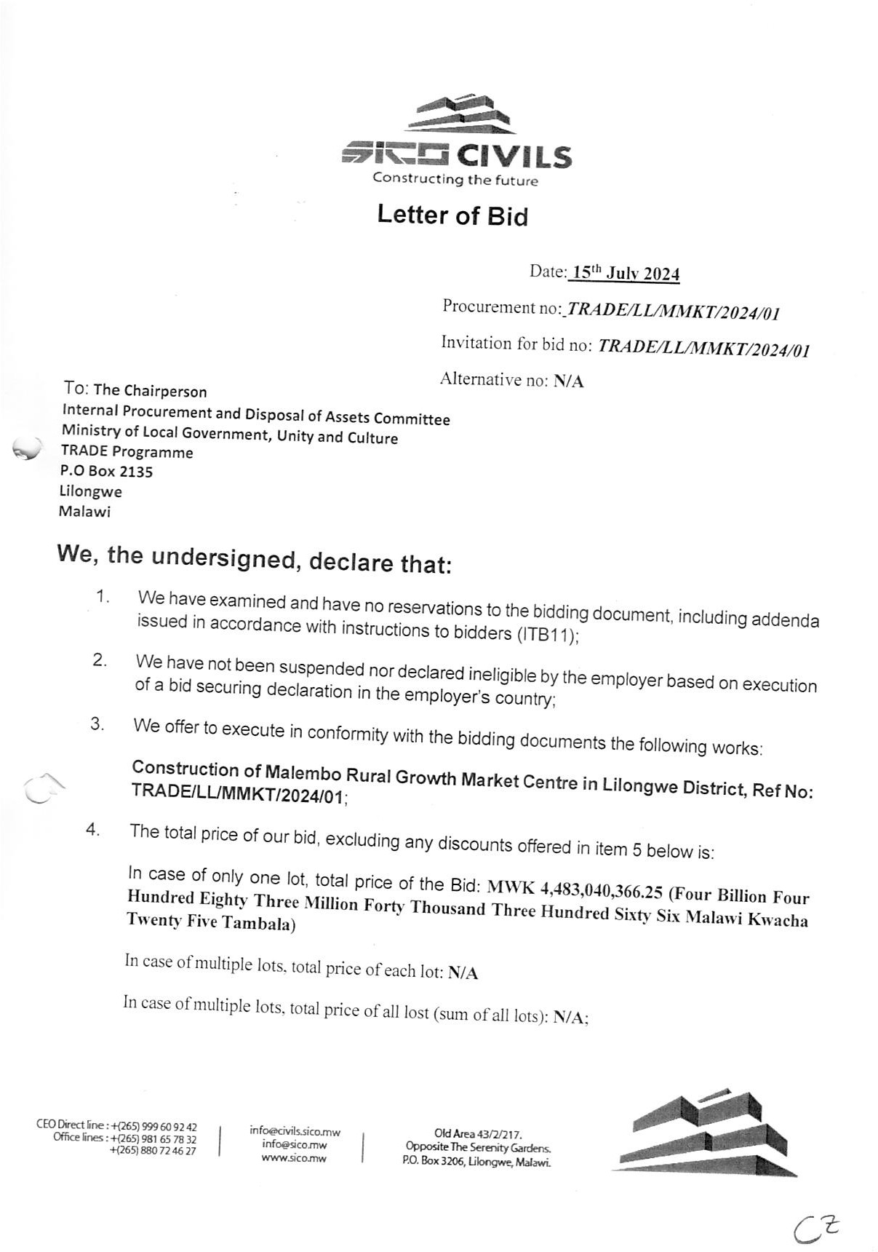

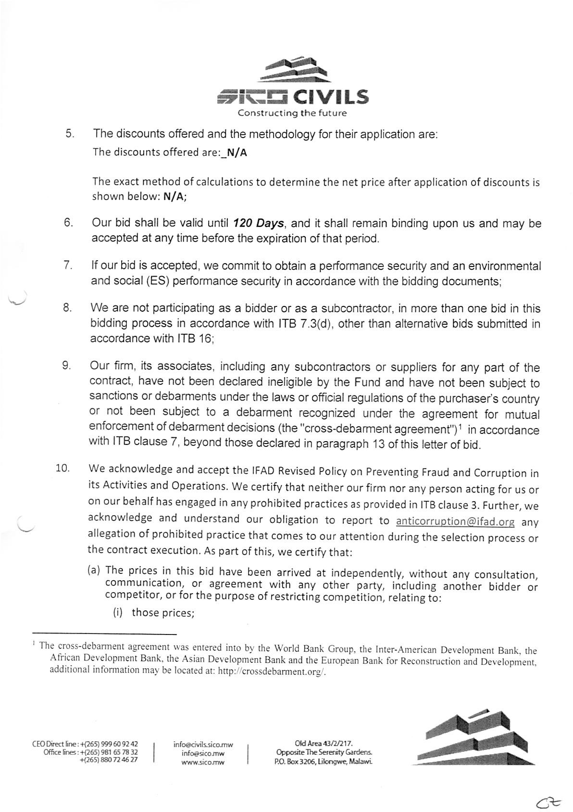

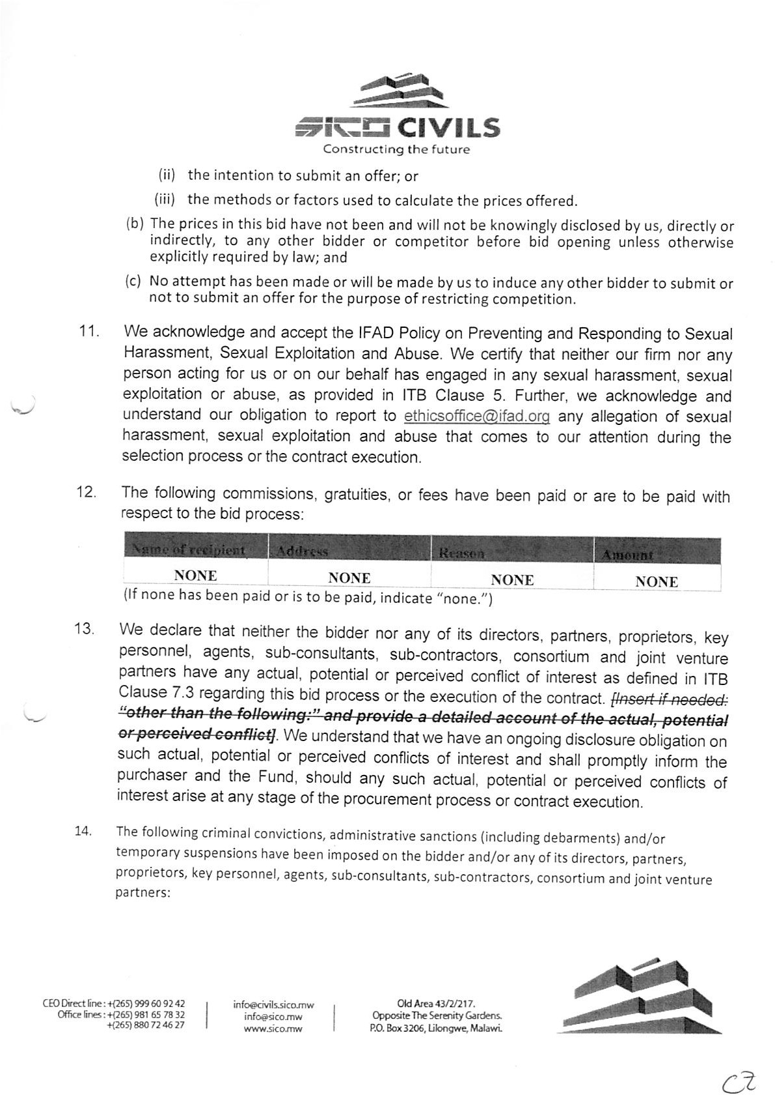

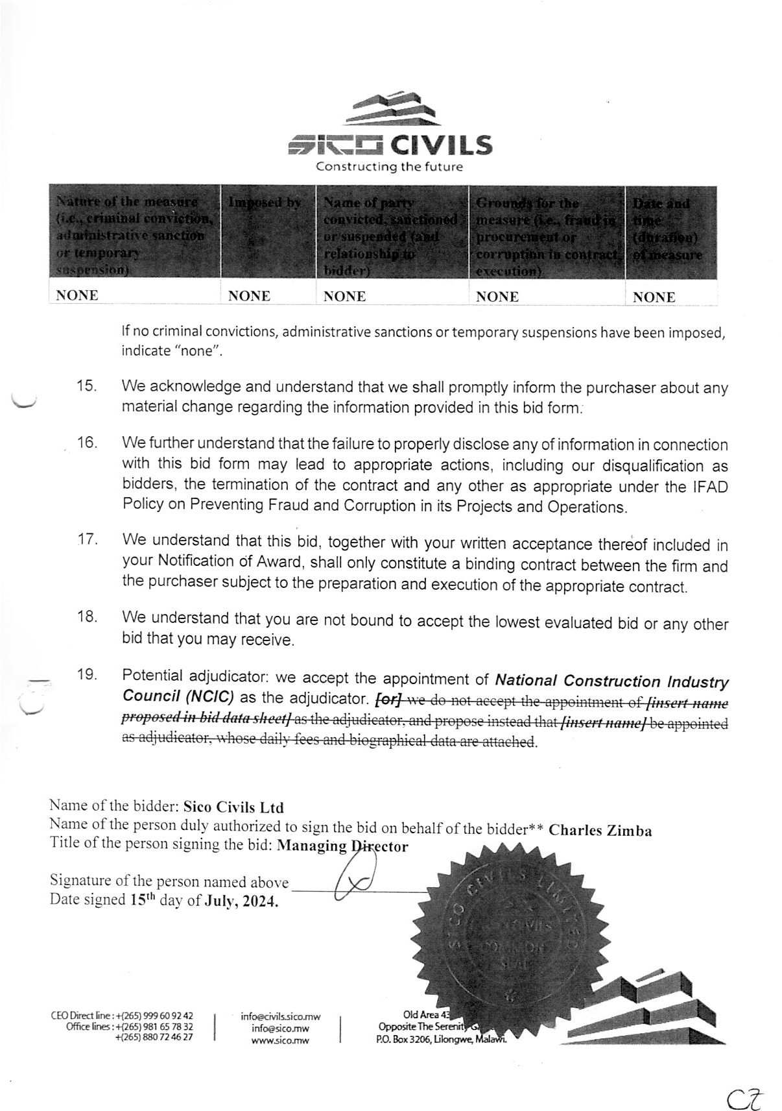


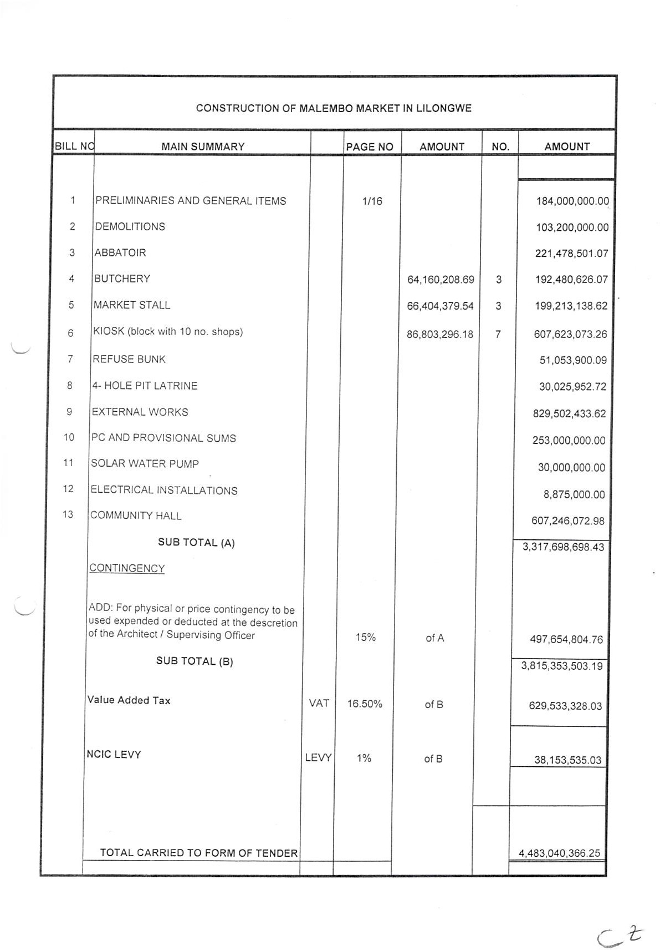

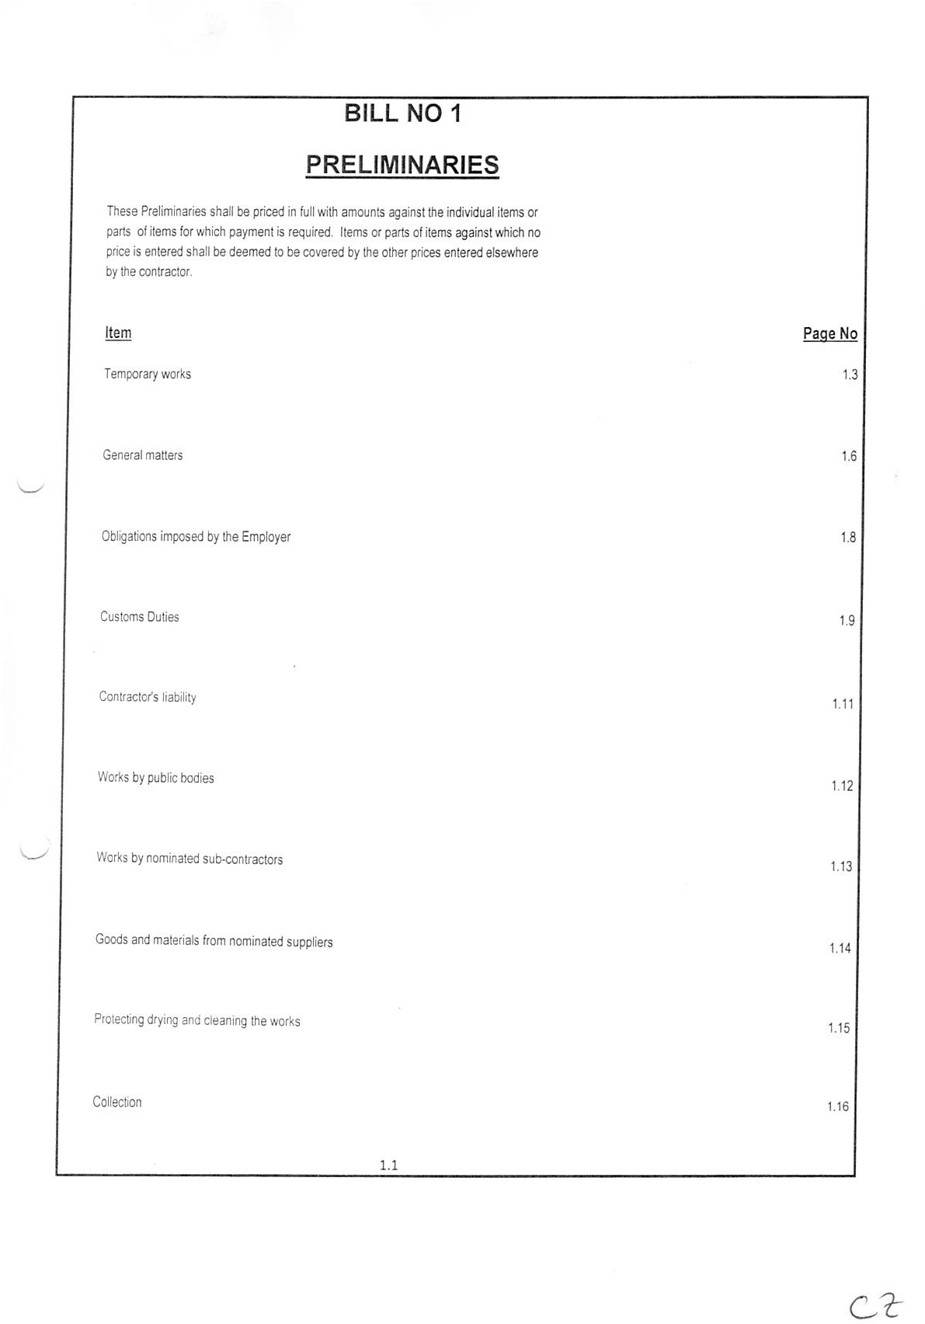

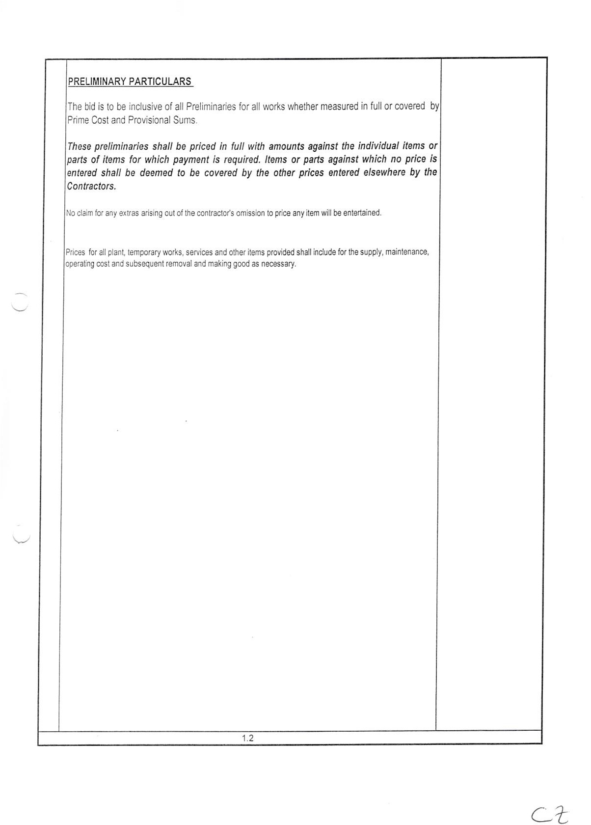

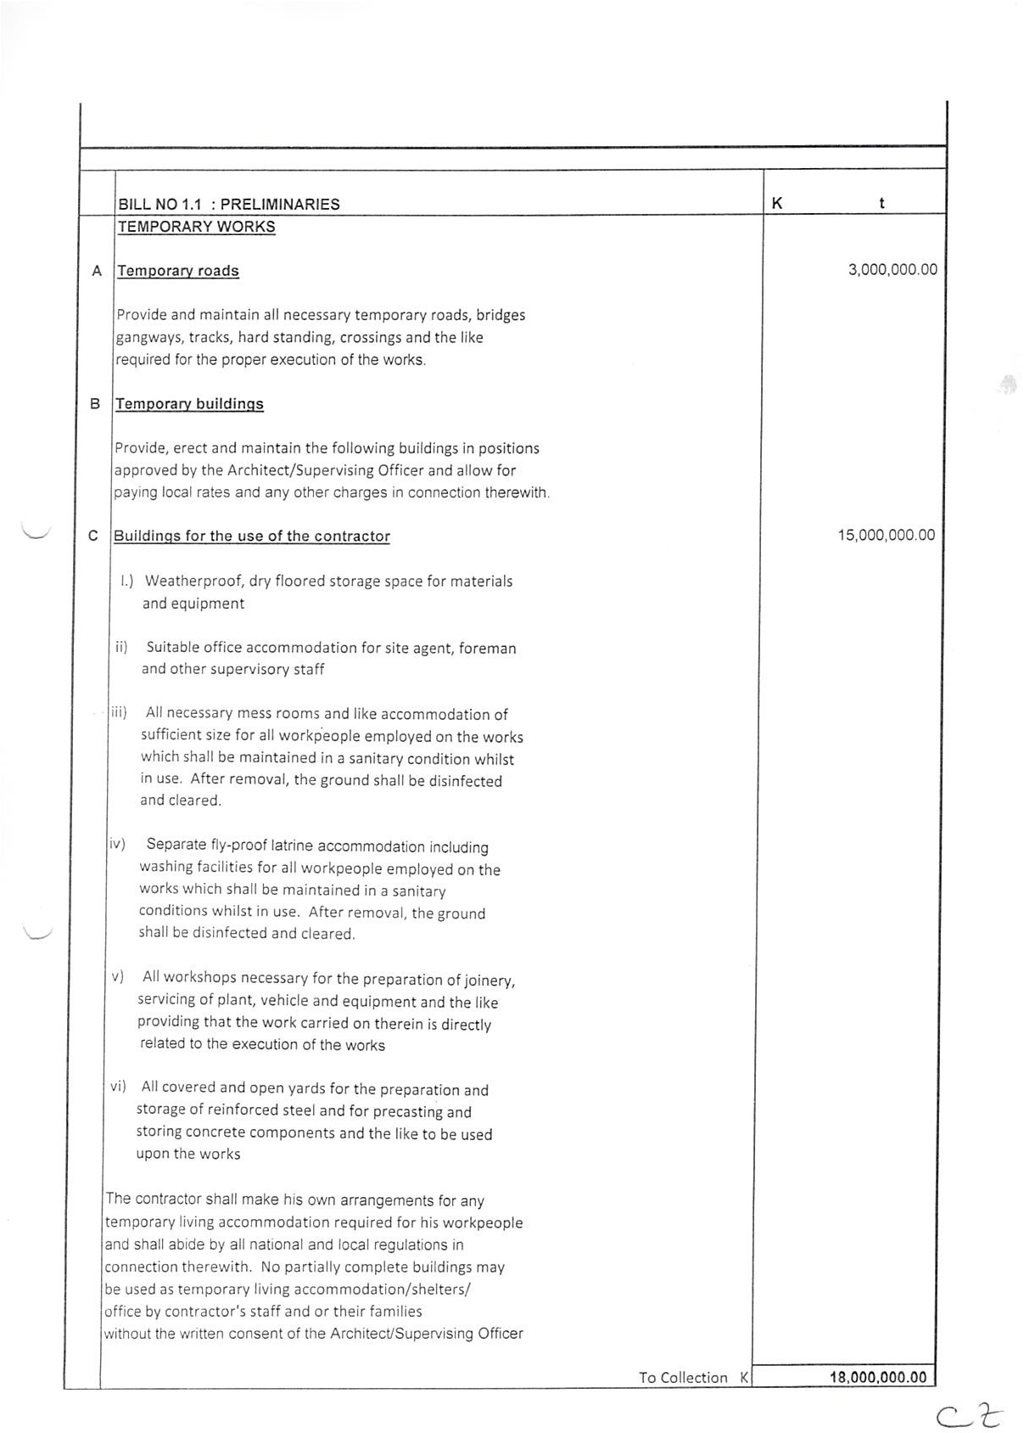

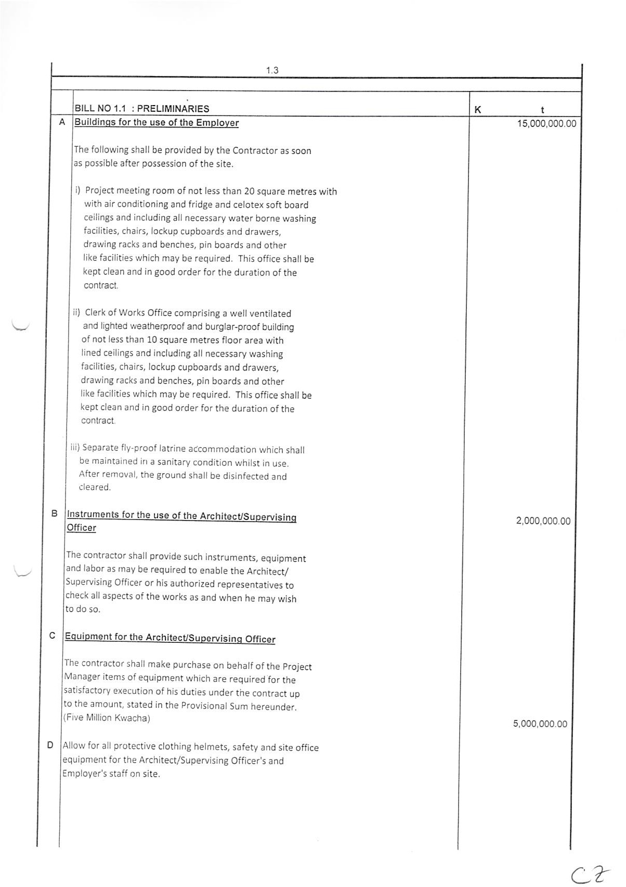

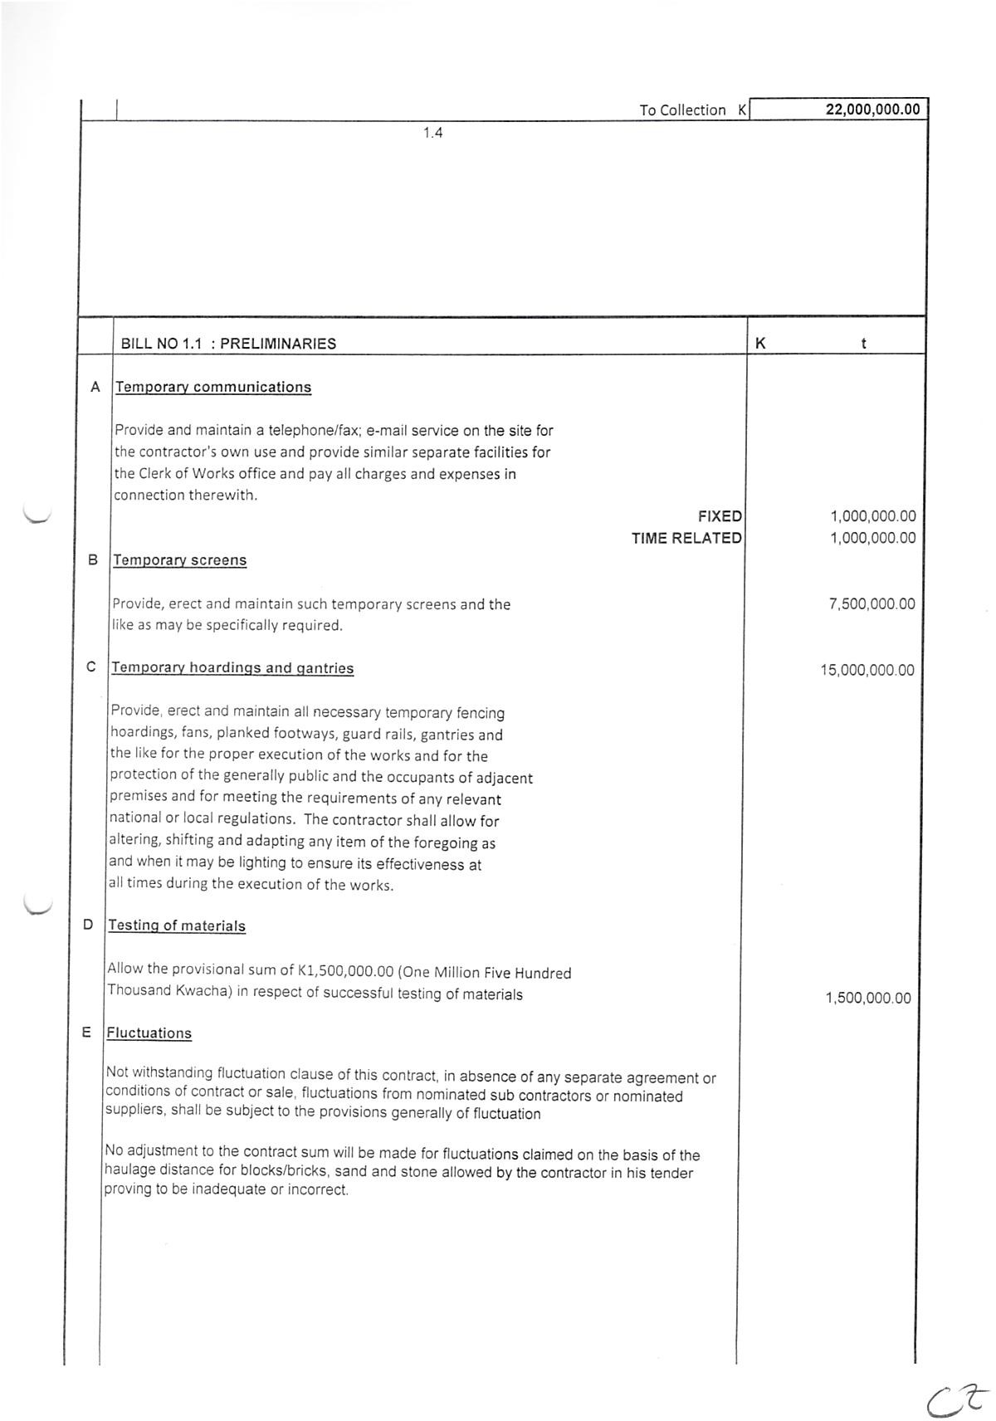

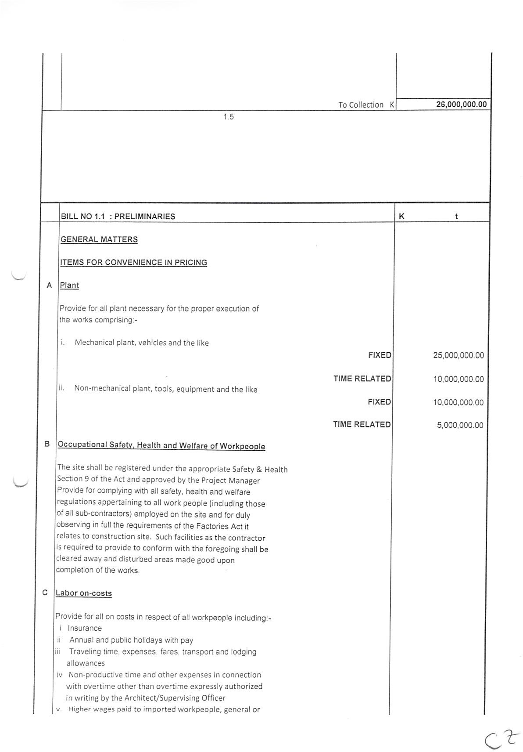

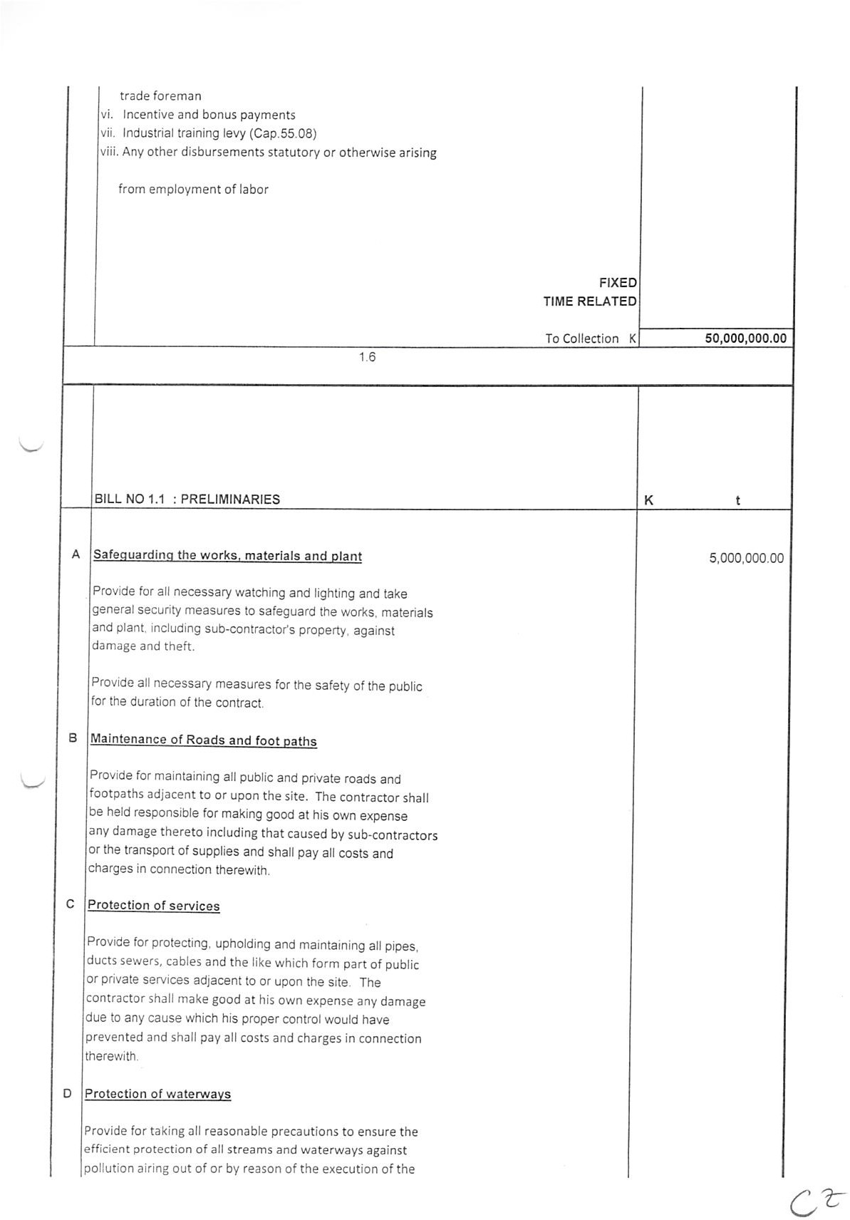

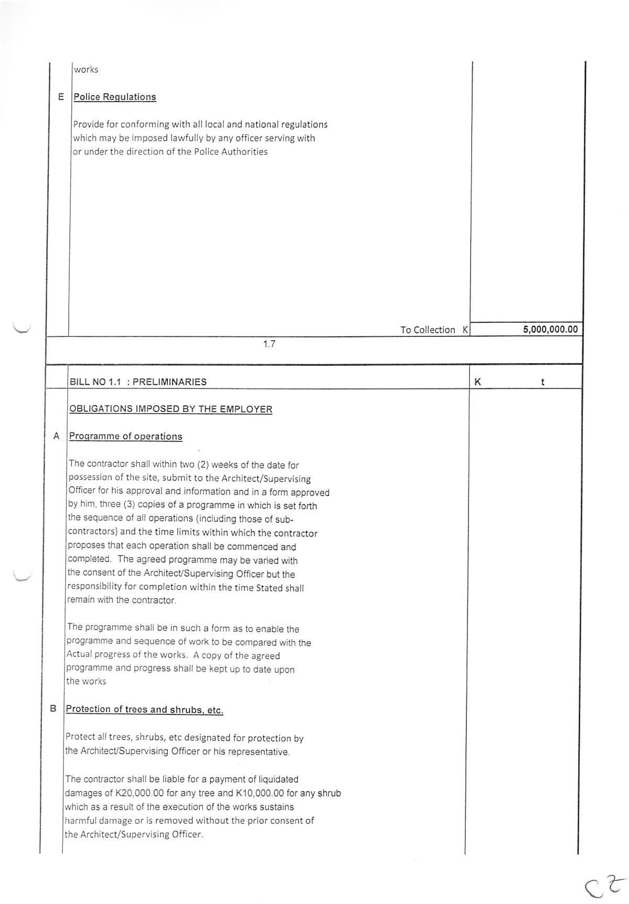

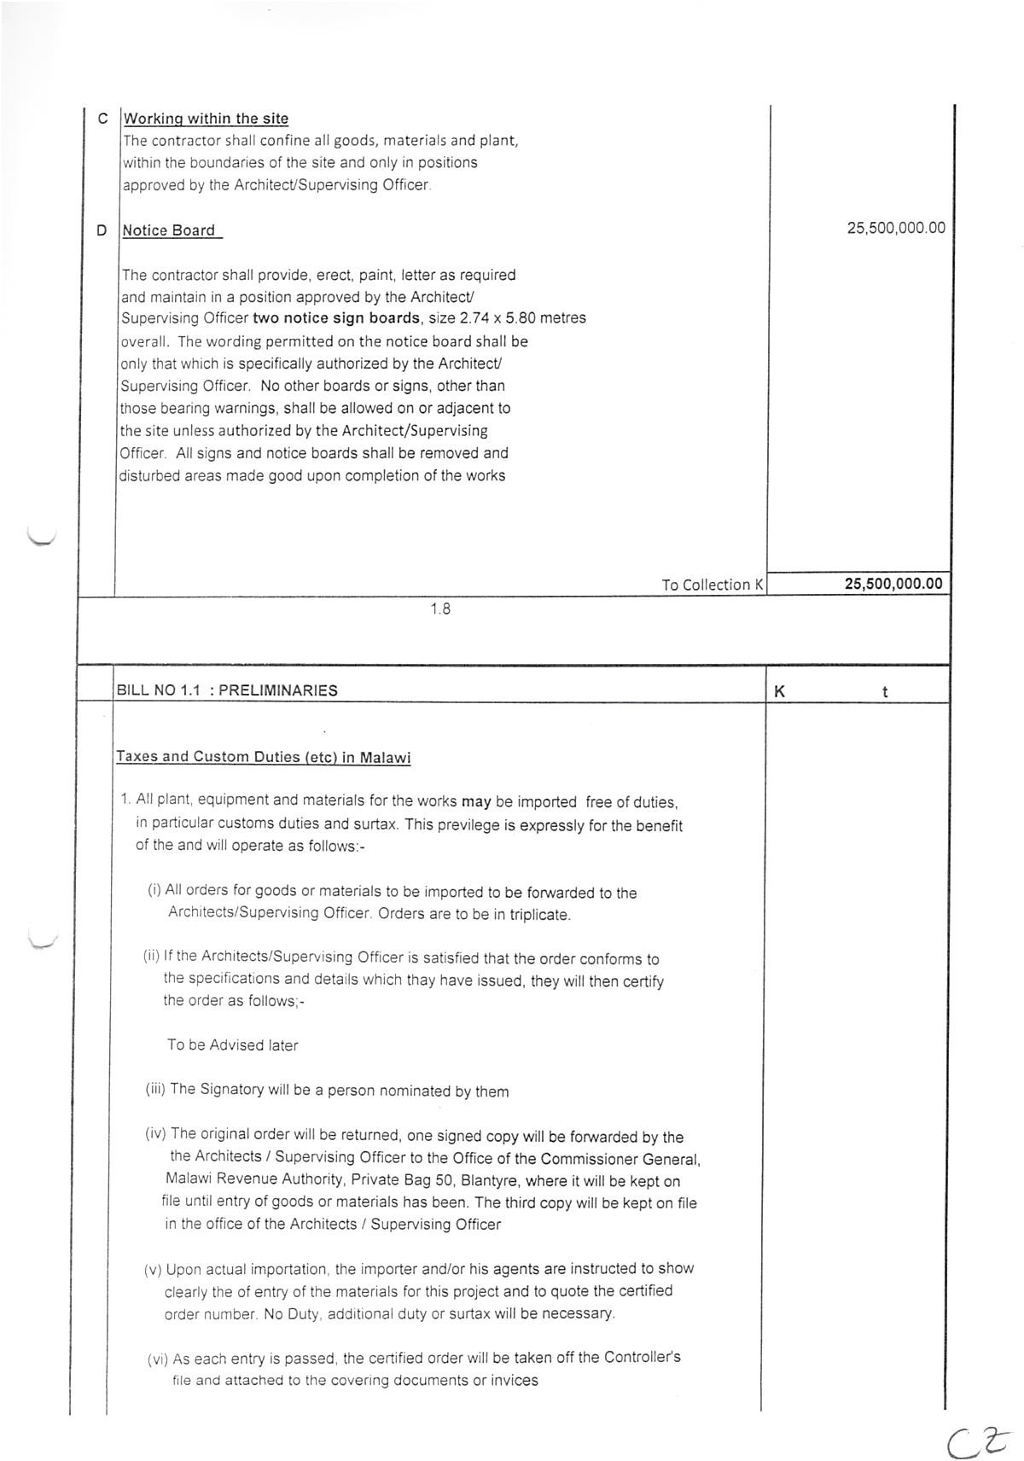

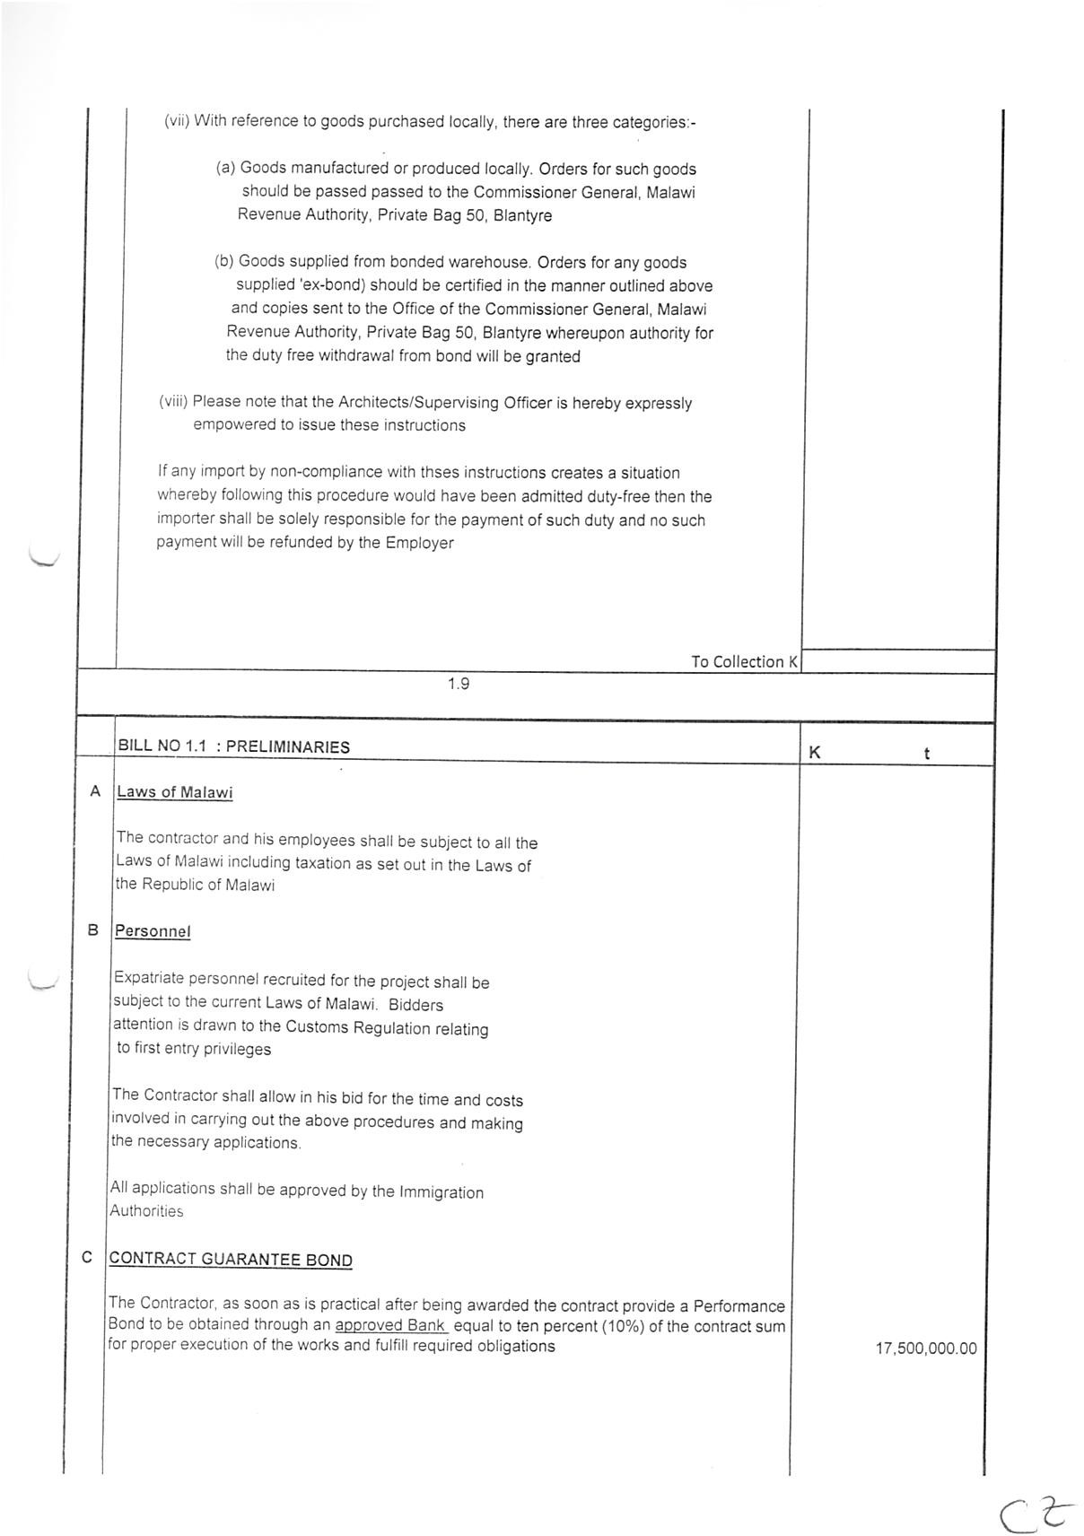

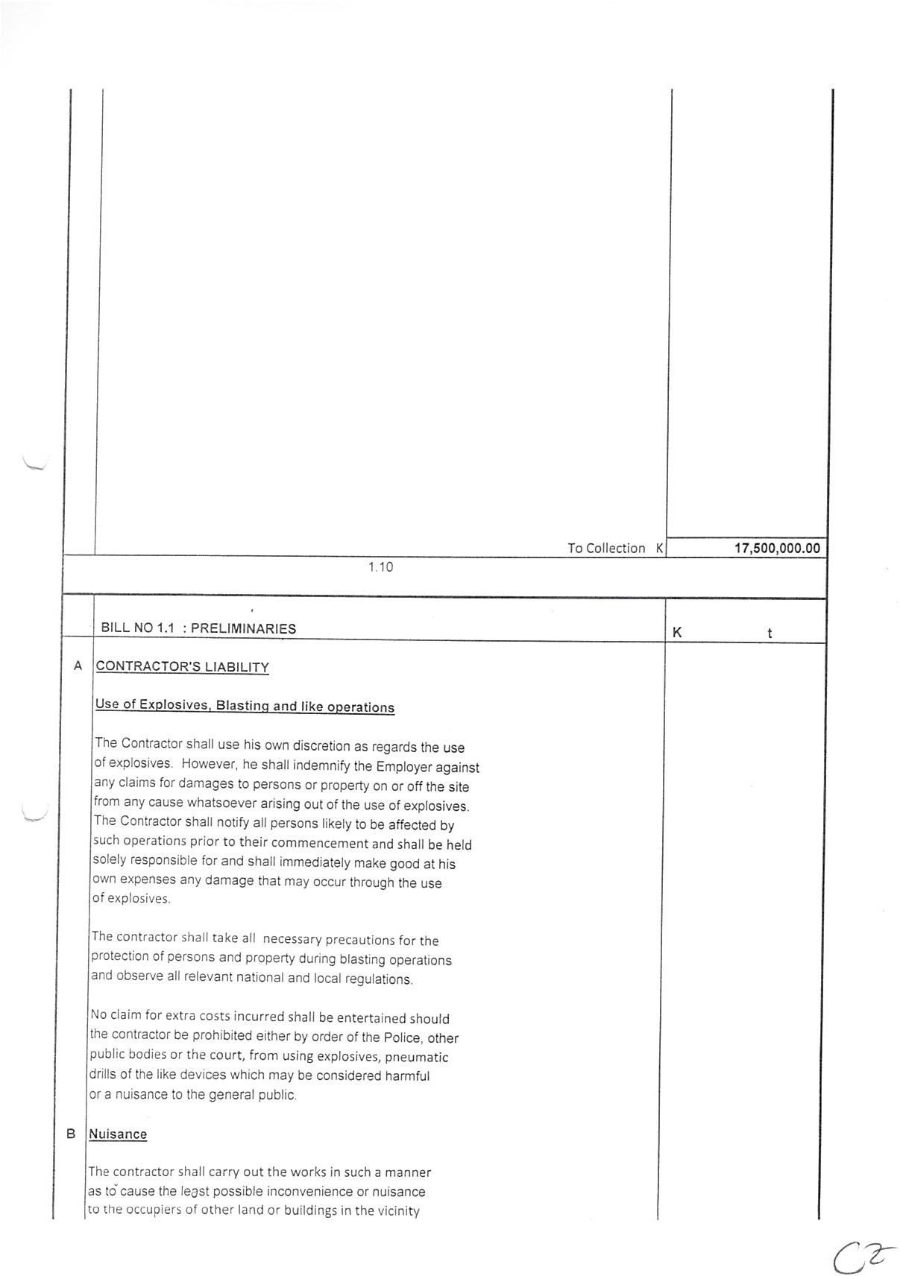

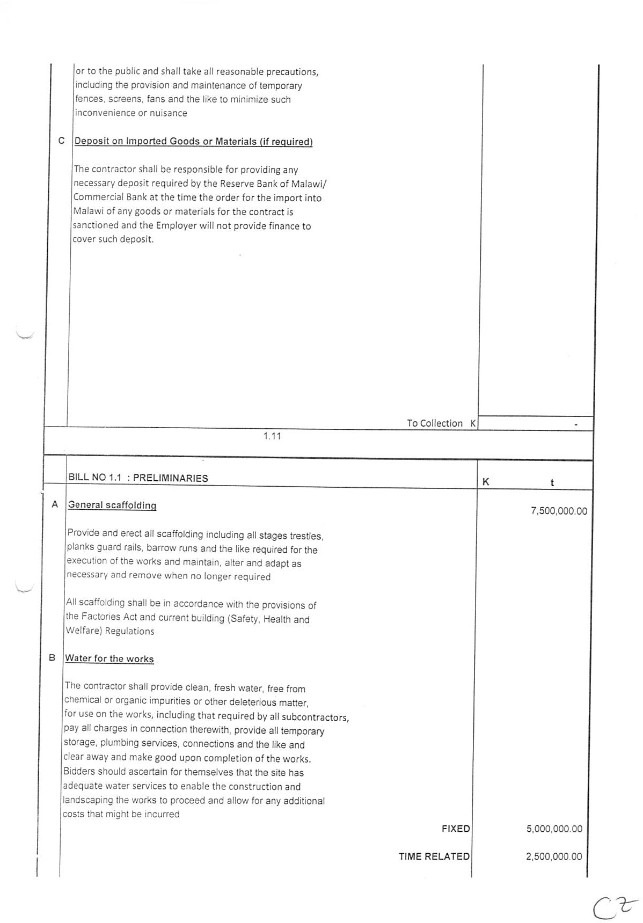

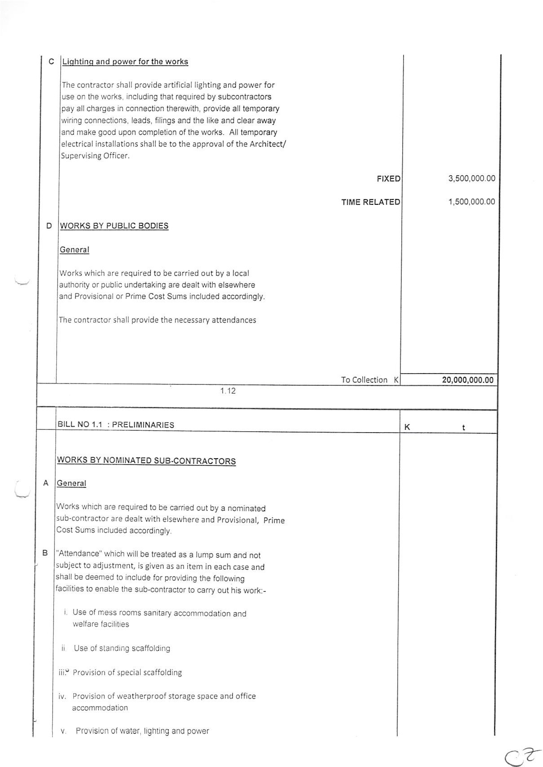

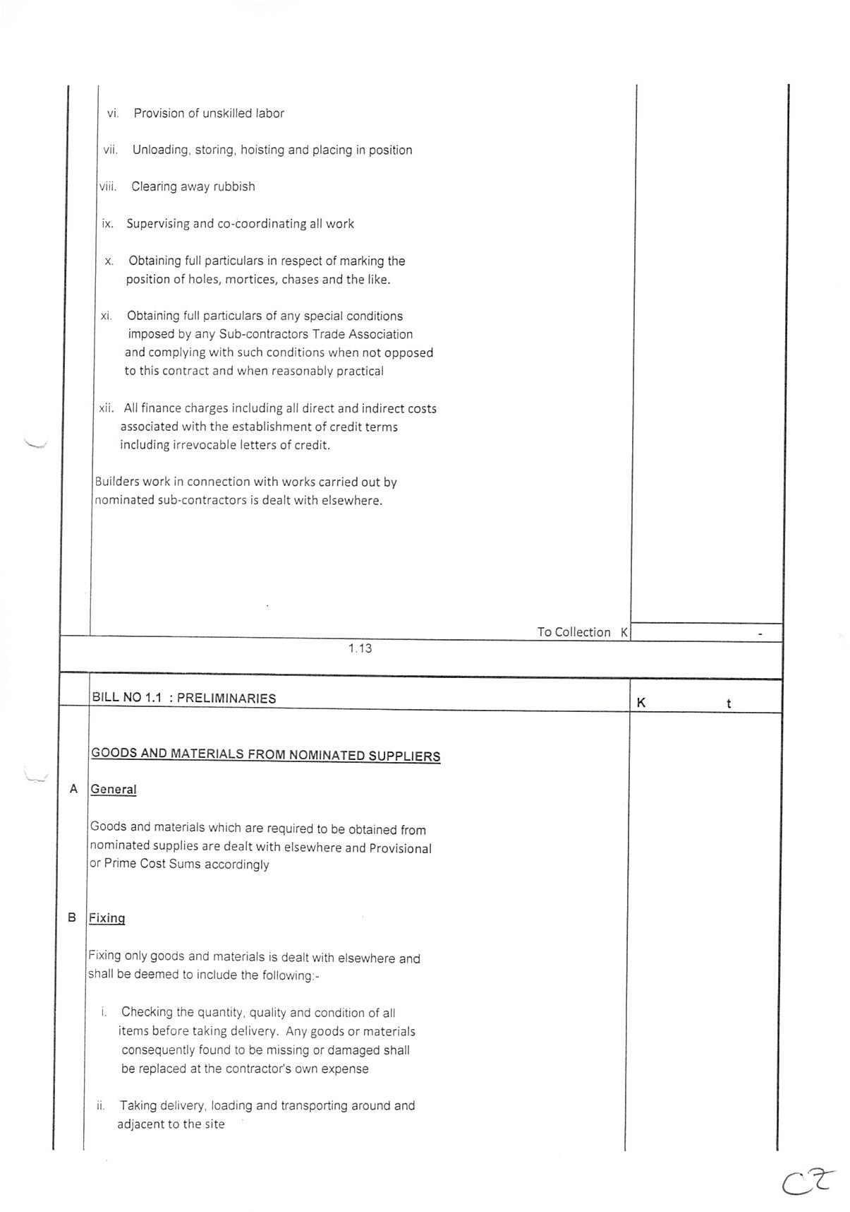

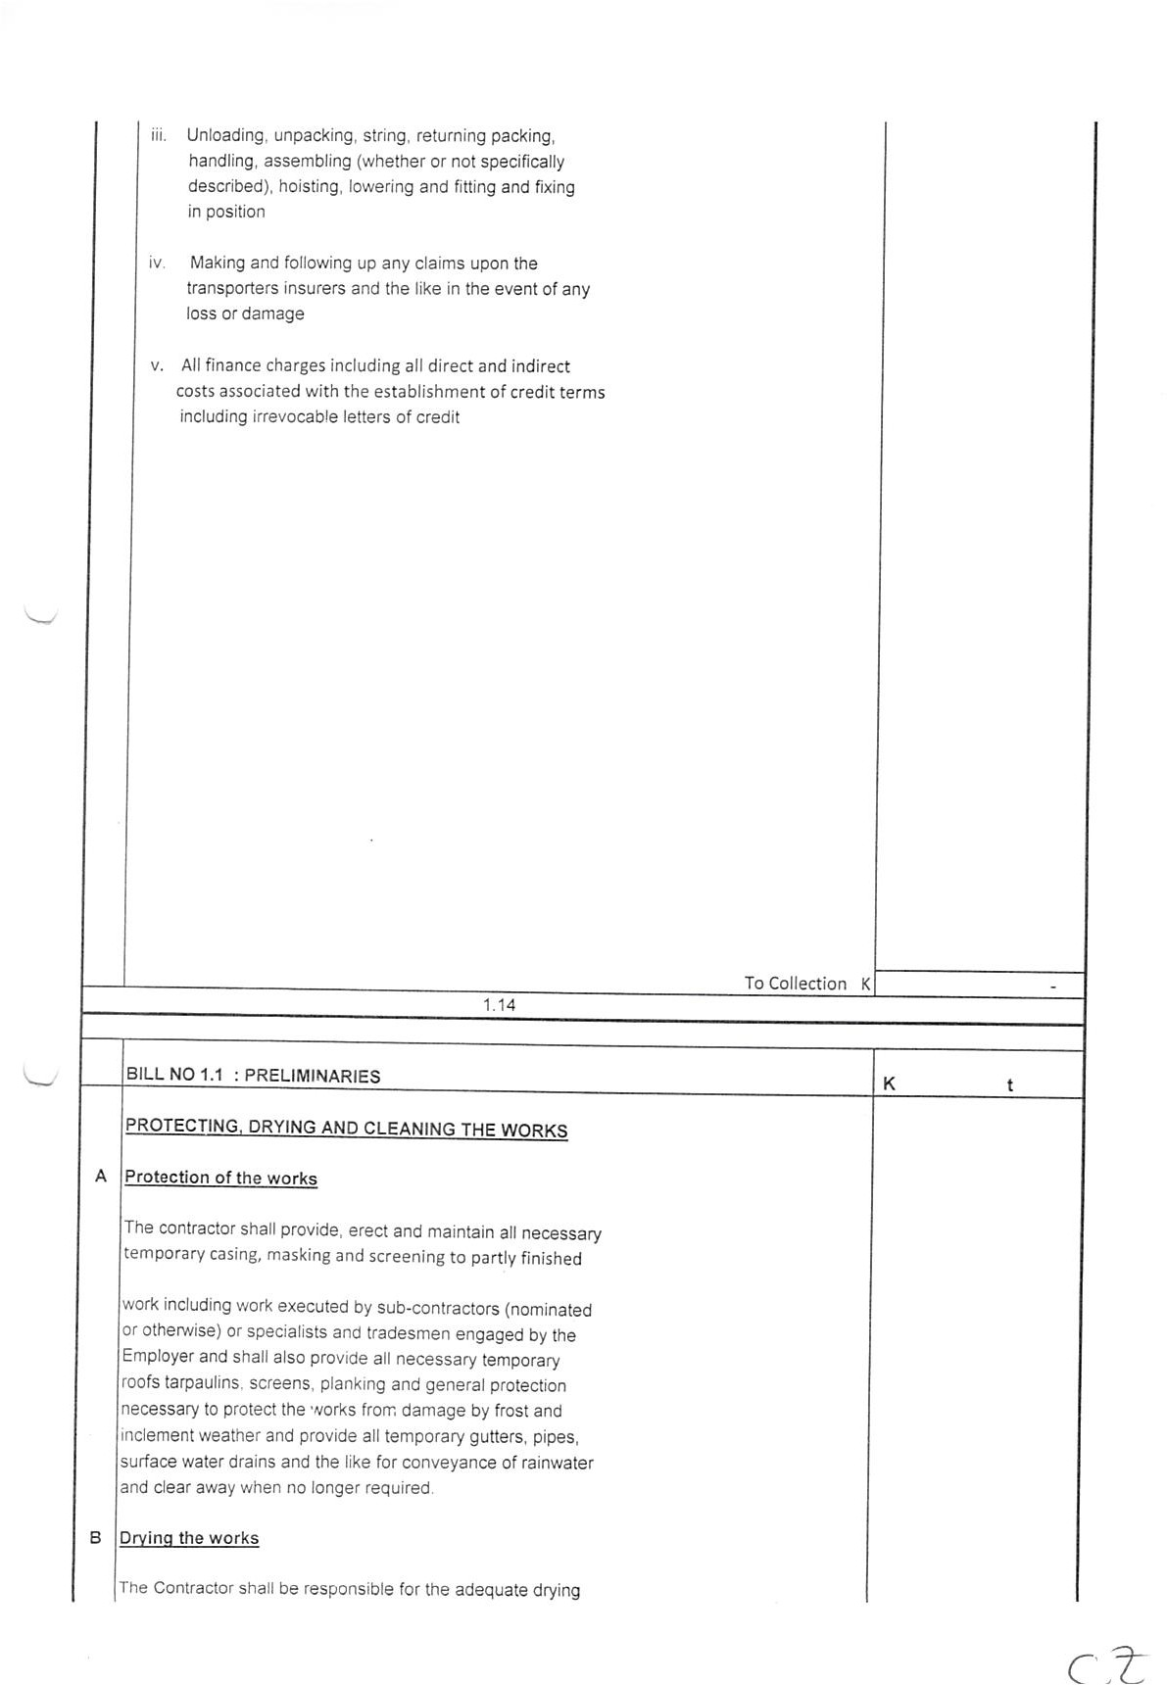

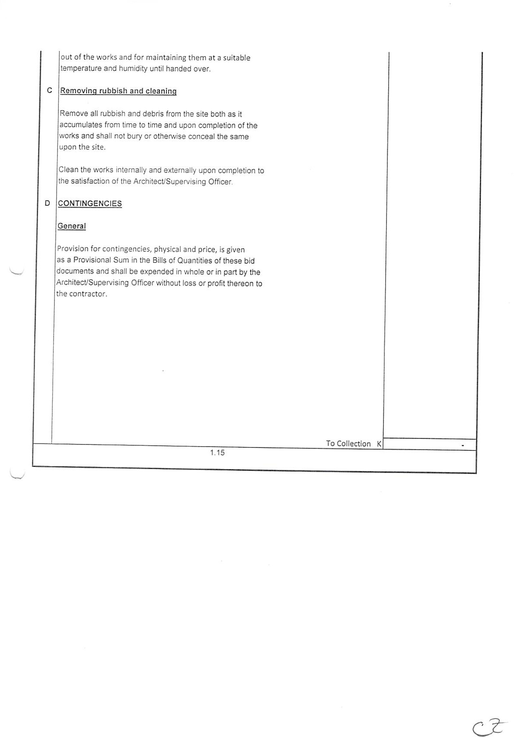

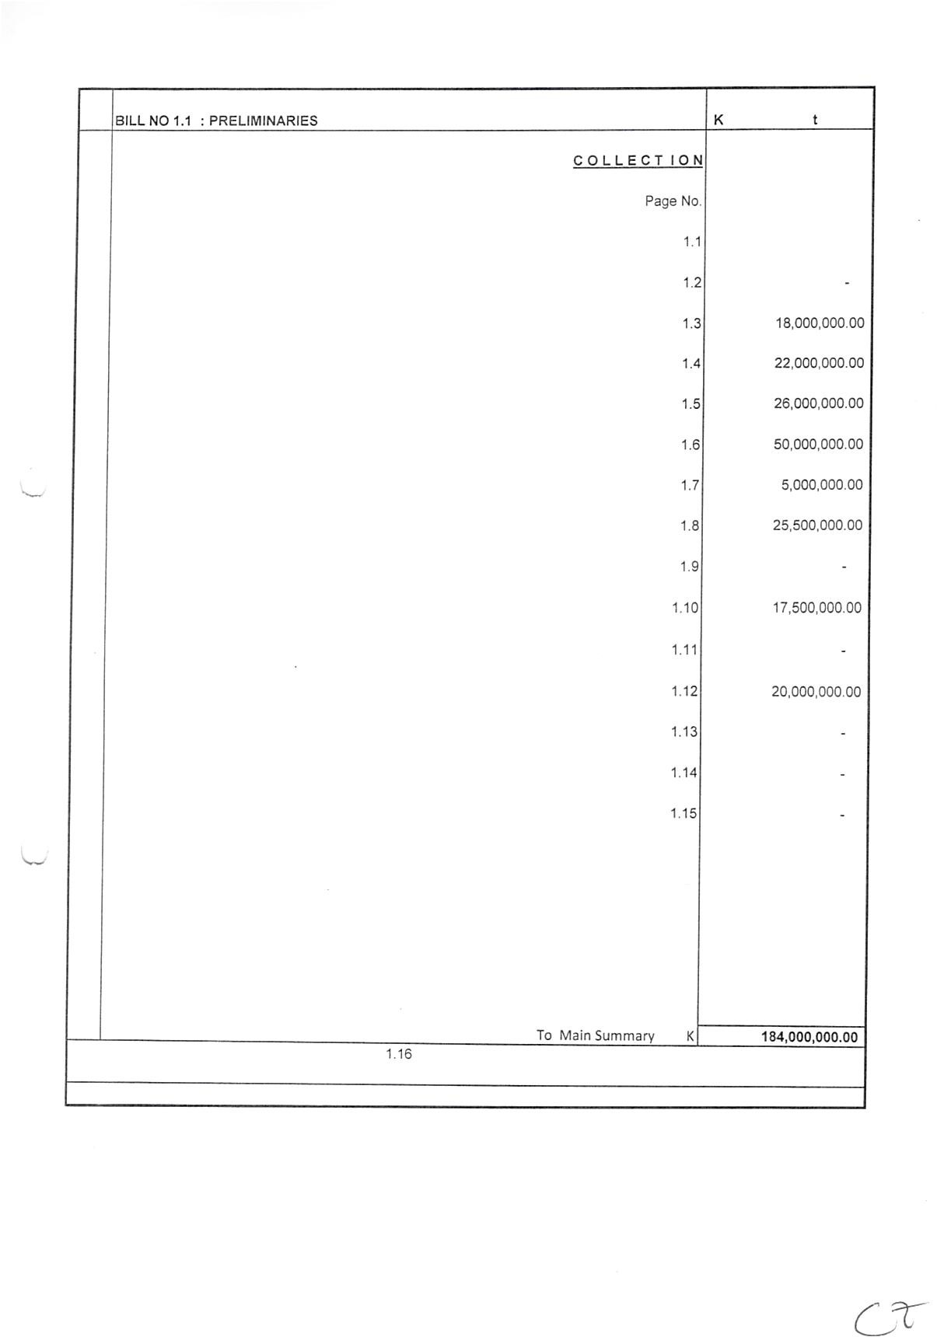

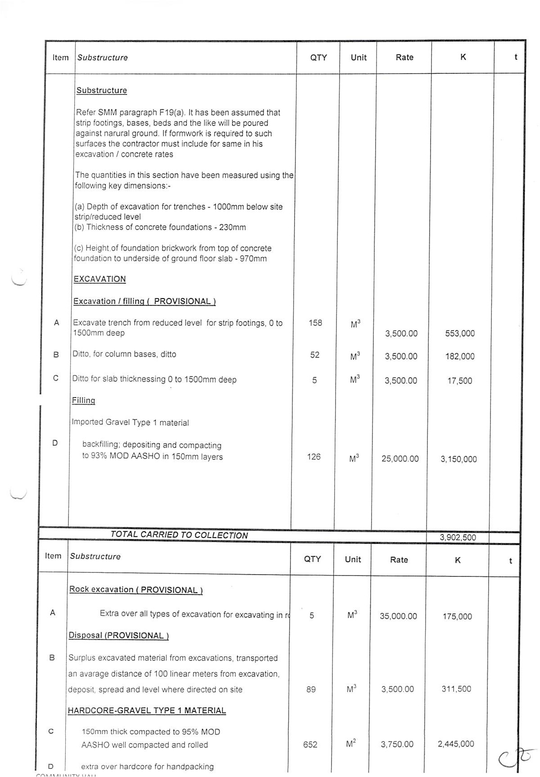

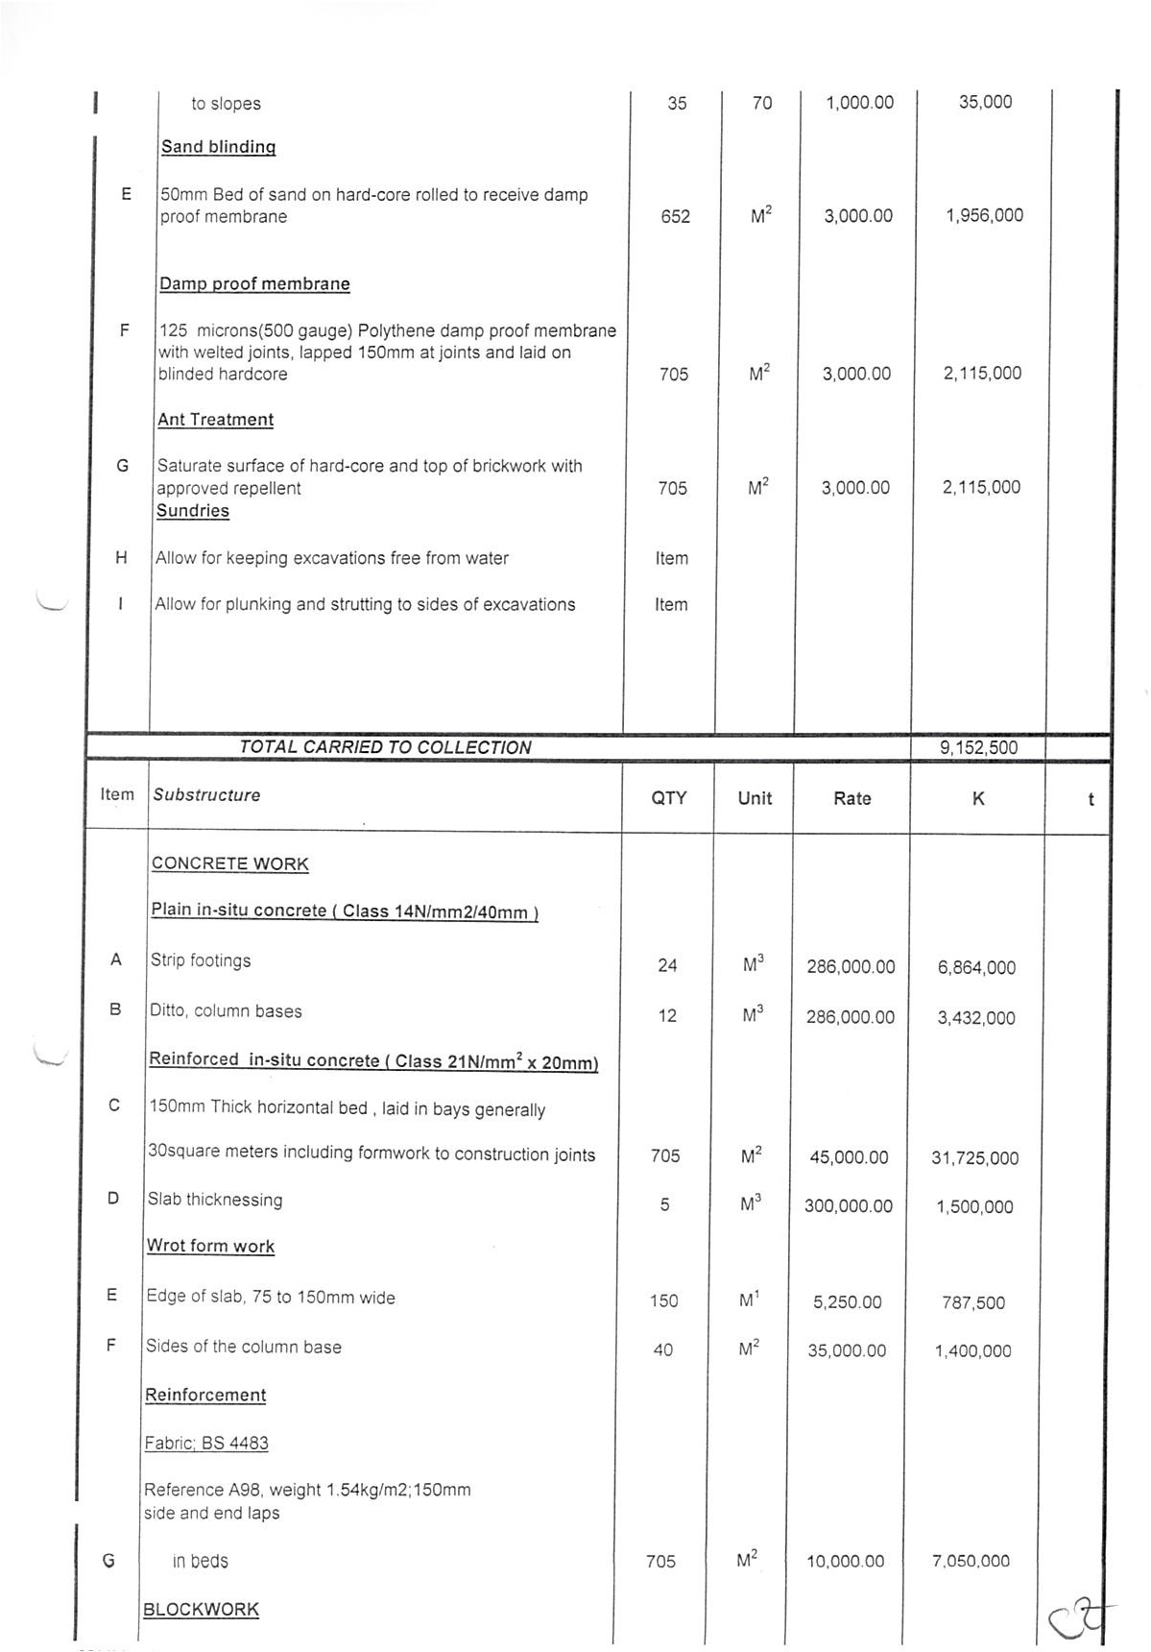

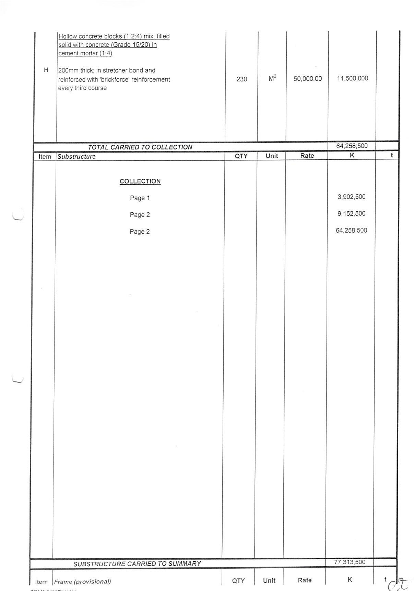

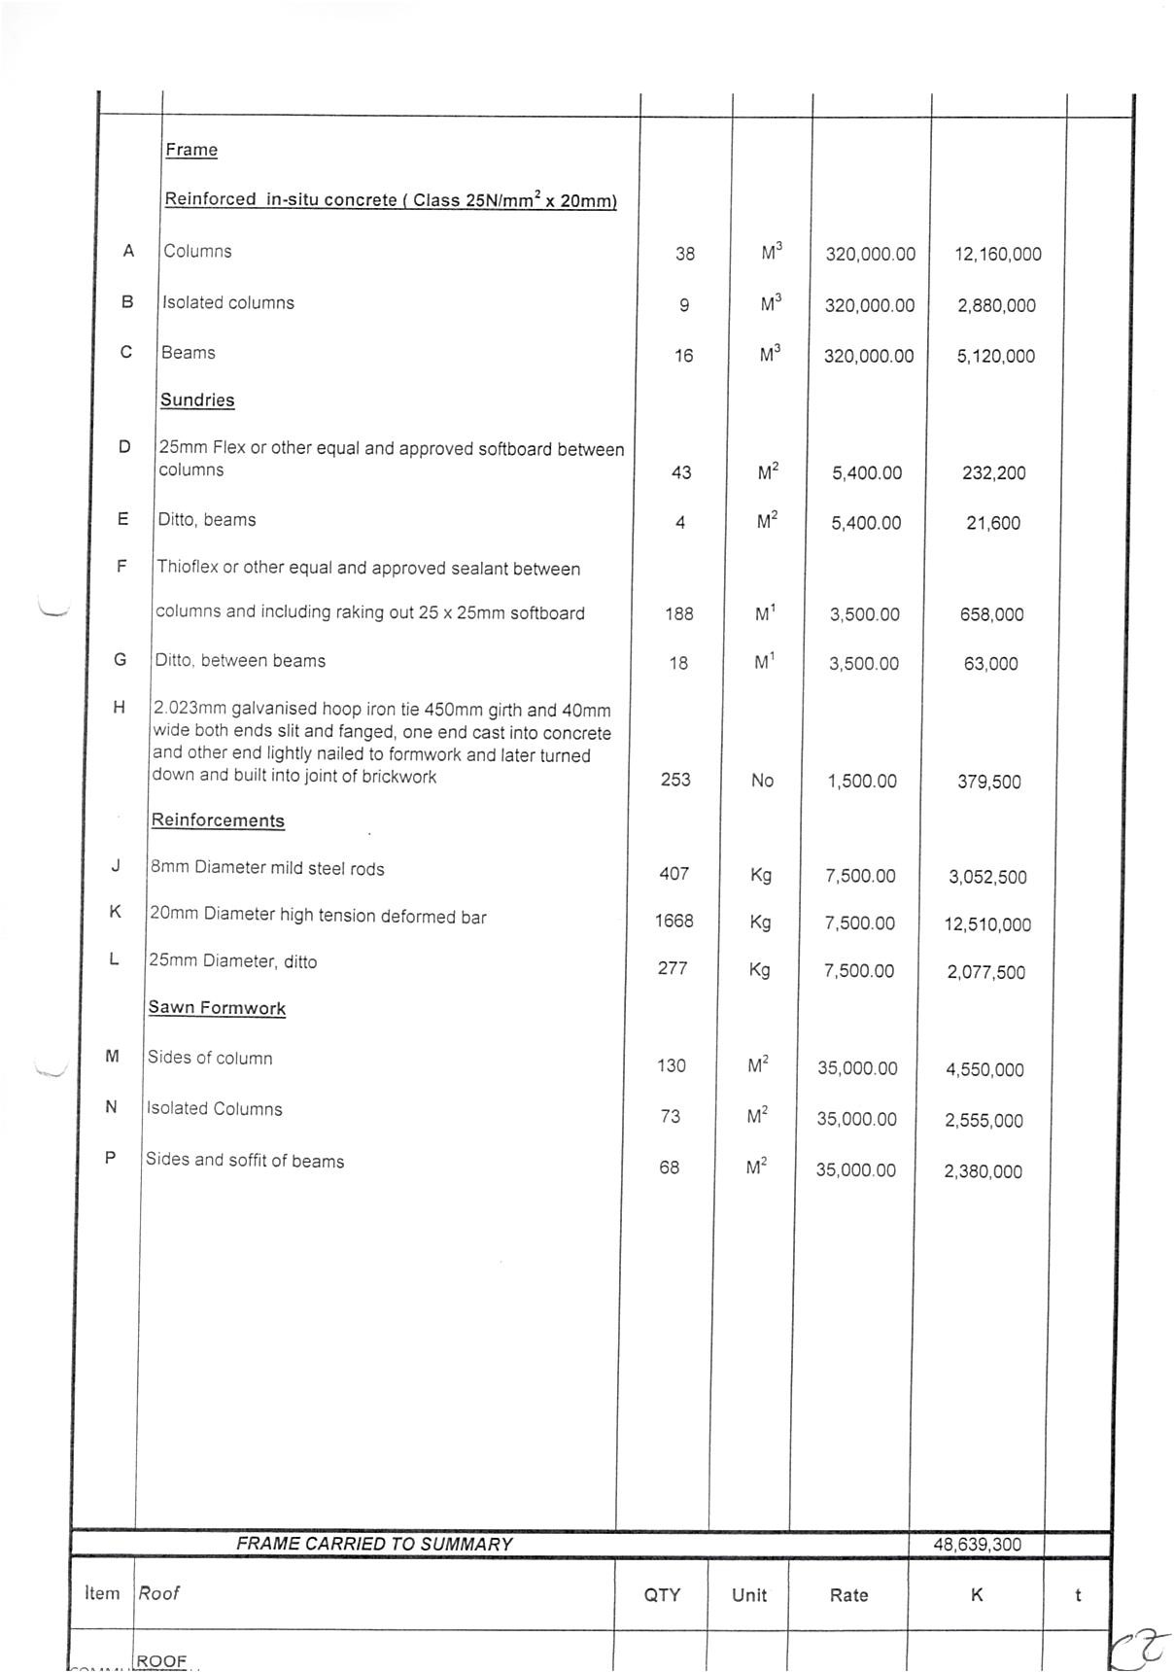

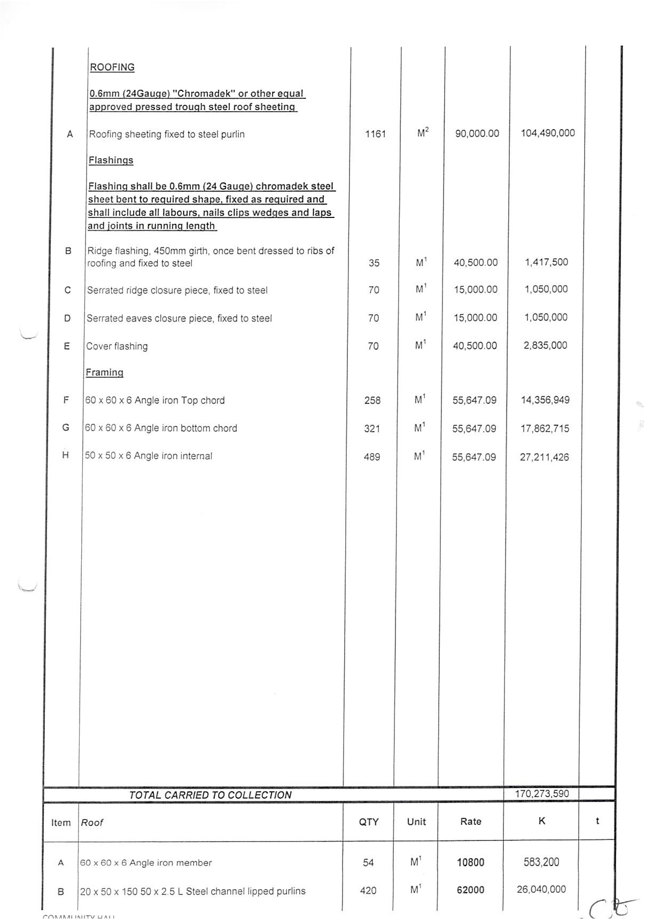

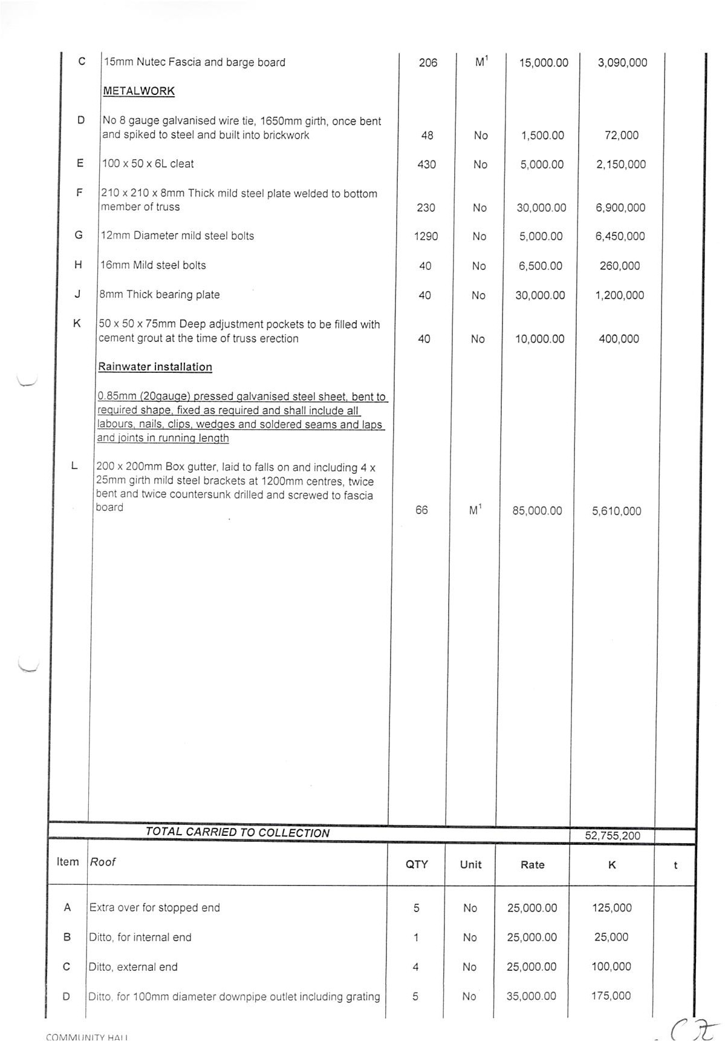

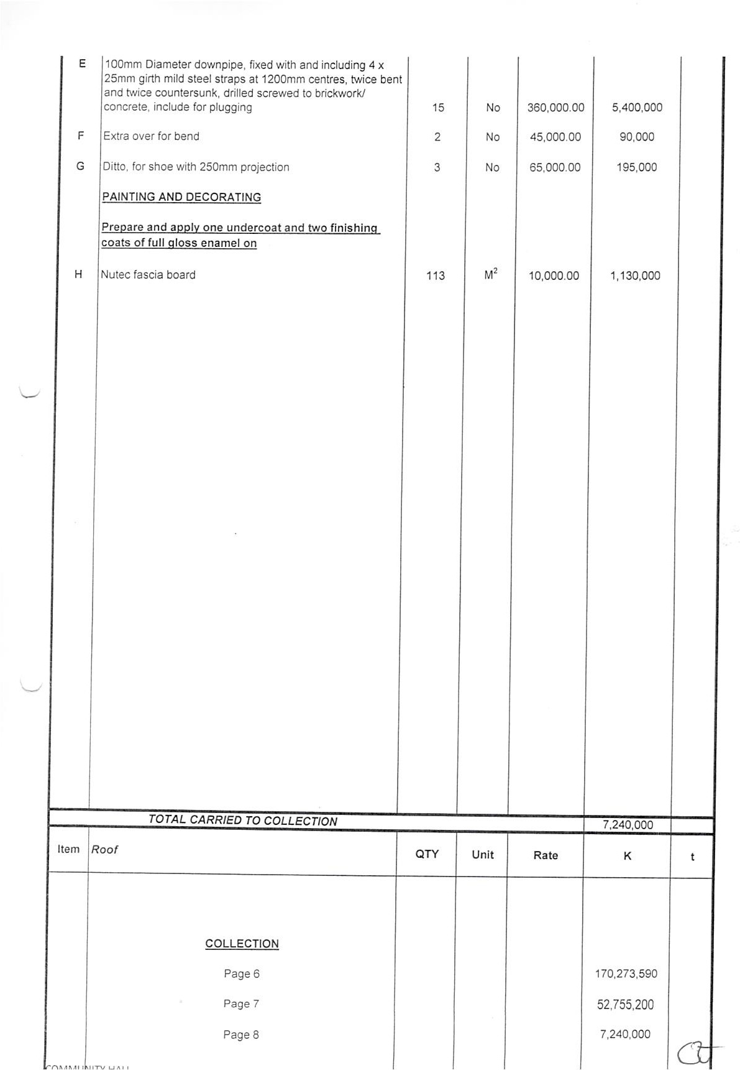



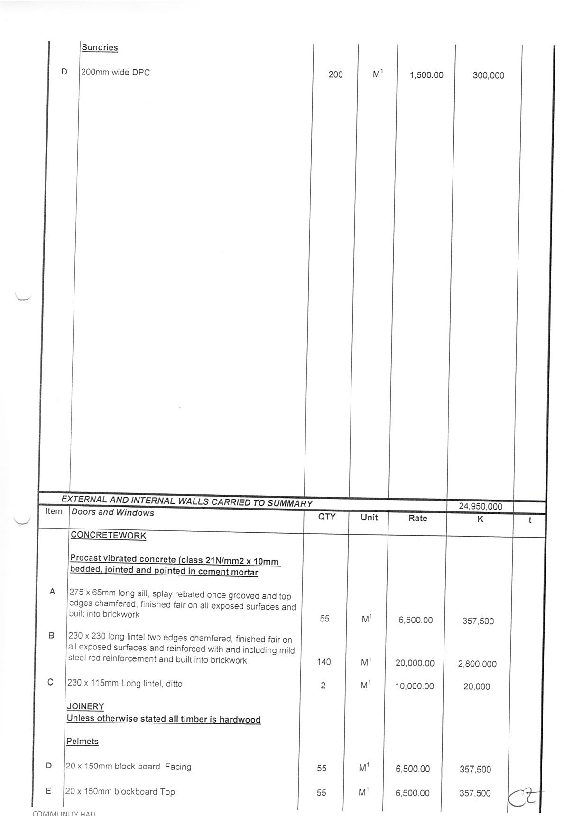

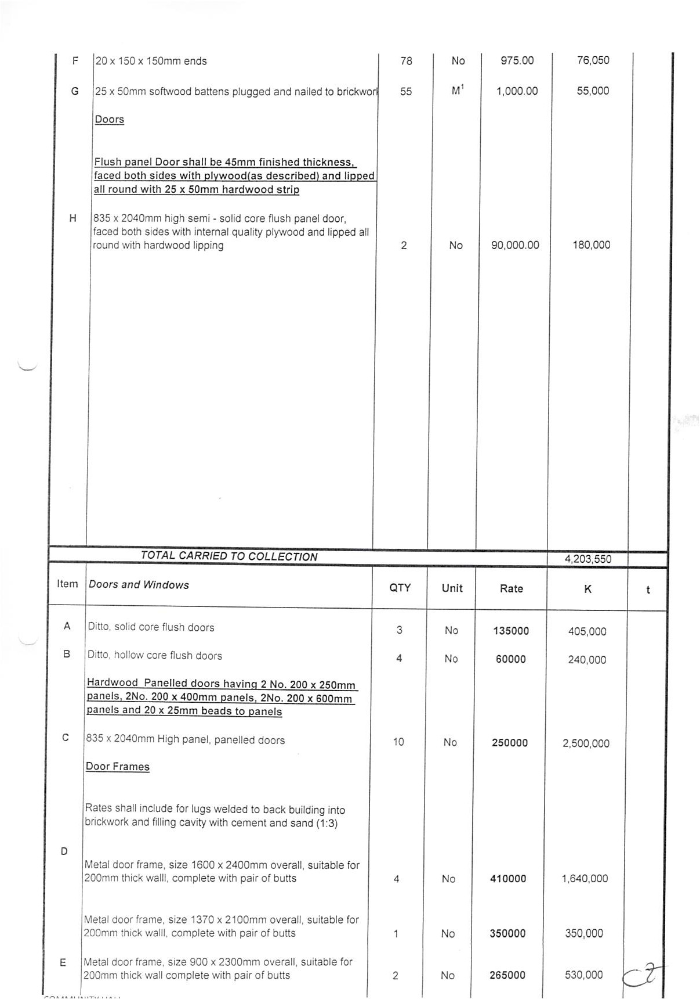

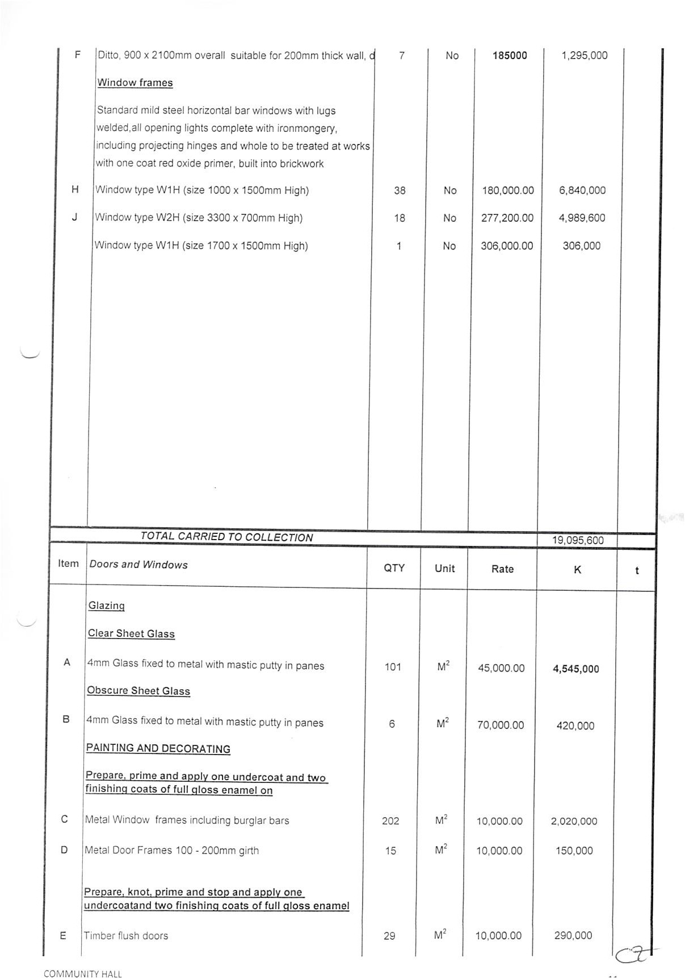

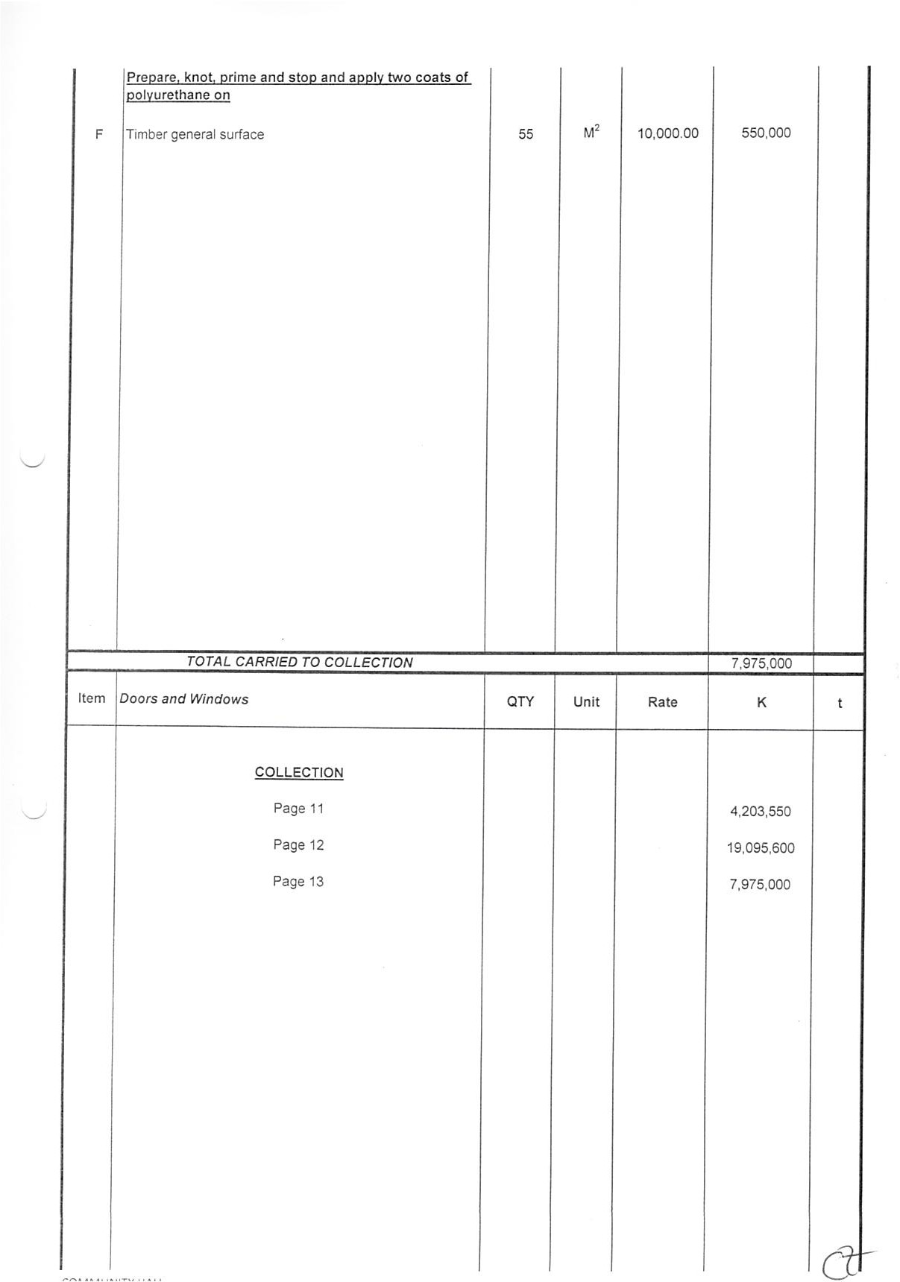

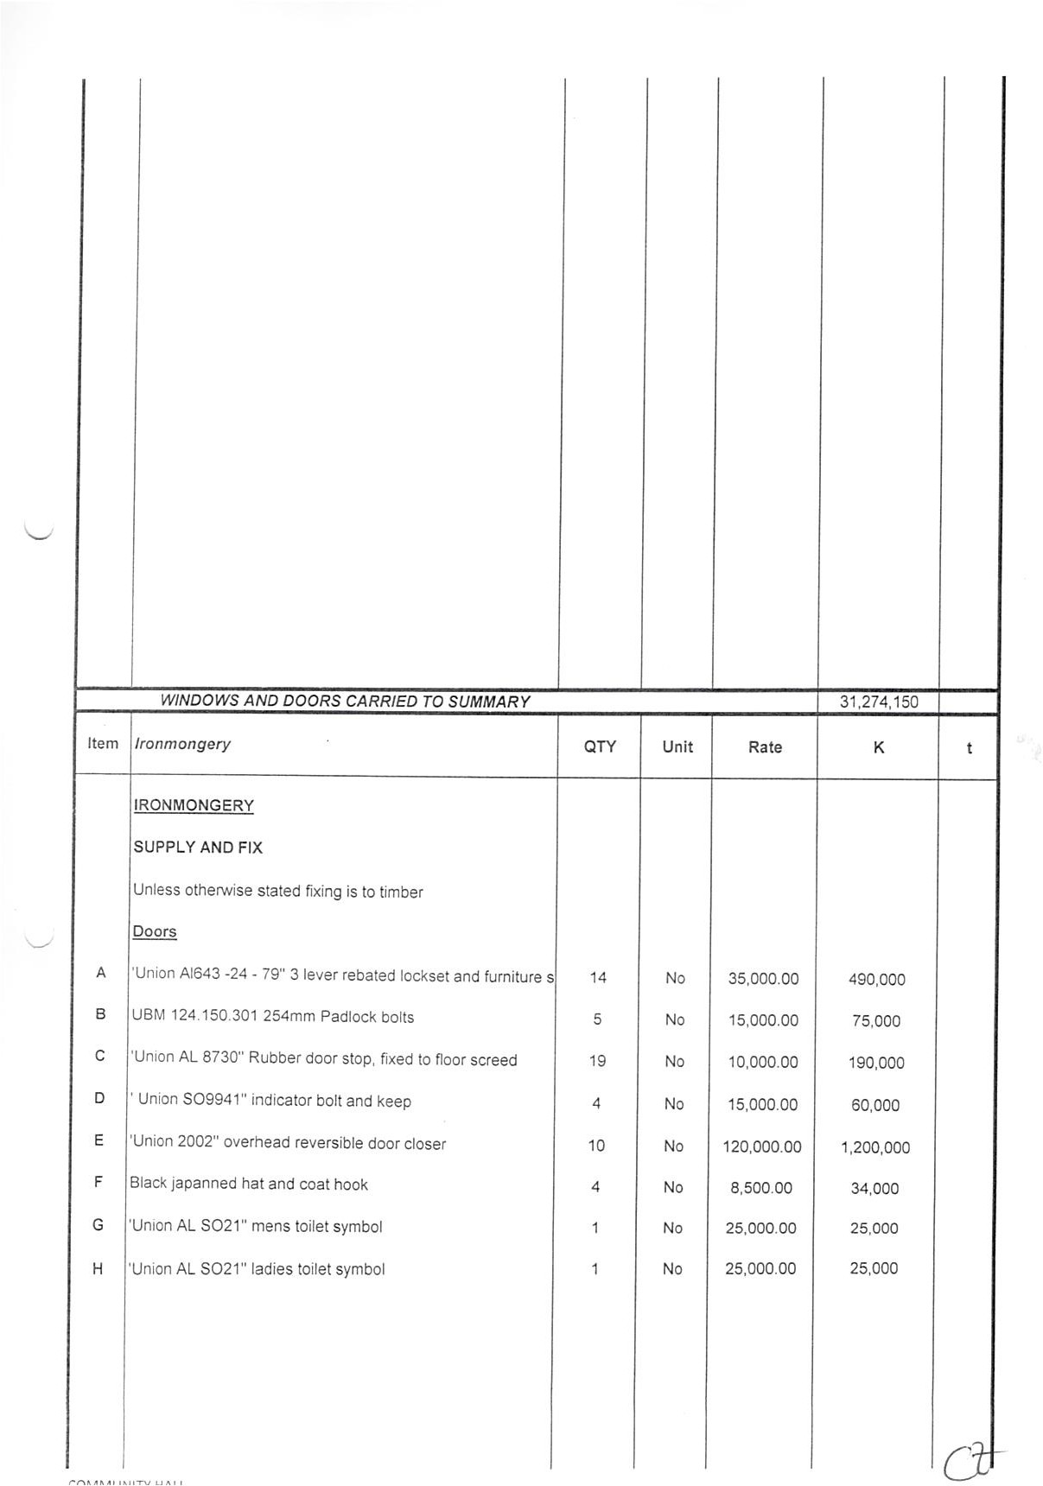

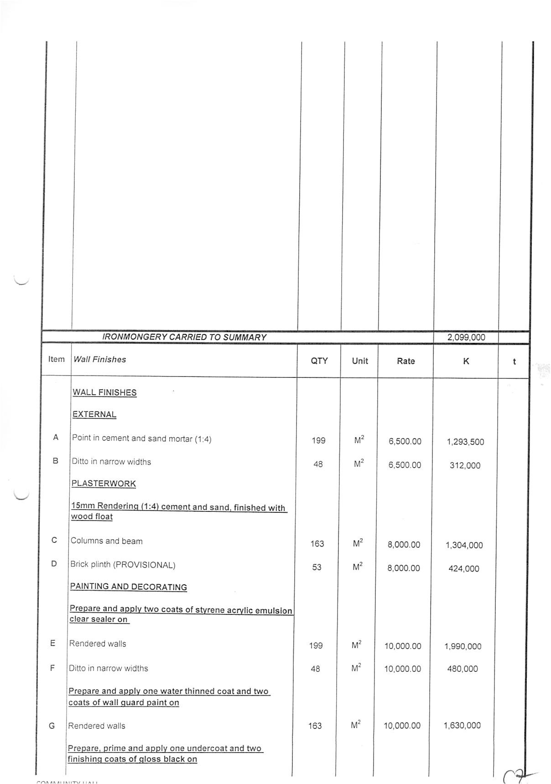

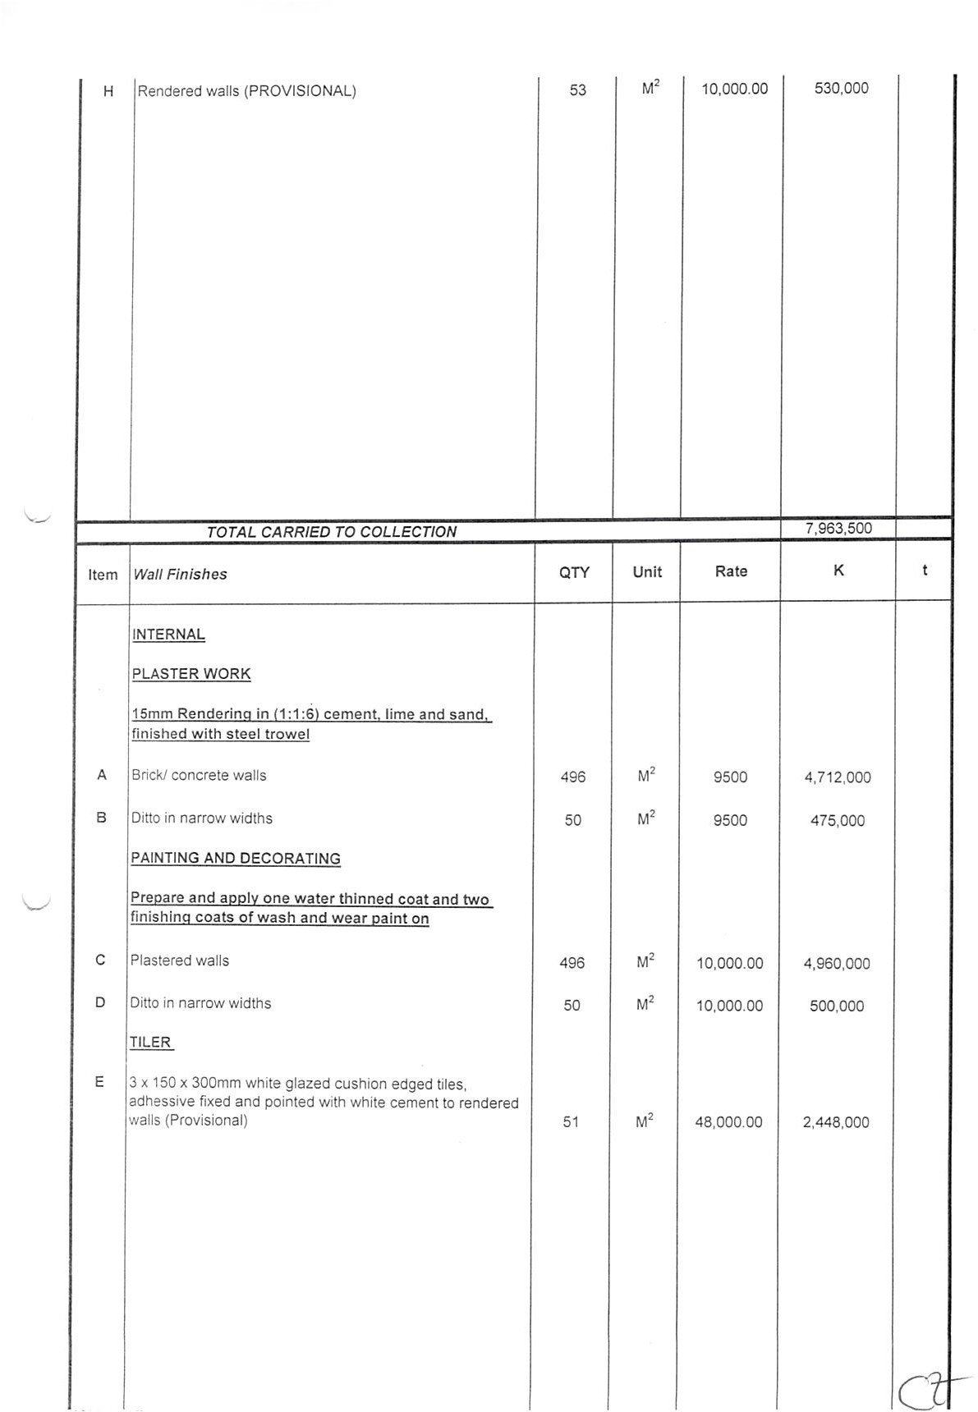

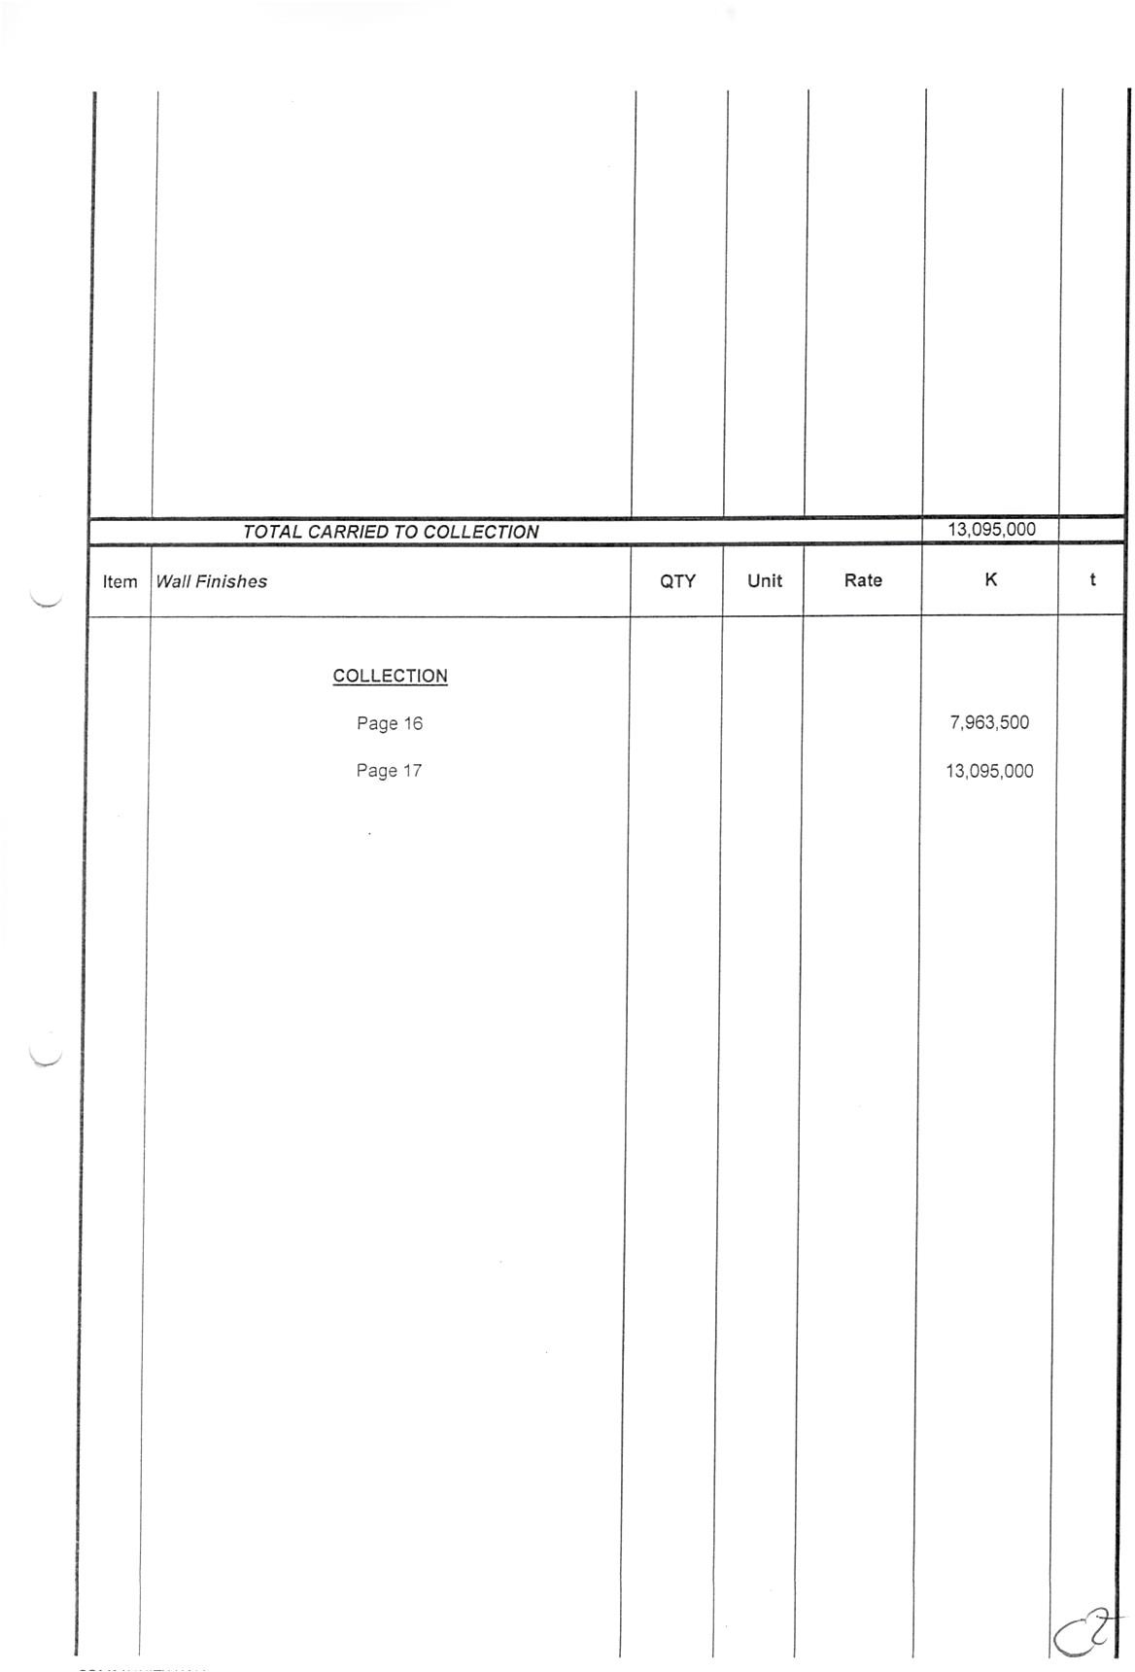

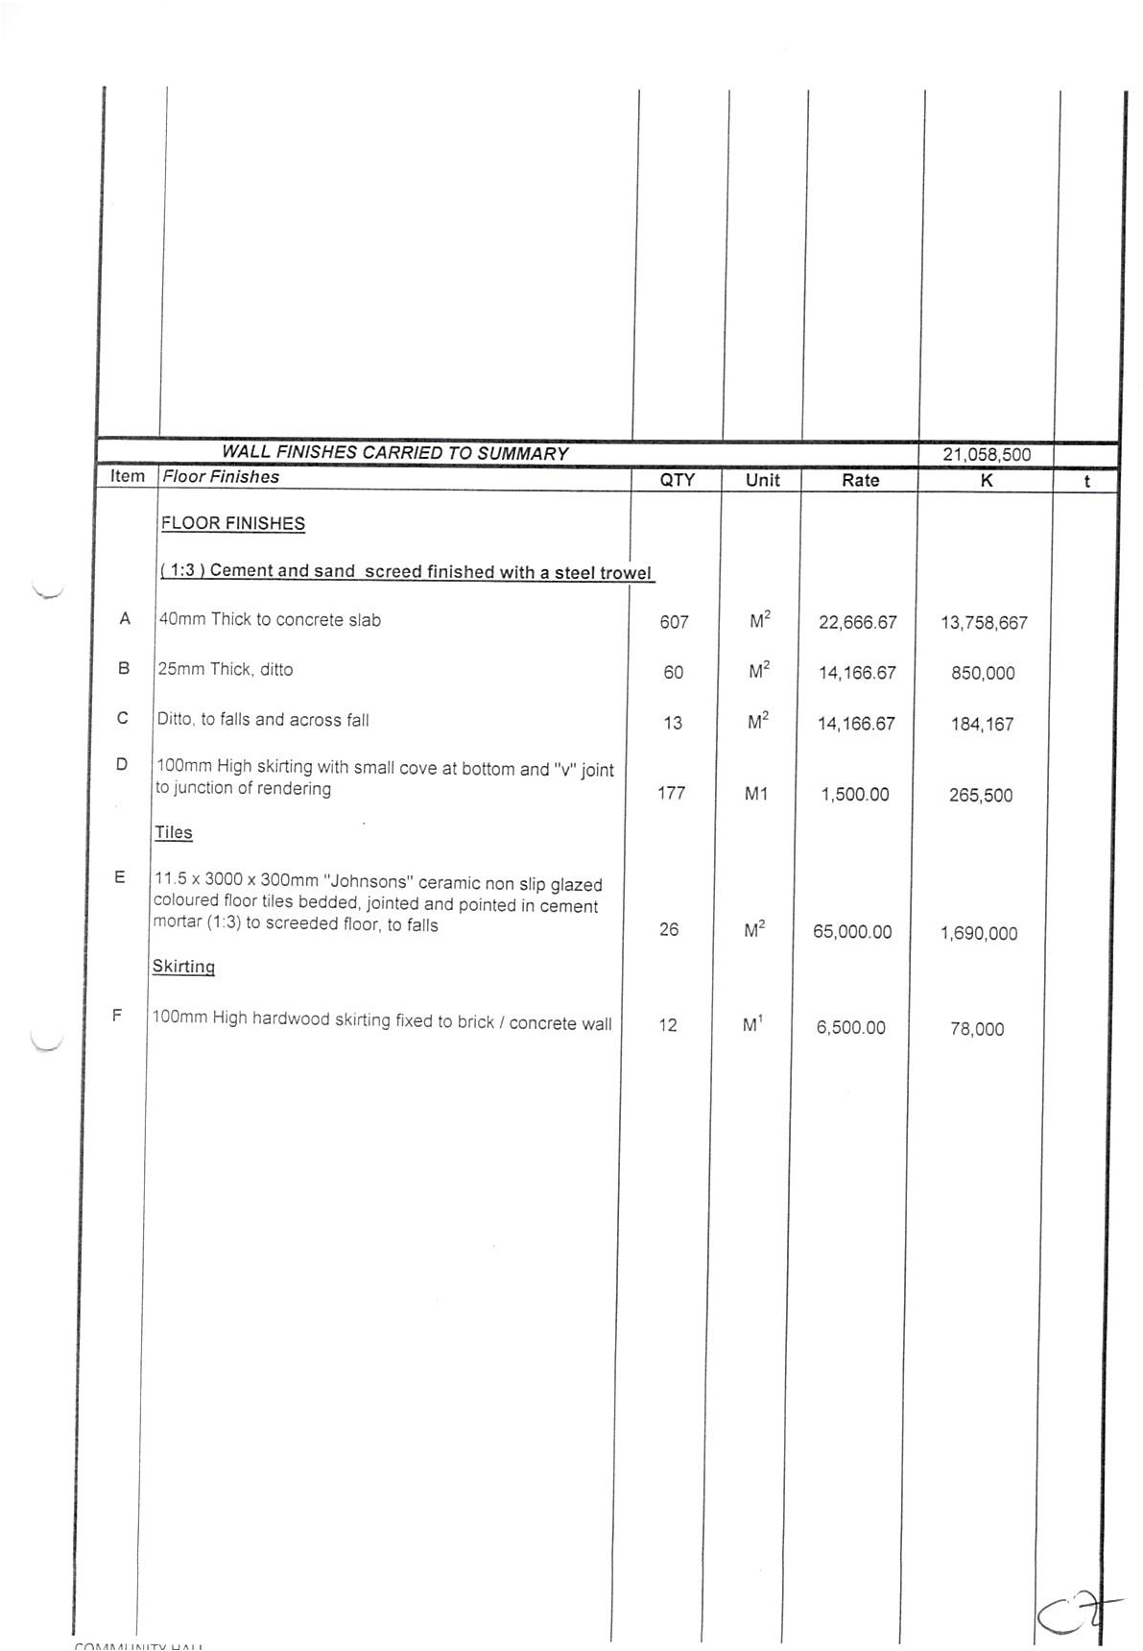

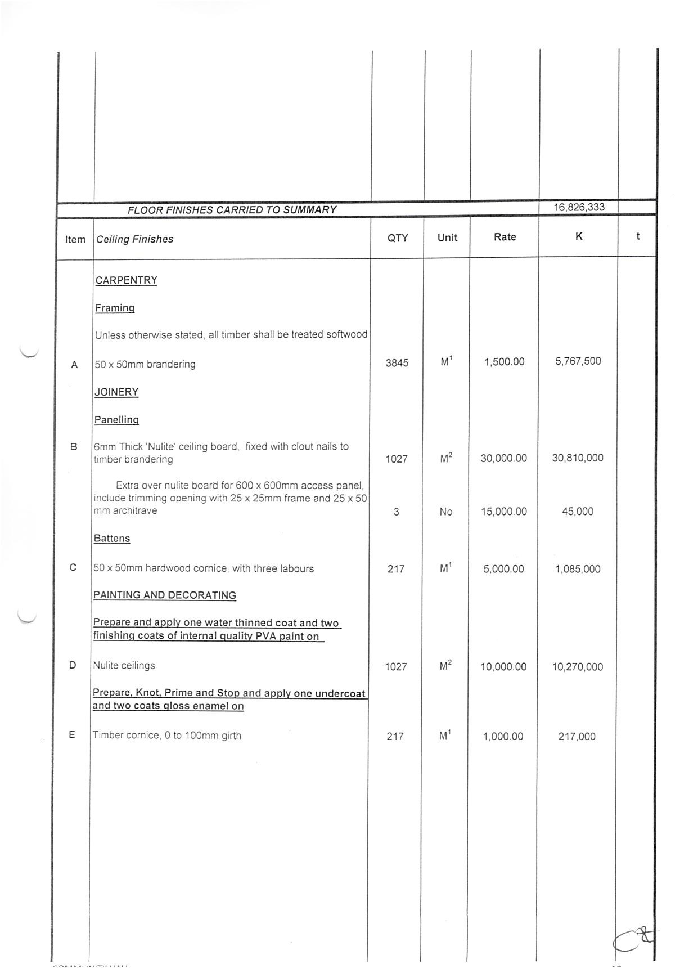

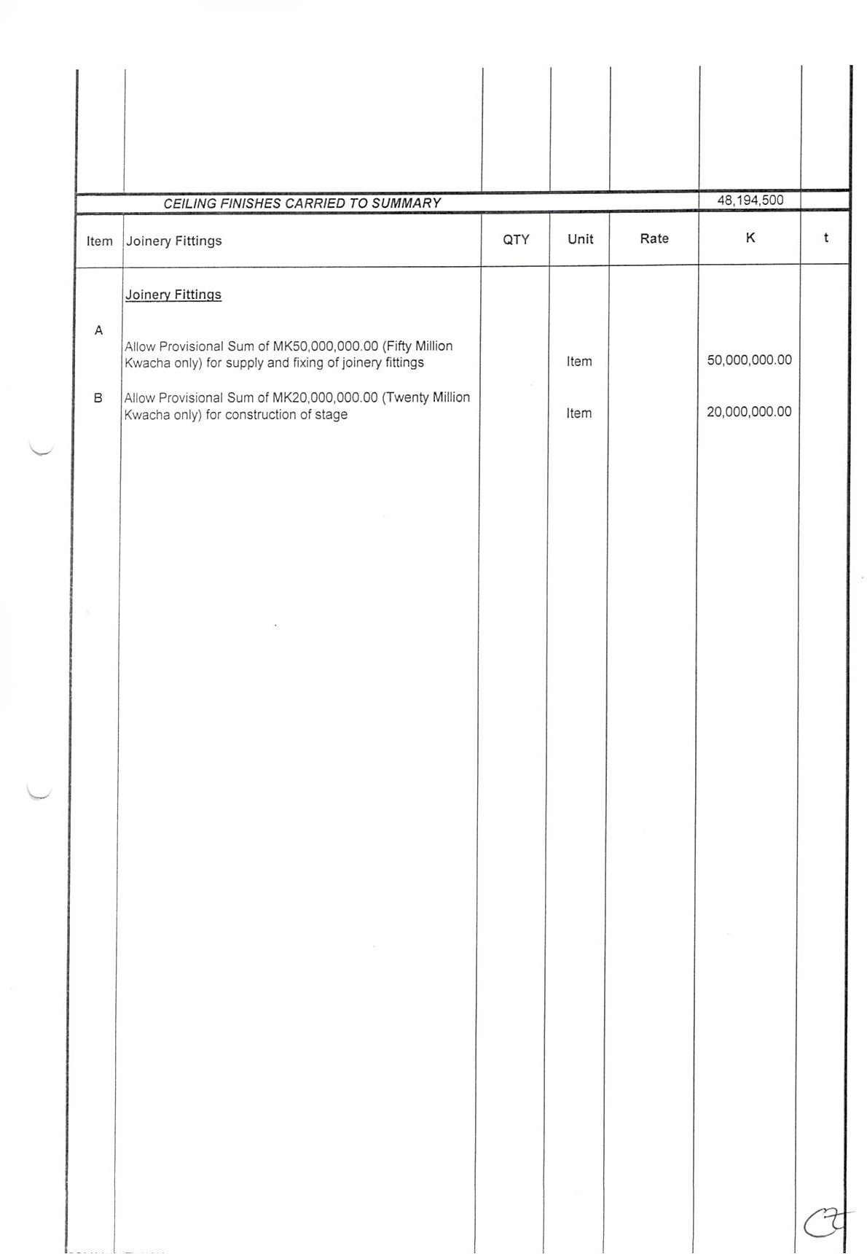

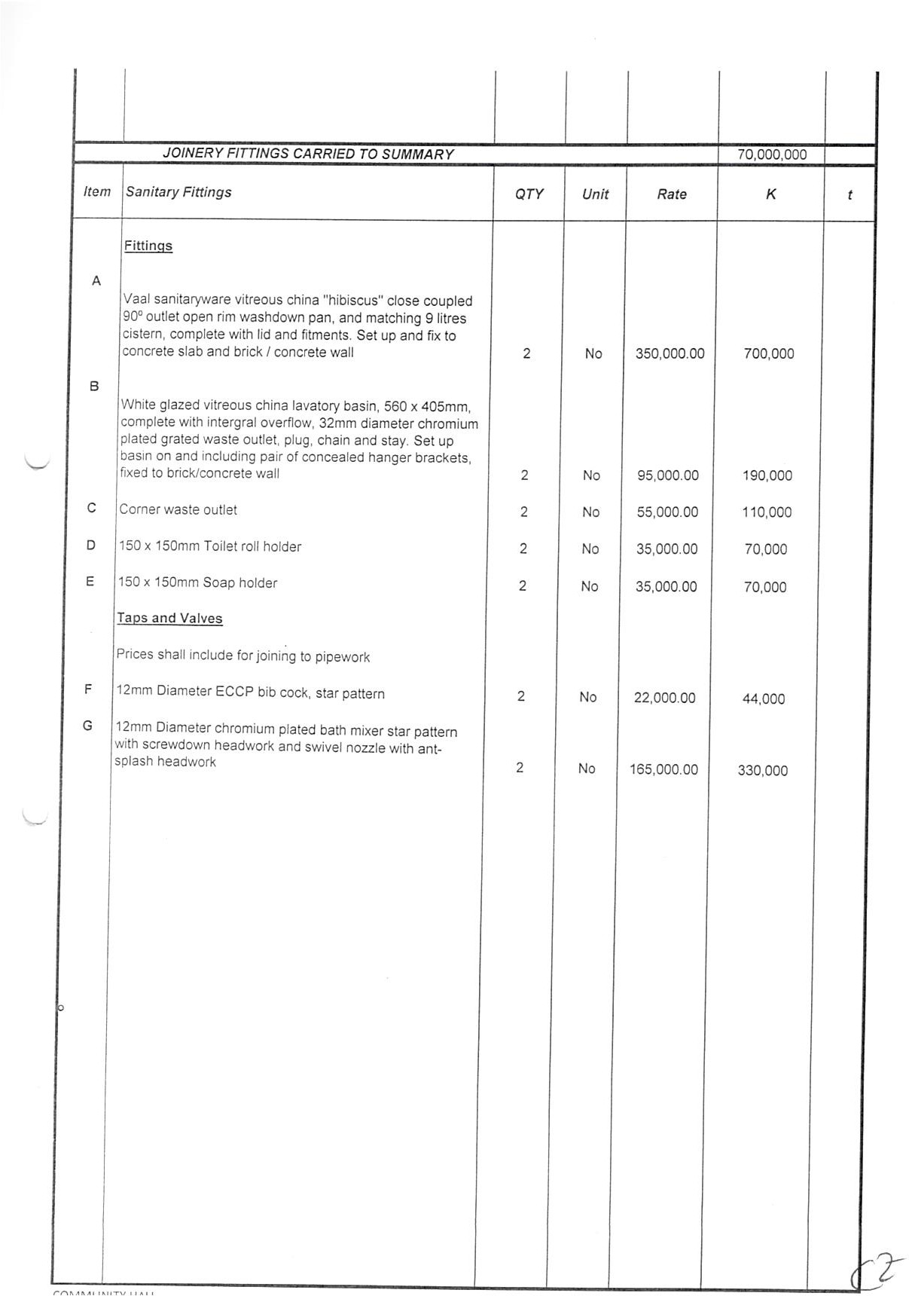

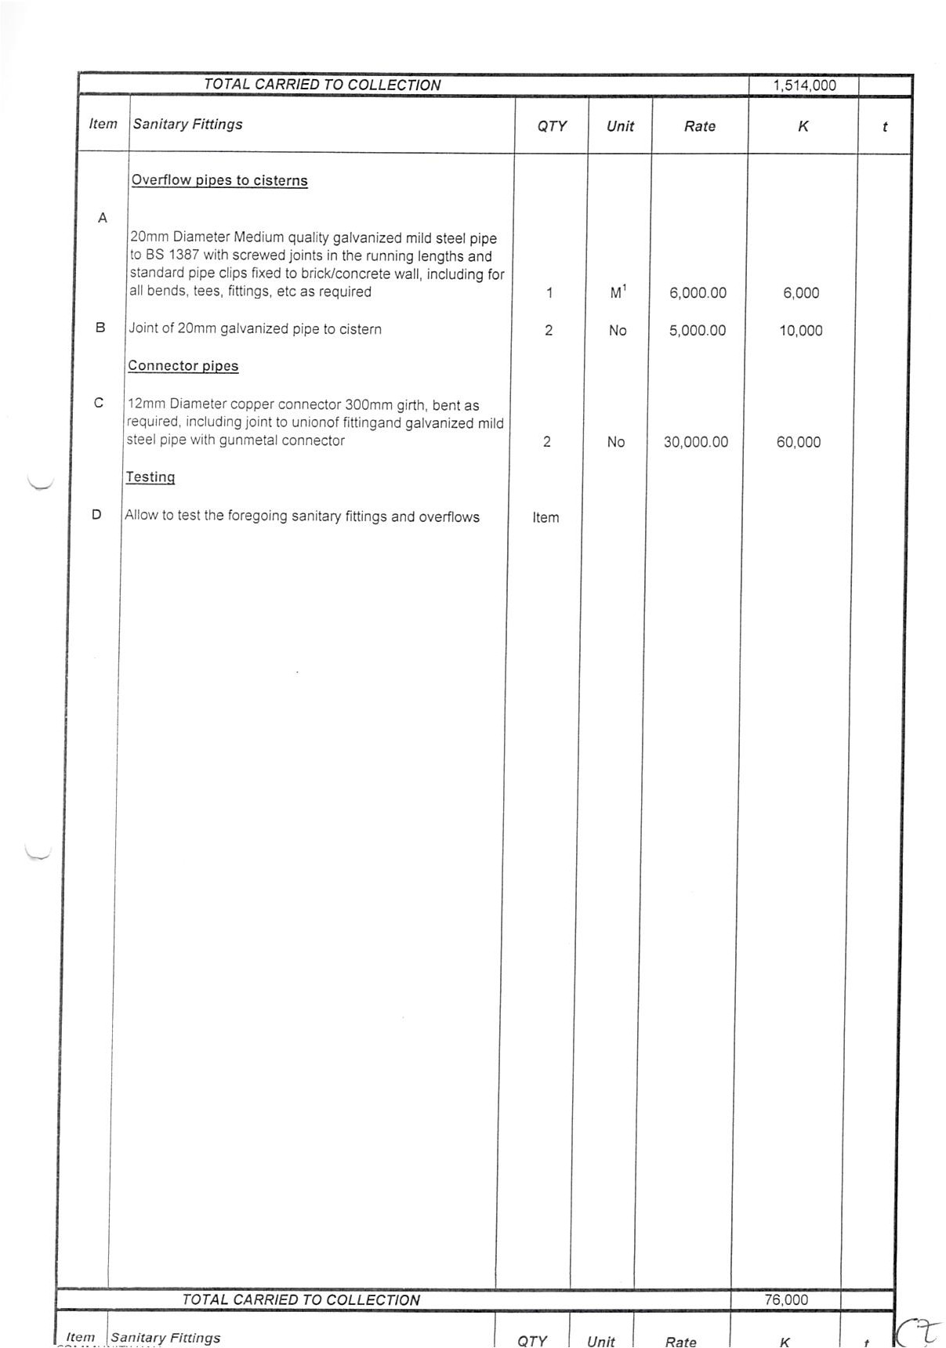

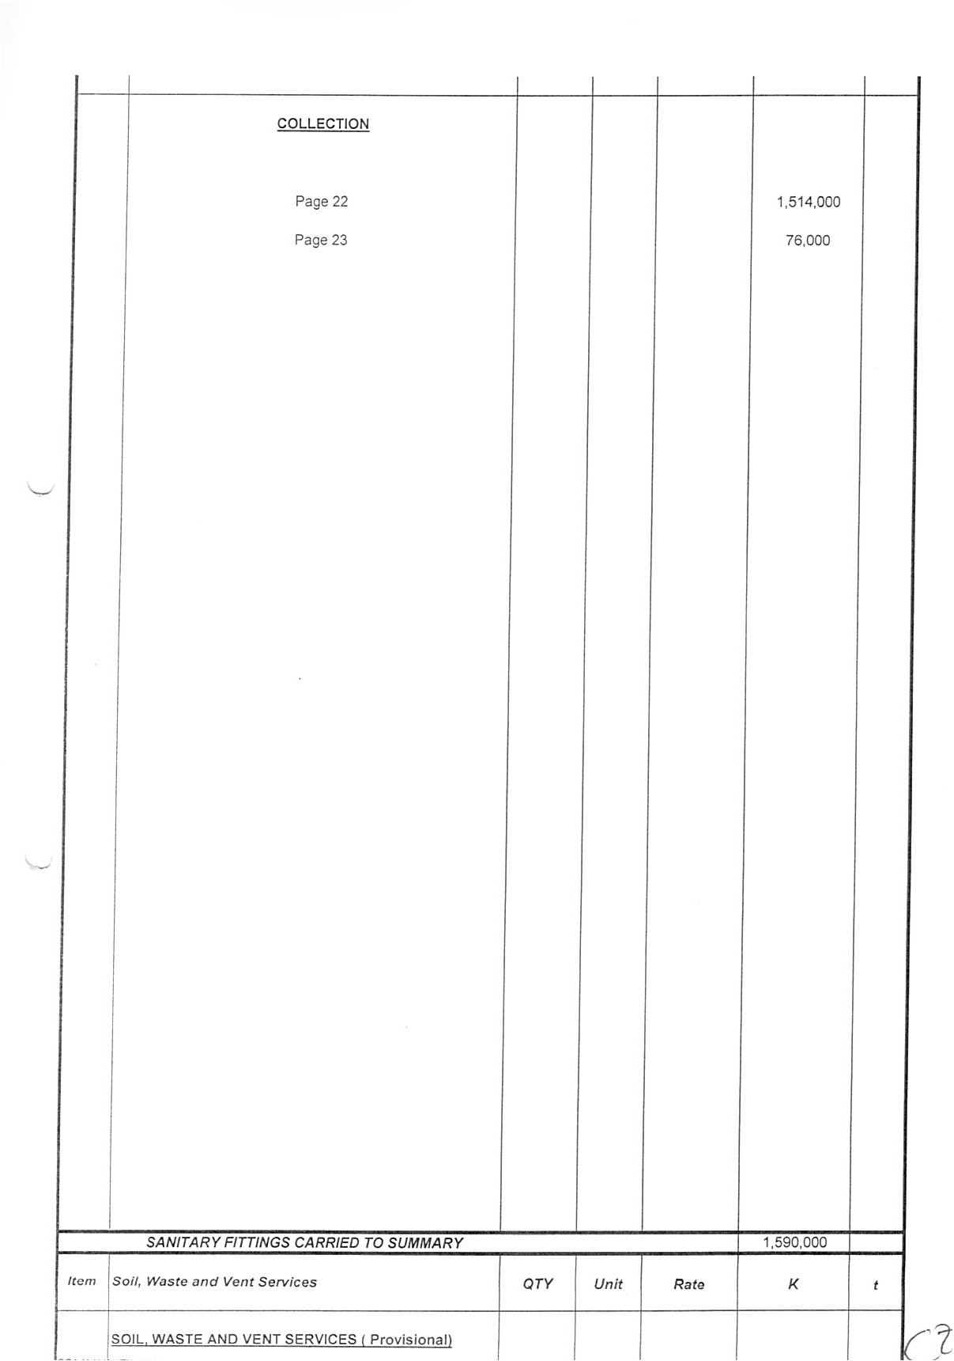

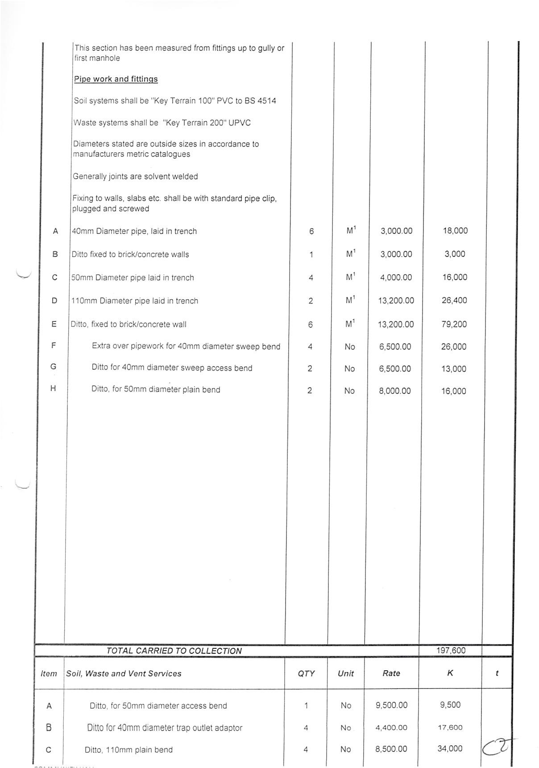

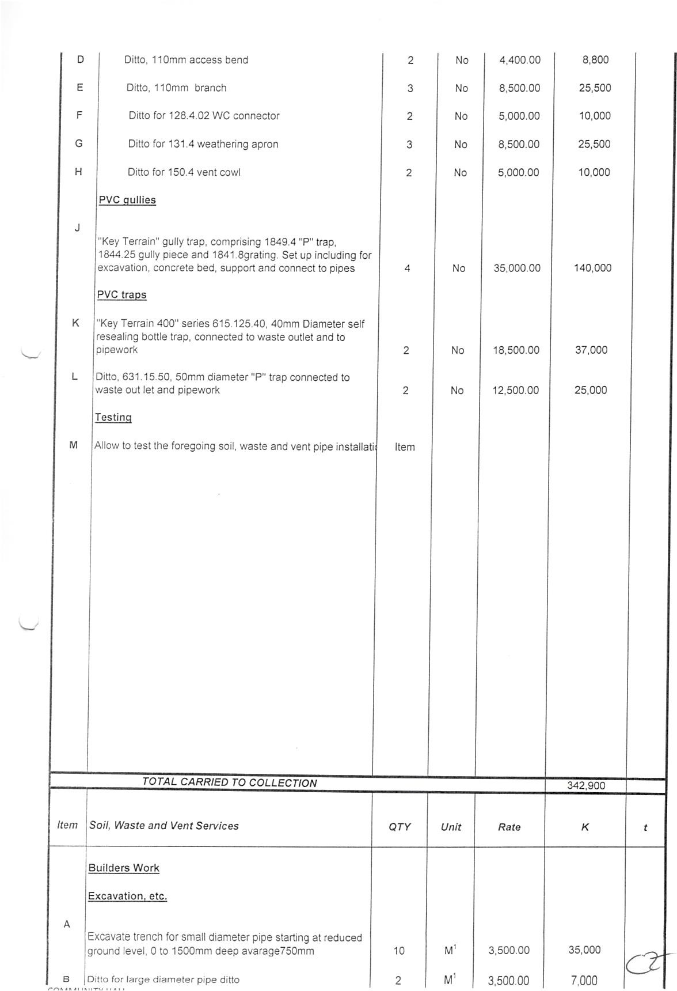

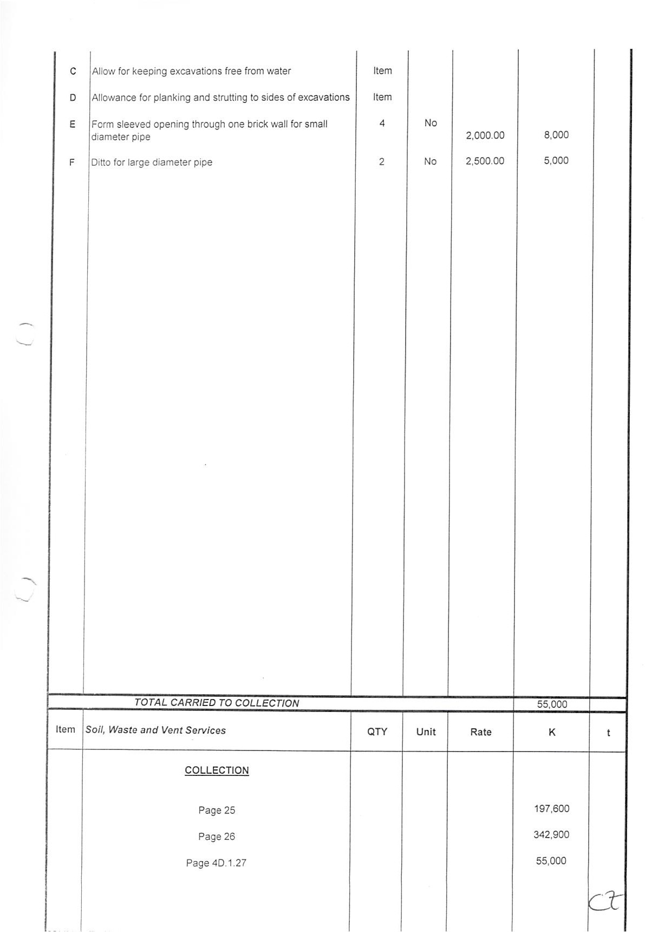



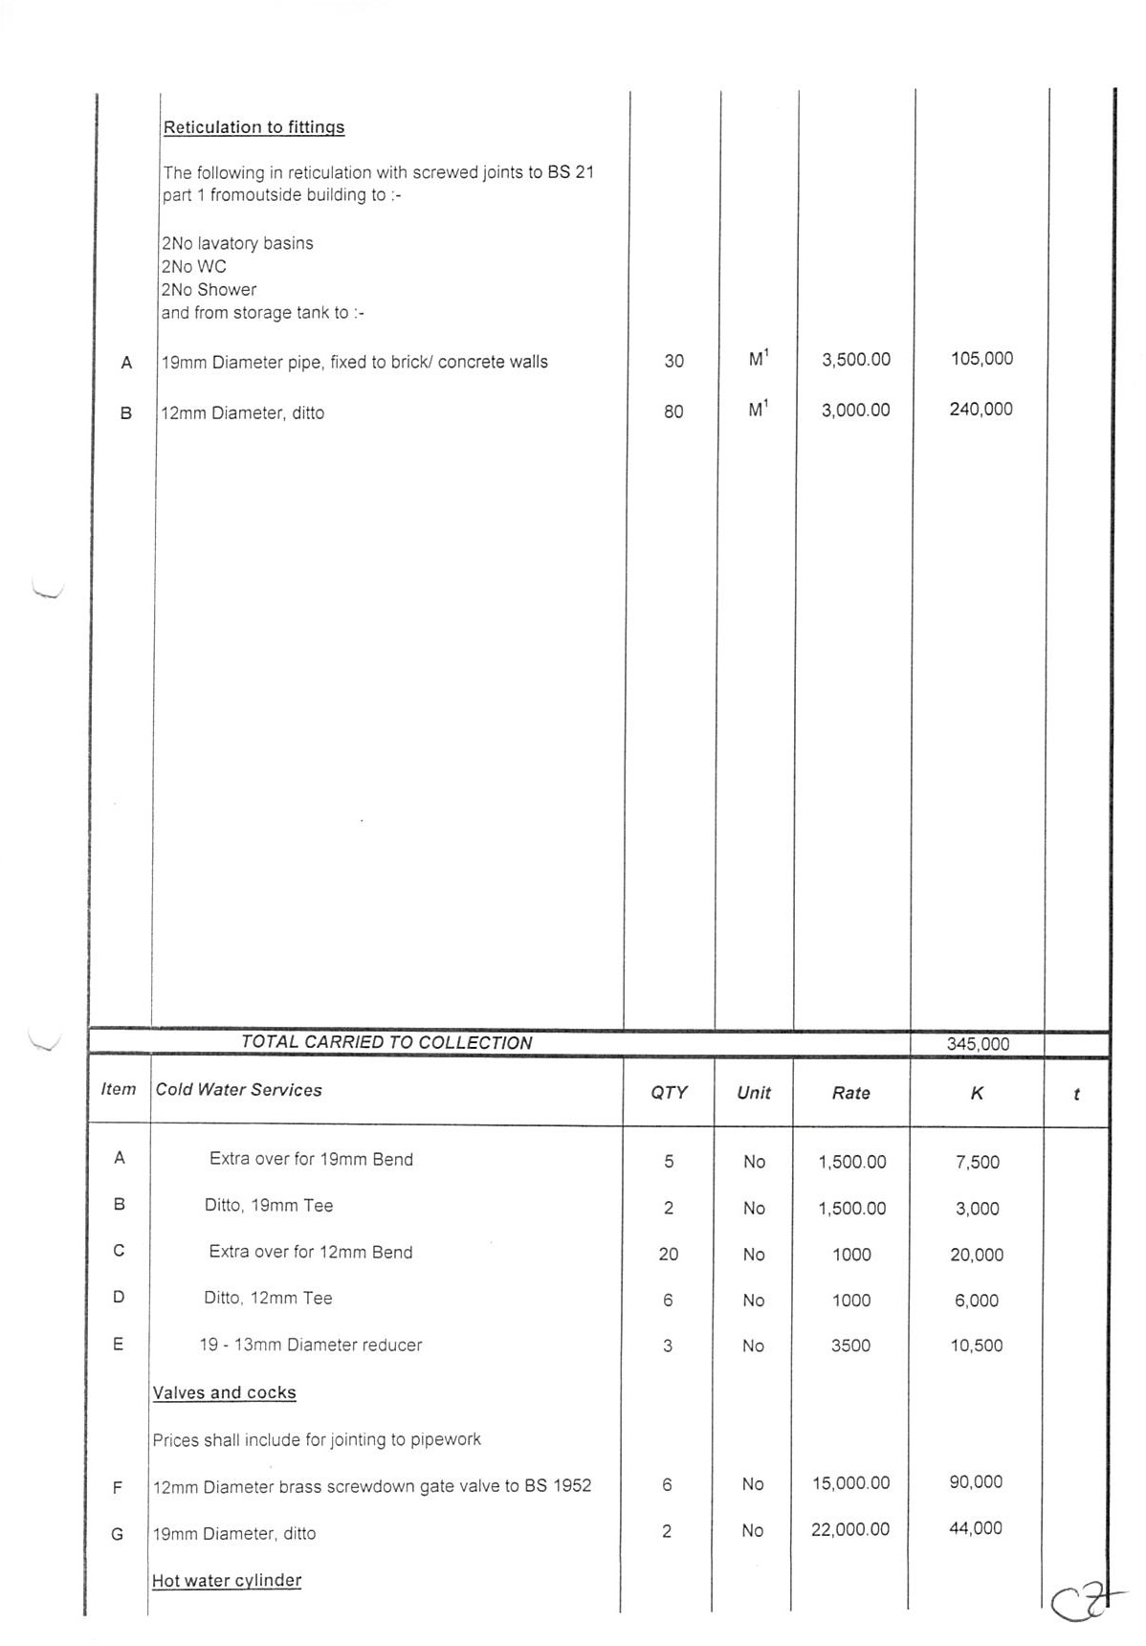

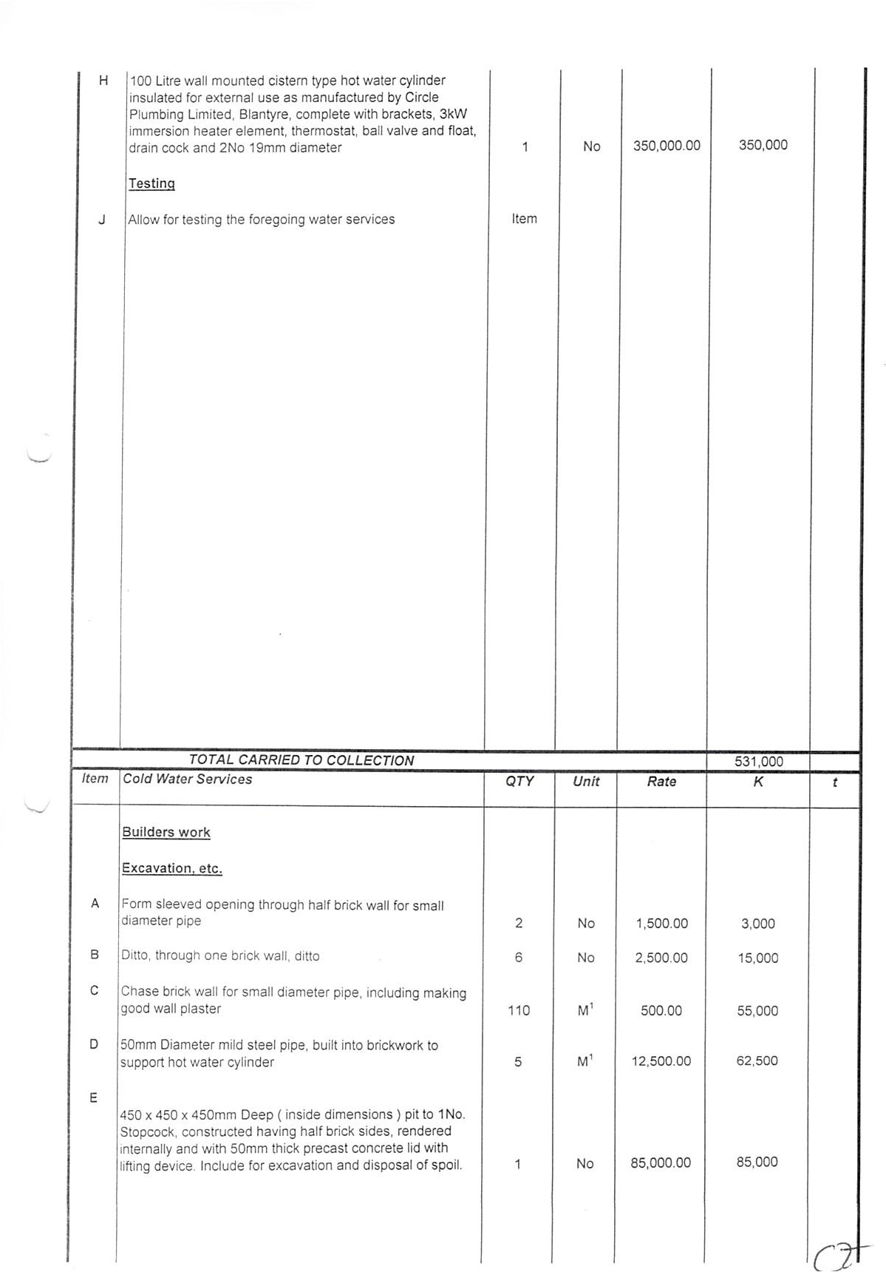

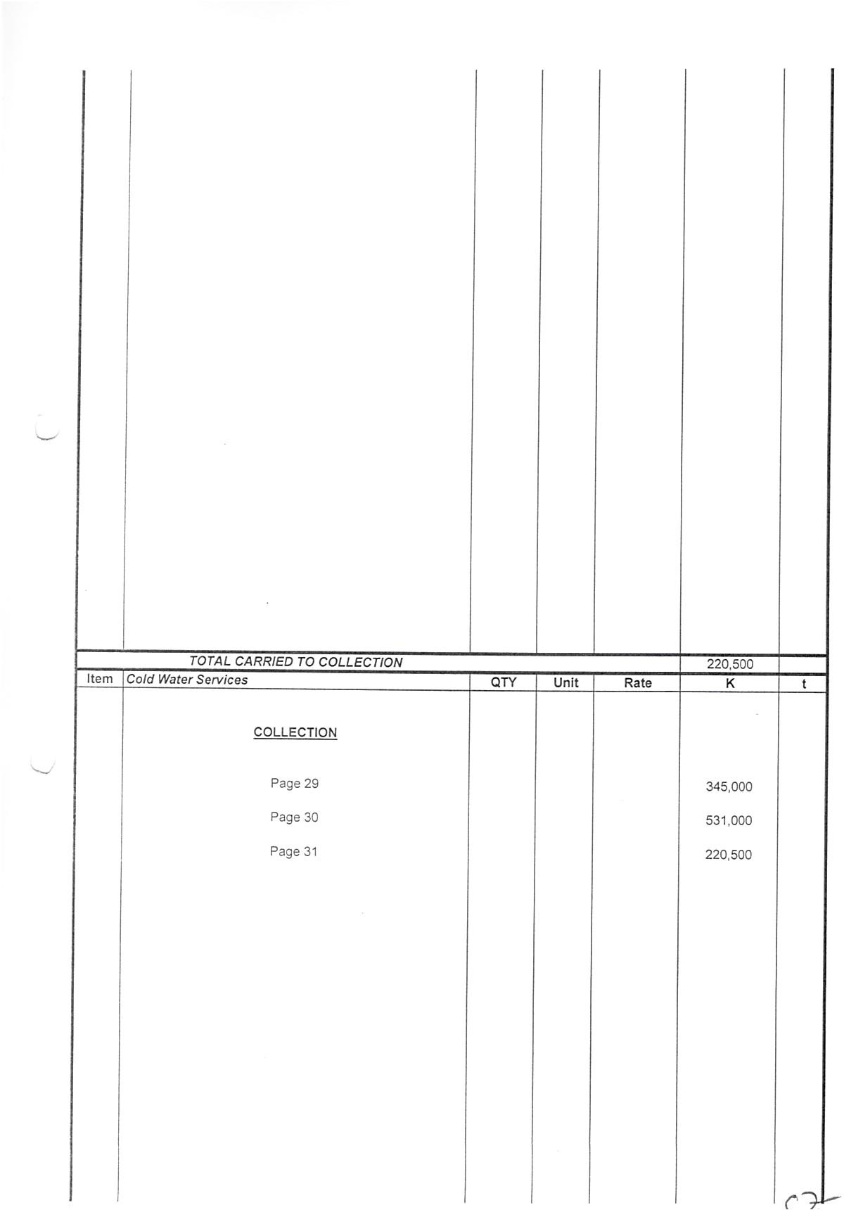

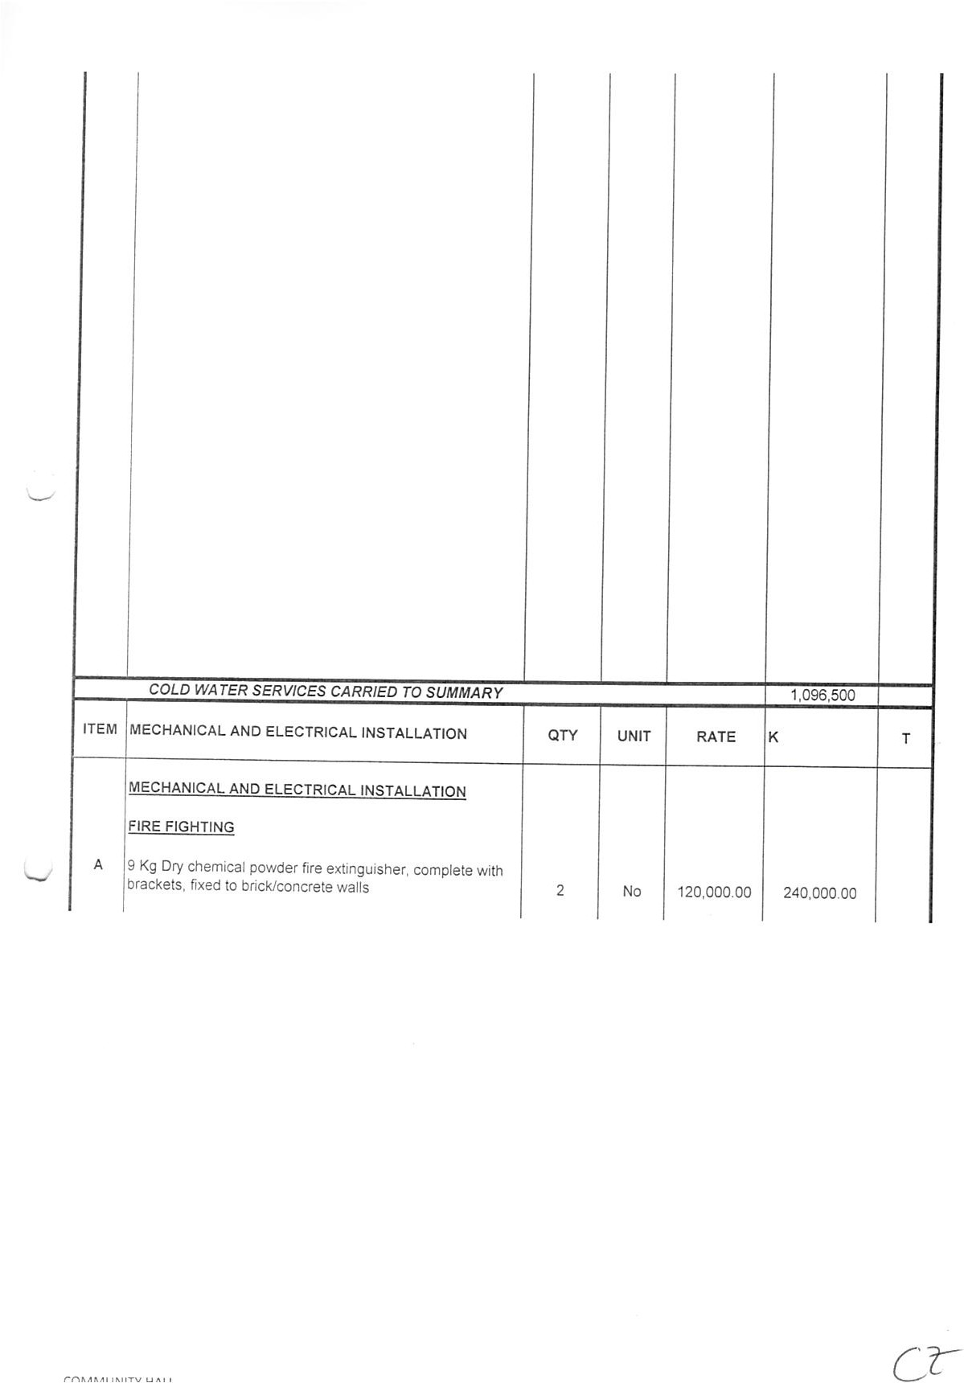

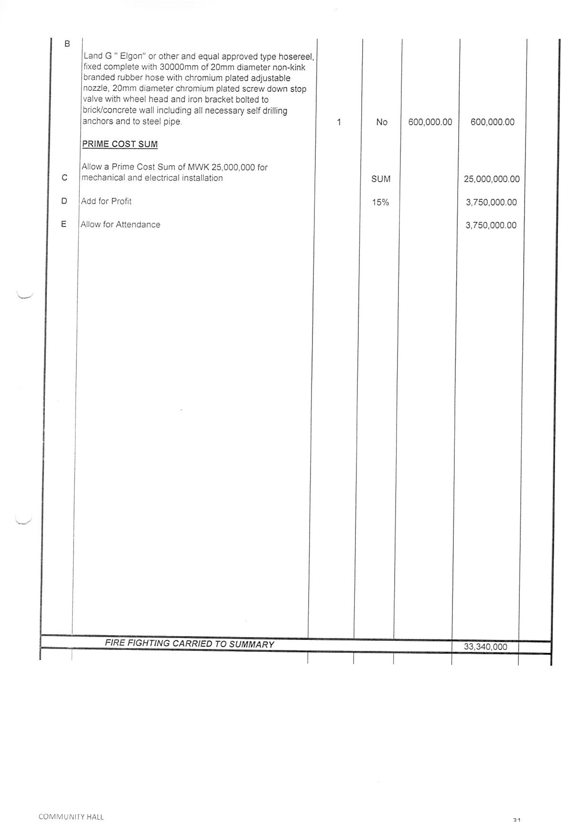

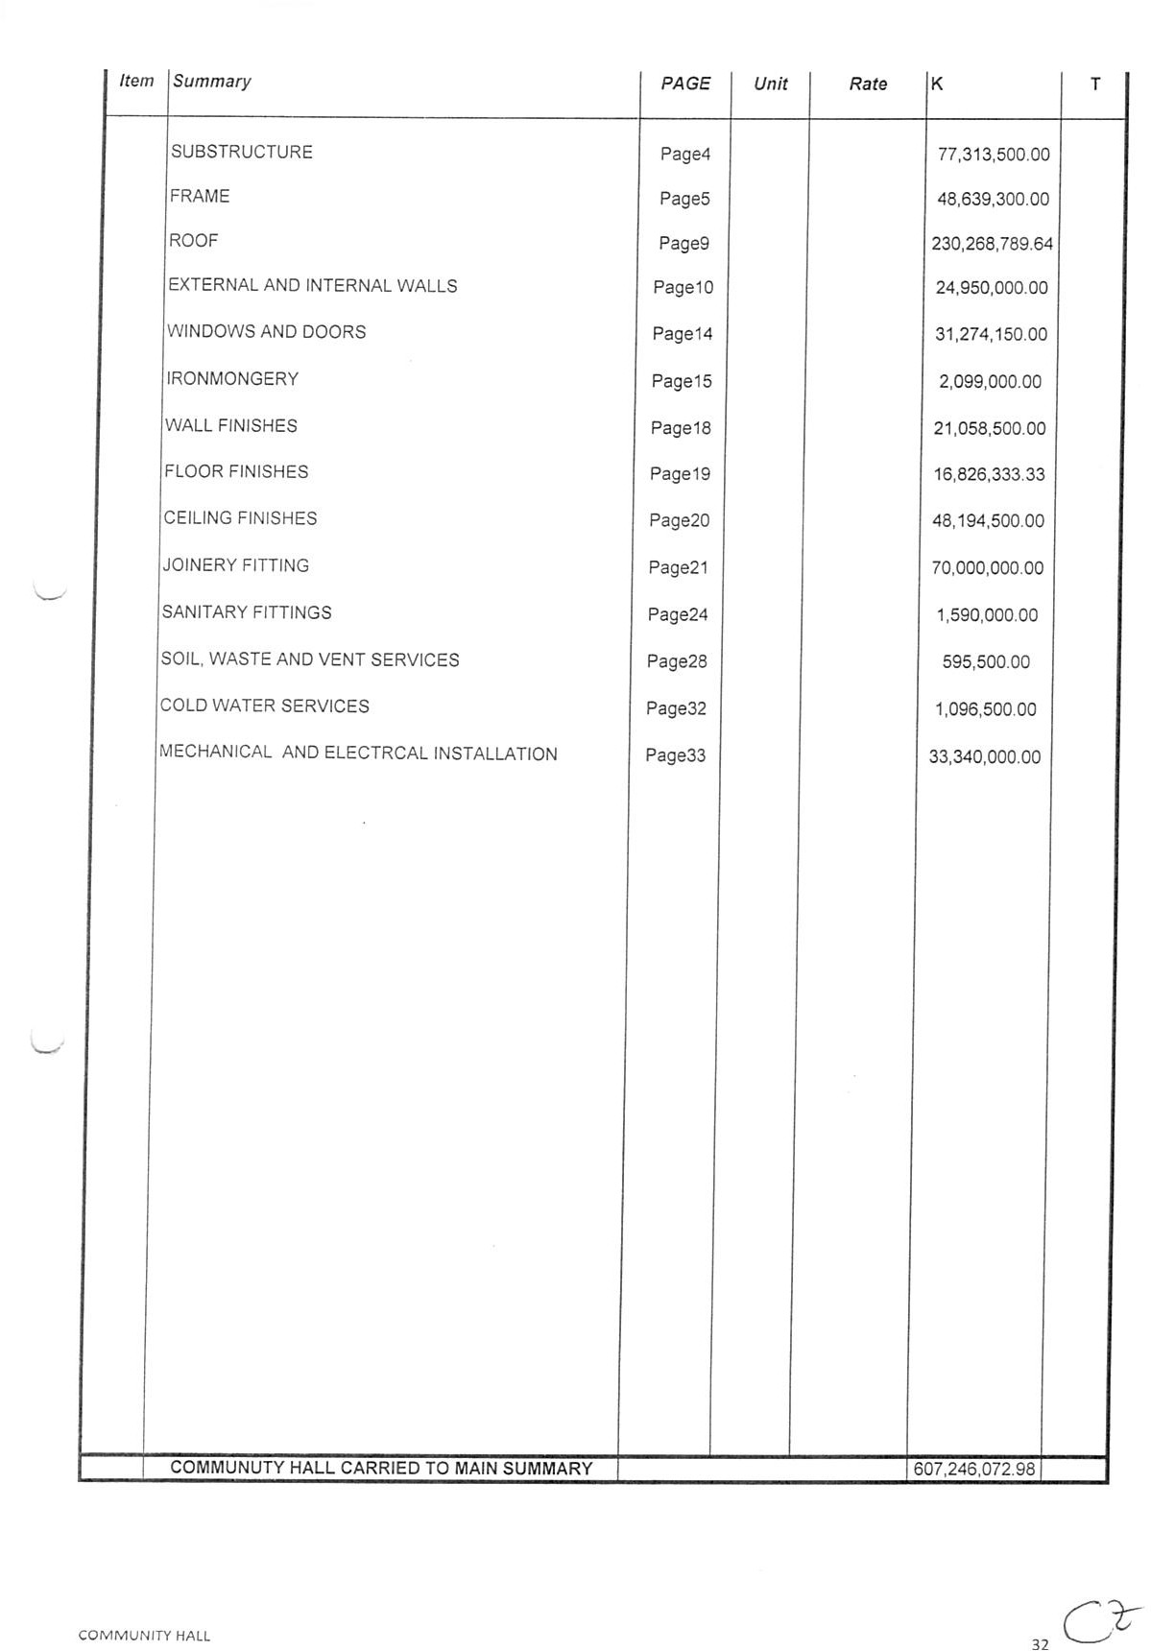



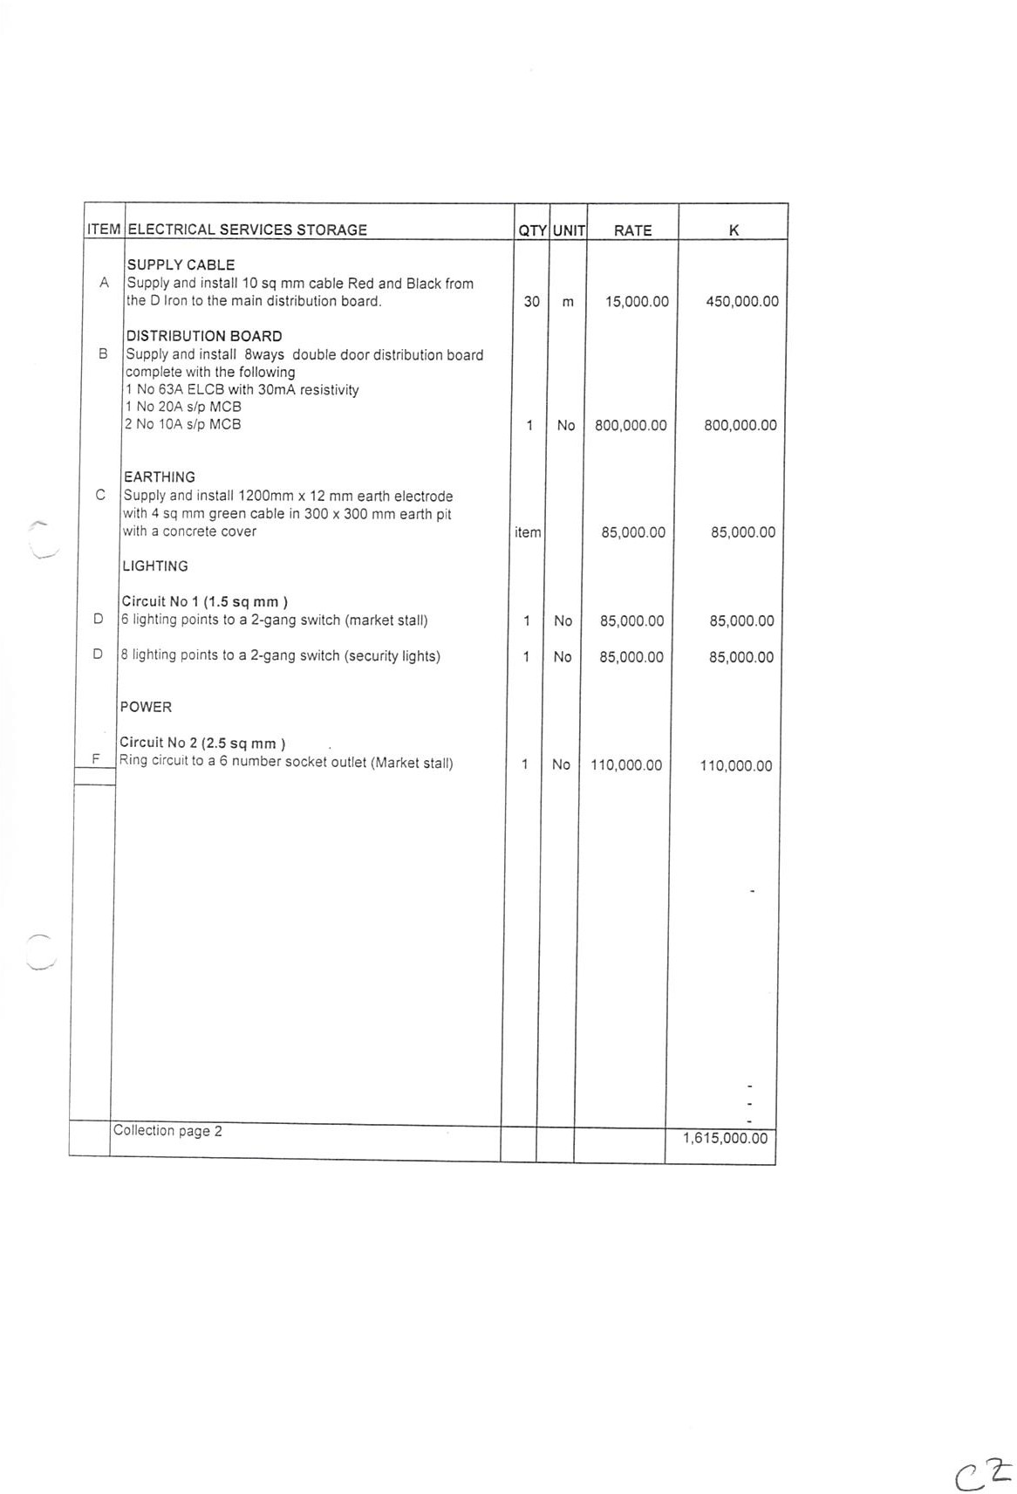

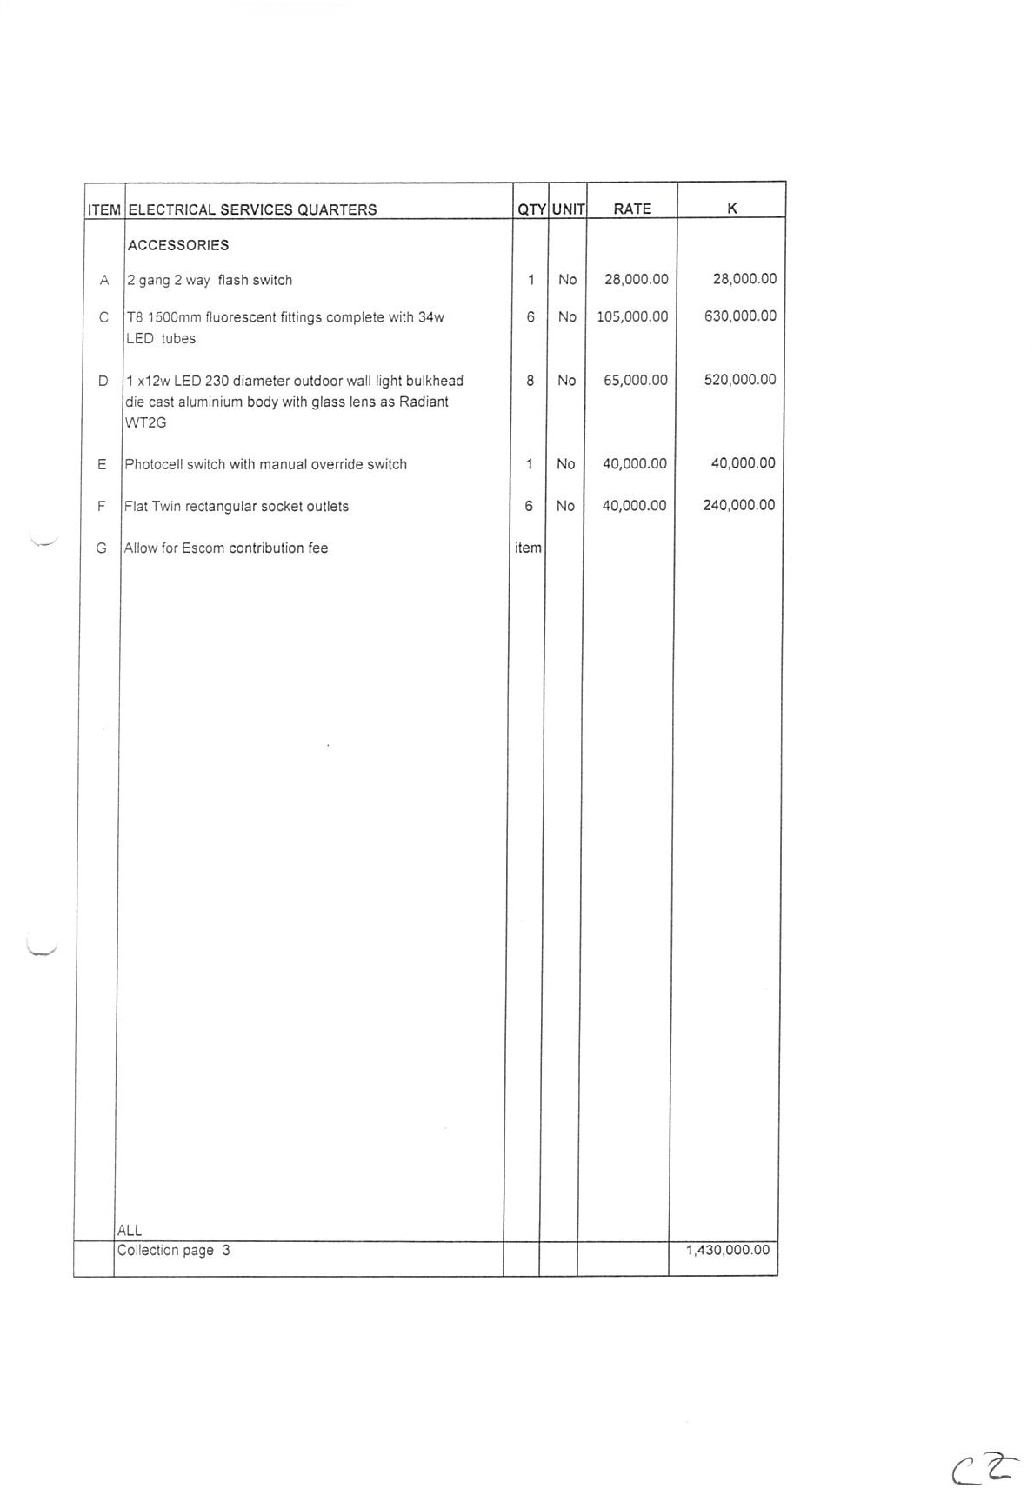

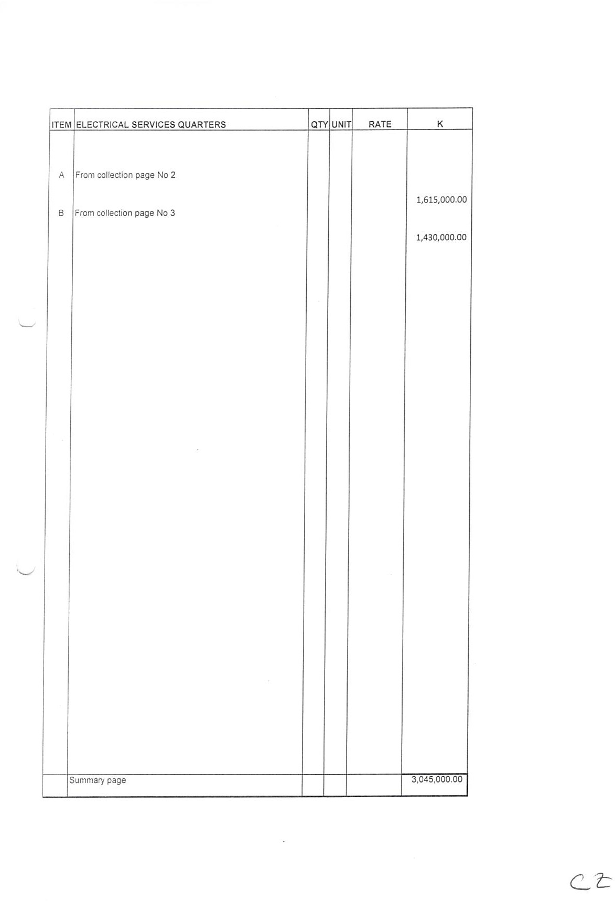



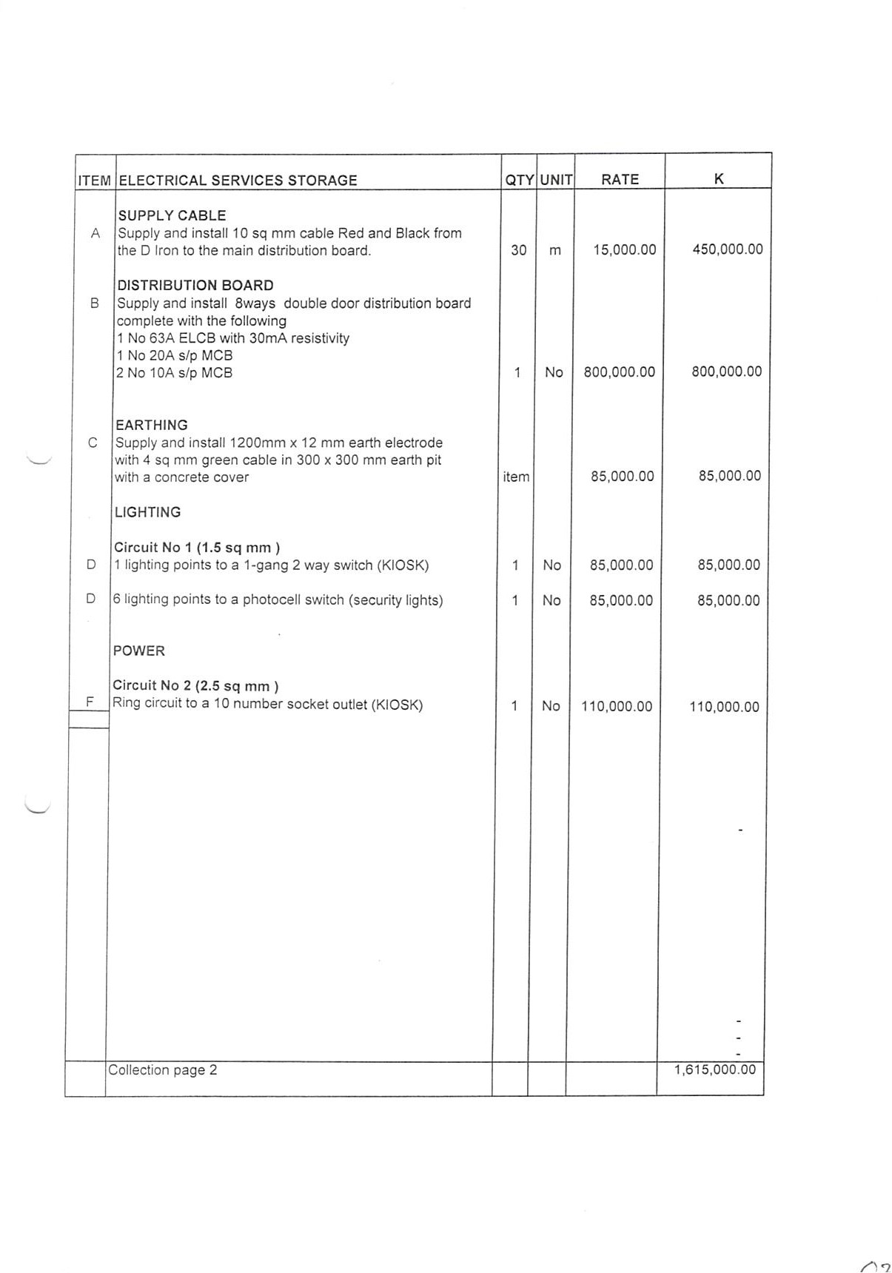

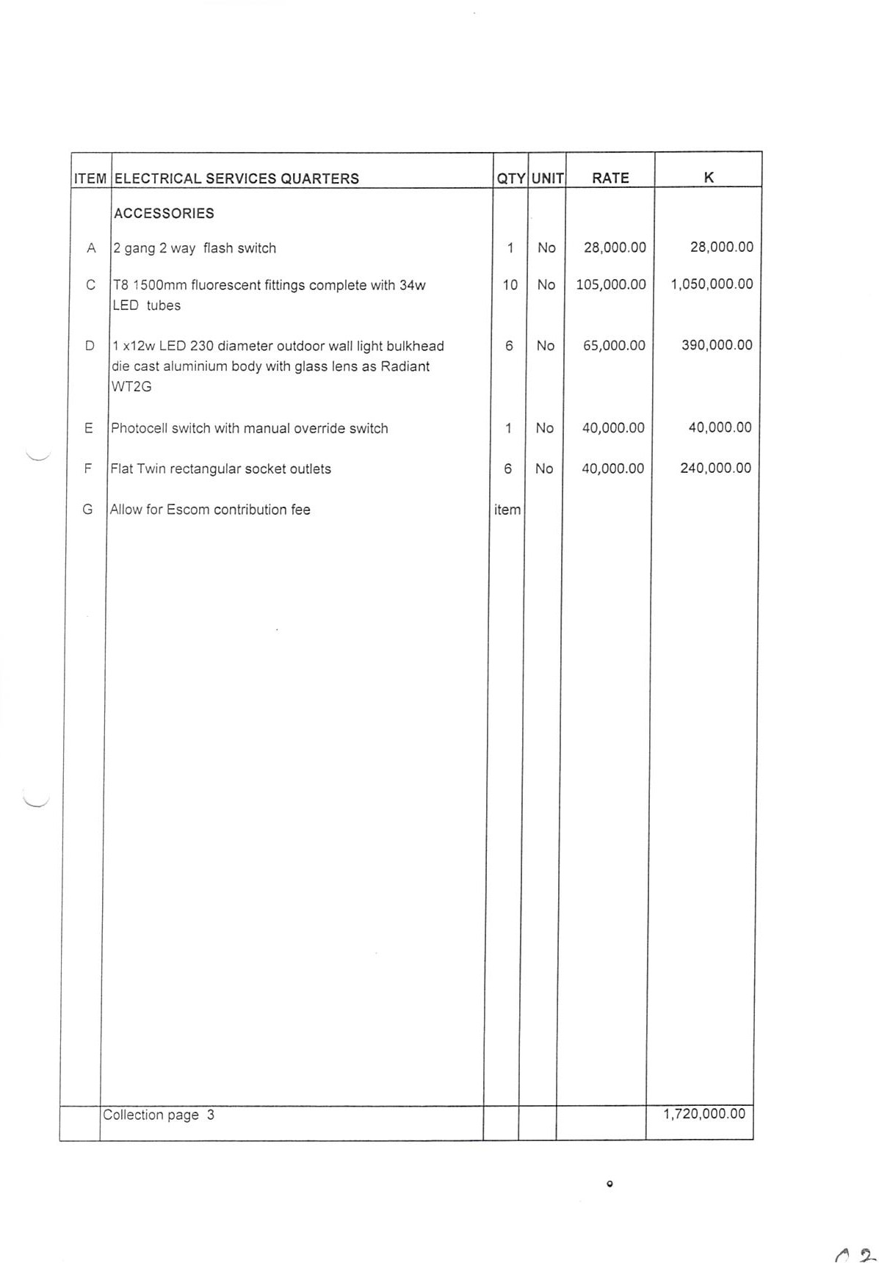

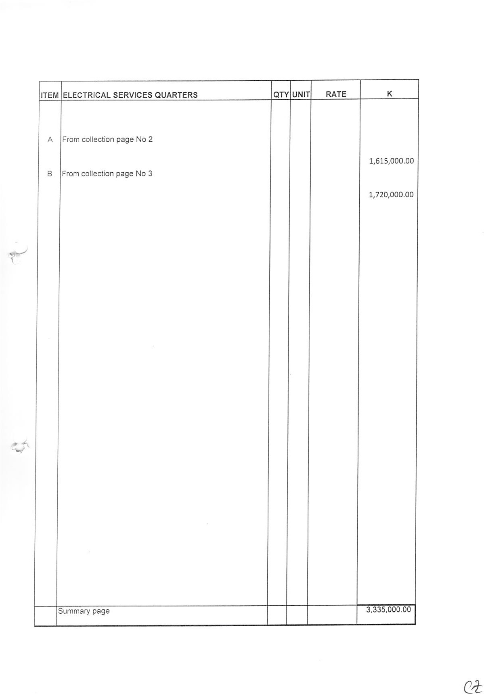



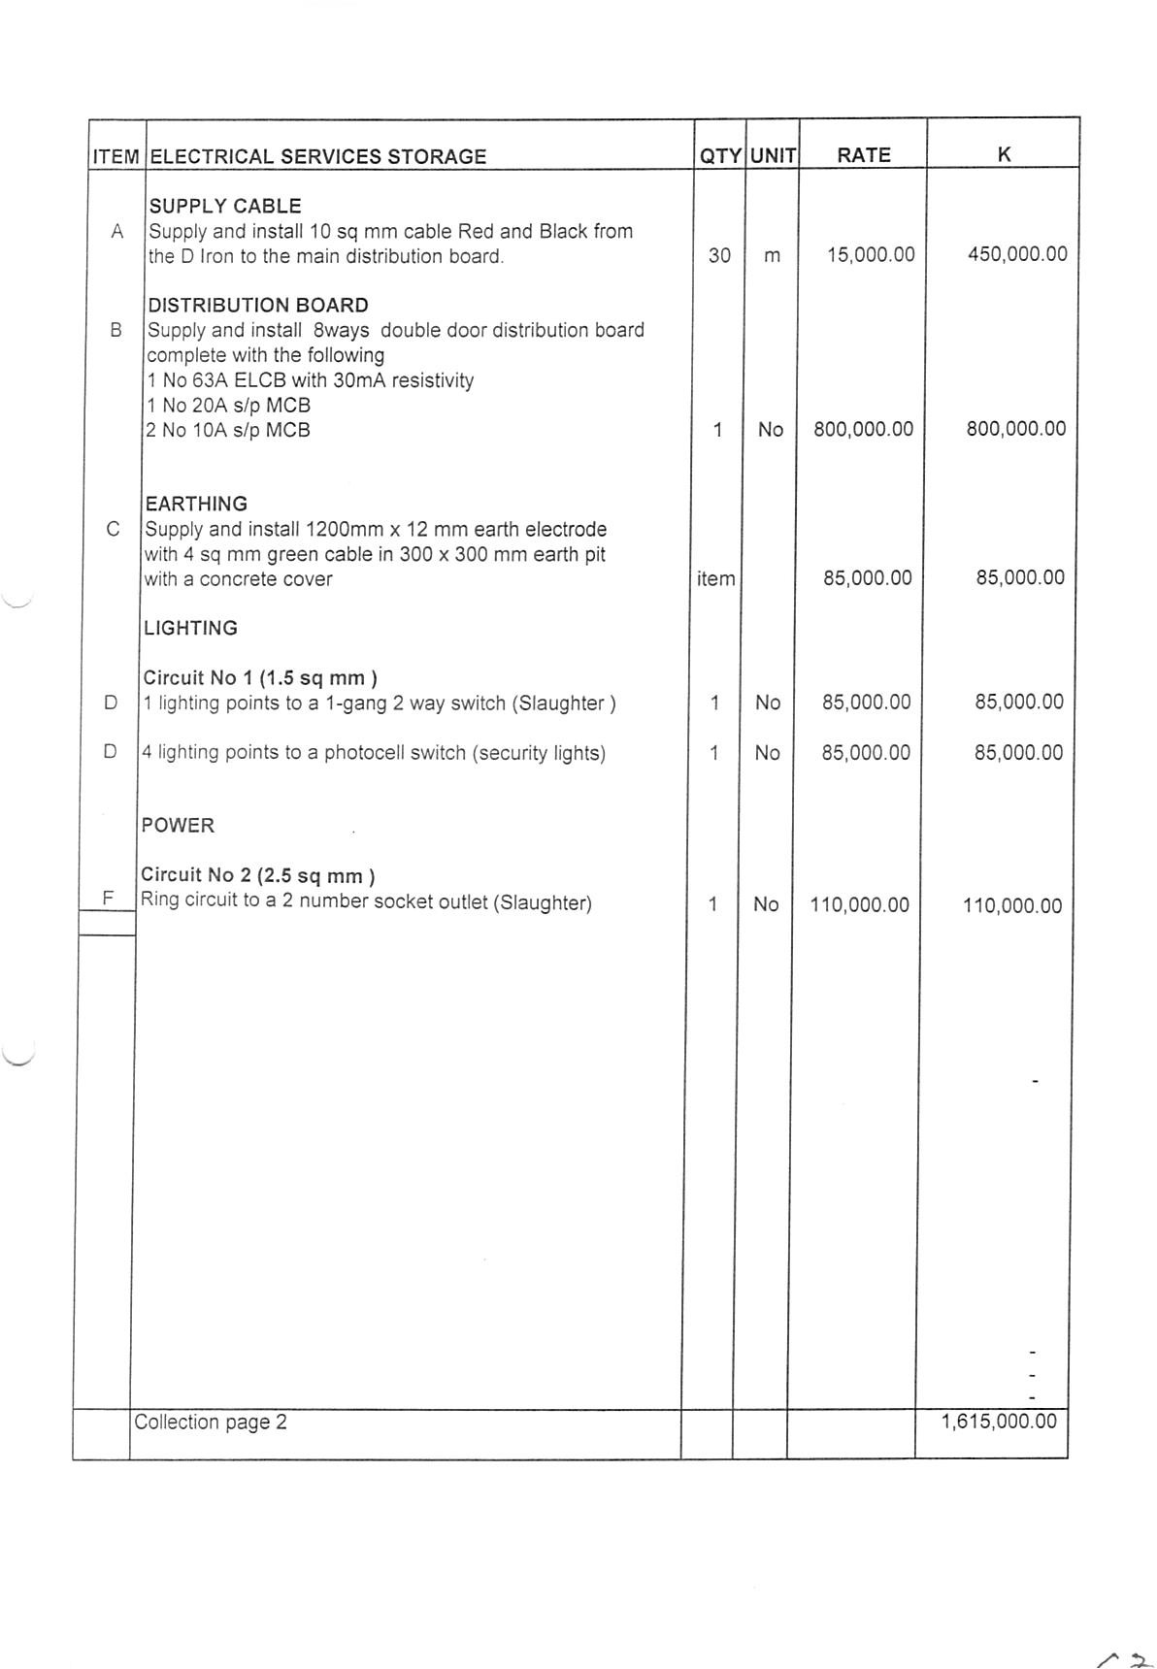

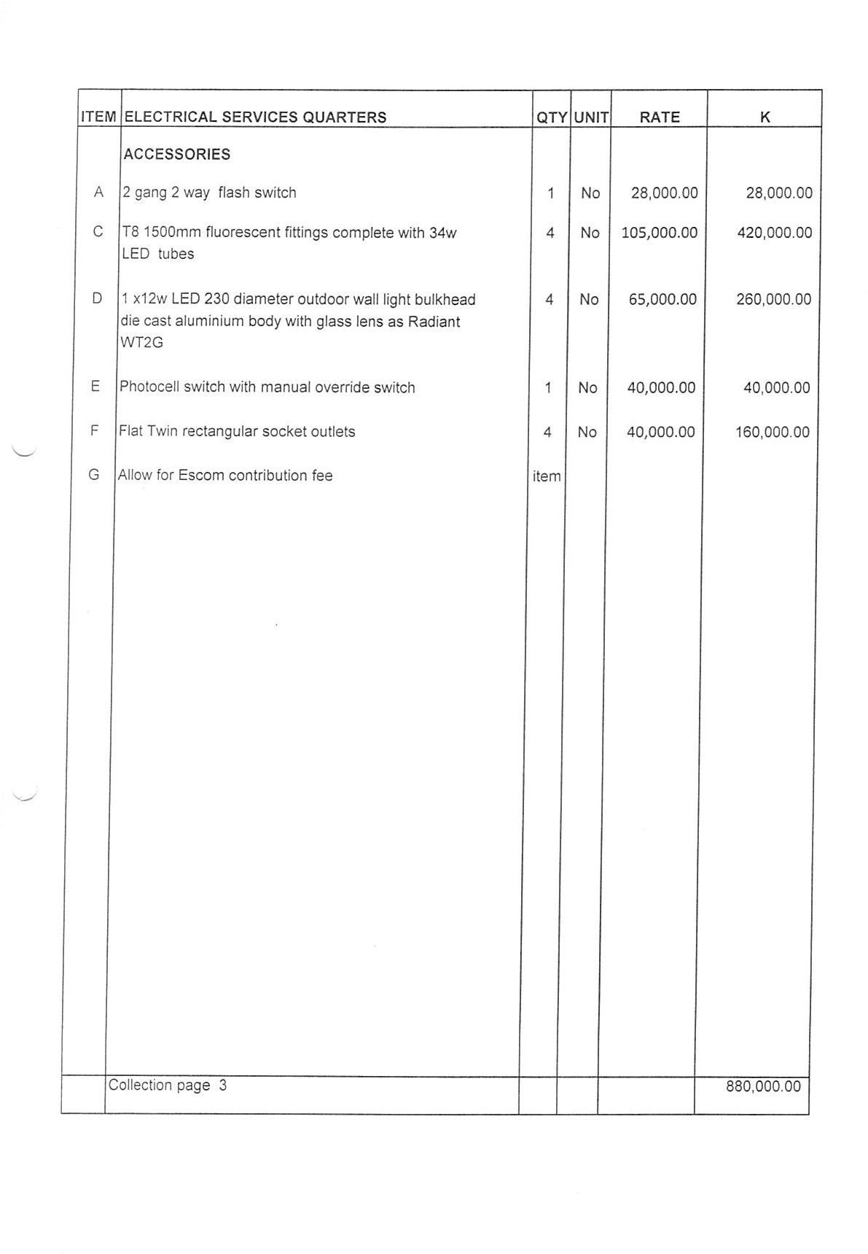

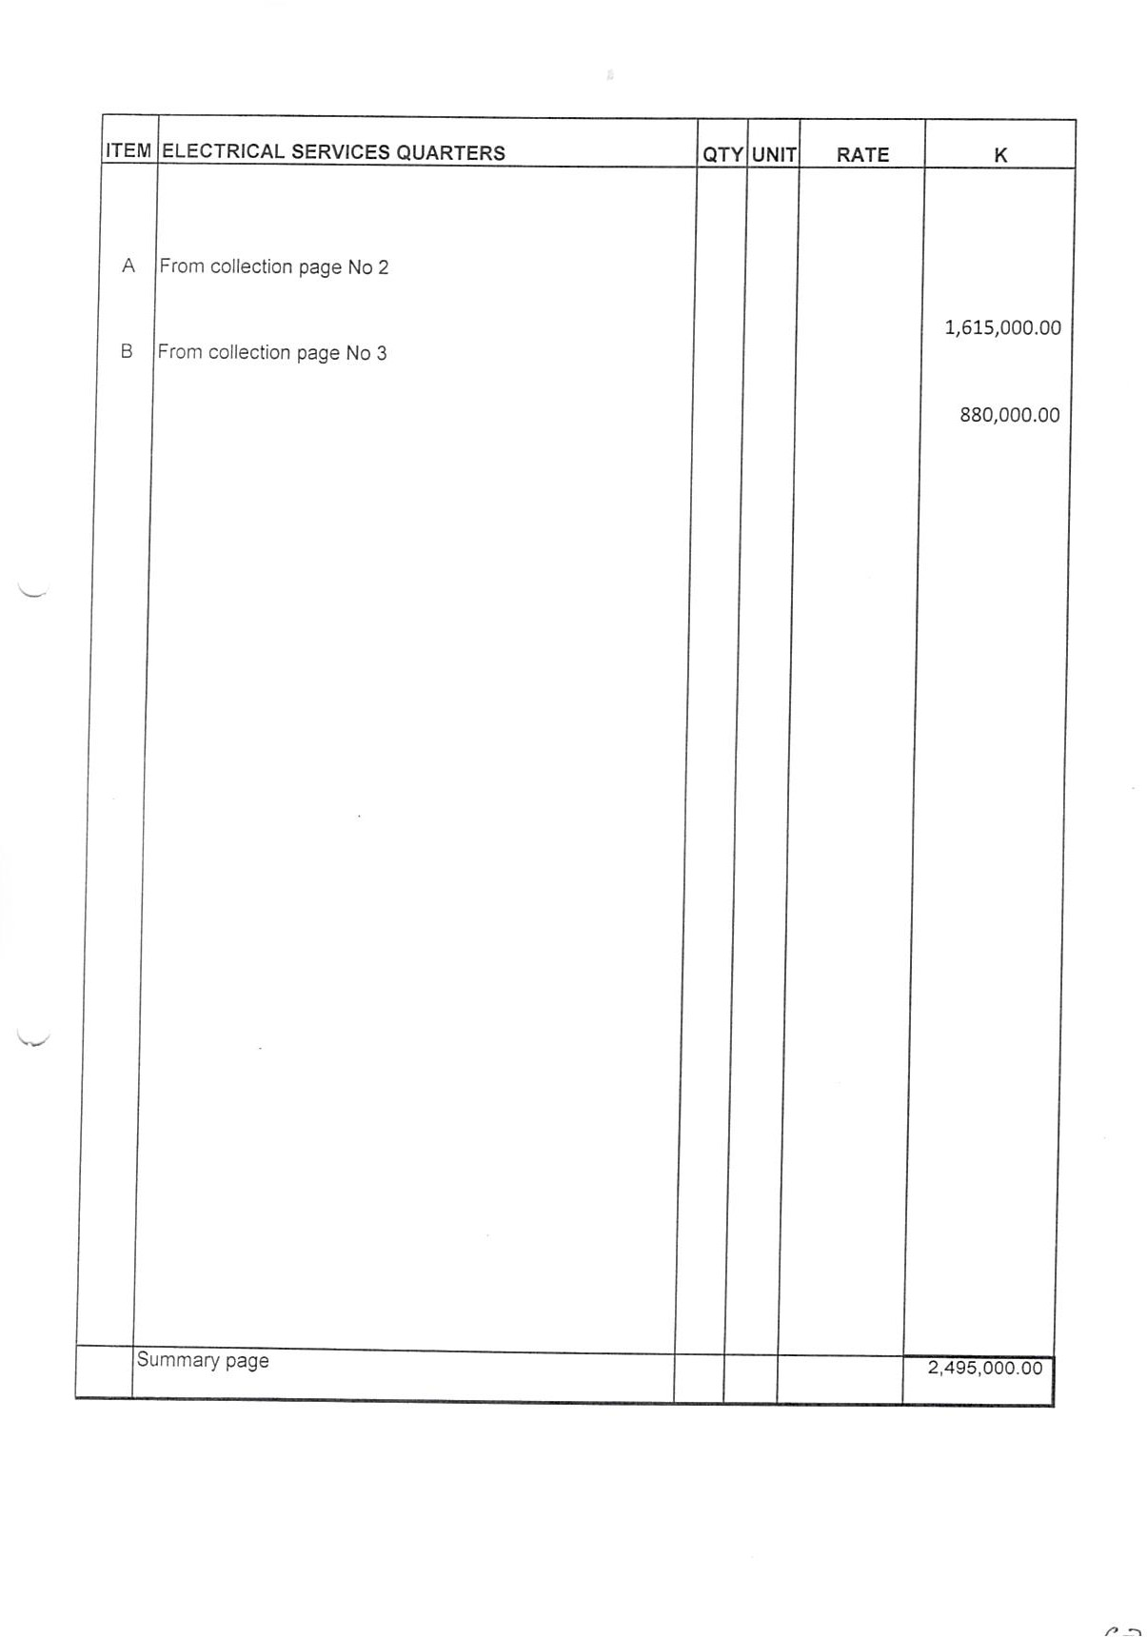

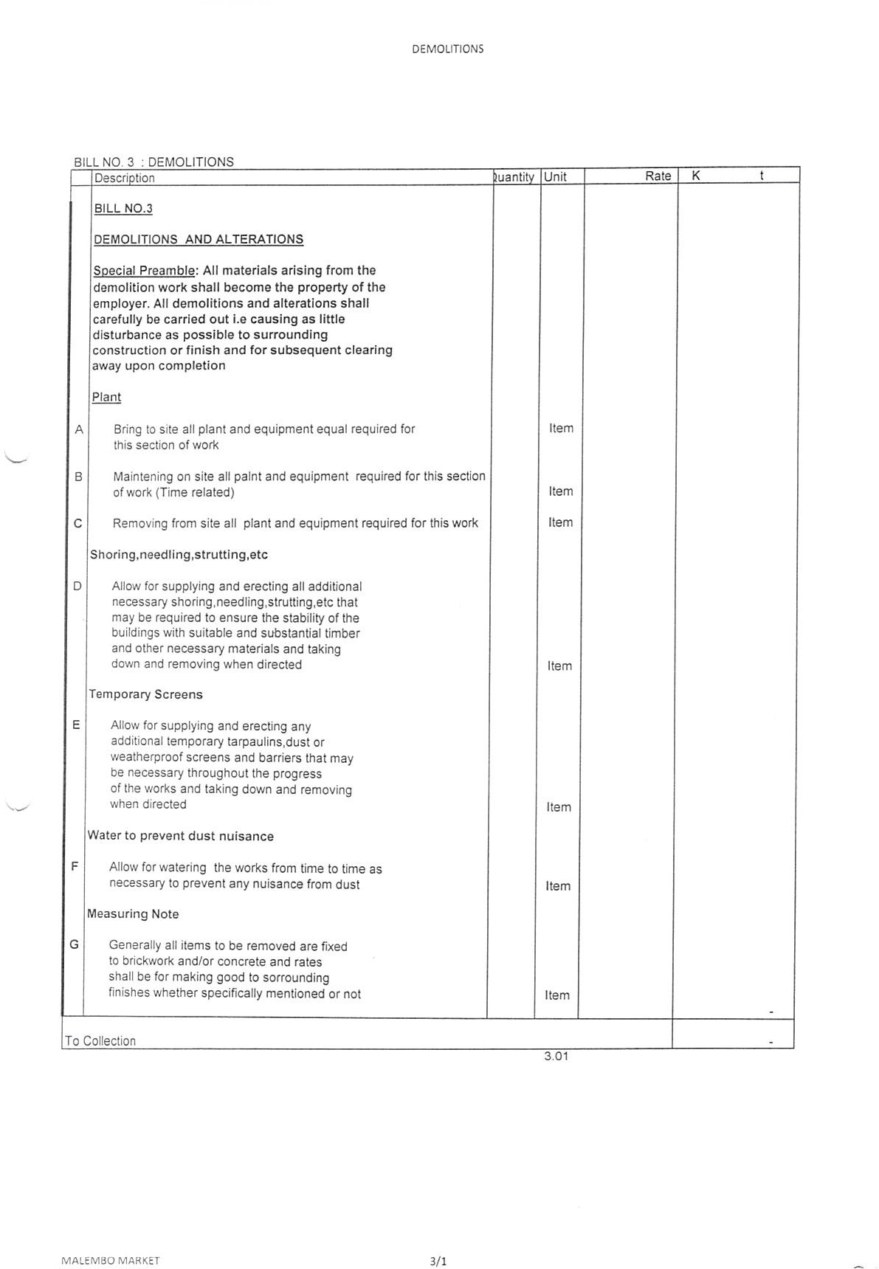

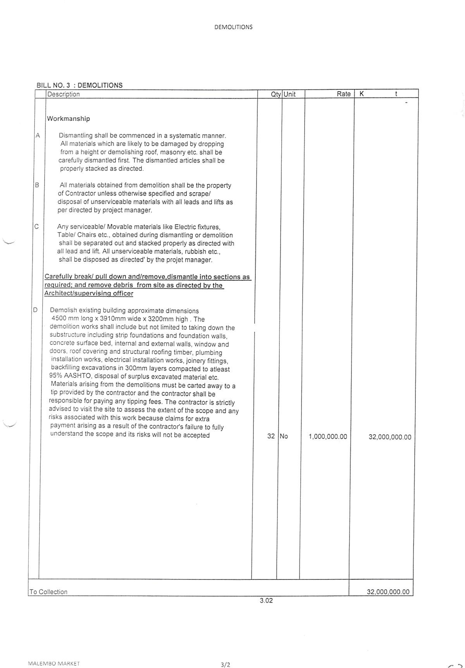

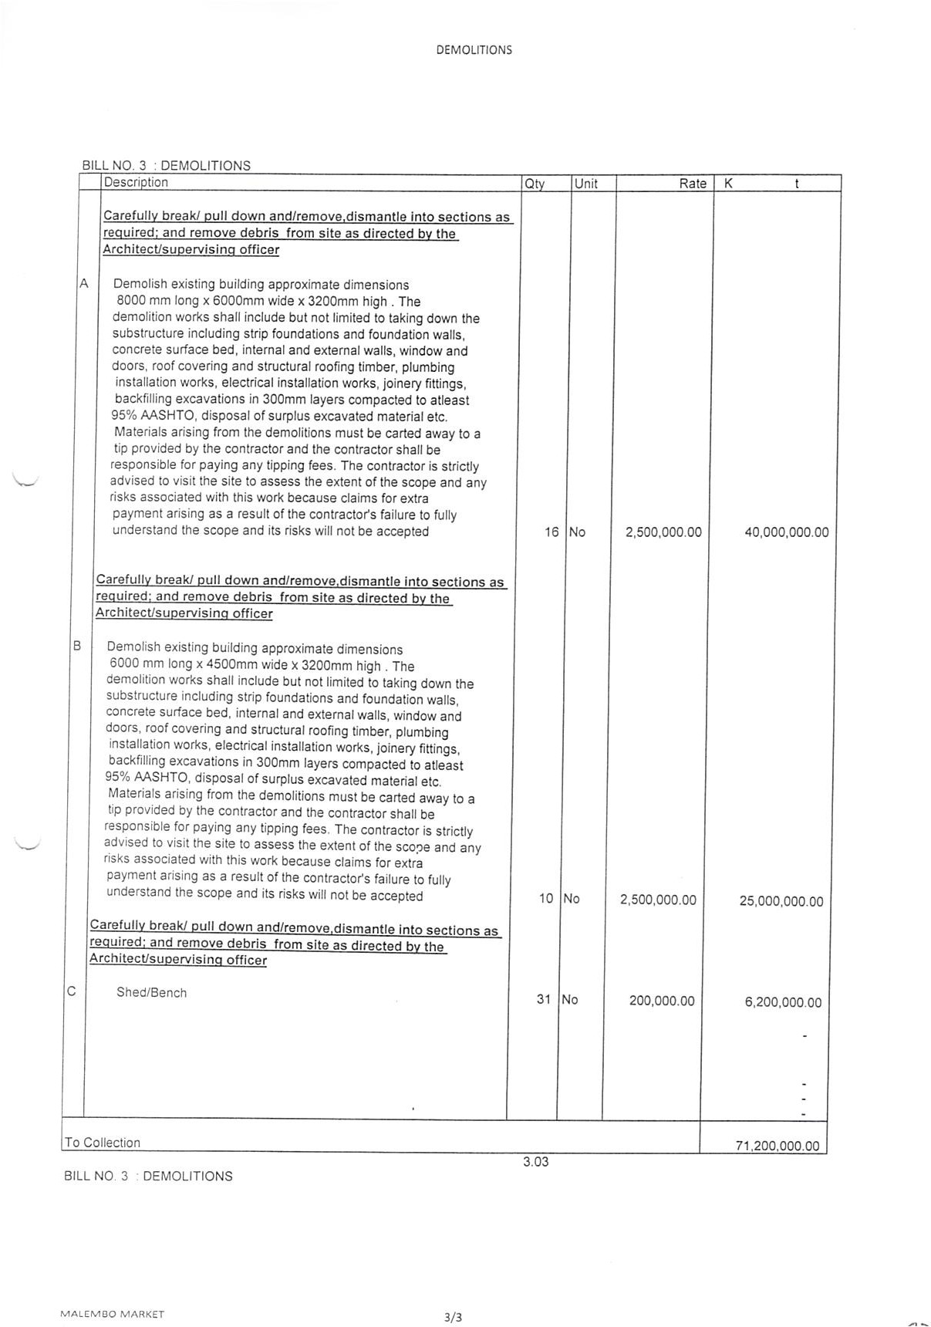

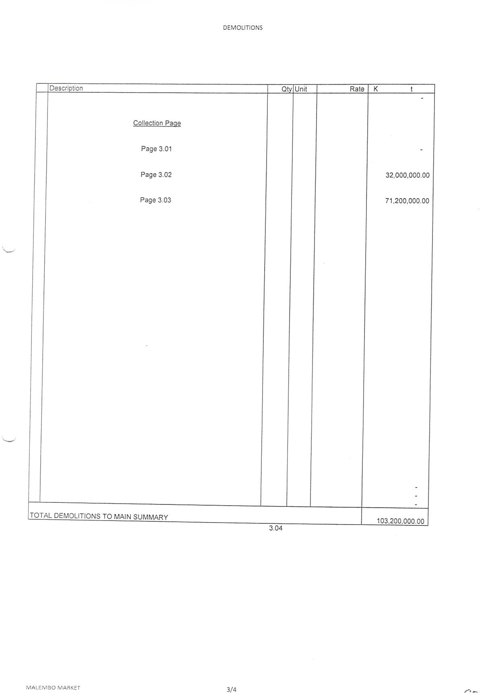

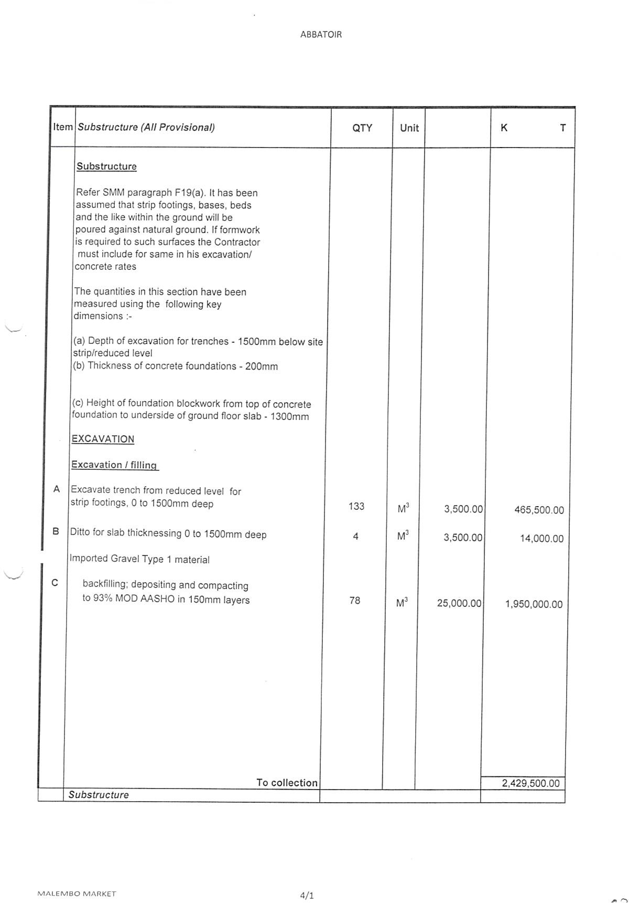

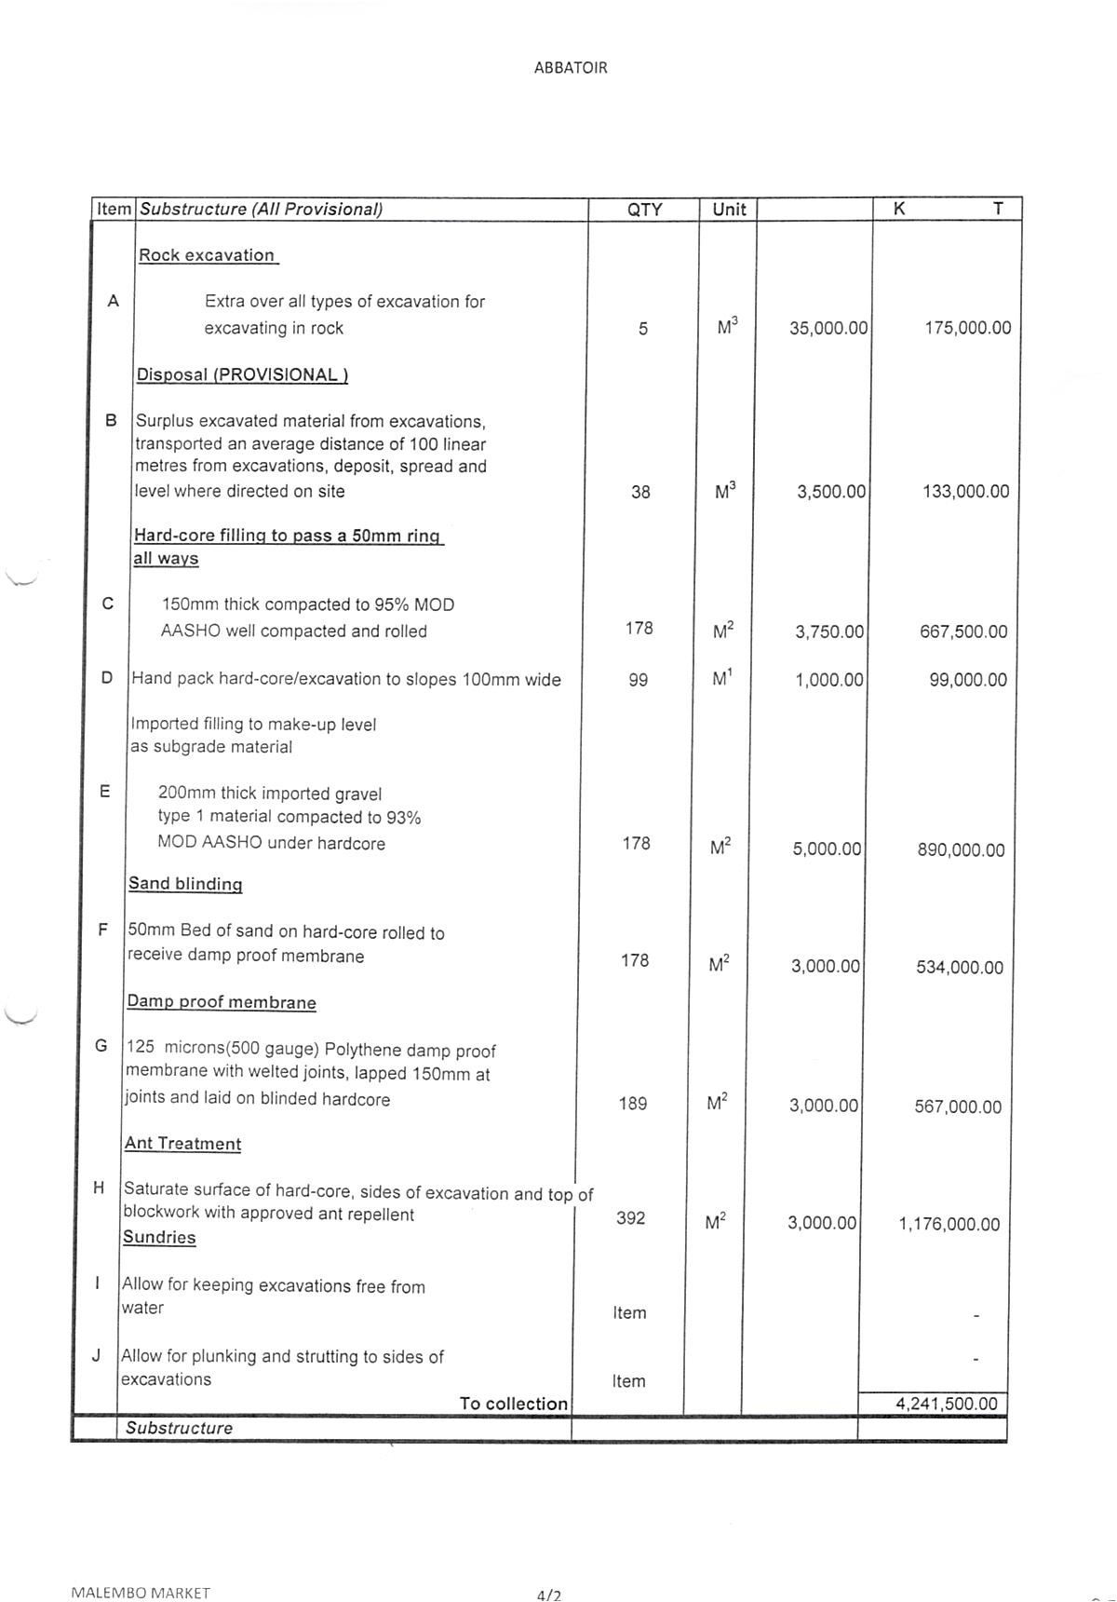

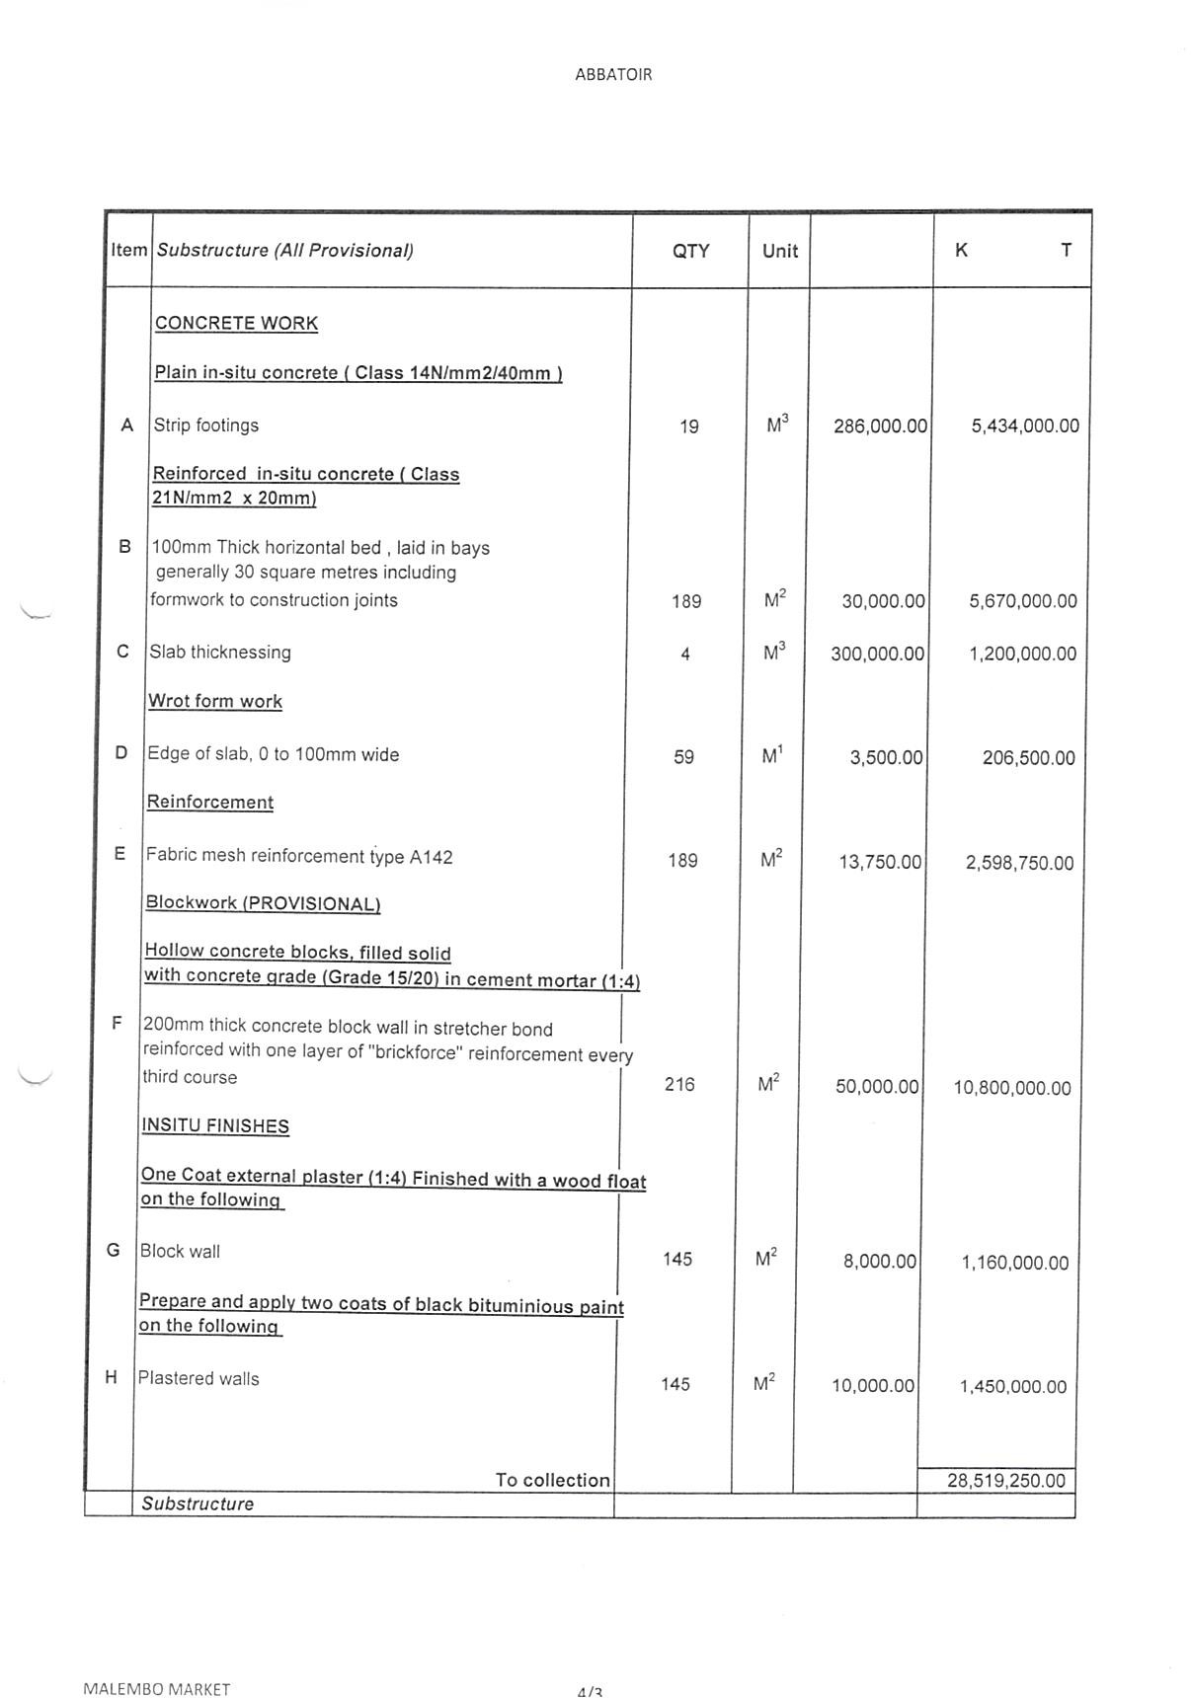

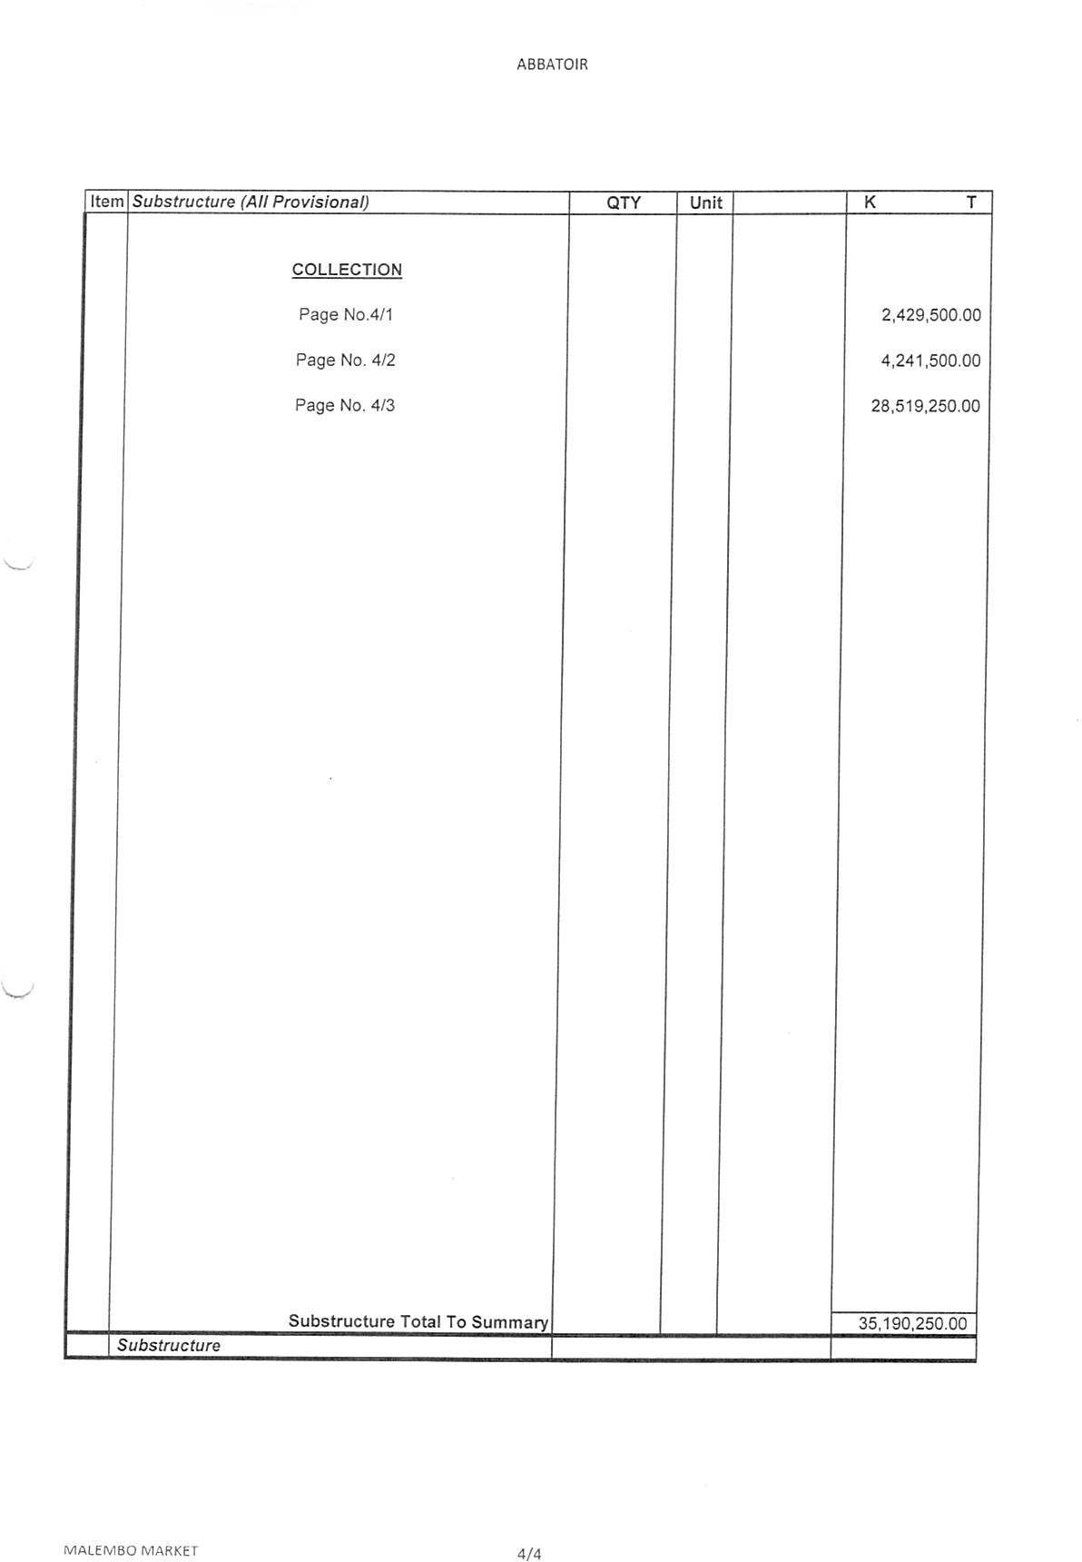

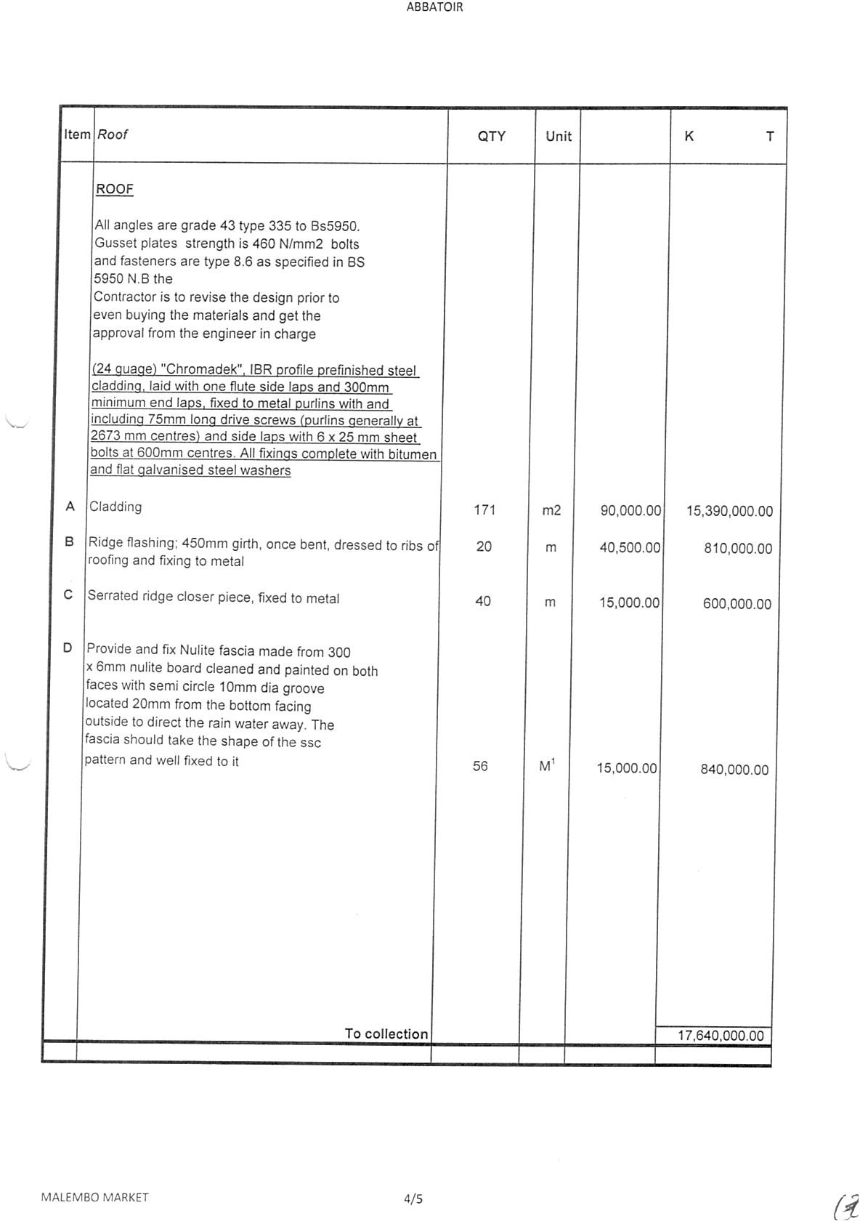

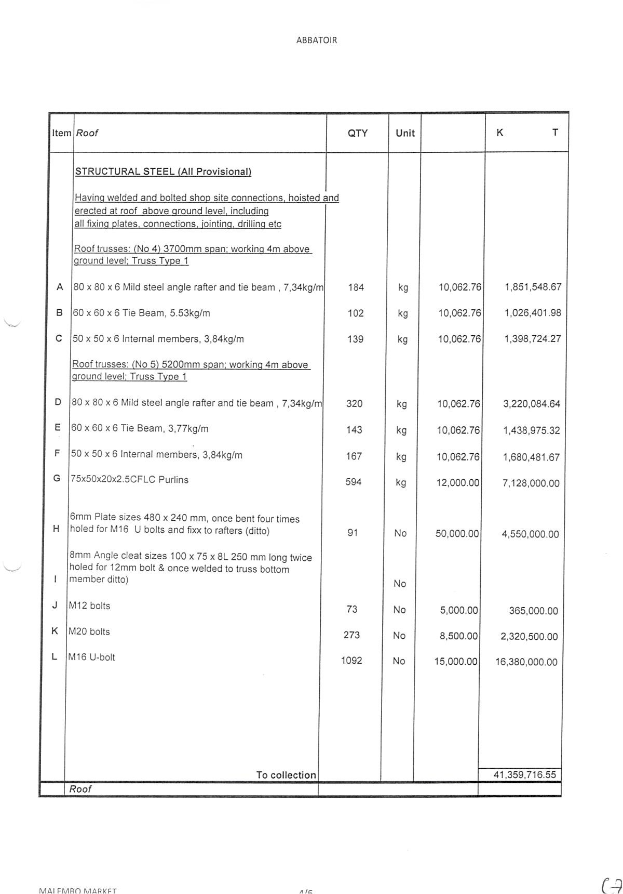

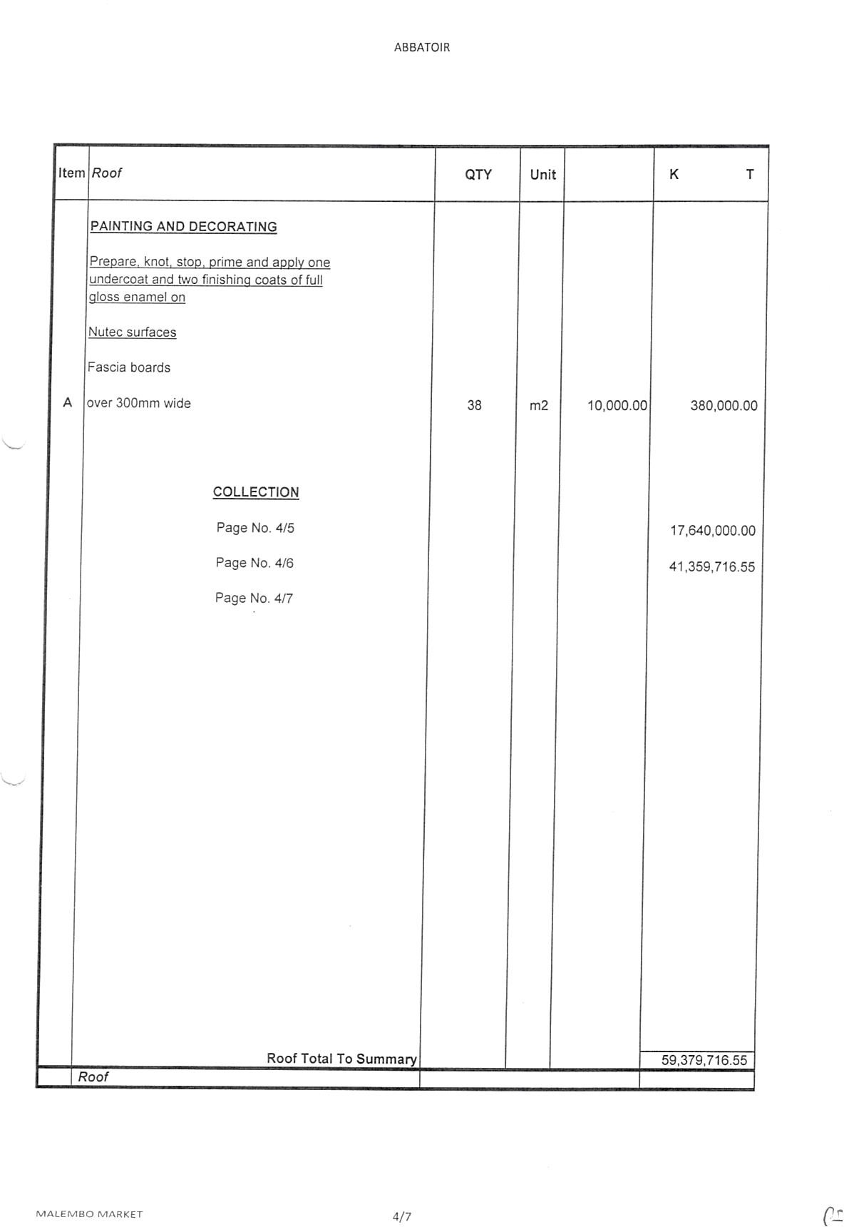

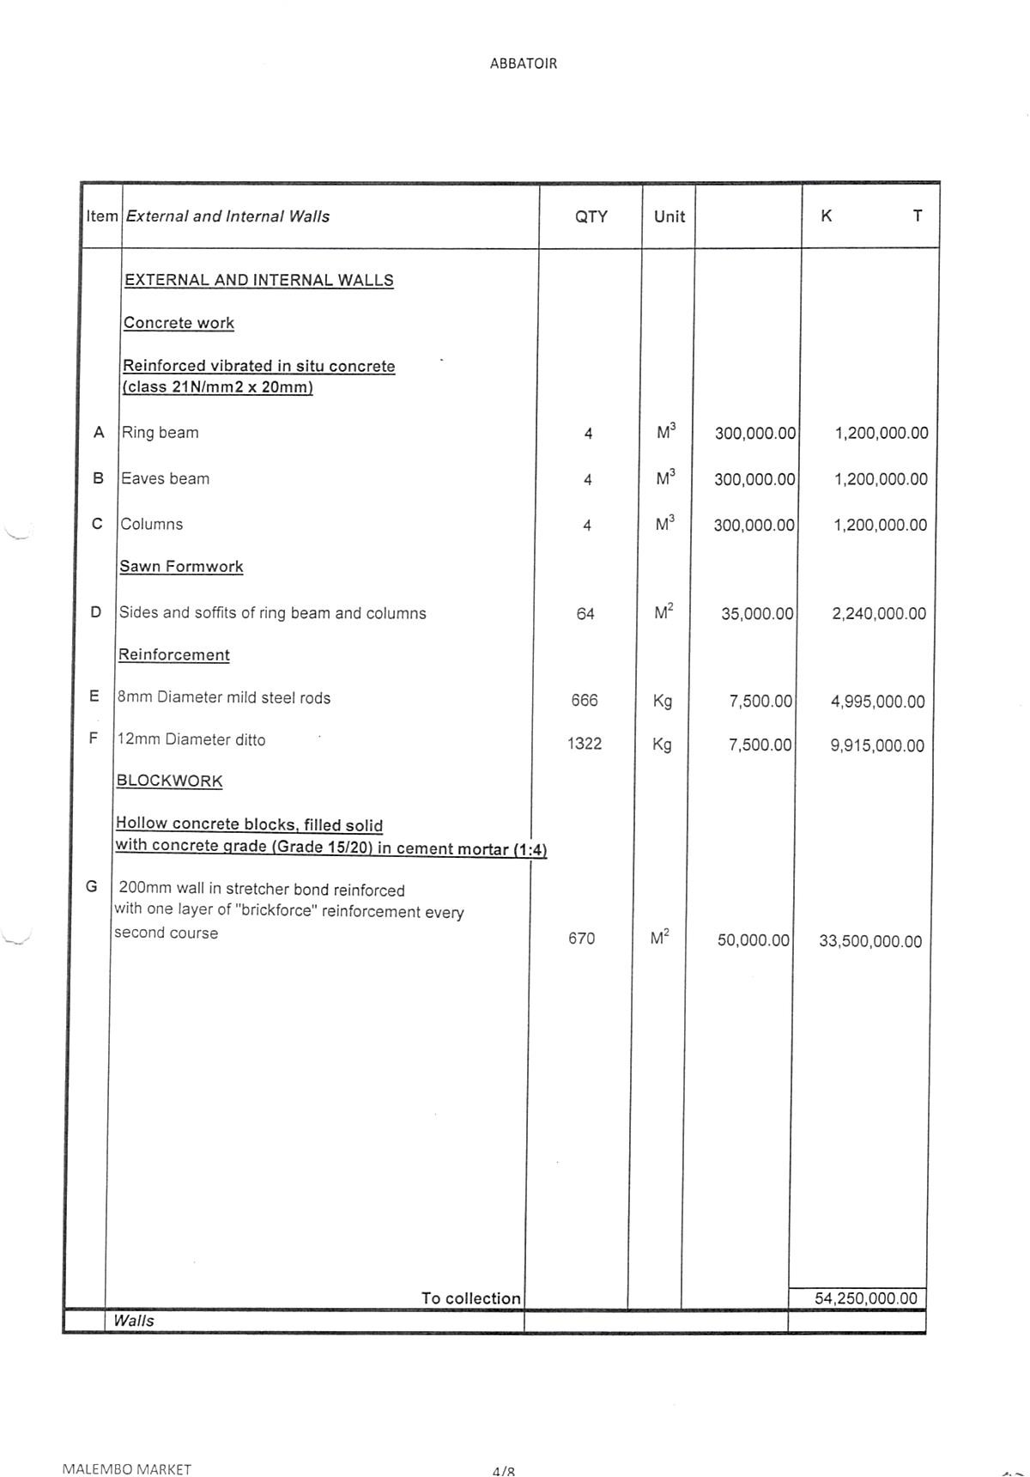

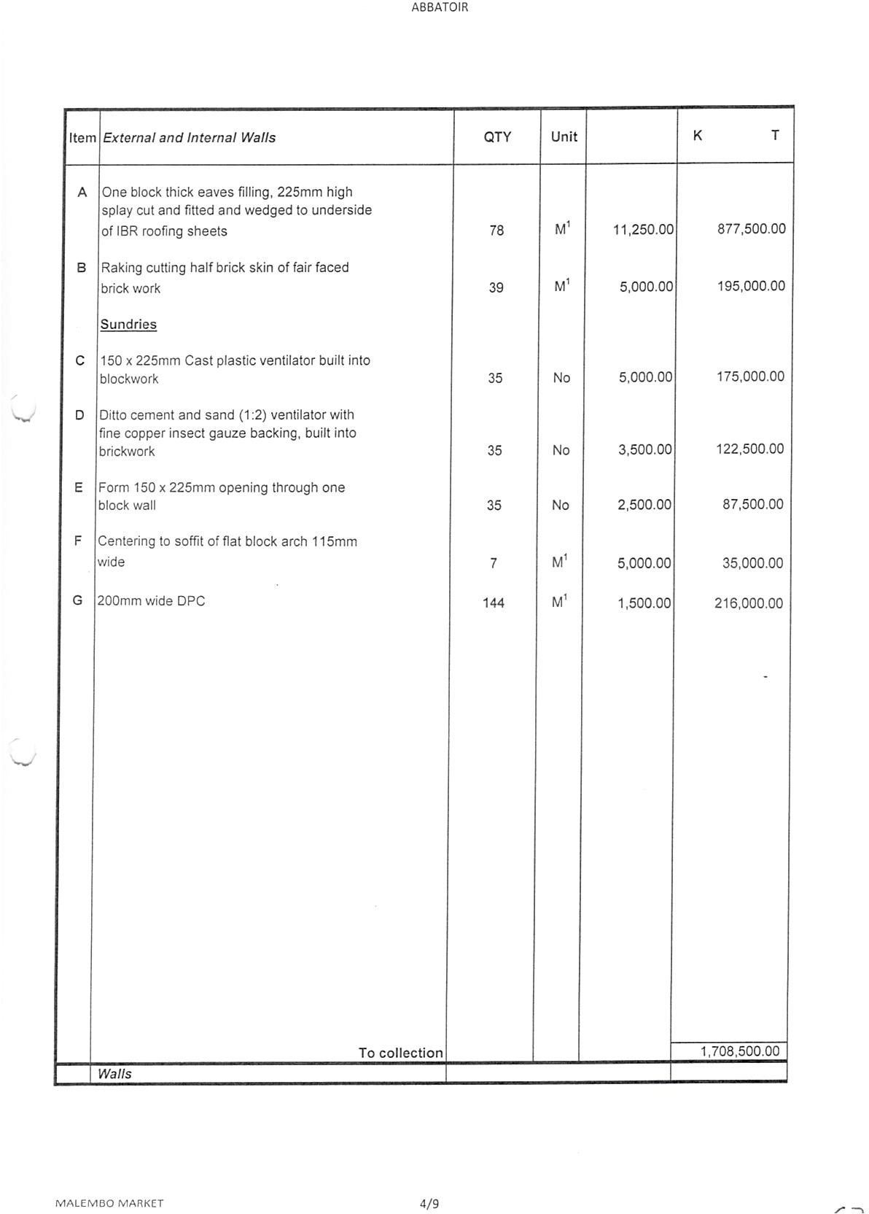

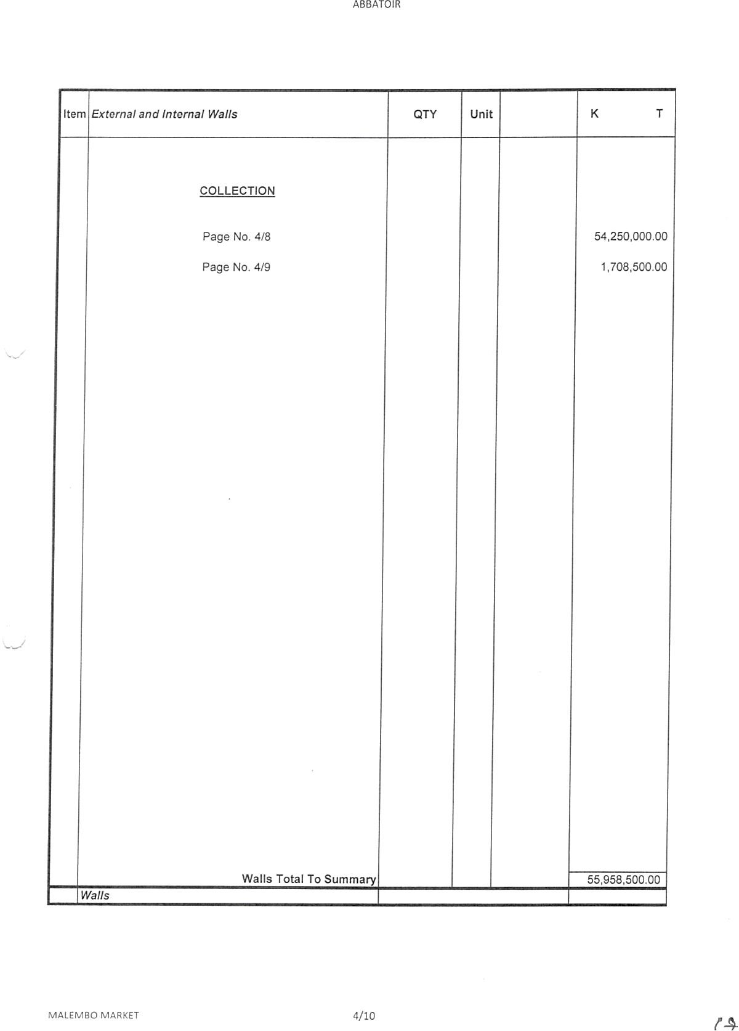

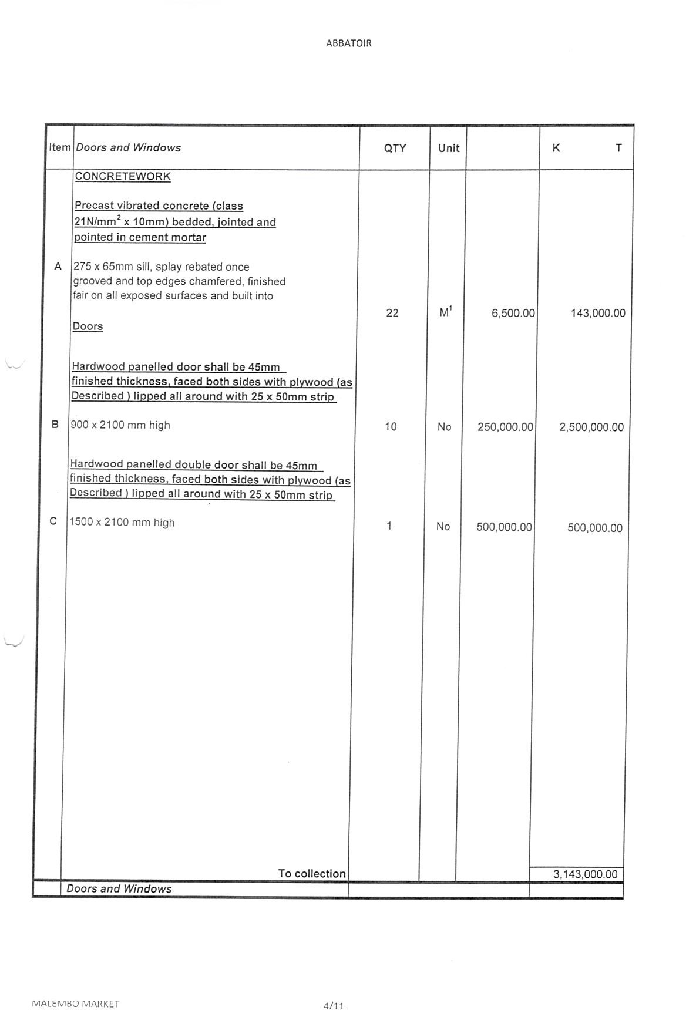

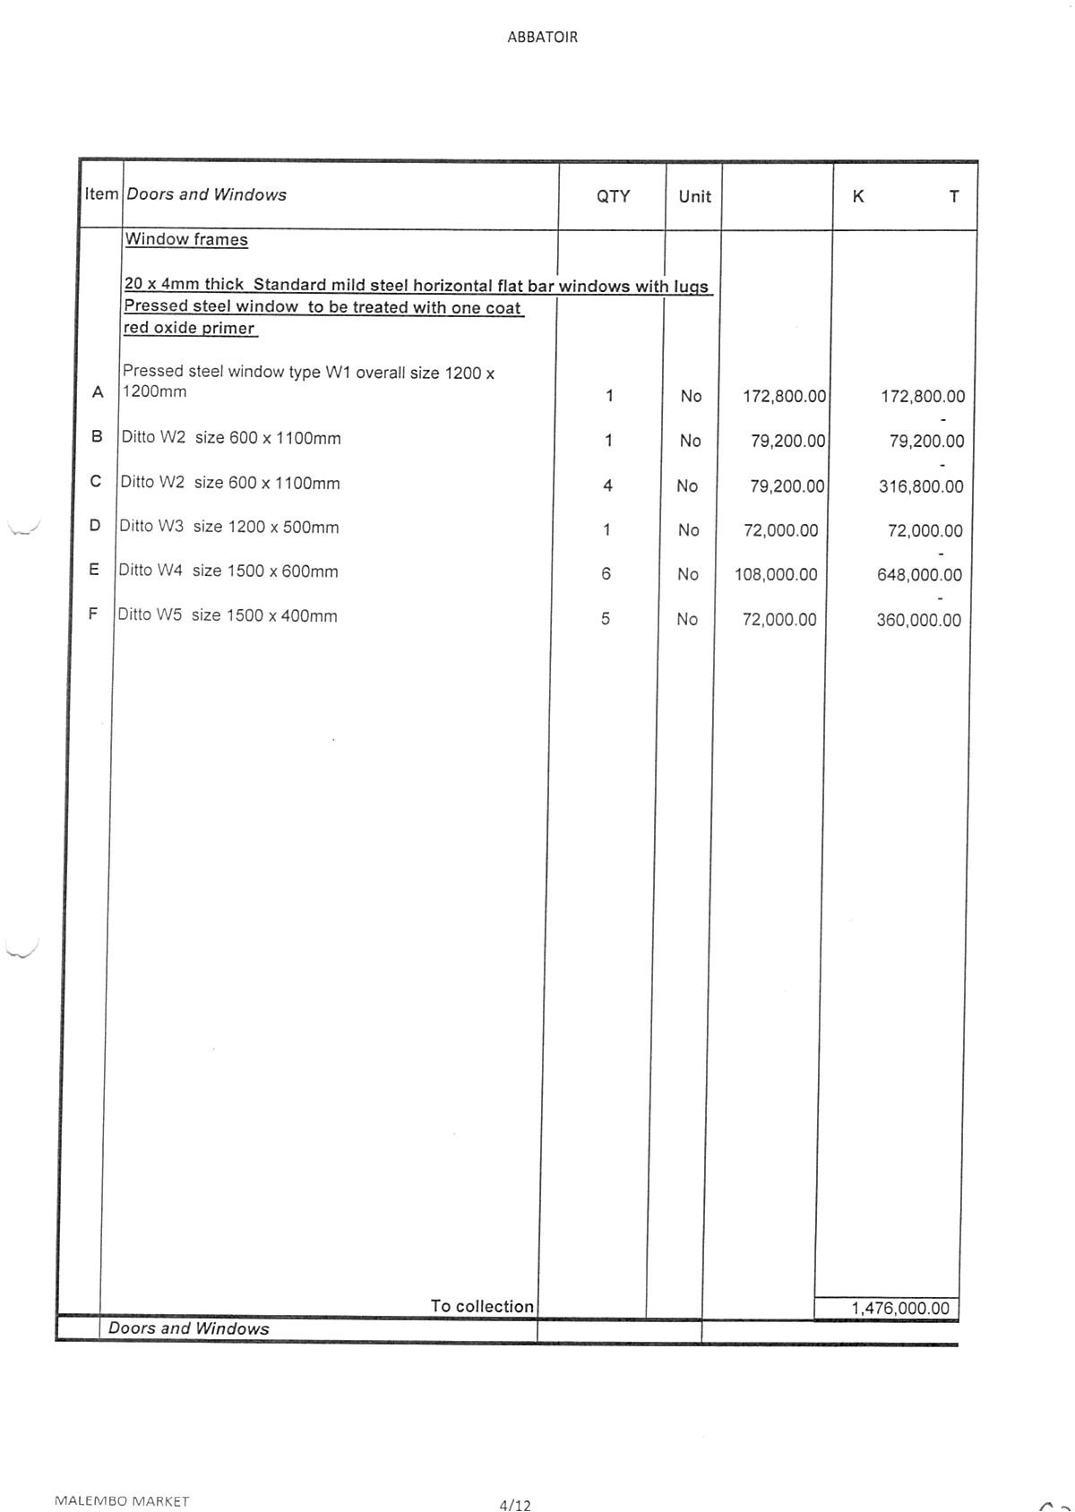

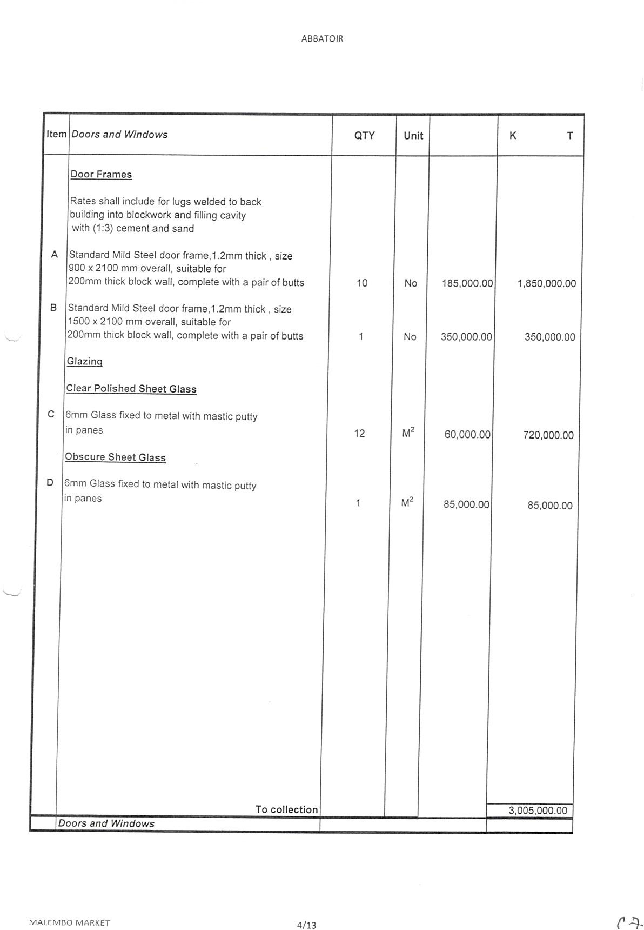

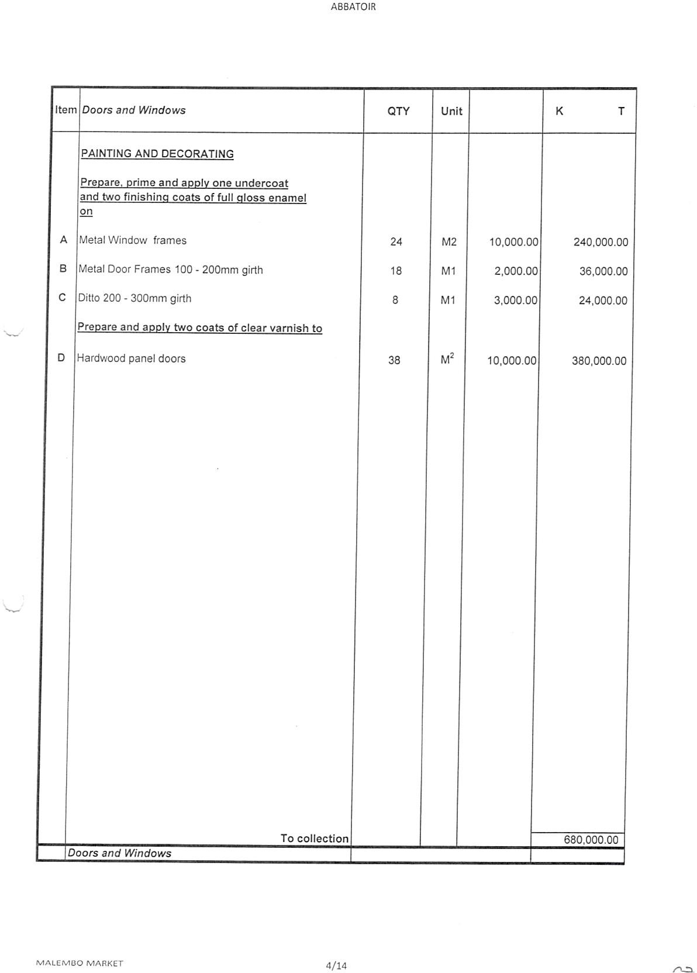

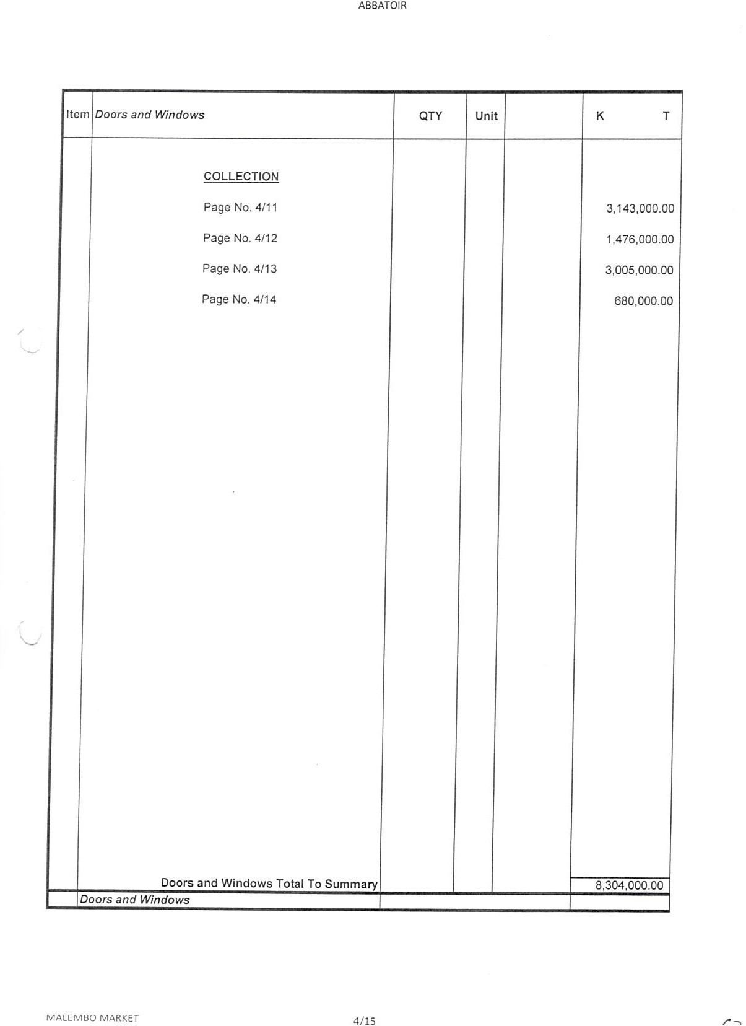

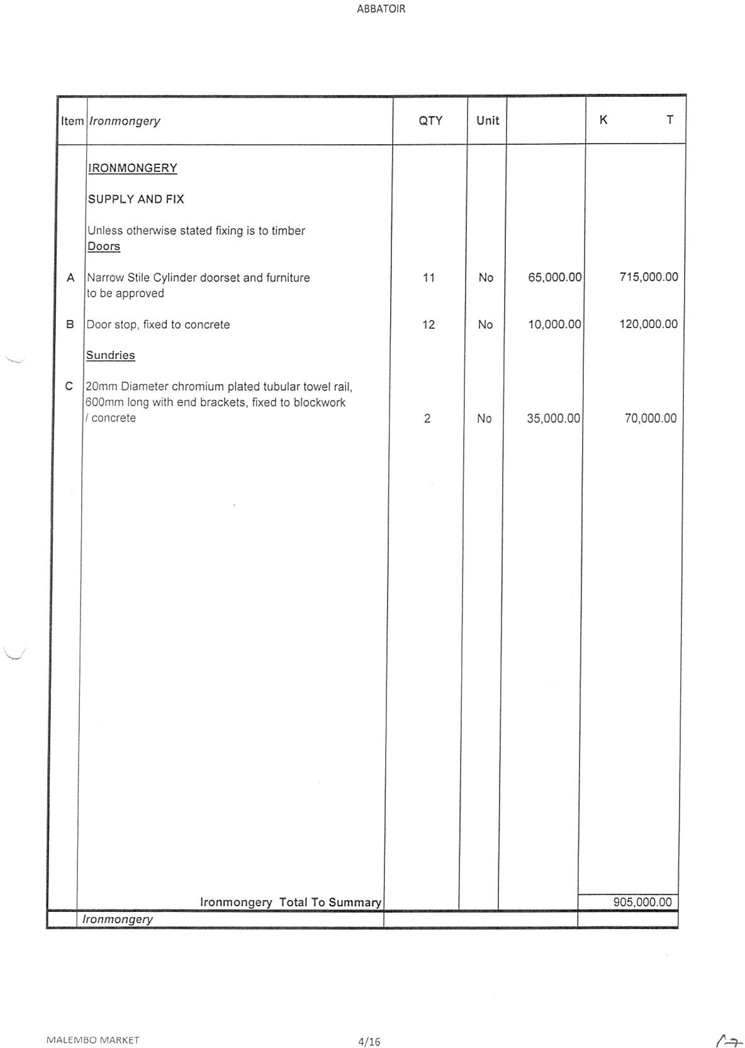

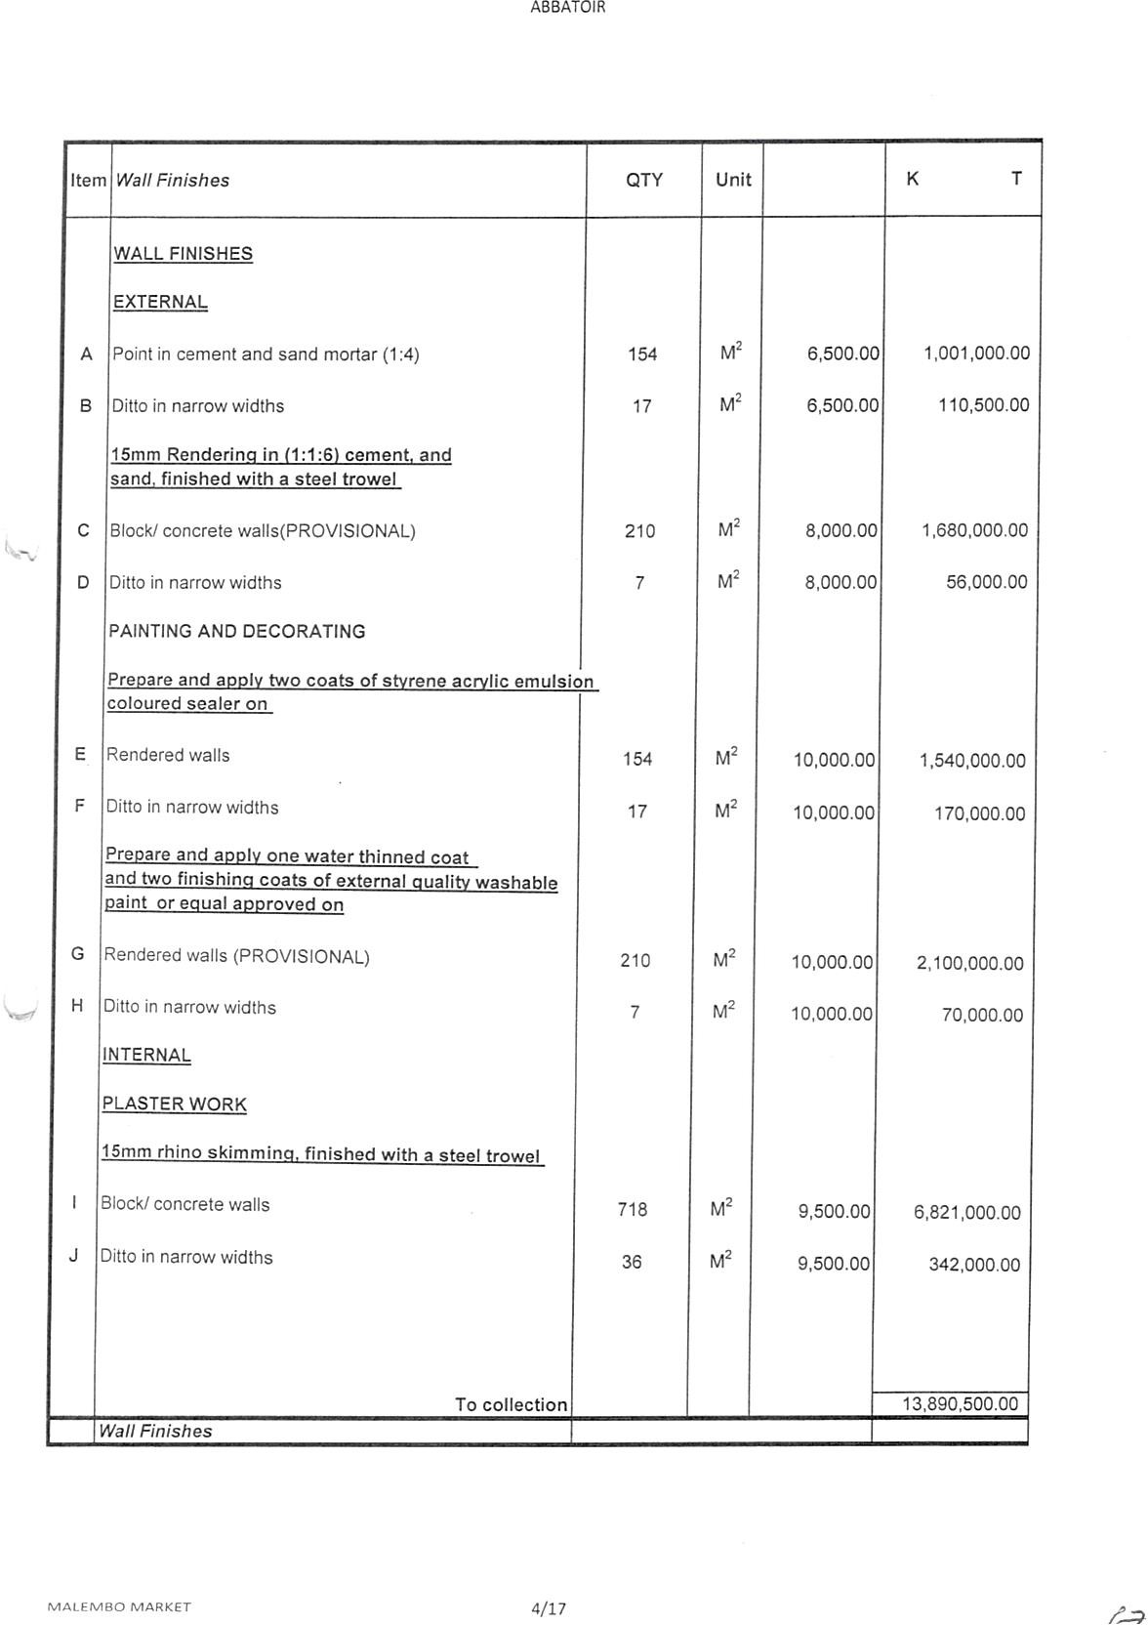

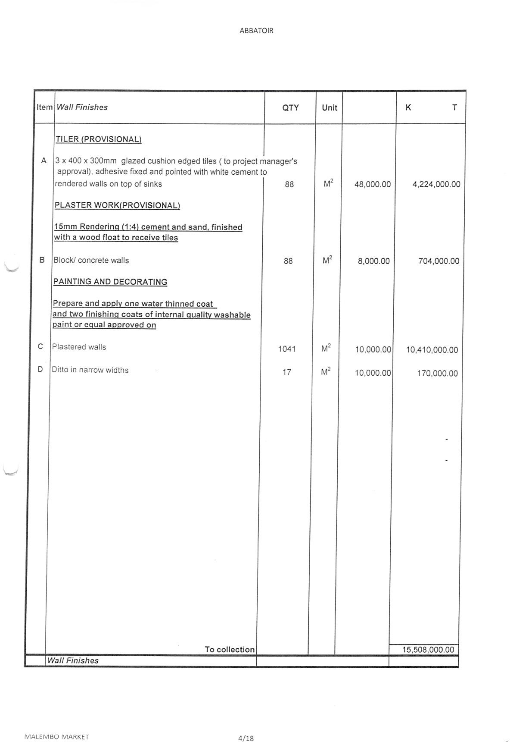

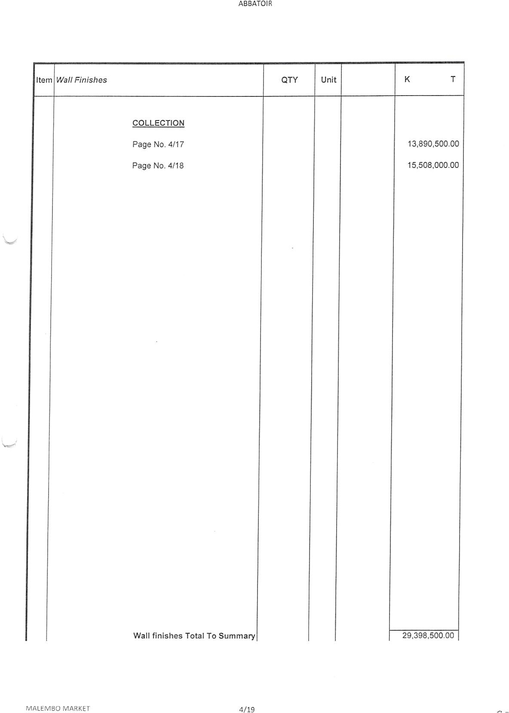



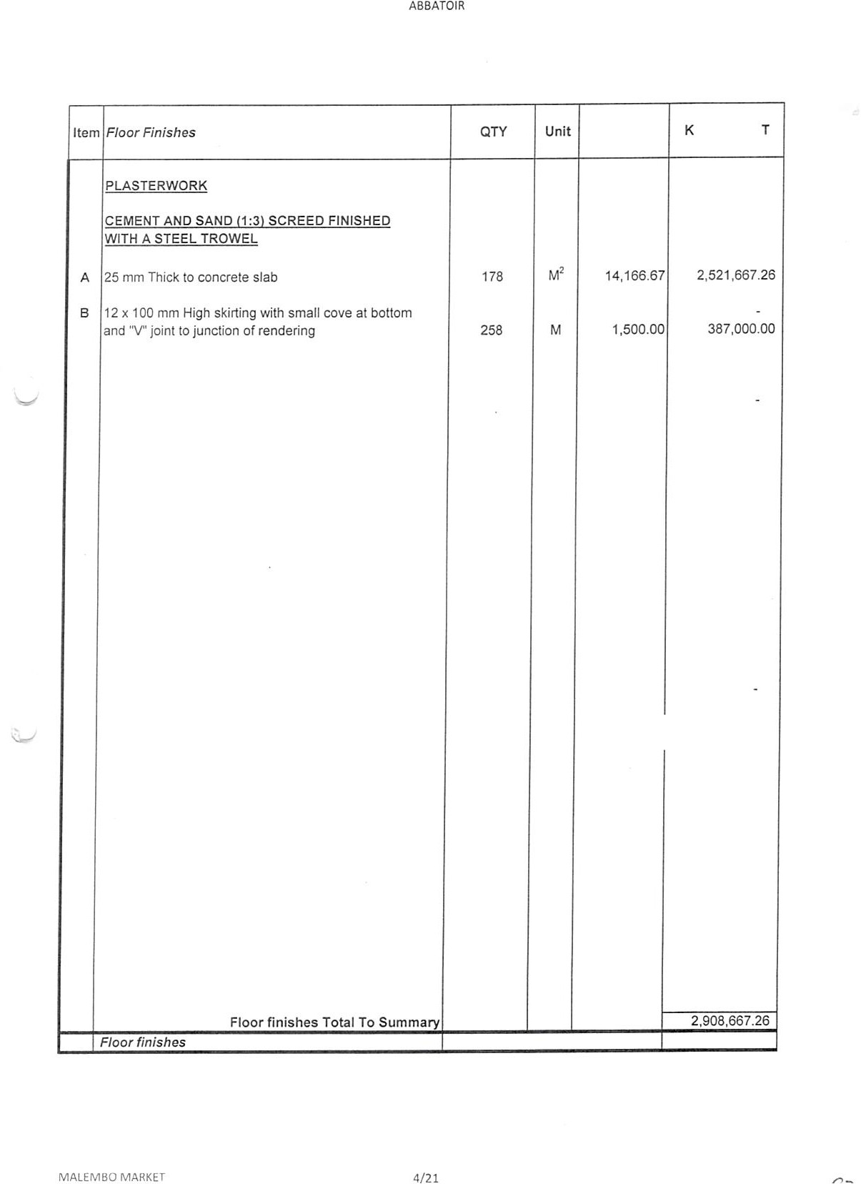

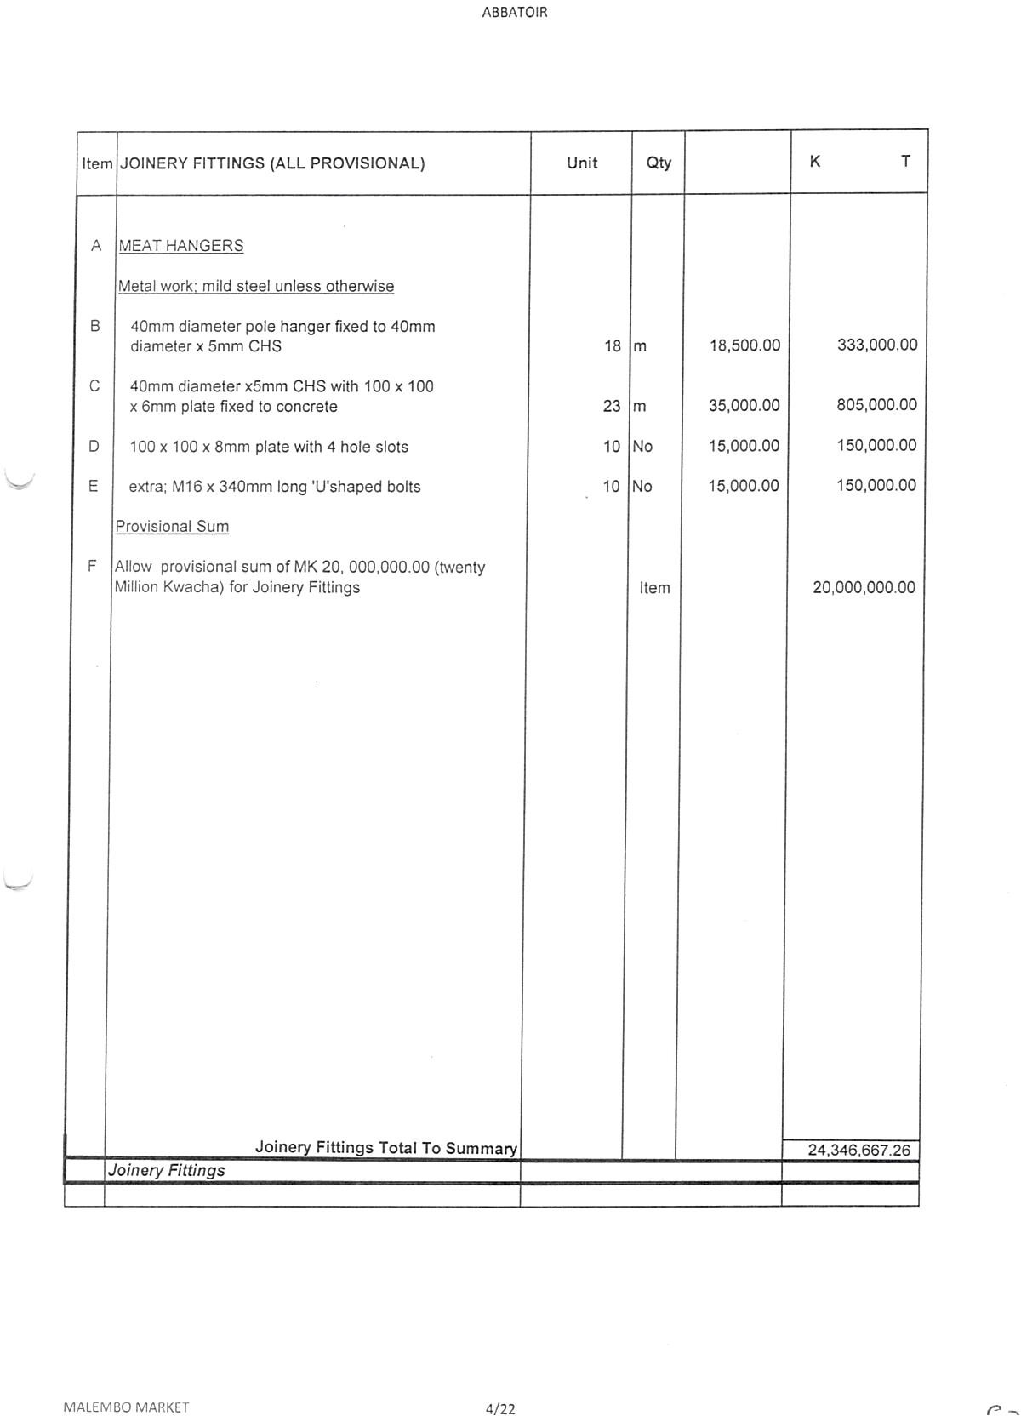

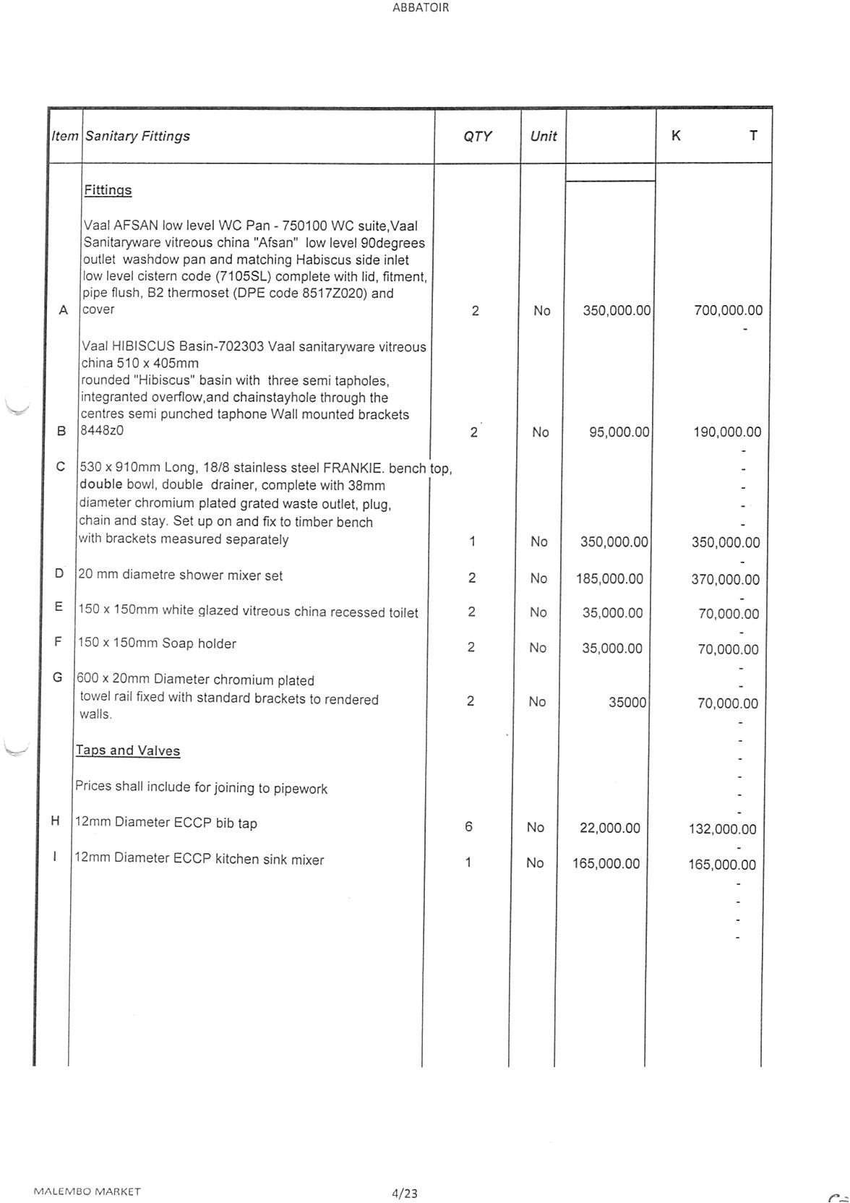



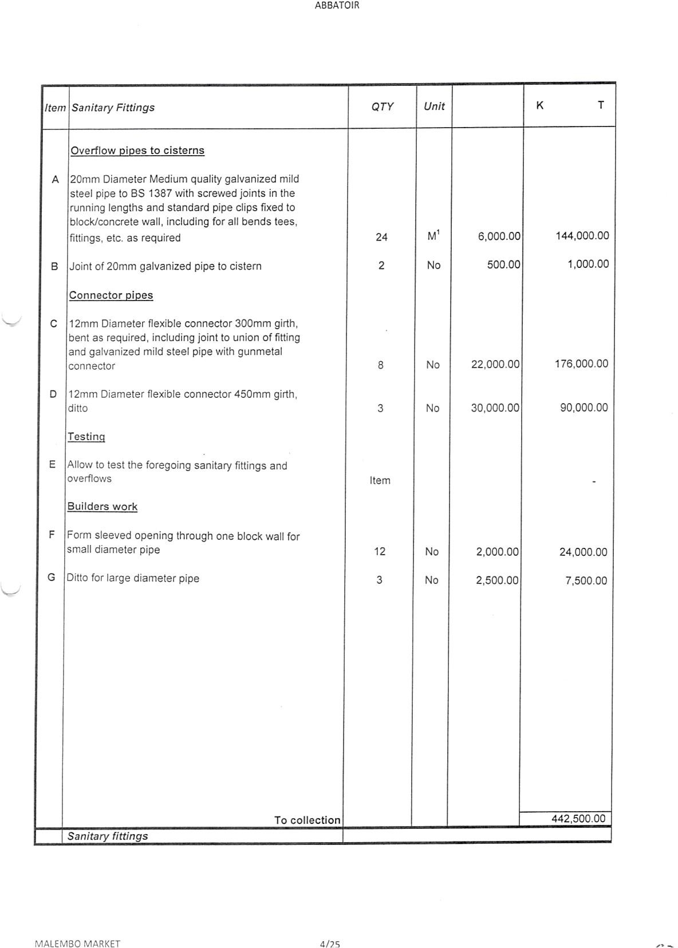

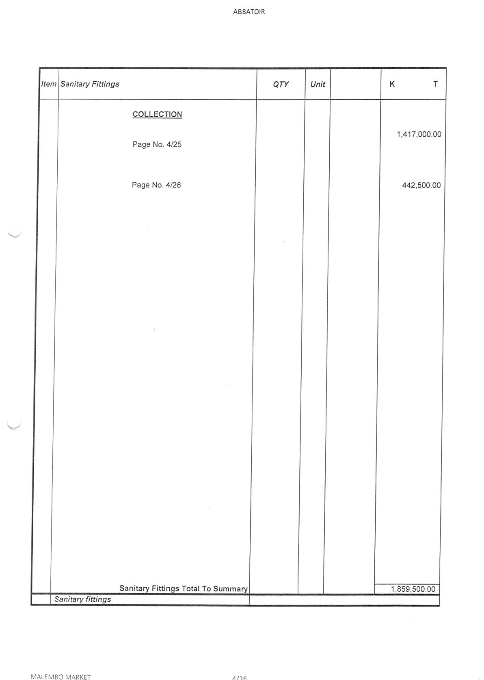

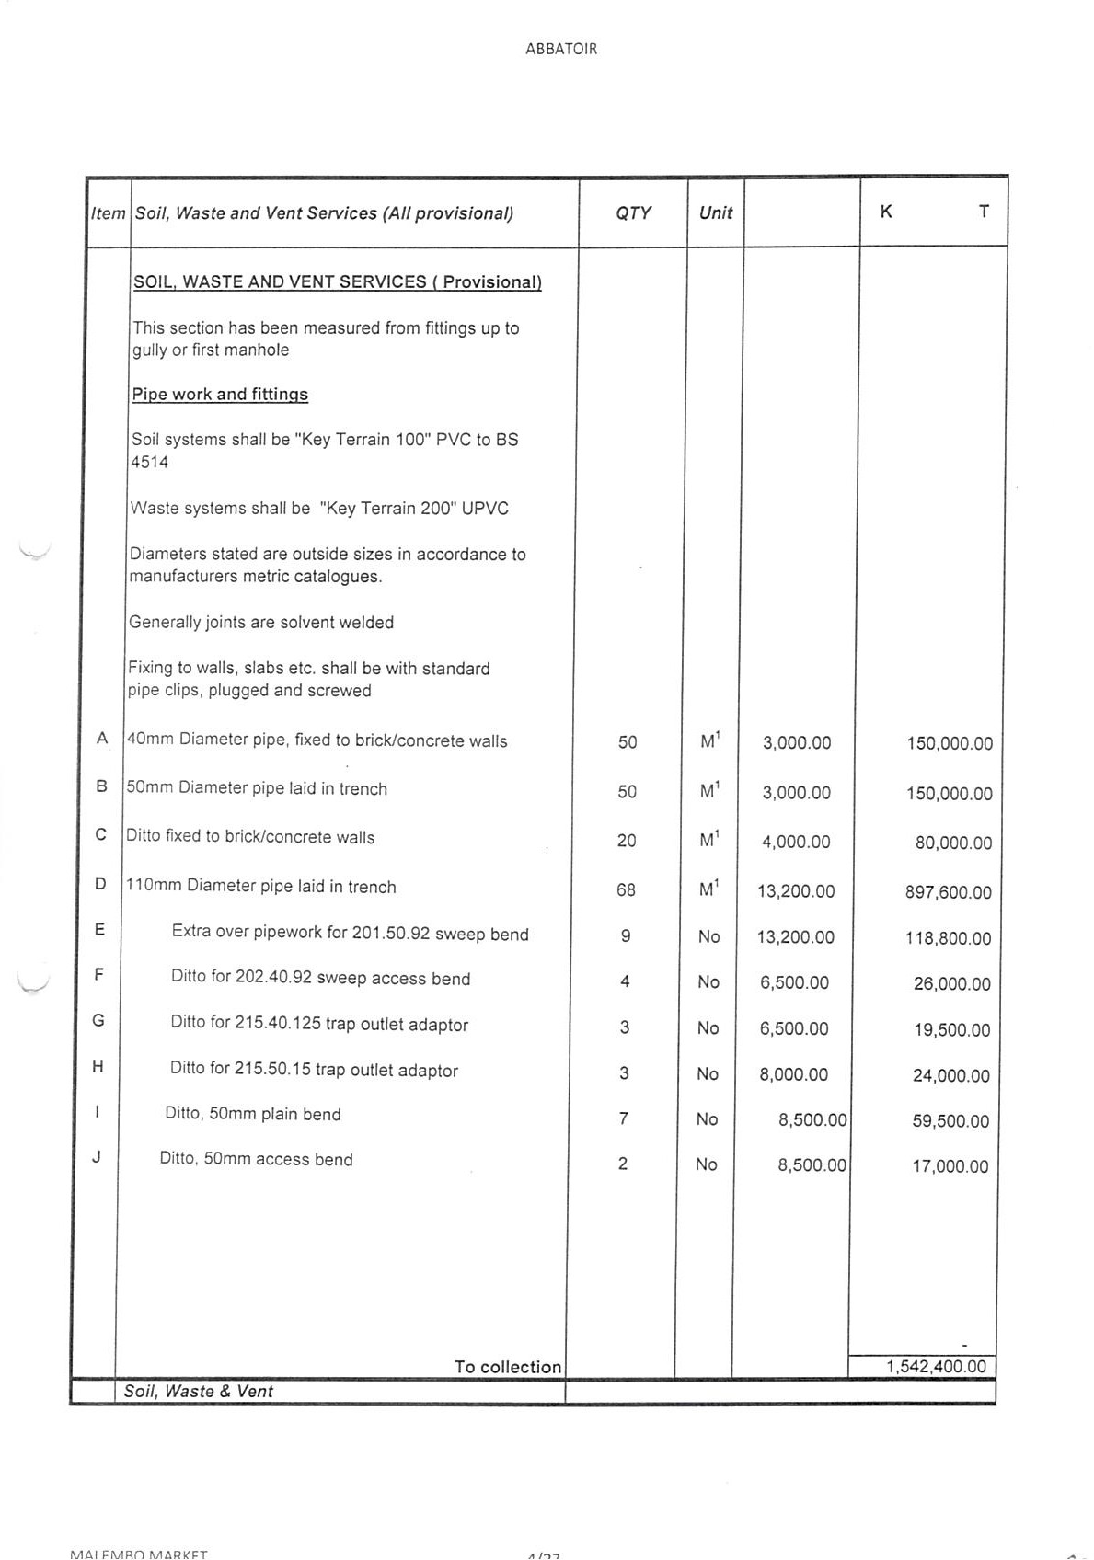

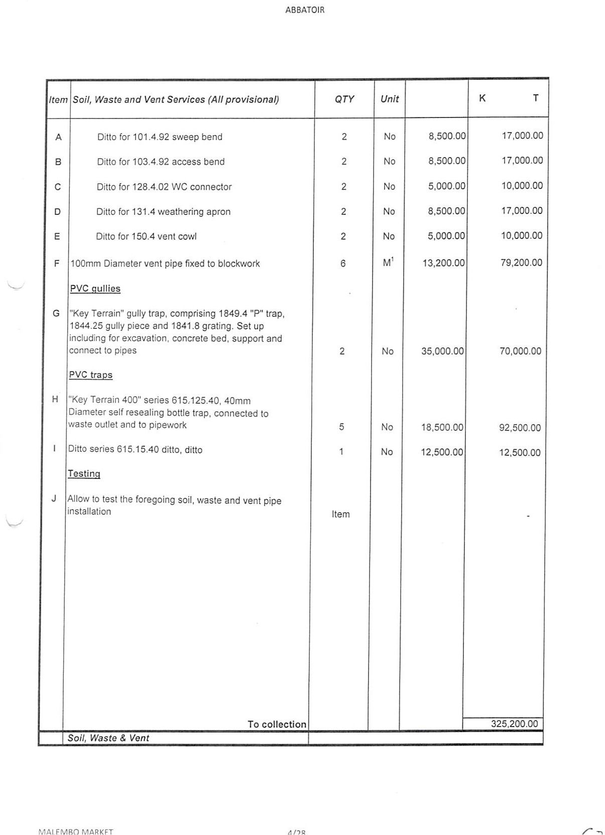

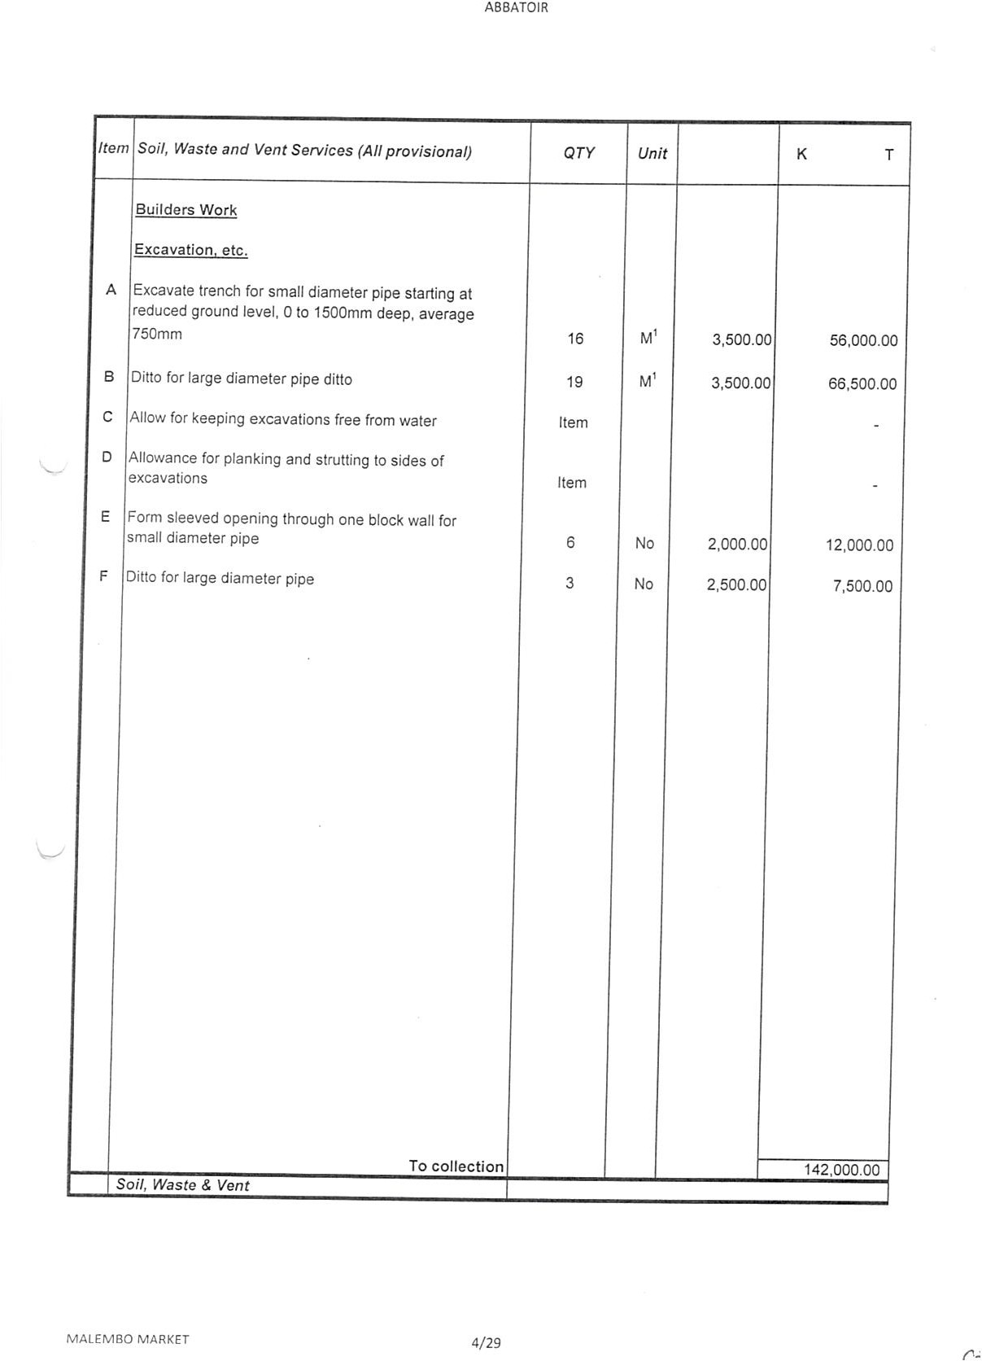

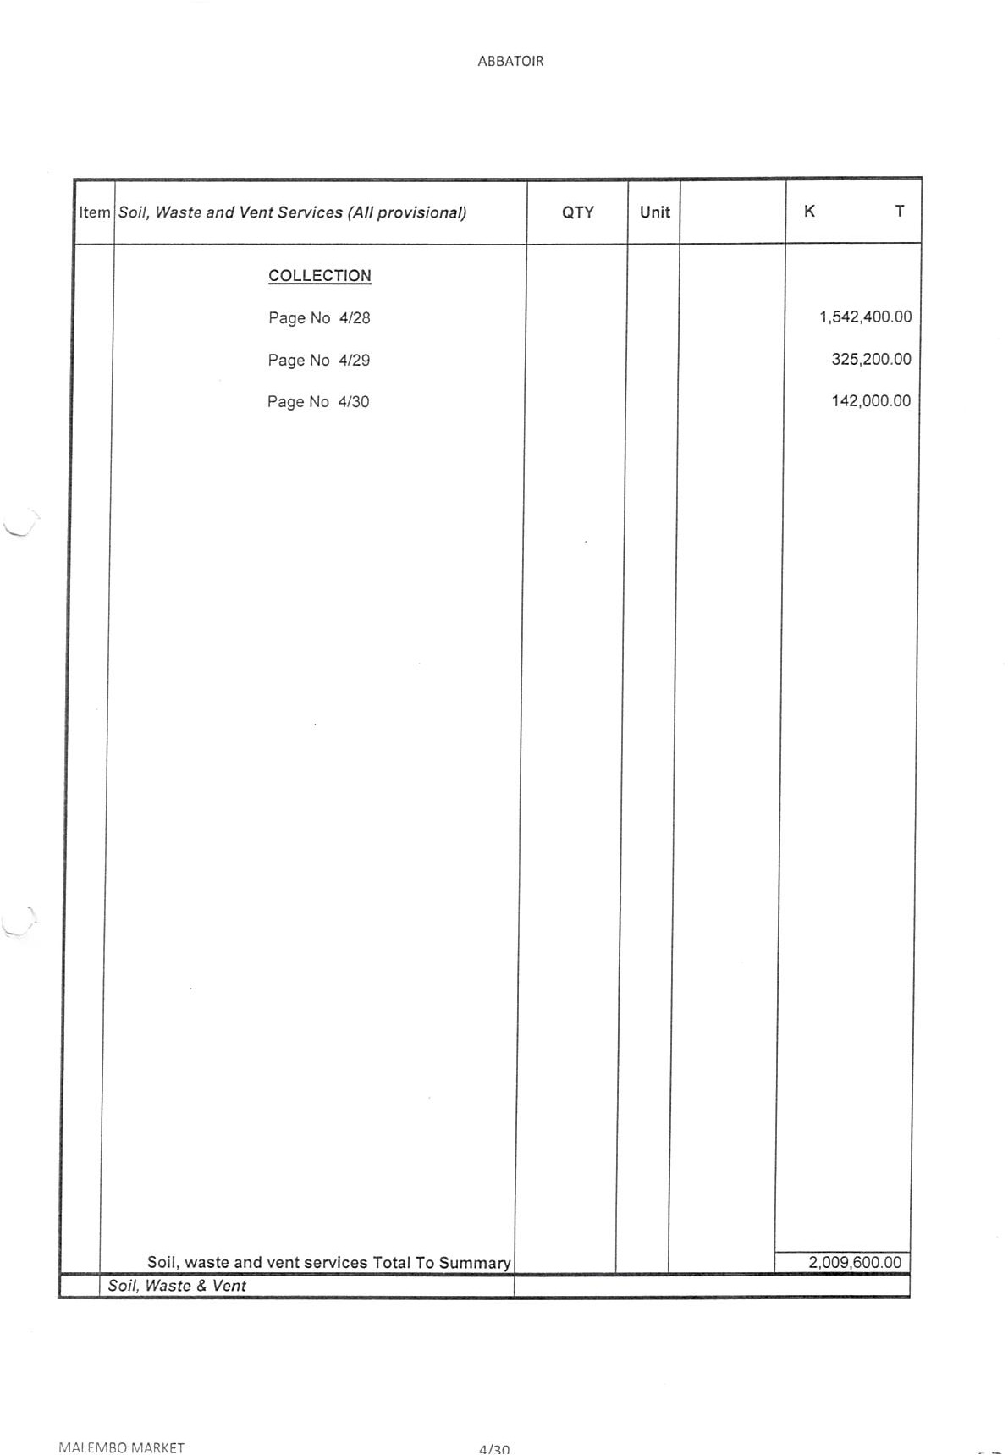

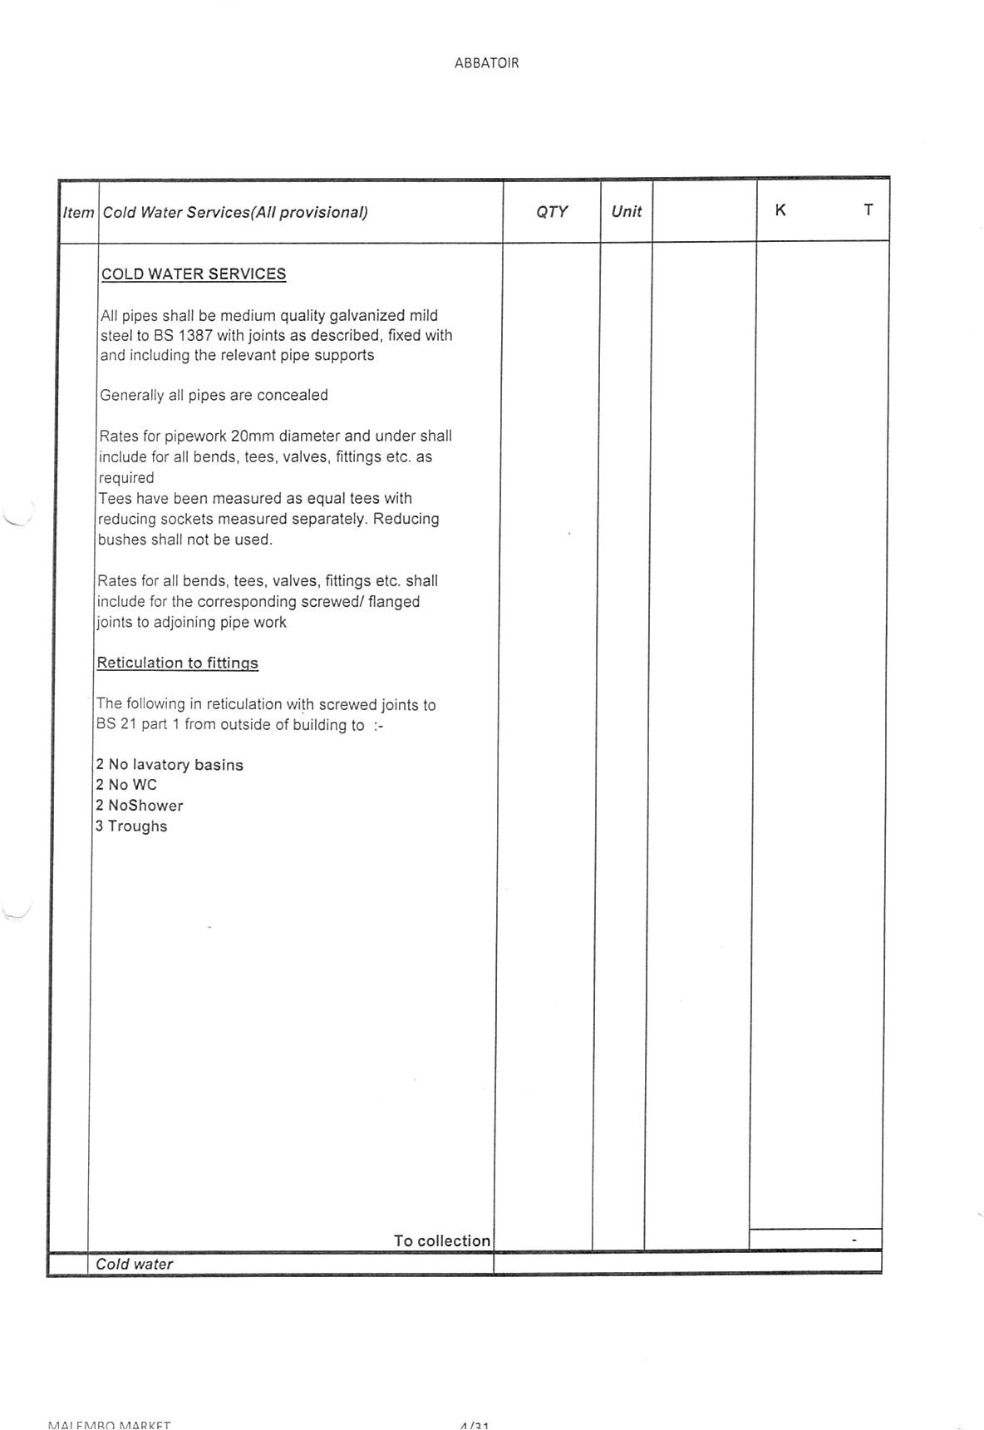

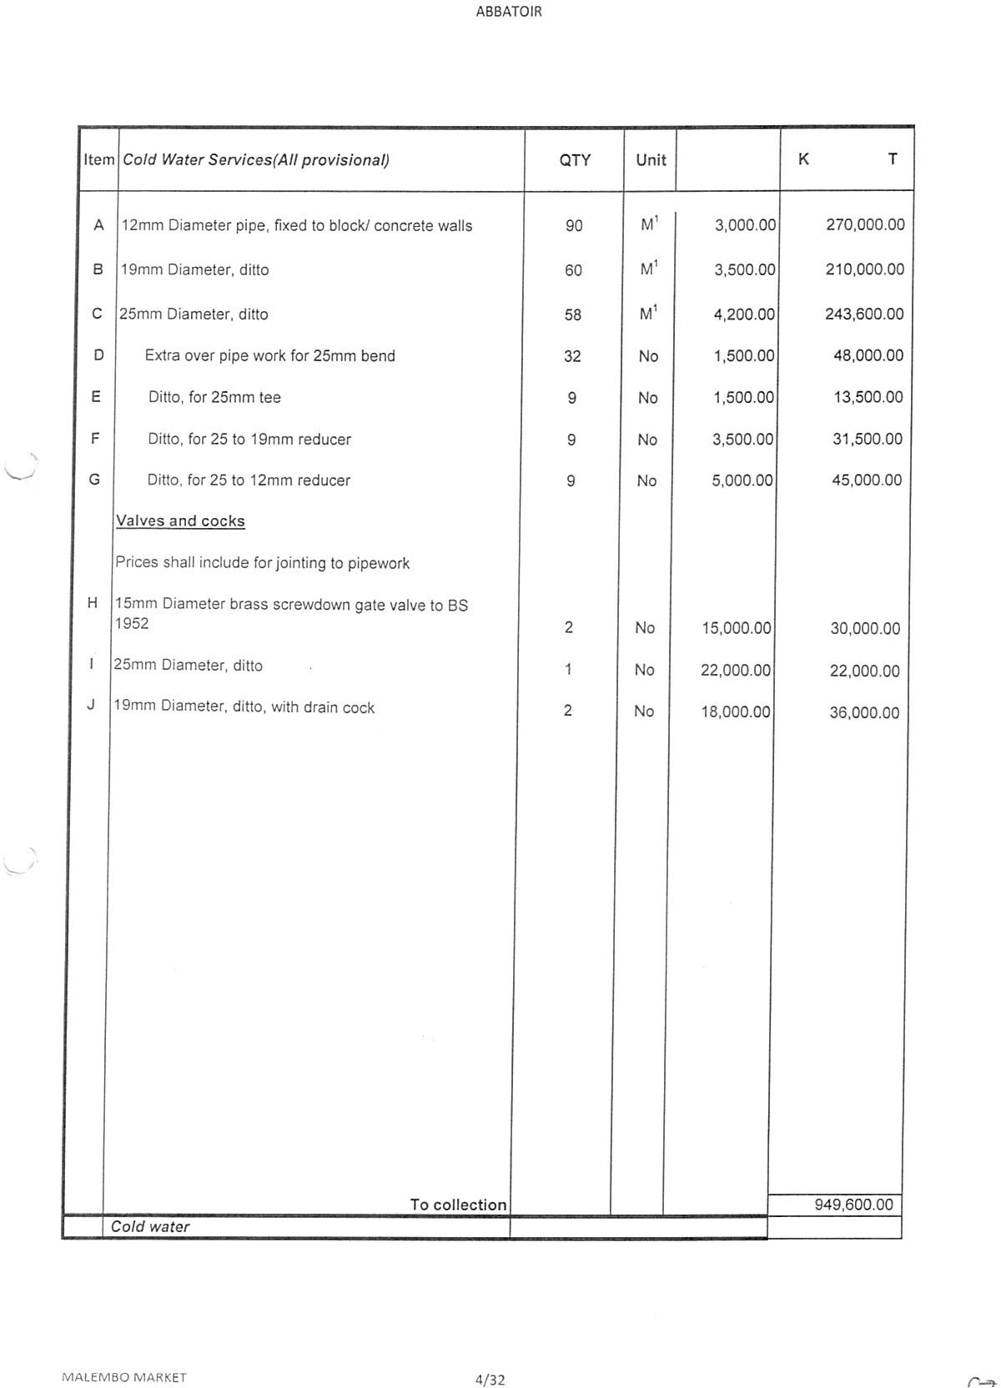

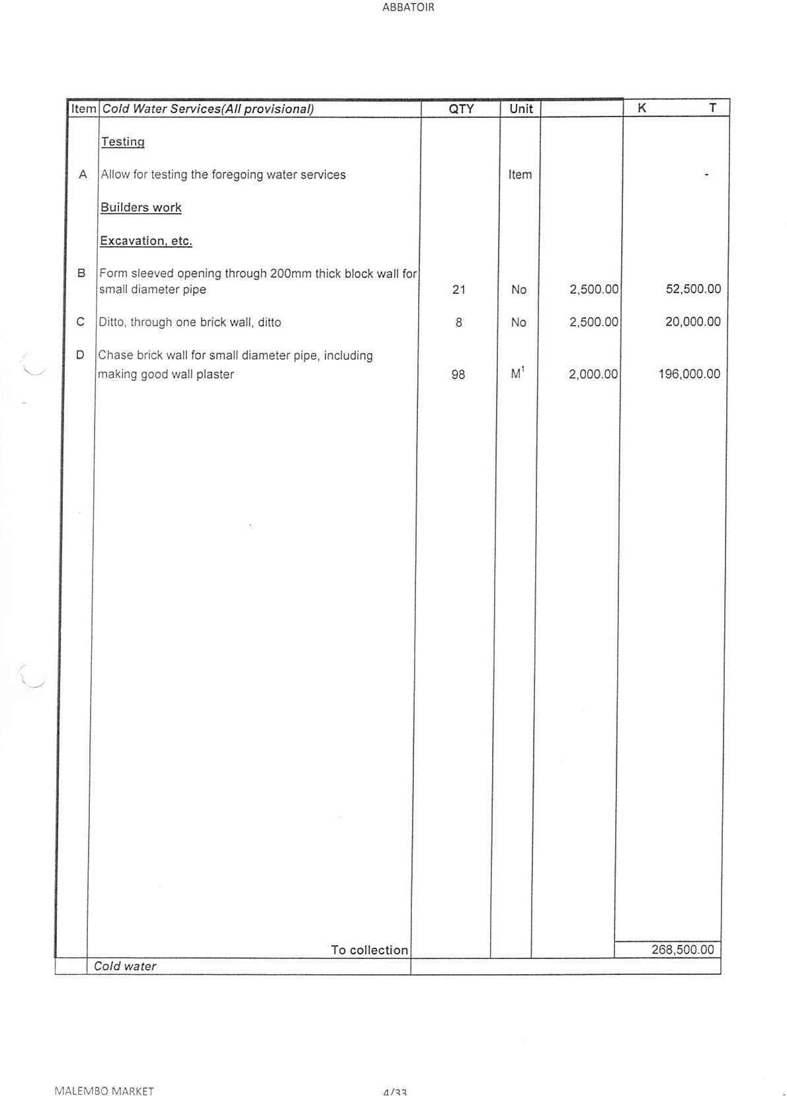

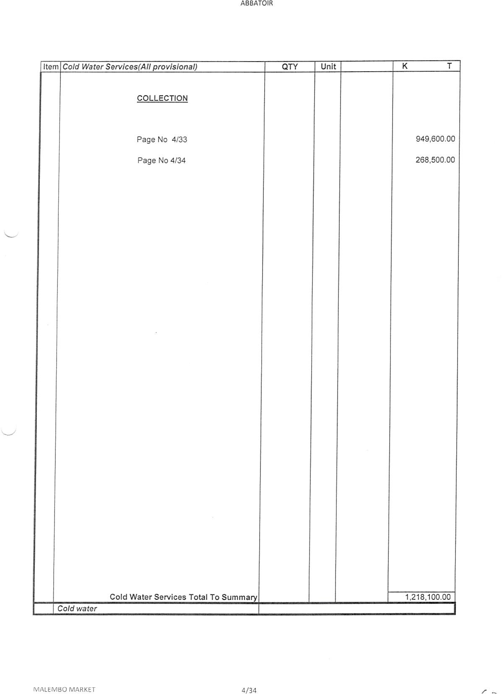

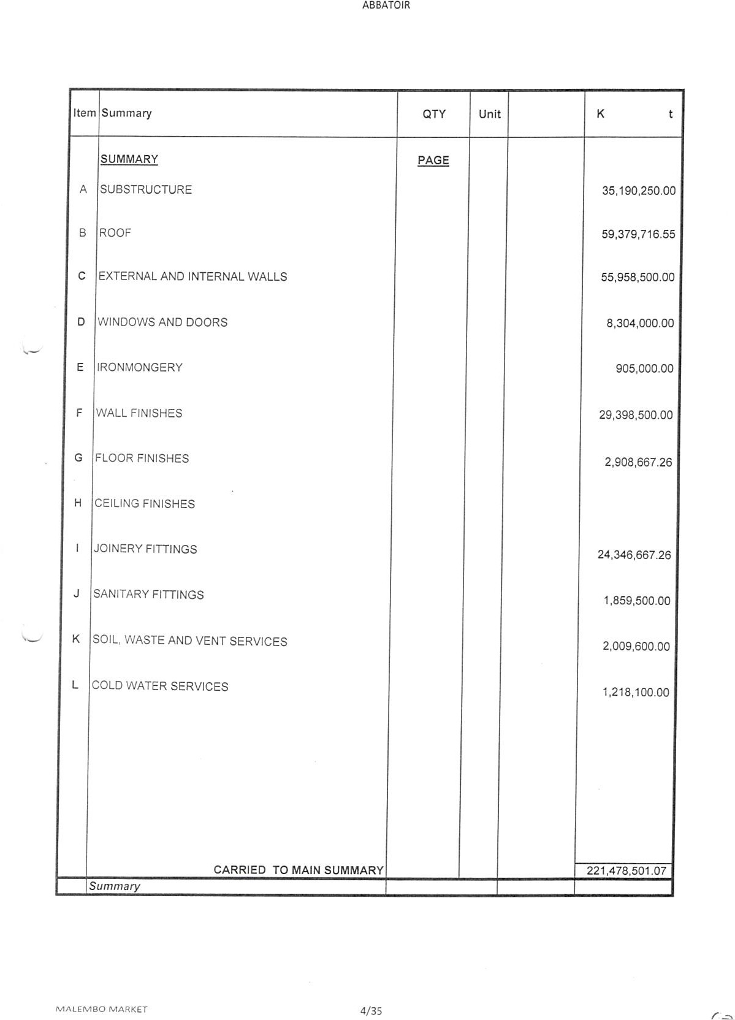



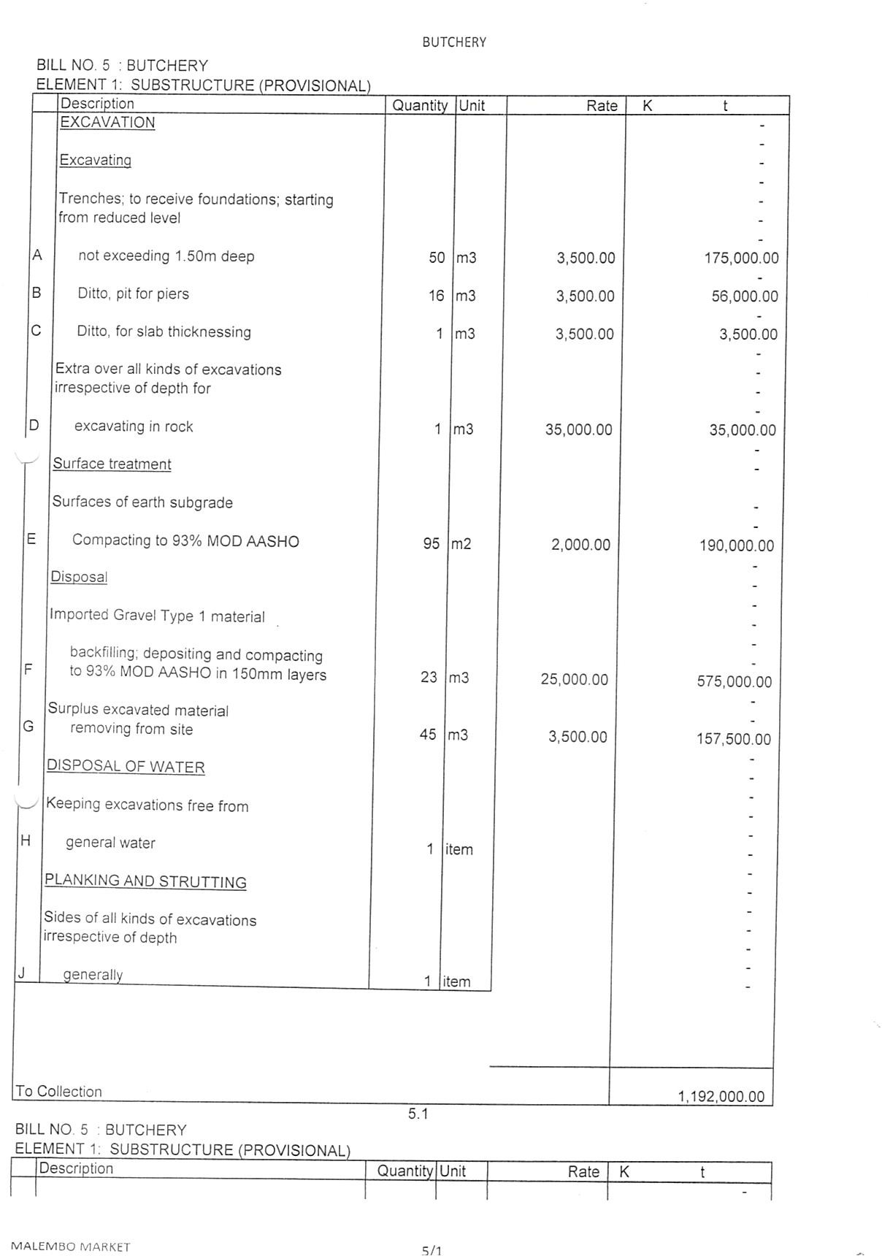

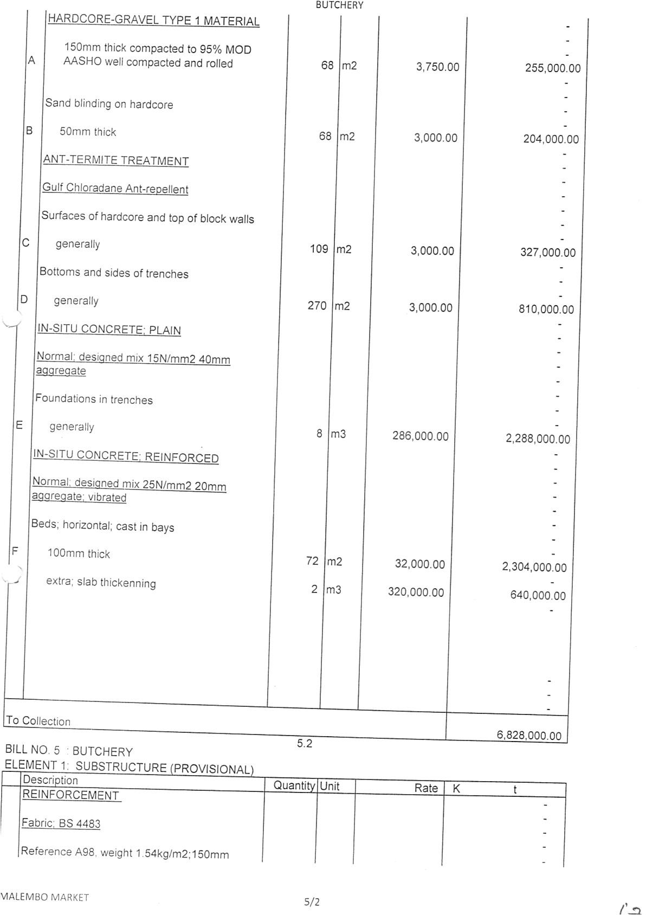

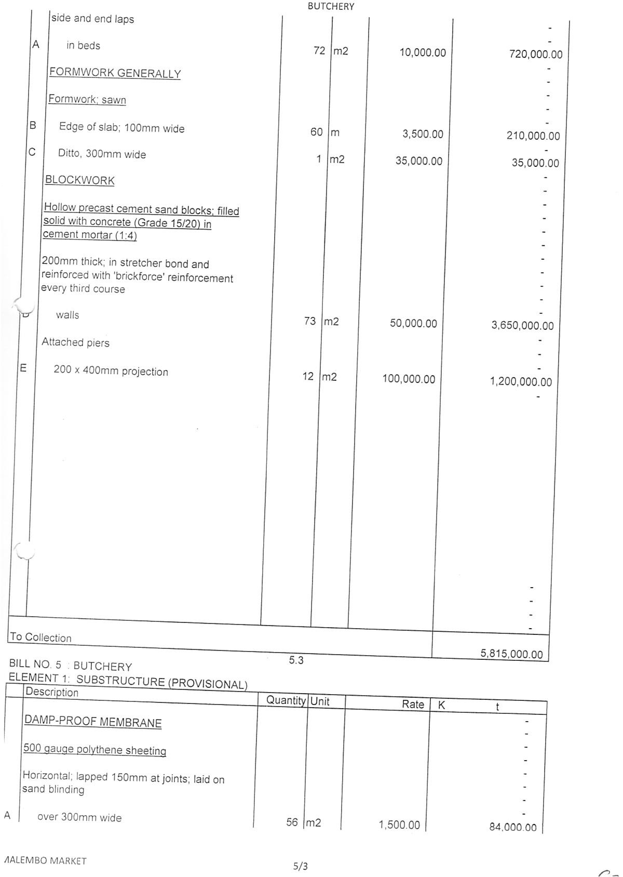

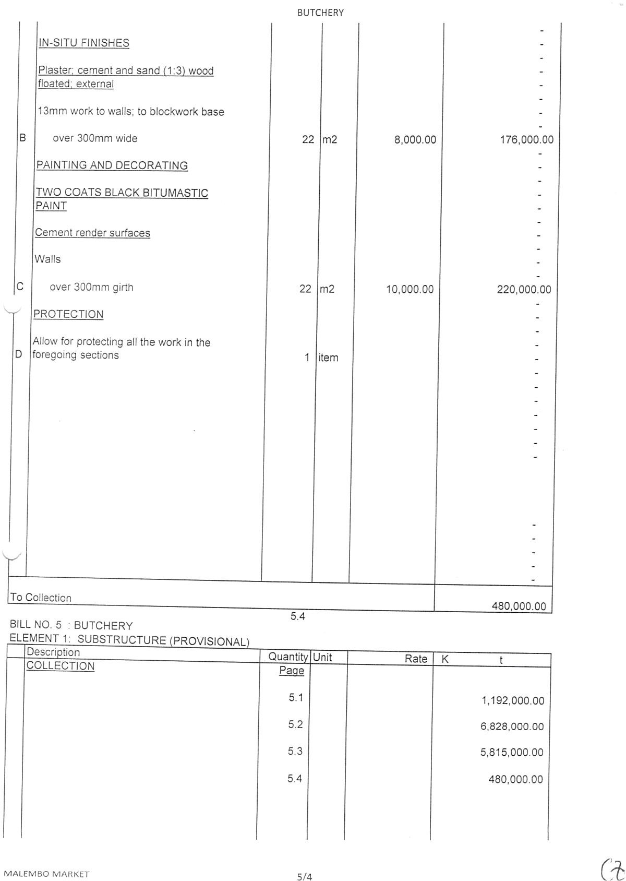

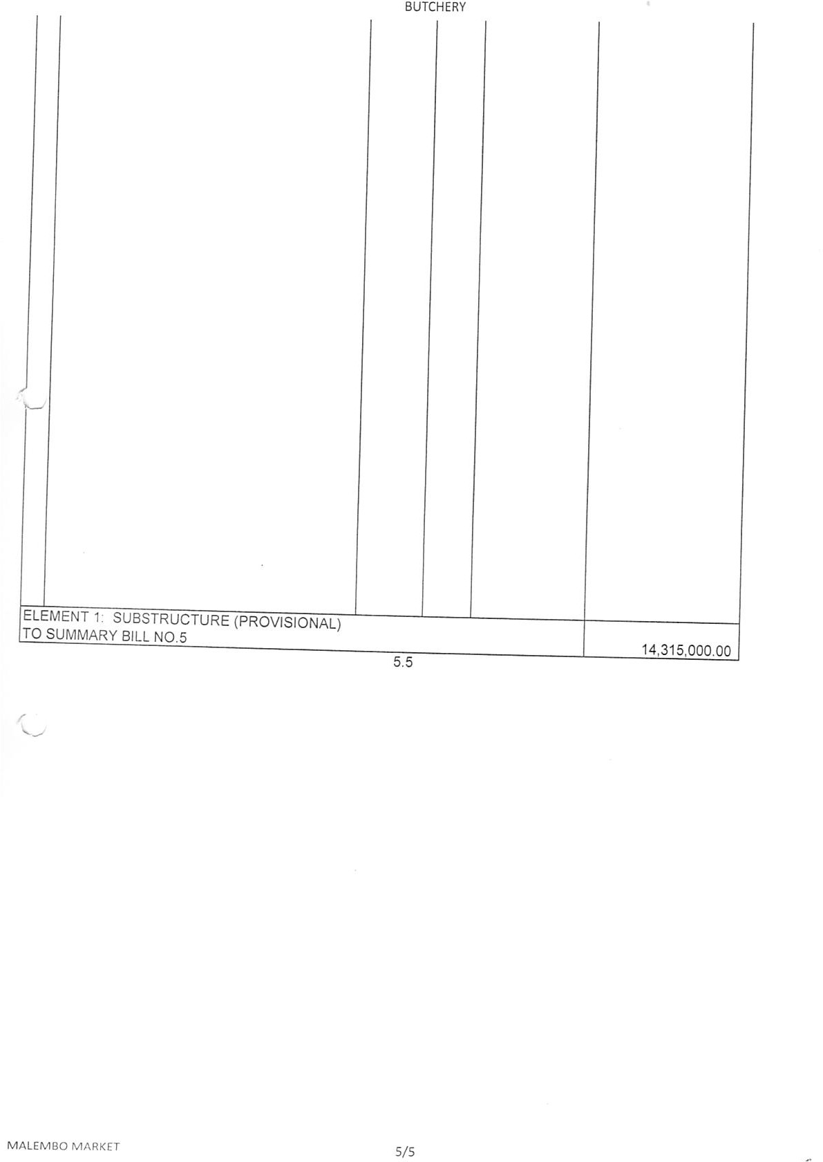

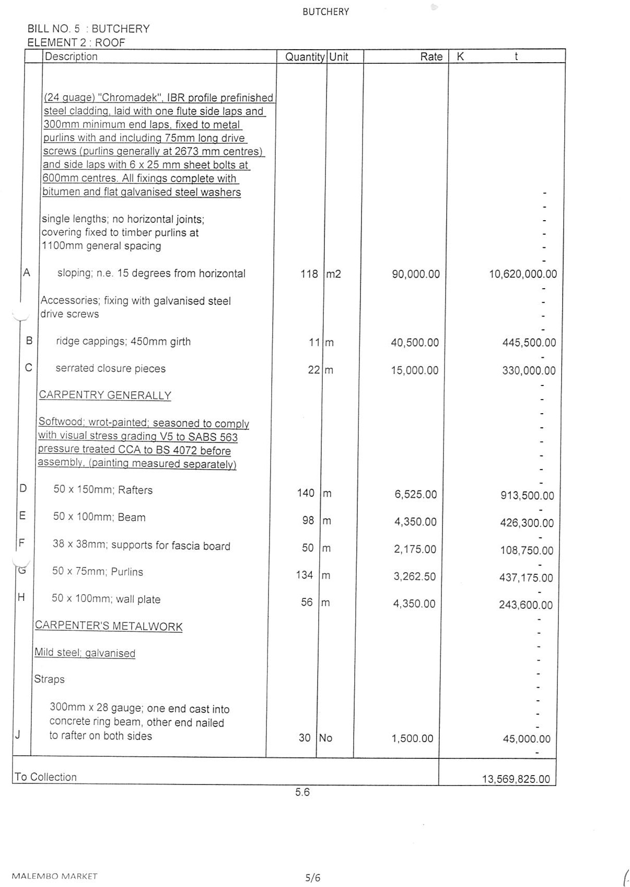

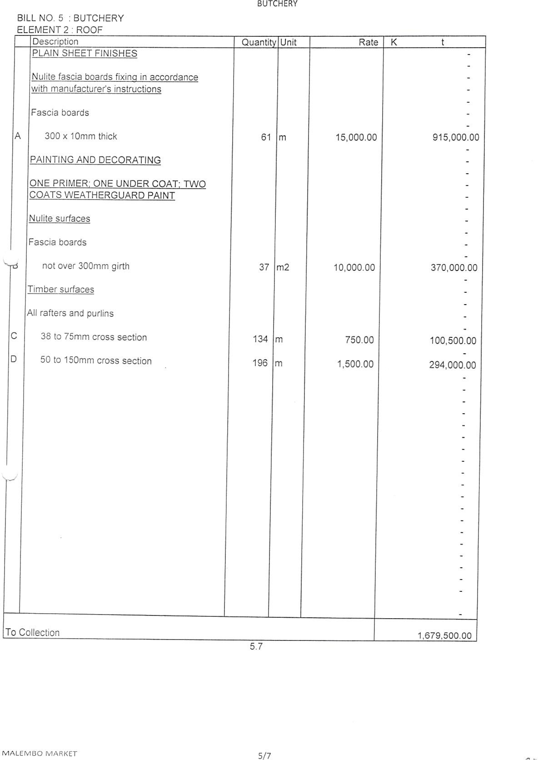

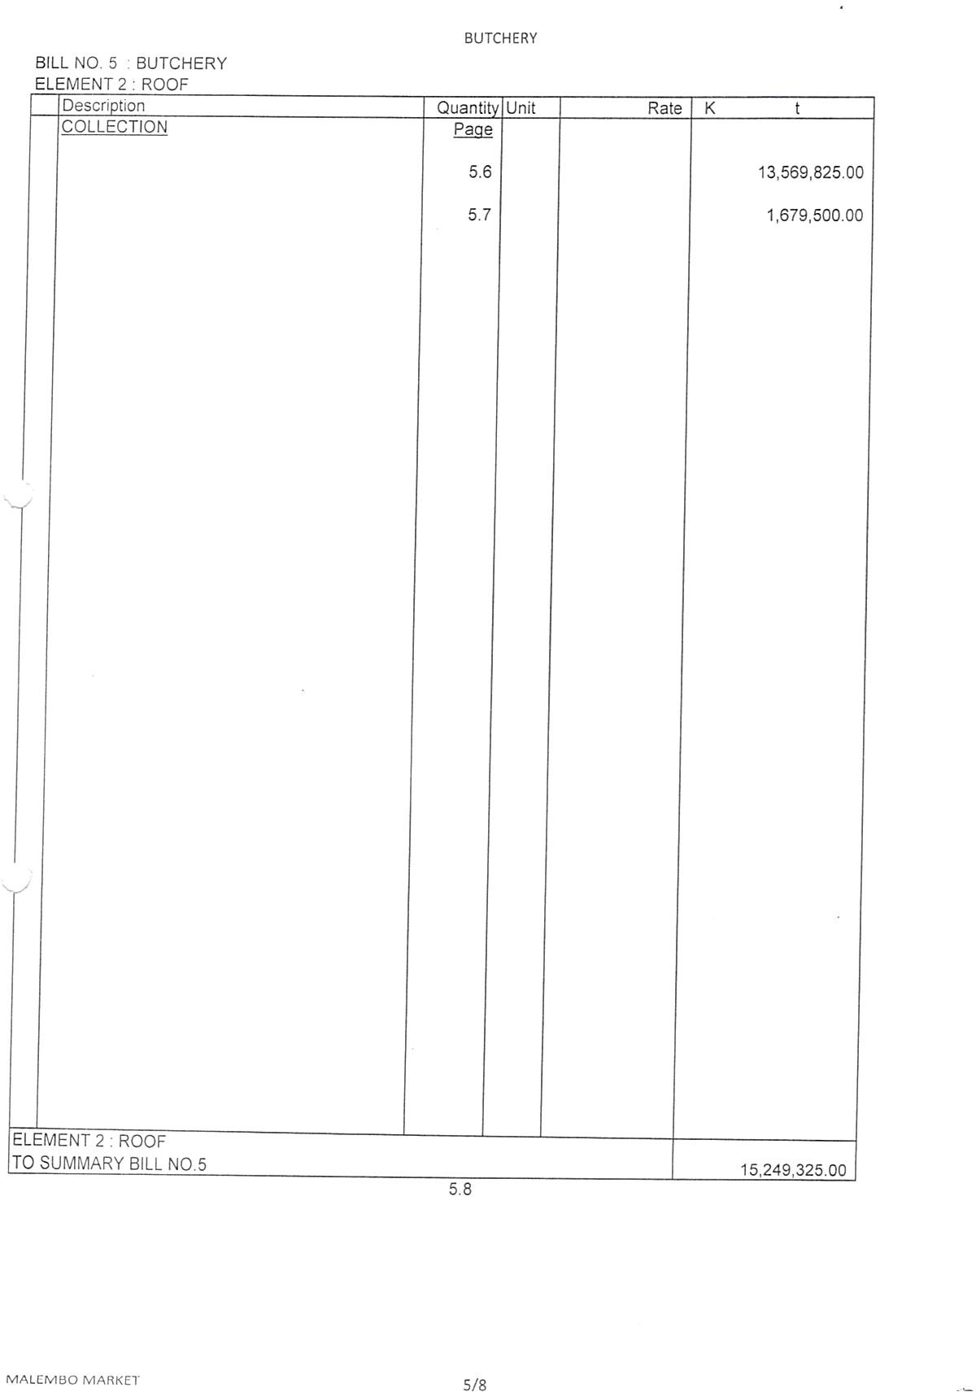

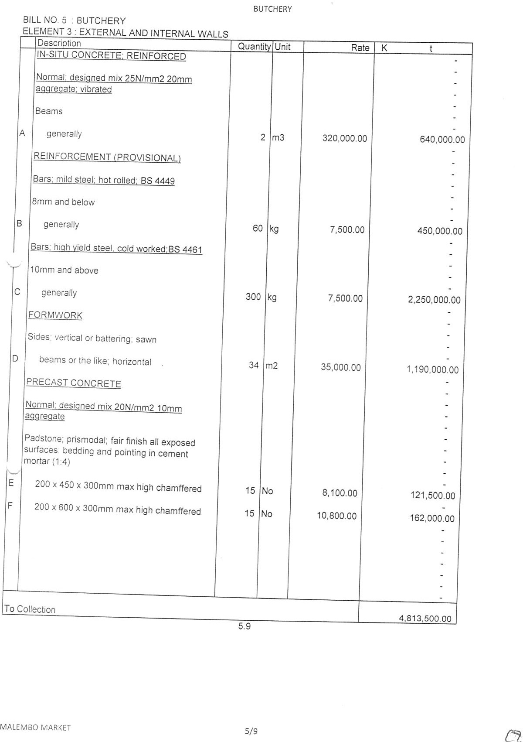

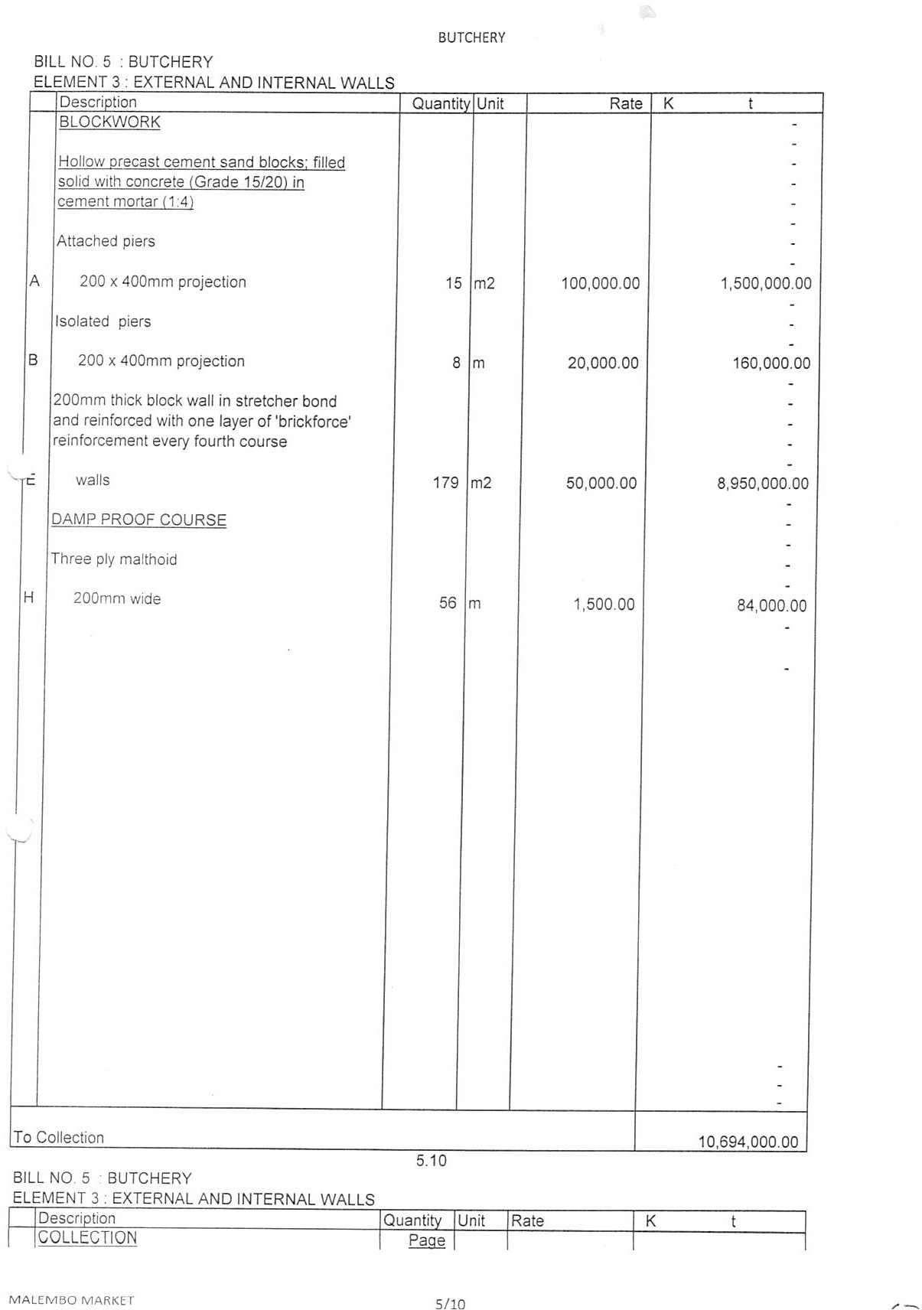

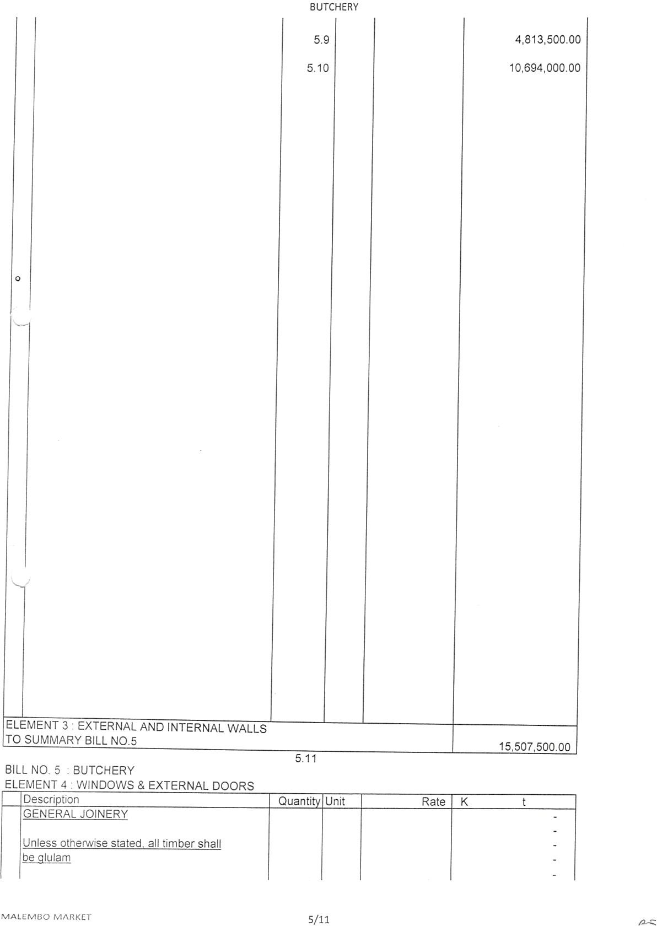

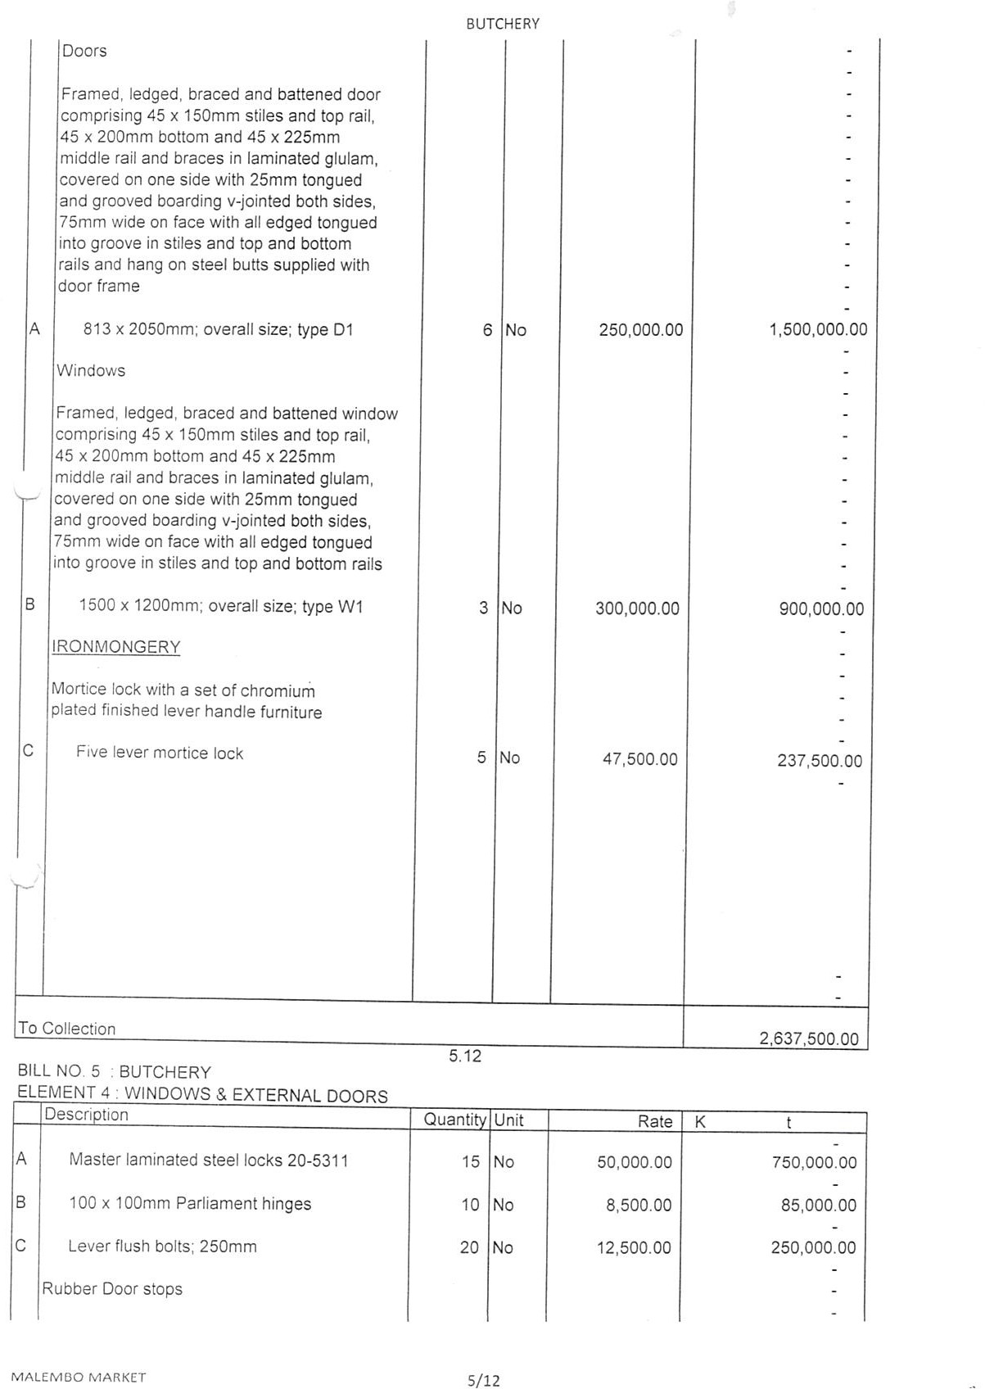

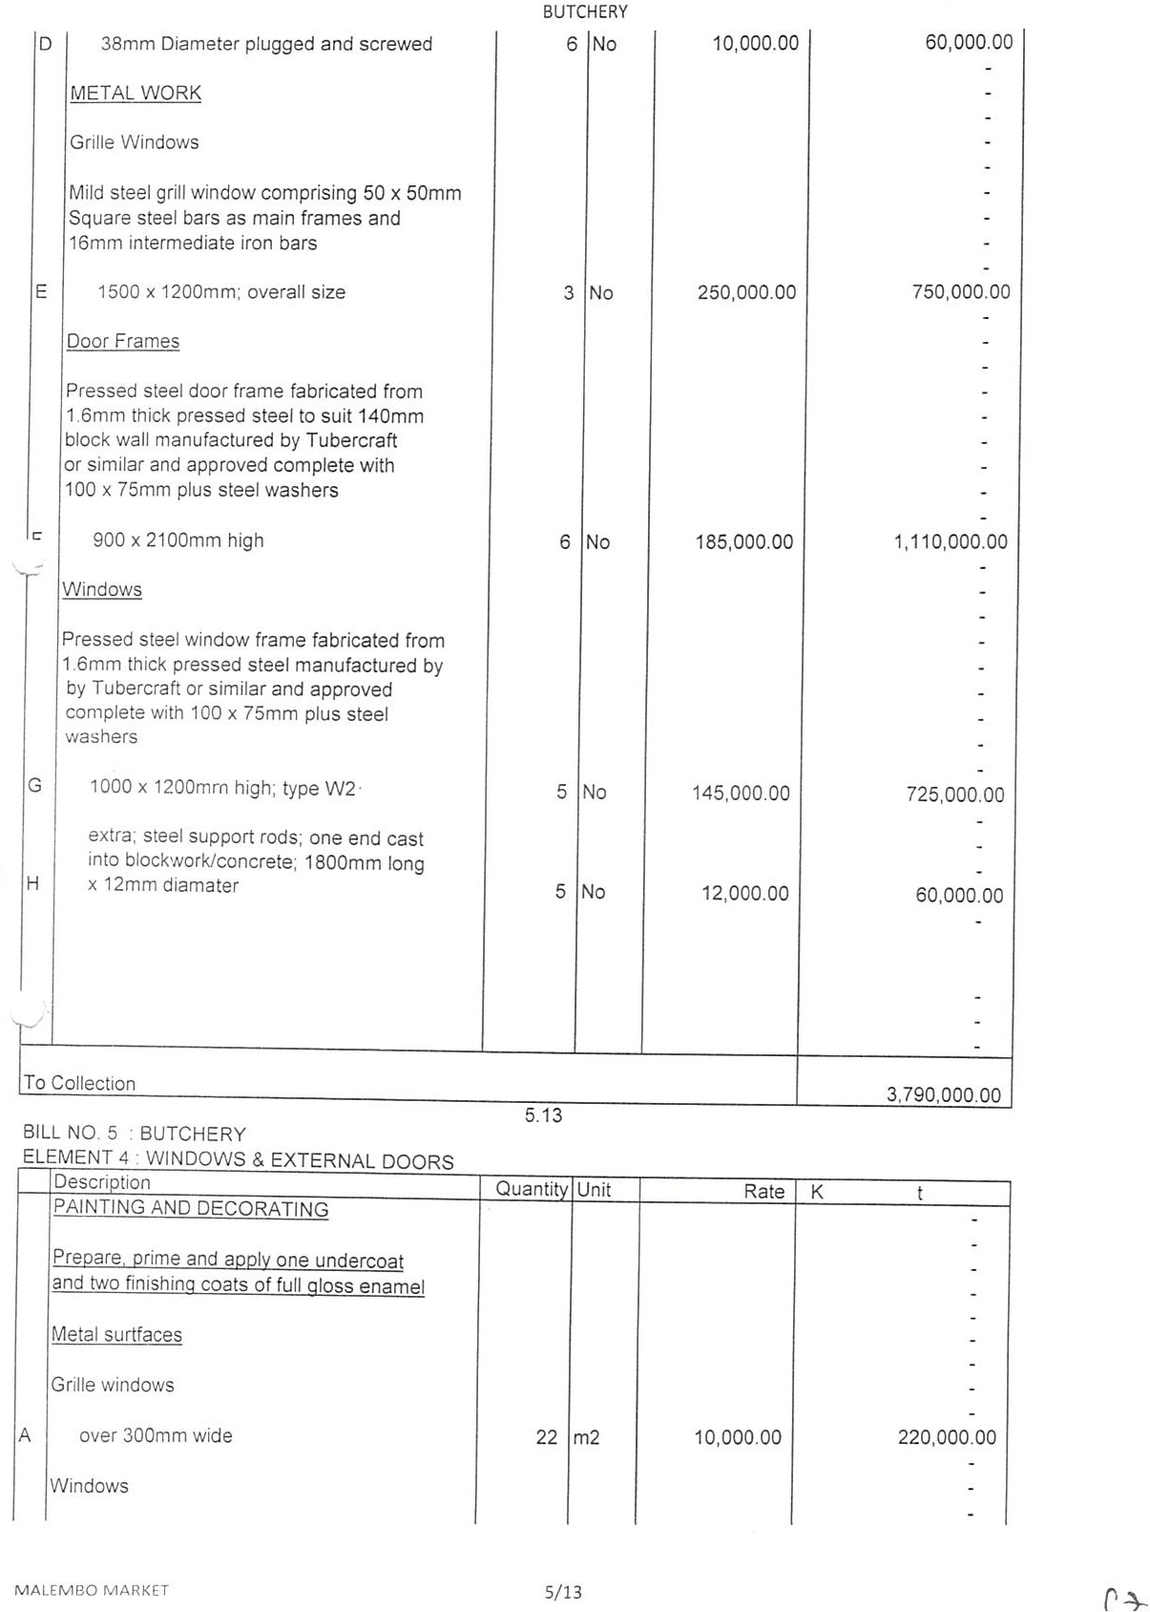

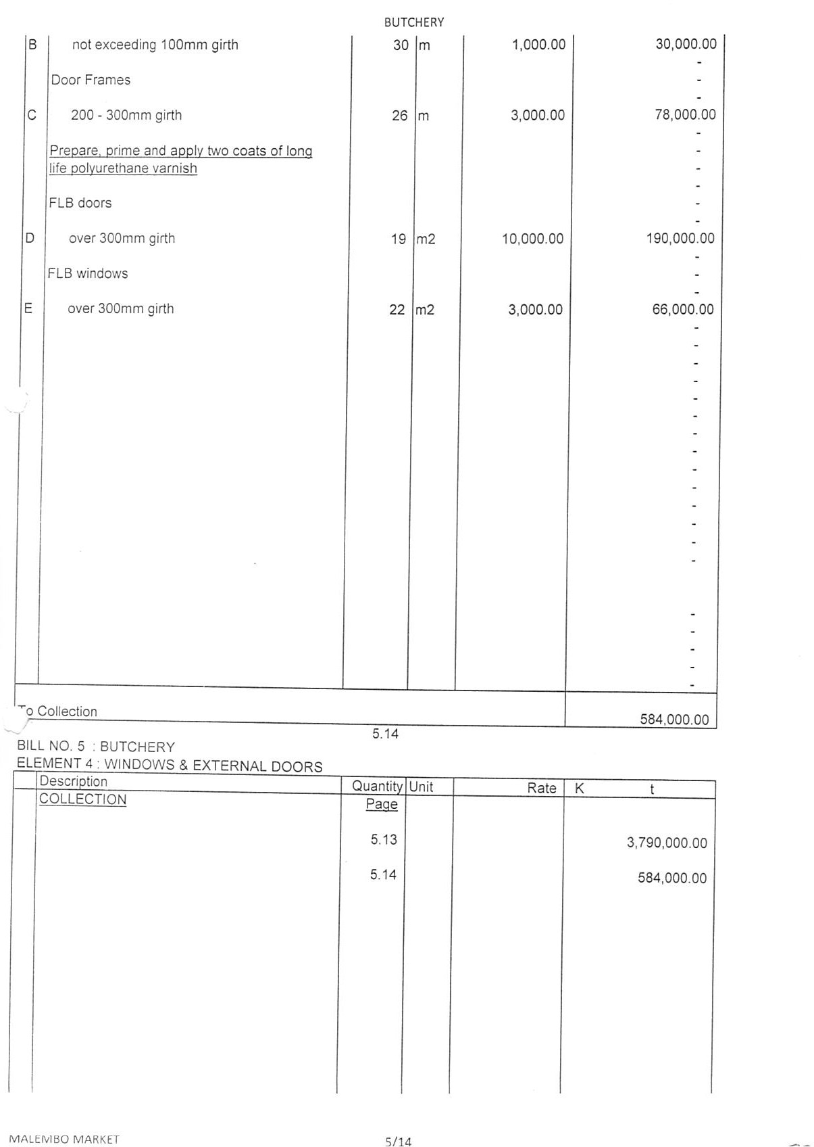

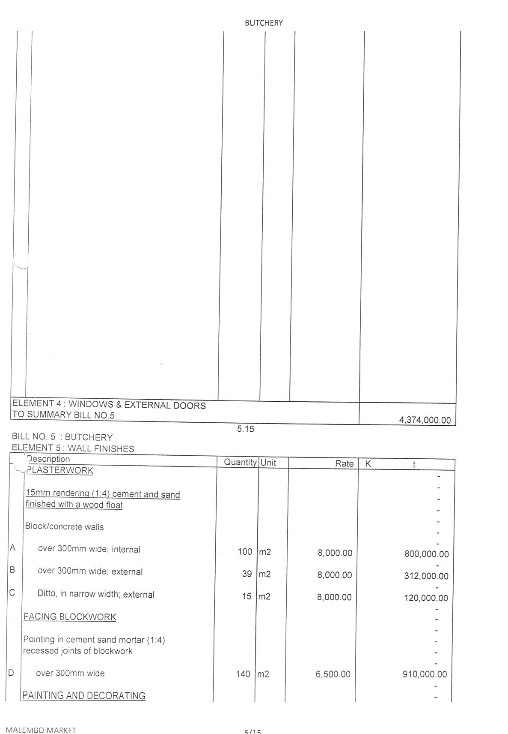

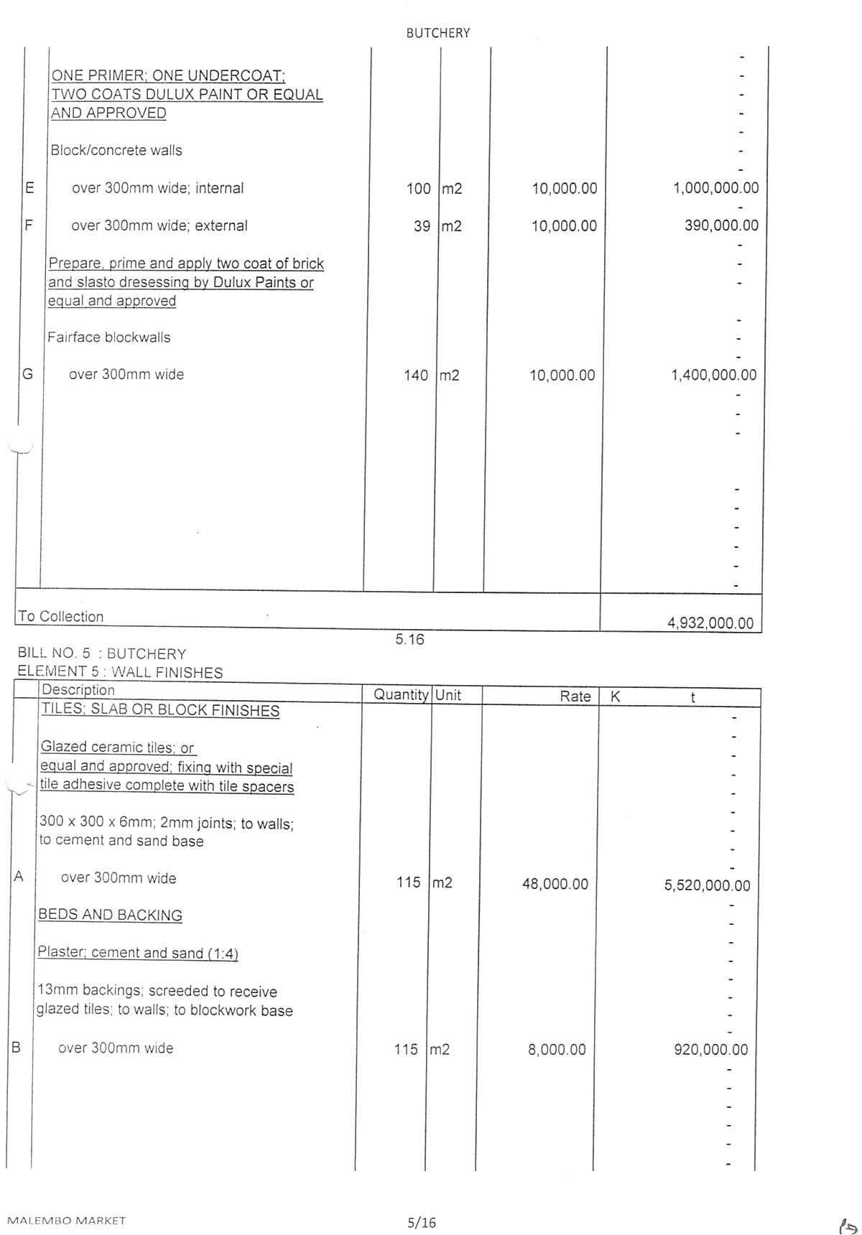

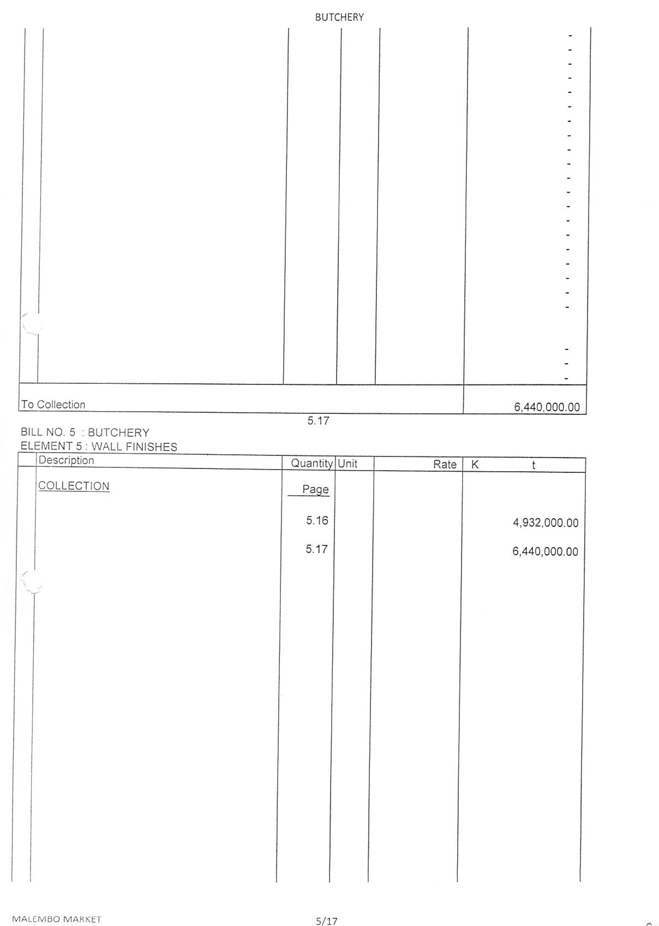

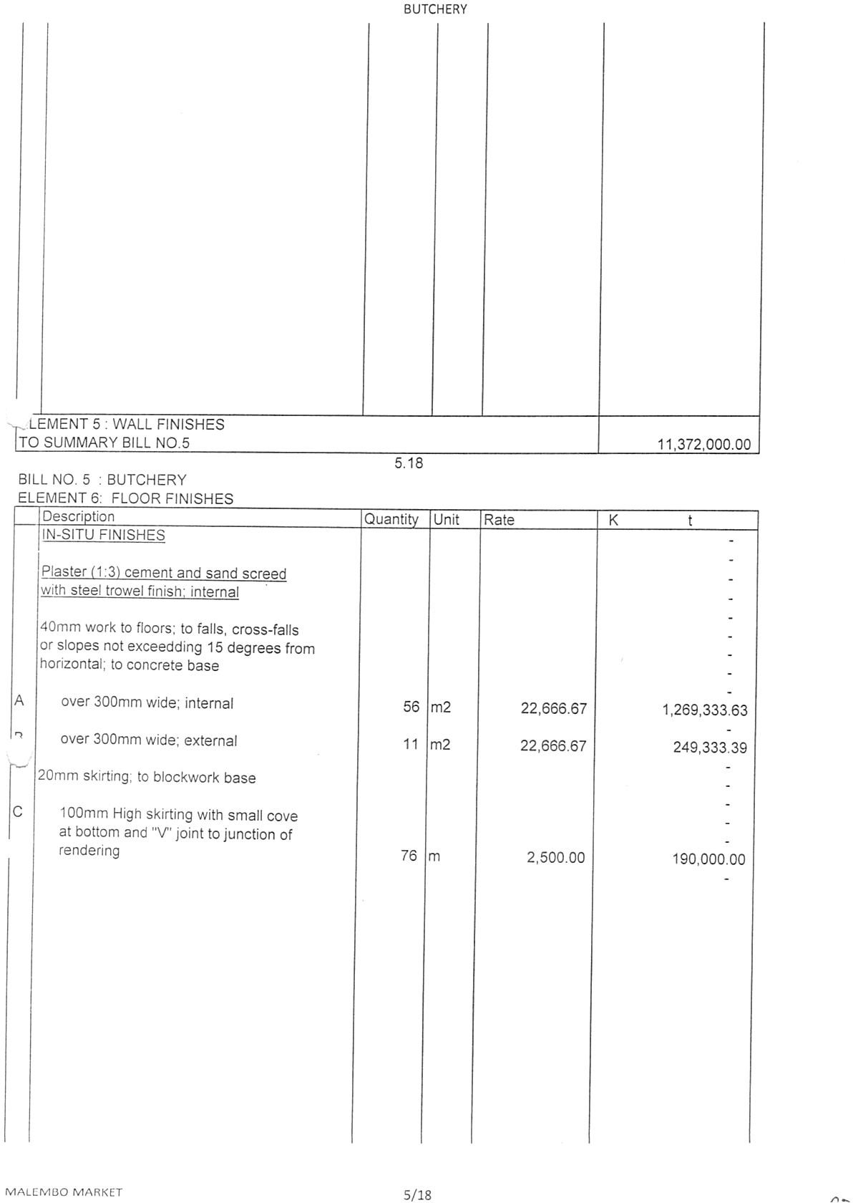

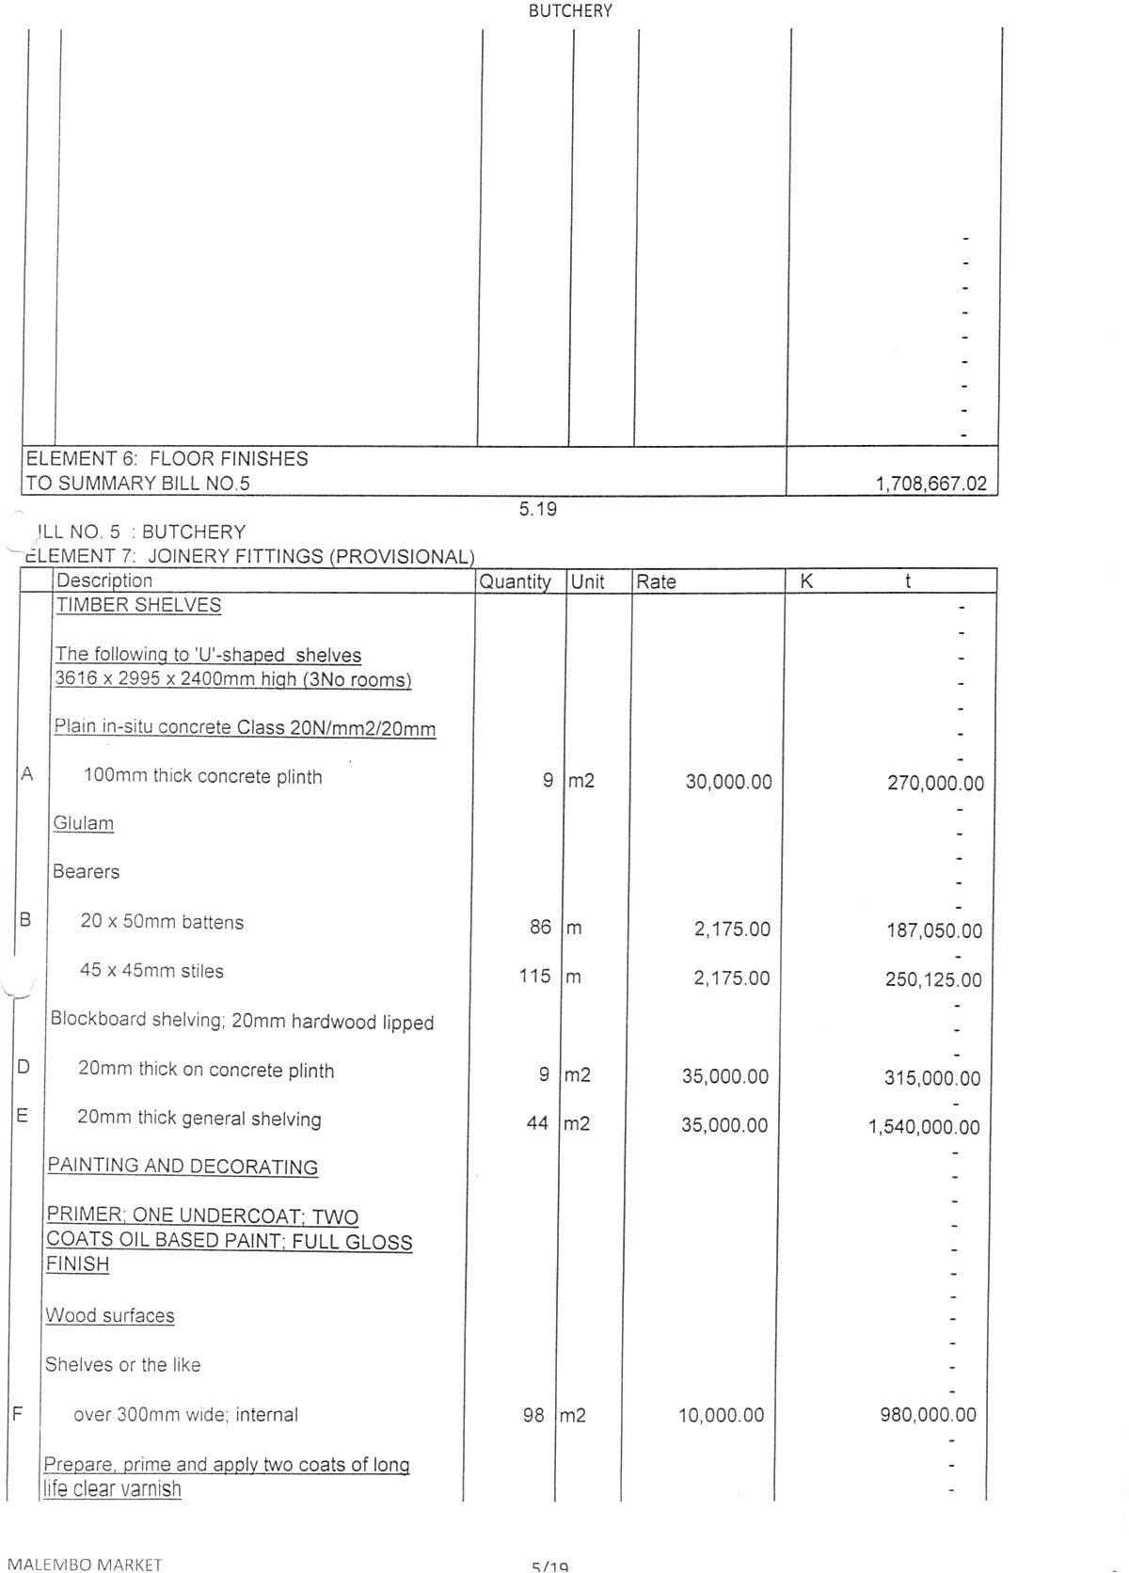

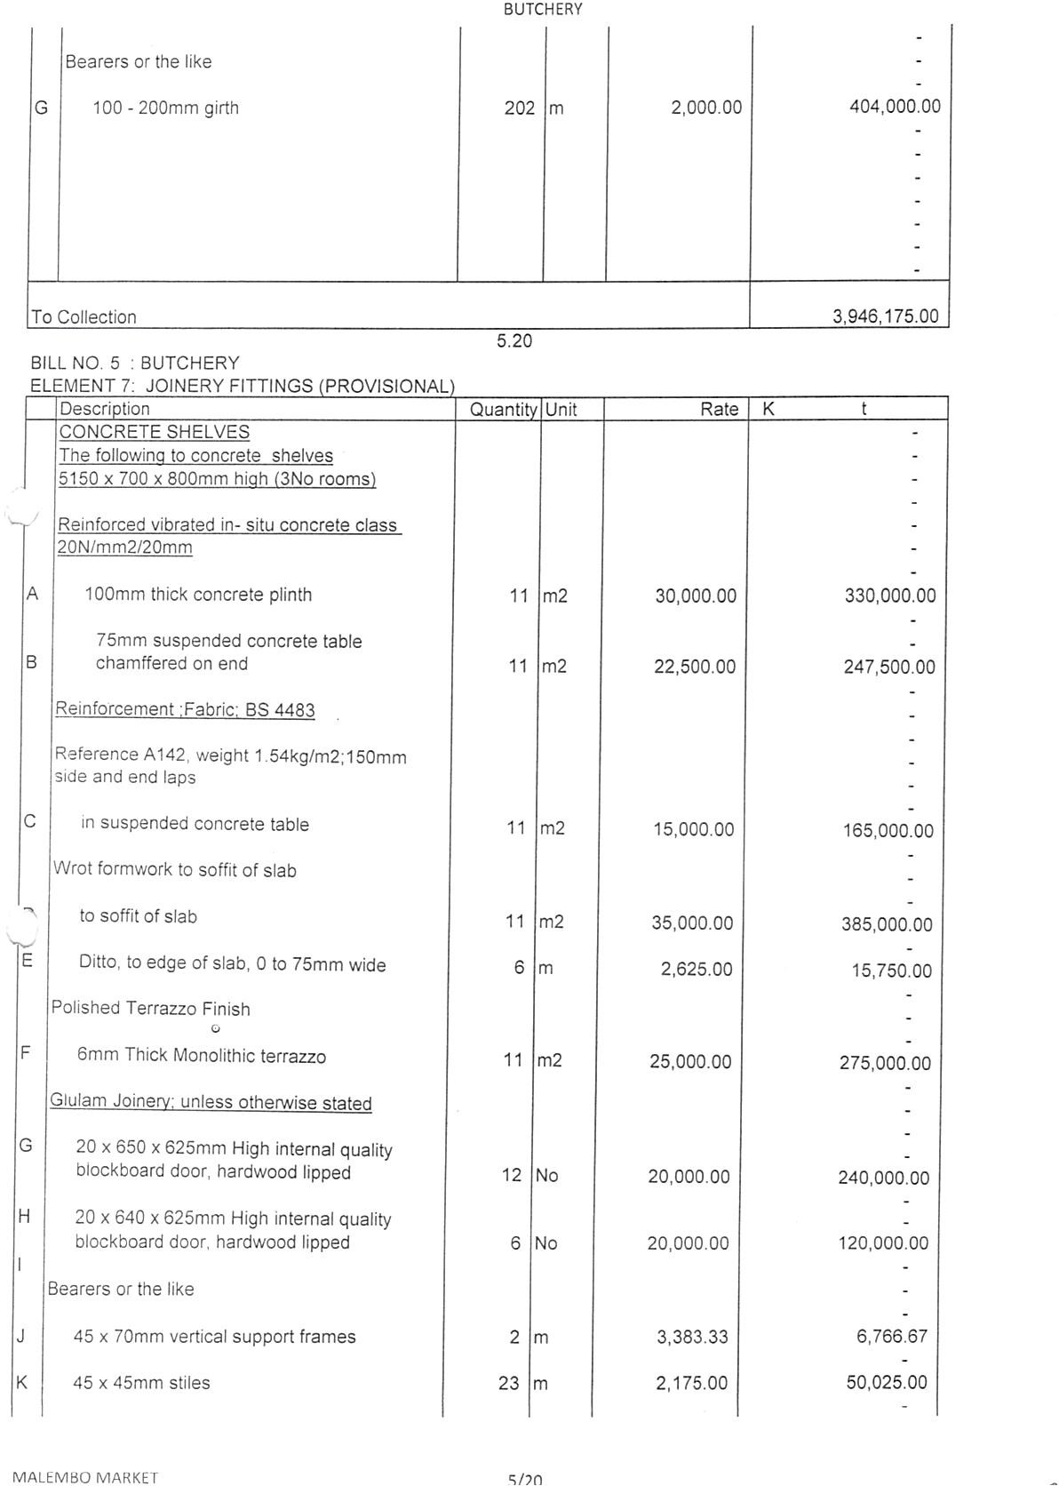

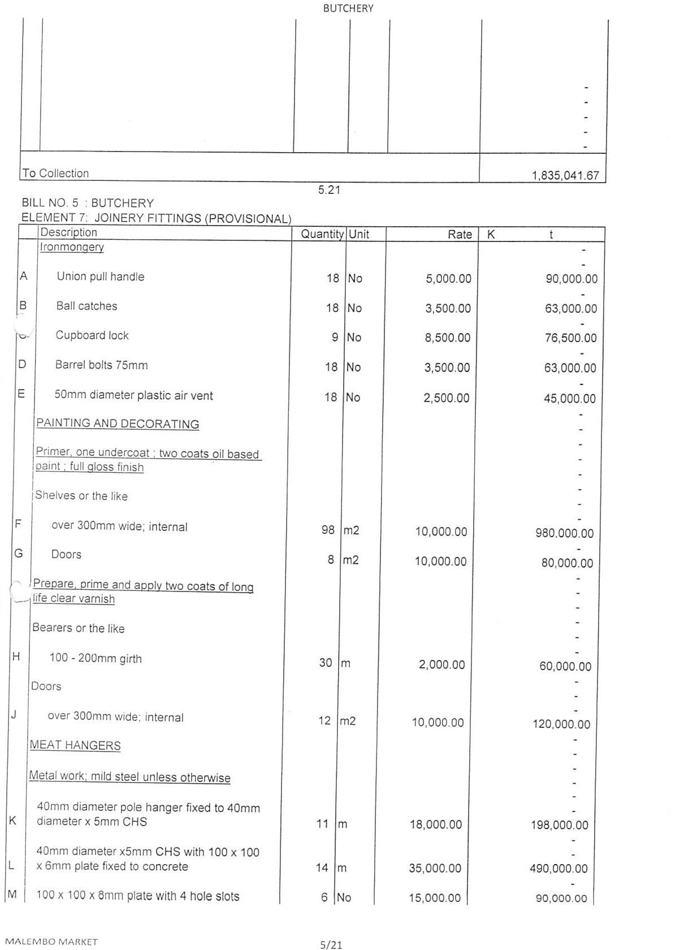

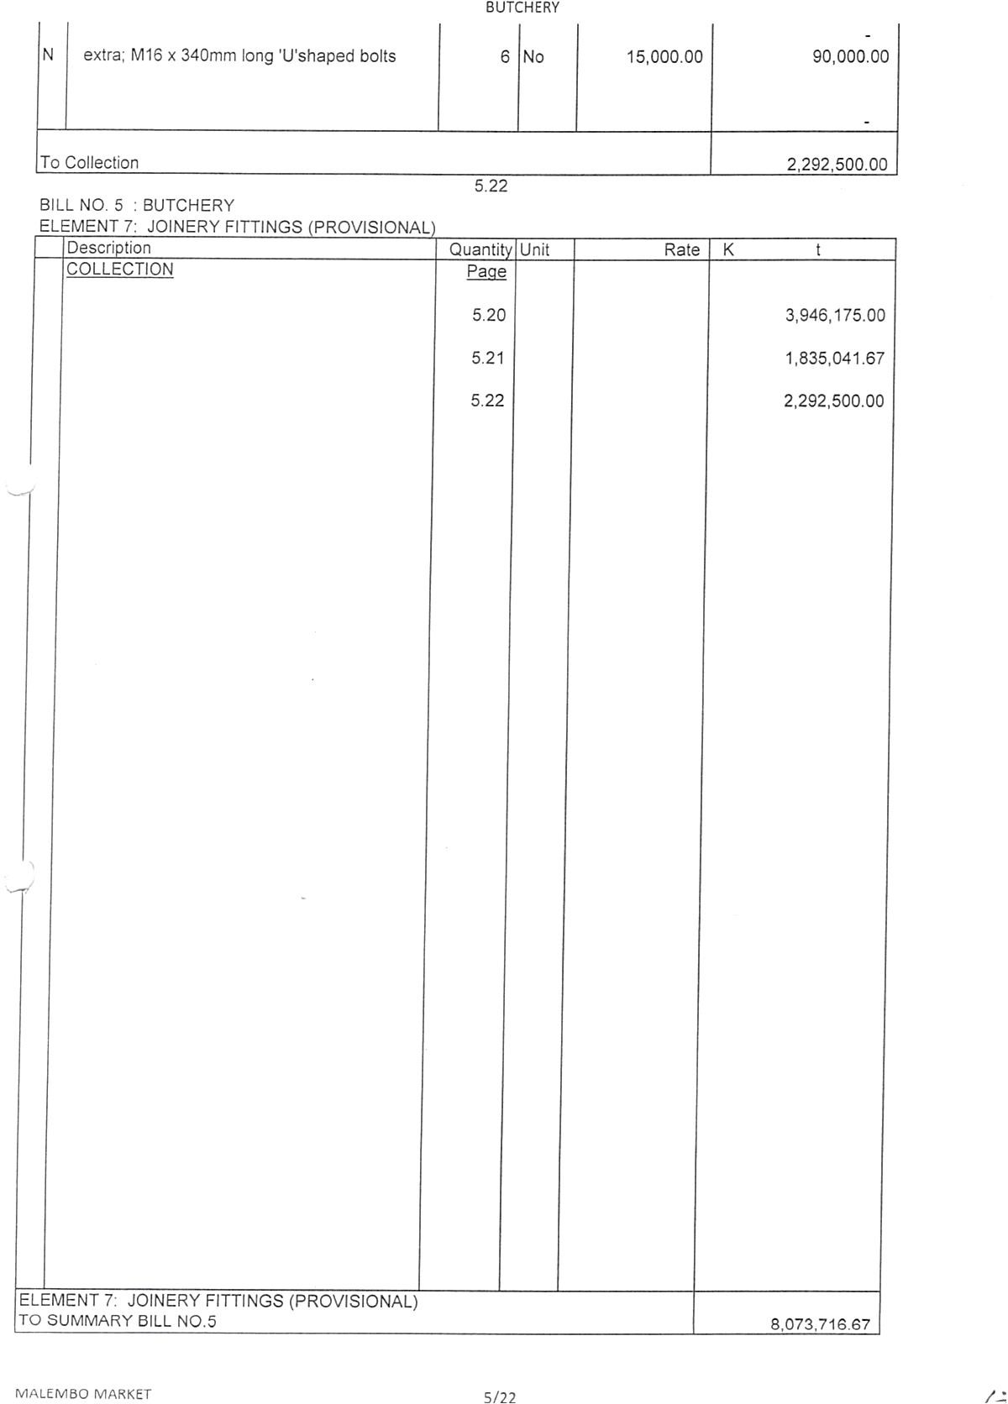

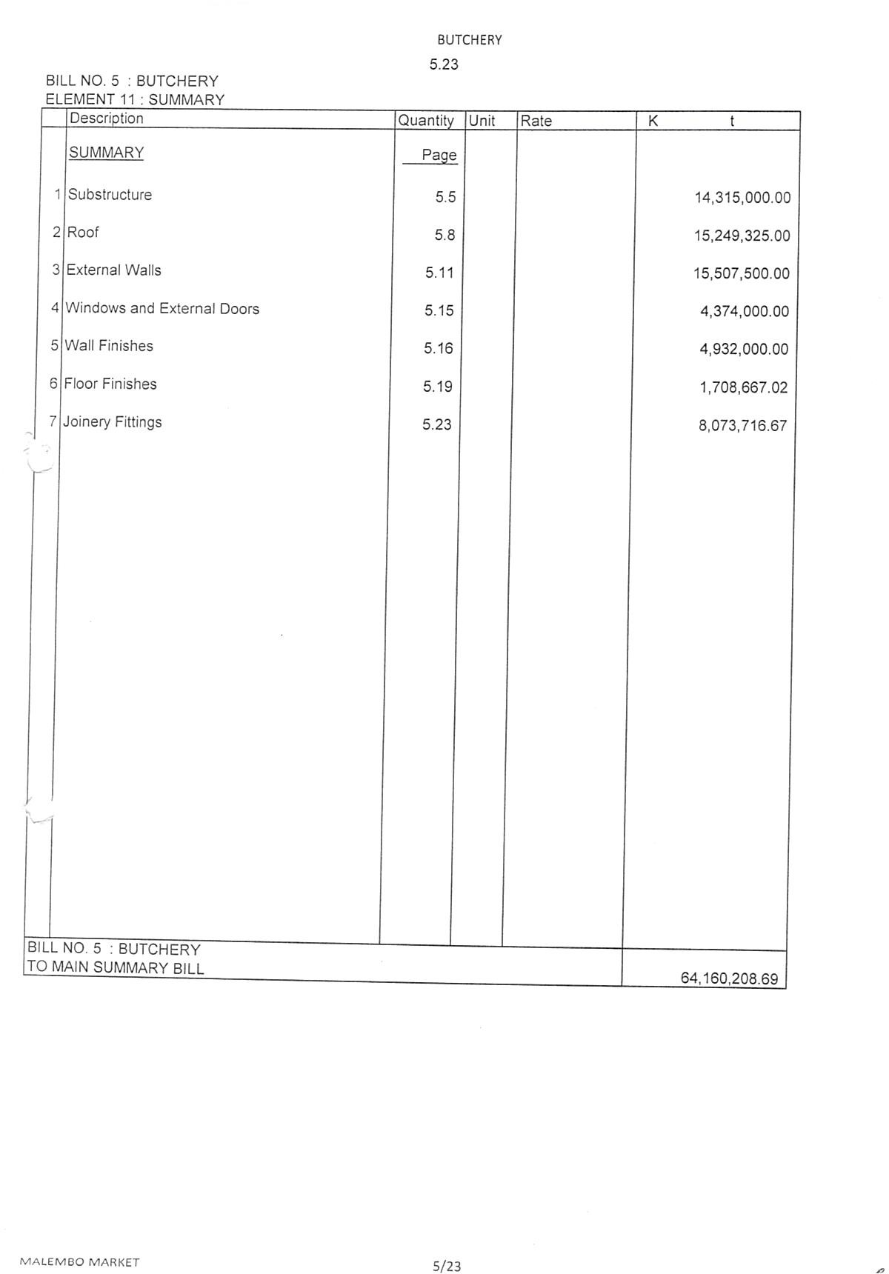
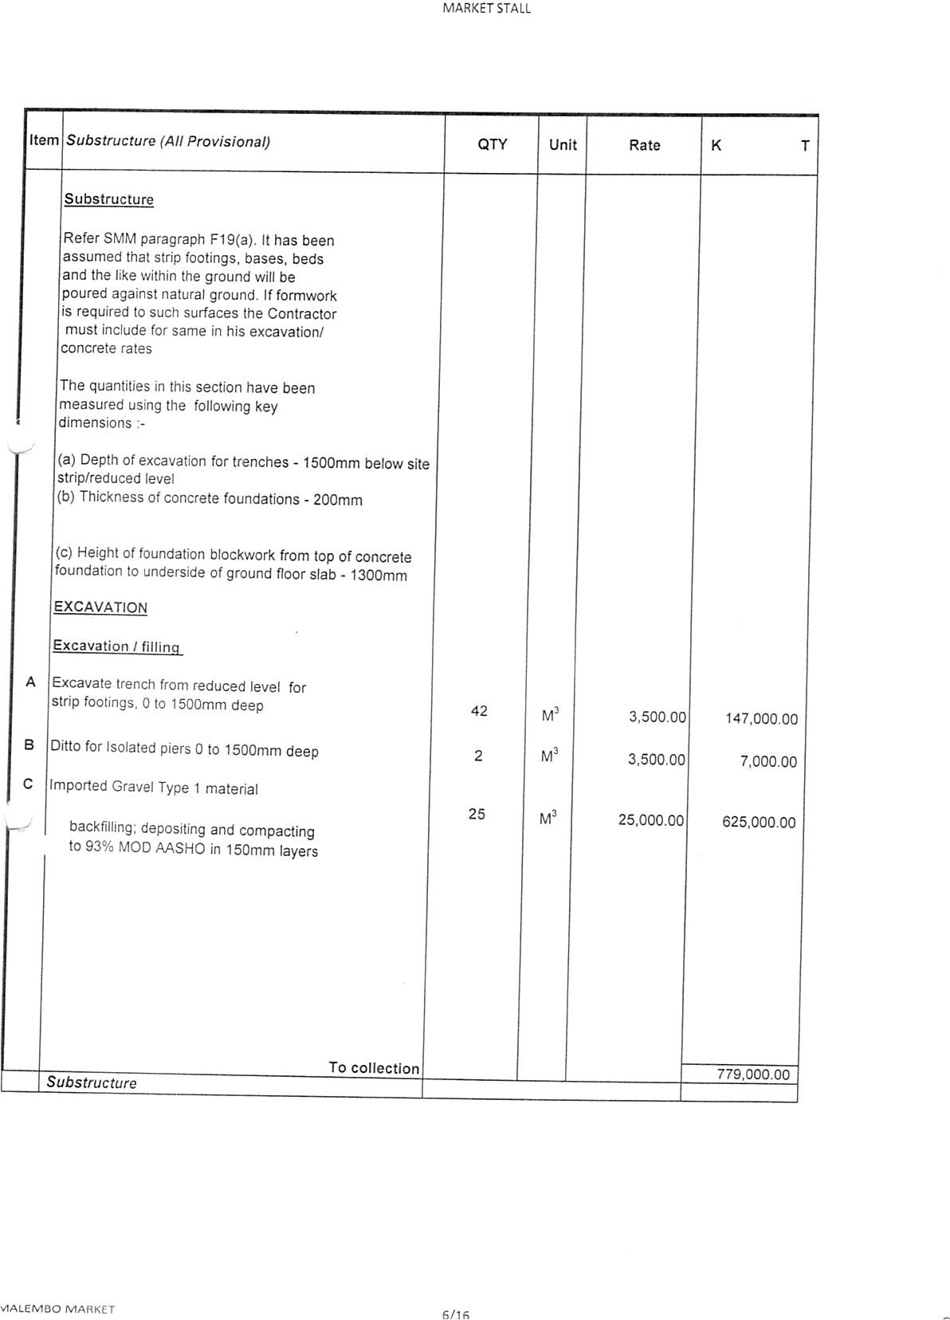

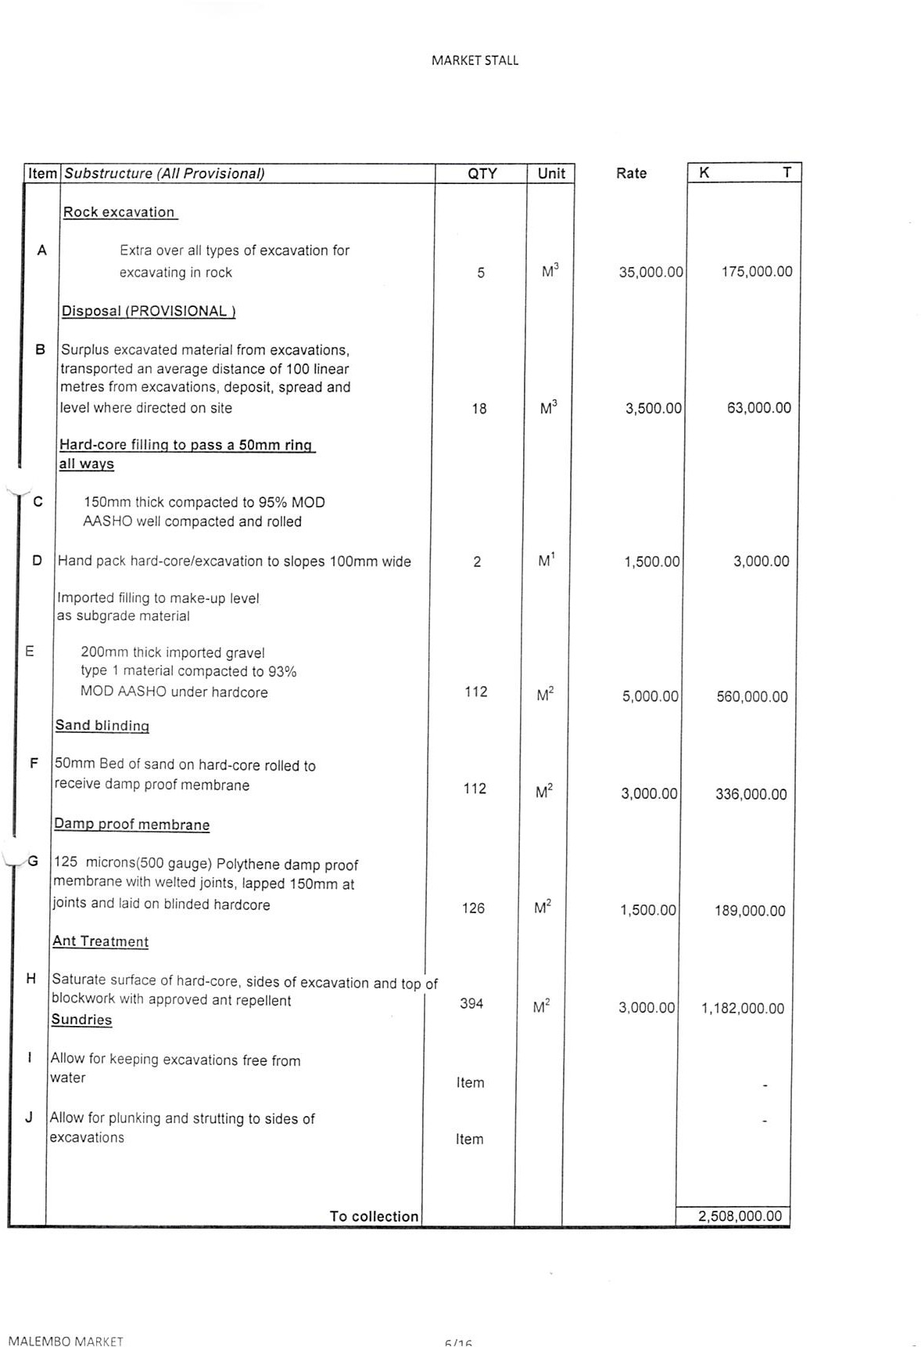

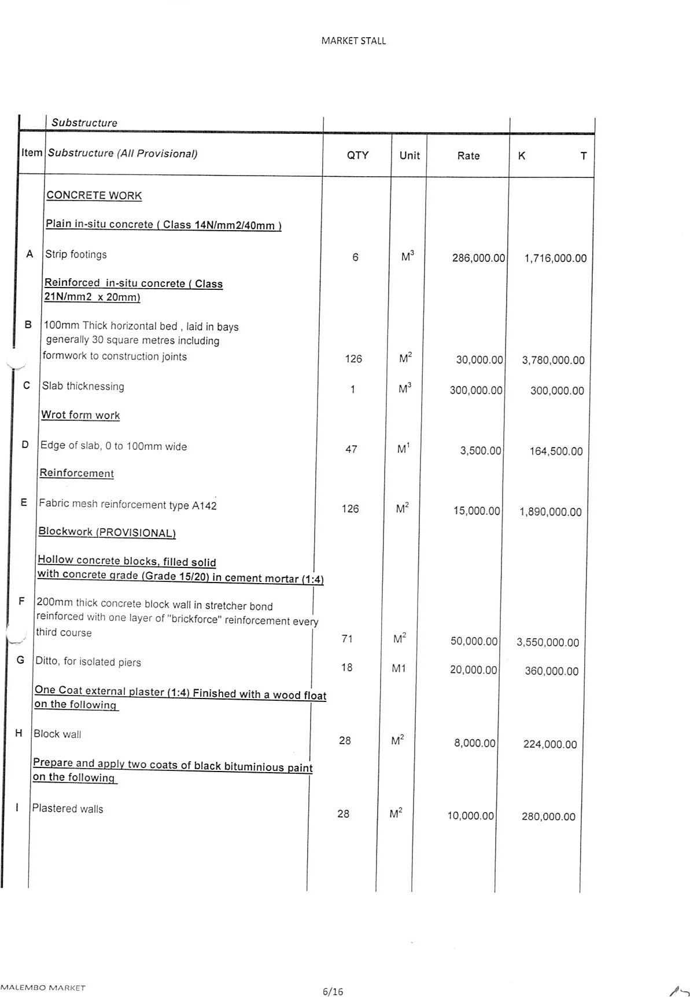

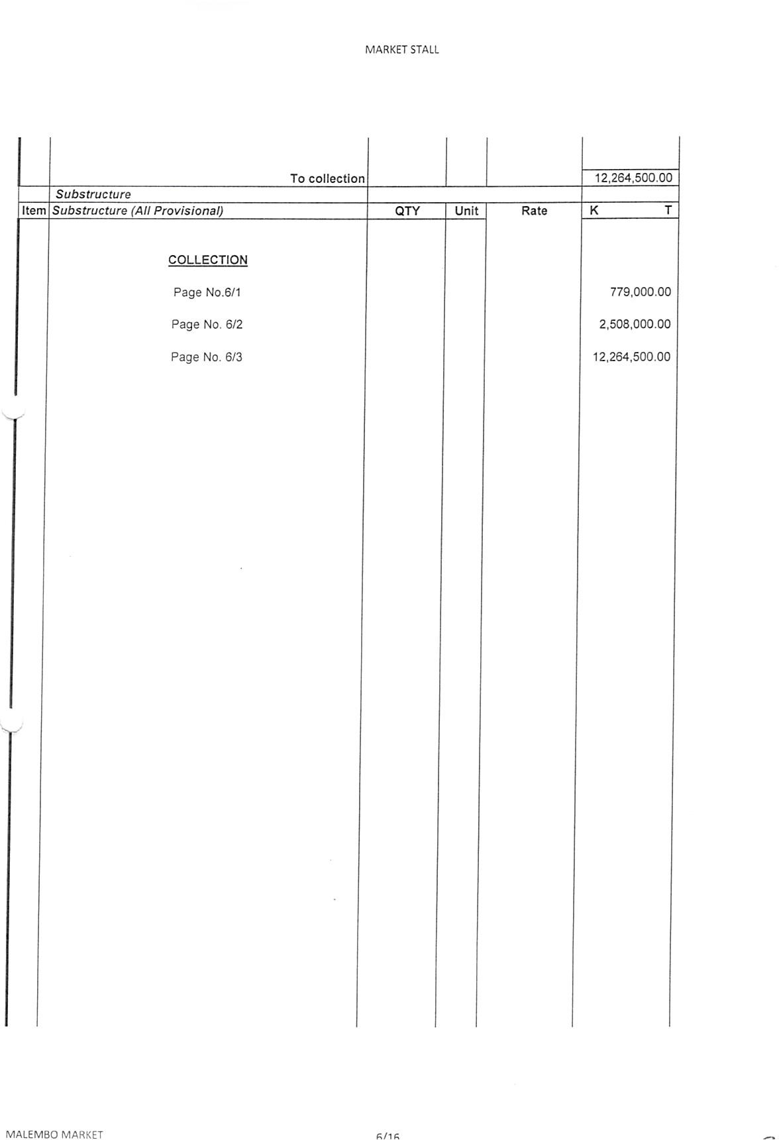

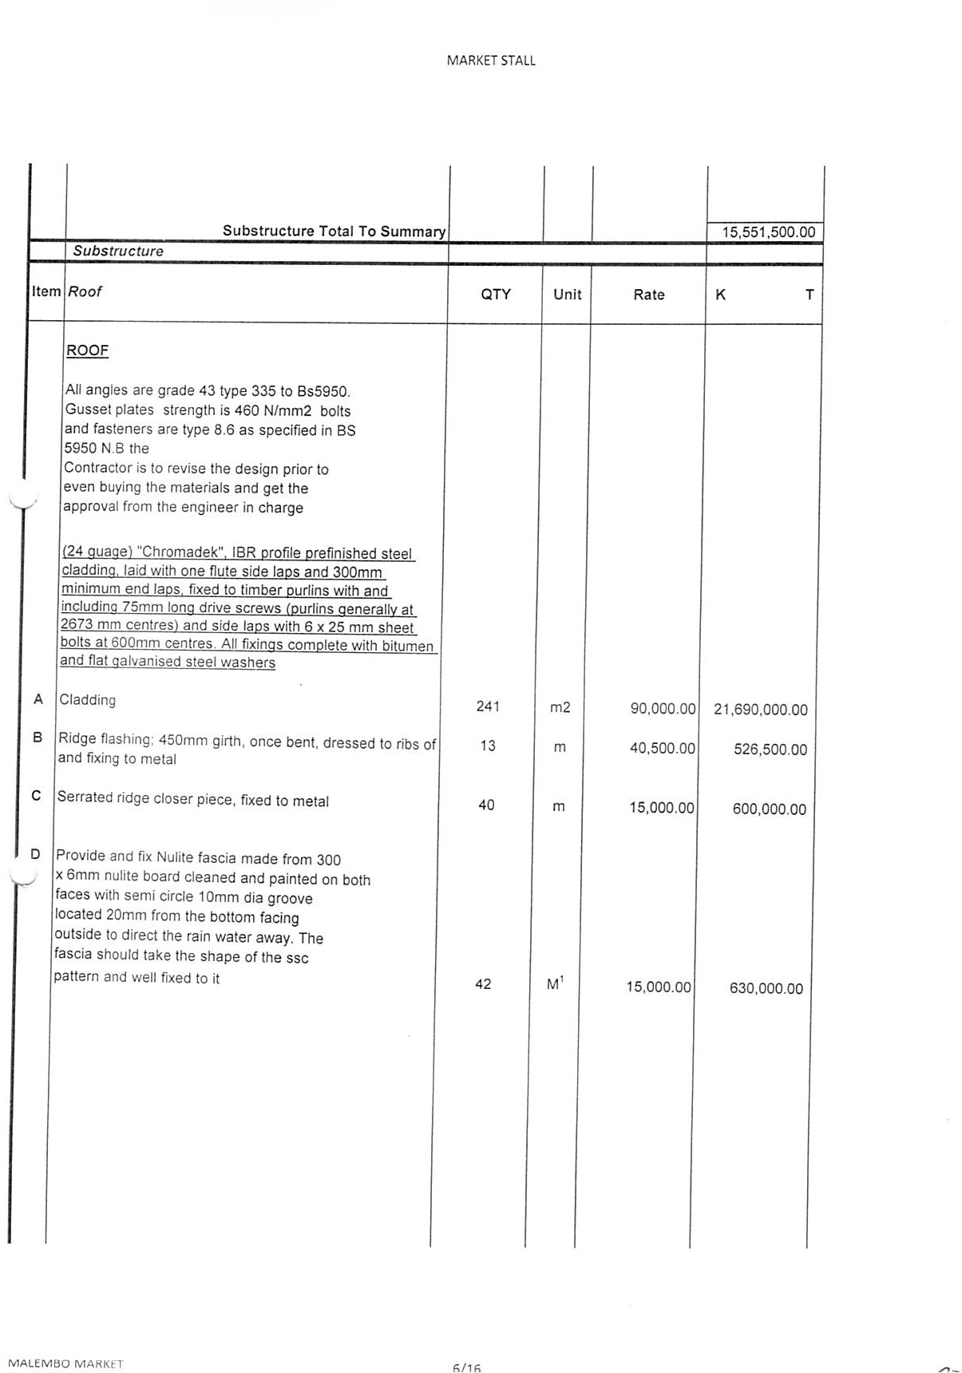

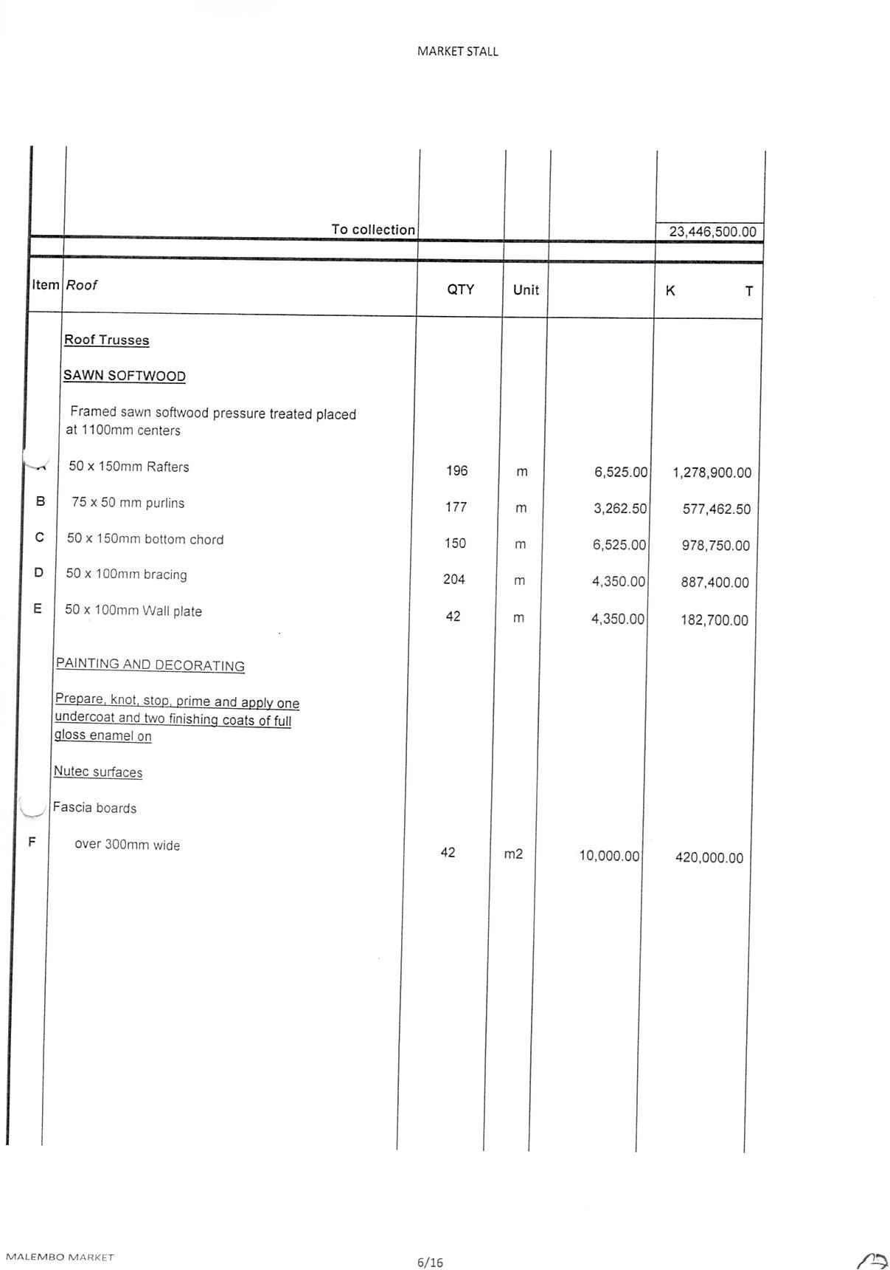

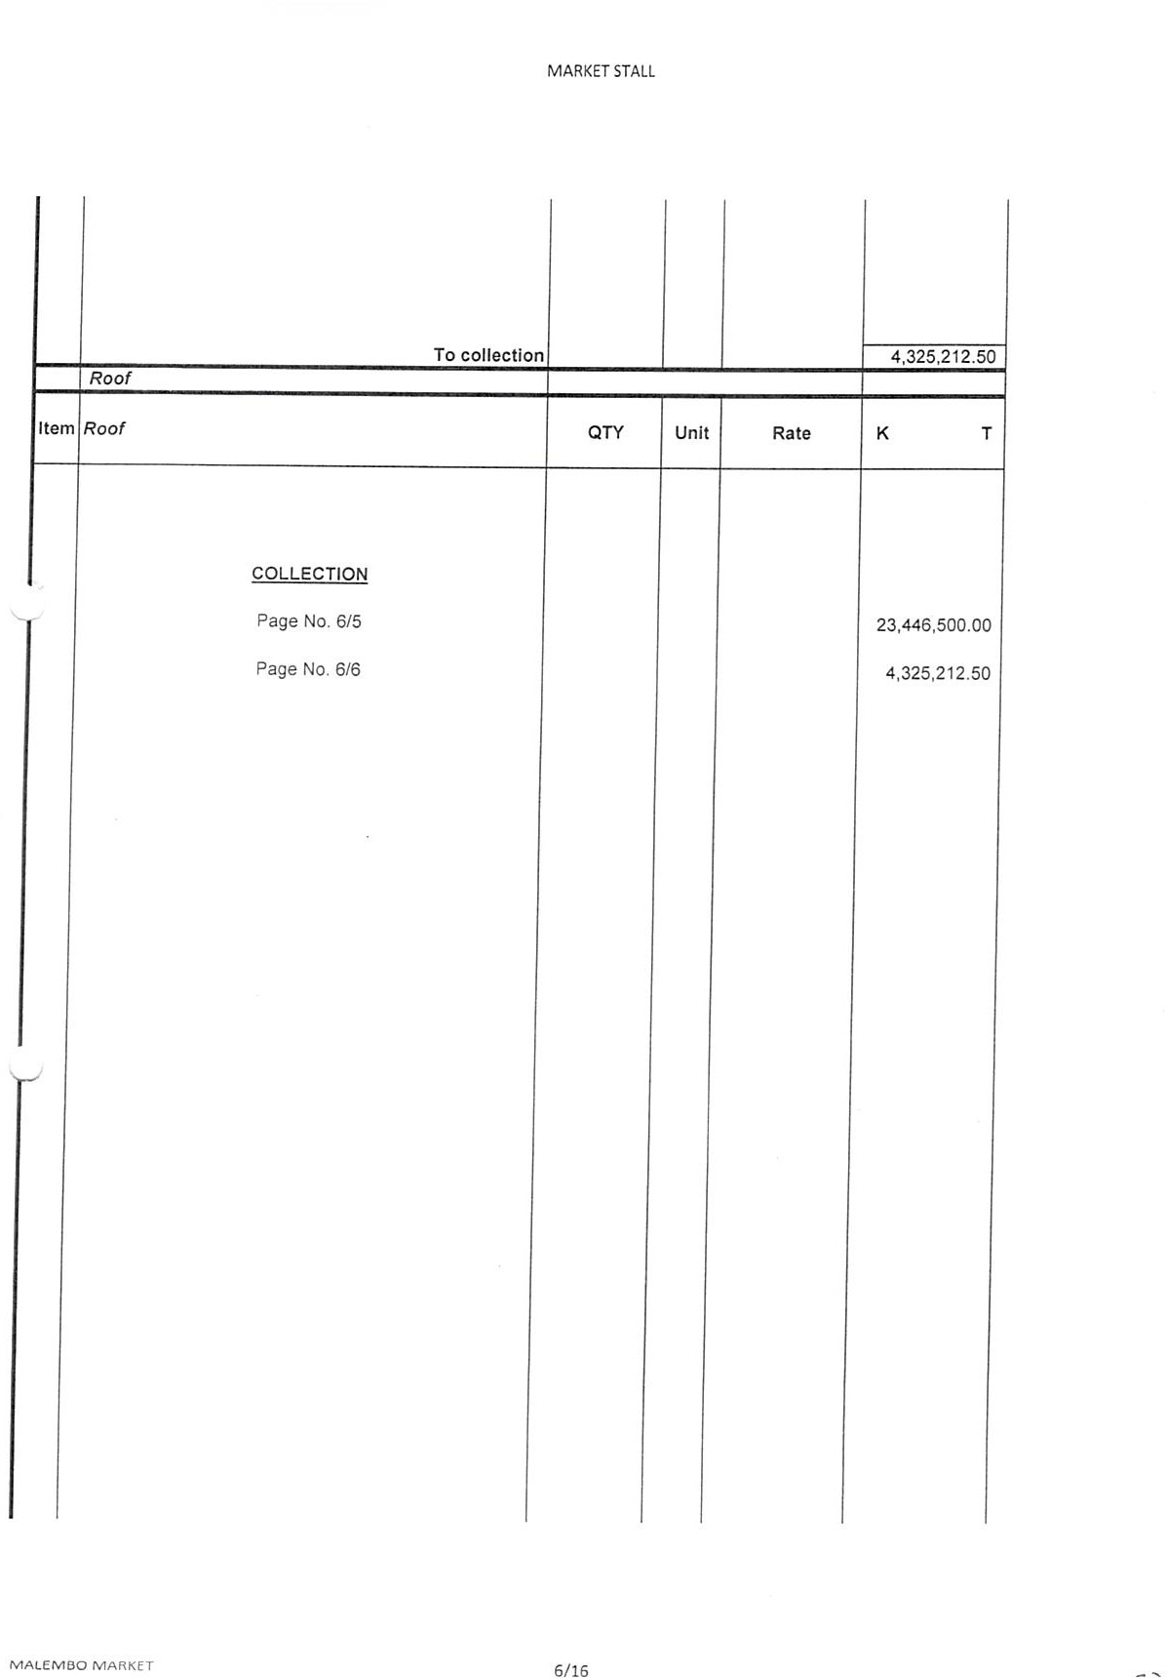

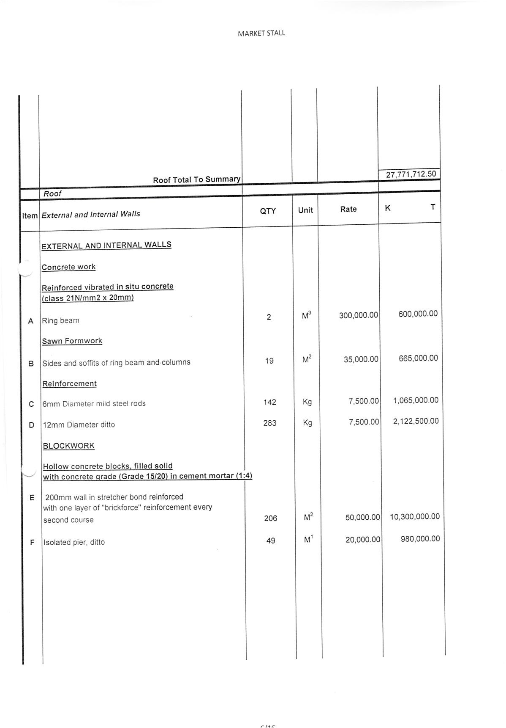

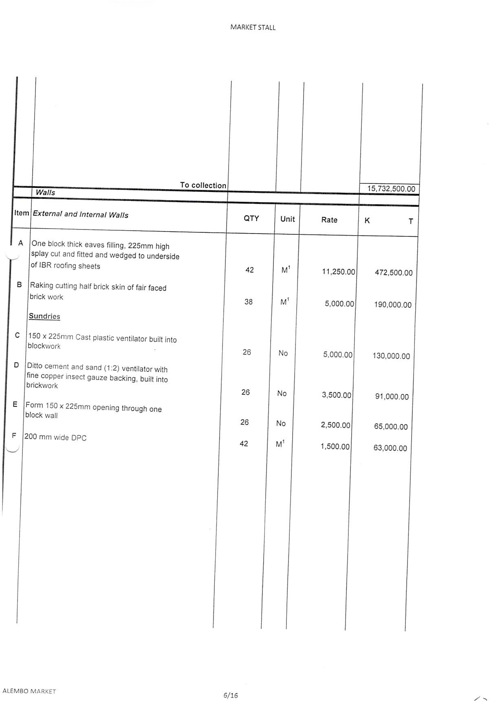

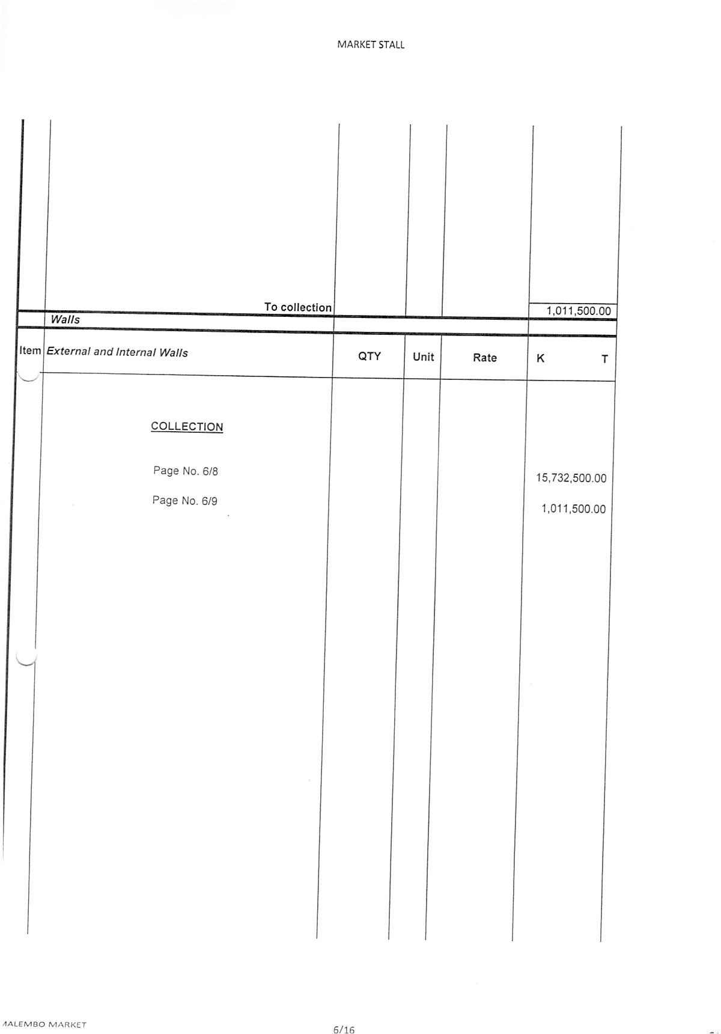

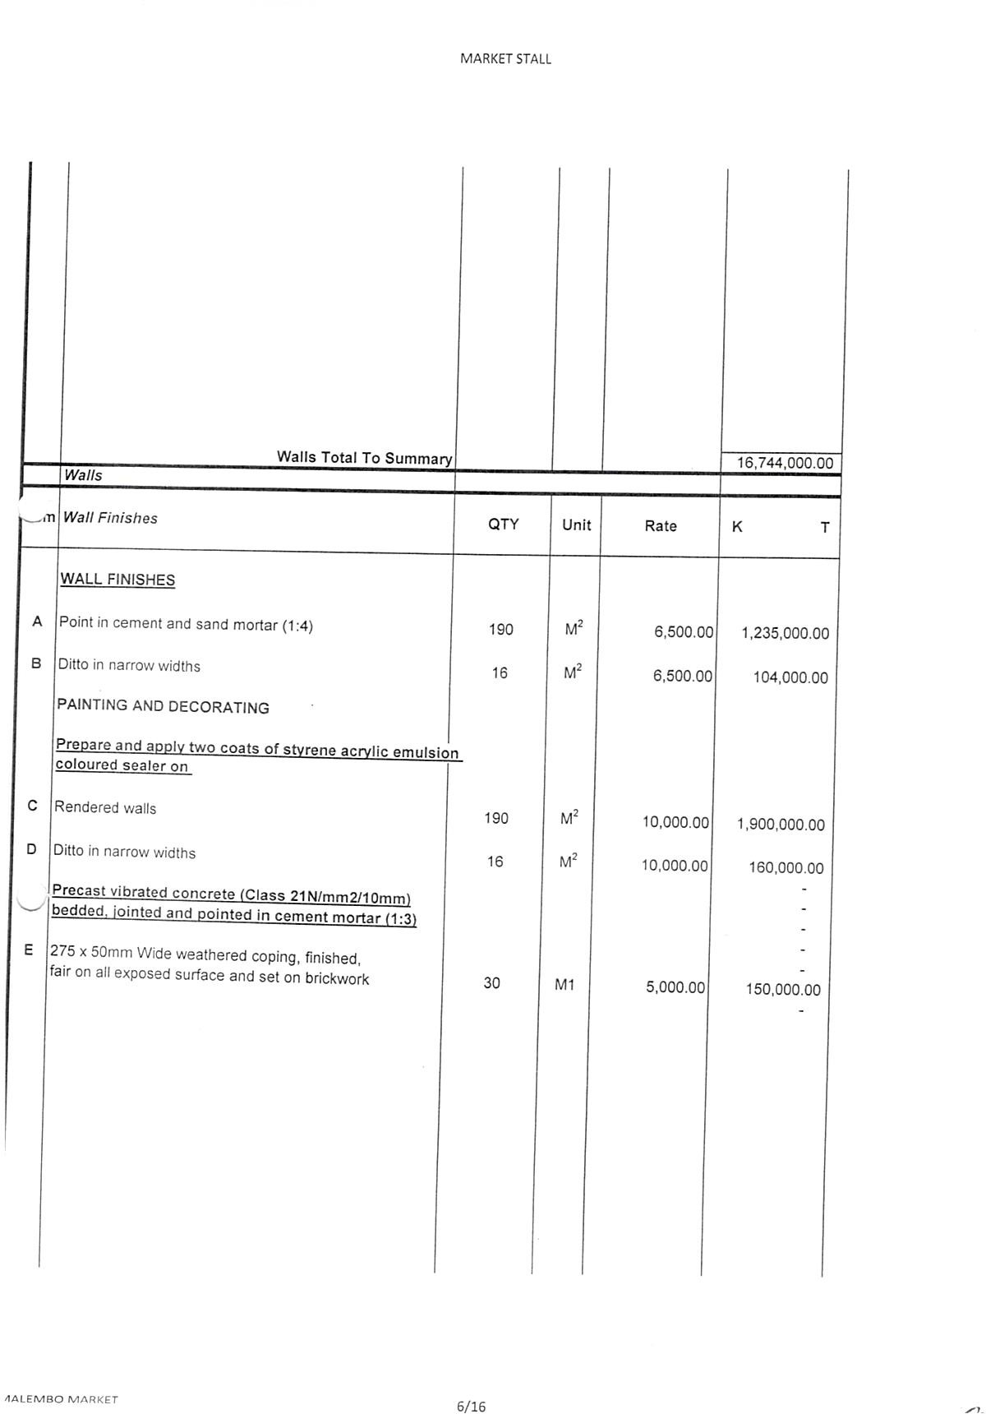

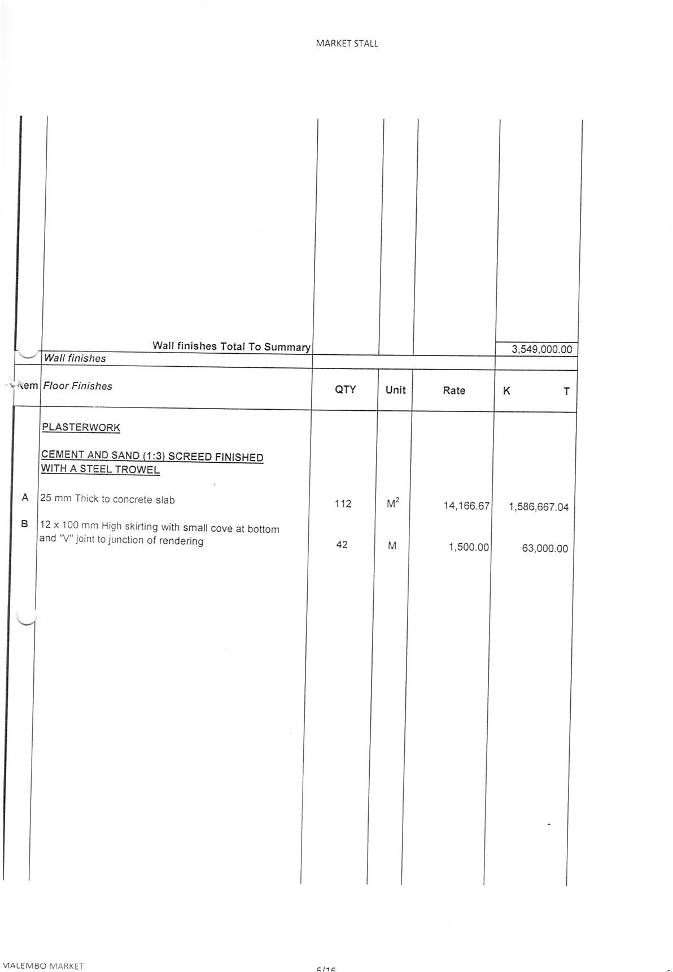

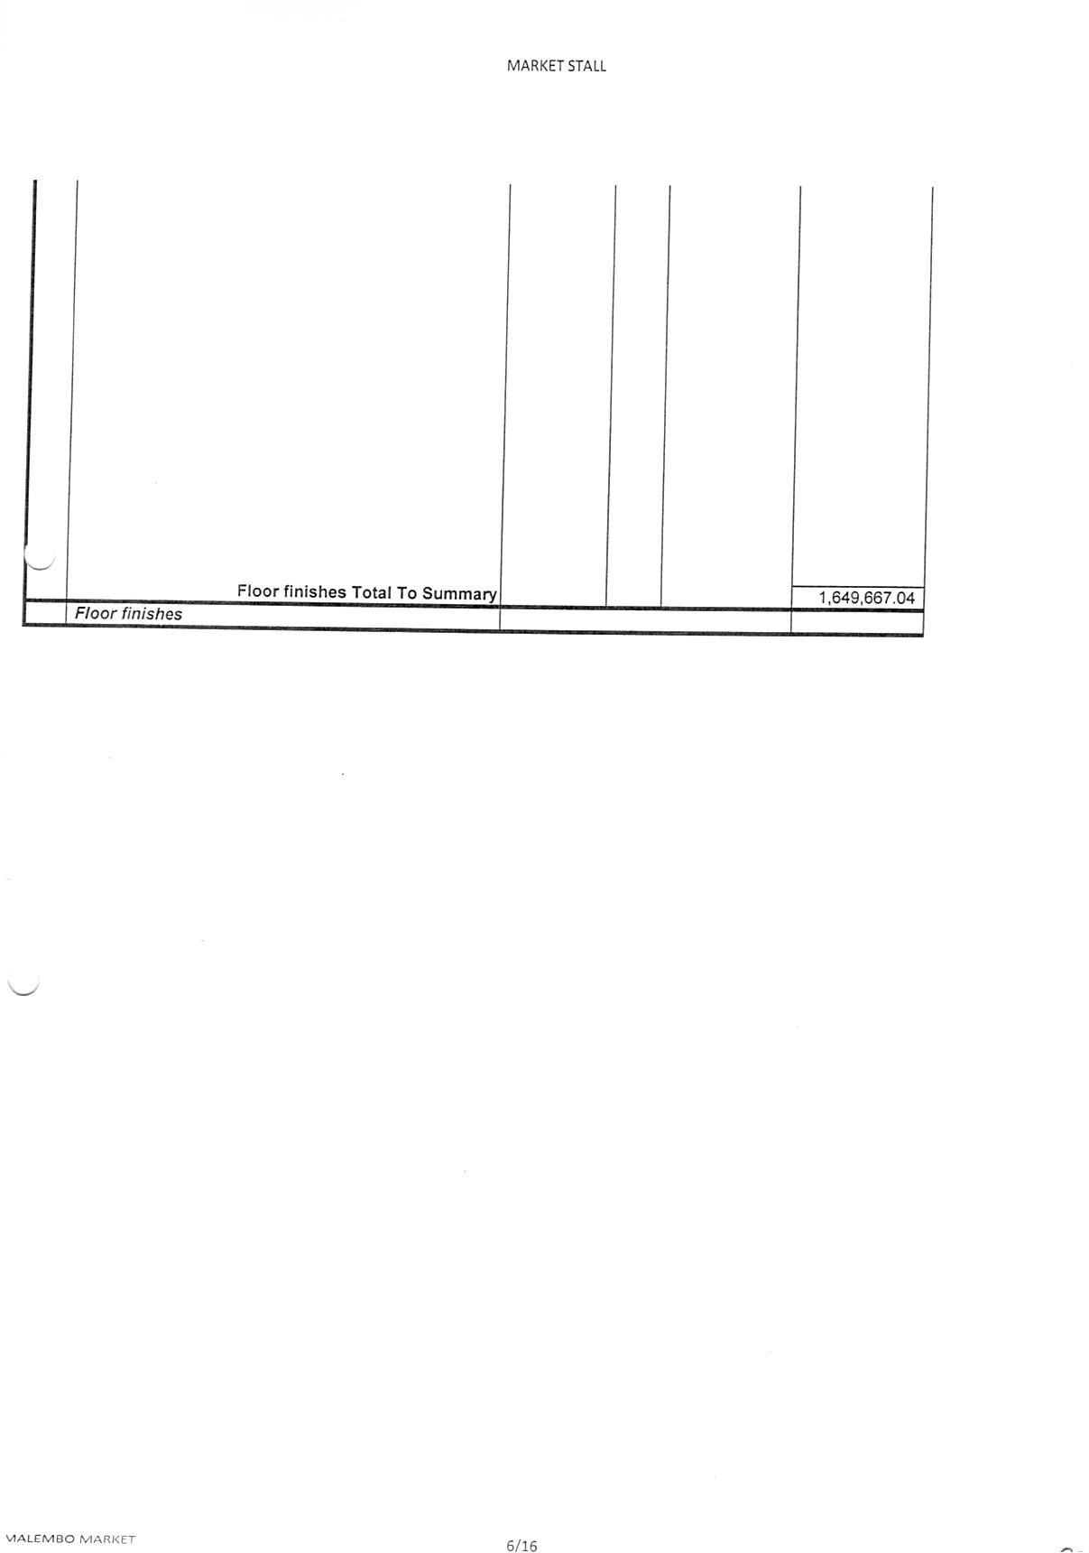

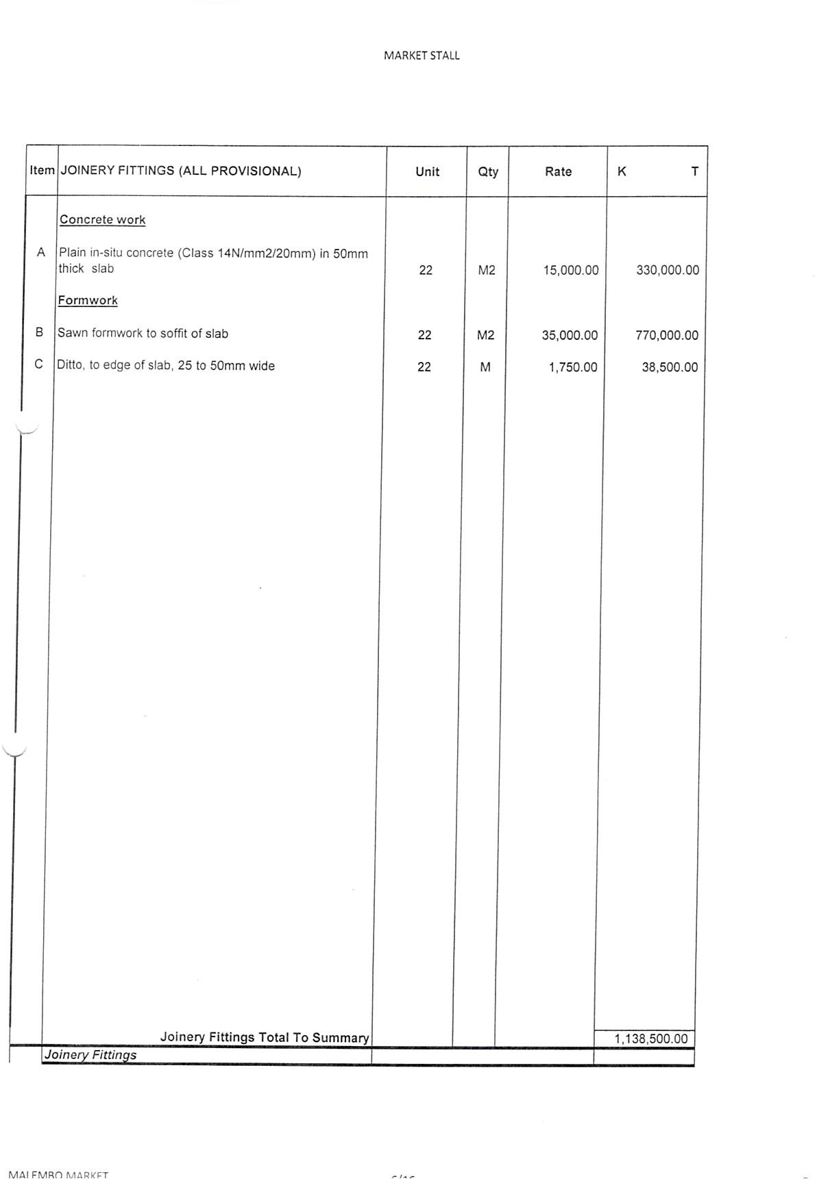



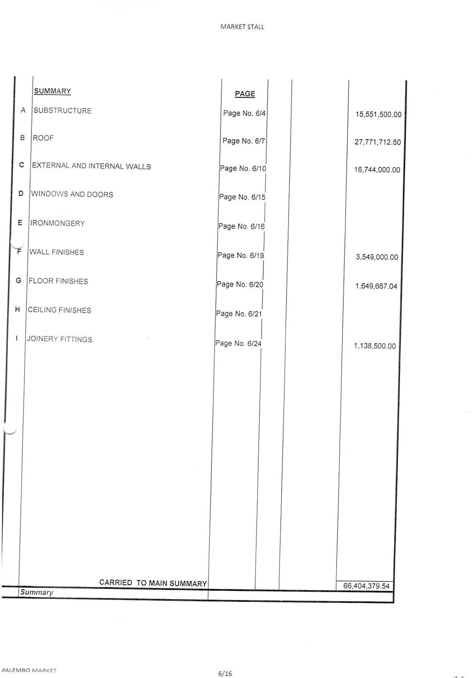

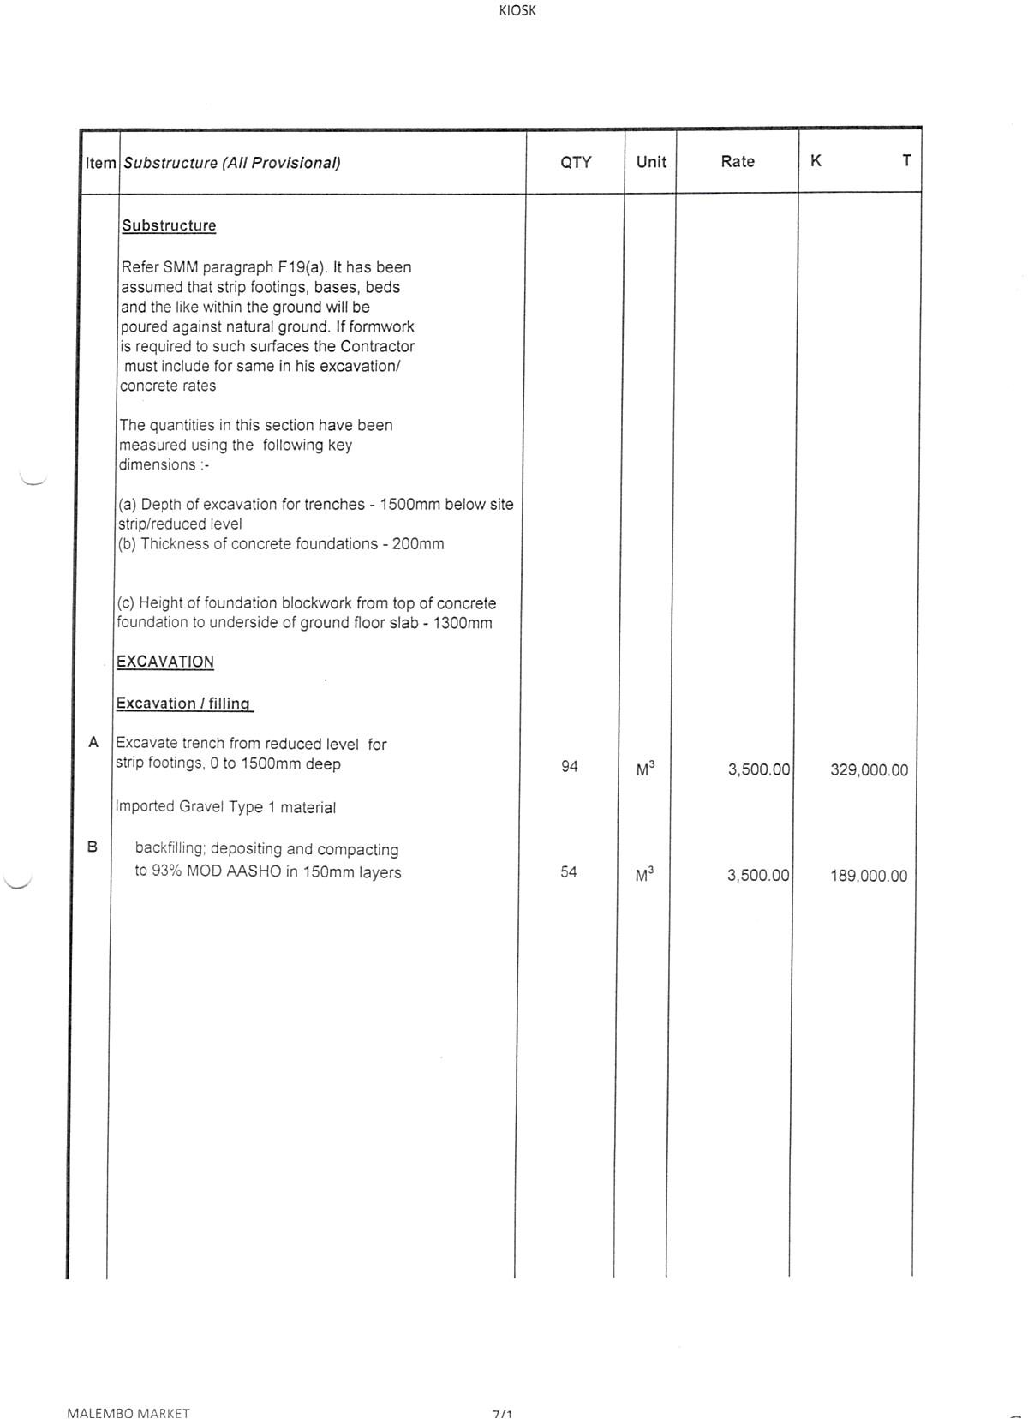

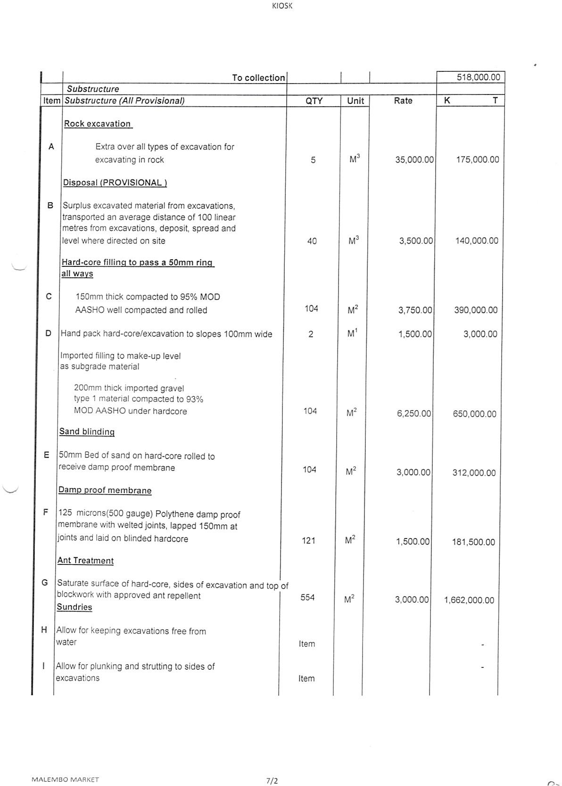

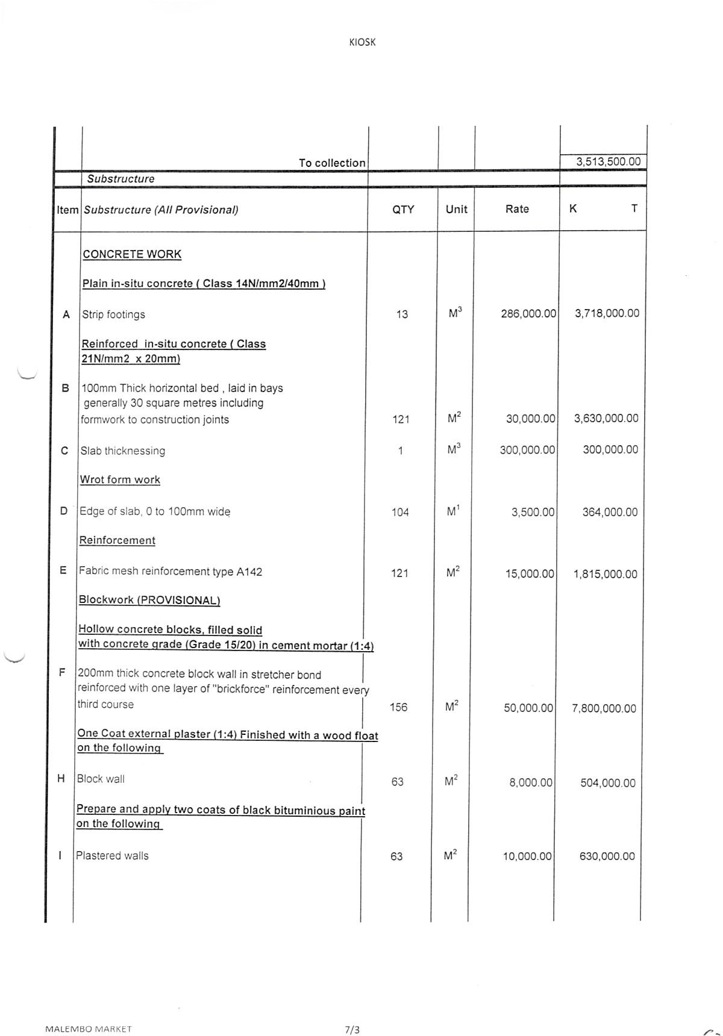

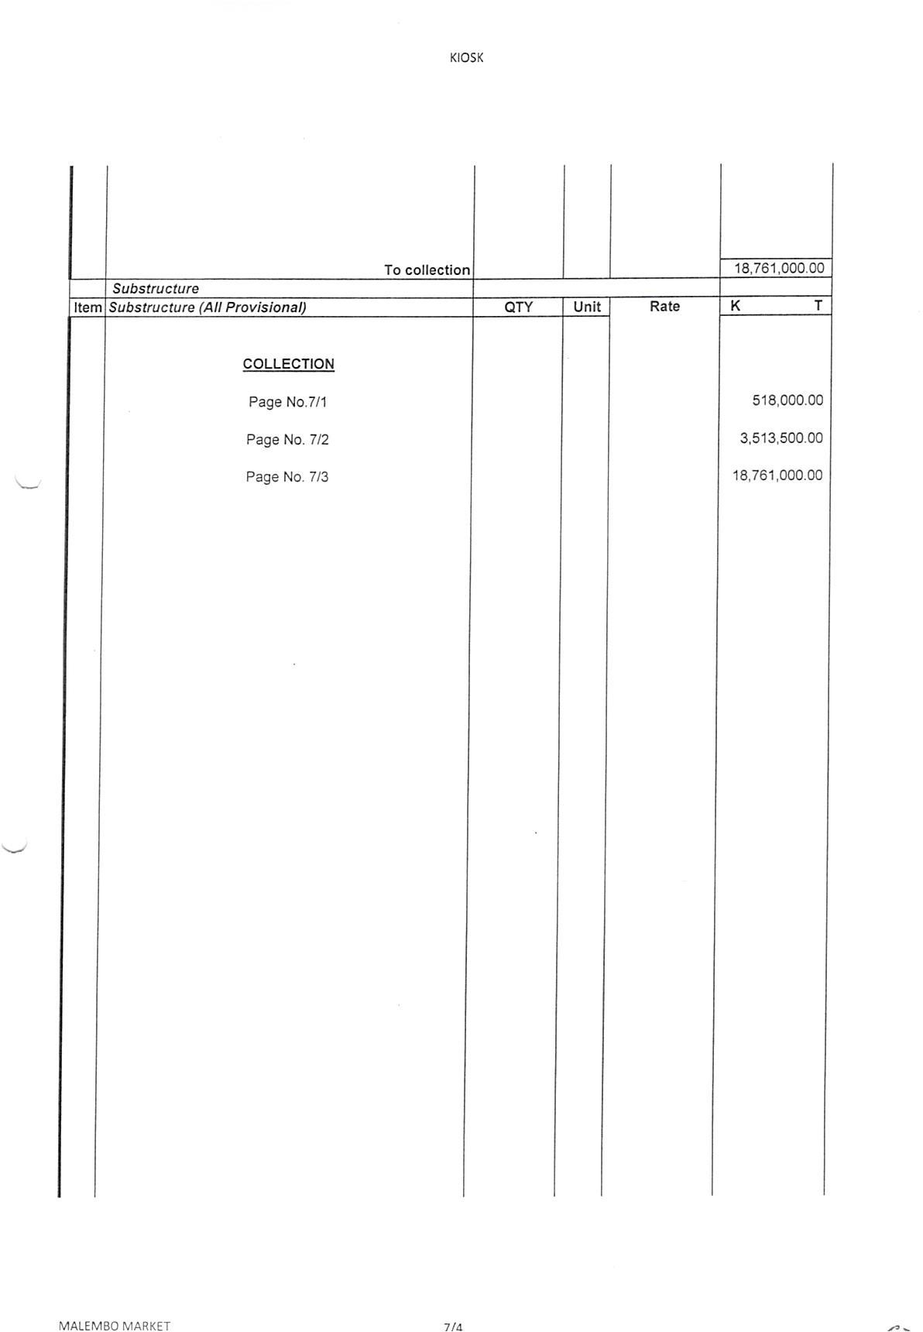

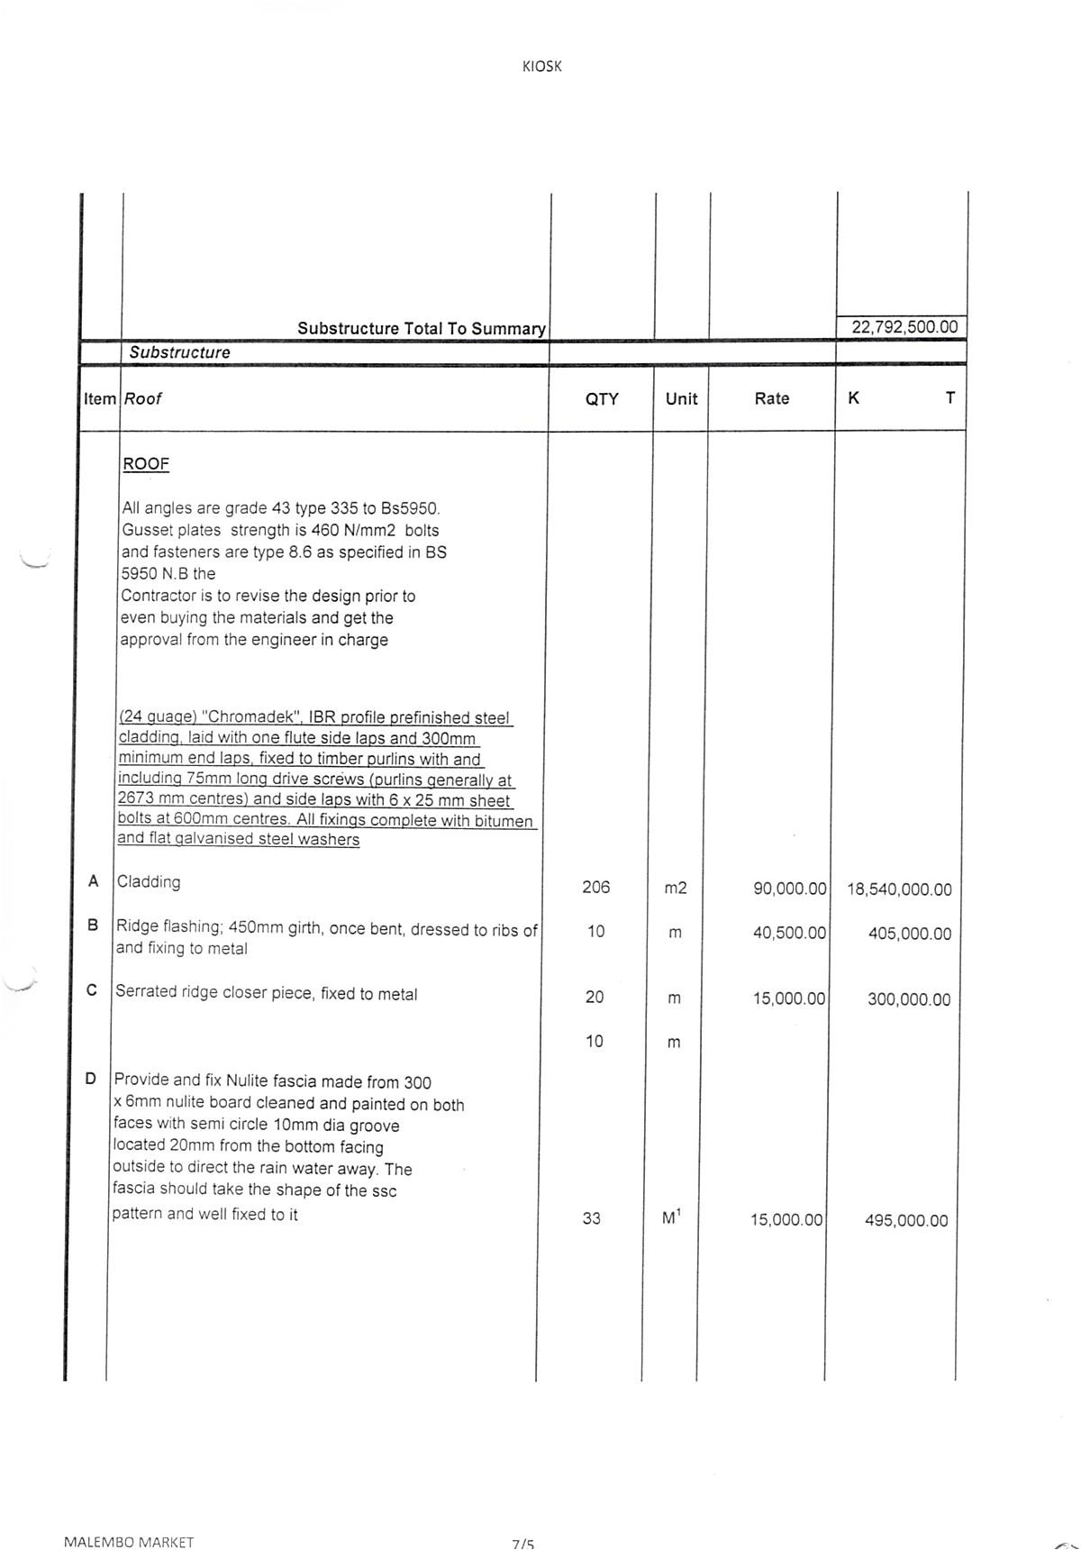

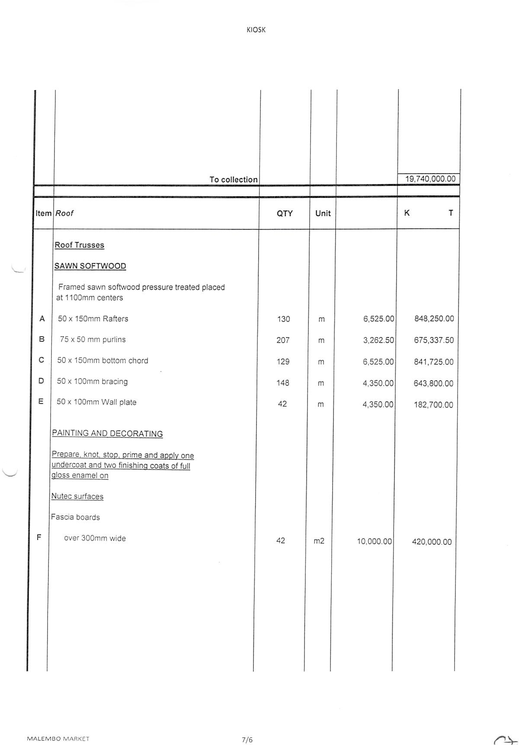

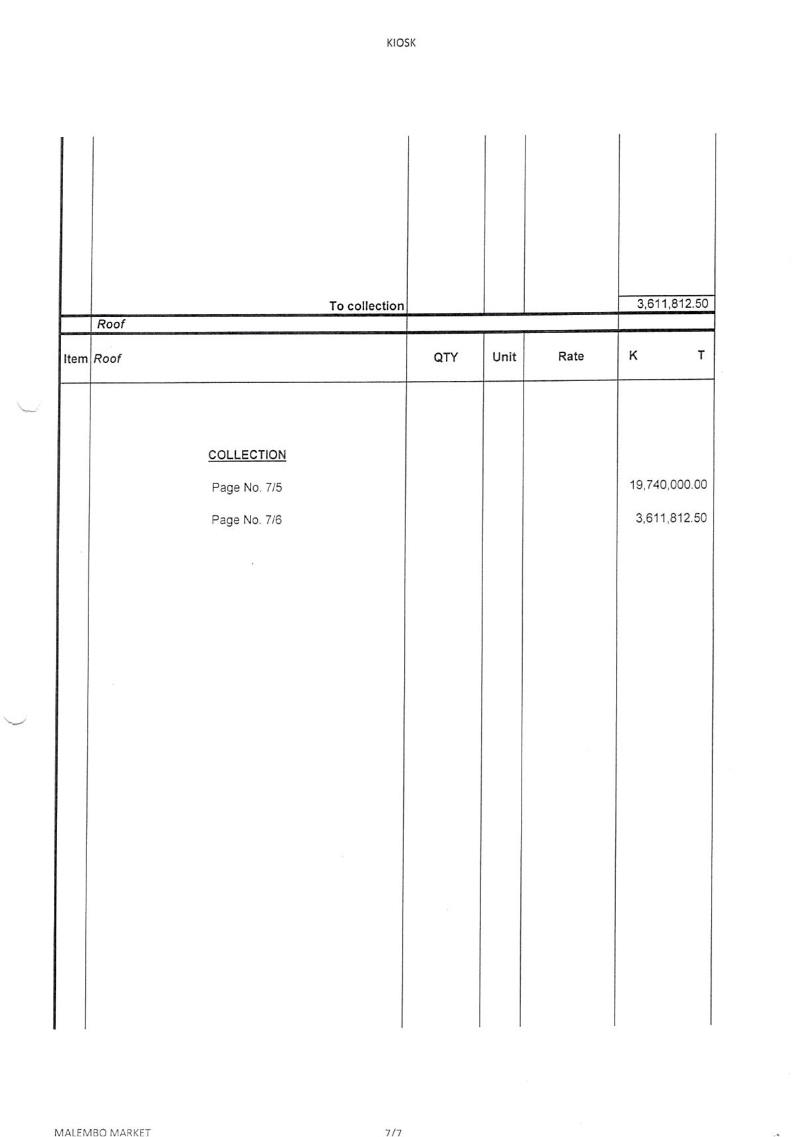

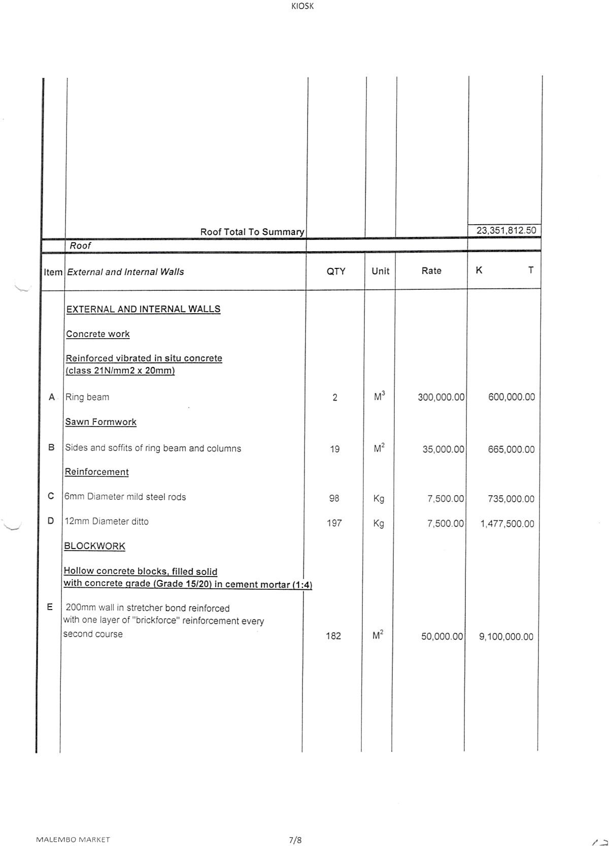

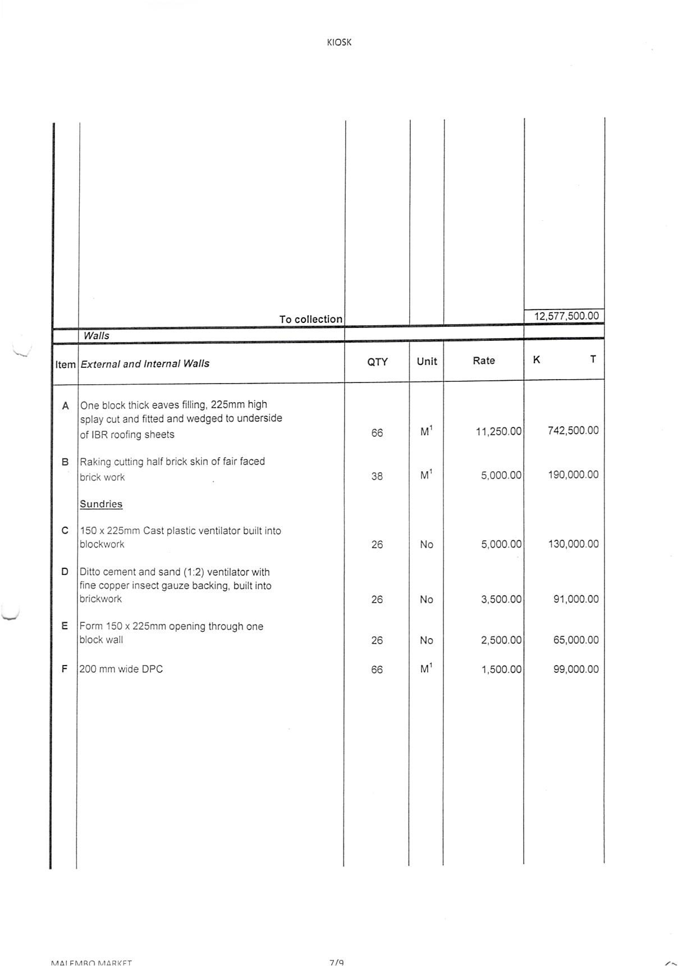

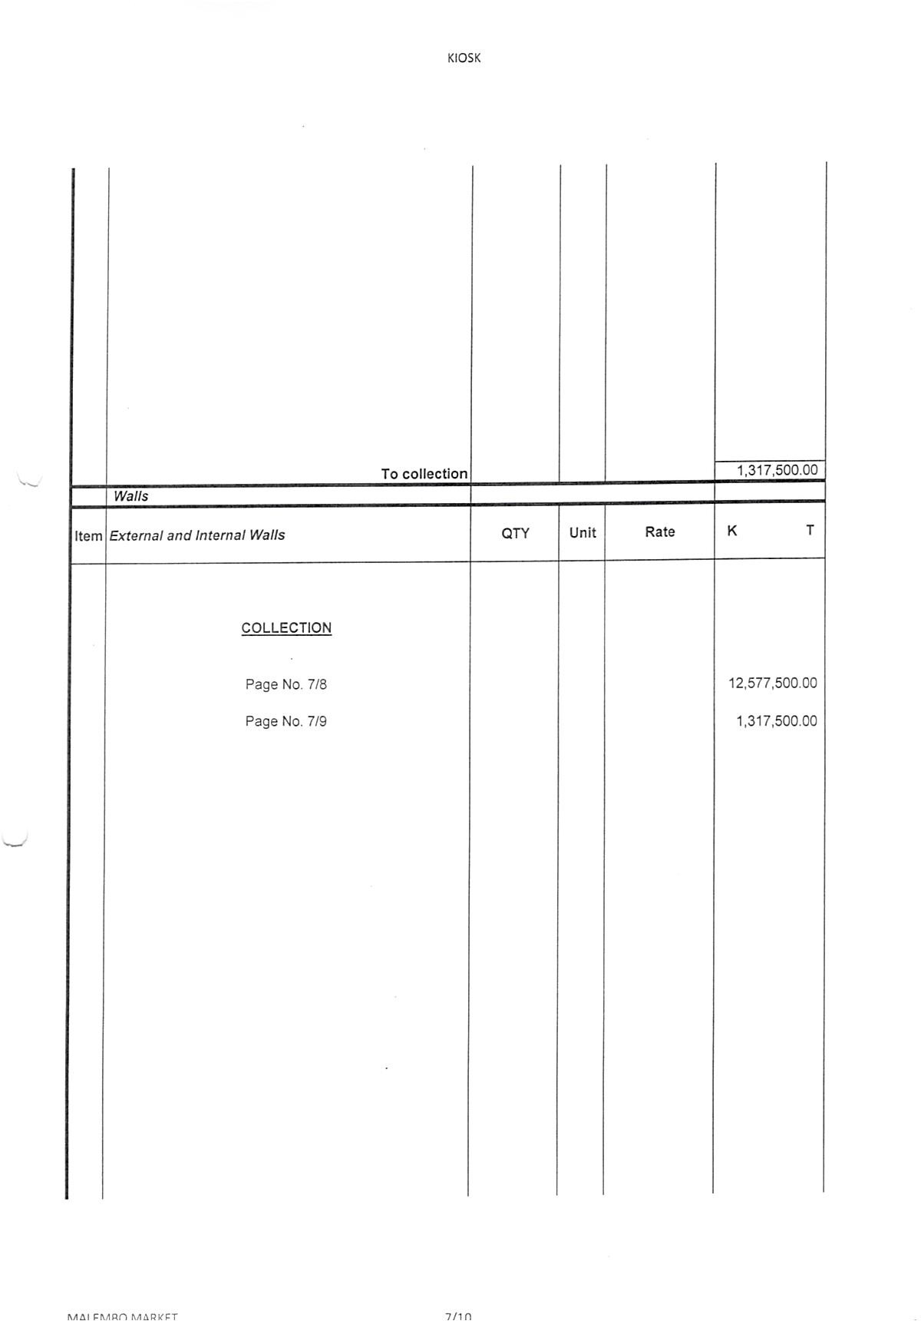

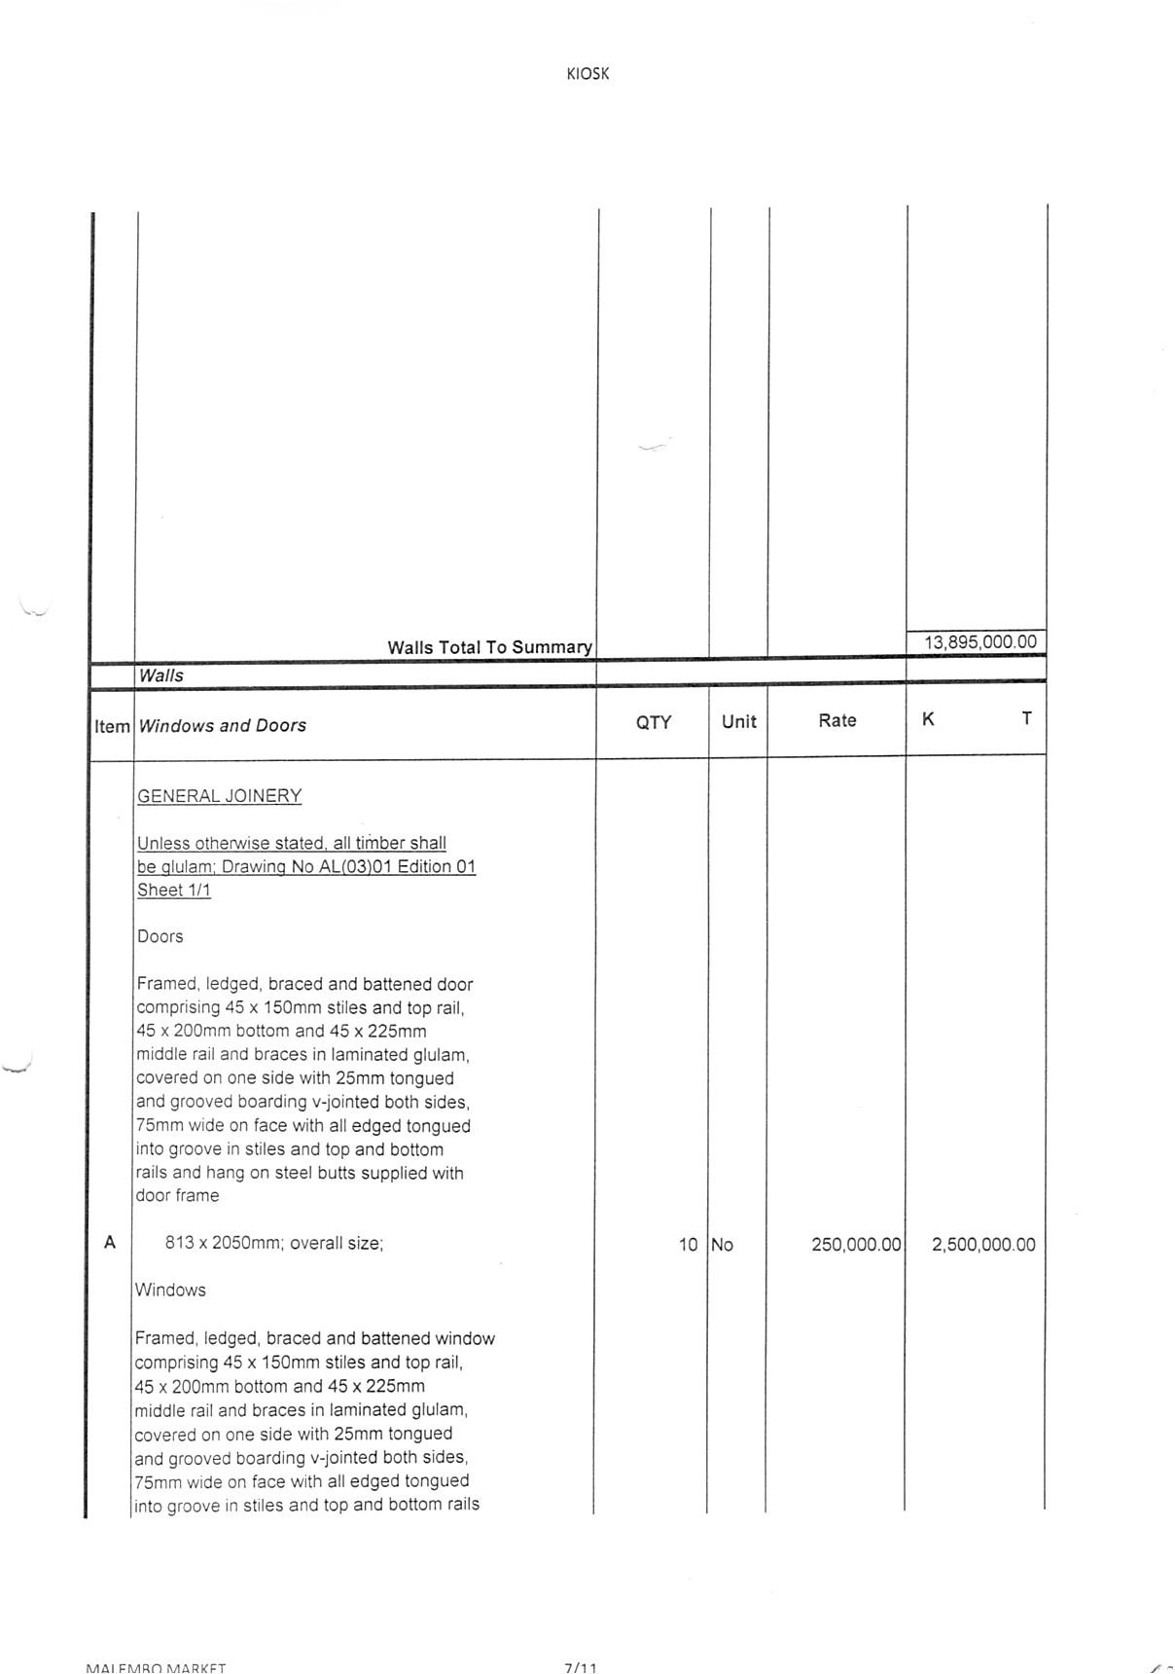

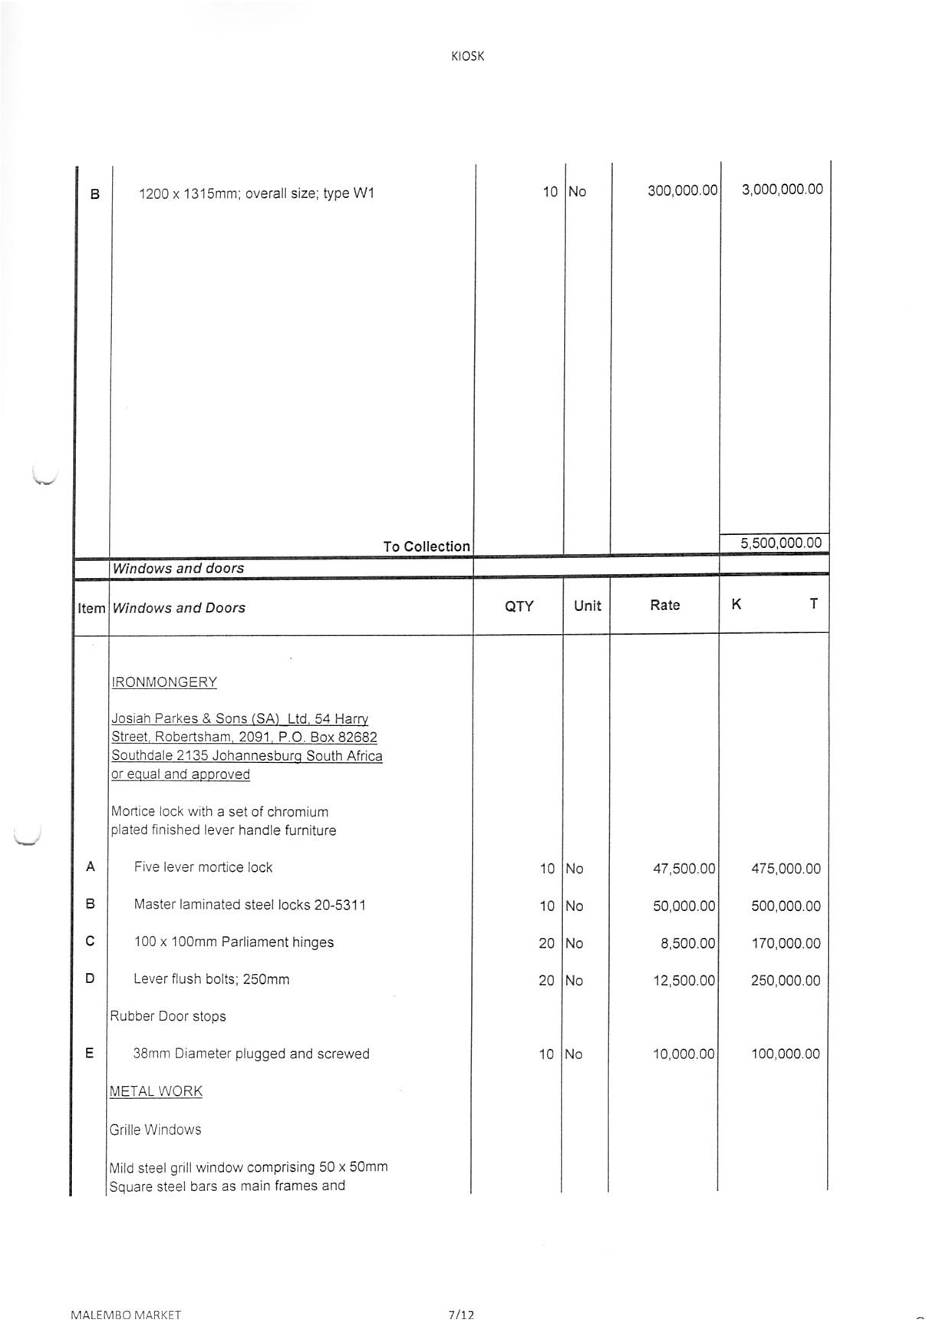

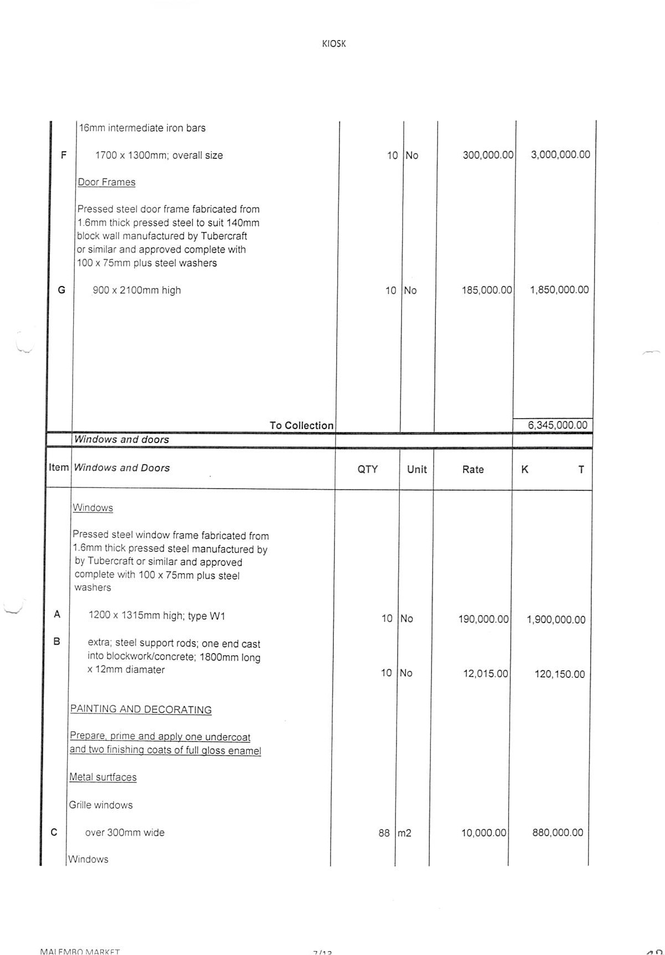

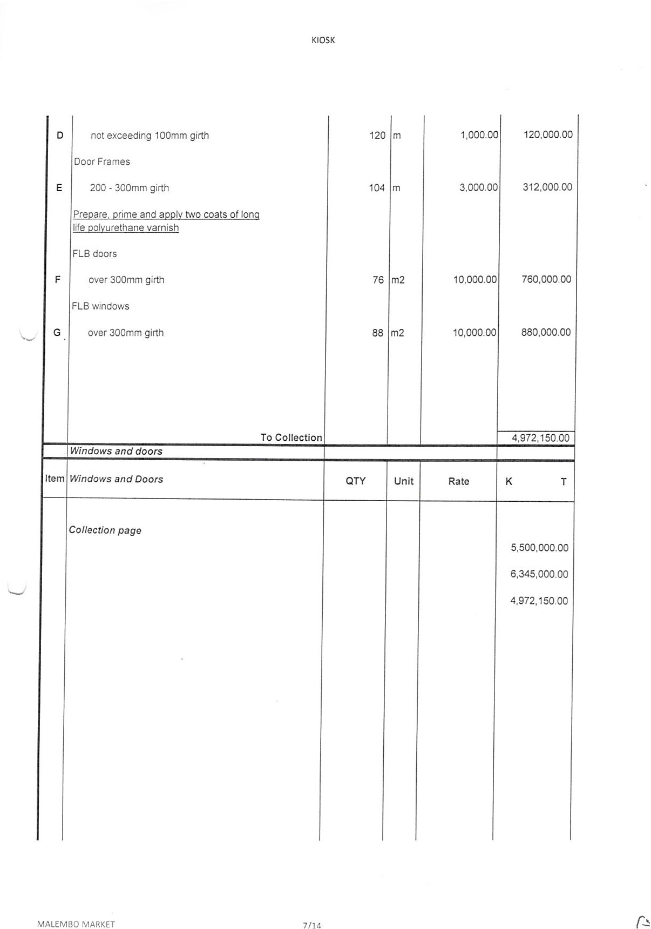

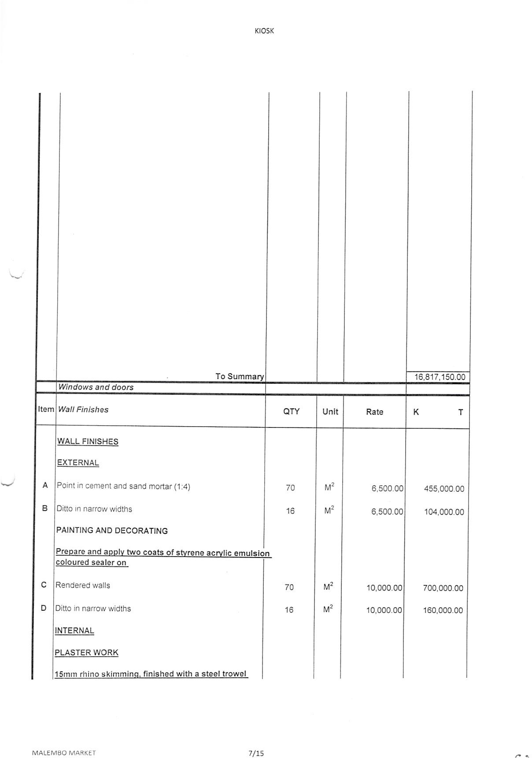

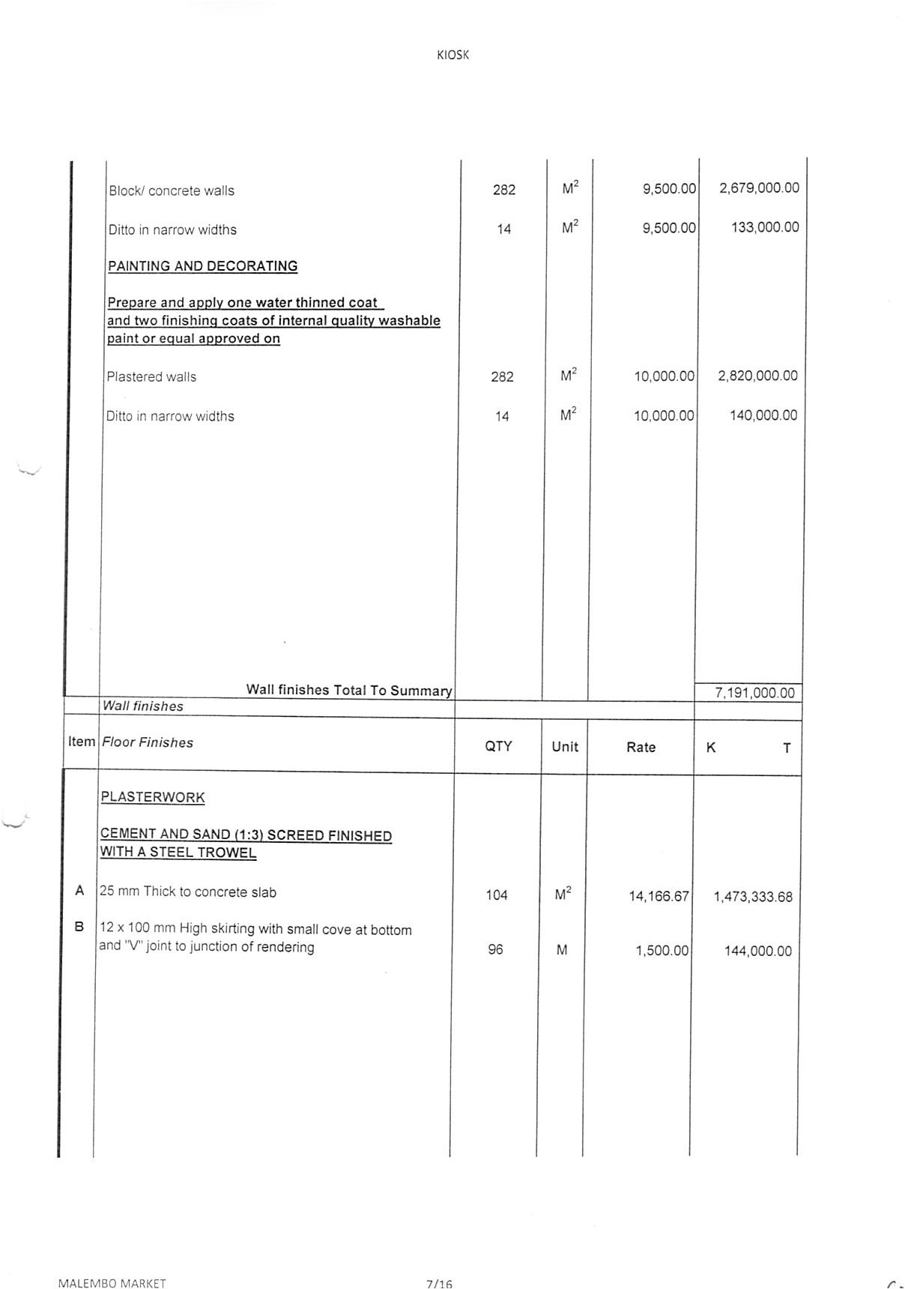

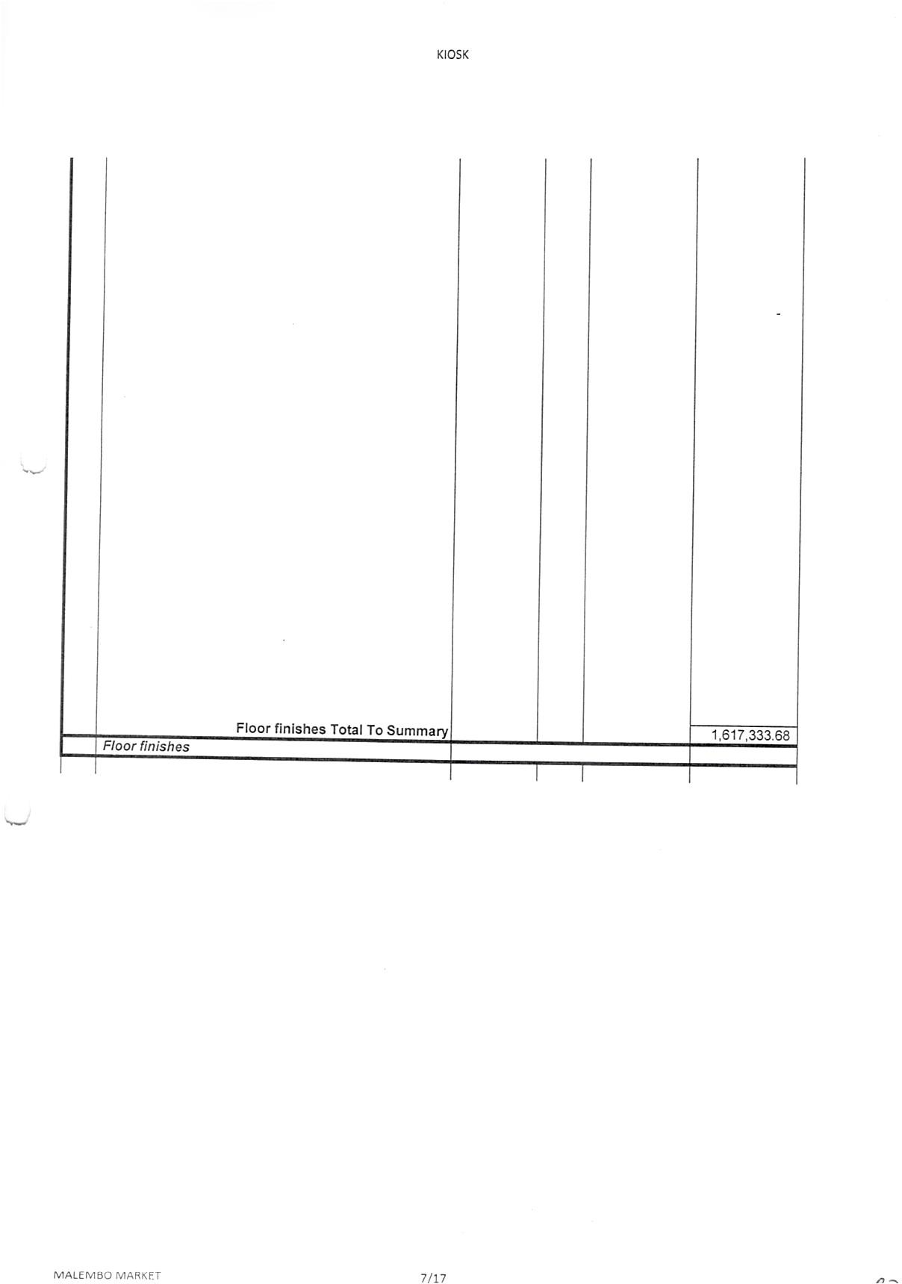

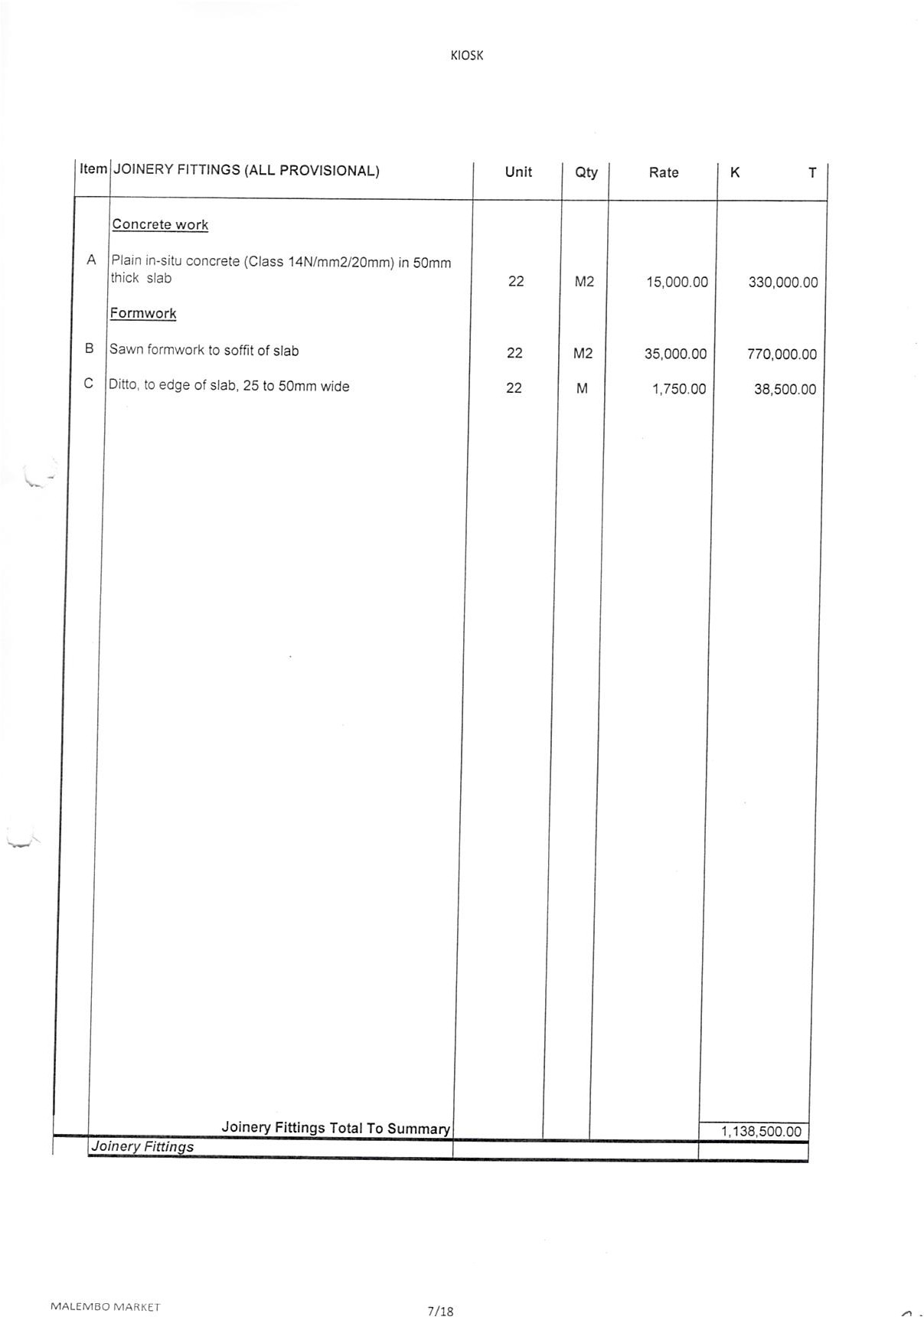

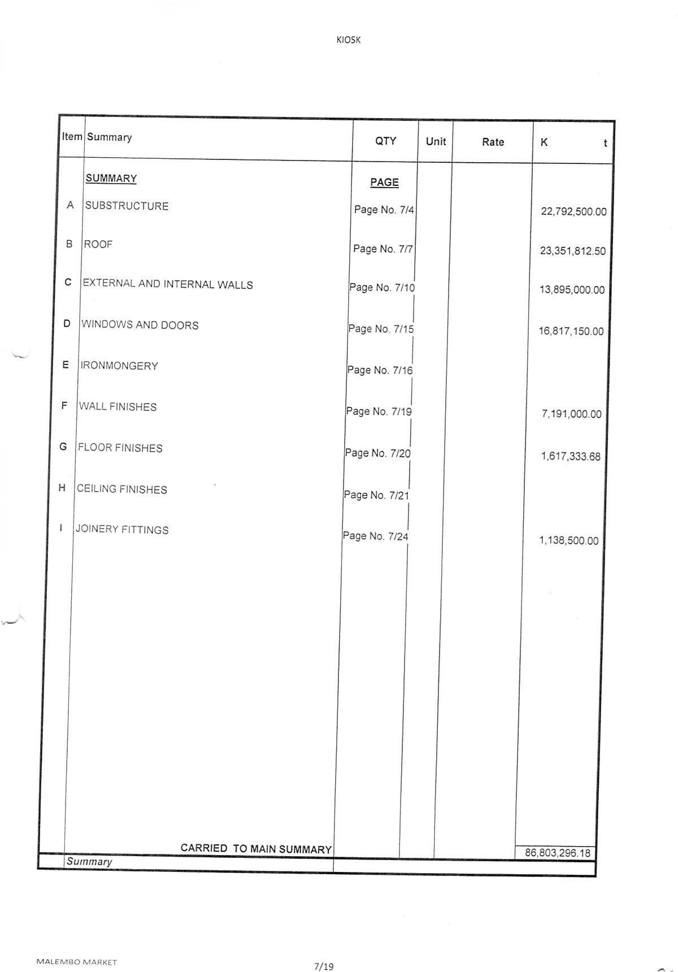

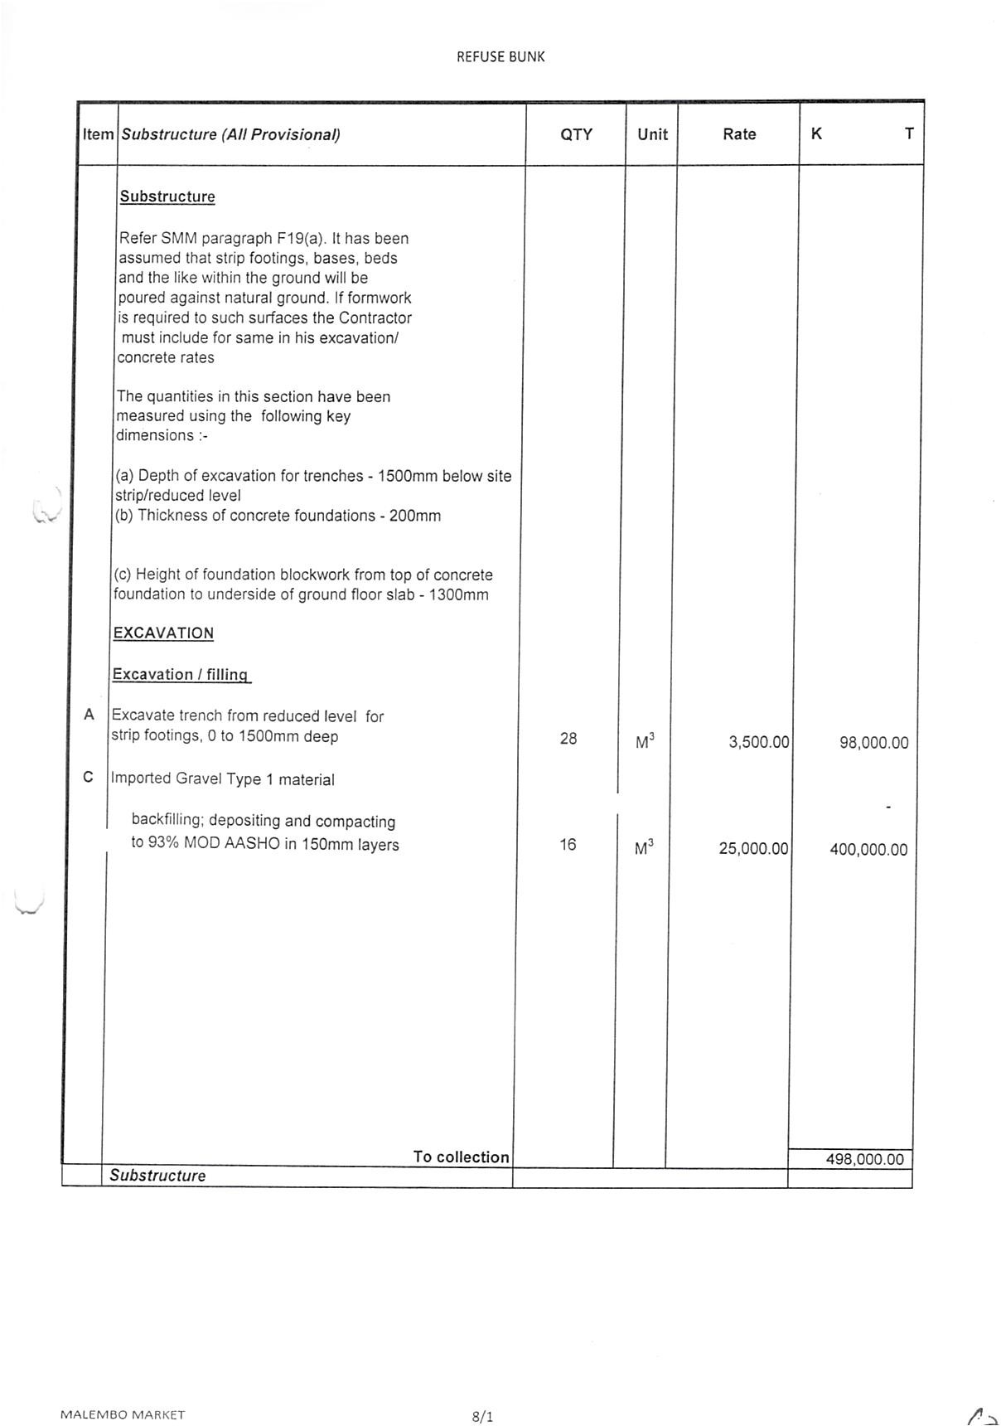

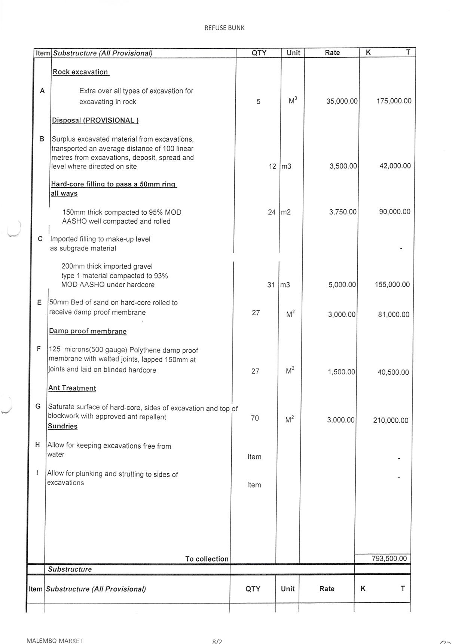

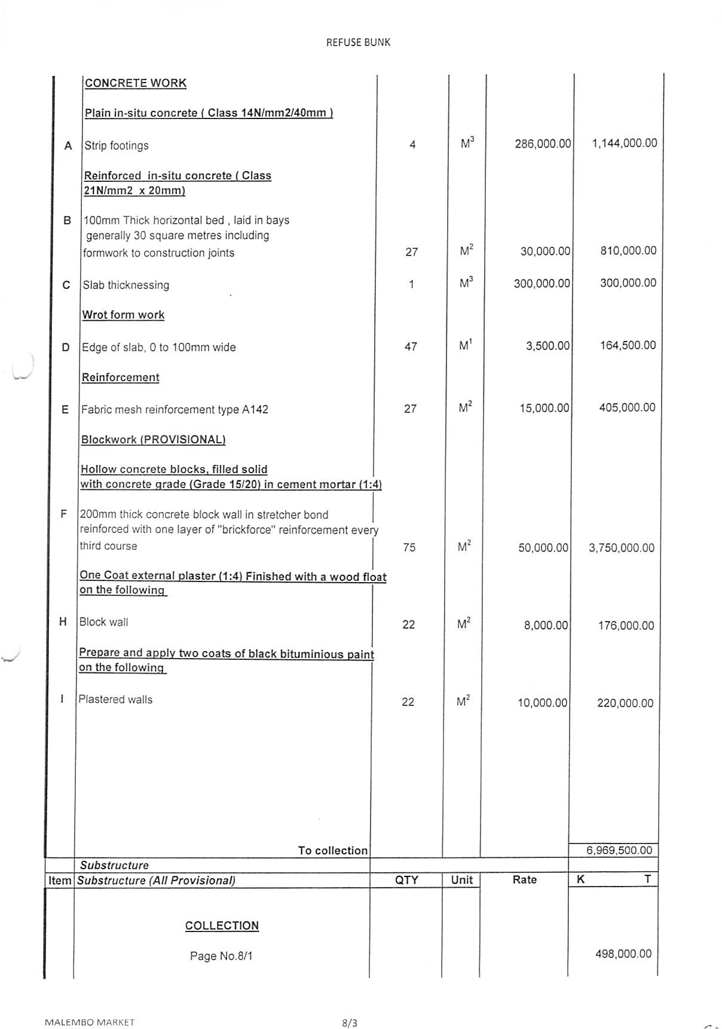

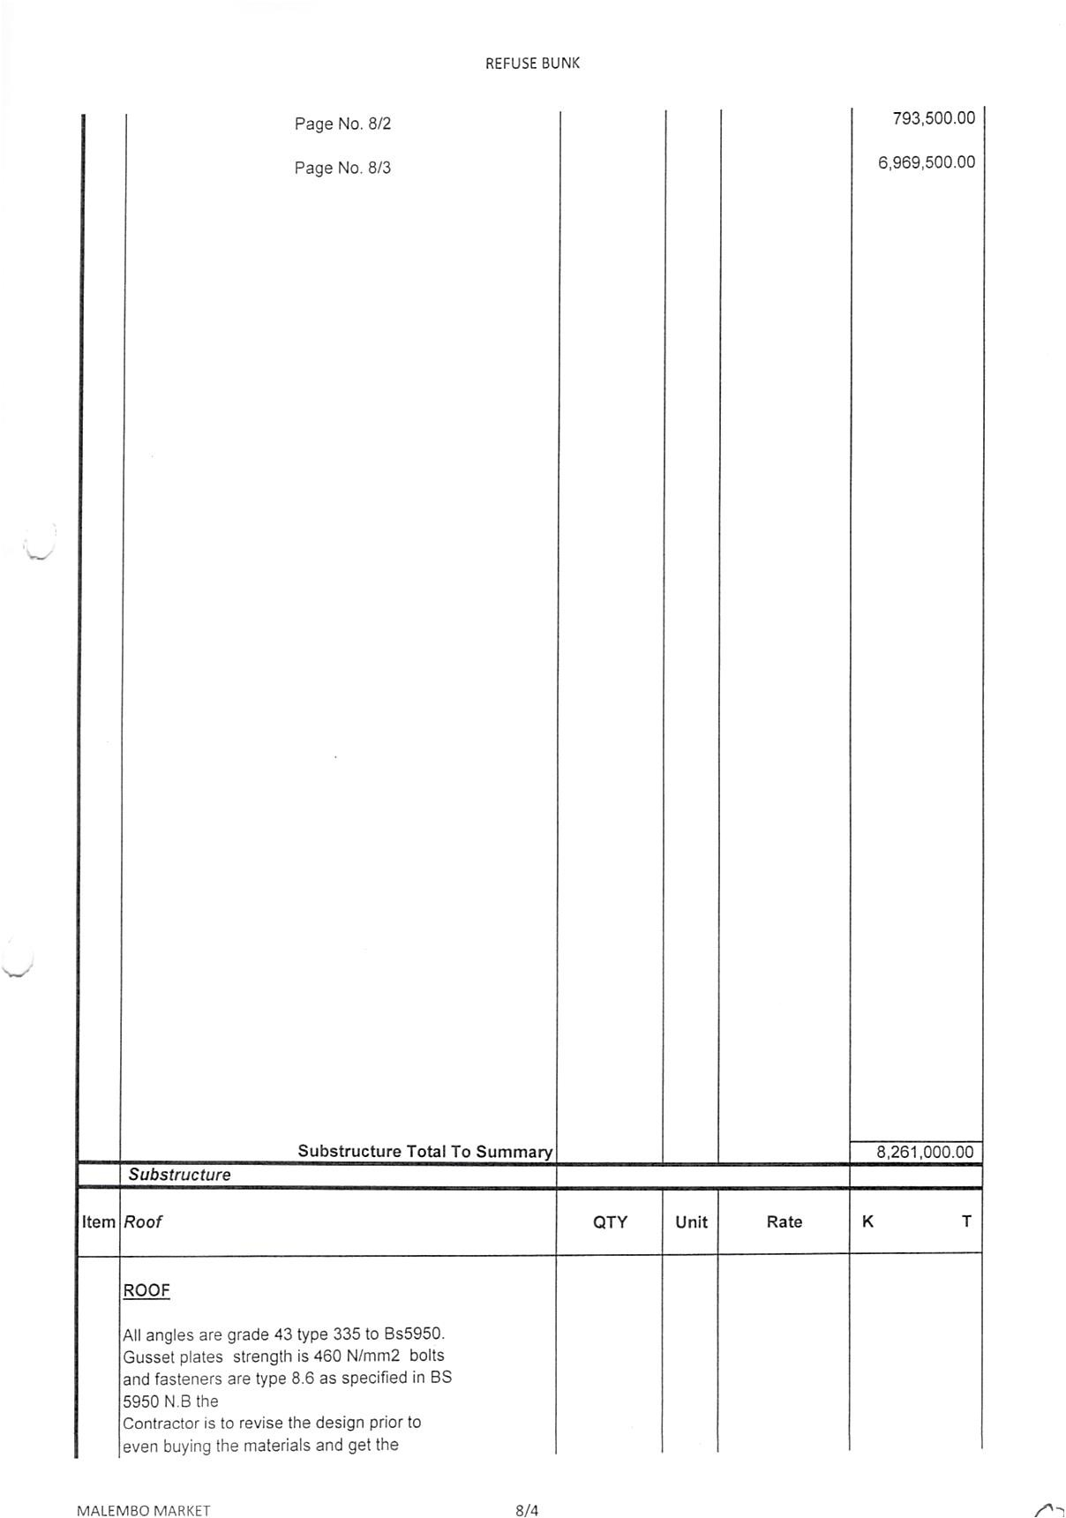

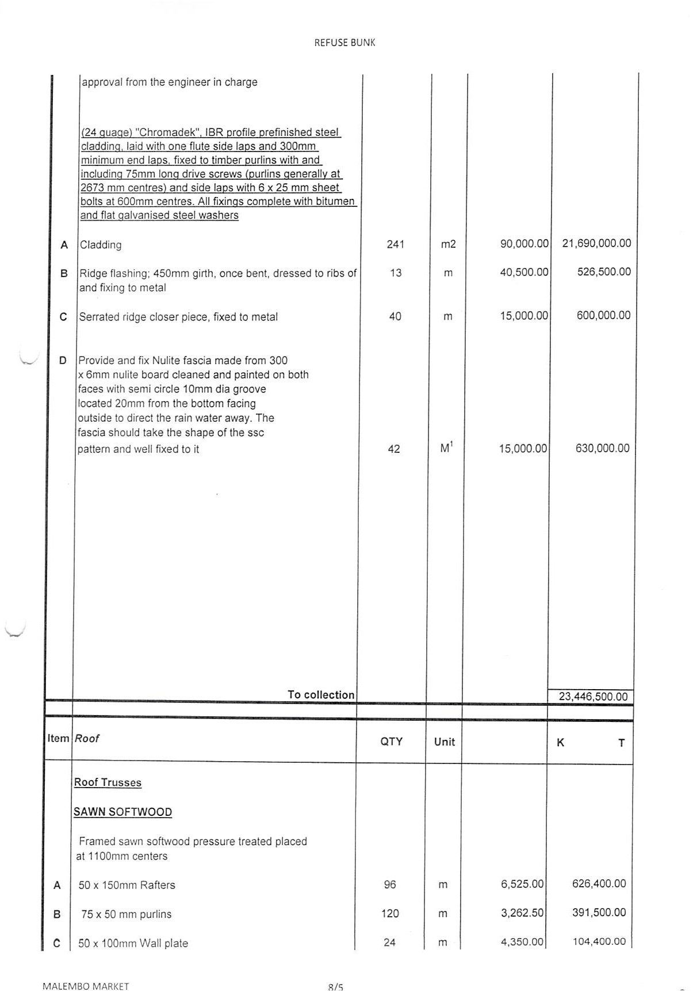

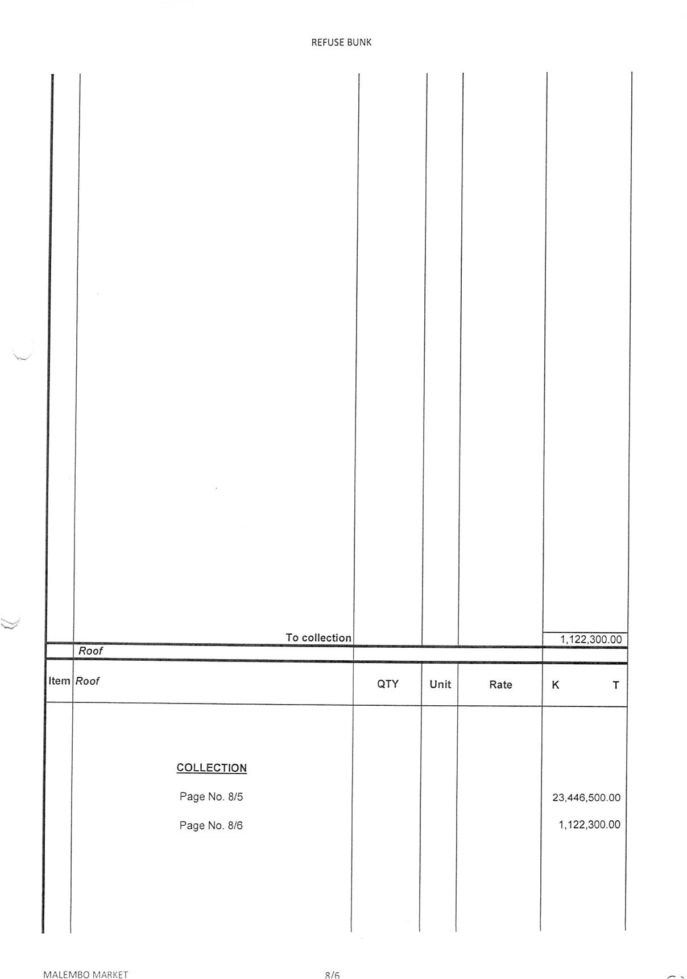

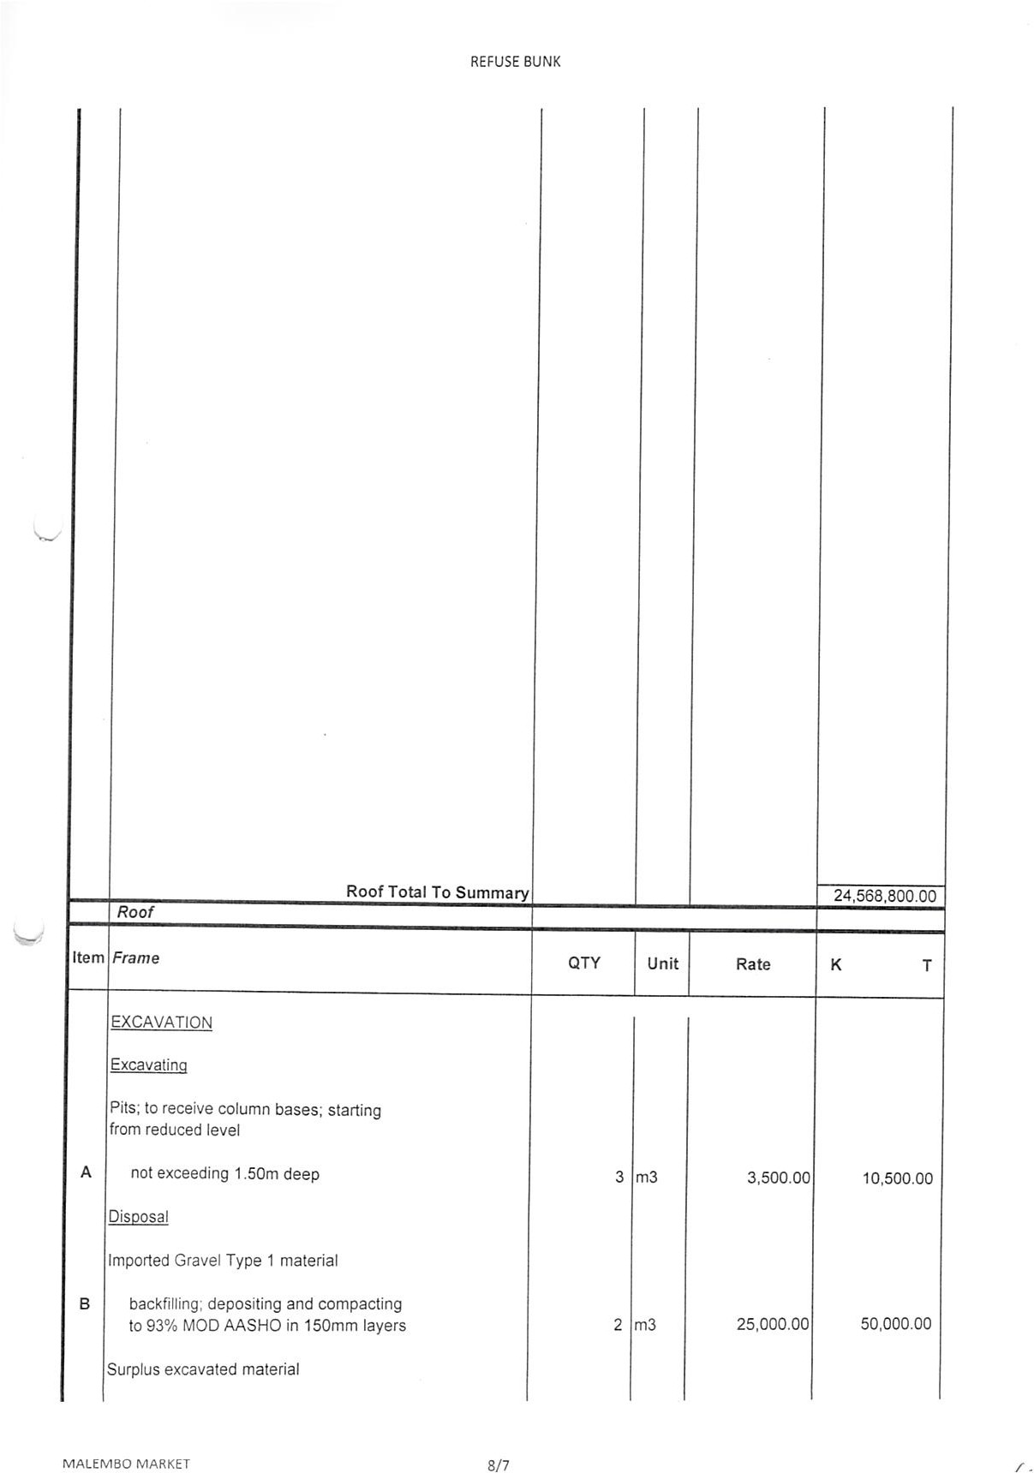

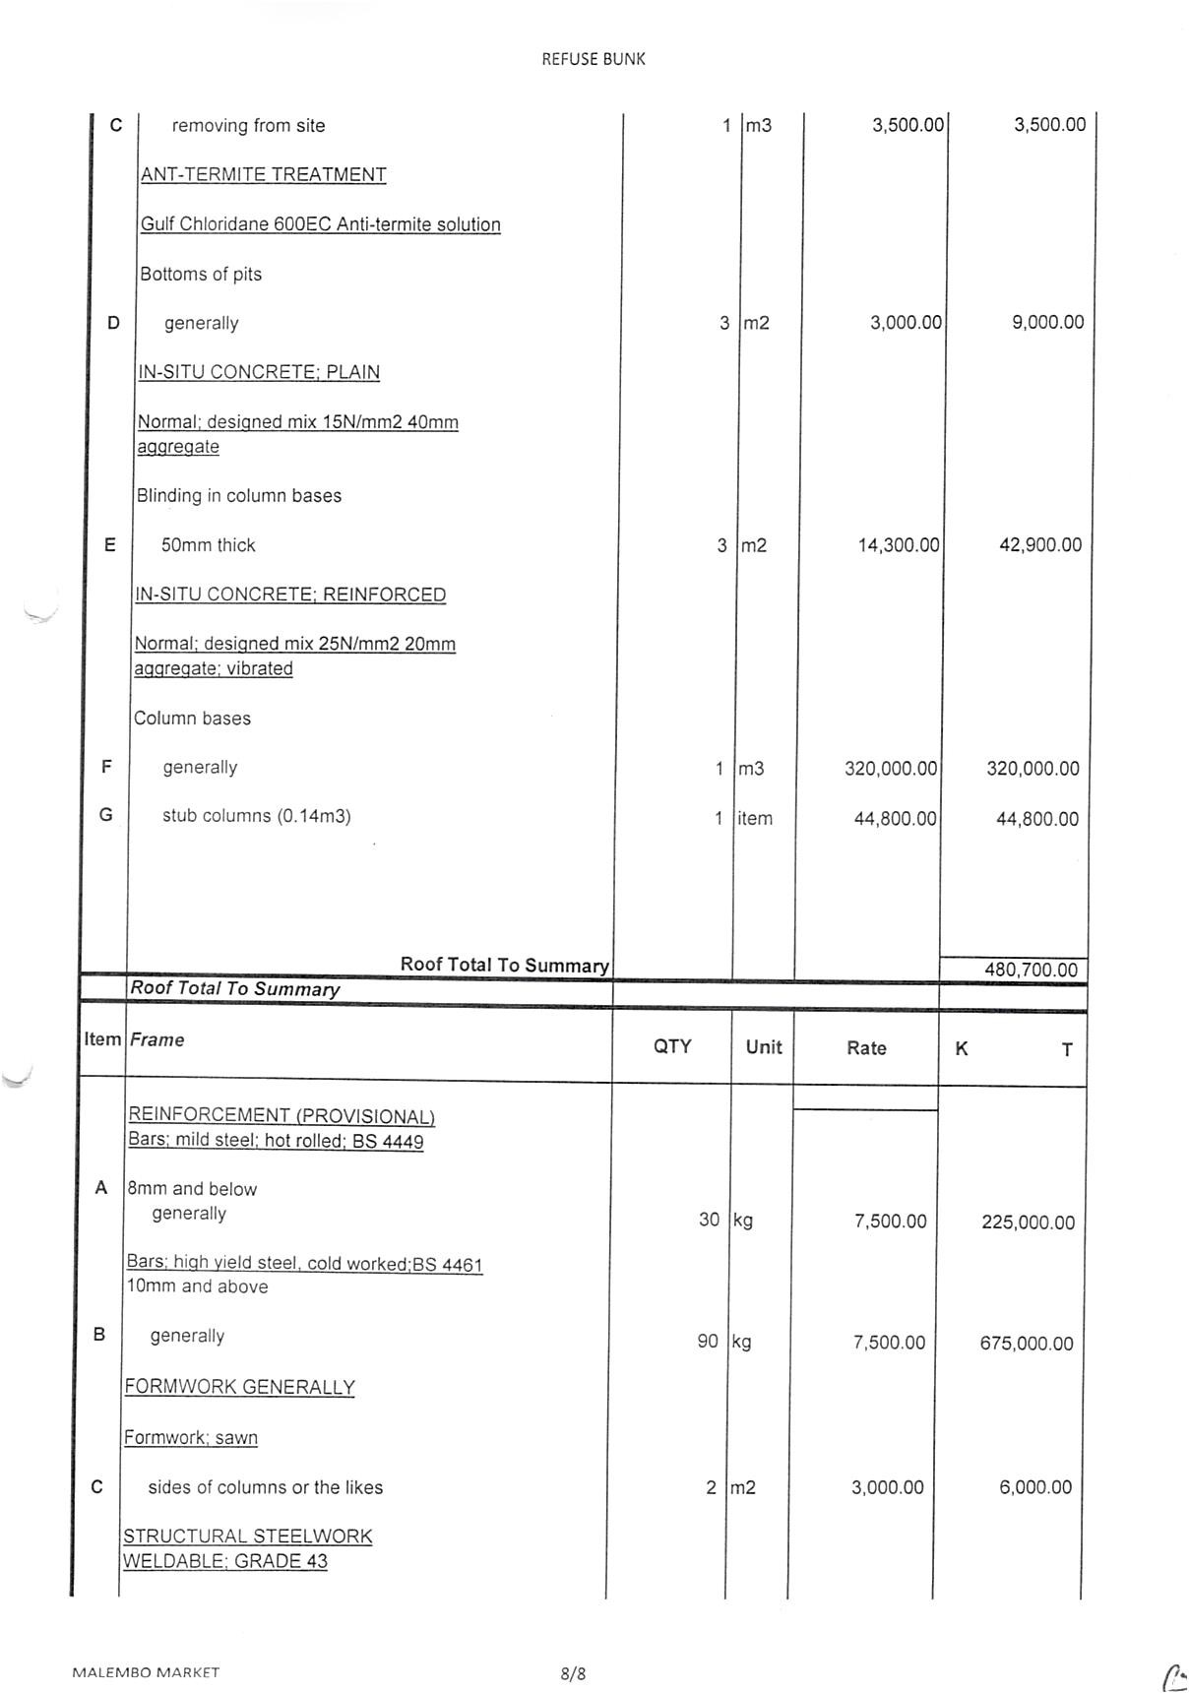

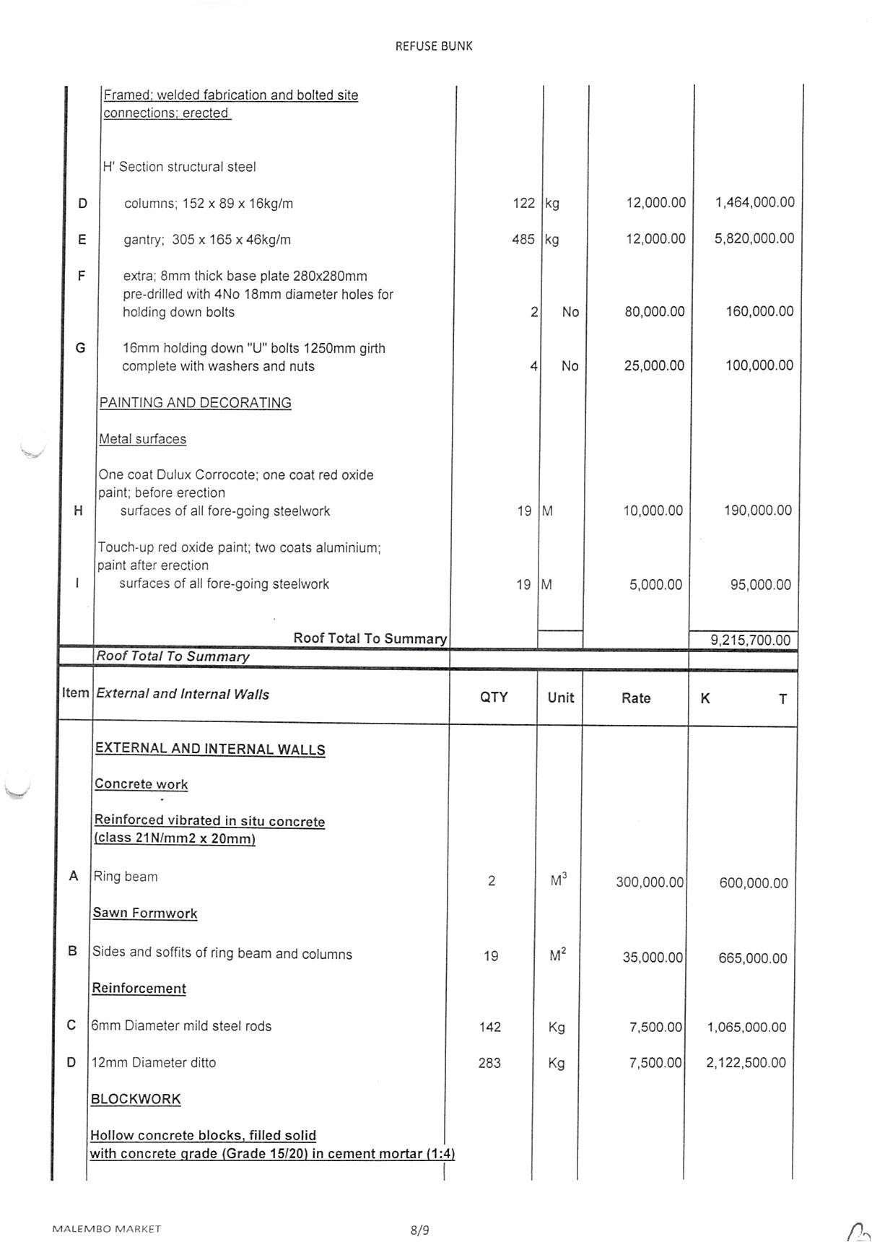

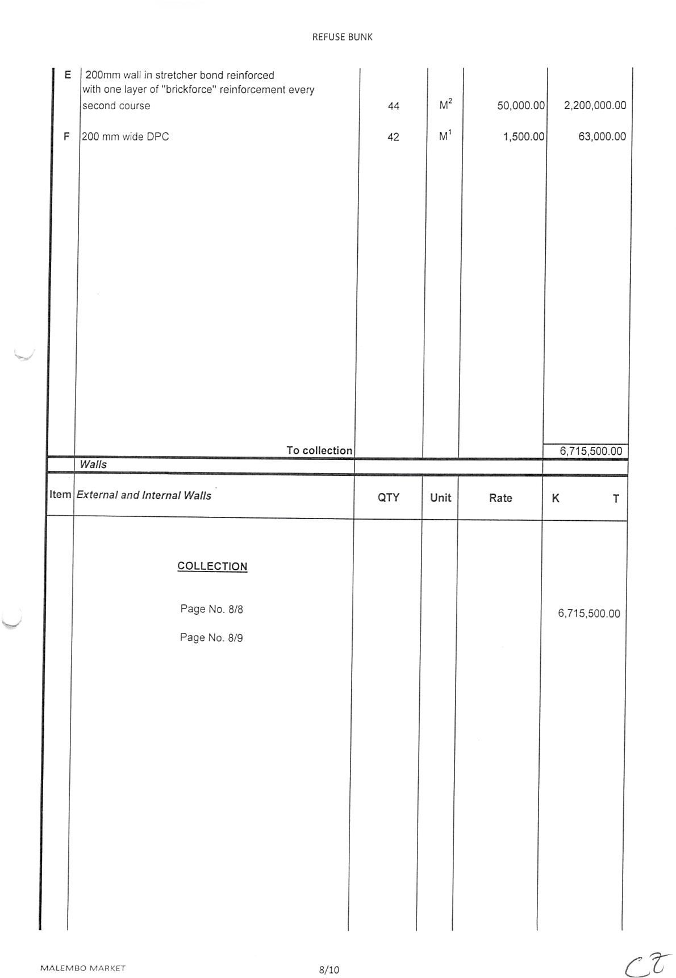

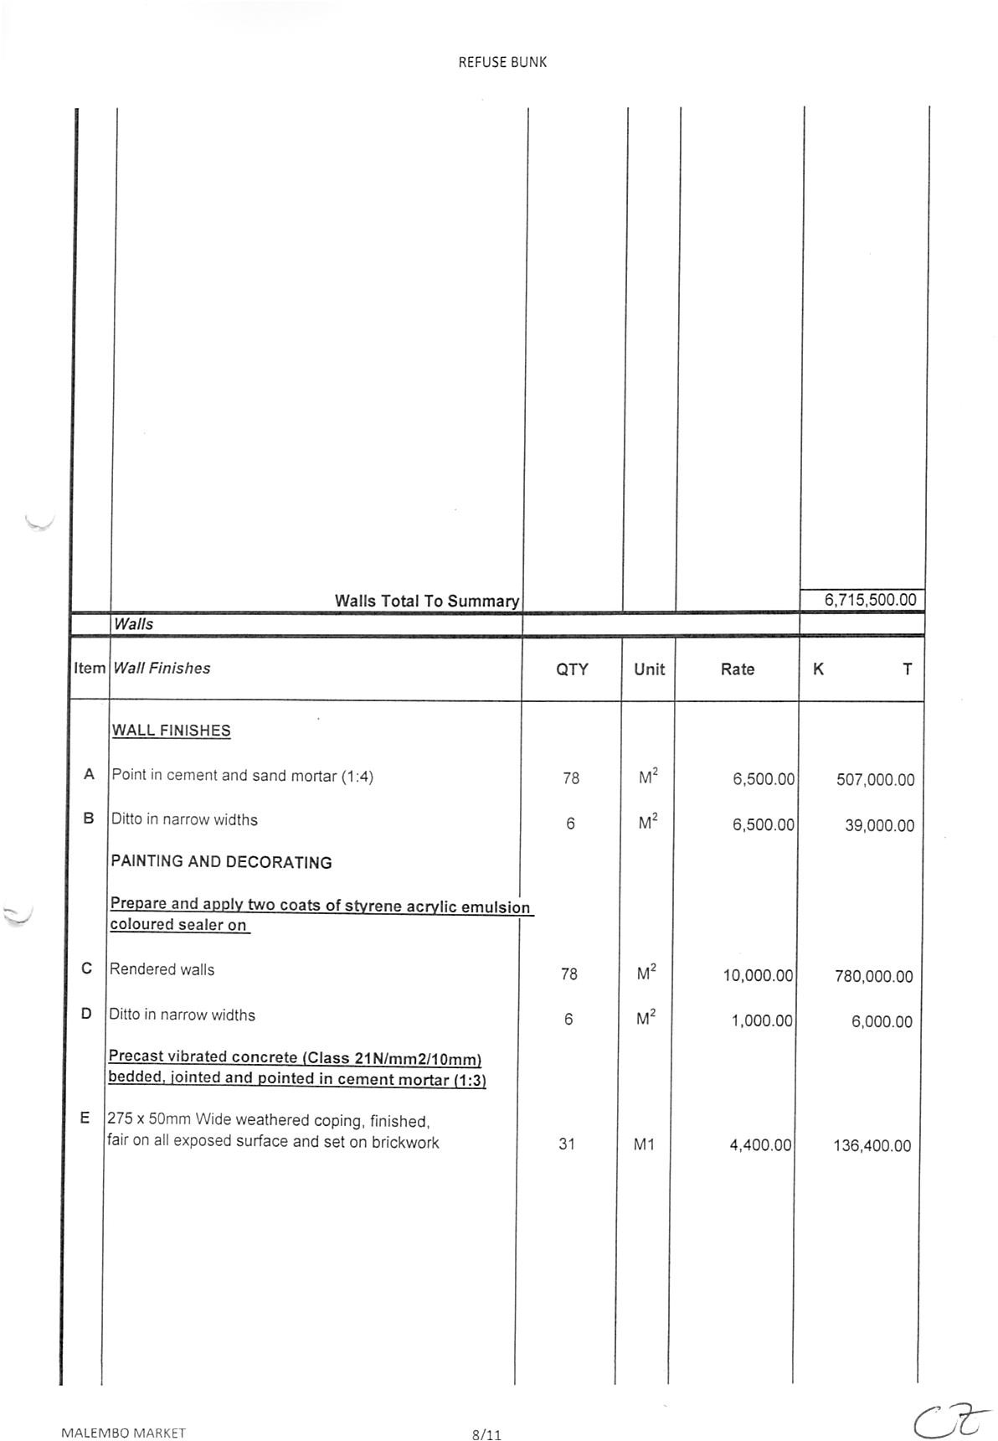

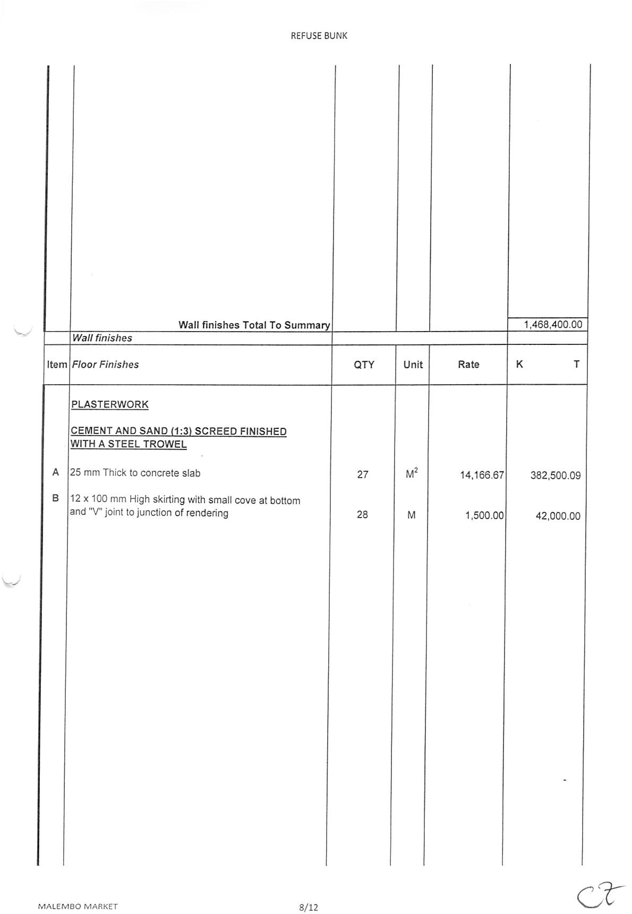

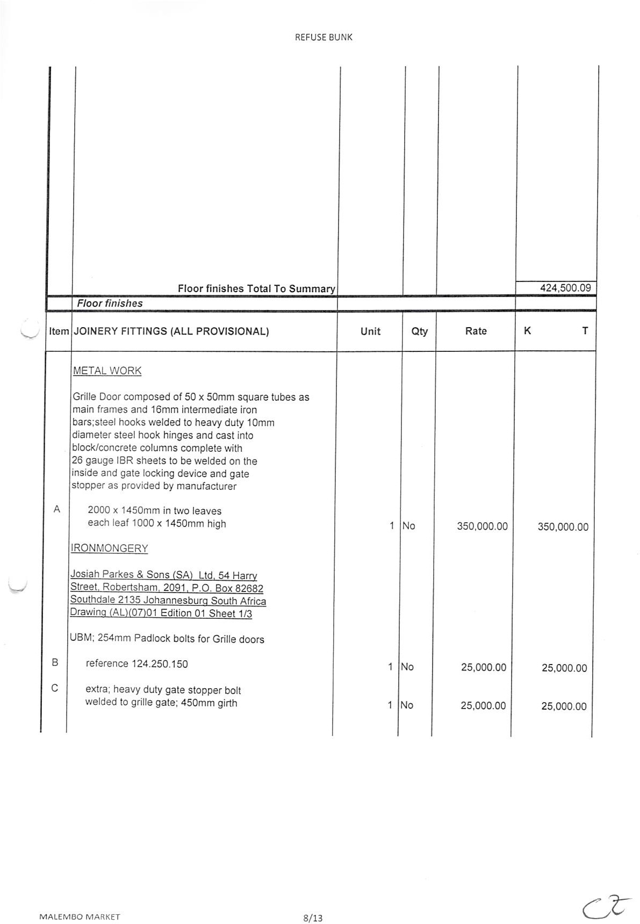

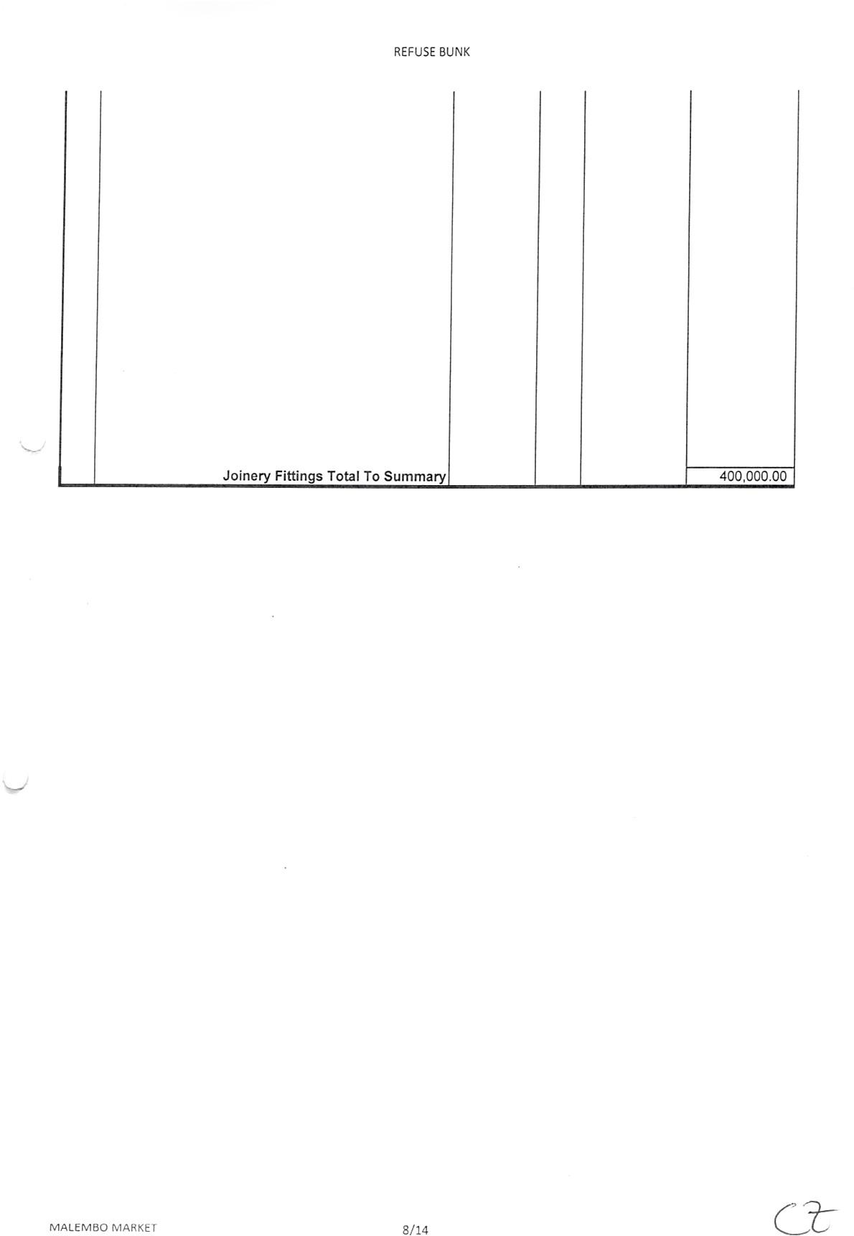

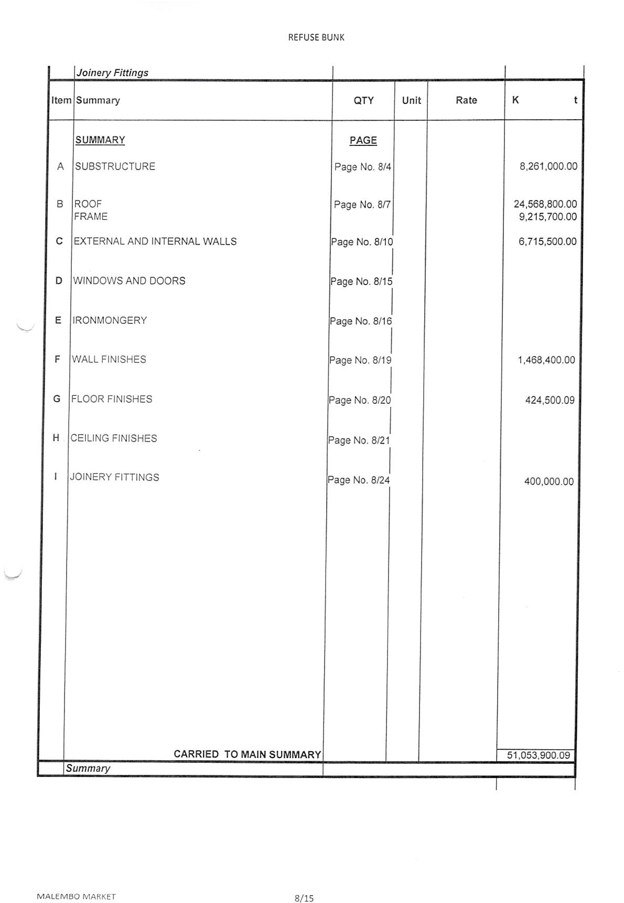



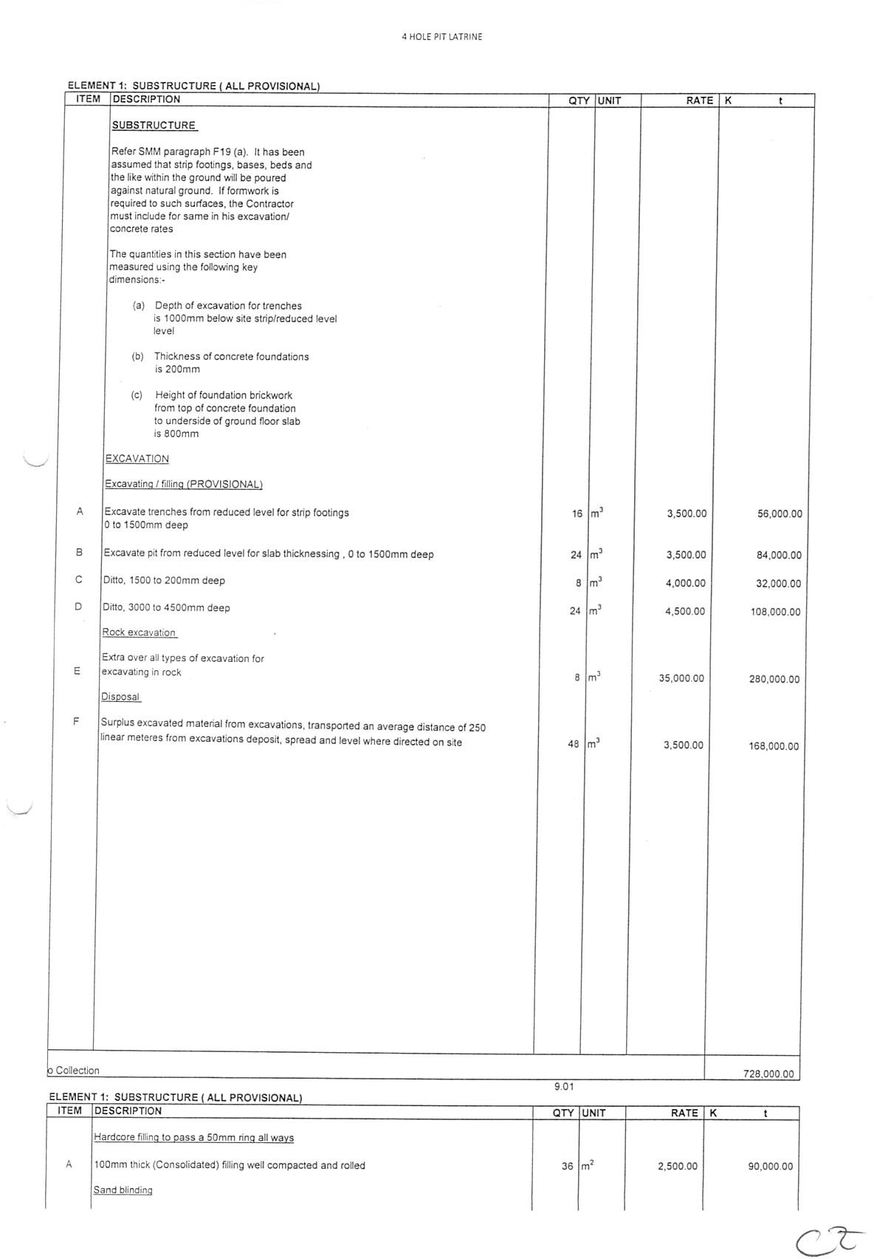

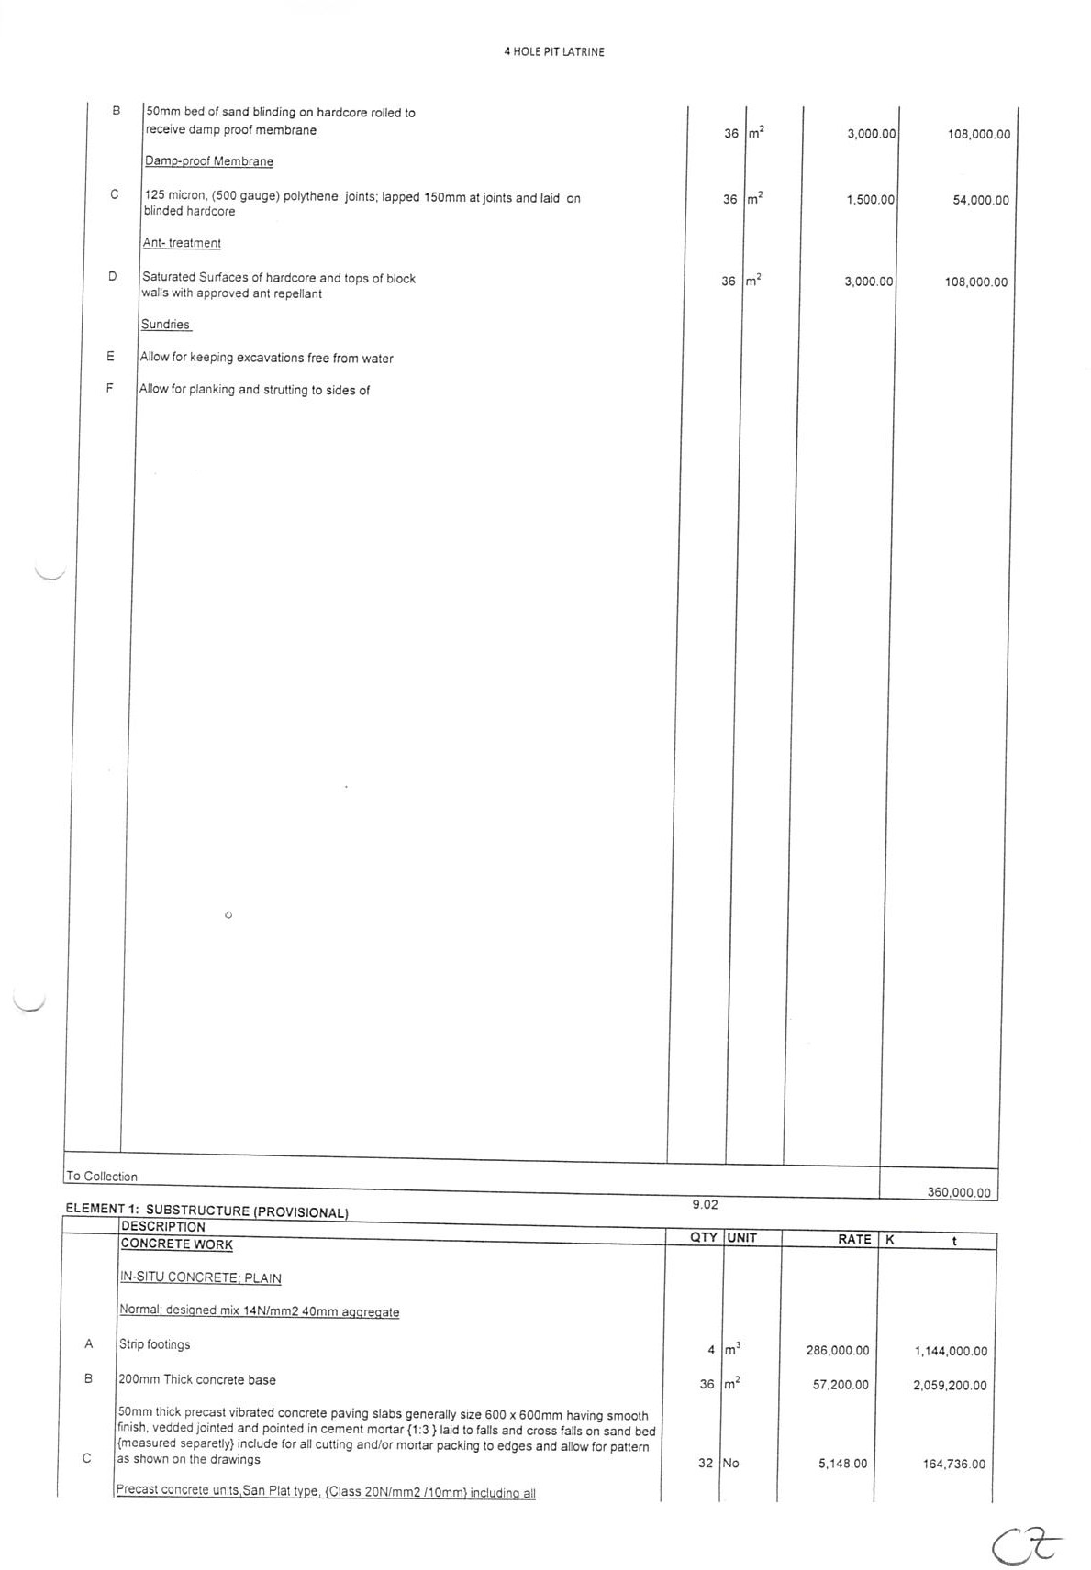

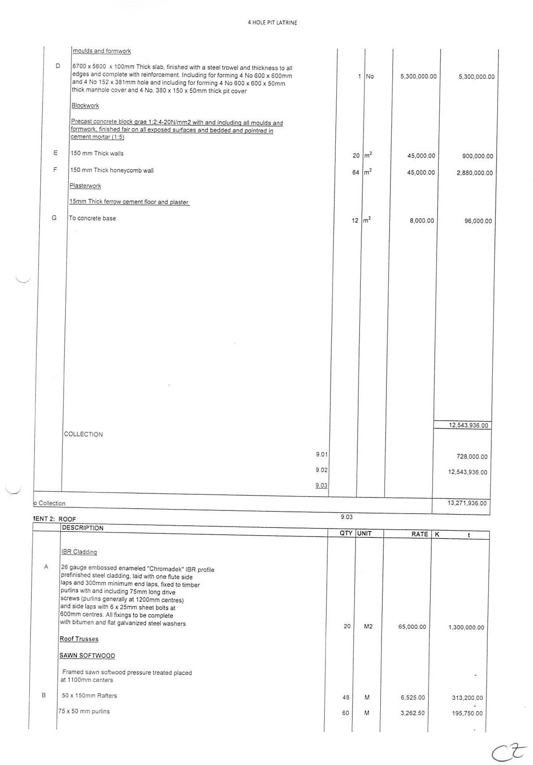

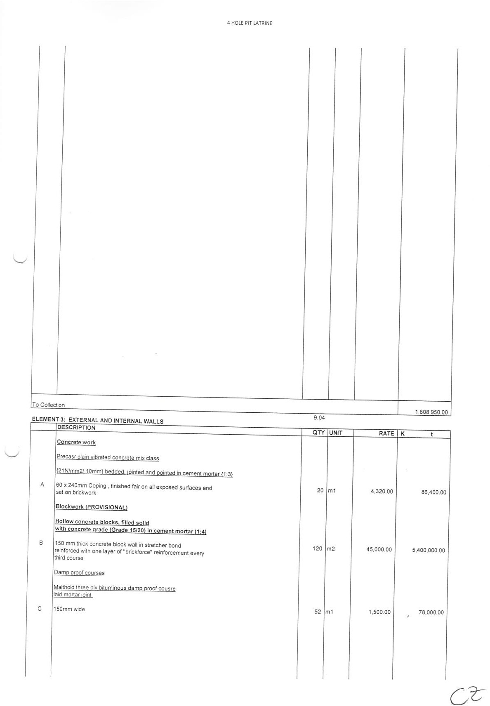

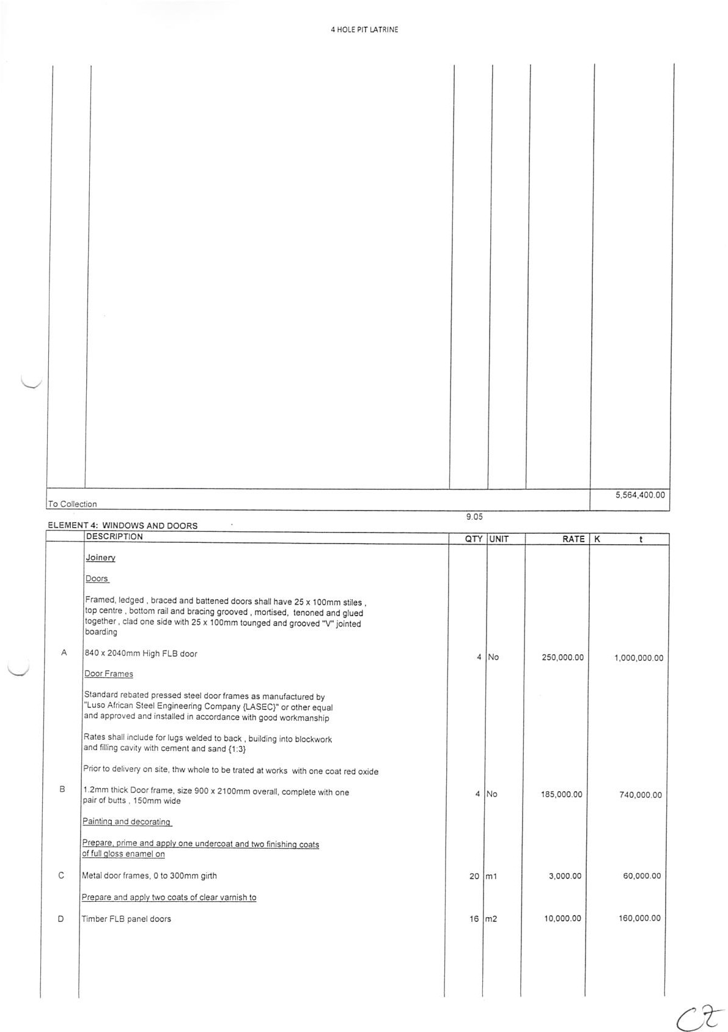

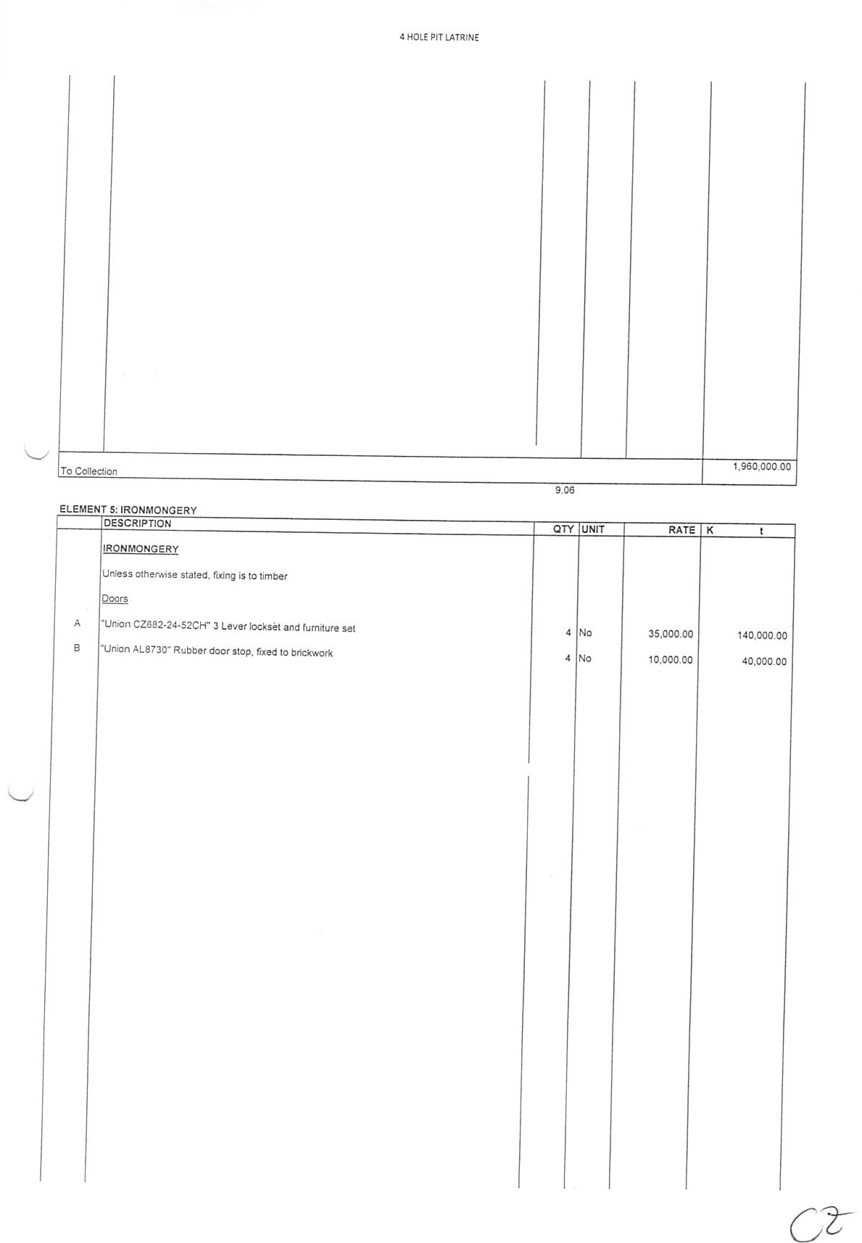

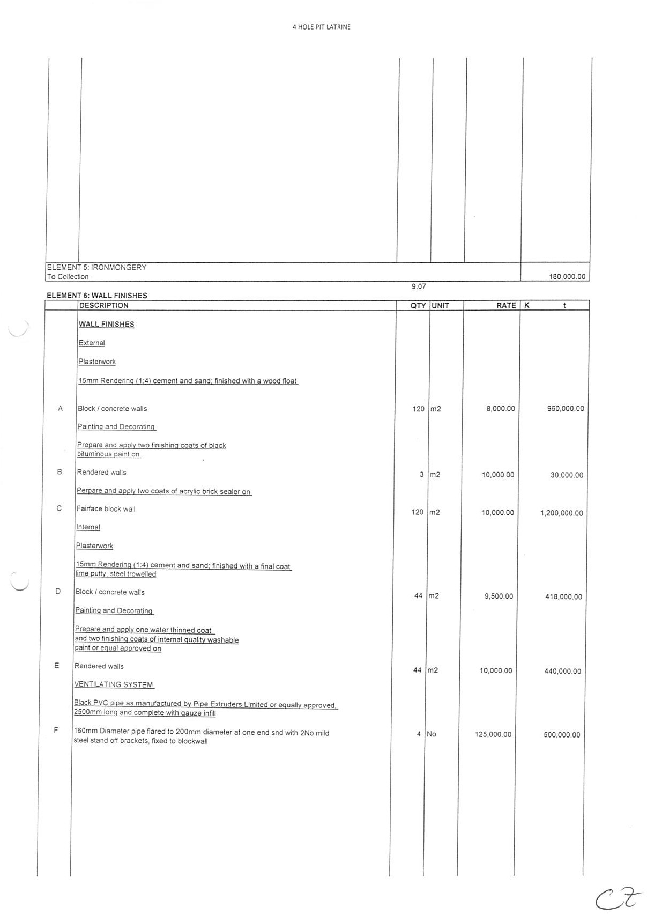



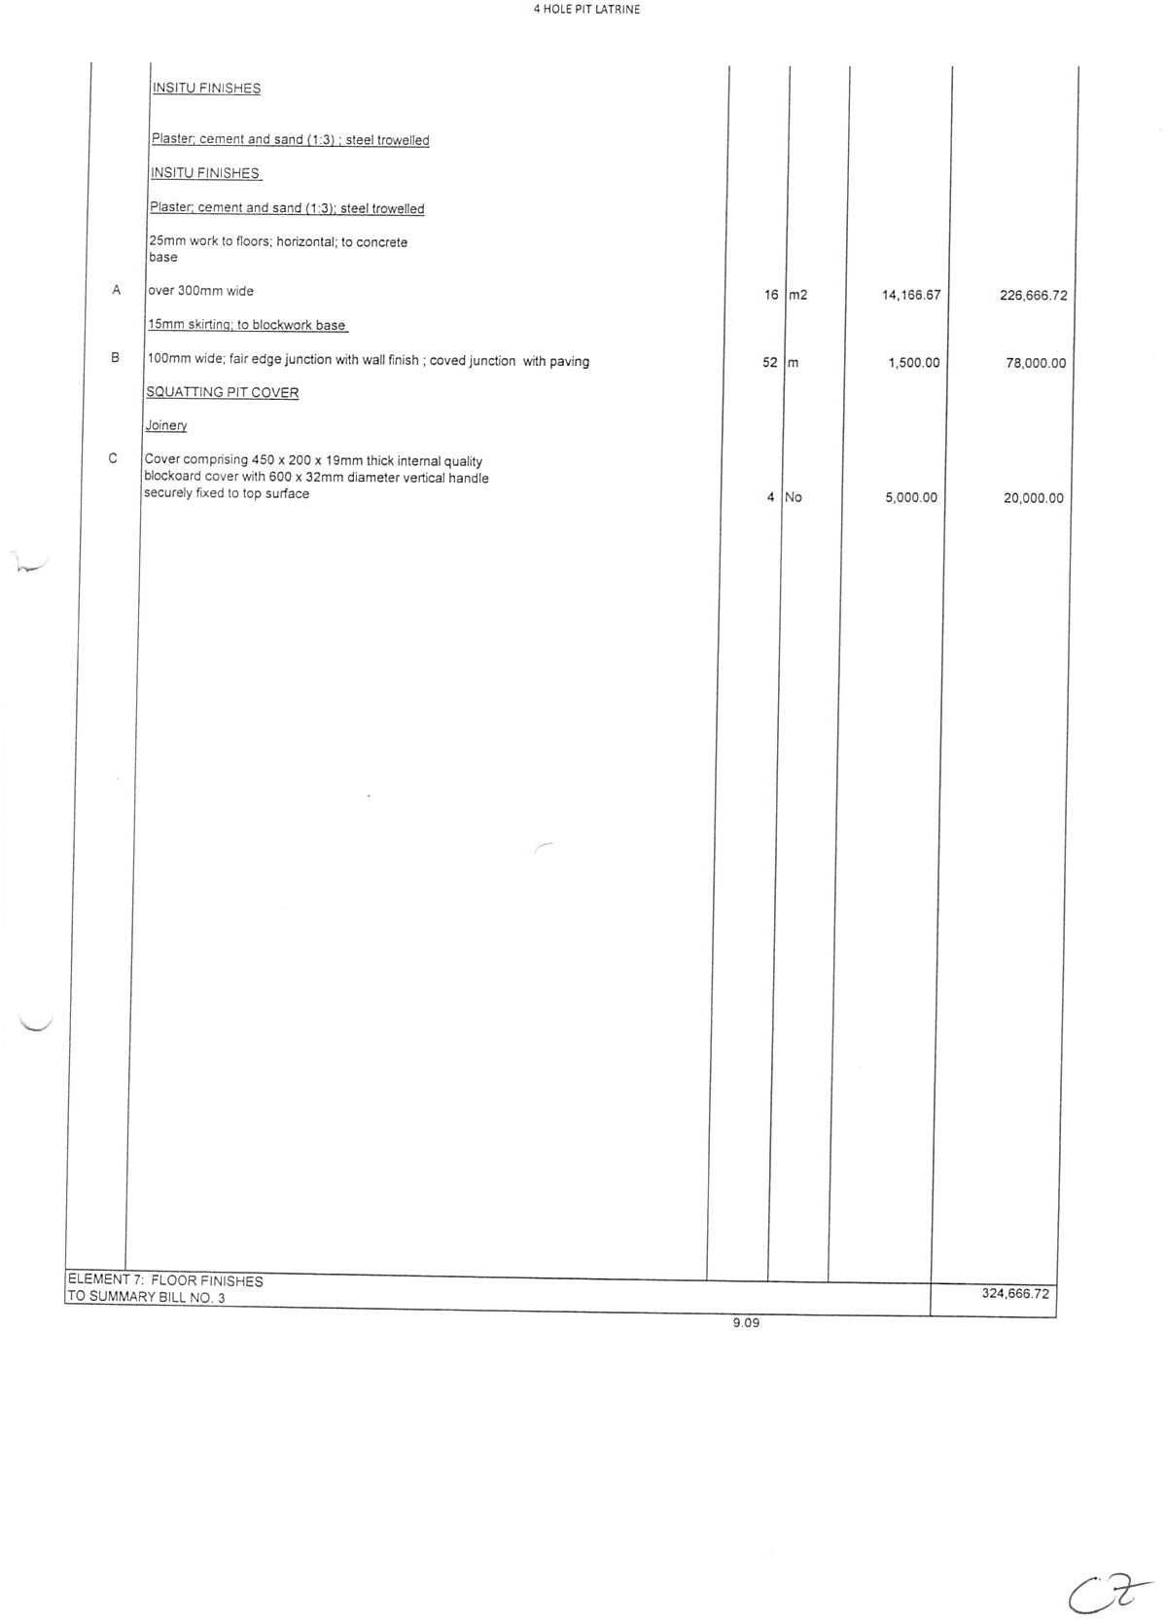

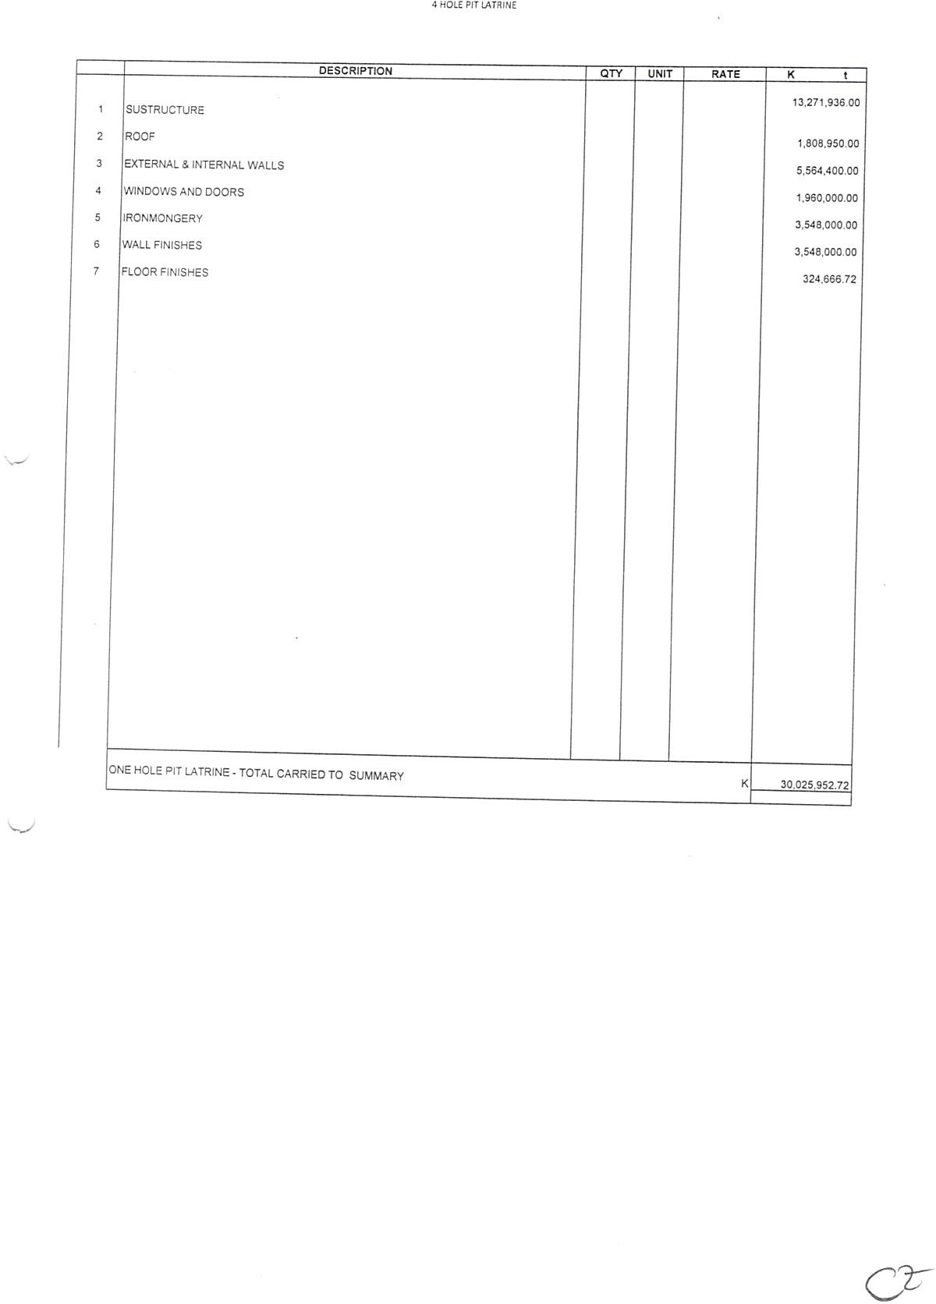

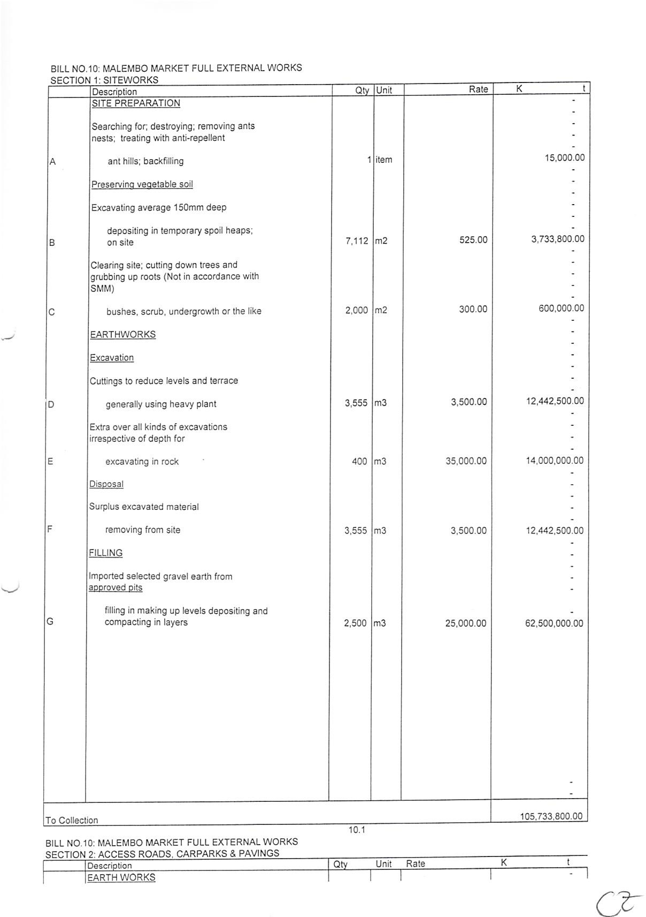

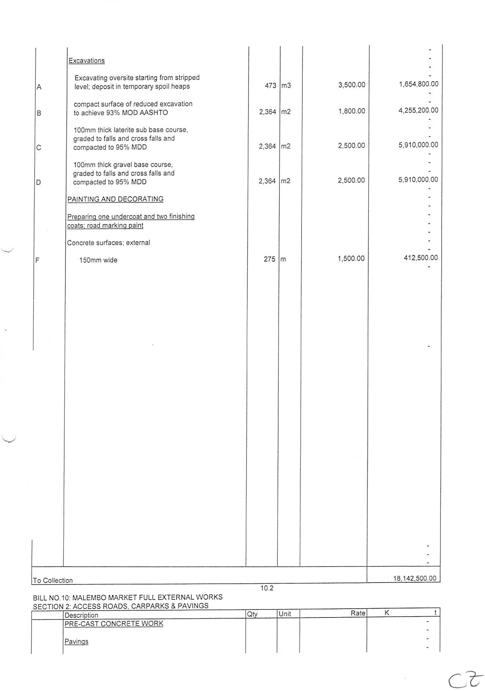

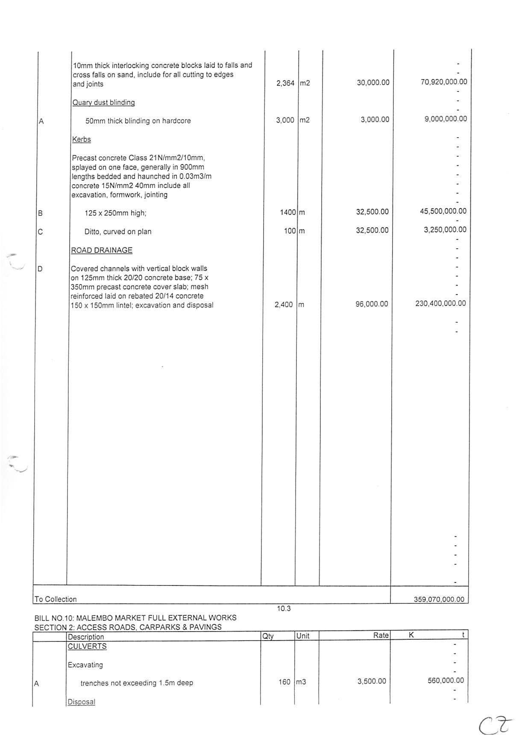

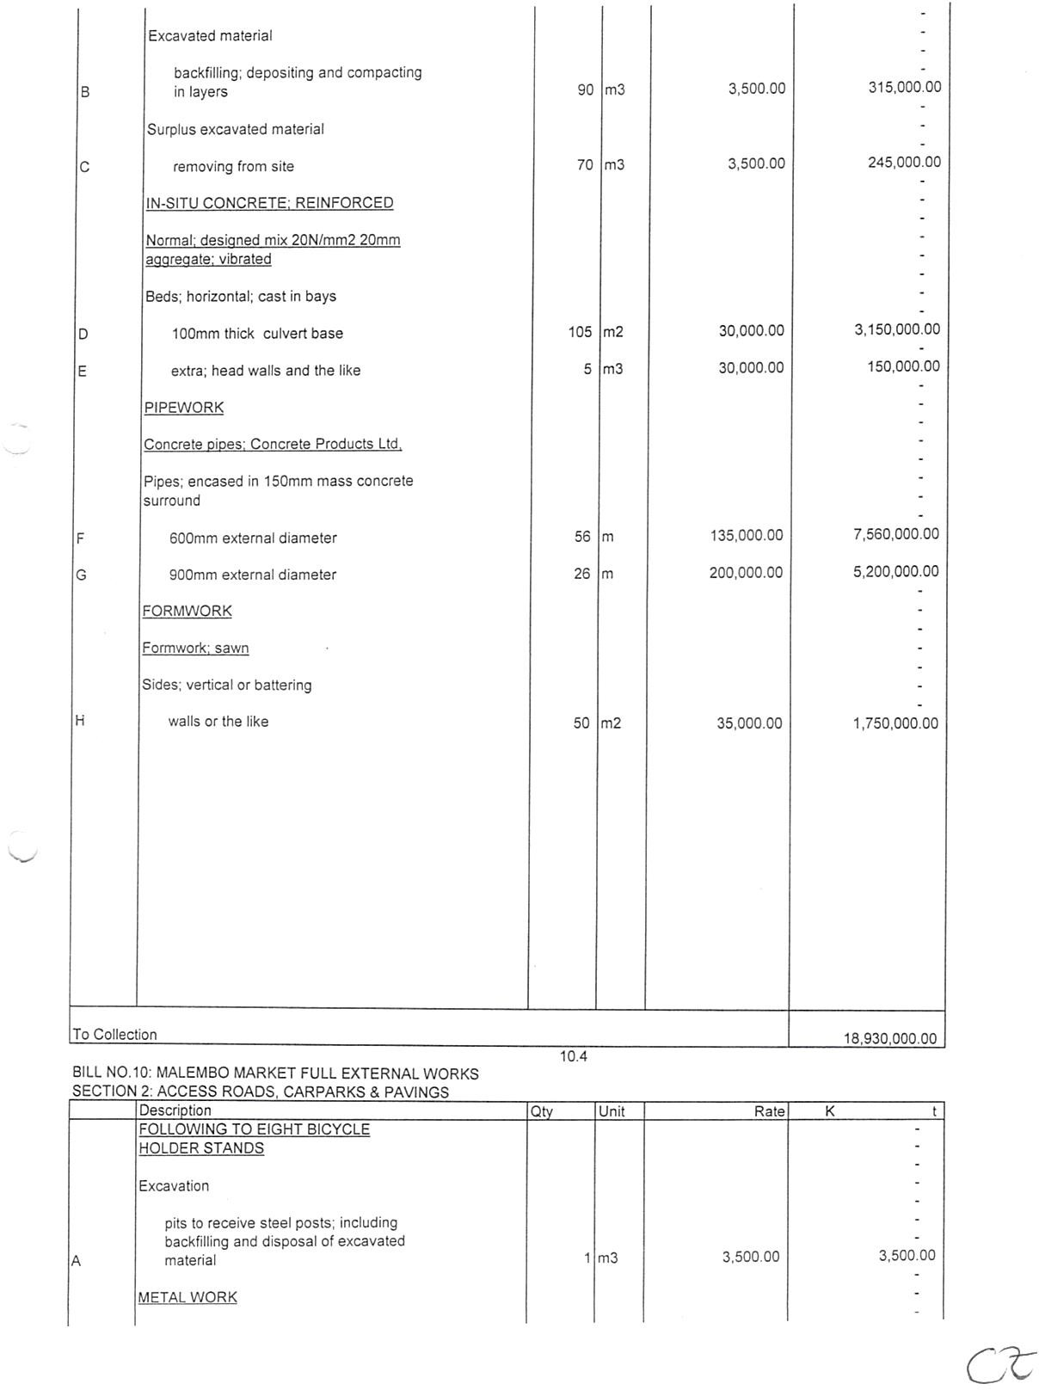

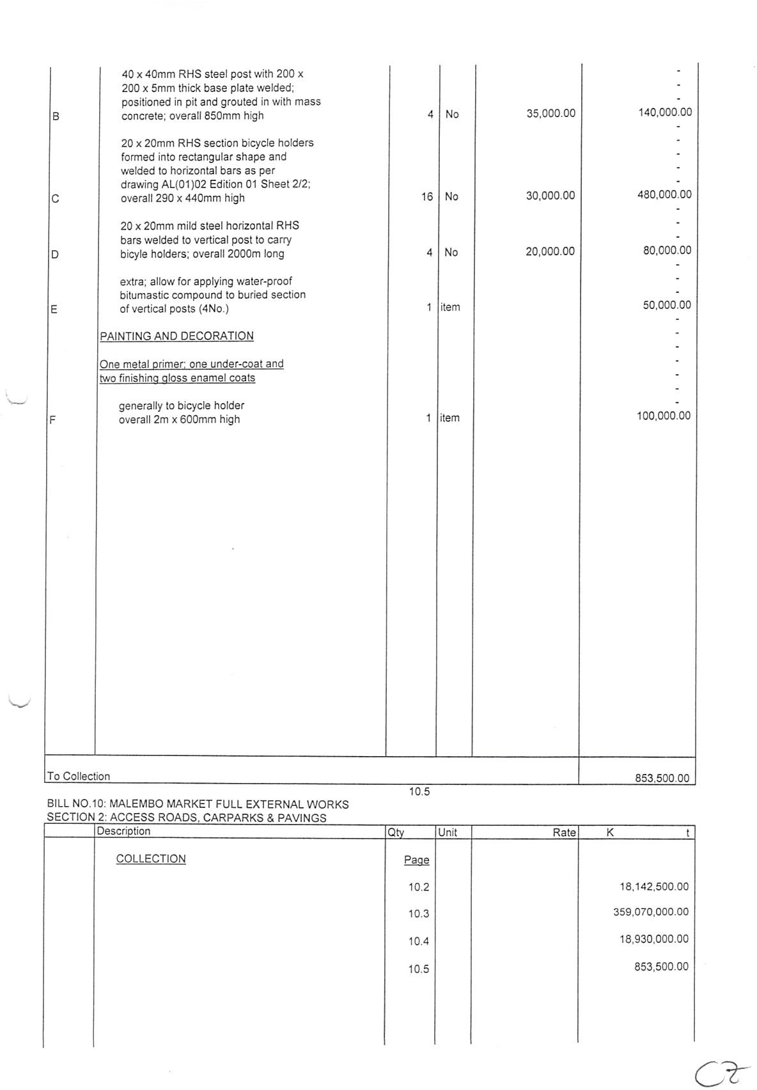

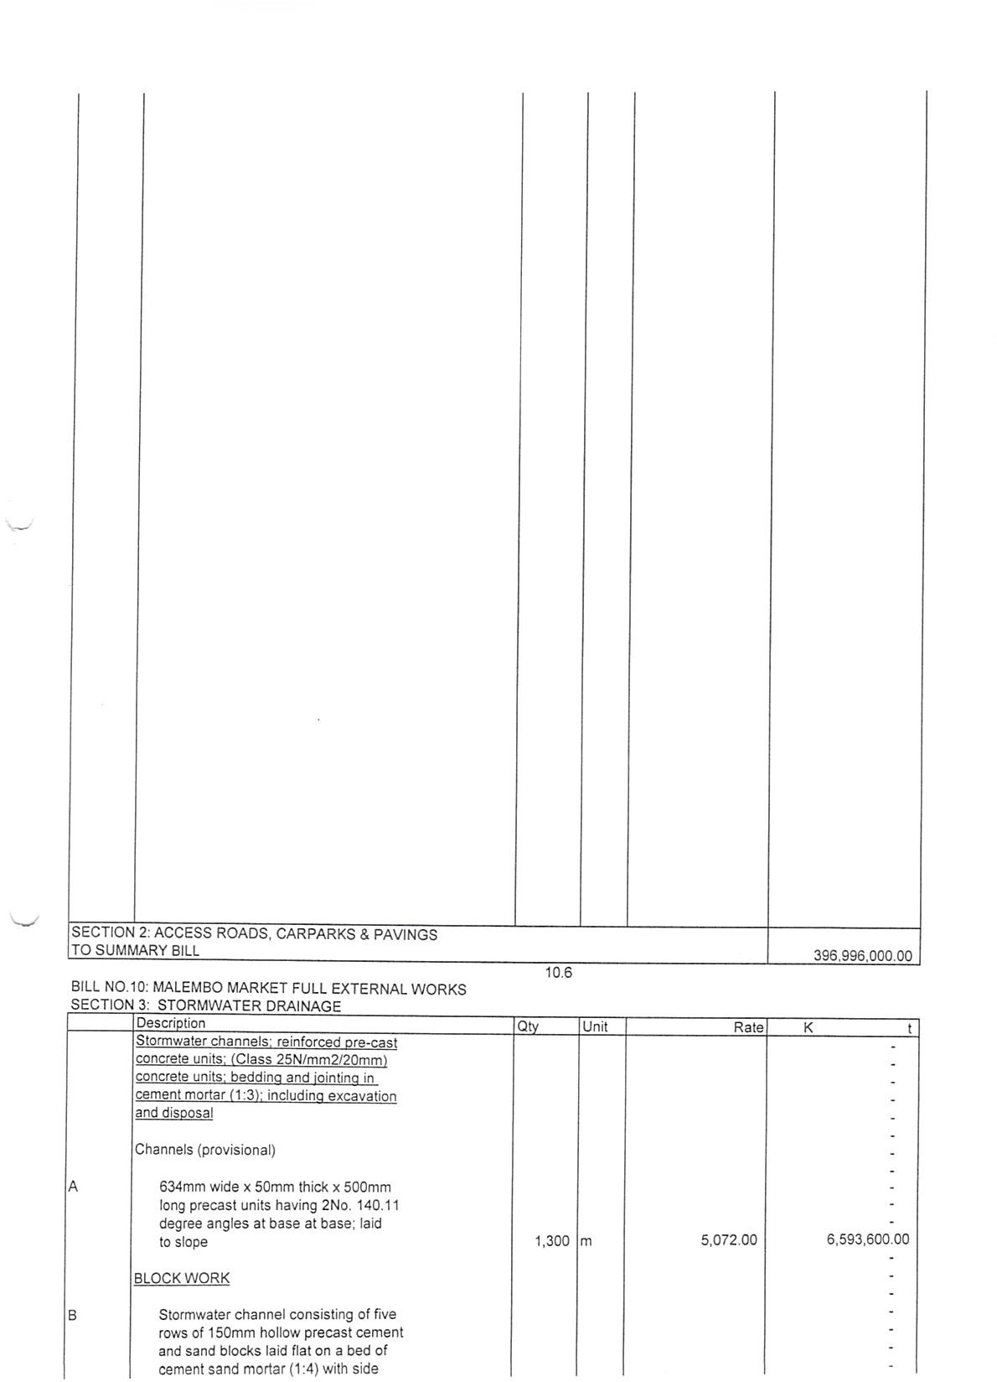

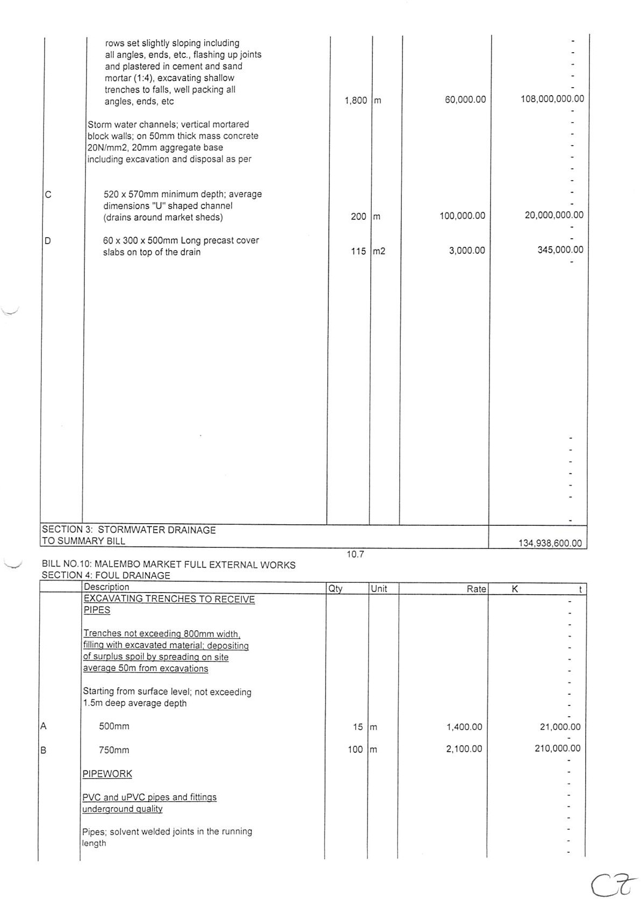

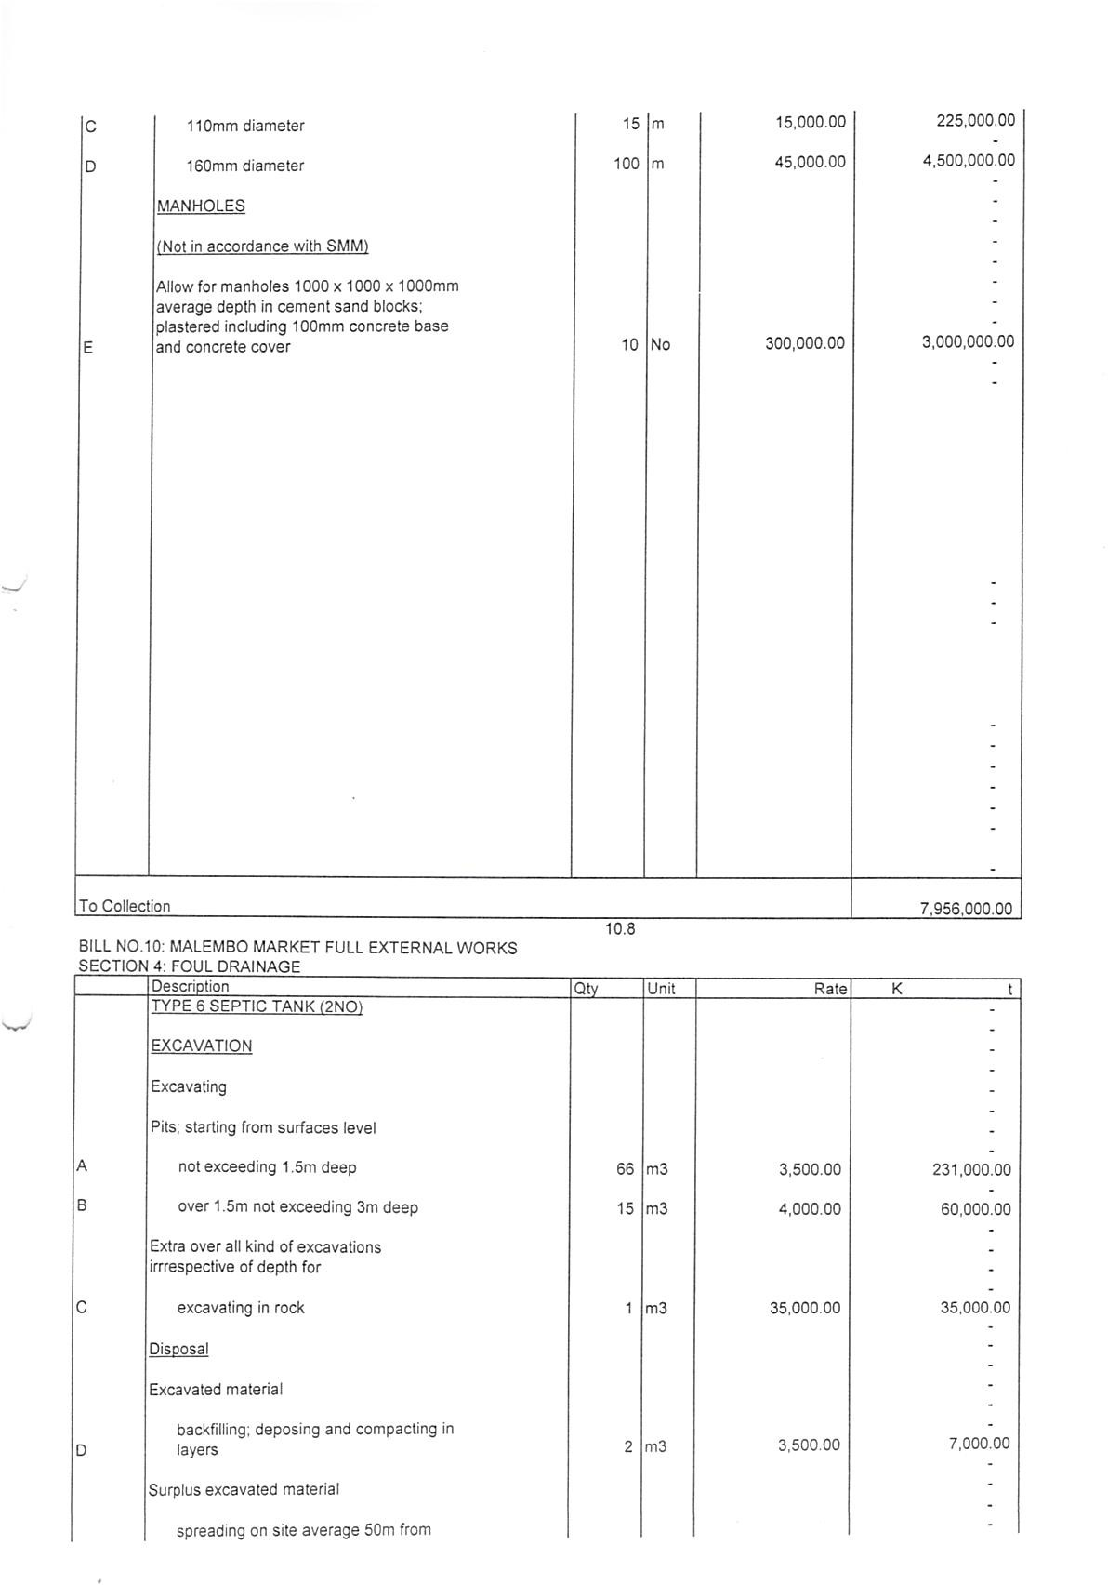

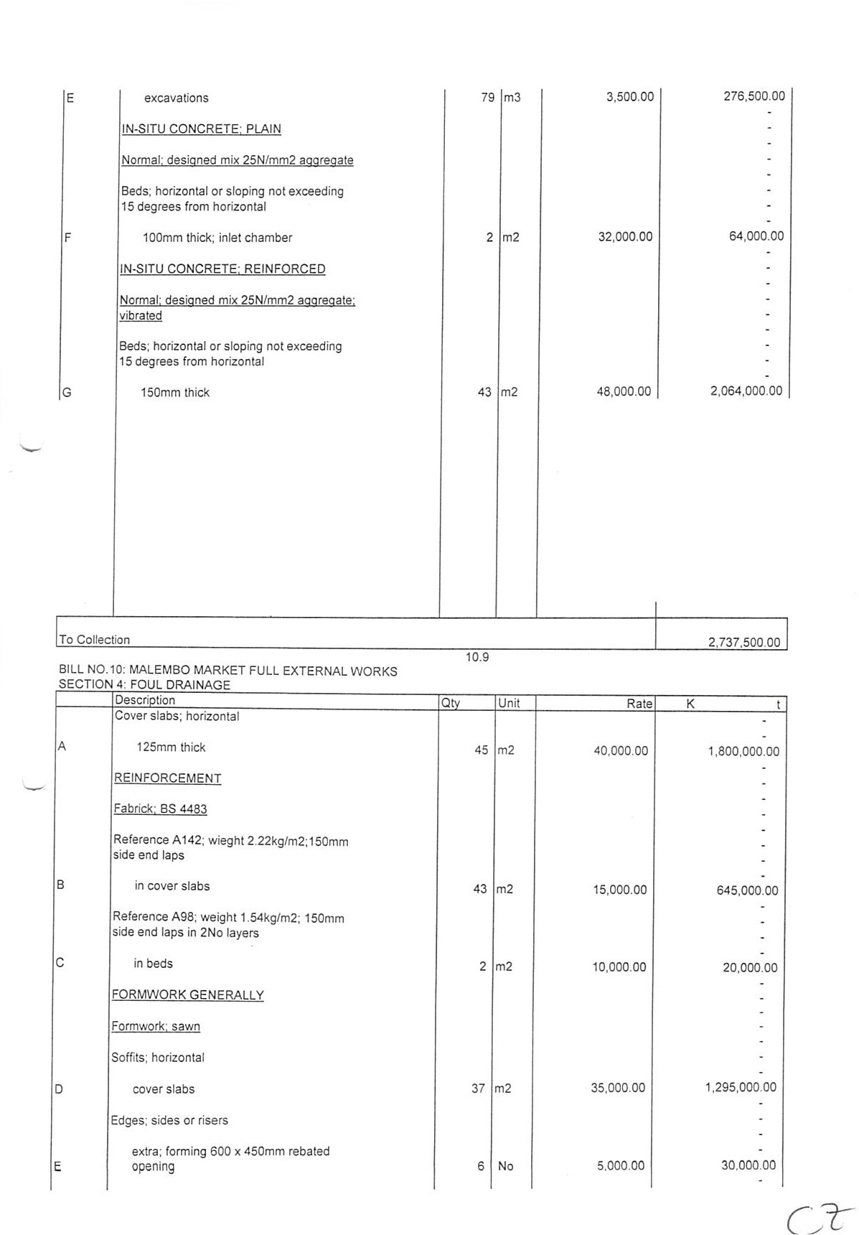

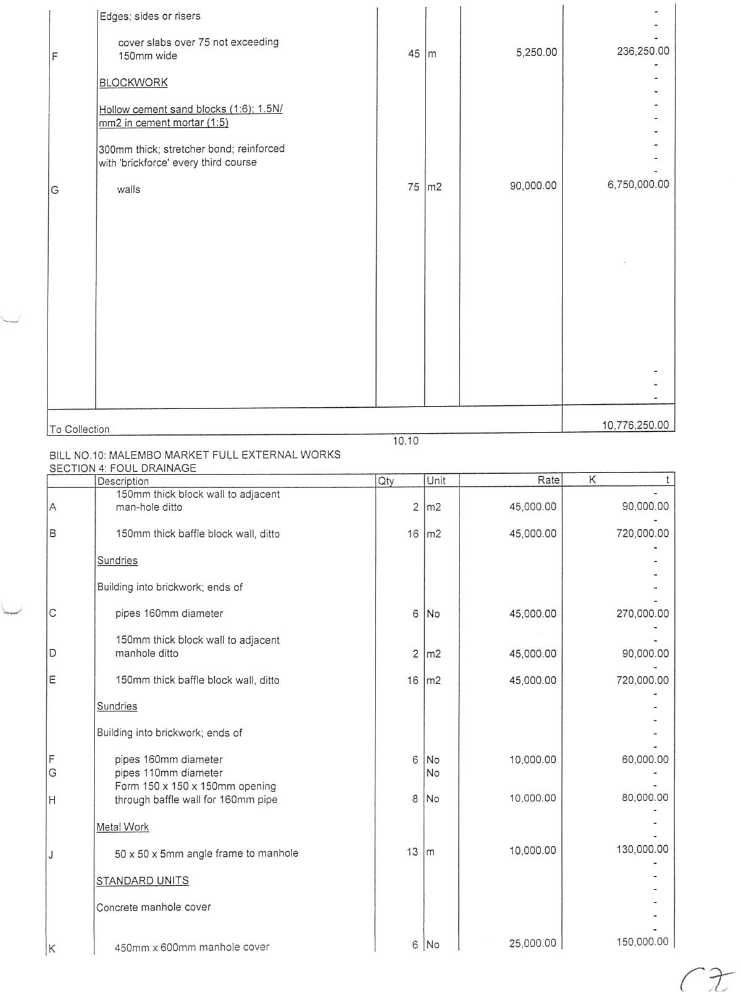

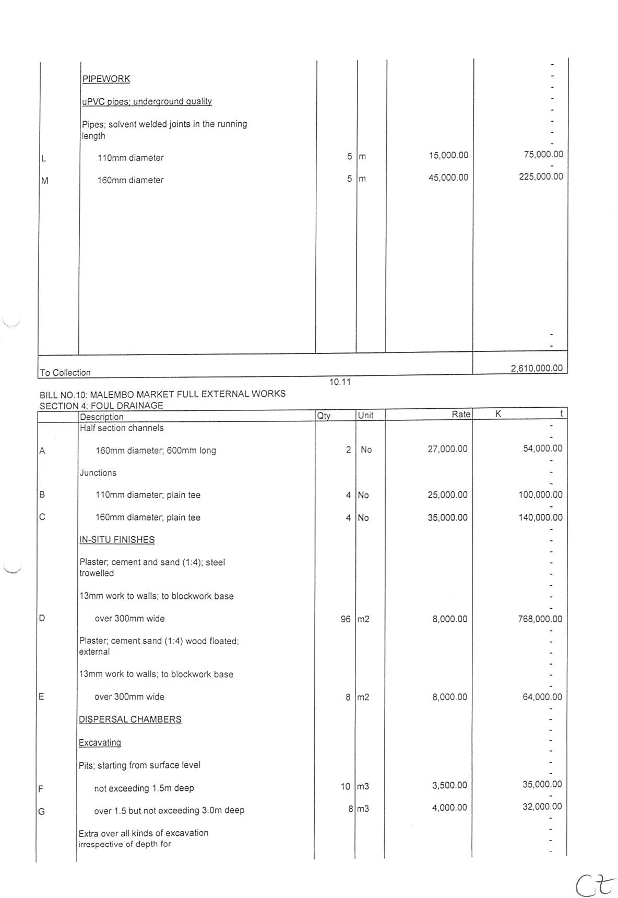

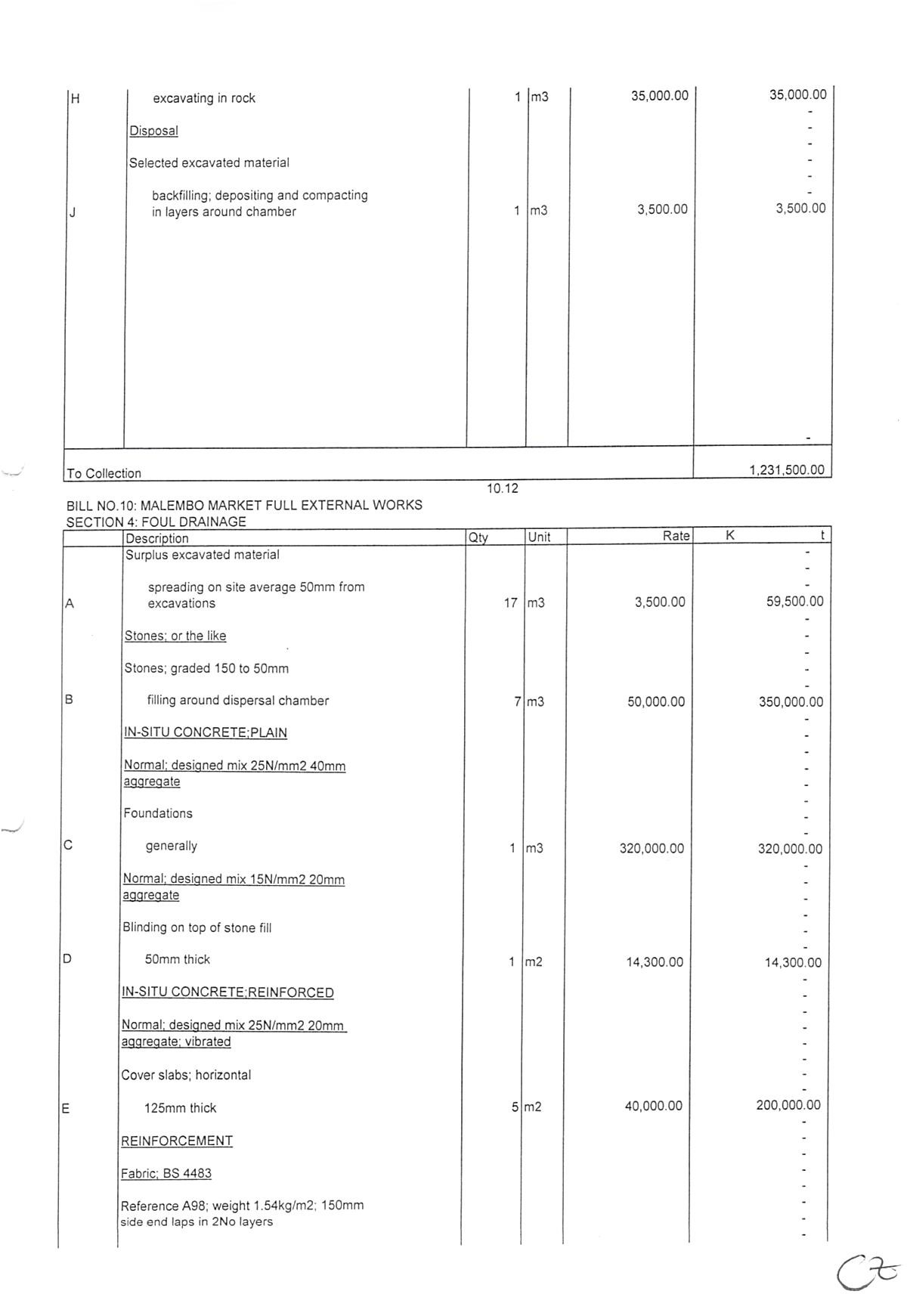

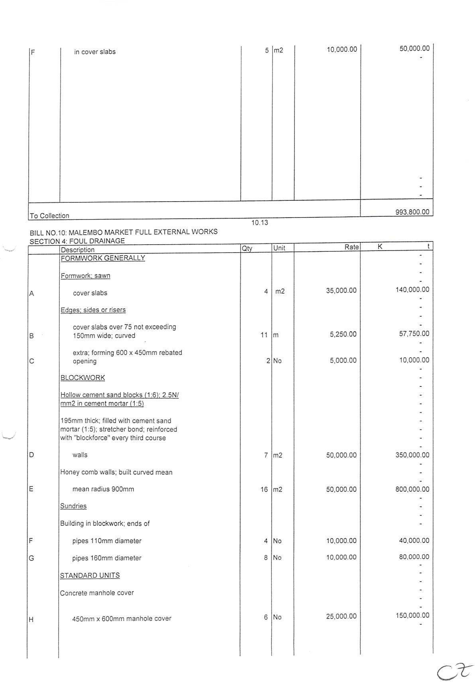

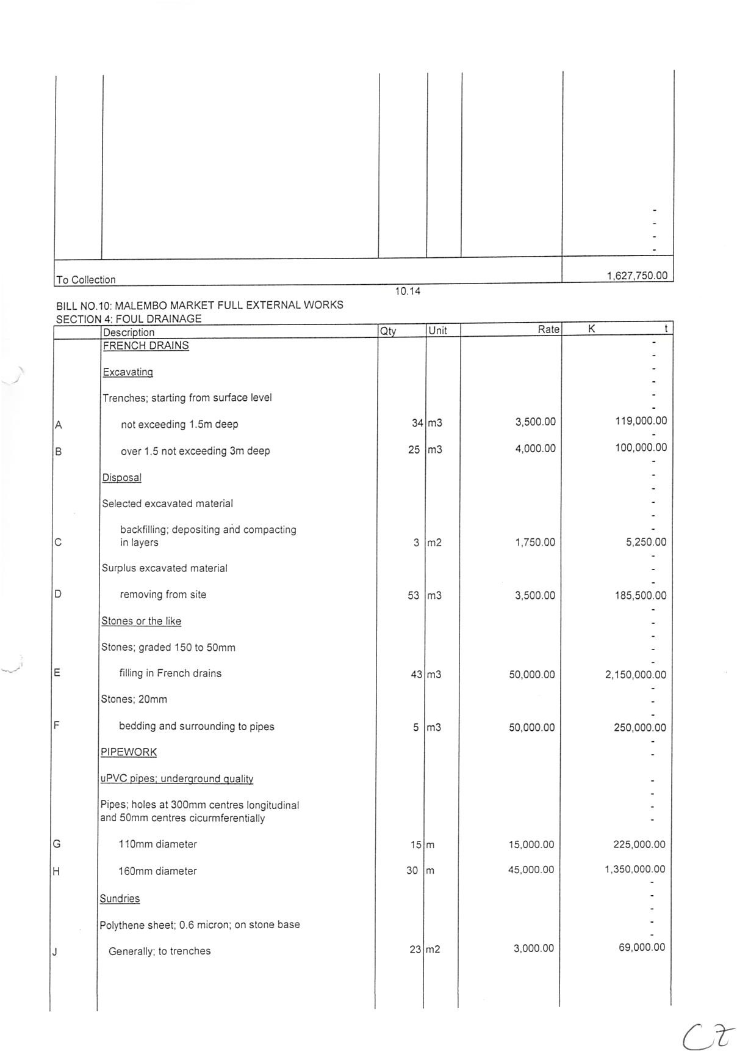

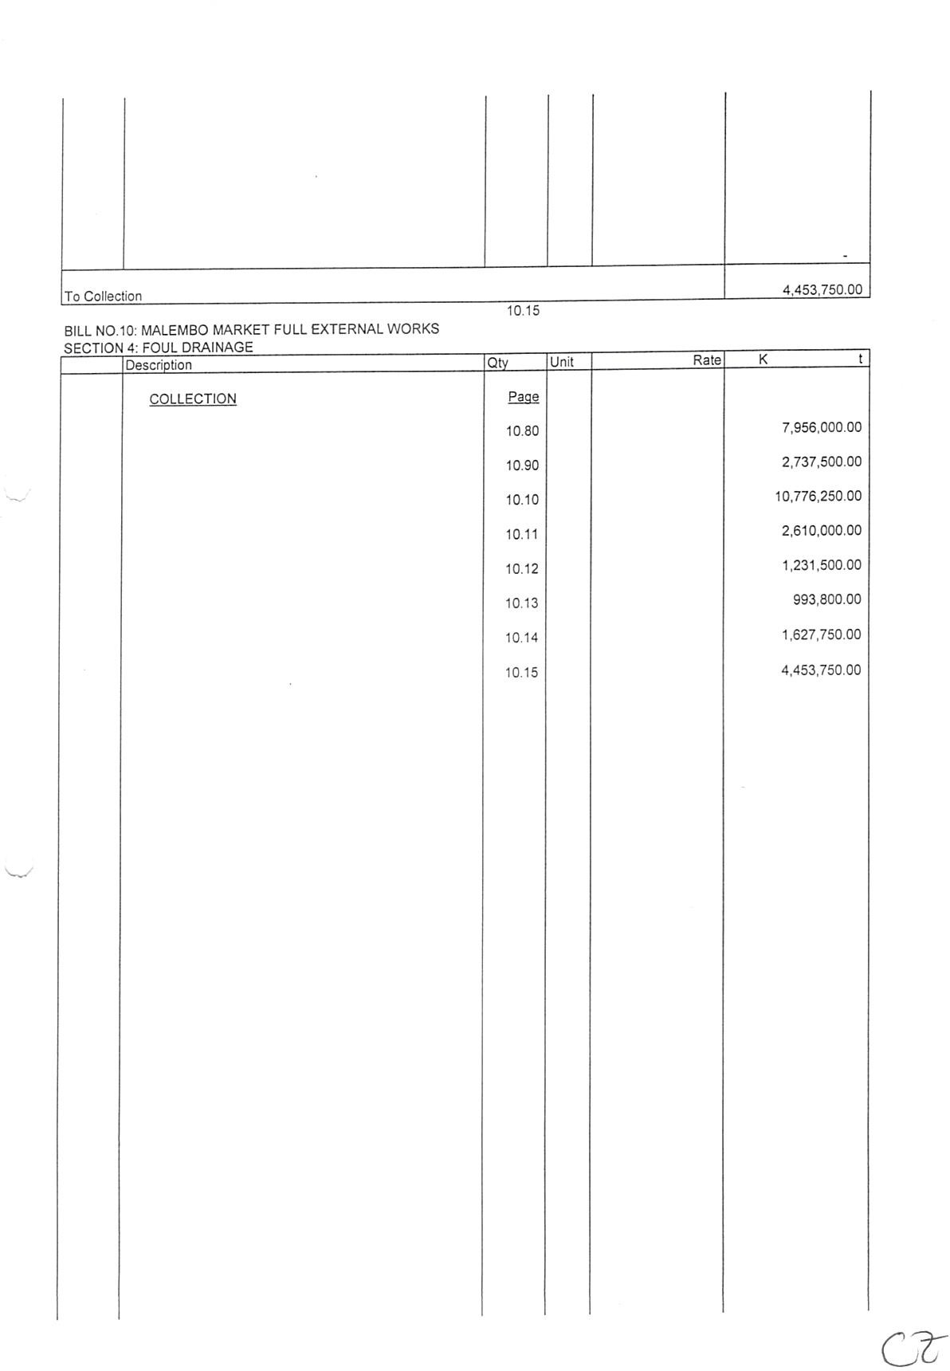

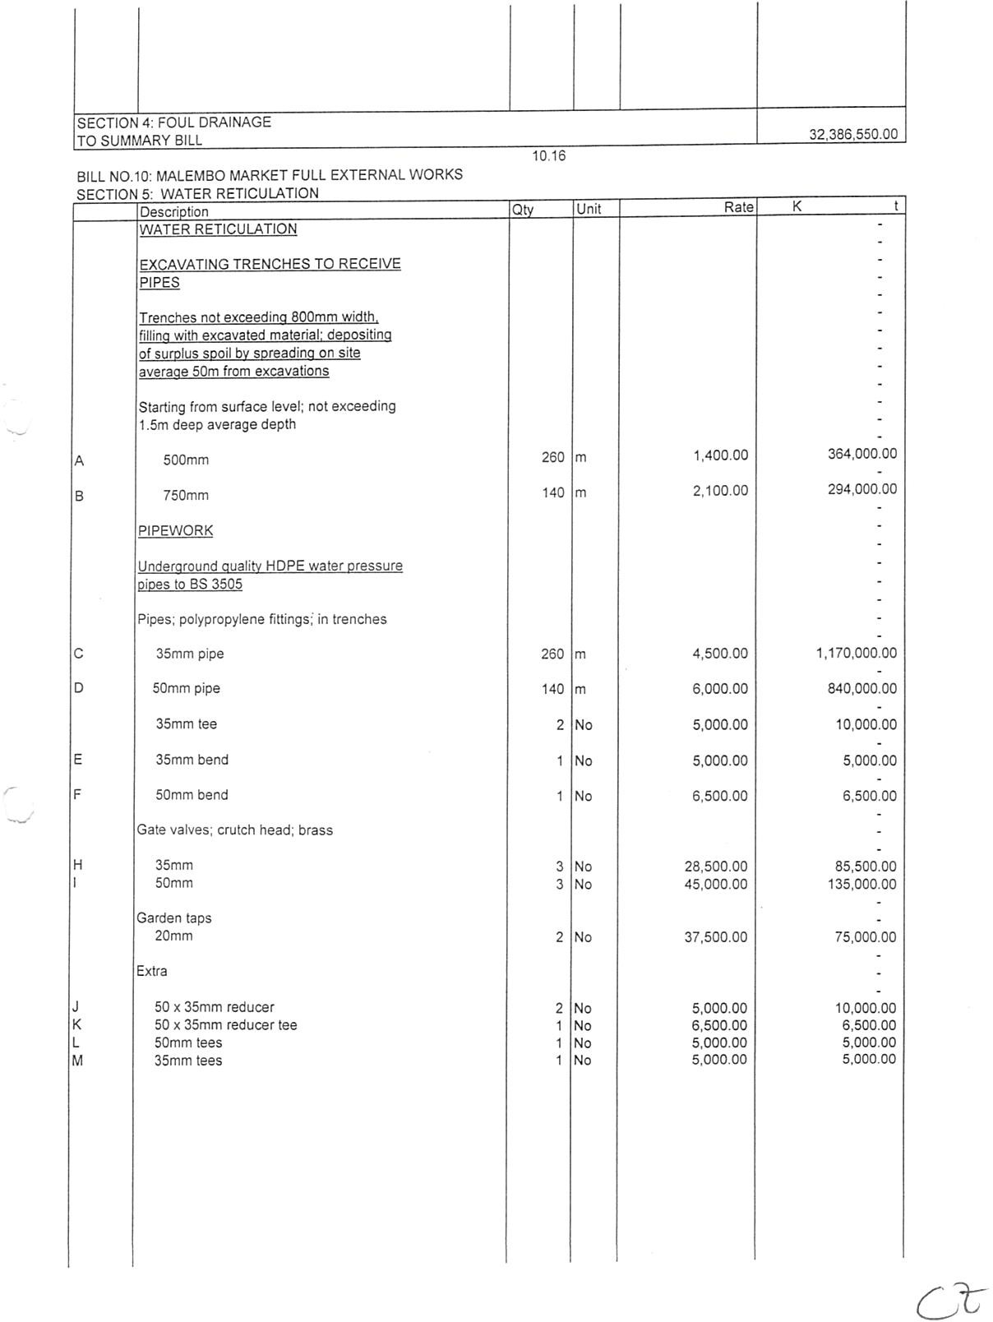

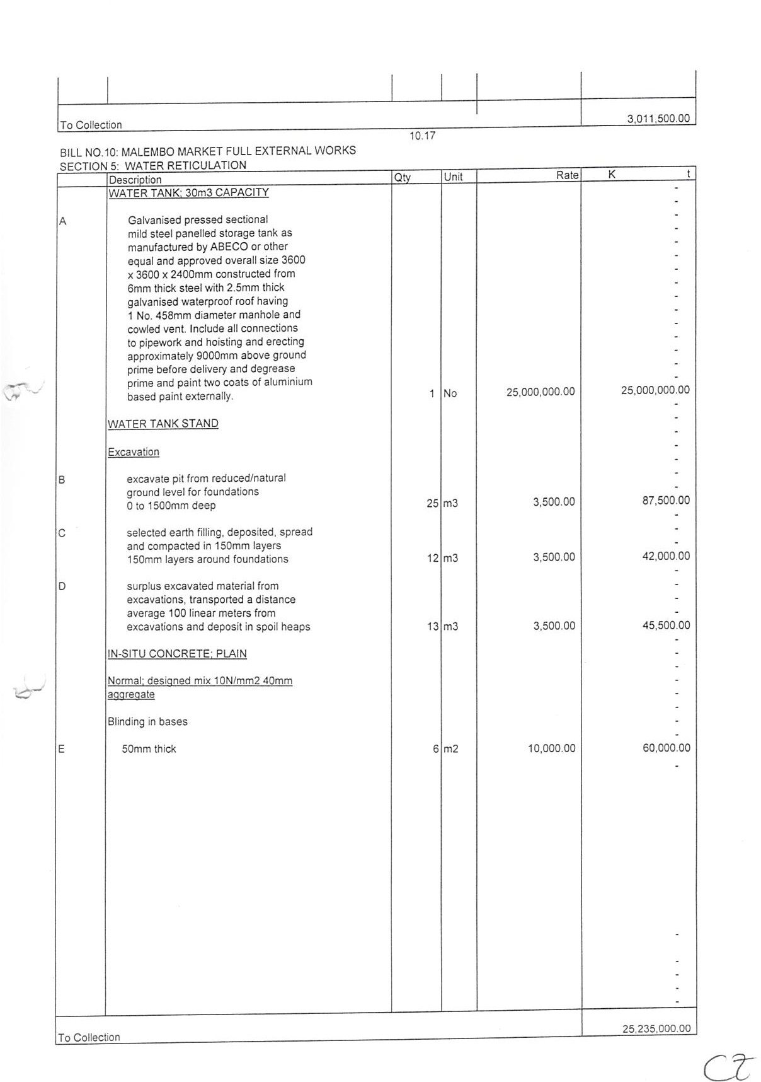

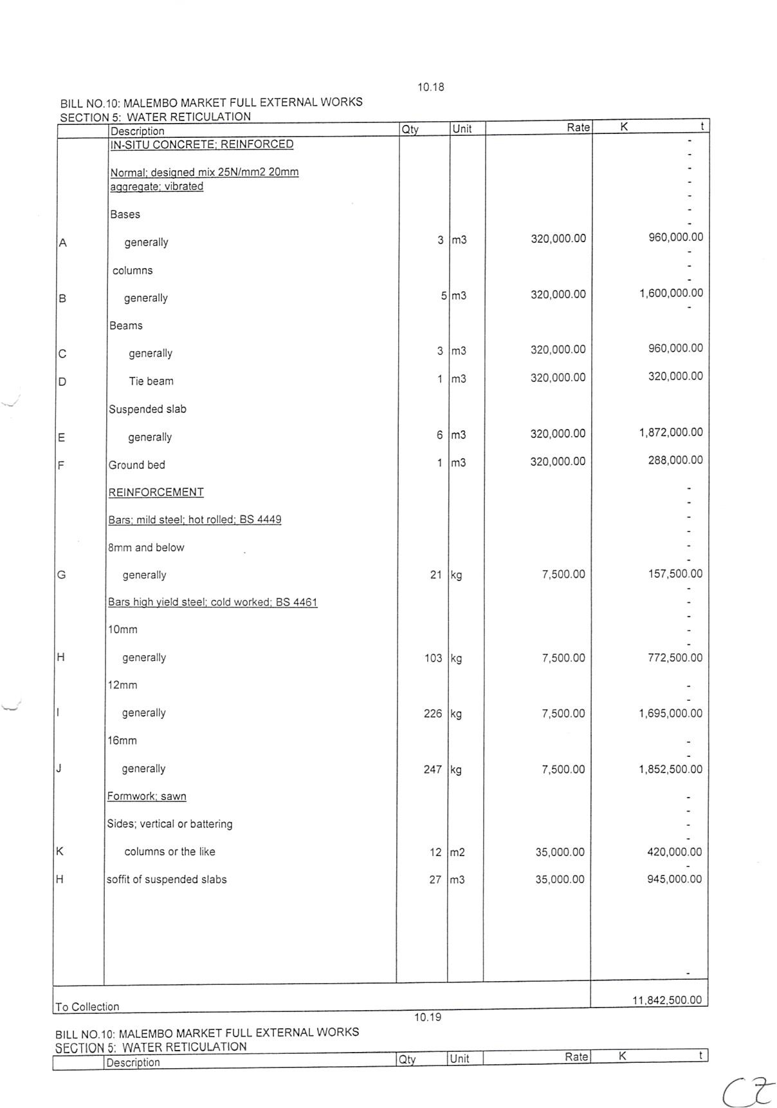

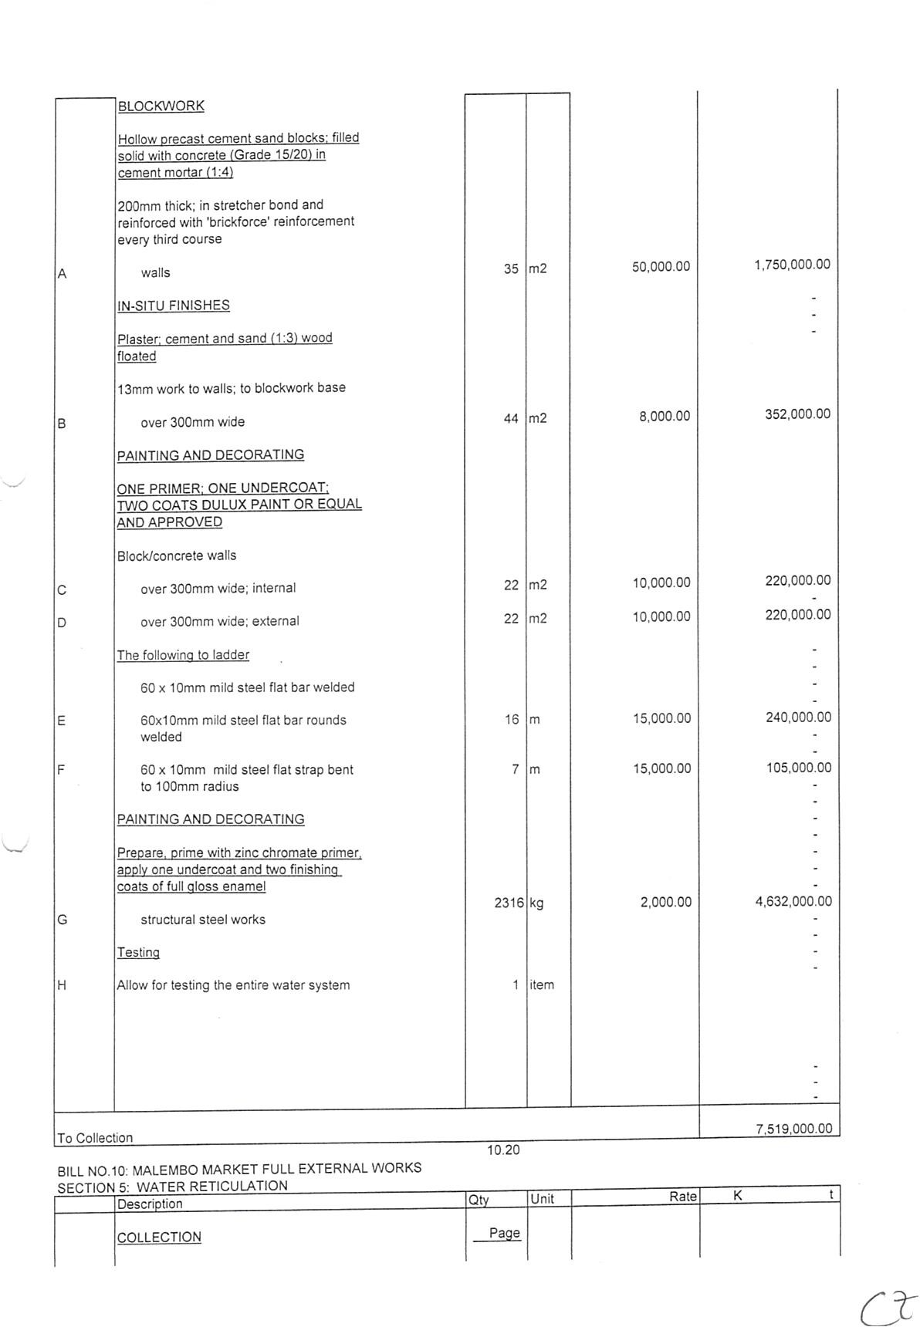

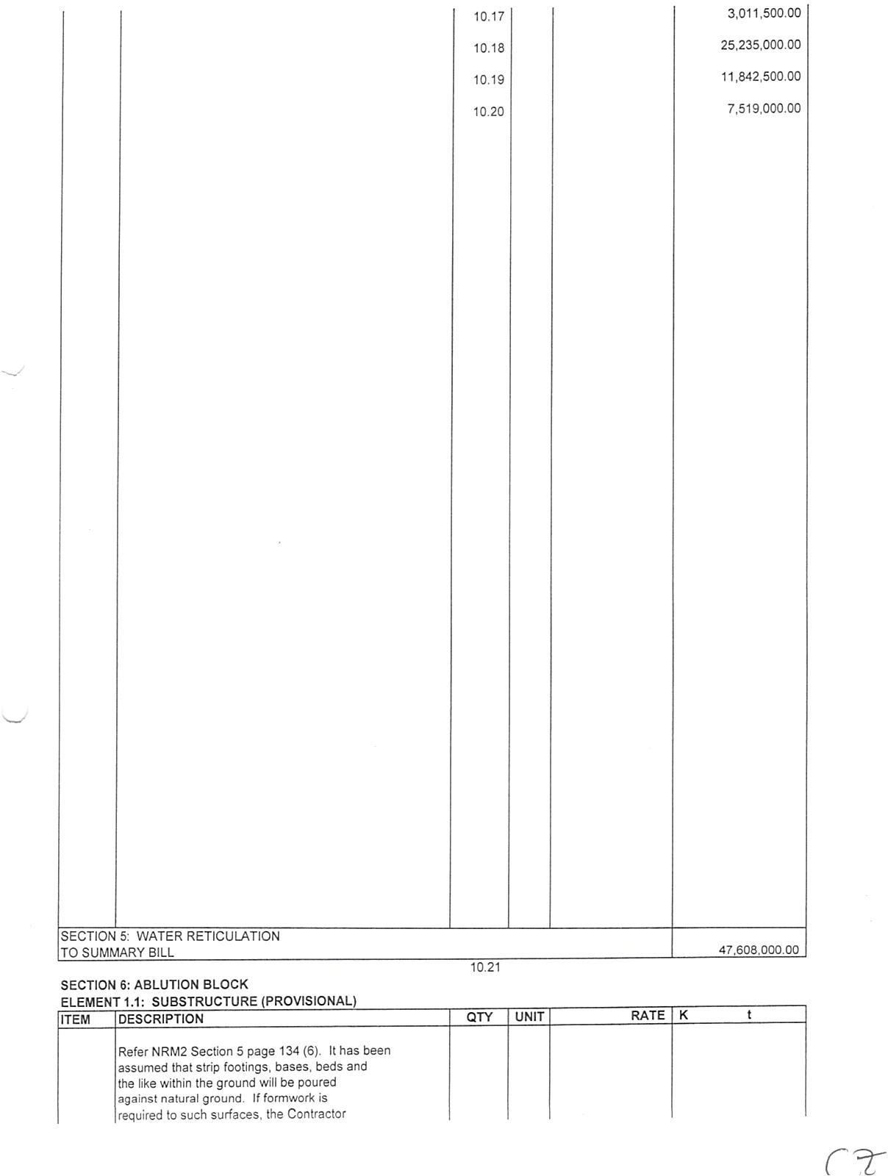

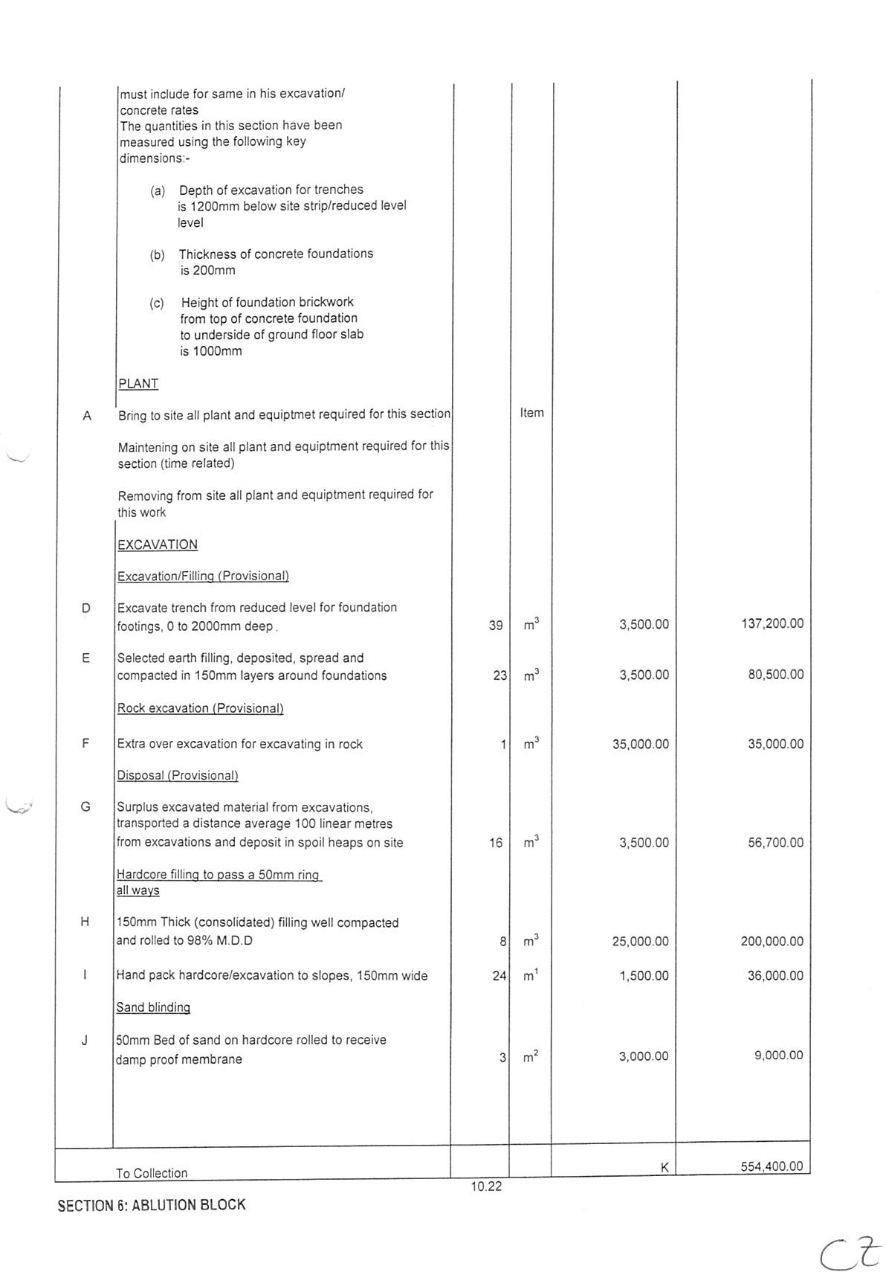

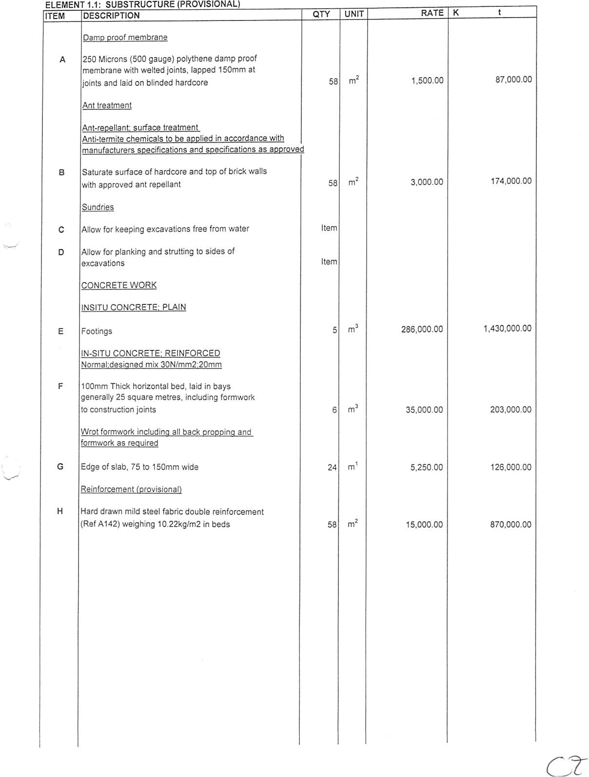

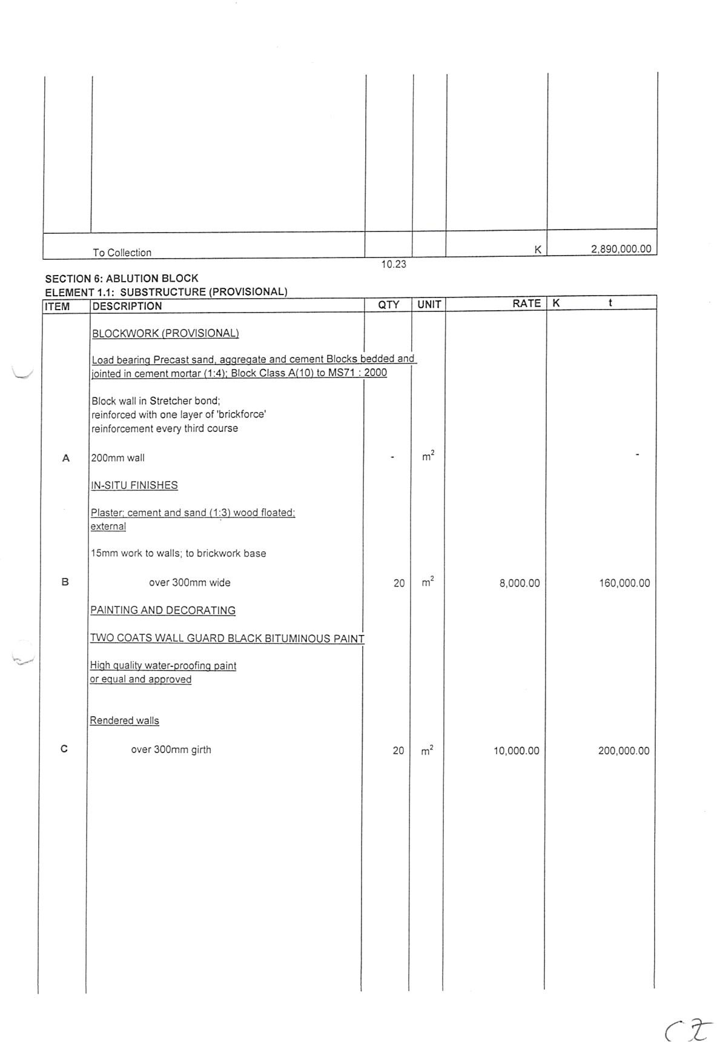

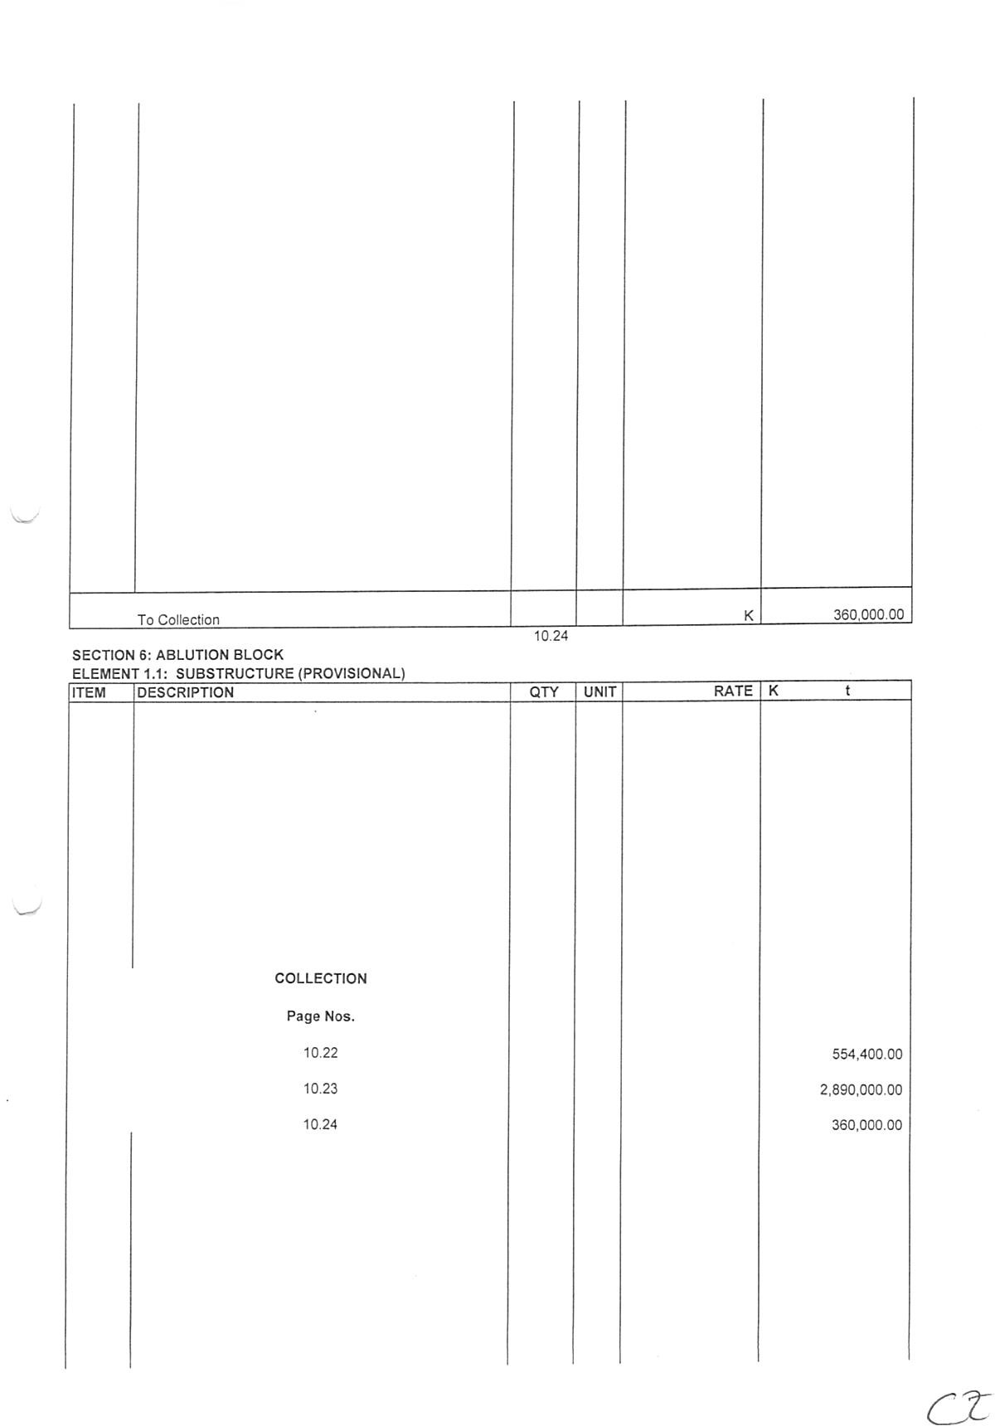

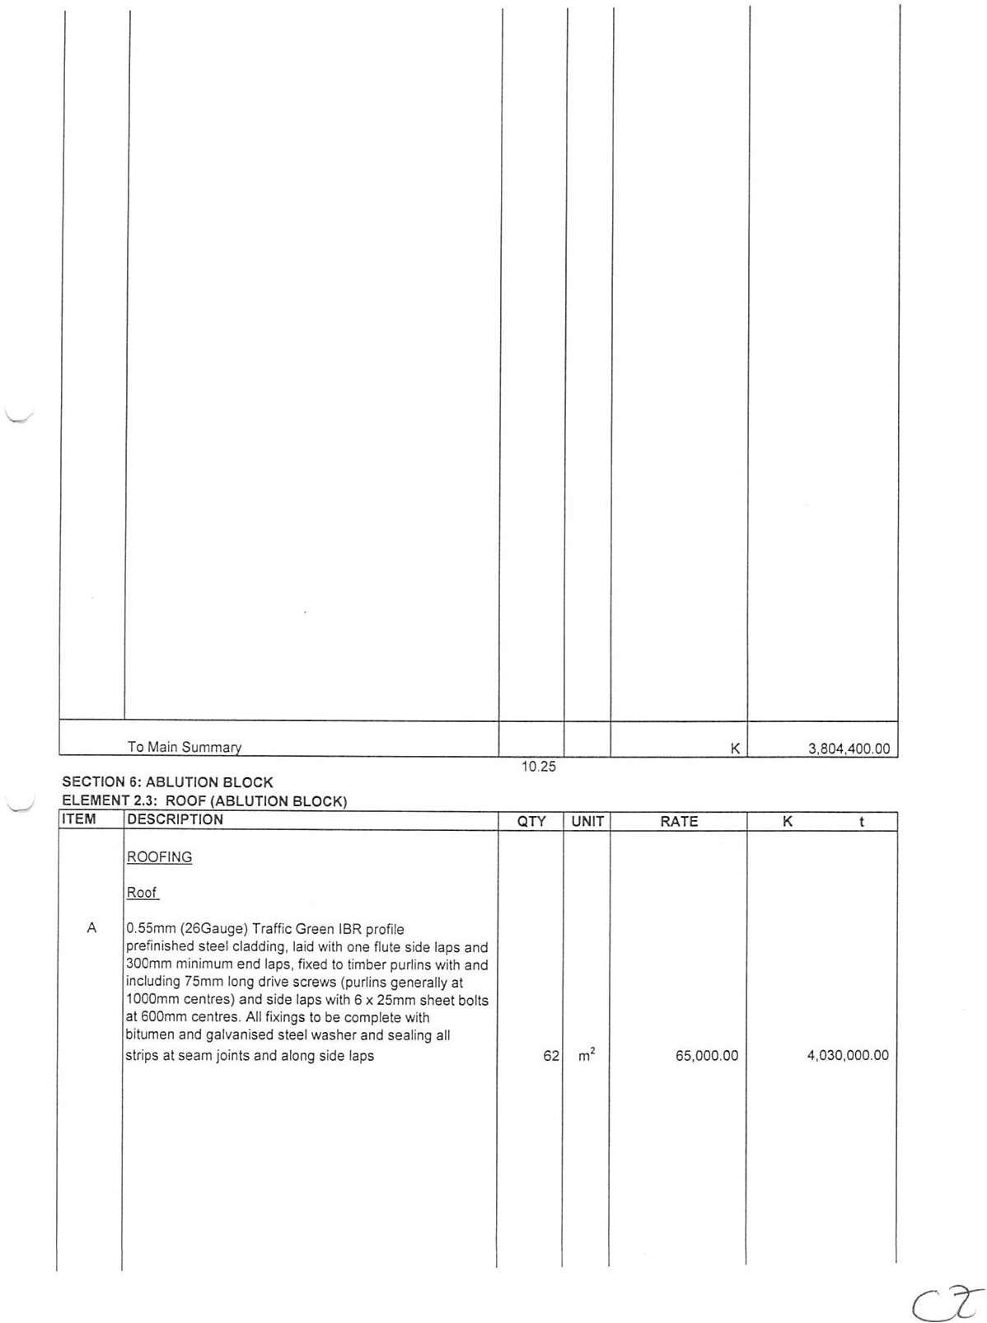

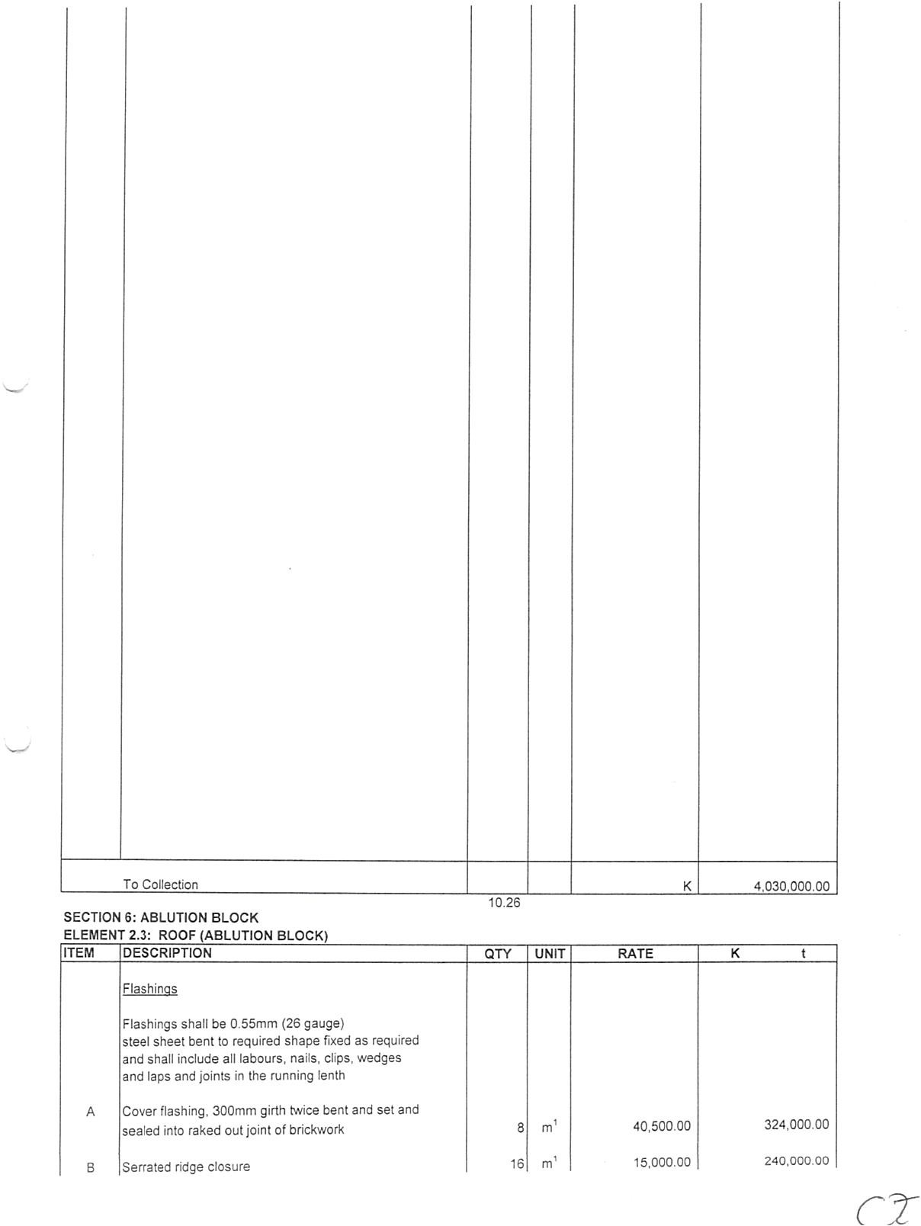

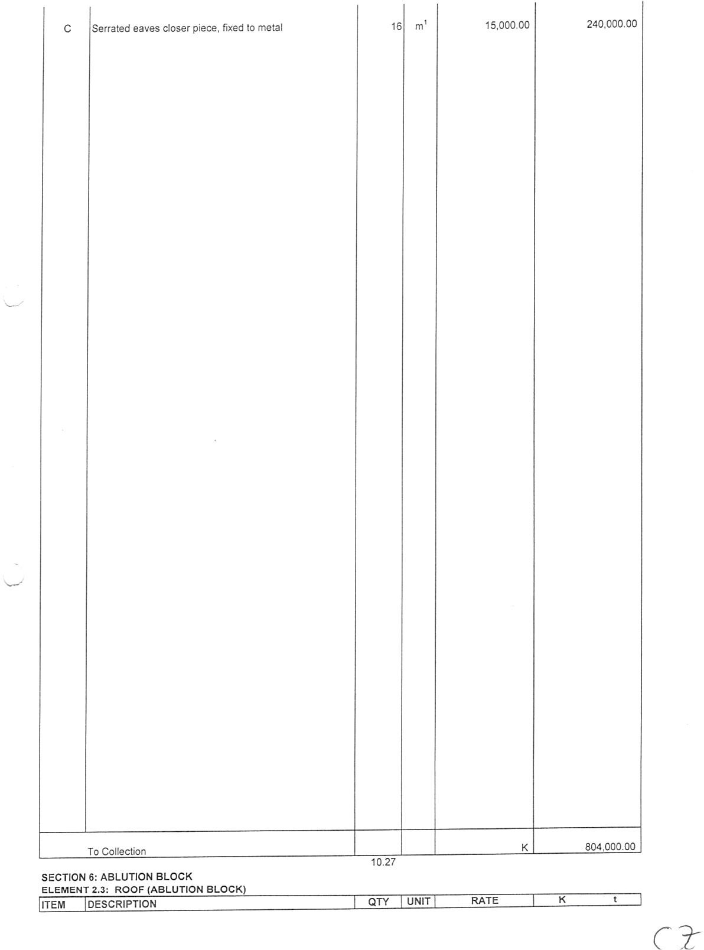

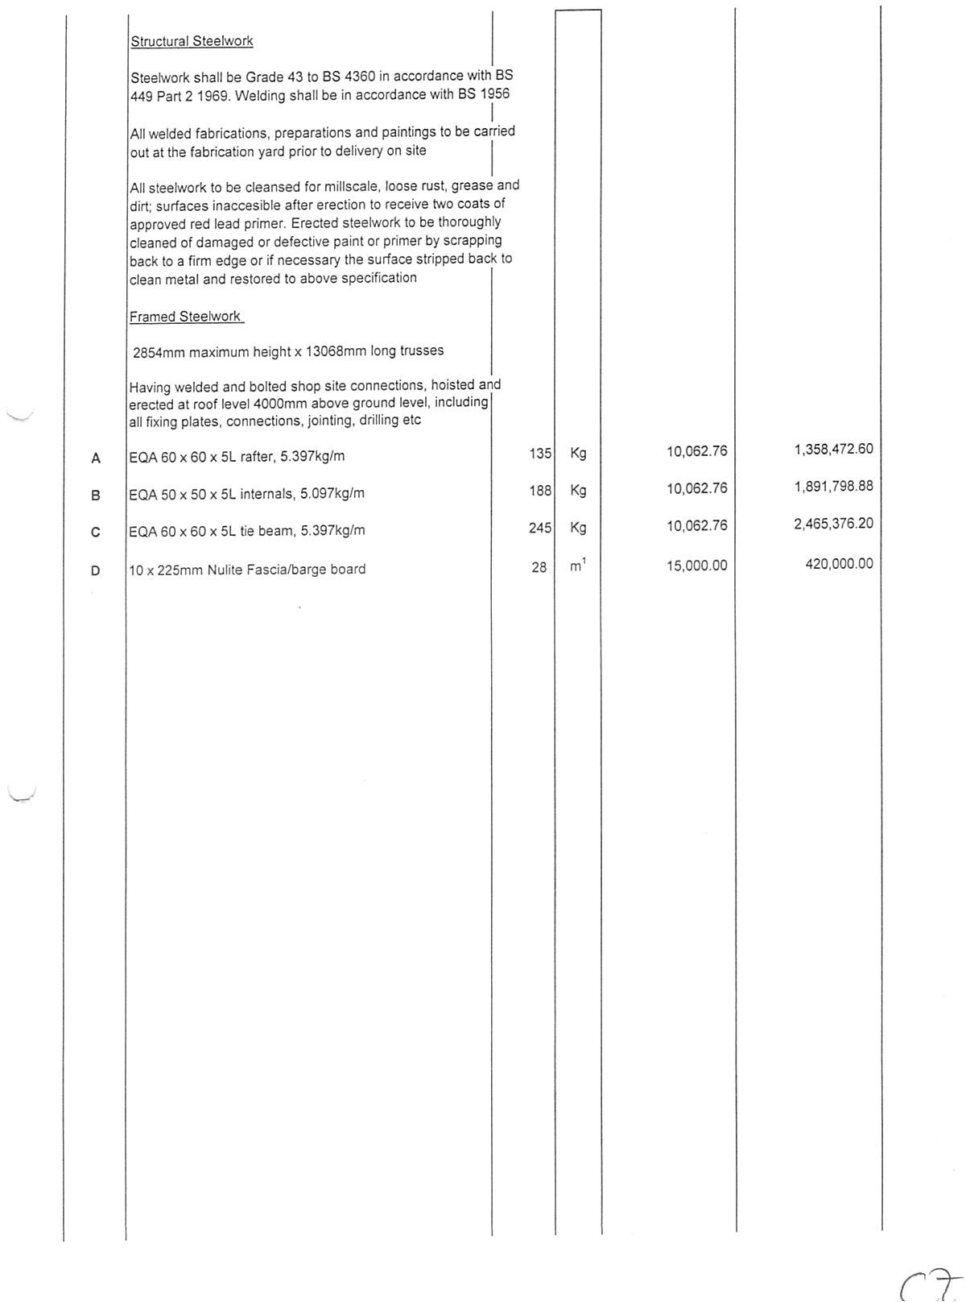

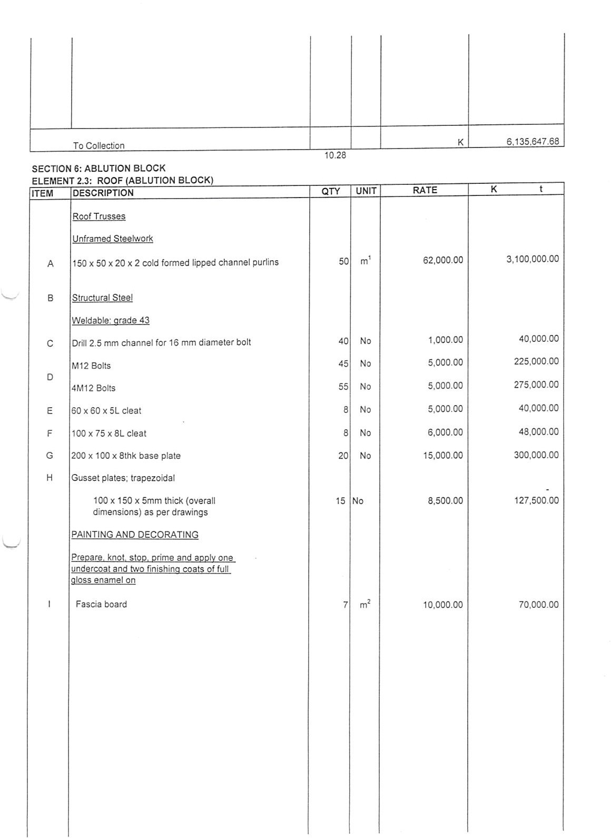

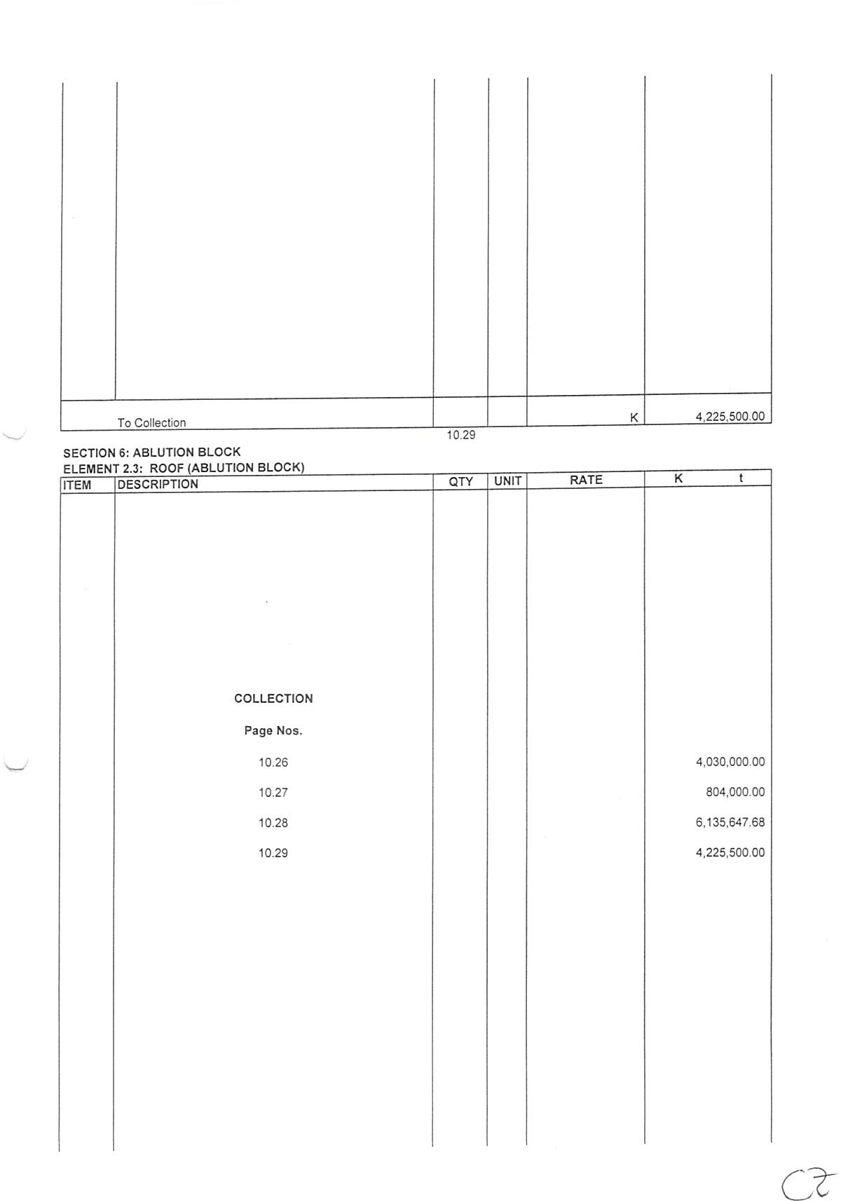

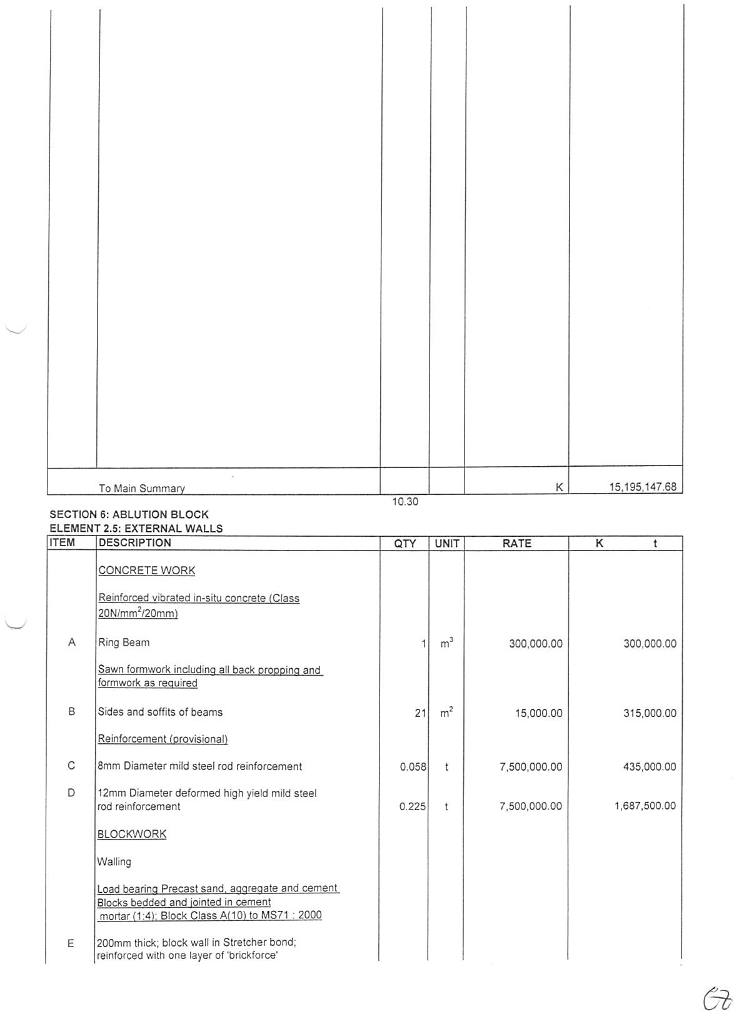

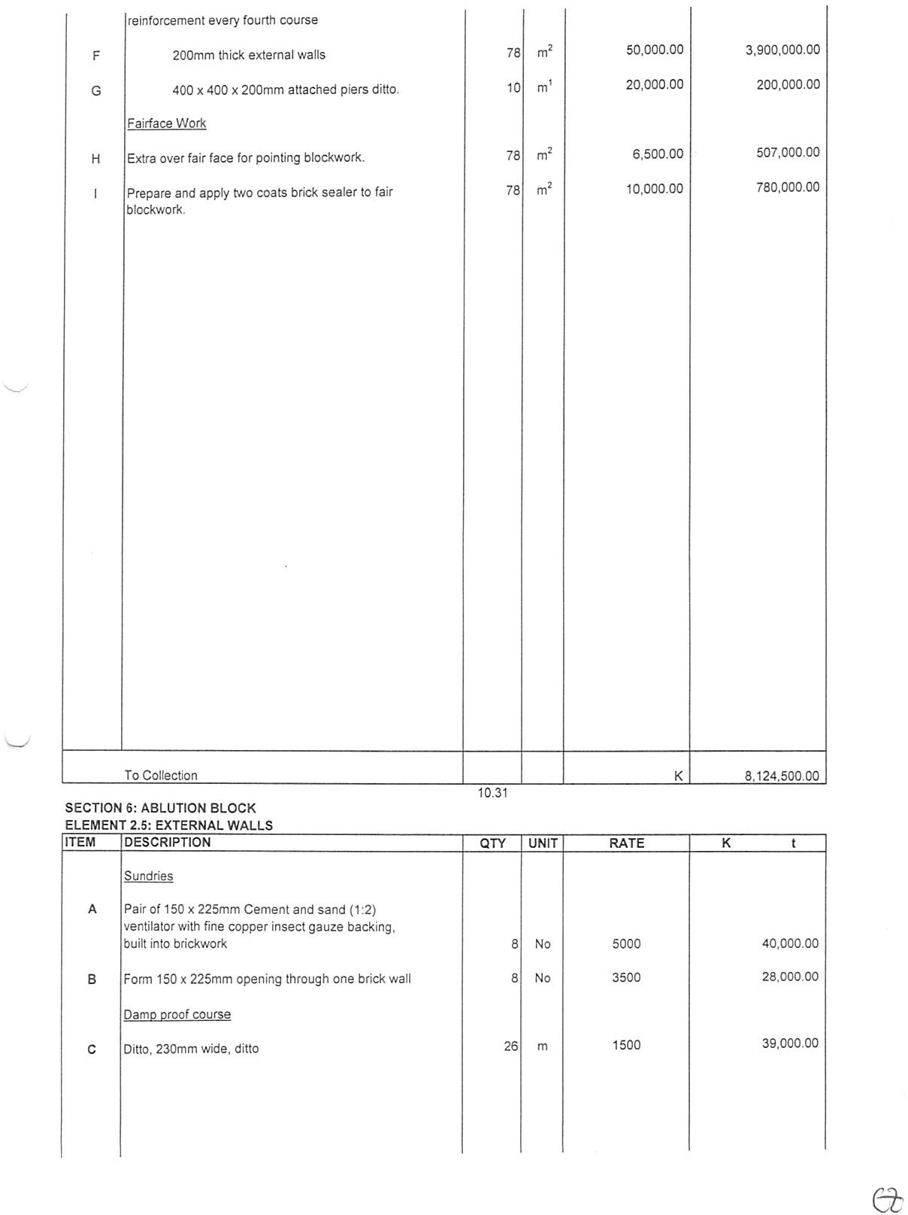





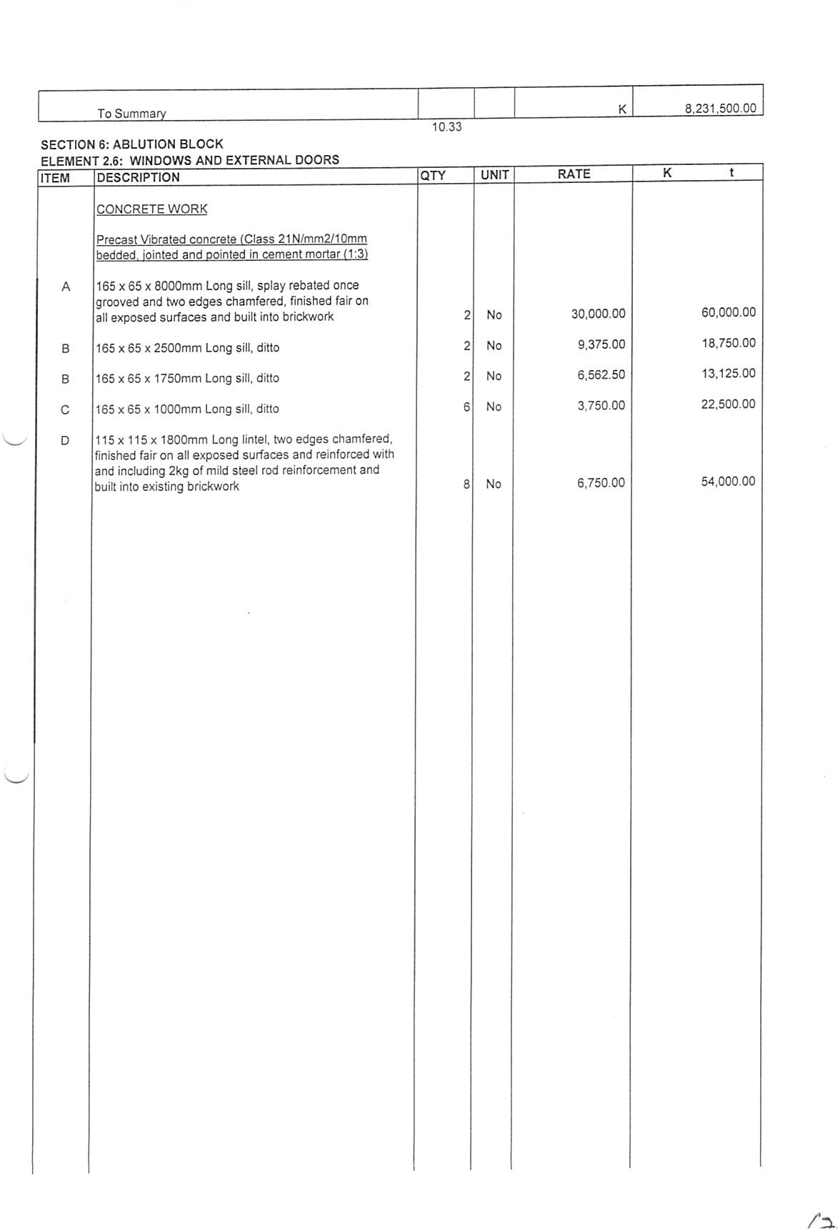

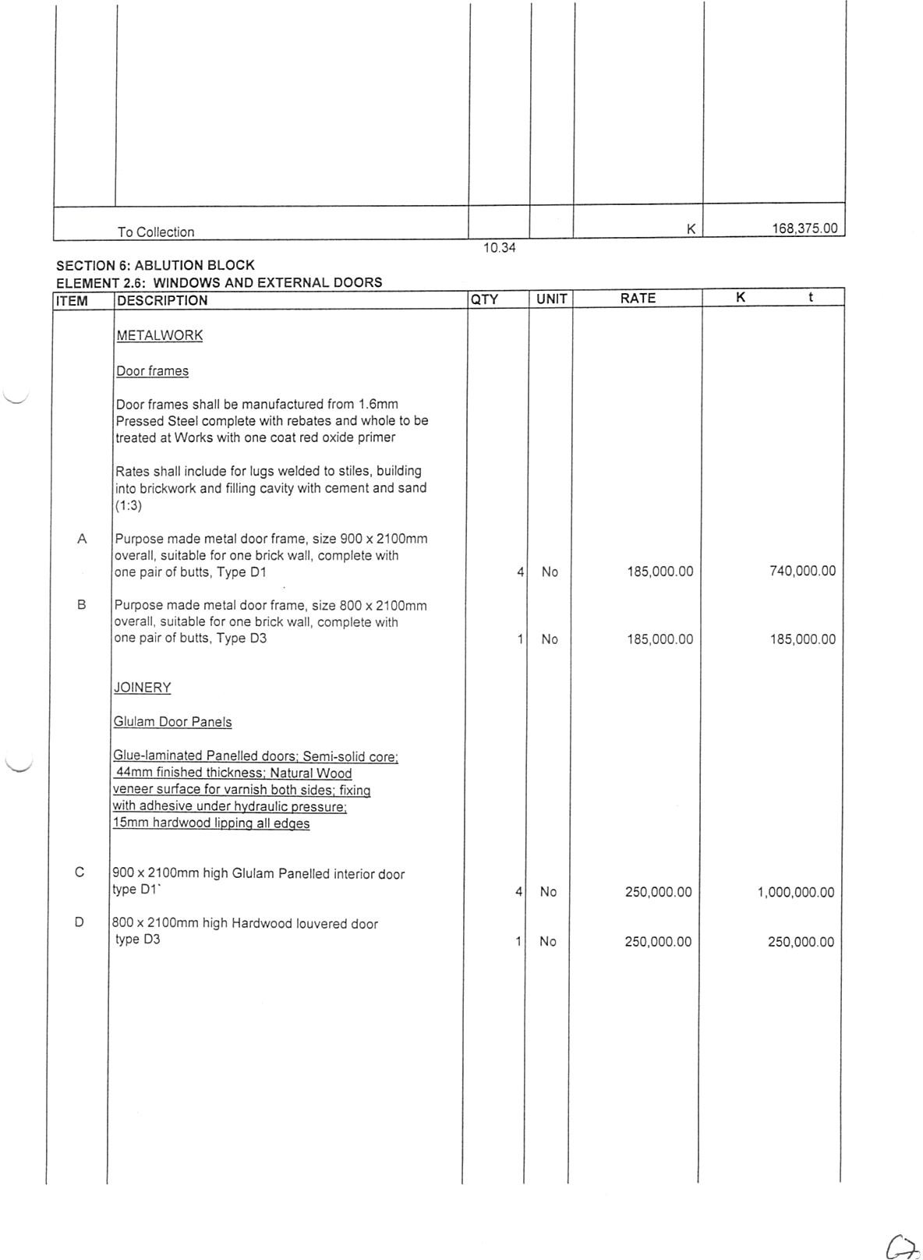

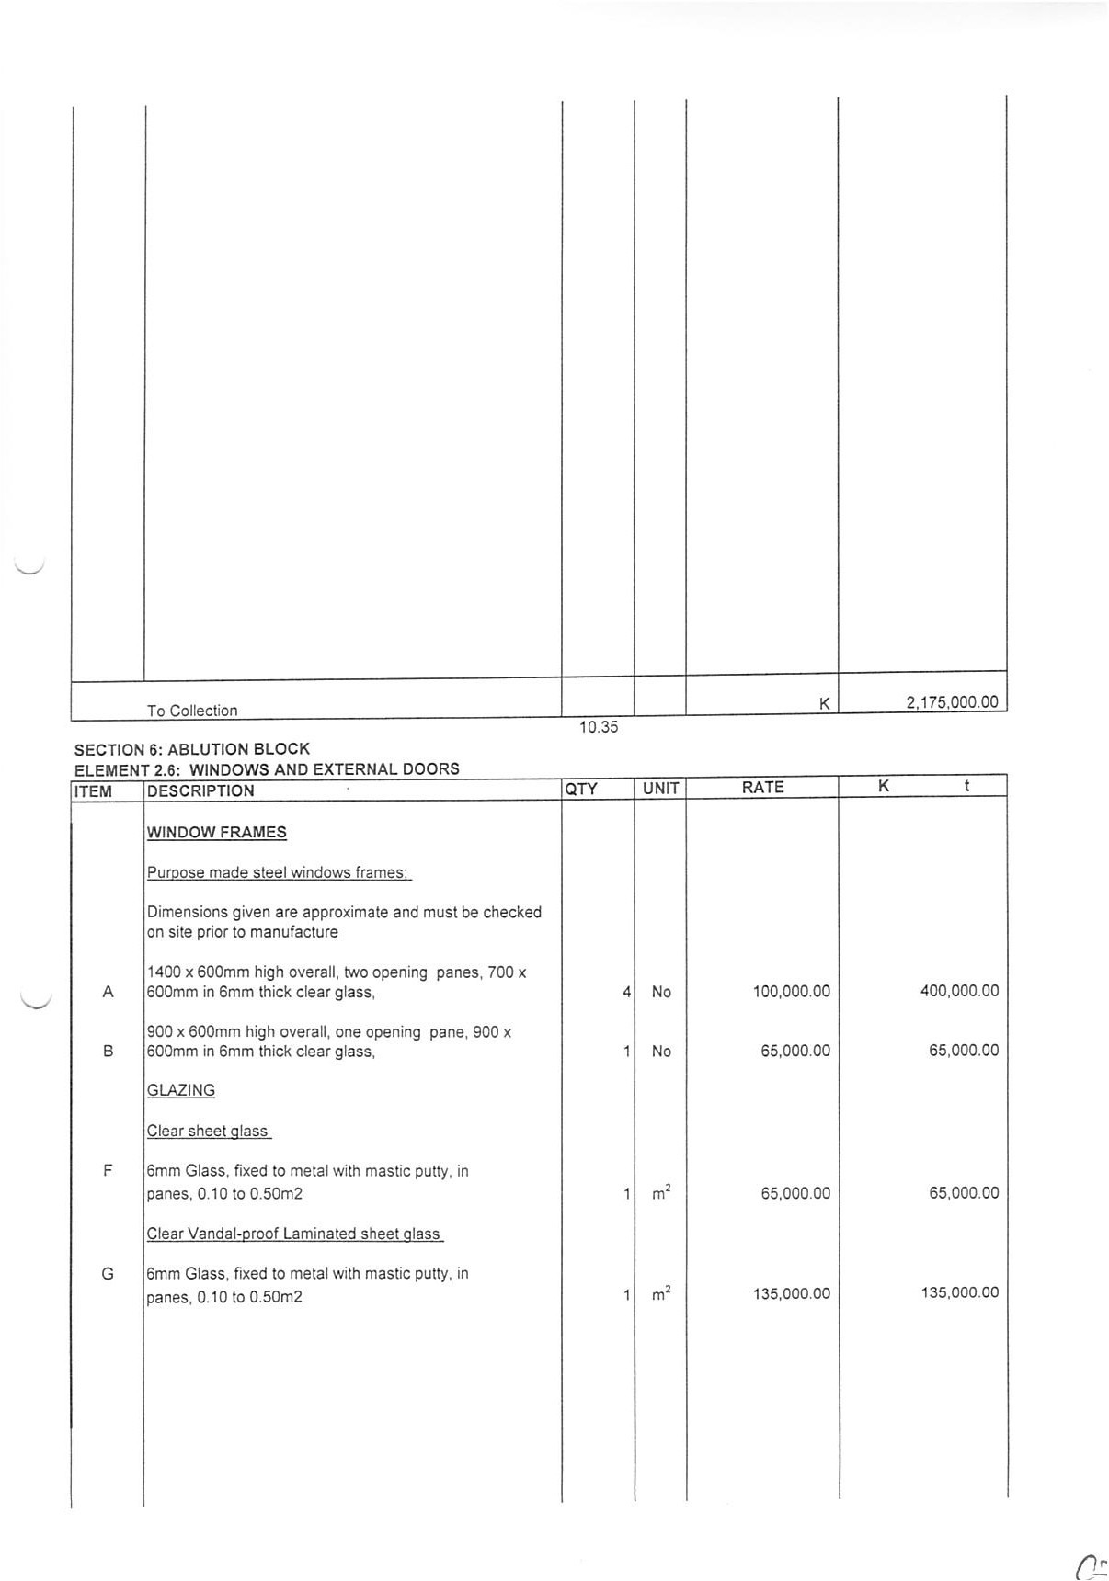

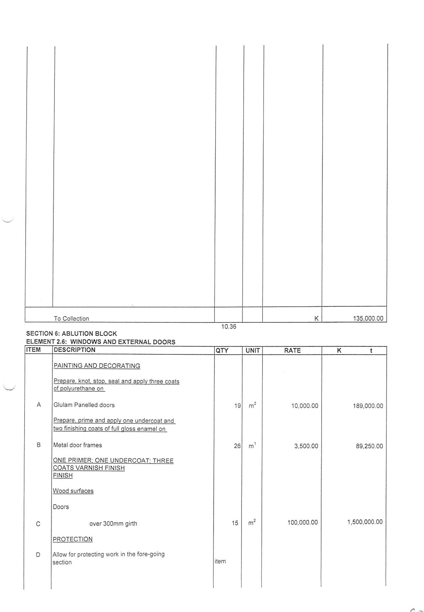

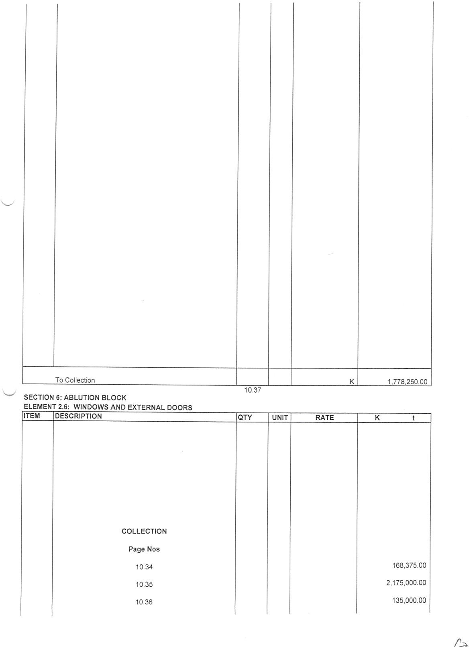



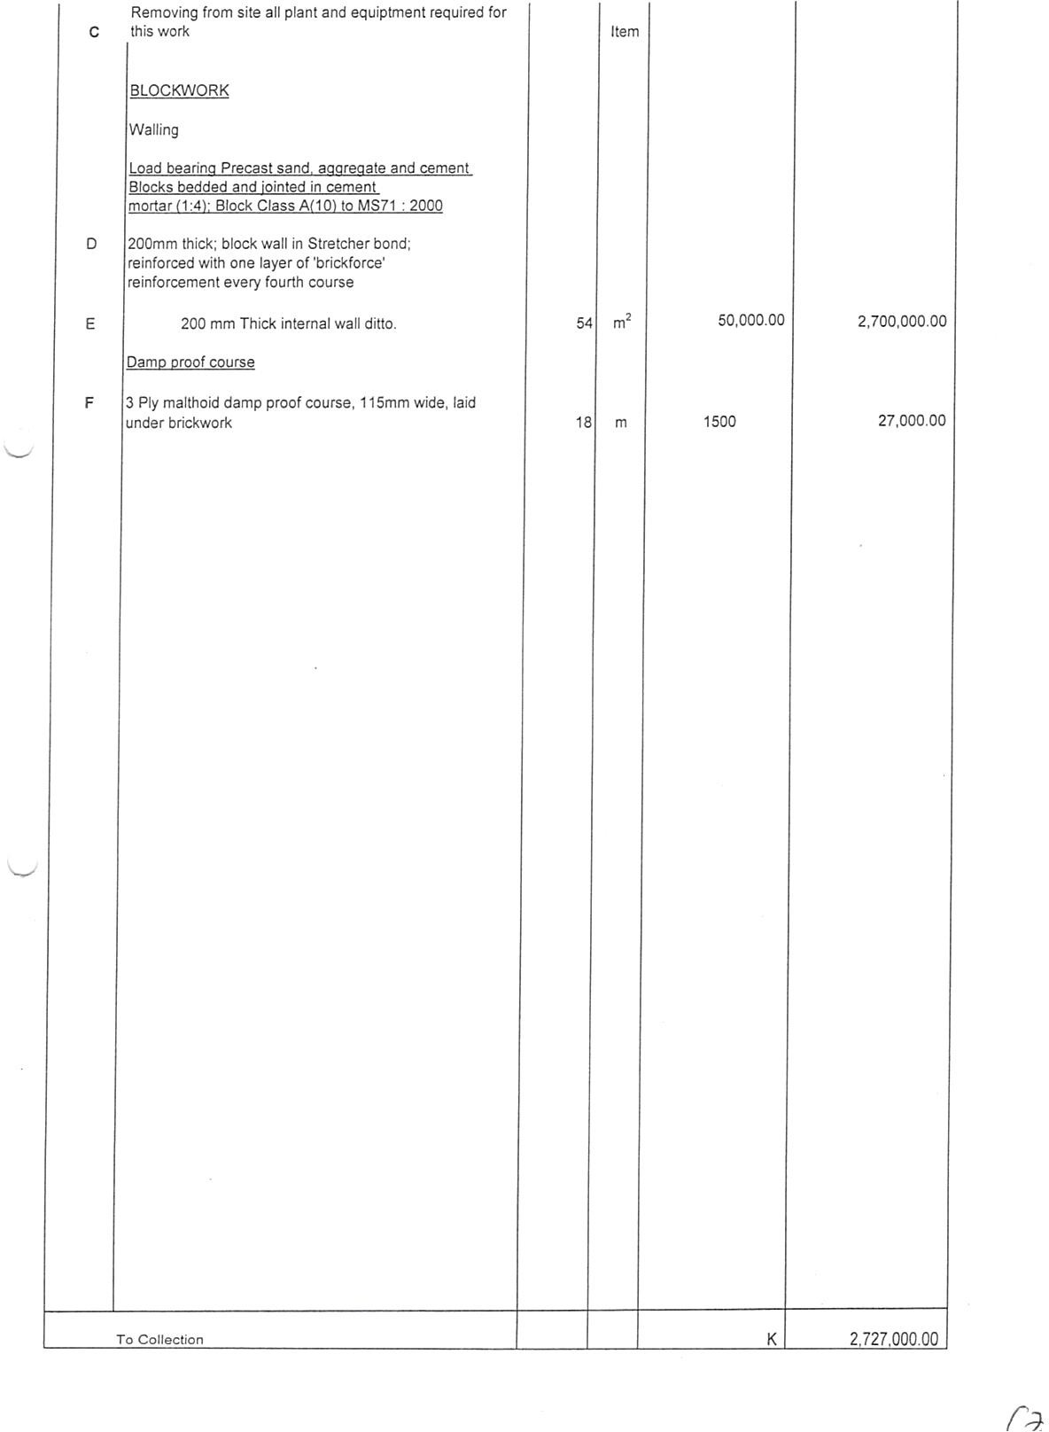

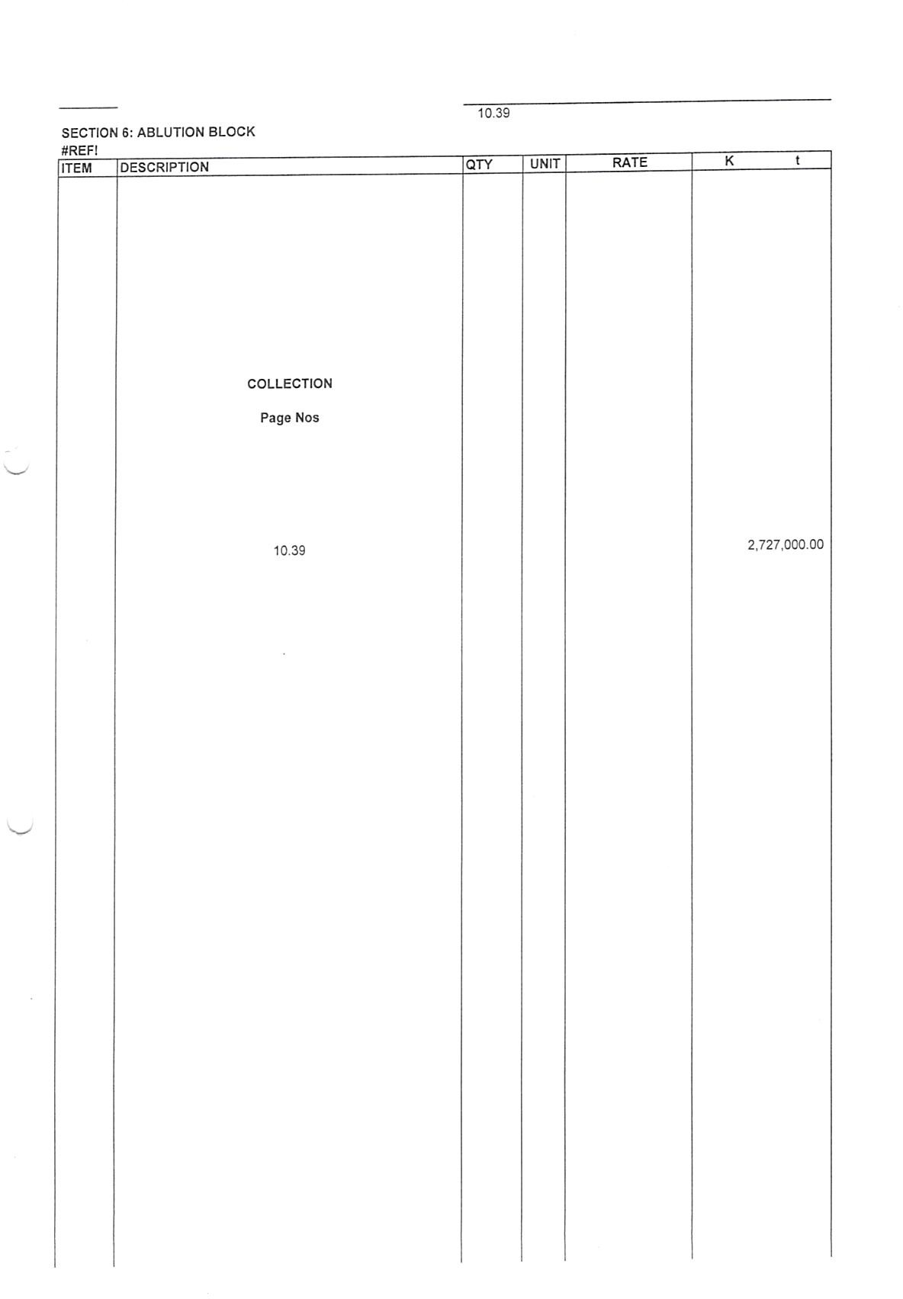

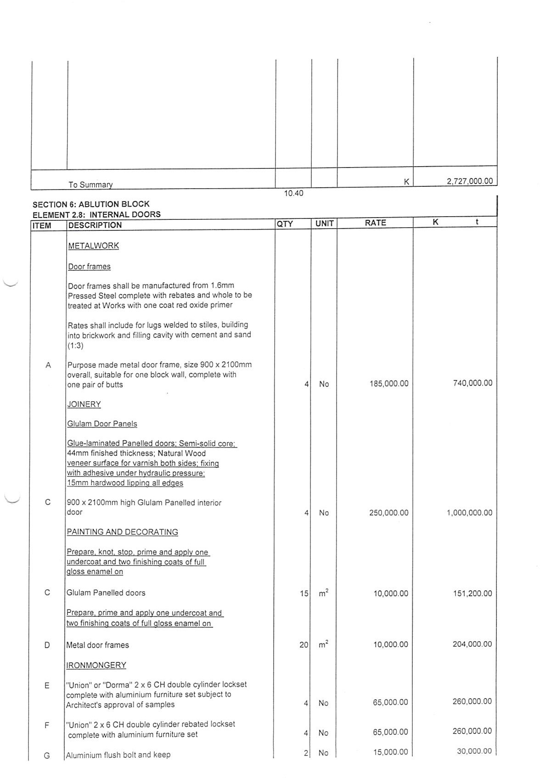

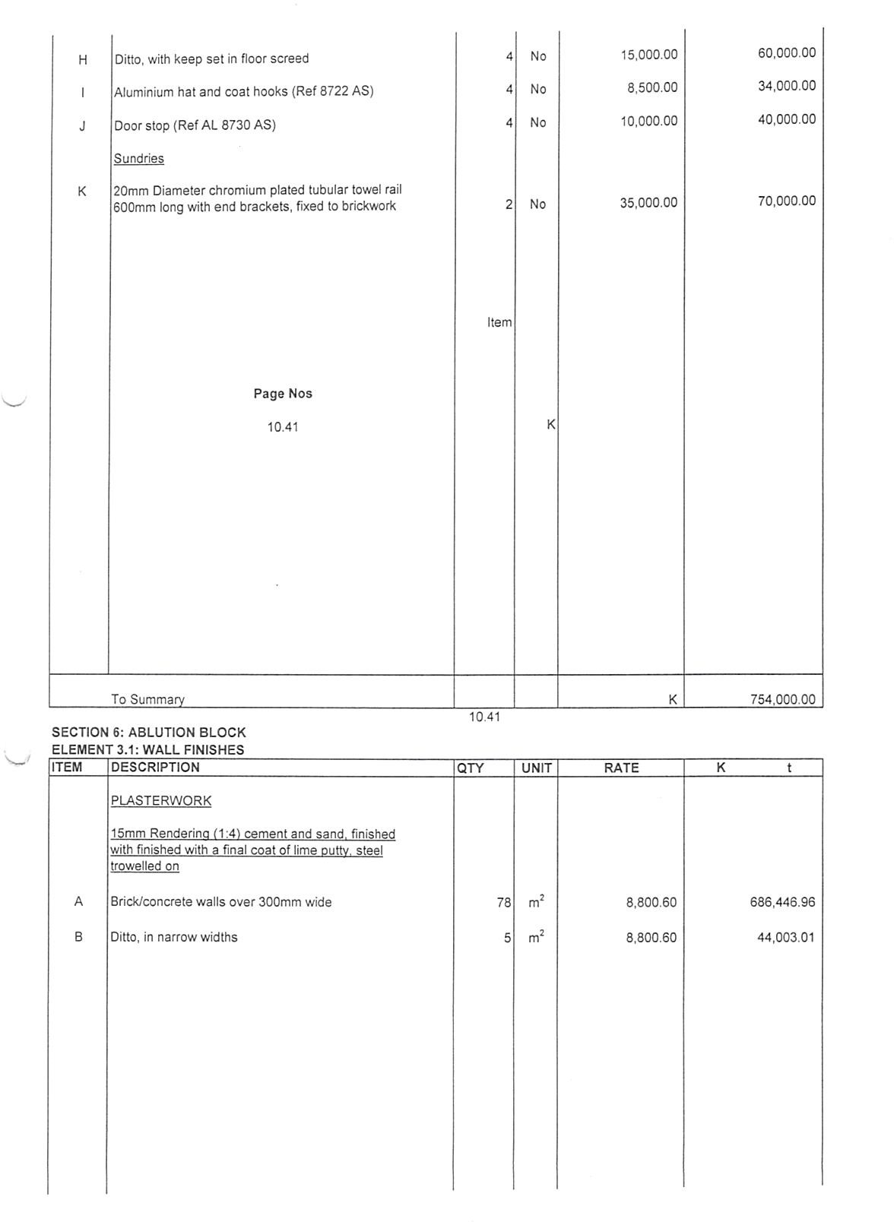



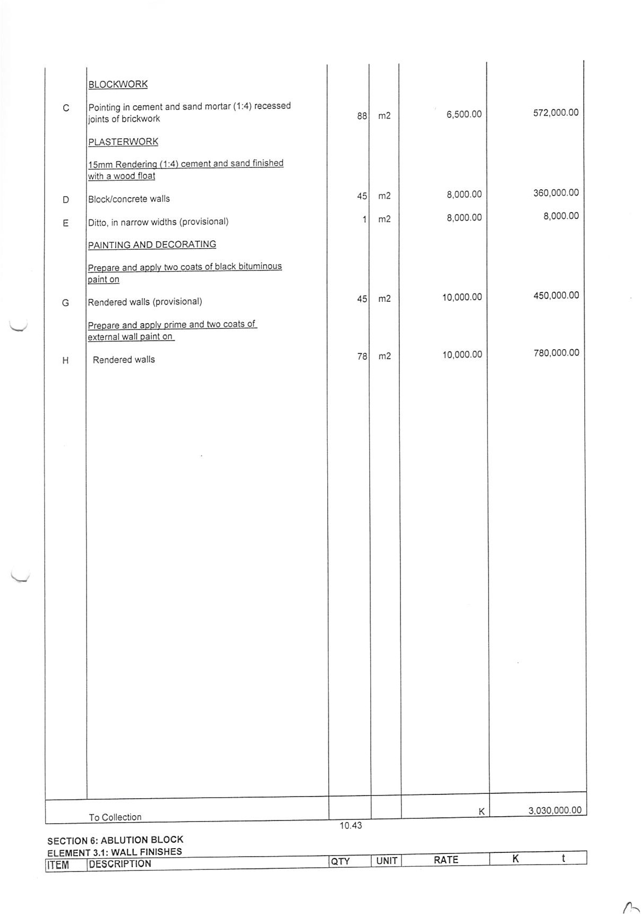



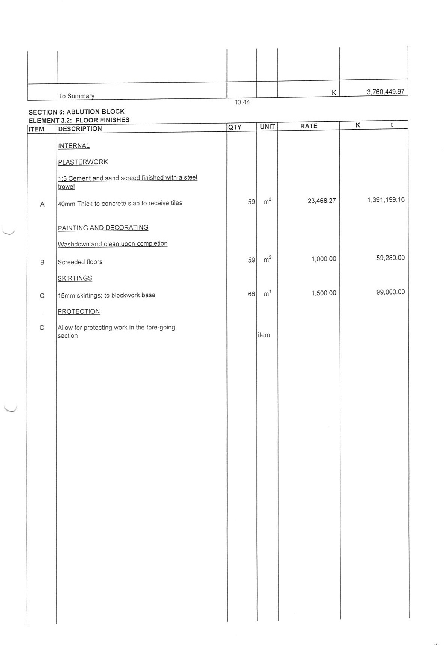

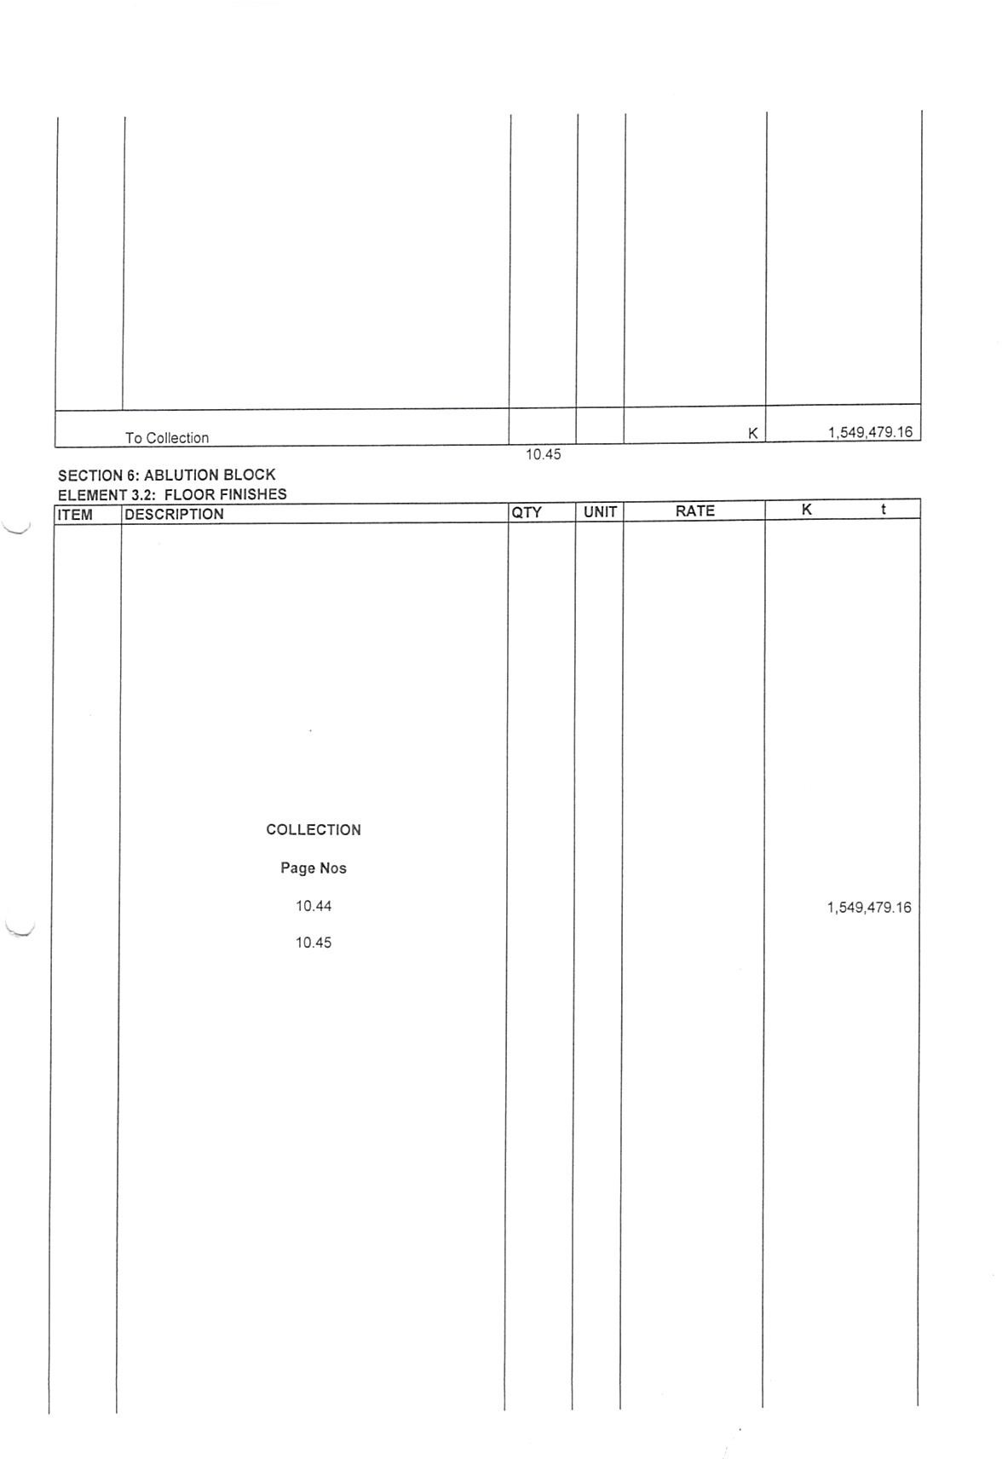

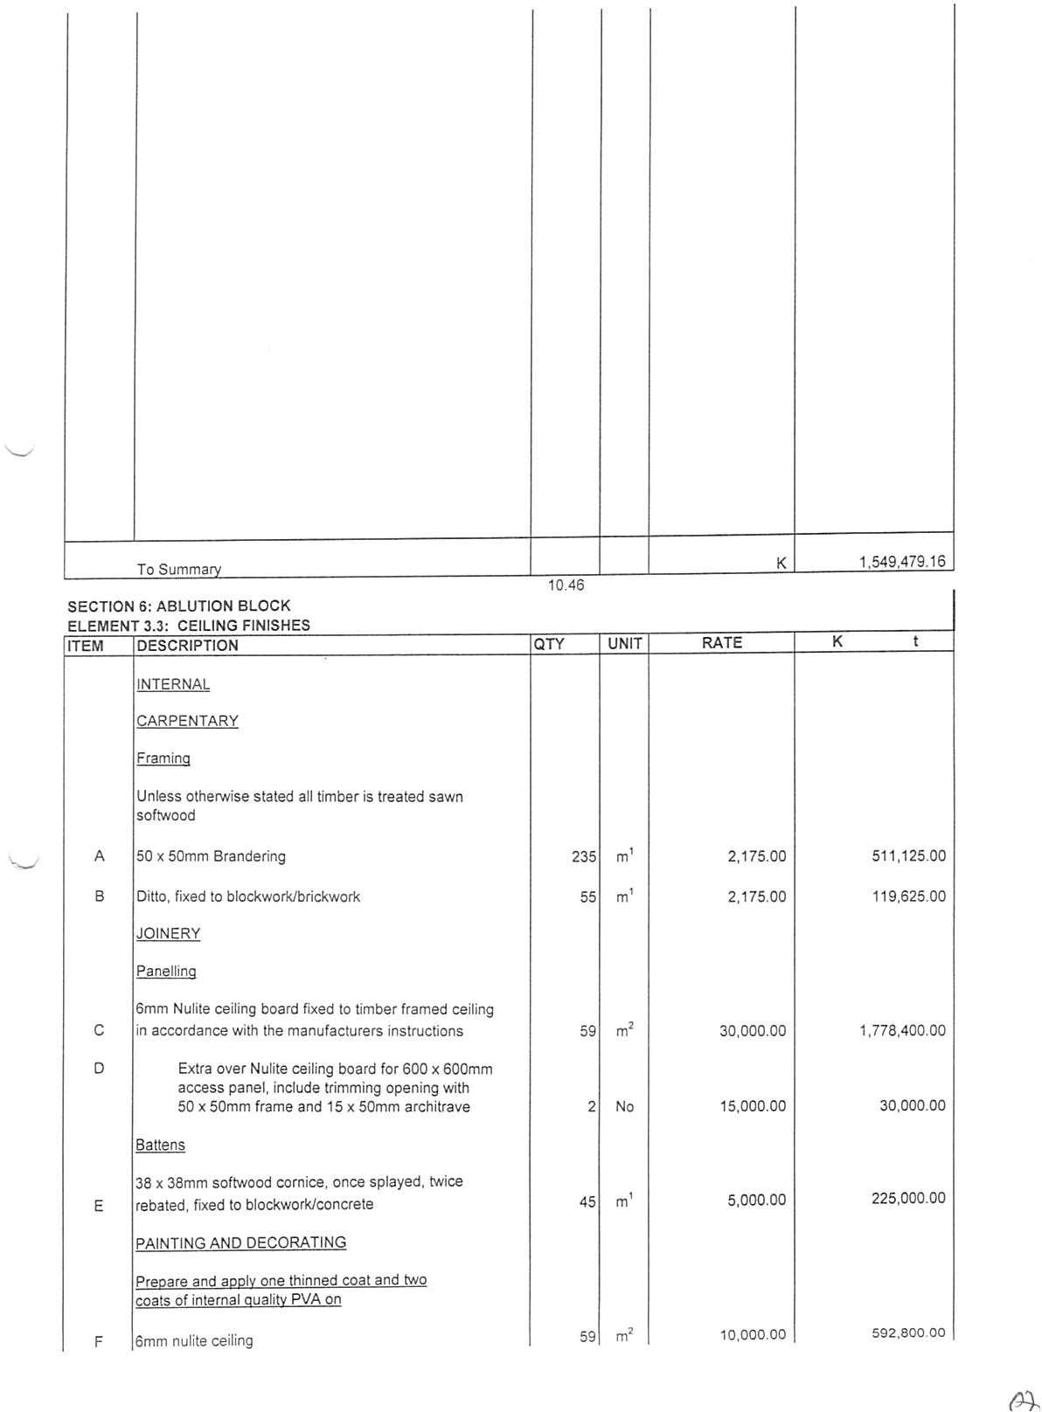

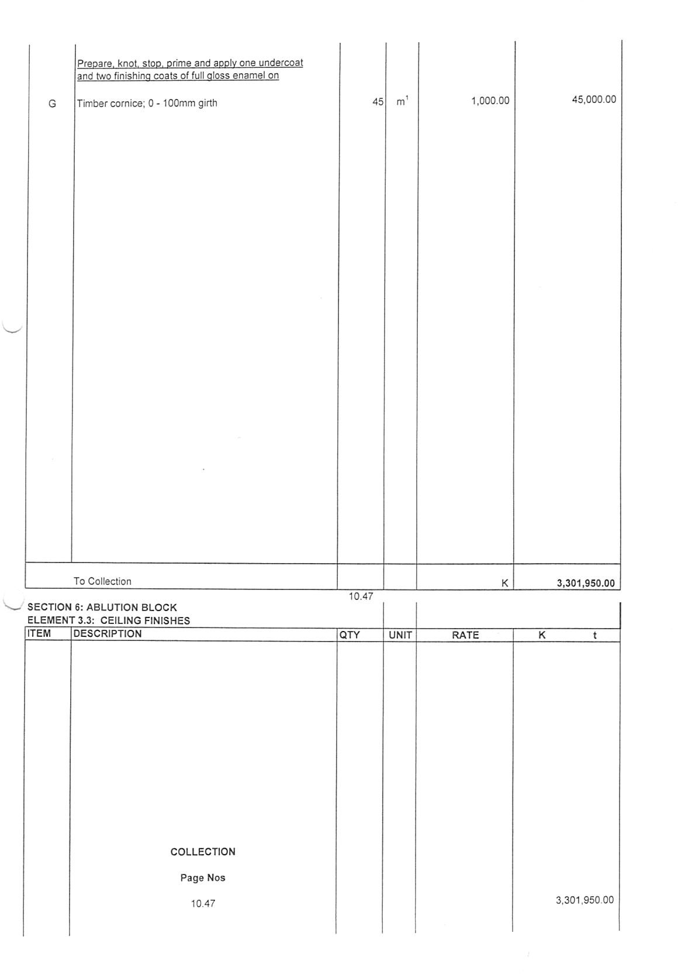



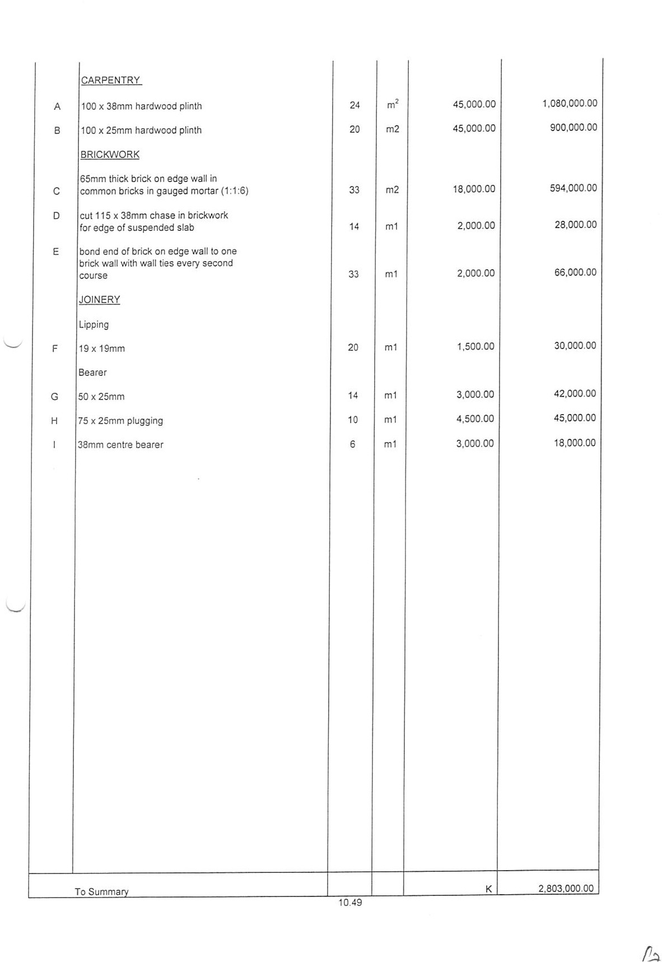

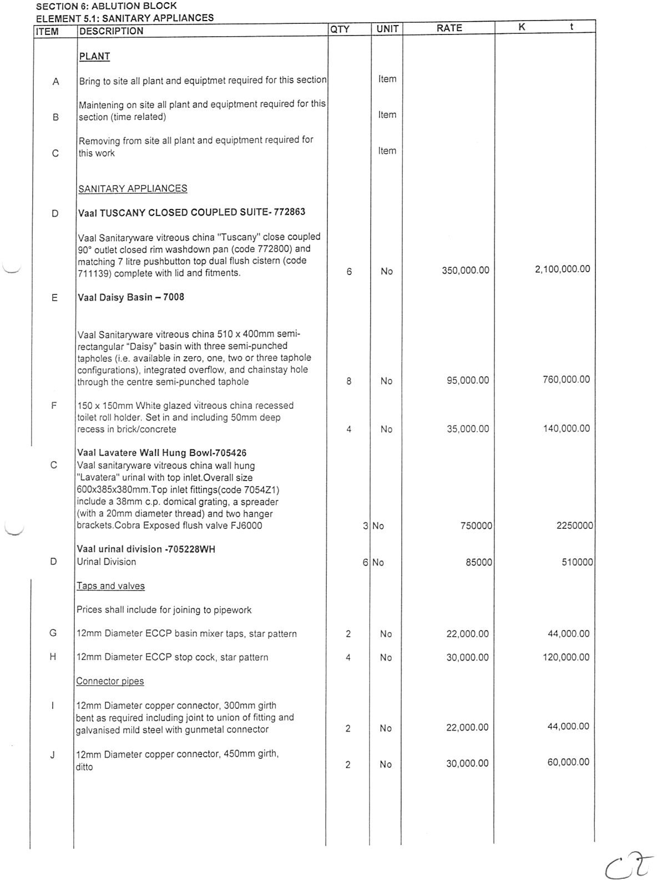

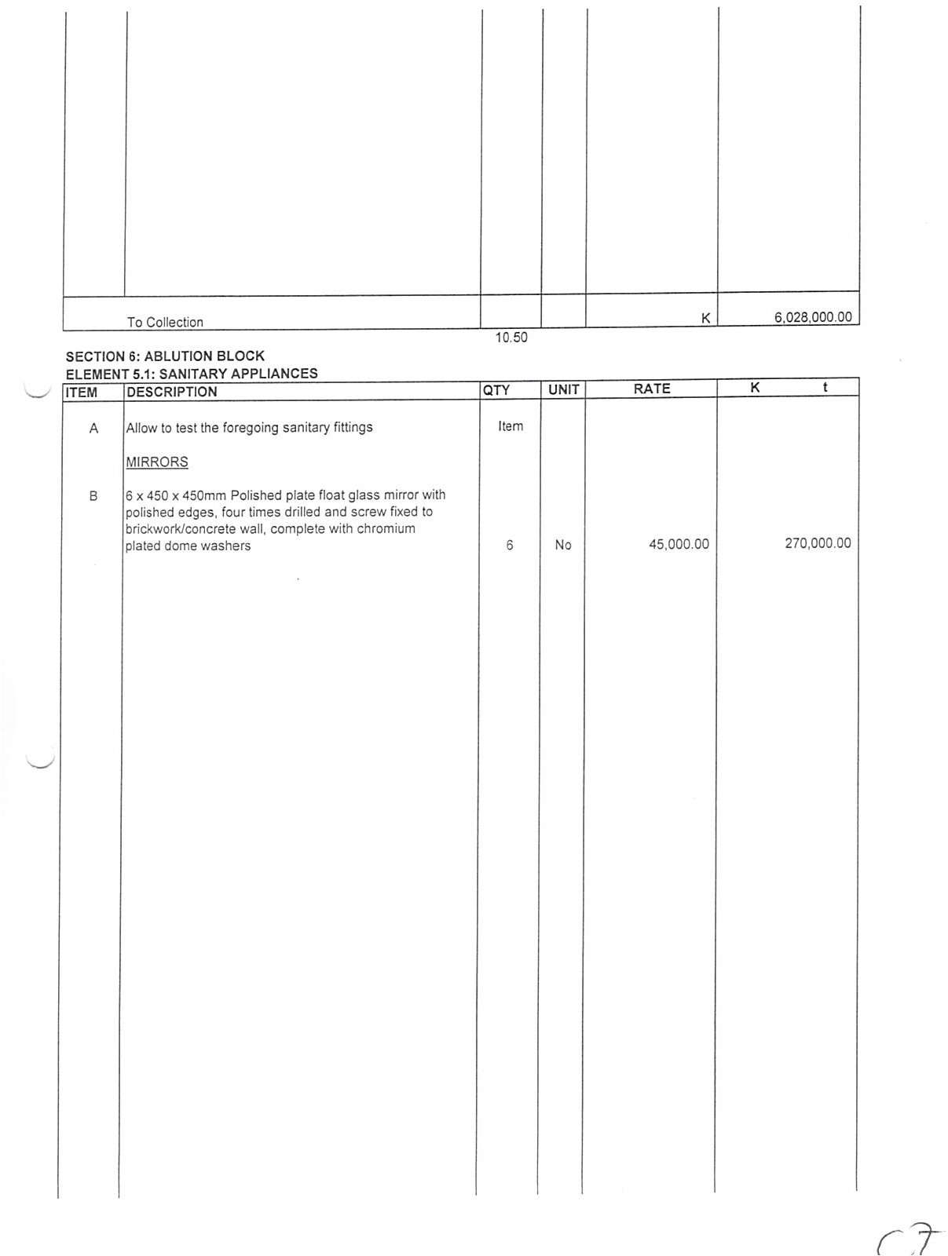

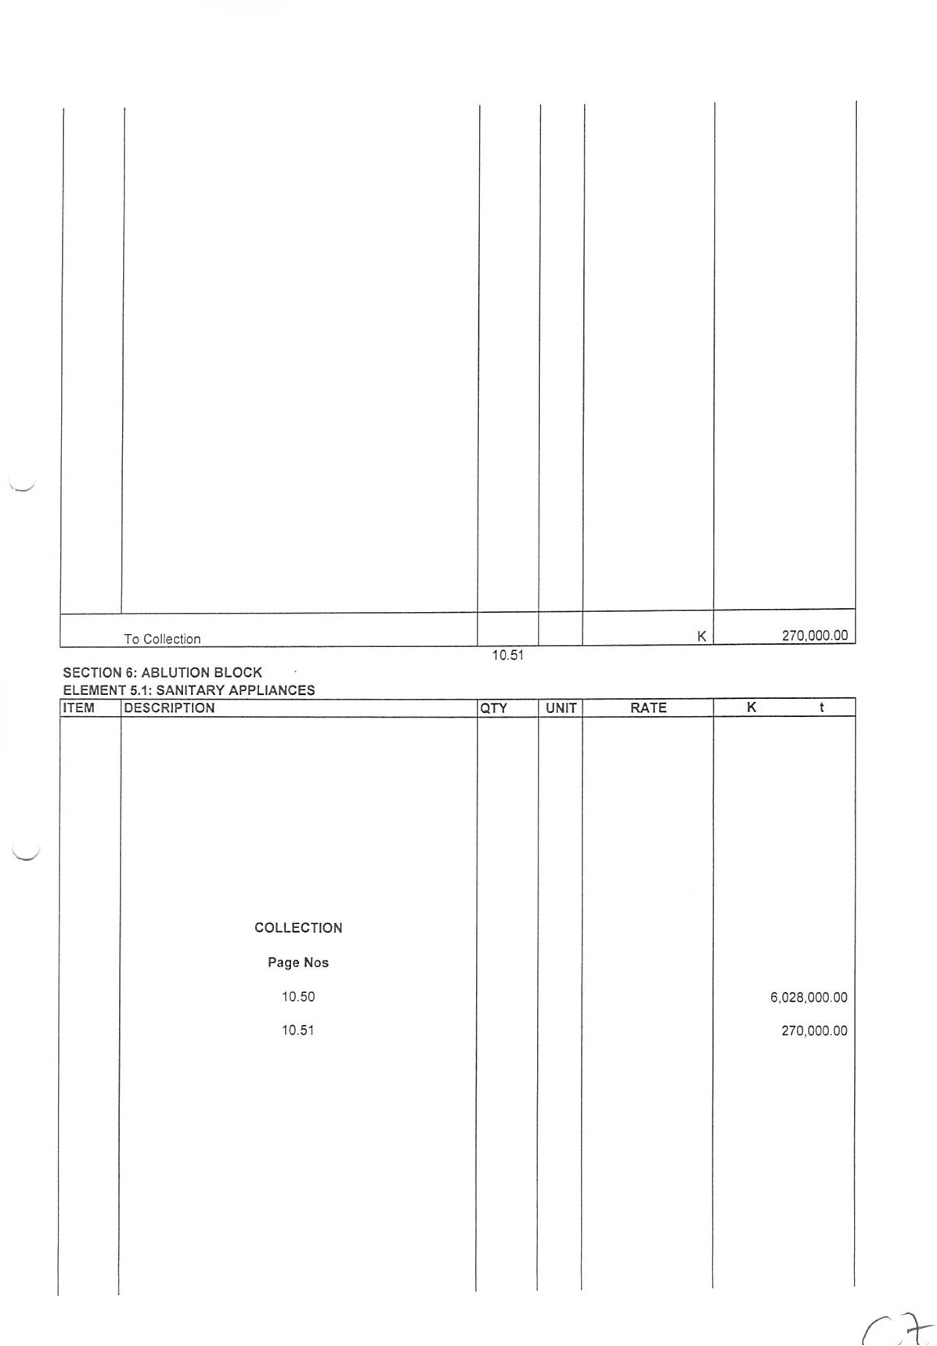

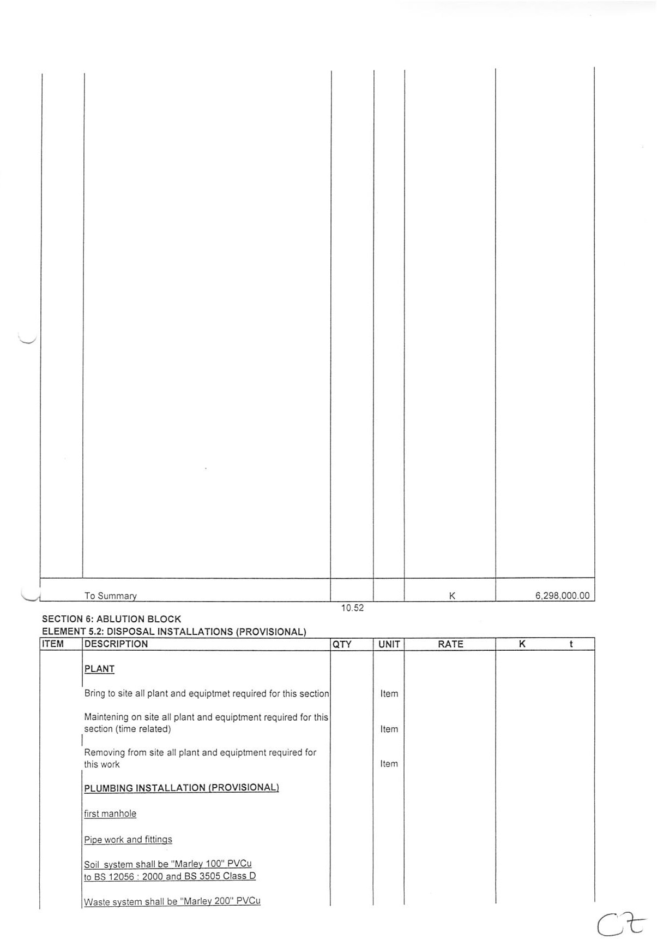

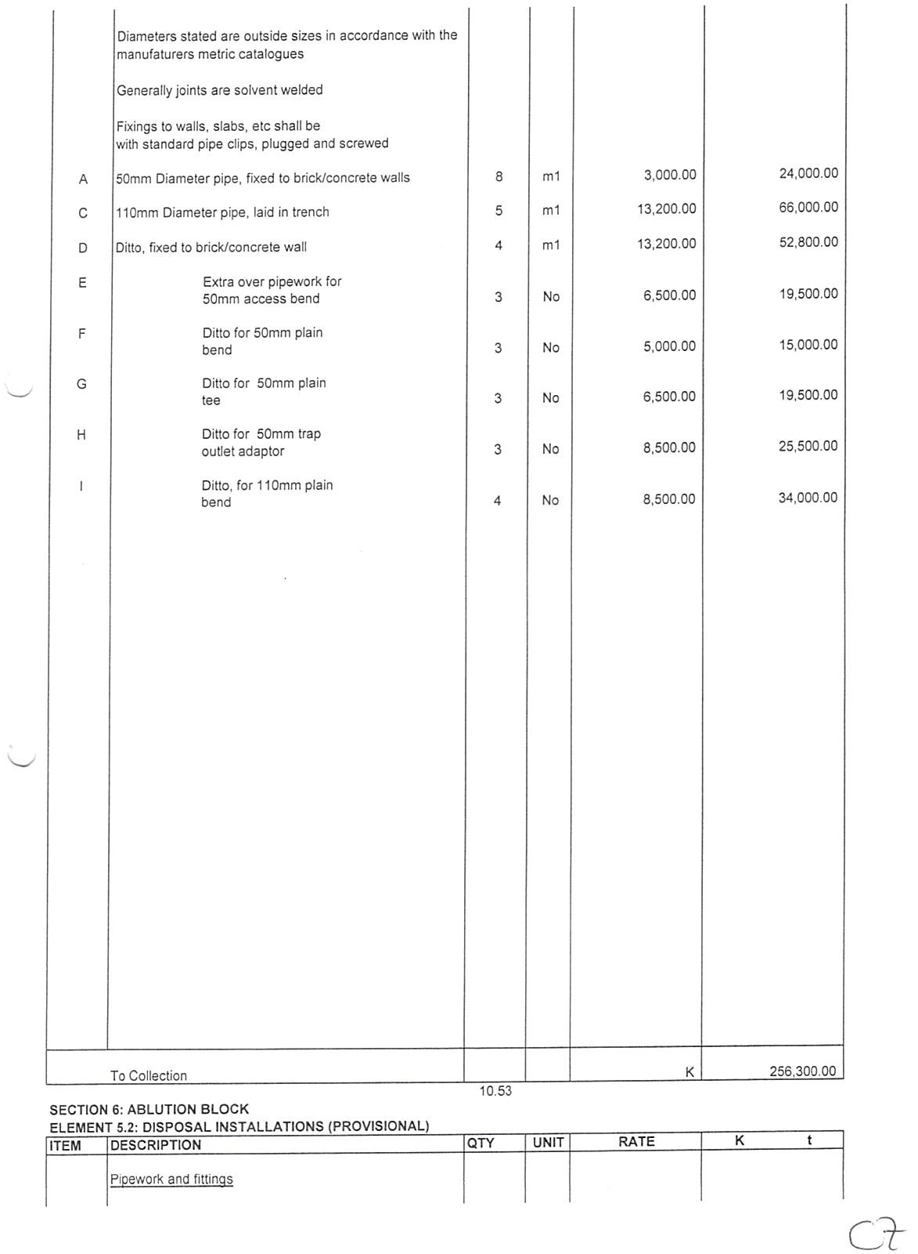

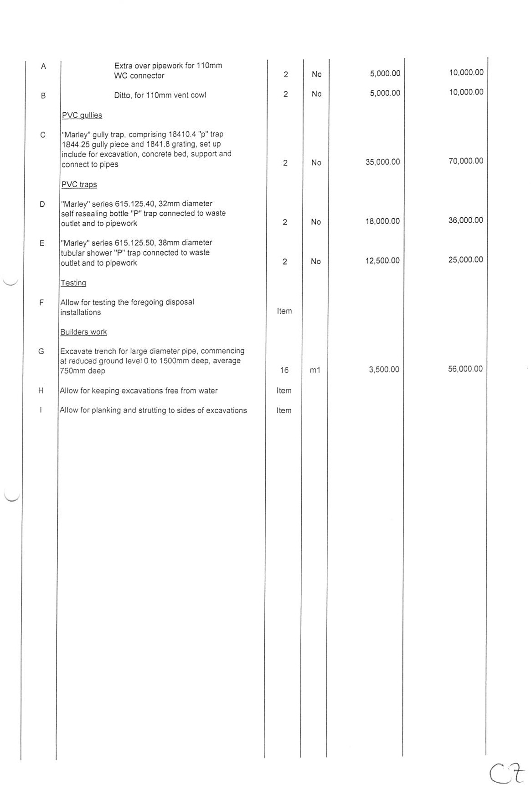

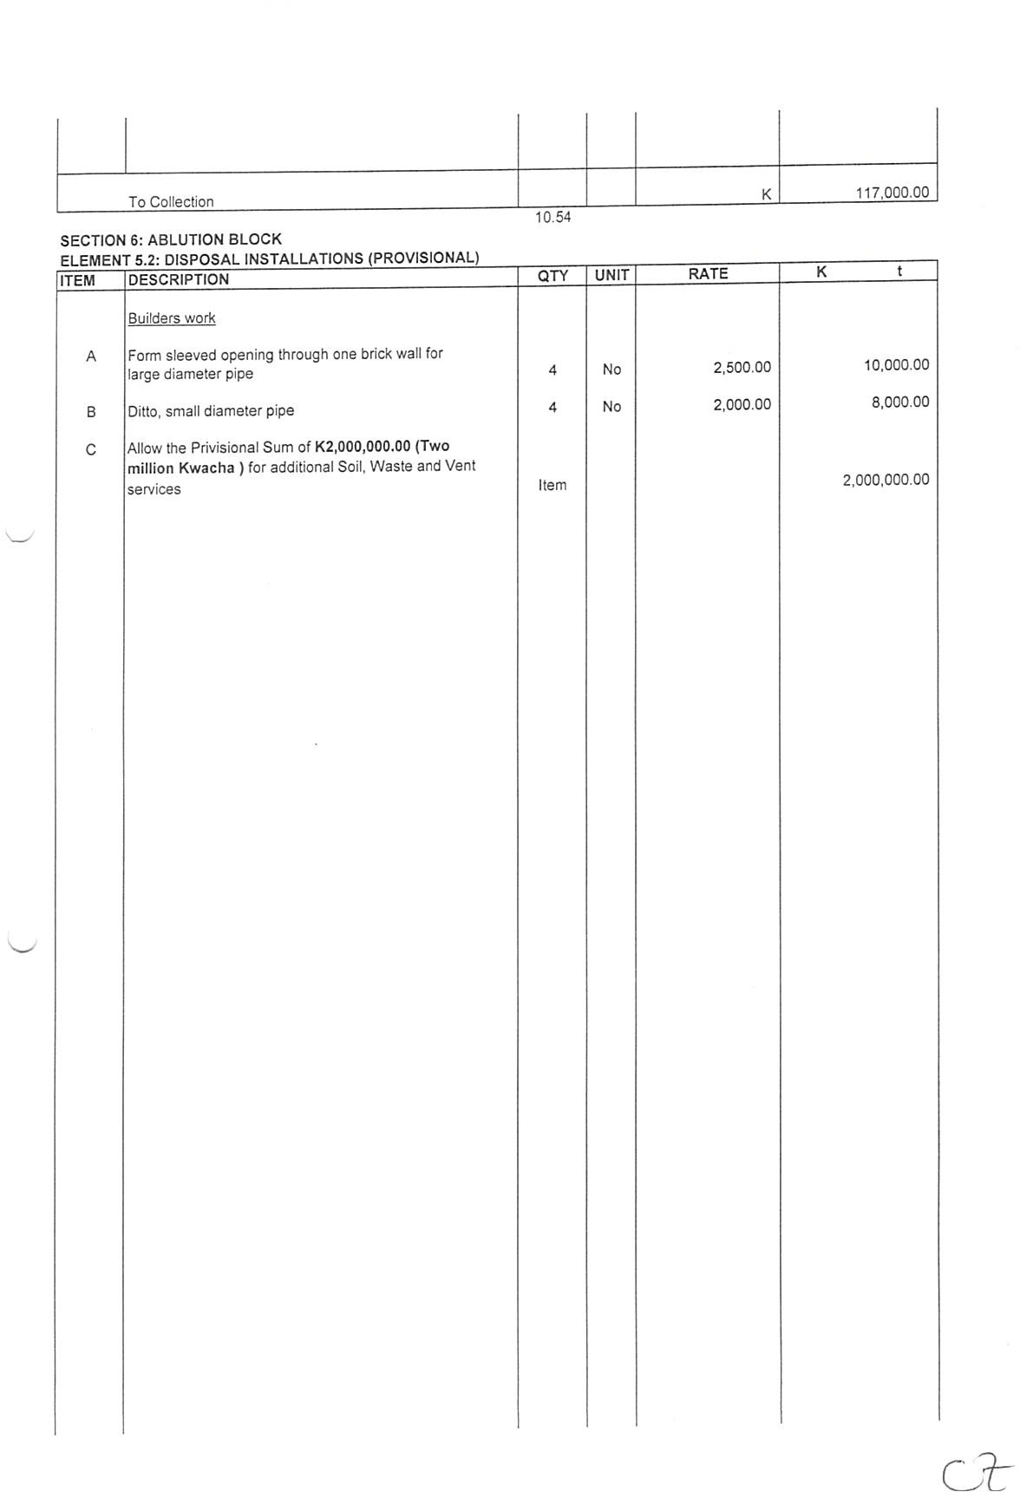

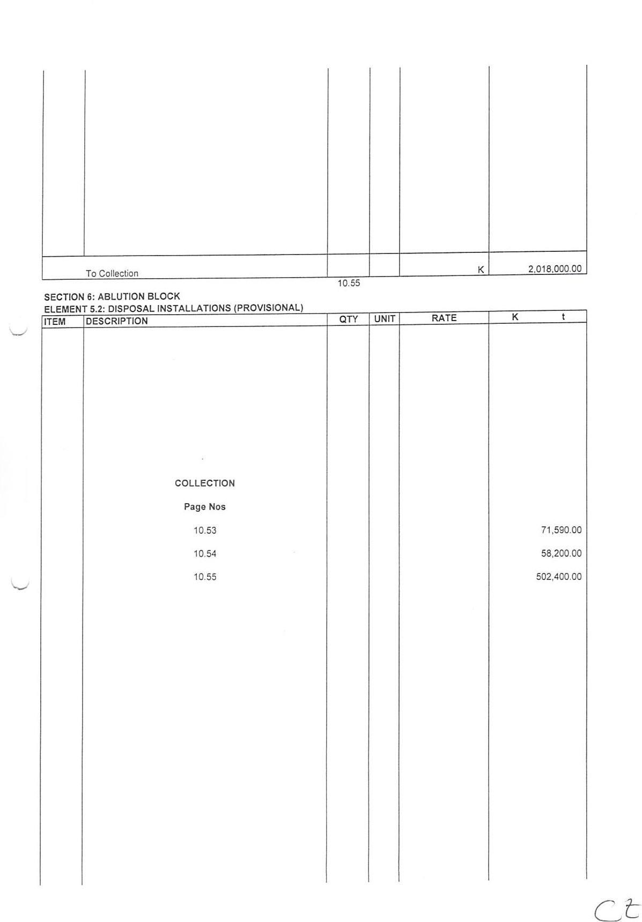

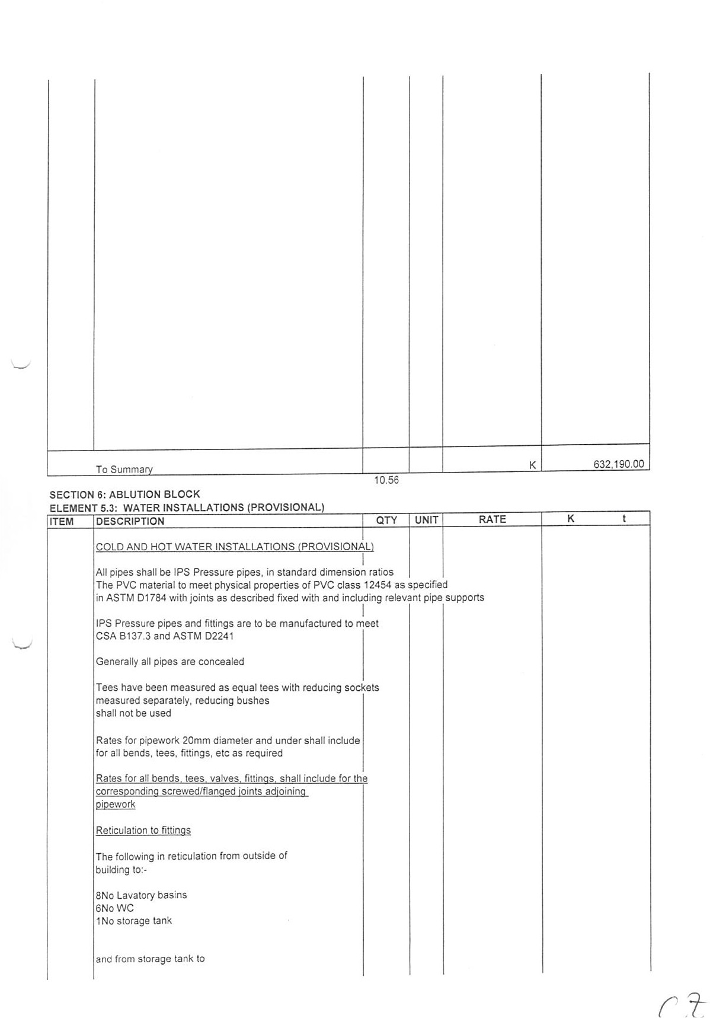

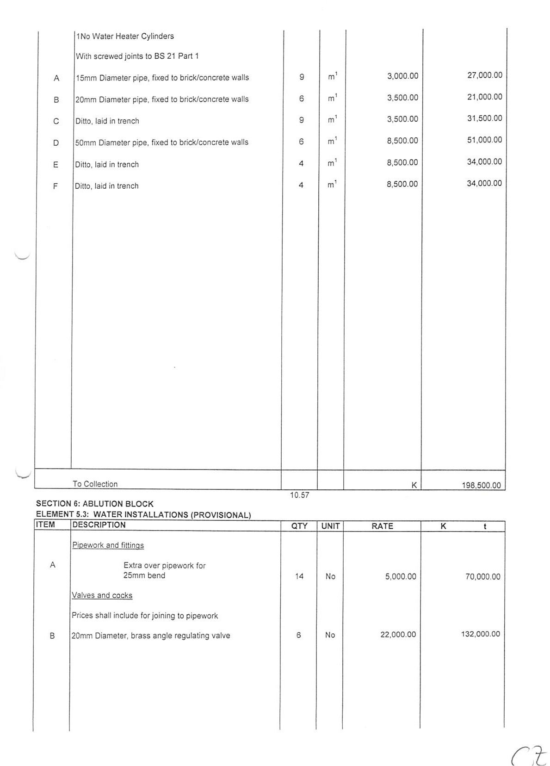



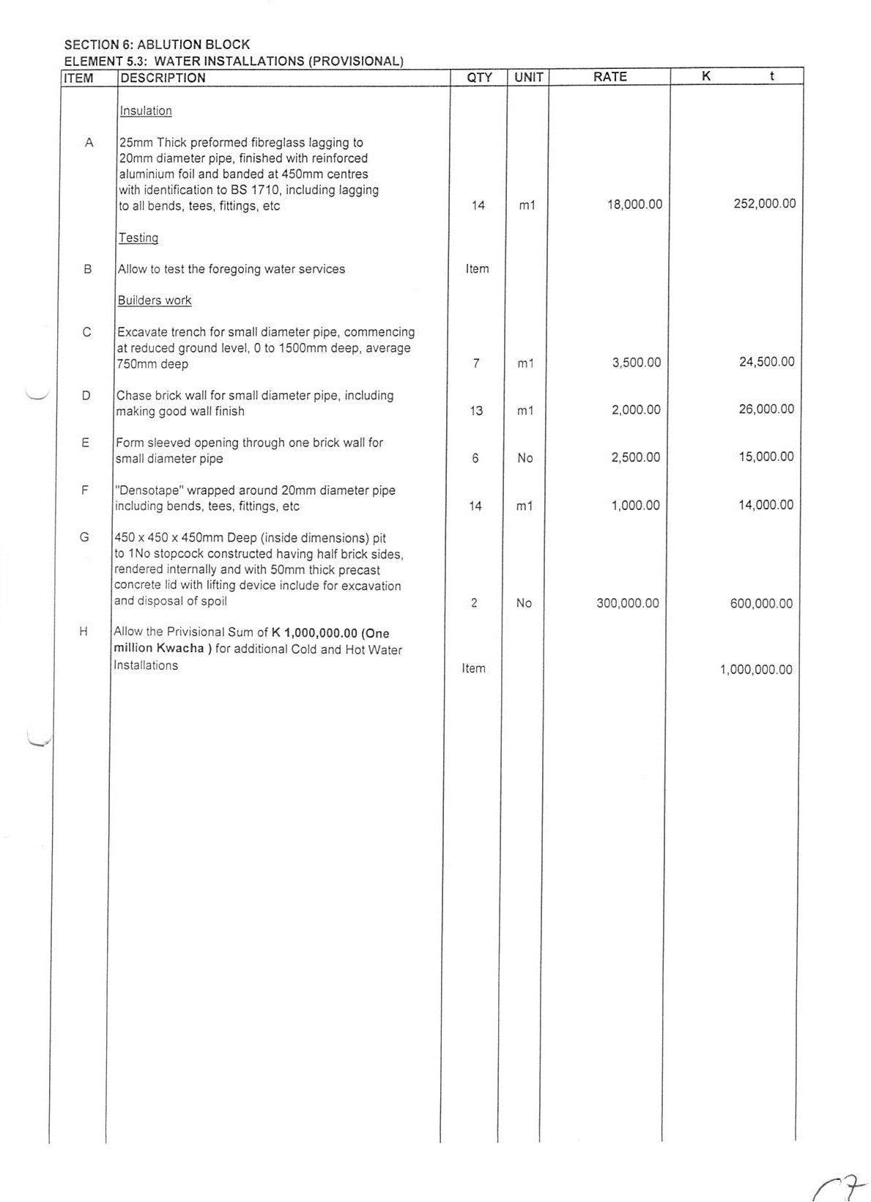

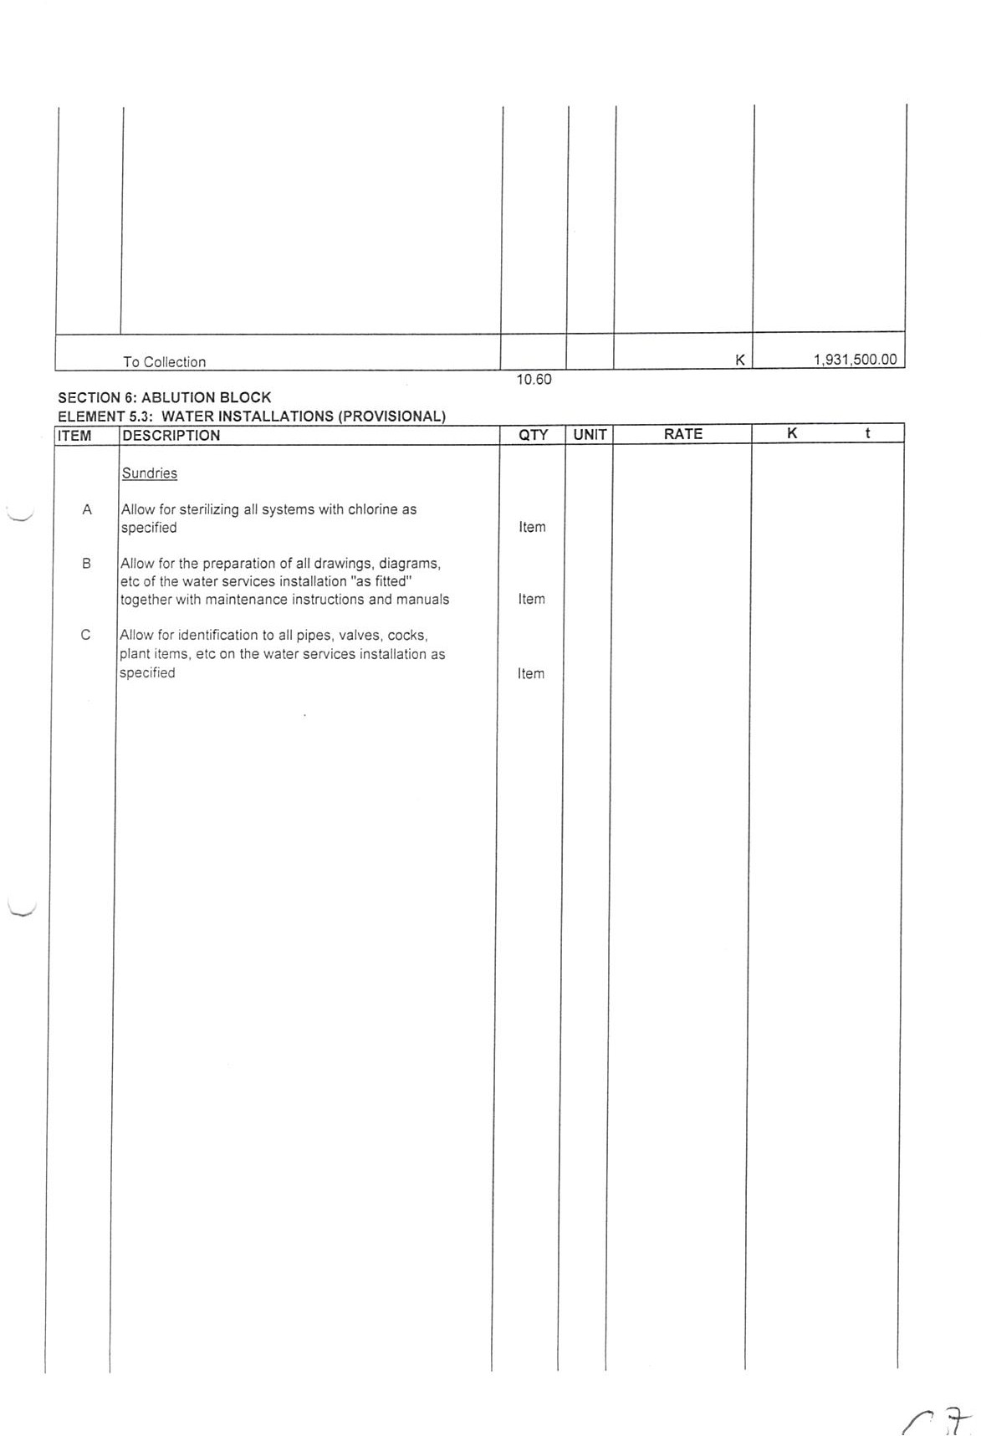

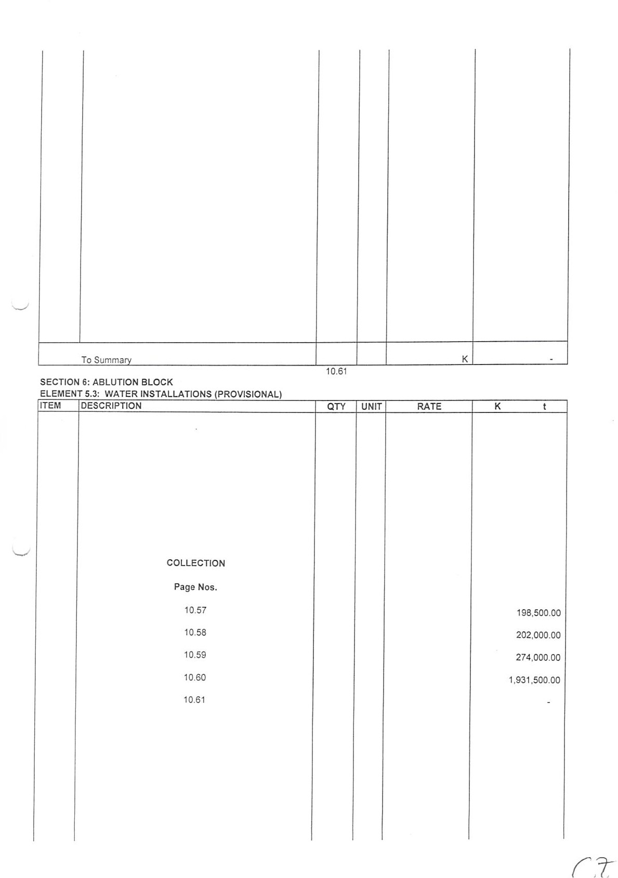

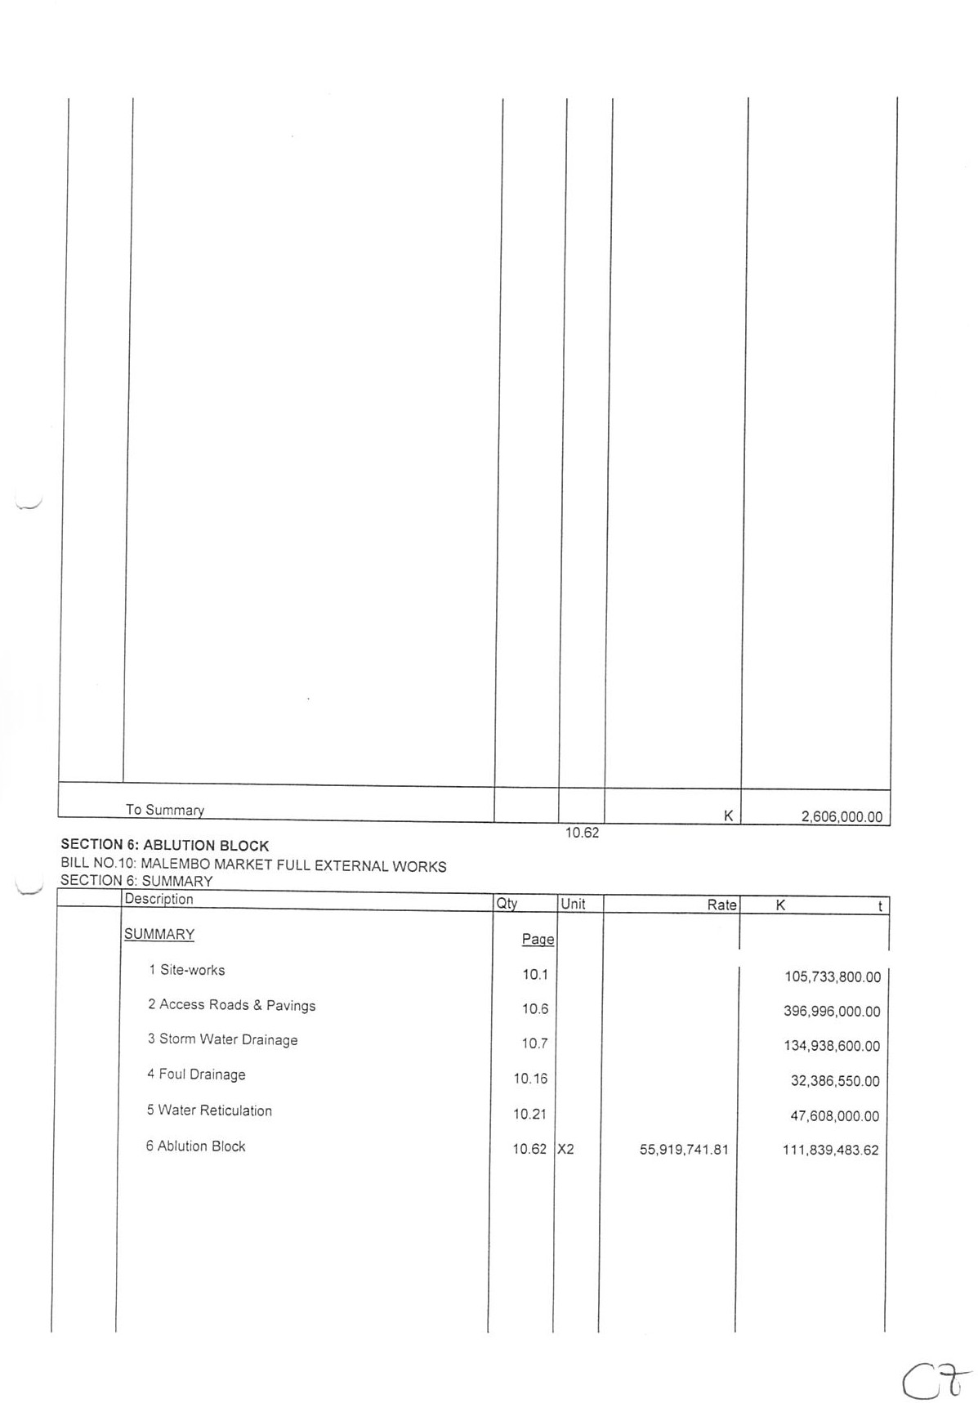

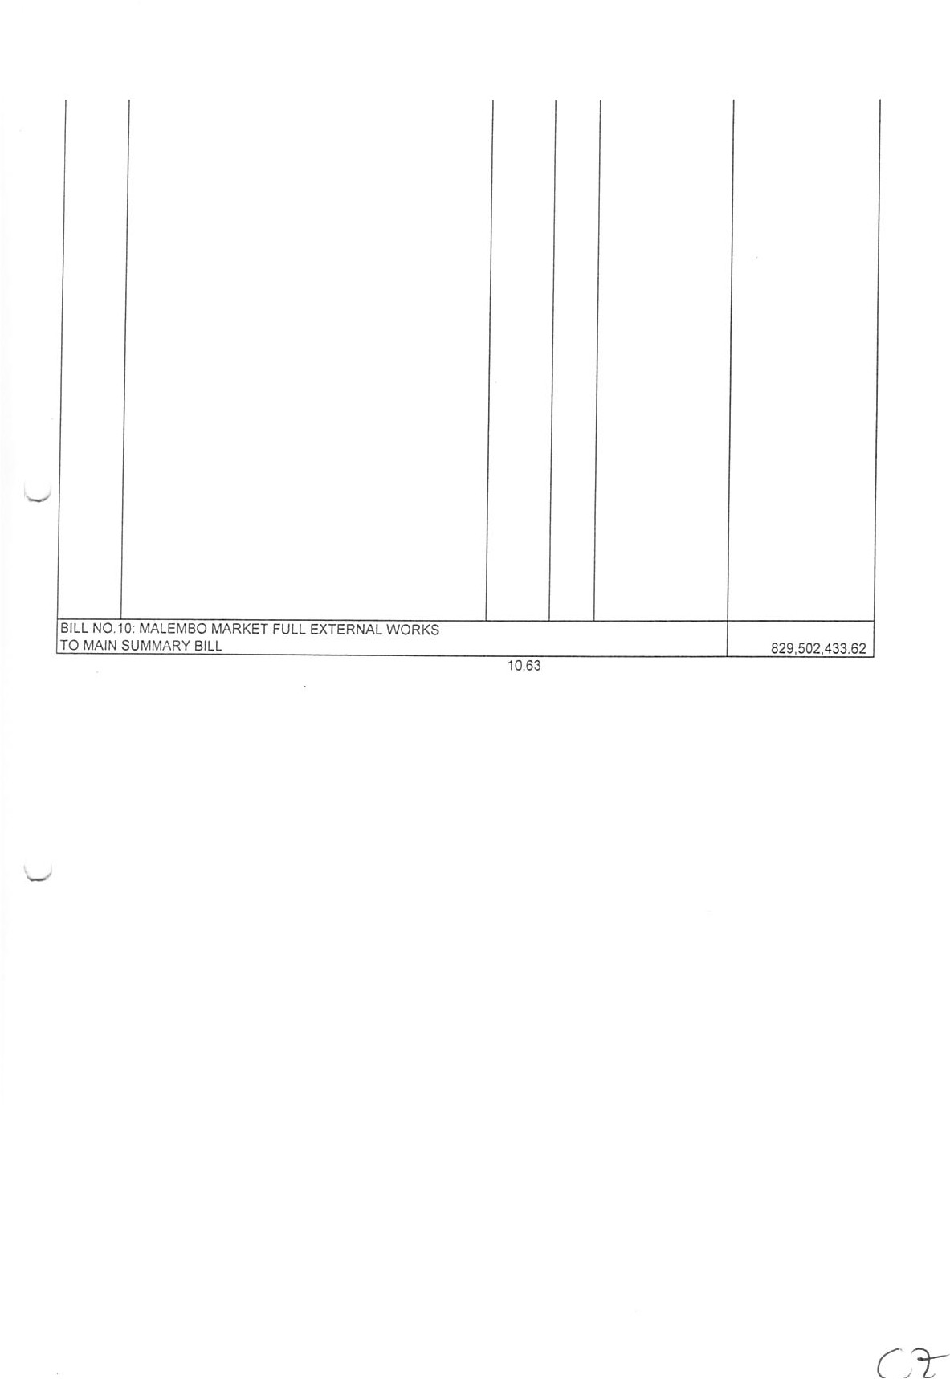

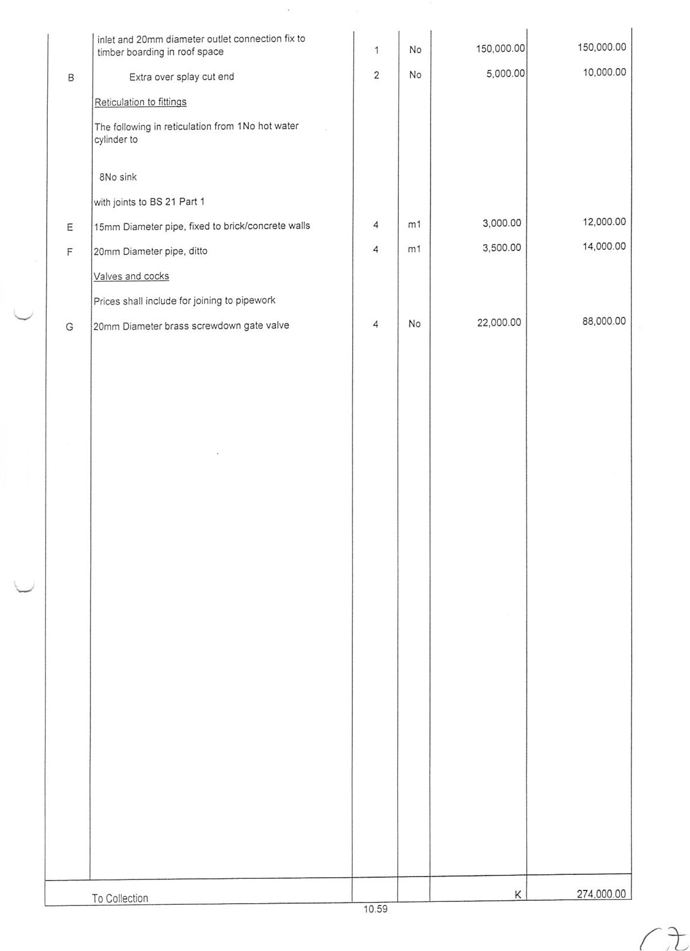

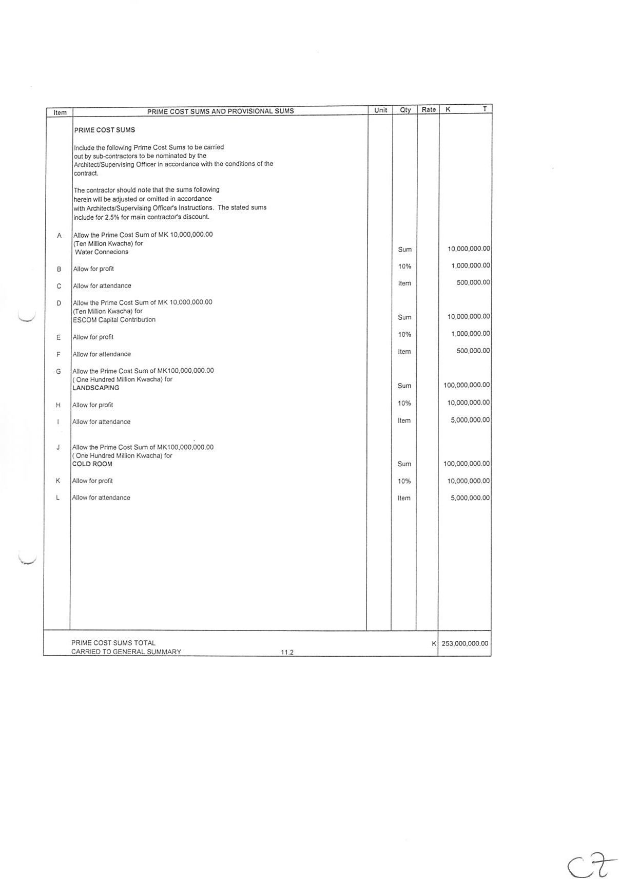

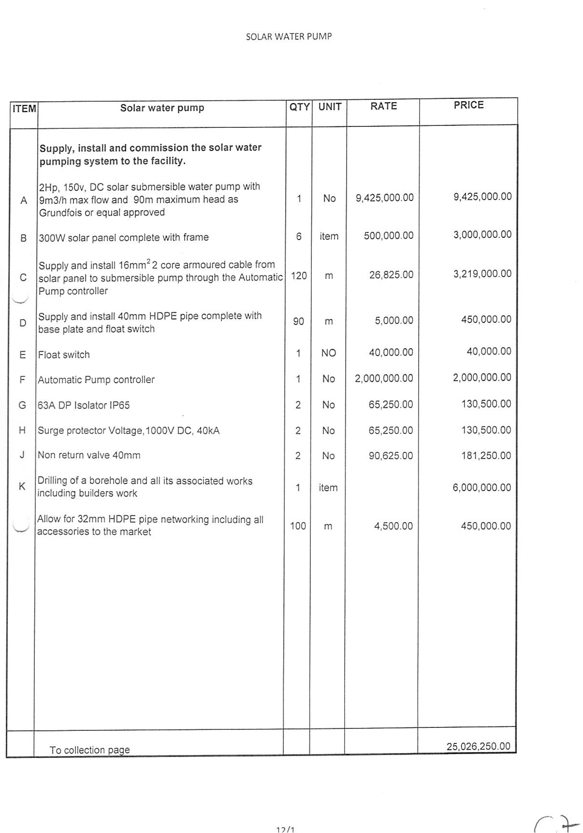

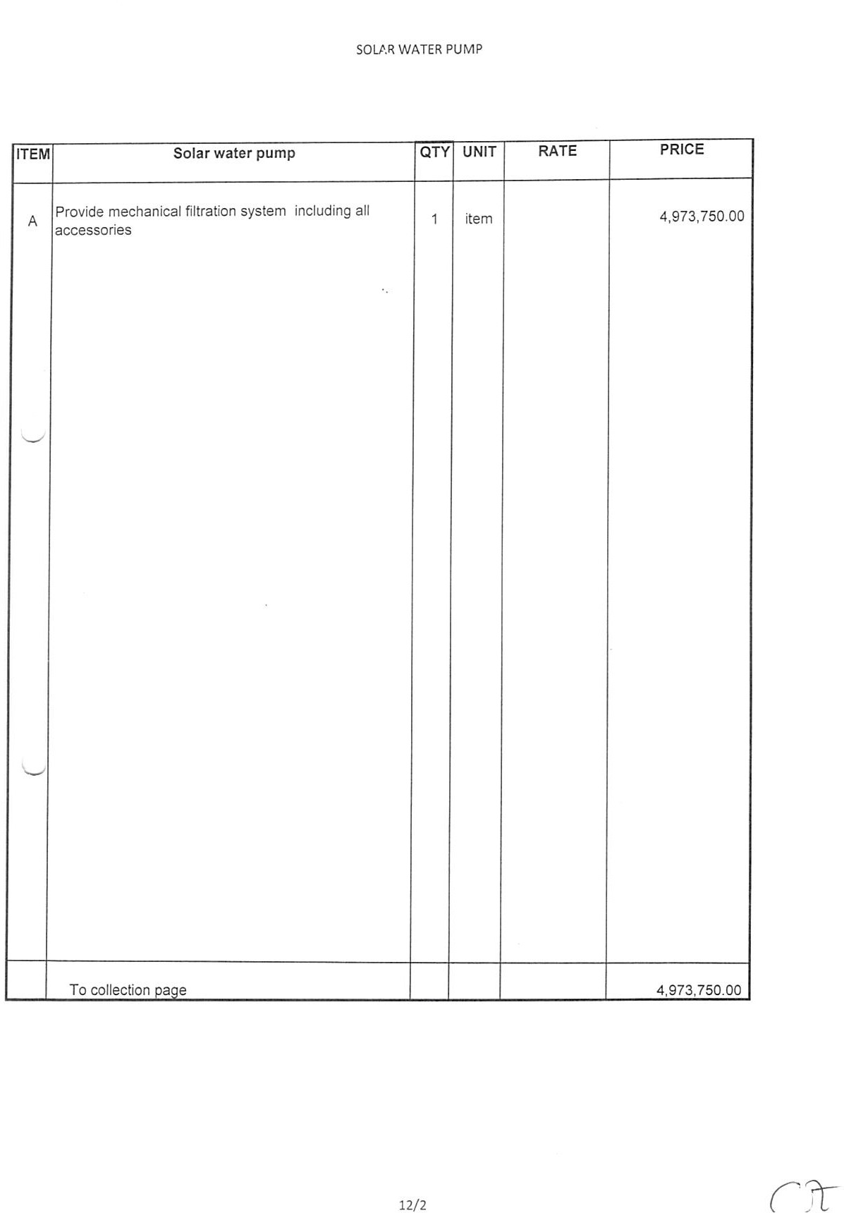

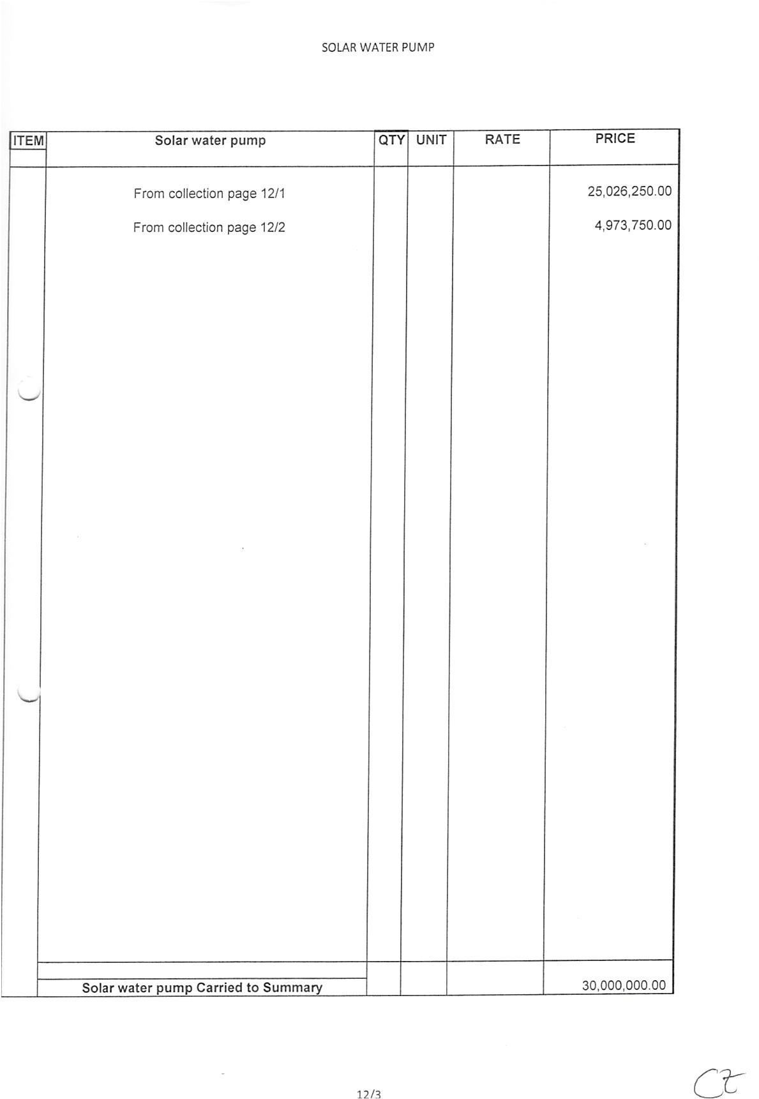





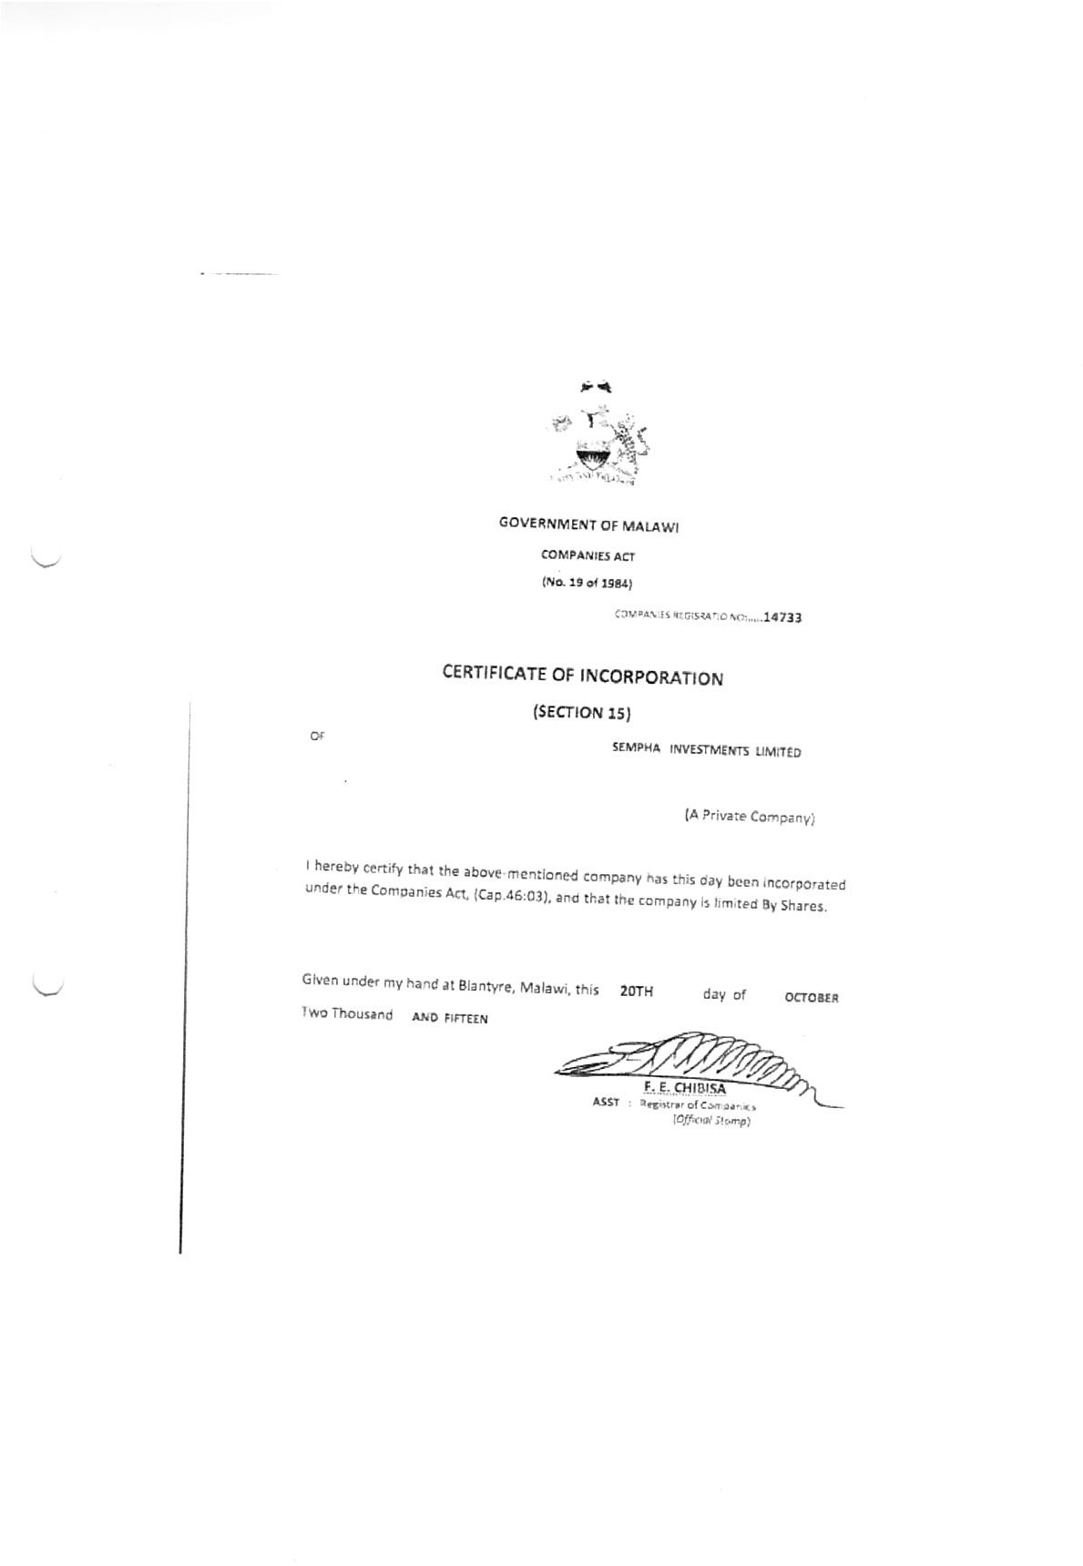







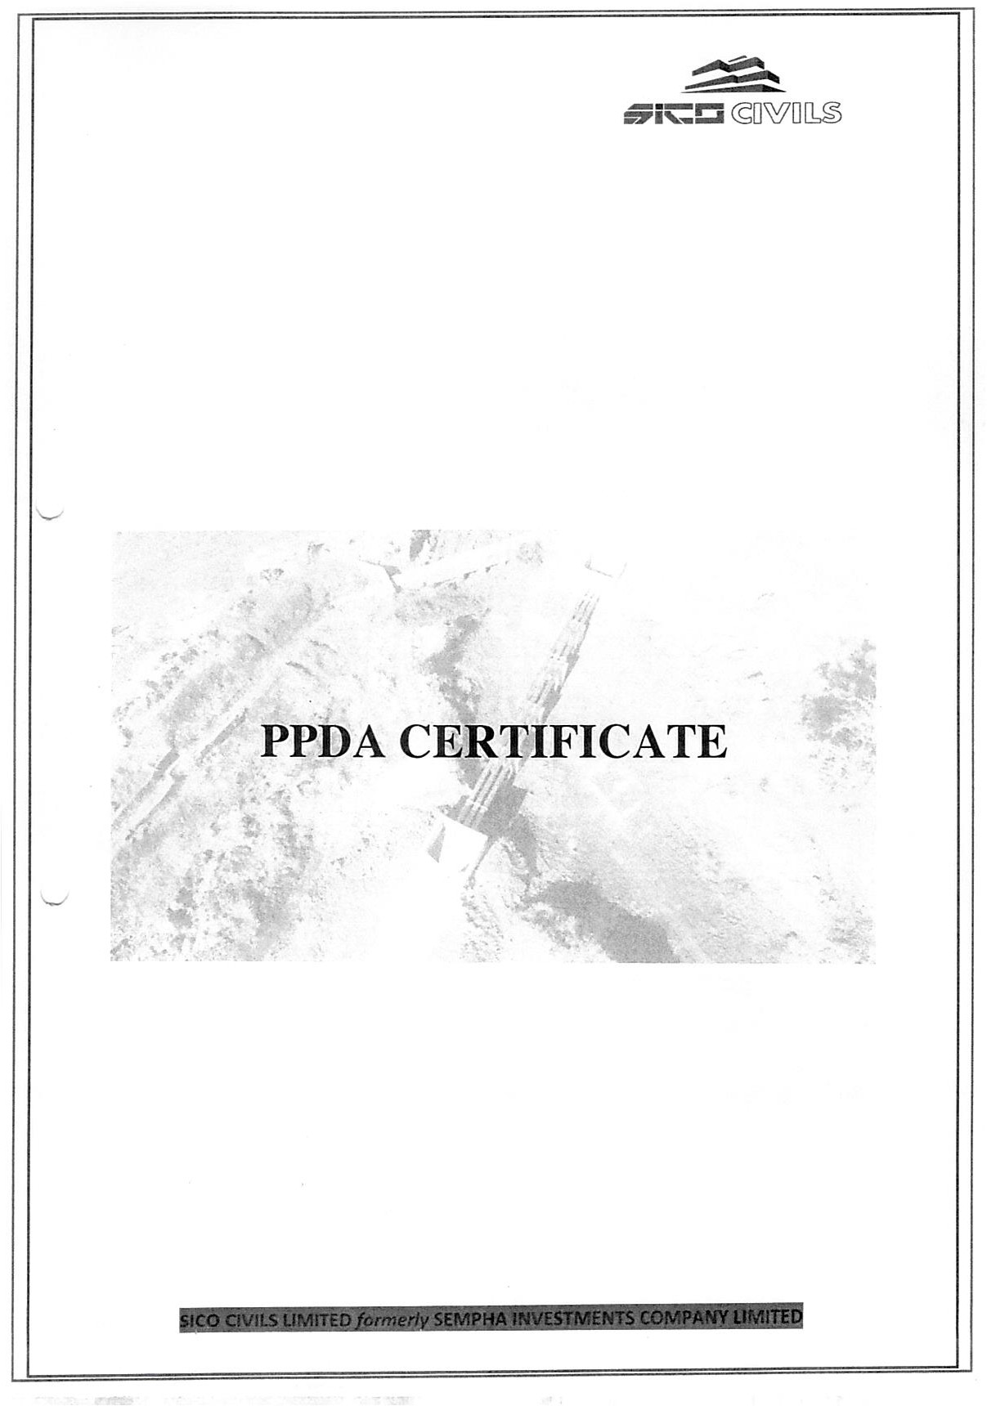

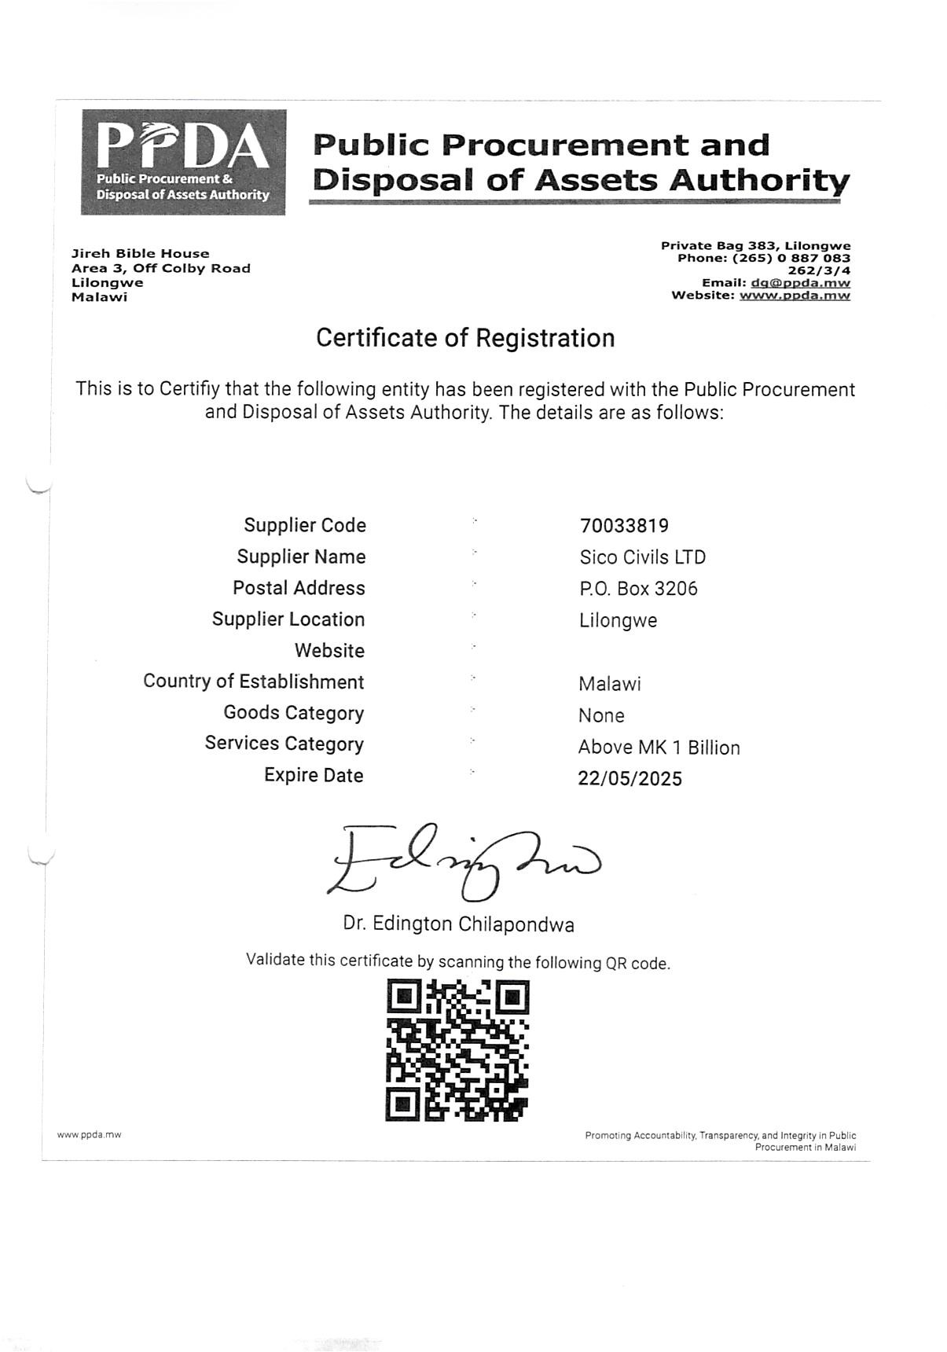





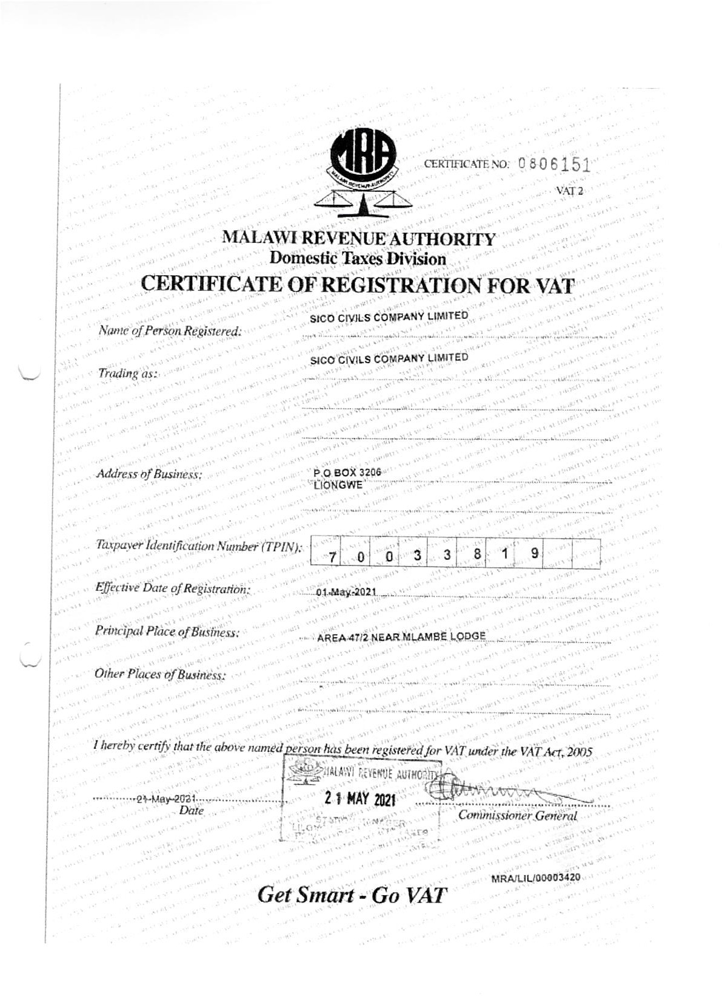

Letter of Acceptance



REF: TRADE/LL/MMKT/2024/01 15th November, 2024

The Managing Director
SICO CIVILS Limited
P. O. Box 3206,
Lilongwe
Malawi

Dear Sir,

NOTIFICATION OF AWARD OF A CONTRACT FOR THE CONSTRUCTION OF MALEMBO RURAL GROWTH MARKET CENTRE IN LILONGWE DISTRICT

This is to notify you that your Bid dated 15th July 2024 for execution of the Construction of Malembo Rural Growth Market Centre in Lilongwe District - Ref. No: TRADE/LL/MMKT/2024/01 for the accepted contract amount of 3,657,384,112.84. (3,657,384,112.84 (Three billion six hundred fifty-seven million three hundred eighty-four thousand one hundred twelve point eight four Kwacha Only), as corrected and modified in accordance with the instructions to bidders is hereby accepted by our agency.

You are requested to furnish (i) the performance security and an environmental and social (ES) performance security within 28 days in accordance with the conditions of contract, using for that purpose the performance security form and the ES performance security form.

The contract is valid for Eleven (11) months from the date of site handover and shall be terminated upon certification that the contractor is in breach of the agreed Contractual terms. To confirm your acceptance of the terms of the Contract, please sign the Contract award letter and return it by hand to the Procurement and Contract Department (Attention: Contracts and Procurement Specialist).

I congratulate you and look forward to our cordial working relation.

Yours faithfully,

Mr. F. Sakala
National Programme Coordinator

On behalf of SICO CIVILS Limited,

I………………….……………...................... (Name) confirm the acceptance of the terms of the above notification of contract award.

Signature: ……………………….…Date: ...................................................

Position: ……………………………………................................................... (STAMP)
(For: SICO CIVILS Limited )

Name of agency: Ministry of Local Government, Unity and Culture

Attachment: Contract agreement

Performance Security - Bank Guarantee

[Guarantor letterhead or SWIFT identifier code]
Beneficiary: [insert name and Address of employer]
Date: _ [Insert date of issue]
PERFORMANCE GUARANTEE No.: [Insert guarantee reference number]
Guarantor: [Insert name and address of place of issue, unless indicated in the letterhead]
We have been informed that _ [insert name of contractor, which in the case of a joint venture shall be the name of the joint venture] (hereinafter called "the applicant") has entered into contract No. TRADE/LL/MMKT/2024/01 dated [insert date] with the Beneficiary, for the execution of Construction of Malembo Rural Growth Market Centre in Lilongwe District (hereinafter called "the contract").
Furthermore, we understand that, according to the conditions of the contract, a performance guarantee is required.
At the request of the applicant, we as guarantor, hereby irrevocably undertake to pay the beneficiary any sum or sums not exceeding in total an amount of [insert amount in figures] (______) [insert amount in words], such sum being payable in the types and proportions of currencies in which the contract price is payable, upon receipt by us of the beneficiary’s complying demand supported by the beneficiary’s statement, whether in the demand itself or in a separate signed document accompanying or identifying the demand, stating that the applicant is in breach of its obligation(s) under the contract, without the beneficiary needing to prove or to show grounds for your demand or the sum specified therein.
This guarantee shall expire, no later than the …. day of ……, 2…, and any demand for payment under it must be received by us at this office indicated above on or before that date.
This guarantee is subject to the Uniform Rules for Demand Guarantees (URDG) 2010 Revision, ICC publication No. 758, except that the supporting statement under article 15(a) is hereby excluded.

_____________________
[signature(s)]

Environmental and Social (ES) Performance Security
ES Demand Guarantee

[Guarantor letterhead or SWIFT identifier code]

Beneficiary: [insert name and address of employer]
Date: _ [Insert date of issue]
ES PERFORMANCE GUARANTEE No.: [Insert guarantee reference number]
Guarantor: [Insert name and address of place of issue, unless indicated in the letterhead]
We have been informed that ________________ (hereinafter called "the applicant") has entered into Contract no. TRADE/LL/MMKT/2024/01 dated ____________ with the beneficiary, for the execution of Construction of Malembo Rural Growth Market Centre in Lilongwe District (hereinafter called "the contract").
Furthermore, we understand that, according to the conditions of the contract, a performance guarantee is required.
At the request of the applicant, we as guarantor, hereby irrevocably undertake to pay the Beneficiary any sum or sums not exceeding in total an amount of ___________ ( ), such sum being payable in the types and proportions of currencies in which the contract price is payable, upon receipt by us of the beneficiary’s complying demand supported by the beneficiary’s statement, whether in the demand itself or in a separate signed document accompanying or identifying the demand, stating that the applicant is in breach of its environmental and/or social (ES) obligation(s) under the contract, without the beneficiary needing to prove or to show grounds for your demand or the sum specified therein.
This guarantee shall expire, no later than the …. day of ……, 2… , and any demand for payment under it must be received by us at this office indicated above on or before that date.
This guarantee is subject to the Uniform Rules for Demand Guarantees (URDG) 2010 Revision, ICC publication No. 758, except that the supporting statement under article 15(a) is hereby excluded.

_____________________
[signature(s)]

Advance Payment Security
Demand Guarantee
[Guarantor letterhead or SWIFT identifier code]
Beneficiary: [Insert name and address of employer]
Date: [Insert date of issue]
ADVANCE PAYMENT GUARANTEE No.: [Insert guarantee reference number]
Guarantor: [Insert name and address of place of issue, unless indicated in the letterhead]

We have been informed that [insert name of contractor, which in the case of a joint venture shall be the name of the joint venture] (hereinafter called “the applicant”) has entered into contract no. TRADE/LL/MMKT/2024/01 dated [insert date] with the beneficiary, for the execution of Construction of Malembo Rural Growth Market Centre in Lilongwe District (hereinafter called "the contract").
Furthermore, we understand that, according to the conditions of the contract, an advance payment in the sum [insert amount in figures] () [insert amount in words] is to be made against an advance payment guarantee.
At the request of the applicant, we as guarantor, hereby irrevocably undertake to pay the beneficiary any sum or sums not exceeding in total an amount of [insert the amount in figures] (…………) [insert amount in words] upon receipt by us of the beneficiary’s complying demand supported by the beneficiary’s statement, whether in the demand itself or in a separate signed document accompanying or identifying the demand, stating either that the applicant:
(a) has used the advance payment for purposes other than the costs of mobilization in respect of the works; or
(b) has failed to repay the advance payment in accordance with the contract conditions, specifying the amount which the applicant has failed to repay.

A demand under this guarantee may be presented as from the presentation to the guarantor of a certificate from the beneficiary’s bank stating that the advance payment referred to above has been credited to the applicant on its account number [insert number] at [insert name and address of applicant’s bank].
The maximum amount of this guarantee shall be progressively reduced by the amount of the advance payment repaid by the applicant as specified in copies of interim statements or payment certificates which shall be presented to us. This guarantee shall expire, at the latest, upon our receipt of a copy of the interim payment certificate indicating that ninety (90) percent of the accepted contract amount, less provisional sums, has been certified for payment, or on the [insert day] day of [insert month], 2….[insert year], whichever is earlier. Consequently, any demand for payment under this guarantee must be received by us at this office on or before that date.
This guarantee is subject to the Uniform Rules for Demand Guarantees (URDG) 2010 Revision, ICC publication No. 758, except that the supporting statement under article 15(a) is hereby excluded.
____________________
[signature(s)]

Self-Certification Form
This self-certification form is to be completed by the contractor. The contractor shall submit the completed form together with the signed contract agreement to TRADE Programme. Instructions for completing this form are provided below.
Full legal name of contractor:
Full legal name of contractor's legal representative and position:
Full name and number of contract: | Construction of Malembo Rural Growth Market Centre in Lilongwe District  TRADE/LL/MMKT/2024/01
Project with which contract was signed: | Transforming Agriculture through Diversification and Entrepreneurship (TRADE) Programme
Country: | Malawi
Date:
I hereby certify that I am the authorized representative of [name of the contractor], as well as that the information provided herein is true and accurate in all material respects and understand that any material misstatement, misrepresentation or failure to provide the information requested in this self-certification may result in sanctions and remedies, including the suspension or termination of the contract between the contractor and the procuring entity, as well as the permanent ineligibility to participate in IFAD-financed and/or IFAD-managed activities and operations, in accordance with the IFAD Procurement Guidelines, the IFAD Procurement Handbook and other applicable IFAD policies and procedures, including IFAD’s Policy on Preventing Fraud and Corruption in its Activities and Operations (accessible at www.ifad.org/anticorruption_policy) and its Policy on Preventing and Responding to Sexual Harassment, Sexual Exploitation and Abuse (accessible at https://www.ifad.org/en/document-detail/asset/40738506).
Authorized Signature: ____________________________ Date: _________________
Printed Name of Signatory: ______________________________________________

- The contractor certifies that itself, including its director(s), partner(s), proprietor(s), key personnel, agents, sub-consultants, sub-contractors, consortium and joint venture partners have NOT engaged in fraudulent, corrupt, collusive, coercive or obstructive practices, in connection with the present procurement process and this contract.

- The contractor declares that the following criminal convictions, administrative sanctions (including debarments under the Agreement for Mutual Enforcement of Debarment Decisions or the "Cross-Debarment Agreement") and/or temporary suspensions have been imposed on the contractor and/or any of its directors, partners, proprietors, key personnel, agents, sub-consultants, sub-contractors, consortium and joint venture partners:
Nature of the measure (i.e., criminal conviction, administrative sanction or temporary suspension) | Imposed by | Name of party convicted, sanctioned or suspended (and relationship to contractor) | Grounds for the measure (i.e., fraud in procurement or corruption in contract execution) | Date and time (duration) of measure

If no criminal convictions, administrative sanctions or temporary suspensions have been imposed, indicate “none”.

- The contractor certifies that its director(s), proprietor(s), and personnel, and the personnel of its agents, sub-consultants, sub-contractors, consortium and joint venture partners are NOT subject to a criminal conviction, administrative sanctions or investigations for incidents of sexual harassment and sexual exploitation and abuse.
- The contractor certifies that itself, its proprietor(s), agents, sub-consultants, sub-contractors, consortium and joint venture partners have NO actual, potential or reasonably perceived conflicts of interest and specifically that they:
- Do not have any actual or potential, and do not reasonably appear to have, at least one controlling partner in common with one or more other parties in the bidding process or the execution of the contract ;
- Do not have any actual or potential, and do not reasonably appear to have the same legal representative as another bidder for purposes of this bid or execution of the contract;
- Do not have any actual or potential, and do not reasonably appear to have a relationship, directly or through common third parties, that puts them in a position to have access to undue or undisclosed information about or influence over the bid process and the execution of the contract, or influence the decisions of the procuring entity regarding the selection process for this procurement or during the execution of the contract;
- Do not participate and do not potentially or reasonably appear to participate in more than one bid in this process; and
- Do not have any actual or potential, and do not reasonably appear to have, a business or family relationship with, a member of the procuring entity’s board of directors or its personnel , the Fund or its personnel, or any other individual that was, has been or might reasonably be directly or indirectly involved in any part of (i) the preparation of the bidding document, (ii) the selection process for this procurement, or (iii) execution of the contract, unless the actual, potential or reasonably conflict stemming from this relationship has been explicitly authorized by the Fund in writing.
- [To be completed only if the previous boxes were not checked]
The contractor declares the following actual, potential or reasonably perceived conflicts of interest, that may affect, or might reasonably be perceived by others to affect, impartiality in any matter relevant to the procurement process, including the selection process and the execution of the contract, with the understanding and acceptance that any action upon this disclosure shall be entirely under the Fund’s discretion:

[provide detailed description of any actual, potential or reasonably perceived conflicts of interest including their nature and the personnel, proprietor(s), agents, sub-consultants, sub-contractors, consortium or joint venture partners affected.]

- The contractor certifies that NO gratuities, fees, commissions, gifts or anything else of value, other than those shown in the bid, have been paid or exchanged or are to be paid or exchanged with respect to the present procurement process and this contract.

OR

- [To be completed only if the previous box was not checked]
The contractor declares that the following gratuities, fees, commissions, gifts or anything else of value have been exchanged, paid or are to be exchanged or paid with respect to the present procurement process and this contract:

- [Name of Recipient/Address/Date/Reason/Amount]
- [Name of Recipient/Address/Date/Reason/Amount]

- The contractor acknowledges and accepts to notify the procuring entity in the event of any material change in connection with this self-certification form throughout the duration of the contract.

Instructions for completing the self-certification form
The World Bank listing of ineligible firms and individuals is a searchable database that returns a positive or negative search results page upon submission of a name to be searched, in order to document the eligibility.
The contractor should print out, date, and attach the results page(s) to the self-certification form, which should read, “no matching records found”.
If (a) record(s) has/have been found – i.e. the results page(s) shows one or more individuals or entities, including the contractor itself are ineligible for contracts of the World Bank on the grounds of “cross-debarment”, the contractor should provide a detailed account of these sanctions and their duration as applicable or notify the procuring entity and in case the contractor believes the finding is a “false positive”.
The procuring entity will determine whether to proceed with the contract or allow the contractor to make a substitution. This determination will be made on a case by case basis and will require approval by IFAD regardless of the estimated value of the proposed contract.
All of these documents must be retained by the contractor as part of the overall record of the contract with the procuring entity for the duration of the contract and for a minimum period of three years following the completion of the contract.

In lump-sum contracts, delete “bill of quantities” and replace with “activity schedule.”
In lump-sum contracts, replace GCC sub-clause 40.1 as follows: 40.1 The Contractor shall provide updated activity schedules within 14 days of being instructed to by the project manager. The activity schedule shall contain the priced activities for the works to be performed by the contractor. The activity schedule is used to monitor and control the performance of activities on which basis the contractor will be paid. If payment for materials on site shall be made separately, the contractor shall show delivery of materials to the site separately on the activity schedule
In lump-sum contracts, replace entire GCC clause 41 with new GCC sub-clause 41.1, as follows: 41.1 The activity schedule shall be amended by the contractor to accommodate changes of program or method of working made at the contractor’s own discretion. Prices in the activity schedule shall not be altered when the contractor makes such changes to the activity schedule
In lump-sum contracts, add “and activity schedules” after “programs.
In lump-sum contracts, delete this paragraph.
In lump-sum contracts, add “or activity schedule” after “program.”
In lump-sum contracts, replace this paragraph with the following: “The value of work executed shall comprise the value of completed activities in the activity schedule.”
The sum of the two coefficients Ac and Bc should be 1 (one) in the formula for each currency. Normally, both coefficients shall be the same in the formulae for all currencies, since coefficient A, for the nonadjustable portion of the payments, is a very approximate figure (usually 0.15) to take account of fixed cost elements or other nonadjustable components. The sum of the adjustments for each currency are added to the contract price.
The Agreement for Mutual Enforcement of Debarment Decisions, dated 9 April 2010, was signed by five of the leading IFIs, namely, the African Development Bank Group, the Asian Development Bank, the European Bank for Reconstruction and Development, the Inter-American Development Bank and the World Bank Group.
The Fund may, in the future, decide to also recognize debarments imposed by entities that are not signatories to the Agreement for Mutual Enforcement of Debarment Decisions.
The guarantor shall insert an amount representing the percentage of the accepted contract amount specified in the letter of acceptance, less provisional sums, if any, and denominated either in the currency (cies) of the contract or a freely convertible currency acceptable to the beneficiary.
Insert the date twenty-eight days after the expected completion date as described in GCC sub- clause 57.1. The employer should note that in the event of an extension of this date for completion of the contract, the employer would need to request an extension of this guarantee from the guarantor. Such request must be in writing and must be made prior to the expiration date established in the guarantee. In preparing this guarantee, the employer might consider adding the following text to the form, at the end of the penultimate paragraph: “The guarantor agrees to a one-time extension of this guarantee for a period not to exceed [six months] [one year], in response to the beneficiary’s written request for such extension, such request to be presented to the guarantor before the expiry of the guarantee.”
Insert the expected completion date as described in GCC sub- clause 57.1. The employer should note that in the event of an extension of the expected completion date of the contract, the employer would need to request an extension of this guarantee from the guarantor. Such request must be in writing and must be made prior to the expiration date established in the guarantee. In preparing this guarantee, the employer might consider adding the following text to the form, at the end of the penultimate paragraph: “The guarantor agrees to a one-time extension of this guarantee for a period not to exceed [six months][one year], in response to the beneficiary’s written request for such extension, such request to be presented to the guarantor before the expiry of the guarantee.”
The Cross-Debarment Agreement was entered into by the World Bank Group, the Inter-American Development Bank, the African Development Bank, the Asian Development Bank and the European Bank for Reconstruction and Development, additional information may be located at: http://crossdebarment.org/.

